1

**Assignment: 04**



**Department of Computer Science**

**Iqra University Islamabad**

**DSA**

**Maqsood Ahmed**

**ID: 3818**

**Binary Search Tree:**

**Scenario:** **Library Book Management System**

Imagine you are developing a Library Book Management System where each book is assigned a unique numeric Book ID. The system needs to efficiently manage the collection of books by supporting the following operations:

**1. Insert:** Add a new book to the library by its unique Book ID. If a book with the same ID already exists, the system should prevent duplicate entries.

**2. Search:** Allow library staff to search for a book by its Book ID to check its availability or fetch its details.

**3. Update:** Modify the details of a book (e.g., title, author, genre) if it exists in the library's collection.

**4. Delete:** Remove a book from the library's collection if it's no longer available or needed.

The library uses a Binary Search Tree (BST) to manage the books because it enables fast operations on the Book IDs, ensuring that the system remains efficient as the collection grows.

**Implementation Logic:**

**1. Nodes:**

Each node in the BST represents a book.

A node contains the following attributes:

▪ book_id: The unique numeric ID of the book (used as the key for BST operations).

▪ title: The title of the book.

▪ author: The author's name.

▪ genre: The genre of the book.

▪ left and right: Pointers to the left and right child nodes.

**2. Insertion:**

Add a new node for the book by traversing the BST.

Place the new book's node in the correct position based on its book_id.

**3. Search:**

Traverse the BST to locate a node with the given book_id.

If found, display the book details; otherwise, notify that the book is not available.

**4. Update:**

Search for the book by its book_id.

If the book exists, update its attributes like title, author, or genre.

**5. Delete:**

Locate the node with the given book_id.

Remove the node using the appropriate BST deletion rules:

▪ If the node is a leaf, delete it directly.

▪ If the node has one child, replace it with its child.

▪ If the node has two children, replace it with its in-order successor or predecessor.

**Source Code:**

#include <iostream>

#include <string>

using namespace std;

class Node {

public:

// book attributes

int book_id;

string title;

string author;

string genre;

Node* left;

Node* right;

Node(int book_id, string title, string author, string genre) {

this->book_id = book_id;

this->title = title;

this->author = author;

this->genre = genre;

this->left = nullptr;

this->right = nullptr;

}

~Node() {

delete left;

delete right;

}

};

class BST {

private:

Node* root;

Node* insert(Node* node, int book_id, string title, string author, string genre) {

if (node == nullptr) {

return new Node(book_id, title, author, genre);

}

if (book_id < node->book_id) {

node->left = insert(node->left, book_id, title, author, genre);

} else if (book_id > node->book_id) {

node->right = insert(node->right, book_id, title, author, genre);

} return node;

}

Node* findMin(Node* node) {

while (node && node->left != nullptr) {

node = node->left;

}

return node;

}

Node* deleteNode(Node* node, int book_id) {

if (node == nullptr) return node;

if (book_id < node->book_id) {

node->left = deleteNode(node->left, book_id);

} else if (book_id > node->book_id) {

node->right = deleteNode(node->right, book_id);

} else {

// Node to be deleted found

if (node->left == nullptr) {

Node* temp = node->right;

node->right = nullptr;

delete node;

return temp;

} else if (node->right == nullptr) {

Node* temp = node->left;

node->left = nullptr;

delete node;

return temp;

}

// Node with two children

Node* temp = findMin(node->right);

node->book_id = temp->book_id;

node->title = temp->title;

node->author = temp->author;

node->genre = temp->genre;

node->right = deleteNode(node->right, temp->book_id);

}

return node;

}

Node* search(Node* node, int book_id) {

if (node == nullptr || node->book_id == book_id) {

return node;

}

if (book_id < node->book_id) {

return search(node->left, book_id);

}

return search(node->right, book_id);

}

void display(Node* node) {

if (node != nullptr) {

display(node->left);

cout << "Book ID: " << node->book_id

<< ", Title: " << node->title

<< ", Author: " << node->author

<< ", Genre: " << node->genre << endl;

display(node->right);

}

}

public:

BST() {

root = nullptr;

}

~BST() {

delete root;

}

void insert(int book_id, string title, string author, string genre) {

root = insert(root, book_id, title, author, genre);

}

void deleteNode(int book_id) {

root = deleteNode(root, book_id);

}

void search(int book_id) {

Node* result = search(root, book_id);

if (result != nullptr) {

cout << "Book found!\n"

<< "Book ID: " << result->book_id

<< ", Title: " << result->title

<< ", Author: " << result->author

<< ", Genre: " << result->genre << endl;

} else {

cout << "Book with ID " << book_id << " not found." << endl;

}

}

void display() {

if (root == nullptr) {

cout << "The library is empty." << endl;

} else {

display(root);

}

}

};

int main() {

BST library;

library.insert(101, "The Great Gatsby", "F. Scott Fitzgerald", "Fiction");

library.insert(102, "1984", "George Orwell", "Dystopian");

library.insert(103, "To Kill a Mockingbird", "Harper Lee", "Fiction");

library.insert(104, "How to hide your self", "Maqsood", "")

cout << "\nLibrary contents:" << endl;

library.display();

cout << "\nSearching for book with ID 102:" << endl;

library.search(102);

cout << "\nDeleting book with ID 102." << endl;

library.deleteNode(102);

cout << "\nLibrary contents after deletion:" << endl;

library.display();

return EXIT_SUCCESS;

}

**OUTPUT:**

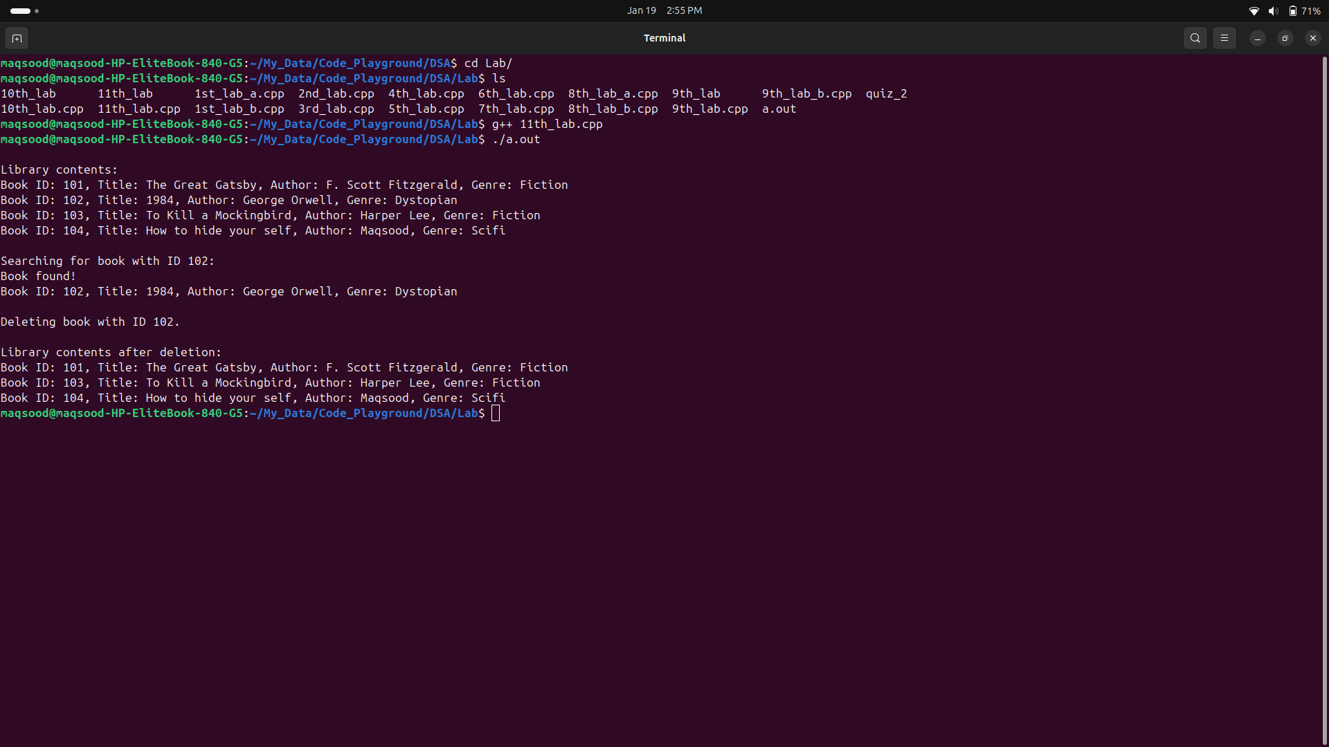

**The End**