Task No: 05

Department of Computer Science

Iqra University Islamabad

Object Oriented Programming

Maqsood Ahmed

ID: 38186

**Problem # 1: [CLO2]**

**Source Code:**

import java.util.Scanner;

public class LabTask5A {

public static void main(String args[]) {

Scanner input = new Scanner(System.in);

Calculation cal = new Calculation();

System.out.println("Enter the value of number1, number2");

cal.setNumber1(input.nextInt());

cal.setNumber2(input.nextInt());

System.out.println("The addition of number1 + number2 is: " + cal.addition());

System.out.println("The subtraction of number1 - number2 is: " + cal.subtraction());

}

}

class Calculator {

public int addition() {

return 0;

}

public int subtraction() {

return 0;

}

}

class Calculation extends Calculator {

private int number1;

private int number2;

Calculation(int number1, int number2) {

this.number1 = number1;

this.number2 = number2;

}

Calculation() {

number1 = 0;

number2 = 0;

}

public void setNumber1(int number1) {

this.number1 = number1;

}

public int getNumber1() {

return number1;

}

public void setNumber2(int number2) {

this.number2 = number2;

}

public int getNumber2() {

return number2;

}

@Override

public int addition() {

return number1 + number2;

}

@Override

public int subtraction() {

return number1 - number2;

}

}

**OUTPUT:**

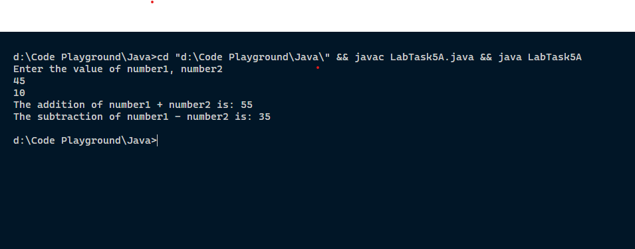

**Problem # 2: [CLO2]**

**Source Code:**

import java.util.Scanner;

public class LabTask5B {

public static void main(String args[]) {

Scanner input = new Scanner(System.in);

Rectangle rectangle = new Rectangle();

System.out.println("Enter the value of number1, number2");

rectangle.setLength(input.nextDouble());

rectangle.setWidth(input.nextDouble());

System.out.println("The area of the rectangle is: " + rectangle.getArea());

}

}

class Shape {

public double getArea() {

return 0;

}

}

class Rectangle extends Shape{

private double length, width;

public void setLength(double length) {

this.length = length;

}

public double getLength() {

return length;

}

public void setWidth(double width) {

this.width = width;

}

public double getWidth() {

return width;

}

@Override

public double getArea() {

return length * width;

}

}**OUTPUT:**

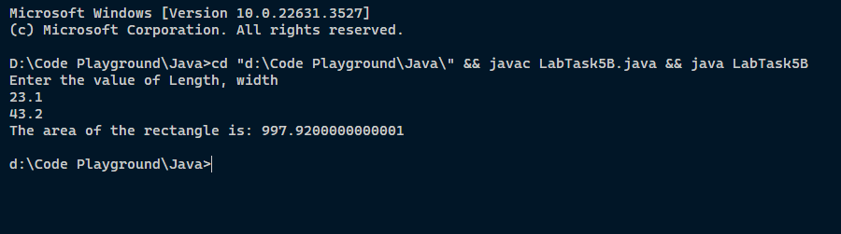

**The End**