FunFit code

<https://github.com/maqsop2024/servletproejct>

SQL script <https://github.com/maqsop2024/servletproejct/blob/main/FunFit.sql>

The FunFit App has 2 tables

Batch contains the batch name and id

Participants contains ParticipantId, BatchId, FullName. Sec, Age.

The application has 2 links to pages that will allow you to add new records, view the data in both tables and then each row will have to links to edit or delete the records.

The following screen are in order

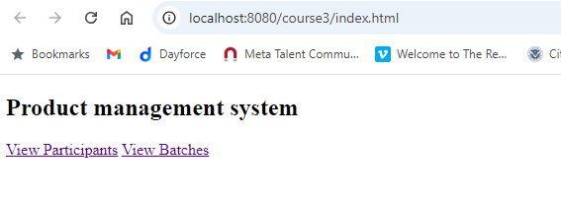

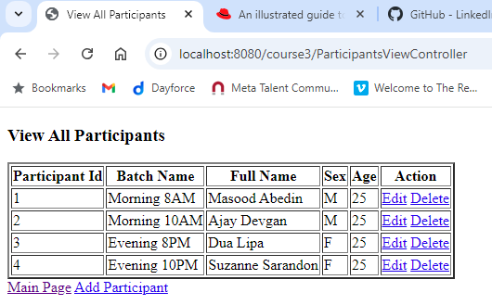

Click Edit will display the following screen

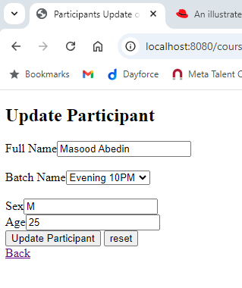

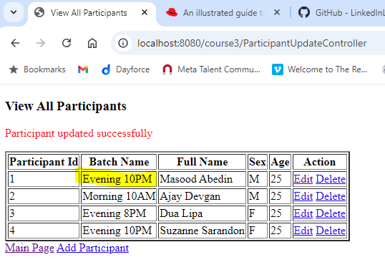

Old values Morning 8AM

Click on Add Particpant will display following page

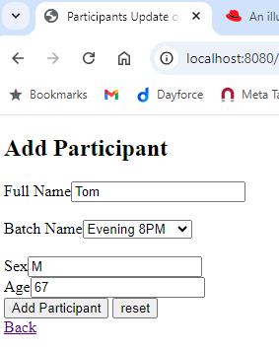

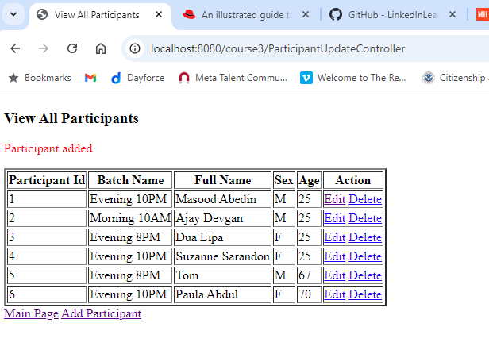

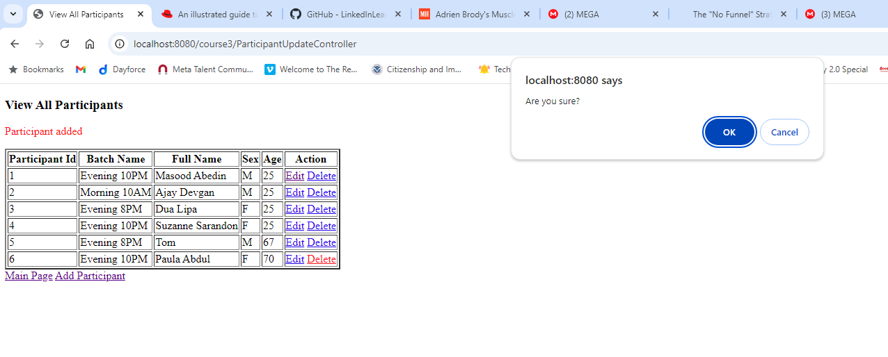

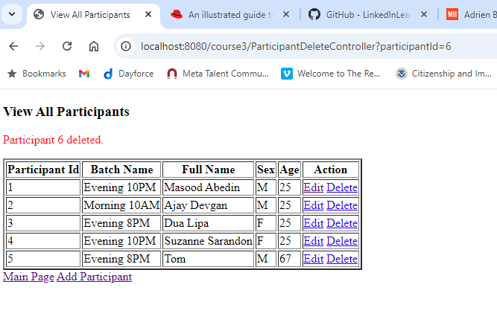

Following page is displayed by going back to Main Page and clicking on View Batches

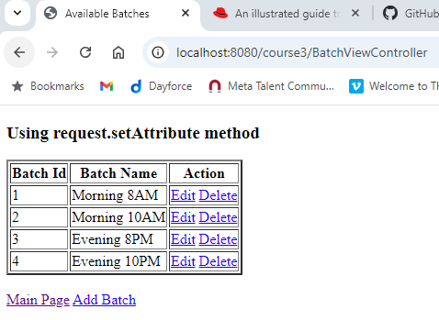

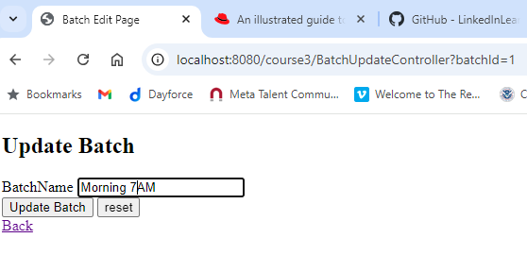

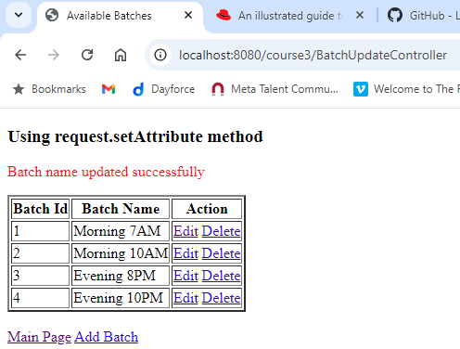

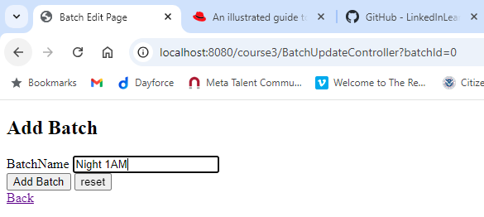

Added 6th record but did not take the screenshot I will add new students in Night 2AM batch and the delete it.

