**1 EchoUDP(wellknown servive) Client**

**String ipAddress=ipaddr.getText();**

**int portNo= Integer.parseInt(port.getText());**

**String reqmsg= Reqmsg.getText();**

**try**

**{**

**DatagramSocket dgs= new DatagramSocket();**

**byte[] sndmsg=reqmsg.getBytes();**

**DatagramPacket sndPacket = new DatagramPacket(sndmsg, sndmsg.length,**

**InetAddress.getByName(ipAddress), portNo);**

**dgs.send(sndPacket);**

**byte[] rcvmsg= new byte[40];**

**DatagramPacket rcvPacket= new DatagramPacket(rcvmsg,40);**

**dgs.receive(rcvPacket);**

**String response = new String(rcvPacket.getData()); resp.append("Received: " + response + "\n");**

**dgs.close();}**

**catch (Exception e) { e.printStackTrace();**

**} }**

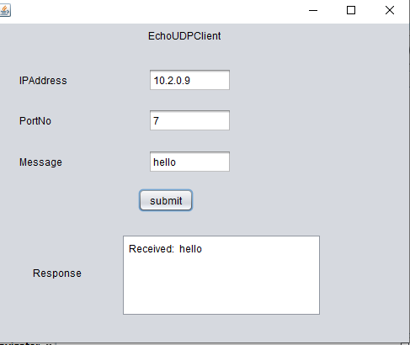

**2 EchoTCP(wellknown service)**

**String ip = Ipaddr.getText();**

**int portno = Integer.parseInt(port.getText());**

**String msg = reqmsg.getText();**

**try{**

**Socket s = new Socket(InetAddress.getByName(ip), portno);**

**DataInputStream dis = new DataInputStream(s.getInputStream());**

**DataOutputStream dos = new DataOutputStream(s.getOutputStream());**

**dos.writeUTF(msg);**

**String response = dis.readUTF(); srvrresp.append("Request Message sent to Server is : " + msg + "\n"); s.close();**

**}**

**catch(Exception e){ e.printStackTrace();**

**} }**

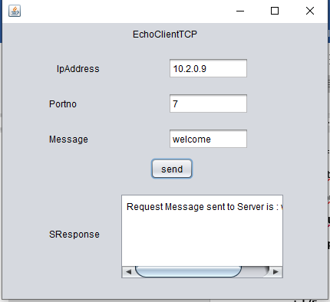

**3 ECHO TCP CLIENT SERVER**

**Client Code:-**

**private void sendbtnActionPerformed(java.awt.event.ActionEvent evt) {**

**// TODO add your handling code here:**

**String ip = ipaddr.getText();**

**int port = Integer.parseInt(portnoo.getText());**

**String msg = reqmsg.getText();**

**try{**

**Socket s = new Socket(InetAddress.getByName(ip), port);**

**DataInputStream dis = new DataInputStream(s.getInputStream());**

**DataOutputStream dos = new DataOutputStream(s.getOutputStream());**

**dos.writeUTF(msg);**

**String response = dis.readUTF();**

**sresp.append(msg + "\n"); s.close();**

**}**

**catch(Exception e){ e.printStackTrace();**

**} }**

**Server code:-**

**public class echotcpserver extends javax.swing.JFrame implements Runnable {**

**@SuppressWarnings("unchecked")**

**public void run() {**

**String ip = sipaddr.getText();**

**int port = Integer.parseInt(sportnoo.getText());**

**try {**

**ServerSocket ss = new ServerSocket(port, 5, InetAddress.getByName(ip));**

**while(true) {**

**Socket s = ss.accept();**

**DataInputStream dis = new DataInputStream(s.getInputStream());**

**DataOutputStream dos = new DataOutputStream(s.getOutputStream());**

**String req = dis.readUTF(); srvrresp.append(req + "\n"); dos.writeUTF(req);**

**s.close();**

**}}**

**catch(Exception e){ e.printStackTrace();**

**} }**

**private void startserverActionPerformed(java.awt.event.ActionEvent evt) {**

**Thread t = new Thread(this, "Server"); t.start();**

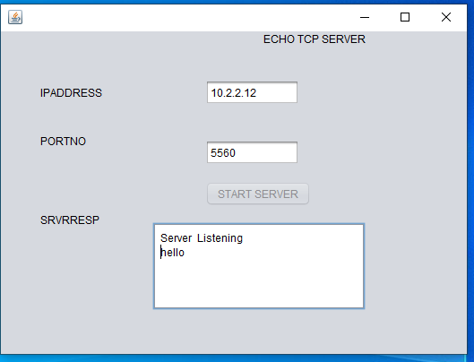 **startserver.setEnabled(false); srvresp.append("Server Listening\n");**

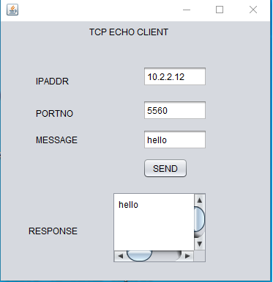

**4 UDP Client Server**

**Server Code:-**

**public void run() {**

**String ipAddress = sipaddr.getText();**

**int portNo = Integer.parseInt(sport.getText());**

**try {**

**DatagramSocket ds = new DatagramSocket(portNo, InetAddress.getByName(ipAddress));**

**while(true) {**

**byte[] rcvMessage = new byte[40];**

**DatagramPacket rcvPacket = new DatagramPacket(rcvMessage,40);**

**ds.receive(rcvPacket);**

**InetAddress clientIP = rcvPacket.getAddress(); int clientPort = rcvPacket.getPort();**

**String received = new String(rcvPacket.getData()); sresp.append("\nMessage recieved from Client " + clientIP + ": " +**

**received + "\n");**

**byte[] sndmsg = received.getBytes();**

**DatagramPacket sndPacket = new DatagramPacket(sndmsg, sndmsg.length, clientIP, clientPort);**

**ds.send(sndPacket);**

**}**

**//ds.close();**

**} catch (Exception e) { e.printStackTrace();**

**}**

**private void startbtnActionPerformed(java.awt.event.ActionEvent evt) {**

**// TODO add your handling code here:**

**Thread thread = new Thread(this, "server");**

**startbtn.setEnabled(false); thread.start();**

**sresp.append("Server Started");**

**}**

**Client Code :-**

**private void sendbtnActionPerformed(java.awt.event.ActionEvent evt) {**

**// TODO add your handling code here:**

**String ipAddress = cipaddr.getText();**

**int portNo = Integer.parseInt(cport.getText()); String message = creqmsg.getText();**

**try {**

**DatagramSocket ds = new DatagramSocket();**

**byte[] sndmsg = message.getBytes();**

**DatagramPacket sndPacket = new DatagramPacket(sndmsg, sndmsg.length, InetAddress.getByName(ipAddress), portNo);**

**ds.send(sndPacket);**

**byte[] rcvmsg = new byte[40];**

**DatagramPacket rcvPacket = new DatagramPacket(rcvmsg, 40); ds.receive(rcvPacket);**

**String response = new String(rcvPacket.getData()); cresp.append("Received: " + response + "\n"); ds.close();**

**} catch (Exception e) { e.printStackTrace();**

**} }**

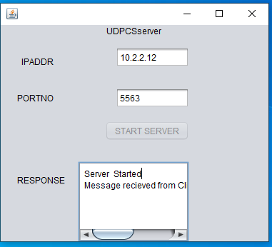 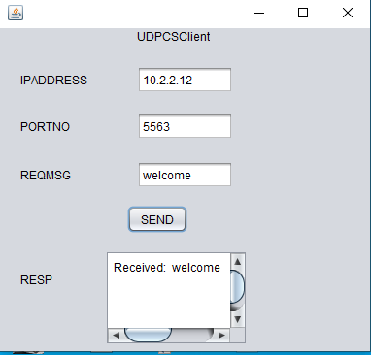

**5. Bulletin Board**

**Server code :-**

**public class BBSERVR extends javax.swing.JFrame implements Runnable {**

**@SuppressWarnings("unchecked")**

**public void run(){**

**String ip = IPField.getText();**

**int port = Integer.parseInt(PortField.getText()); try{**

**ServerSocket ss = new ServerSocket(port, 5, InetAddress.getByName(ip));**

**while(true){**

**Socket s = ss.accept();**

**DataInputStream dis = new DataInputStream(s.getInputStream());**

**DataOutputStream dos = new DataOutputStream(s.getOutputStream());**

**String announcement = dis.readUTF(); BBSResp.append("\n" +"message recieved is..." + announcement);**

**dos.writeUTF("Sent Message is...:" + announcement); s.close();**

**} }**

**catch(Exception e){ e.printStackTrace();**

**} }**

**private void startserverActionPerformed(java.awt.event.ActionEvent evt) {**

**Thread t = new Thread(this, "Server"); t.start();**

**startserver.setEnabled(false); BBSResp.append("Server Listening\n");**

**Client code : -**

**private void SENDBTNActionPerformed(java.awt.event.ActionEvent evt) {**

**String ip=BBIPADDR.getText();**

**Integer port=Integer.parseInt(BBPORT.getText());**

**String str=BBMSG.getText();**

**try {**

**Socket s=new Socket(InetAddress.getByName(ip),port);**

**DataInputStream dis = new DataInputStream(s.getInputStream());**

**DataOutputStream dos=new DataOutputStream(s.getOutputStream());**

**dos.writeUTF(str); String res = dis.readUTF();**

**BBCResp.append(res + "\n");**

**s.close(); }**

**catch(Exception e)**

**{ e.printStackTrace();**

**} }** 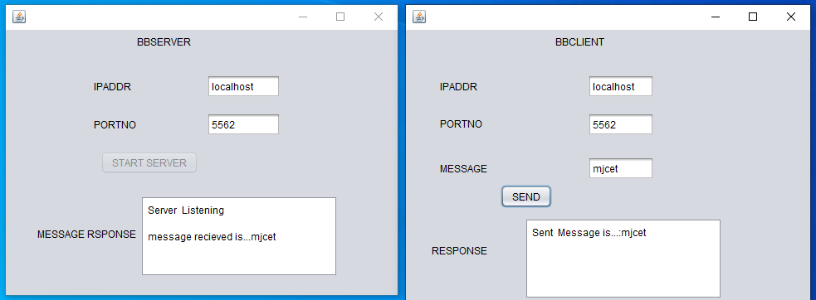

**6 DNS**

**@SuppressWarnings("unchecked")**

**public void run() {**

**String ipAddress = sipaddr.getText();**

**int portNo = Integer.parseInt(sportno.getText());**

**try{**

**ServerSocket ss = new ServerSocket(portNo,5, InetAddress.getByName(ipAddress));**

**while(true){ try(**

**Socket s = ss.accept();**

**DataInputStream dis = new DataInputStream(s.getInputStream());){**

**DataOutputStream dos = new DataOutputStream(s.getOutputStream());**

**String url = dis.readUTF();**

**srvrresp.append(s.getInetAddress().toString()+"/");**

**boolean found = false;**

**File f = new File("C:\\Users\\admin\\Documents\\NetBeansProjects\\dns24\\data.txt");**

**Scanner scanner = new Scanner(f);**

**while(scanner.hasNextLine()){**

**String[] tokens = scanner.nextLine().split(" ");**

**if(url.equals(tokens[0]))**

**{**

**dos.writeUTF(" - the IP for url is : "+tokens[1]+"\n");**

**found = true;**

**} }**

**if(!found){**

**dos.writeUTF("Not Found"); }**

**} catch(Exception e) { e.printStackTrace();**

**} } } catch(Exception e) { e.printStackTrace();**

**} //To change body of generated methods, choose Tools | Templates.**

**}**

**private void startbtnActionPerformed(java.awt.event.ActionEvent evt) {**

**// TODO add your handling code here:**

**Thread t = new Thread(this, "server");**

**startbtn.setEnabled(false); t.start();**

**srvrresp.append("server is listening...\n");**

**}**

**Client Code :-**

**String ipAddress = clntipaddr.getText();**

**int portNo = Integer.parseInt(clntportno.getText());**

**String url = clntdomain.getText();**

**try {**

**Socket s = new Socket(InetAddress.getByName(ipAddress), portNo);**

**DataInputStream dis = new DataInputStream(s.getInputStream());**

**DataOutputStream dos = new DataOutputStream(s.getOutputStream());**

**dos.writeUTF(url);**

**clntresp.append(url);**

**String response = dis.readUTF();**

**clntresp.append(": " + response +"\n");**

**s.close();**

**} catch(Exception e) { e.printStackTrace();**

**} }**

