Using Simulations to Analyse and Compare -based Age-depth Models

Marco A Aquino-López[1] [2]

Nicole K Sanderson[3]

Maarten Blaauw[4]

J Andrés Christen[5]

The increasing interest in understanding the impact of humans on the environment, has led to a considerable number of studies focusing on the analysis of sediment accumulation for the last 200 years. Dating this period is often complicated by poor chronological resolution and large errors associated with recent radiocarbon (14C) ages, which is the most popular dating technique. The use of lead-210 () is a popular method as it allows for the measurement of absolute and continuous dates for this period of time. dating method has traditionally relied on the Constant Rate of Supply (CRS) model which uses the radioactive decay equation resulting in a restrictive model to approximate dates.

Recent studies in radiocarbon age-depth models have shown that the Bayesian models provide a more reliable and trustworthy chronology. Following the recent development of *Plum*, the only Bayesian model, this work presents a thorough and objective comparison between the classical approach to dating (CRS) and its Bayesian alternative (*Plum*). Three different simulations, representing three different sedimentation processes and meeting the assumptions imposed by the CRS model, were used to produce a fair and honest comparison. Results from this study not only confirm the results obtained by , they also show a series of worrying outcomes regarding the accuracy and precision of the CRS model, mainly that the uncertainty associated with the model is consistently insufficient to capture the true values even when the sediment is entirely dated. The most concerning result is the fact that the CRS model does not appear to improve its accuracy as more information is available, which results in a model for which accuracy is chaotic and unpredictable. On the other hand, the Bayesian alternative (*Plum*) provides consistently accurate results even with few samples, and its accuracy and precision constantly improve as more information is available.

1

1

**Using Simulations to Analyse and Compare -based Age-depth Models**

/

*Keywords:* Plum, Age-depth models, Chronology, Constant Rate of Supply, Comparison.

# Introduction

Lead-210 () is a radioactive nuclide, part of the decay chain, which forms naturally in the atmosphere as well as in the sediment. This isotope, with a half-life of 22.23 years, is commonly used to date recently accumulated sediments ( to years). Unlike other dating techniques such as (radiocarbon), using a single measurement of is not possible for dating; it is only when a suitable portion of the decay curve (the total inventory) is measured and when certain assumptions about the sedimentation process are met that a chronology can be established. In recent decades, increasing amounts of palaeoecological and pollution studies have focused on recent sediments in order to evaluate human impacts on the environment. These studies strongly rely on the accuracy of their chronologies in order to correctly assign dates to and quantify chemical, biological and ecological changes.

Several ‘classical’ models are available for dating recent sediments using . The most commonly used are the Constant Rate of Supply (CRS), Constant Flux:Constant sedimentation (CF:CS) and Constant Initial Concentration (CIC) models. The CRS model, also known as Constant Flux (CF) model is by far the most popular (see Figure 1) and has the most flexible assumptions. The CRS model assumes a constant supply of to the sediment from the atmosphere and allows for changes in the sedimentation rate. In order to build a chronology, the CRS model uses a ratio between the complete inventory (the complete estimate of radioactivity in the sediment column between the surface and the ‘equilibrium depth’ where from the atmosphere can no longer be detected) and the remaining inventory from depth , , where is the complete inventory and the decay constant of the .

The flexibility of the CRS assumptions comes at the cost of needing to measure a sufficient portion of the inventory or using interpolation in order to estimate the complete inventory of in the sediment. The CRS model has undergone several revisions in the last decades in order to improve its accuracy and applicability. There are two types of revisions to this model: (1) to its uncertainty estimates and (2) to its application where extra information is available, such as external independent dating markers (e.g. ) or laminated sediments. Other more restrictive models such as CF:CS and CIC require additional assumptions of the sedimentation process, as well as that of a constant supply of .

Frequency of ^{210}Pb dating models used in papers between 1964 and 2017. Data gathered by  from literature a review of 271 papers. The models include CF:CS model The Constant Flux - Constant Sedimentation;, CIC (Constant Initial Concentration)  and CRS - Constant Rate of Supply;. 

Frequency of dating models used in published papers between 1964 and 2017 (data gathered by from a review of 271 papers). The models include CF:CS, CIC and CRS.

A recent inter-laboratory model comparison experiment presented concerning results. A series of measurements were sent to 14 laboratories around the world. Each laboratory was ask to provide a chronology, given the same data. This experiment resulted in a wide range of chronologies when different models were used, and even when the same model was applied. The authors strongly recommended the use of independent time markers (independent dating sources) to validate chronologies. This research clearly and critically shows the impact that user decisions have on resulting chronologies, which becomes extremely important when trying to replicate or update chronologies. Users attempting to do so will not only need access to the raw data but also to every user decision in constructing the chronology; unfortunately, these raw data sets and decisions are rarely reported.

Recently presented an alternative to these classical models by introducing *Plum*, a Bayesian approach to the dating methodology. This model treats every data point as originating from a system that includes the sedimentation process as well as the decay process. It also incorporates an important variable to the inferred processes, the level of supported , which naturally forms in the sediment and is normally threaded as a hindrance variable. *Plum* assumes that there exists a function such that,

where is the total amount of in a sample, is the supported , the supply of to the sediment, the thickness of the sample and the age of the sample at depth . The age-depth model is based on a piece-wise linear model constrained by prior information on accumulation rate and its variability.

This treatment of the data allows for a formal statistical inference, and by using a Bayesian approach all the parameters of the model can be inferred. This differs from the CRS model as the latter uses the decay equation to obtain the age-depth function resulting in a more restrictive age-depth model, removes assumed values of supported before modelling, and does not provide a formal statistical inference.

presented a comparison between classical and Bayesian age-depth model construction, both for real and simulated -dated cores. They concluded that Bayesian age-depth models provide a more accurate result and more realistic uncertainties under a wide range of scenarios - simulations and real cores. Similarly, *Plum* has shown to provide accurate results with a realistic precision depending on different scenarios, both in simulations as well as for real cores. Under optimal conditions, *Plum* and the CRS model have shown to provide similar dates , with *Plum* providing more realistic uncertainties with minimal user interaction. In this study, we compare dates and uncertainties from the widely applied CRS model against *Plum* using simulated cores (sedimentation "scenarios"). The objective of this study is to test whether the results obtained by concerning the accuracy and precision of using a Bayesian are maintained in a more complex modelling situation, such as the construction of -based age-depth models. We also wish to observe the learning process of each of the models and estimate the amount of information needed to obtain a reasonable chronology for each model.

# Experimental Setup: Simulations and Percentage of Information

In order to observe the accuracy and precision of any model, a known true age-depth function is required. presented a methodology for simulating radiocarbon dates and their uncertainties, while presented an approach for simulating data given an age-depth function . It is important to note that these simulations follow the equations presented by , guaranteeing that the CRS assumptions are met. By using the approach presented by for simulating data and the structure of uncertainty estimation presented by , reliable simulated data can be obtained.

## Simulation Construction

Three different scenarios (see Table 1) were chosen for our sedimentation simulations, each with their own age-depth functions and parameters. These scenarios were selected as they provide three key challenges for the models: Scenario 1 presents an age-depth function which is quite common for recent sediments, with less compaction toward the surface at 0 cm depth; Scenario 2 presents a challenging core structure as the function replicates a drastic and rapid shift in sediment accumulation behaviour around 15 cm depth; and lastly, Scenario 3 presents a cyclic and periodic change in accumulation rates. Using the age-depth functions and parameters defined in Table 1, we obtain the 210Pb activity, or concentration, at any given depth or interval by integrating the age-depth curve for that interval.

Simulated age-depth functions and parameters used for each of the three scenarios.

|  |  |  |  |
| --- | --- | --- | --- |
| Label | Age-depth |  | Supported |
|  | function | () | () |
| Scenario 1 |  | 100 | 10 |
| Scenario 2 |  | 50 | 25 |
| Scenario 3 |  | 500 | 15 |

[tab:sim_param]

Simulated sedimentation scenarios with their corresponding ^{210}Pb profiles. Upper panel: Age-depth function for the three different scenarios (Table 1). Lower panel: Corresponding ^{210}Pb profiles in relation to depth.

Simulated sedimentation scenarios with their corresponding profiles. Left panel: Age-depth functions for the three different scenarios (Table 1). Right panel: Corresponding activity profiles in relation to depth.

These concentrations (see Figure 2) can be interpreted as error-free measurements. As all sampling and measuring equipment are subject to error, we therefore need to replicate these procedural and instrumental errors to be incorporated for each simulation. presents error structure for radiocarbon dates, which we can use for our simulations, as both measurements are subject to similar analytical issues.

Let be the true concentration in the interval , given the age-depth function and parameters and . To simulate disturbances in the material, we can introduce scatter centred around the true value, , where is the amount of scatter for this variable (in this case ). Now, to replicate outliers, a shift from the true value () is defined, which occurs with a probability . This results in a new variable which is defined as

To simulate the uncertainty provided by the laboratory, we can define the simulated measurements as , where is the standard deviation reported by the laboratory. is defined as , where is the minimum standard deviation assigned to a measurement. While this variable differs between laboratories, we use a default value of . Finally, is the analytical uncertainty (default .01) and an error multiplier (default 1.5).

For this this study we created a data set for each of the three simulation by integrating in intervals of 1 cm from 0 to 30 depth (where radioactive equilibrium was guaranteed). The complete simulated data sets can be found in the Supplementary Material 5, and Figure 2 shows the concentration curves with their corresponding age-depth functions.

## Percentage of information

With these data sets, we then define a new variable called ‘Percentage of information’ relating to the quantity of the available information measured. Assuming that background was reached at depth , information percentage is defined as the proportion of the core that was measured, e.g. if background was reached at depth cm and the core was sampled using 20 cm-thick slices, the percentage of information would be 20 %. This variable will allow us to have a measuring tool to estimate the information is needed for a good chronology, without depending on the number or size of the samples.

In order to compare both the CRS model and *Plum* under similar conditions, samples from the the previously described data sets were randomly selected, given a percentage of information. In the case of cores which did not reach the background supported level, *Plum* has shown to provide accurate results without the need for user interference. At the same time, in such cases, the CRS model can only provide a reliable chronology if the complete inventory is estimated using extrapolation, and/or if the model is forced to pass through a known independent date, for instance as estimated by a 137Cs peak related to the CE 1986 Chernobyl accident. As these manipulations require user intervention, in order to avoid this problem and to allow for a more objective comparison, here every simulated sampling data set reaches background, which guarantees a consistent, unbiased application of the CRS model.

# Model Comparison

To allow for a reasonable comparison between models, and to evaluate the effect that different percentages of information may have on the accuracy and precision of models, we used our three simulated data sets (see previous section). For these simulated cores, samples were randomly selected given a percentage of information (e.g. for a 20% information data set , 6 random 1-cm samples were simulated of a possible total 30 cm). As the CRS model assumes that background has been reached in order to reduce user manipulation, we decided to fix the last sample (30 cm depth) for every run. This step not only guarantees the consistent application of the CRS model, it also provides the model with a single bottom-most depth to be removed as is common practice when using the CRS model.

100 different samples were randomly selected for information percentages from 10% to 95% at 5% intervals (i.e., 10%, 15%, 20%,...,95%); the complete sample set was also used (i.e 100% percentage of information). After a random sample was selected, both the CRS model and *Plum*.To have an objective comparison, both models were run with their default configuration (*Plum* with default settings and CRS estimates and uncertainties as described in ). Both sets of outputs were then compared against the true known age value.

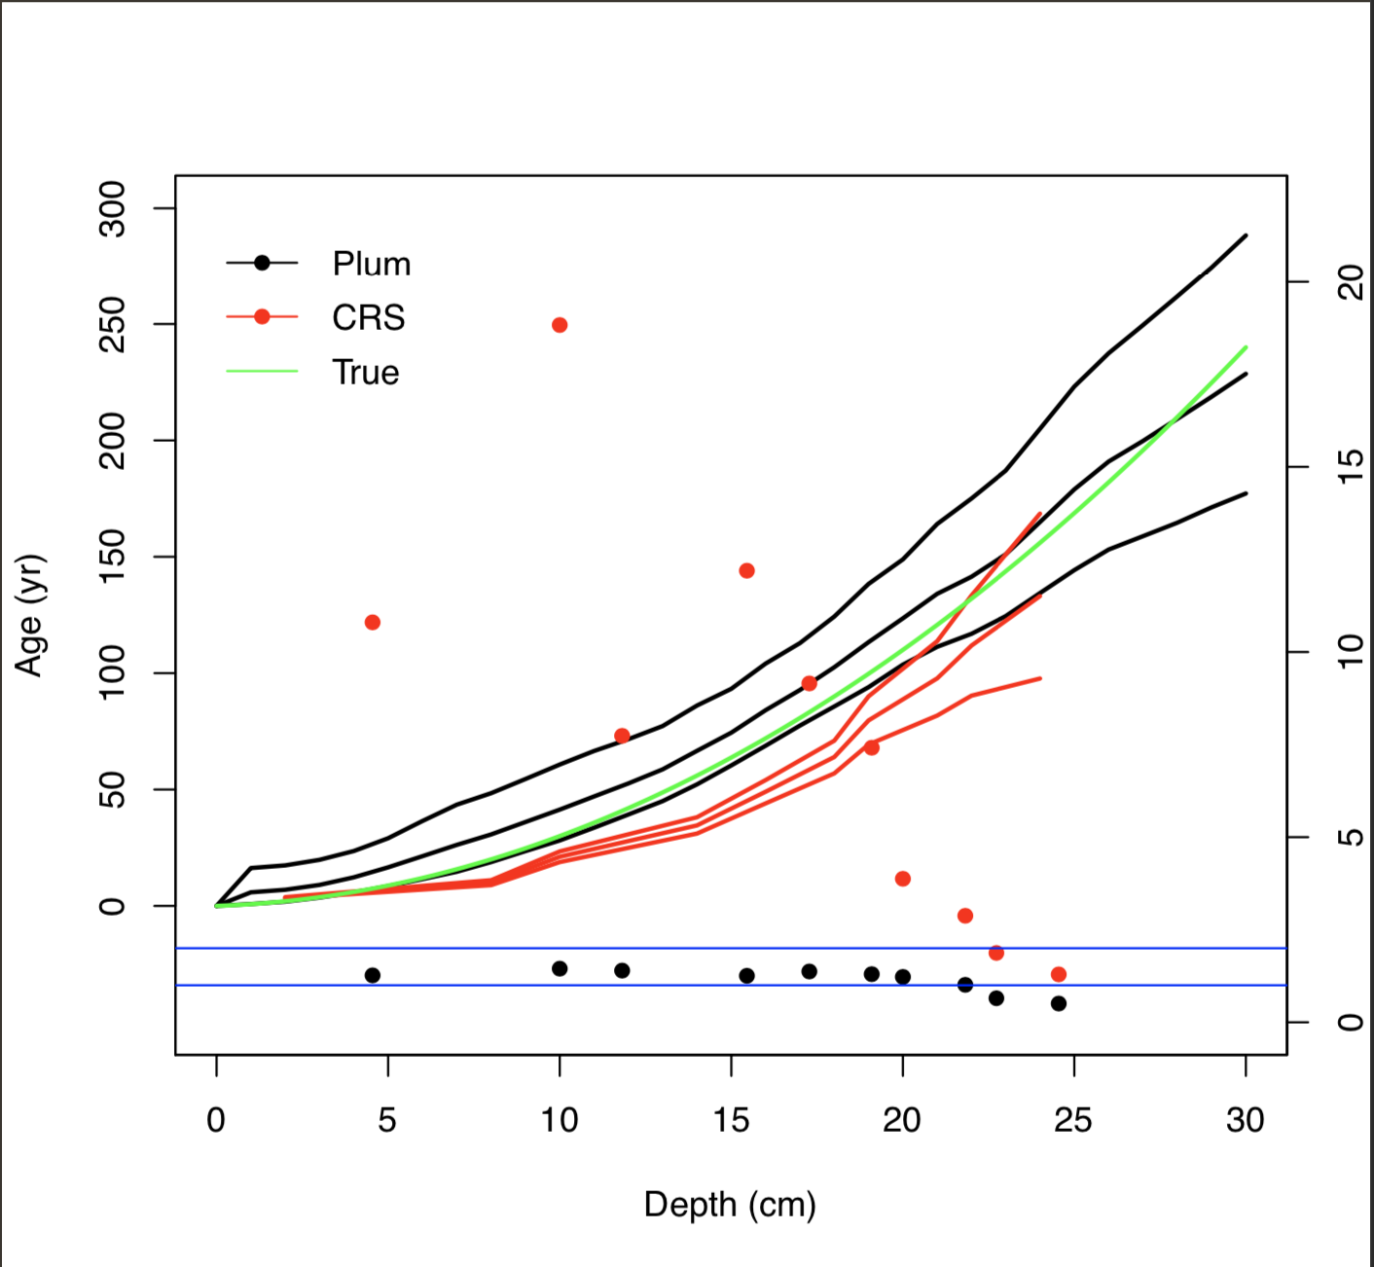

Comparison between Plum and the CRS model against the true age-depth model using 50% of the information percentage (using 1-cm samples at depths 2, 8, 10, 14, 16, 18, 19, 21, 22, 24, 25, 27, 28, 29, 30). Lines show the age estimates with the 95% credible intervals (Plum) and the 95% confidence interval (CRS). Dots show the normalized offset, i.e. distance between the inferred age and the true age in relation to the standard error (the standard deviation in the case of the CRS and the length of the confidence interval divided by 4 in the case of Plum).

Figure 3 shows an example of the comparison between the models against the true value. As we are dealing with a total of n = 5333 simulations, in order to evaluate the overall precision and accuracy of both models, we decided to calculate the mean offset (in yr), the mean of length of the 95% intervals (in yr), as well as the mean normalized accuracy indicating the distance of modelled ages from the true value given the model’s own uncertainty at each depth.

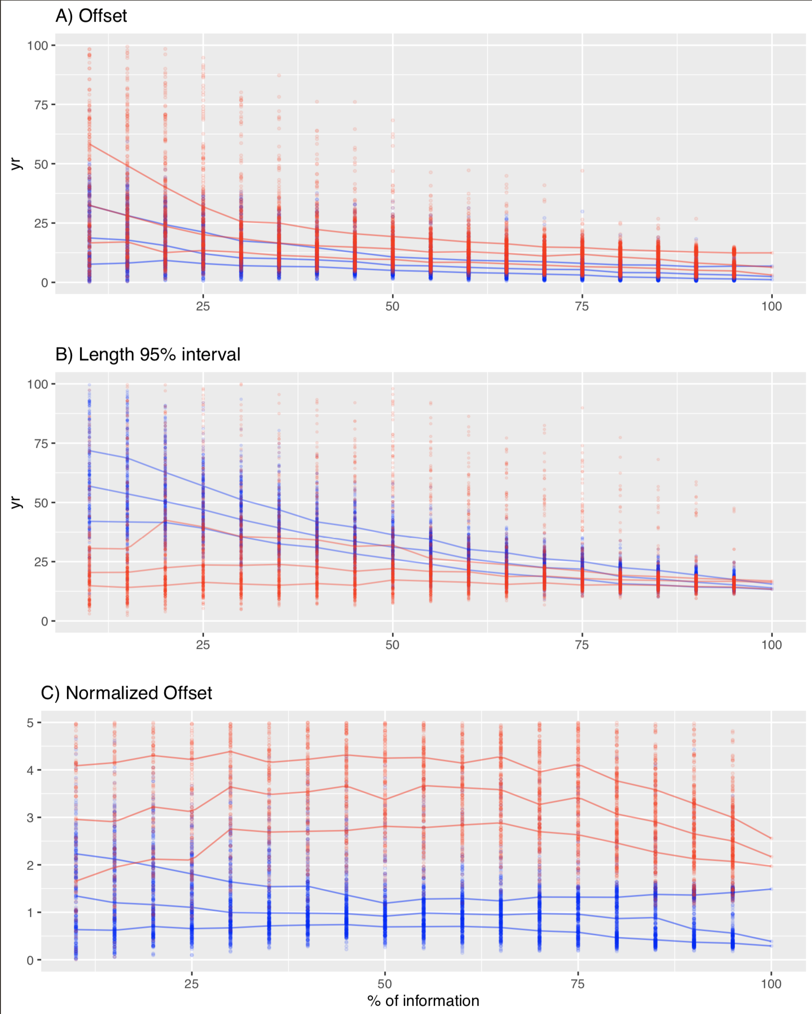

Top panel A) shows the offset between true age and ages modelled using the CRS model (red) and Plum (blue). This panel shows how Plum gives a smaller offset in almost every % information scenario, with both models improving their offset as more information is available. Middle panel B) shows the 95% confidence intervals. It is clear, from this panel, that while the uncertainty provided by Plum is a lot larger for low % information, it constantly improves as more information is added, whereas the length of the intervals provided by the CRS appear to stay constant regardless of the available information. Bottom panel C) shows the normalized offsets, presenting the distance between the modelled age and the true age, normalized, divided by the standard deviation (in the case of Plum, the length of the 95% interval divided by 4). This panel presents a worrying situation where the CRS model’s calculated standard deviation (on average) is incapable of of capturing the true age. On the other hand, Plum’s credible intervals almost always capture the true age even when little information is available.

Figure 4 show results similar to those presented by . The classical model (CRS) at first appears to provide similar results (similar offsets) to the Bayesian alternative (*Plum*), but at higher estimated precision, if we only look at the length of the 95% interval. These results can be misleading if we do not consider both the offset and length of interval together. To have a more realistic representation of how the models capture the true age-depth relationships, we should observe the normalized offset. This variable shows the degree to which the average models contain the truth within their uncertainty intervals (normalized to one standard deviation). Any model with a normalized offset larger than two (two standard deviations) is incapable of capturing true ages within its uncertainty intervals. This means that, while the CRS estimates smaller uncertainties, it does so at the cost of its accuracy. It also appears that the length of the 95% interval and offset are not affected by how much information is provided to the CRS model.

On the other hand, *Plum* seems to provide increasingly accurate results as more information is added to the model. This again coincides with the results outlined by . When we observe the regular offset (not normalized), we find that Plum provides a smaller offset in comparison to the CRS model; this in combination with slightly larger modelled uncertainties results in more consistently accurate age-depth models which are capable of capturing the true values within their uncertainty intervals. This result supports the claim that *Plum* provides more realistic uncertainties than those of the CRS. Another important statistic to take into account is that 87.86% (4686/5333) of *Plum*’s runs remain under the 2 standard deviations, as opposed to 7.48% (399/5333) for the CRS model. Furthermore, only 0.54% (29/5333) of CRS model runs remain under the 1 standard deviation, which is the most commonly reported interval when reporting CRS results. We can also observe a clear structure in the way that Plum increases its accuracy and precision to obtain a better chronology as more information is available, whereas the CRS model does not appear to learn from additional data.

These results are presented for the overall chronology (the mean offset, interval and normalized offset of the overall chronology). In order to evaluate whether certain models are better predicting ages at certain section of the sediment cores, we have to look at the normalized offset of every depth.

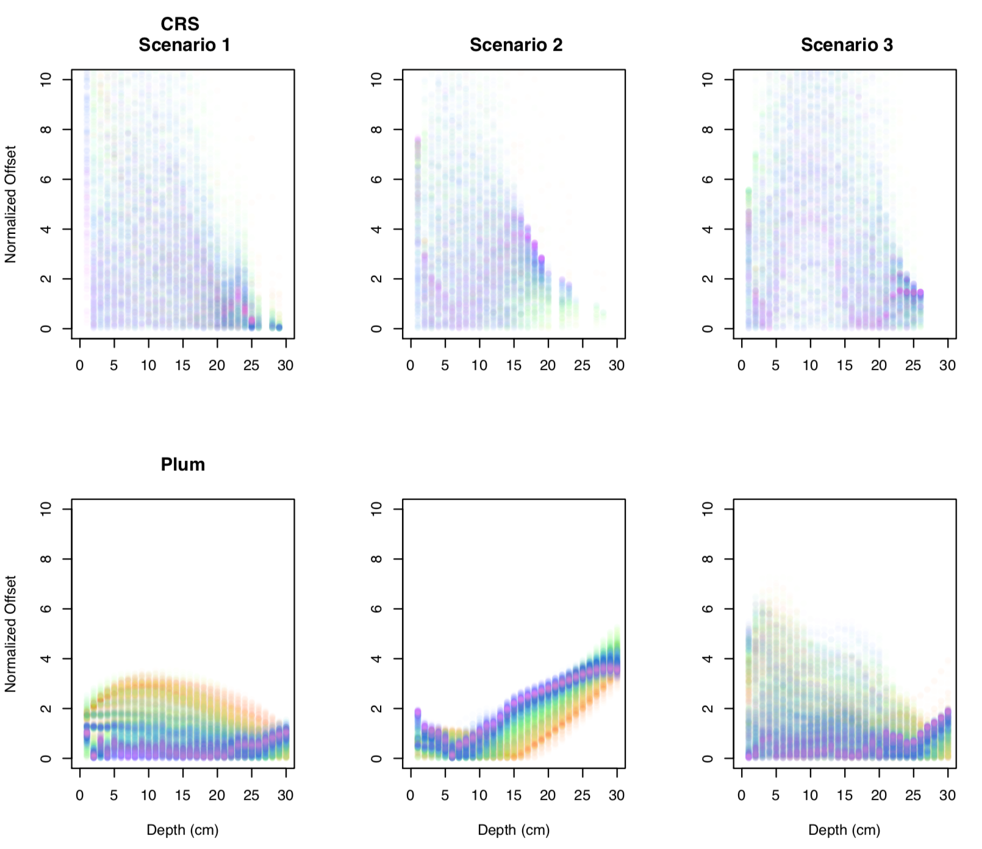

Normalized offset of every sampling sample at every depth for the three simulated scenarios - CRS age estimates at samples depths and Plum’s age estimates at 1 cm intervals. Dots colours range from lowest information percentage samples (few dated depths; red) to high percentage samples (nearly completely dated cores; purple). The CRS model’s normalized offset shows no structure at any particular depth regardless of the available information. This means that the model can provide a reasonable chronology with low levels of information or a very inaccurate age estimate with high levels of information at any given depth, resulting in an unreliable age-depth model. On the other hand, Plum demostrates a systematic improvement in its age estimates as more data are added. This results assures that a Bayesian approach would consistently provide more reliable results.

Figure 5 shows the normalized accuracy of every simulation according to depth for both models. *Plum* shows a clear learning structure which depends on the information available to the model. The information percentage appears to be irrelevant to the accuracy of the CRS model, contrary to the results obtained by *Plum*. It is important to note that the inaccuracies of the CRS model are not exclusive to any particular section of the chronology; this is most likely driven by the small uncertainties estimated by the CRS model. See below for a discussion of how Plum behaved in sedimentation simulation 2.

# Discussion and Conclusions

These results clearly show biases associated with the CRS model. discussed this point and states that the bias is the product of the use of a logarithmic function for the age-depth model. It is also evident from these results that the CRS model’s uncertainty estimates are not sufficient to capture the true age-depth function. This is an important point given the fact that it is common practice among the dating community to report credible intervals to one single deviation, instead of the 95% confidence intervals, which have become the norm in other chronological reconstructions. Other confidence intervals have been calculated for this model but the fact that these intervals are even smaller than the ones obtained by error propagation is of concern.

Previous work on model comparison has shown the problems with the variability of dating results from different users, even when the same or similar models are applied to a single data set. In our study, user input was reduced to a minimum in an effort to show the potential effects that different percentages of information have on the resulting chronology. The results of this experiment show that the CRS model can provide extremely different results with data originating from the same data set, even while the effect of user input is mitigated. Figure 4 showed that the CRS model appears not to learn from using more data. This explains why over the years, many authors have insisted in the use of other dating techniques to validate chronologies provided by the CRS model , a point which these results also highly encourage.

On the other hand, *Plum* shows a consistently accurate result by capturing the true values within the 95% credible intervals for most of the simulated sampling strategies. It is important to note that one of the big advantages of *Plum* is its increase in accuracy and decrease in precision as more data becomes available. In the case of scenario 2, we observe that *Plum* appears to behave worse as more data is available, which would be of concern if we did not take into consideration that this sedimentation simulation was extremely unusual in the real world and also if users would not double check the resulting chronologies. If more information is available about the core or the sediment, such as 210Pb influx rates or independent dating markers, this information can easily be implemented as prior information in *Plum*, and this will result in a much better chronology. It is also important to note that even when *Plum* performs less well in this specific case, it is providing a much better chronology in upper first 10-15 cm of the core than that of the more chaotic CRS age-depth model.

In conclusion, we recommend that users validate their chronology when possible, and if no additional information is available for this validation, we recommend the use of Plum, the Bayesian approach, and provide it with as as many measurements as possible (at least 60% of the available information of the core) in order to get the best possible chronology

# Supplementary Material

Data for each simulation and code used is hosted at: https://github.com/maquinolopez/Paper_Simulations

|  |  |  |  |  |  |  |  |
| --- | --- | --- | --- | --- | --- | --- | --- |
| Label | Depth | Density | 210Pb | sd(210Pb) | Thickness | 226Ra | sd(226Ra) |
|  | (cm) | () | (Bq/kg) |  | (cm) | (Bq/kg) |  |
| Sim01-01 | 1 | 0.10009 | 63.50103 | 2.85755 | 1 | 23.8045 | 1.125 |
| Sim01-02 | 2 | 0.10064 | 80.08738 | 3.60393 | 1 | 23.2924 | 1.125 |
| Sim01-03 | 3 | 0.10173 | 98.32806 | 4.42476 | 1 | 23.434 | 1.125 |
| Sim01-04 | 4 | 0.10334 | 125.45705 | 5.64557 | 1 | 26.0873 | 1.125 |
| Sim01-05 | 5 | 0.10547 | 141.27971 | 6.35759 | 1 | 22.8041 | 1.125 |
| Sim01-06 | 6 | 0.10809 | 130.27571 | 5.86241 | 1 | 23.4333 | 1.125 |
| Sim01-07 | 7 | 0.11116 | 134.04051 | 6.03182 | 1 | 25.6156 | 1.125 |
| Sim01-08 | 8 | 0.11466 | 129.69245 | 5.83616 | 1 | 26.1371 | 1.125 |
| Sim01-09 | 9 | 0.11855 | 134.93655 | 6.07214 | 1 | 25.4813 | 1.125 |
| Sim01-10 | 10 | 0.12278 | 109.39886 | 4.92295 | 1 | 25.8877 | 1.125 |
| Sim01-11 | 11 | 0.12731 | 110.68133 | 4.98066 | 1 | 24.4414 | 1.125 |
| Sim01-12 | 12 | 0.13209 | 102.38094 | 4.60714 | 1 | 24.9053 | 1.125 |
| Sim01-13 | 13 | 0.13706 | 75.80895 | 3.4114 | 1 | 22.9151 | 1.125 |
| Sim01-14 | 14 | 0.14218 | 77.60406 | 3.49218 | 1 | 24.4808 | 1.125 |
| Sim01-15 | 15 | 0.14738 | 68.4401 | 3.0798 | 1 | 24.9343 | 1.125 |
| Sim01-16 | 16 | 0.15262 | 60.72037 | 2.73242 | 1 | 25.2659 | 1.125 |
| Sim01-17 | 17 | 0.15782 | 50.28147 | 2.26267 | 1 | 22.961 | 1.125 |
| Sim01-18 | 18 | 0.16294 | 44.24641 | 1.99109 | 1 | 22.9139 | 1.125 |
| Sim01-19 | 19 | 0.16791 | 39.85997 | 1.7937 | 1 | 28.3774 | 1.125 |
| Sim01-20 | 20 | 0.17269 | 38.40823 | 1.72837 | 1 | 23.5379 | 1.125 |
| Sim01-21 | 21 | 0.17722 | 32.75922 | 1.47416 | 1 | 25.4363 | 1.125 |
| Sim01-22 | 22 | 0.18145 | 28.02545 | 1.26115 | 1 | 24.8995 | 1.125 |
| Sim01-23 | 23 | 0.18534 | 27.8749 | 1.25437 | 1 | 22.6783 | 1.125 |
| Sim01-24 | 24 | 0.18884 | 30.74797 | 1.38366 | 1 | 24.8575 | 1.125 |
| Sim01-25 | 25 | 0.19191 | 28.36187 | 1.27628 | 1 | 24.8724 | 1.125 |
| Sim01-26 | 26 | 0.19453 | 27.24535 | 1.22604 | 1 | 24.3778 | 1.125 |
| Sim01-27 | 27 | 0.19666 | 23.59236 | 1.06166 | 1 | 24.7209 | 1.125 |
| Sim01-28 | 28 | 0.19827 | 25.74855 | 1.15868 | 1 | 24.6615 | 1.125 |
| Sim01-29 | 29 | 0.19936 | 25.05368 | 1.12742 | 1 | 24.7199 | 1.125 |
| Sim01-30 | 30 | 0.19991 | 25.0065 | 1.12529 | 1 | 24.4937 | 1.125 |

|  |  |  |  |  |  |  |  |
| --- | --- | --- | --- | --- | --- | --- | --- |
| Label | Depth | Density | 210Pb | sd(210Pb) | Thickness | 226Ra | sd(226Ra) |
|  | (cm) | () | (Bq/kg) |  | (cm) | (Bq/kg) |  |
| Sim02-01 | 1 | 0.1001 | 909.3928 | 40.9227 | 1 | 8.9761 | 0.45 |
| Sim02-02 | 2 | 0.1006 | 683.9989 | 30.7799 | 1 | 10.0607 | 0.45 |
| Sim02-03 | 3 | 0.1017 | 453.0503 | 20.3873 | 1 | 9.8701 | 0.45 |
| Sim02-04 | 4 | 0.1033 | 310.7897 | 13.9855 | 1 | 10.37 | 0.45 |
| Sim02-05 | 5 | 0.1055 | 218.0058 | 9.8103 | 1 | 10.0418 | 0.45 |
| Sim02-06 | 6 | 0.1081 | 158.6974 | 7.1414 | 1 | 10.104 | 0.45 |
| Sim02-07 | 7 | 0.1112 | 113.9062 | 5.1258 | 1 | 10.2049 | 0.45 |
| Sim02-08 | 8 | 0.1147 | 75.5493 | 3.3997 | 1 | 9.334 | 0.45 |
| Sim02-09 | 9 | 0.1185 | 56.6252 | 2.5481 | 1 | 10.5145 | 0.45 |
| Sim02-10 | 10 | 0.1228 | 44.1595 | 1.9872 | 1 | 9.8677 | 0.45 |
| Sim02-11 | 11 | 0.1273 | 34.7448 | 1.5635 | 1 | 9.7694 | 0.45 |
| Sim02-12 | 12 | 0.1321 | 25.384 | 1.1423 | 1 | 10.5134 | 0.45 |
| Sim02-13 | 13 | 0.1371 | 24.0007 | 1.08 | 1 | 10.4589 | 0.45 |
| Sim02-14 | 14 | 0.1422 | 21.3643 | 1 | 1 | 9.9504 | 0.45 |
| Sim02-15 | 15 | 0.1474 | 17.7932 | 1 | 1 | 10.5135 | 0.45 |
| Sim02-16 | 16 | 0.1526 | 15.0416 | 1 | 1 | 10.3362 | 0.45 |
| Sim02-17 | 17 | 0.1578 | 14.2937 | 1 | 1 | 10.5131 | 0.45 |
| Sim02-18 | 18 | 0.1629 | 12.3844 | 1 | 1 | 10.368 | 0.45 |
| Sim02-19 | 19 | 0.1679 | 12.6023 | 1 | 1 | 10.5297 | 0.45 |
| Sim02-20 | 20 | 0.1727 | 11.9329 | 1 | 1 | 10.0924 | 0.45 |
| Sim02-21 | 21 | 0.1772 | 9.301 | 1 | 1 | 10.118 | 0.45 |
| Sim02-22 | 22 | 0.1815 | 10.7777 | 1 | 1 | 10.249 | 0.45 |
| Sim02-23 | 23 | 0.1853 | 12.9491 | 1 | 1 | 10.134 | 0.45 |
| Sim02-24 | 24 | 0.1888 | 10.6571 | 1 | 1 | 10.1151 | 0.45 |
| Sim02-25 | 25 | 0.1919 | 9.6297 | 1 | 1 | 9.6608 | 0.45 |
| Sim02-26 | 26 | 0.1945 | 8.4331 | 1 | 1 | 8.7821 | 0.45 |
| Sim02-27 | 27 | 0.1967 | 10.4921 | 1 | 1 | 9.8995 | 0.45 |
| Sim02-28 | 28 | 0.1983 | 11.135 | 1 | 1 | 9.2481 | 0.45 |
| Sim02-29 | 29 | 0.1994 | 10.109 | 1 | 1 | 10.4398 | 0.45 |
| Sim02-30 | 30 | 0.1999 | 9.5404 | 1 | 1 | 10.1114 | 0.45 |

|  |  |  |  |  |  |  |  |
| --- | --- | --- | --- | --- | --- | --- | --- |
| Label | Depth | Density | 210Pb | sd(210Pb) | Thickness | 226Ra | sd(226Ra) |
|  | (cm) | () | (Bq/kg) |  | (cm) | (Bq/kg) |  |
| Sim03-01 | 1 | 0.1001 | 6384.1354 | 287.2861 | 1 | 15.8007 | 0.675 |
| Sim03-02 | 2 | 0.1006 | 3550.0809 | 159.7536 | 1 | 14.5245 | 0.675 |
| Sim03-03 | 3 | 0.1017 | 1954.5702 | 87.9557 | 1 | 15.6527 | 0.675 |
| Sim03-04 | 4 | 0.1033 | 1183.8917 | 53.2751 | 1 | 14.5175 | 0.675 |
| Sim03-05 | 5 | 0.1055 | 760.2132 | 34.2096 | 1 | 14.9242 | 0.675 |
| Sim03-06 | 6 | 0.1081 | 360.2553 | 16.2115 | 1 | 14.801 | 0.675 |
| Sim03-07 | 7 | 0.1112 | 212.9402 | 9.5823 | 1 | 14.8738 | 0.675 |
| Sim03-08 | 8 | 0.1147 | 104.2684 | 4.6921 | 1 | 14.9028 | 0.675 |
| Sim03-09 | 9 | 0.1185 | 44.3849 | 1.9973 | 1 | 15.0768 | 0.675 |
| Sim03-10 | 10 | 0.1228 | 18.6447 | 1 | 1 | 15.3764 | 0.675 |
| Sim03-11 | 11 | 0.1273 | 23.2778 | 1.0475 | 1 | 14.6231 | 0.675 |
| Sim03-12 | 12 | 0.1321 | 53.1587 | 2.3921 | 1 | 15.1629 | 0.675 |
| Sim03-13 | 13 | 0.1371 | 97.363 | 4.3813 | 1 | 14.3047 | 0.675 |
| Sim03-14 | 14 | 0.1422 | 116.9788 | 5.264 | 1 | 14.0261 | 0.675 |
| Sim03-15 | 15 | 0.1474 | 153.2901 | 6.8981 | 1 | 15.9723 | 0.675 |
| Sim03-16 | 16 | 0.1526 | 151.8496 | 6.8332 | 1 | 14.7579 | 0.675 |
| Sim03-17 | 17 | 0.1578 | 136.3609 | 6.1362 | 1 | 16.114 | 0.675 |
| Sim03-18 | 18 | 0.1629 | 107.2736 | 4.8273 | 1 | 15.4595 | 0.675 |
| Sim03-19 | 19 | 0.1679 | 76.8966 | 3.4603 | 1 | 15.9439 | 0.675 |
| Sim03-20 | 20 | 0.1727 | 48.9213 | 2.2015 | 1 | 14.6235 | 0.675 |
| Sim03-21 | 21 | 0.1772 | 40.4439 | 1.82 | 1 | 14.6716 | 0.675 |
| Sim03-22 | 22 | 0.1815 | 26.5638 | 1.1954 | 1 | 16.2541 | 0.675 |
| Sim03-23 | 23 | 0.1853 | 21.714 | 1 | 1 | 14.4826 | 0.675 |
| Sim03-24 | 24 | 0.1888 | 17.6428 | 1 | 1 | 15.5109 | 0.675 |
| Sim03-25 | 25 | 0.1919 | 17.3533 | 1 | 1 | 13.6898 | 0.675 |
| Sim03-26 | 26 | 0.1945 | 17.4211 | 1 | 1 | 14.4684 | 0.675 |
| Sim03-27 | 27 | 0.1967 | 16.4246 | 1 | 1 | 15.3889 | 0.675 |
| Sim03-28 | 28 | 0.1983 | 12.4828 | 1 | 1 | 15.0698 | 0.675 |
| Sim03-29 | 29 | 0.1994 | 13.5514 | 1 | 1 | 15.2346 | 0.675 |
| Sim03-30 | 30 | 0.1999 | 14.3145 | 1 | 1 | 14.7846 | 0.675 |

1. Centro de Investigación en Matemáticas (CIMAT), Jalisco s/n, Valenciana, 36023 Guanajuato, Gto, Mexico. email: aquino@cimat.mx
2. Corresponding author.
3. GEOTOP Research Centre, Université du Québec à Montréal, Montréal, Québec, H2X 3Y7, Canada. email: sanderson.nicole@uqam.ca
4. School of Natural and Built Environment, Queen’s University Belfast, Belfast, BT7 1NN, UK. email: maarten.blaauw@qub.ac.uk
5. Centro de Investigación en Matemáticas (CIMAT), Jalisco s/n, Valenciana, 36023 Guanajuato, Gto, Mexico. email: jac@cimat.mx