1 00

A simulation study to compare Pb dating analyses
Marco A Aquino-López¹ ²
Nicole K. Sanderson³
Maarten Blaauw⁴
Joan-Albert Sanchez-Cabeza⁵
Ana Carolina Ruiz-Fernandez⁶
J Andrés Christen⁷

00
A simulation study to compare Pb dating analyses
Abstract
The increasing interest in understanding anthropogenic impacts on the environment have led to a considerable number of studies focusing on sedimentary records for the last ∼ 100 - 200 years. Dating this period is often complicated by the poor resolution and large errors associated with radiocarbon (14C) ages, which is the most popular dating technique. To improve age-depth model resolution for the recent period, sediment dating with lead-210 (Pb) is widely used as it provides absolute and continuous dates for the last ∼ 100 - 150 years. The Pb dating method has traditionally relied on the Constant Rate of Supply (CRS, also known as Constant Flux - CF) model which uses the radioactive decay equation as an age-depth relationship resulting in a restrictive model to approximate dates. In this work, we compare the classical approach to Pb dating (CRS) and its Bayesian alternative (Plum). To do so, we created simulated Pb profiles following three different sedimentation processes, complying with the assumptions imposed by the CRS model, and analysed them using both approaches. Results indicate that the CRS model does not capture the true values even with a high dating resolution for the sediment, nor improves does its accuracy improve as more information is available. On the other hand, the Bayesian alternative (Plum) provides consistently more accurate results even with few samples, and its accuracy and precision constantly improves as more information is available.
Keywords: Plum, Age-depth models, Chronology, Constant Rate of Supply, Comparison.

1.45

1 Introduction
Lead-210 (Pb) is a radionuclide, part of the U decay chain, which forms naturally in the atmosphere as well as in sediments. This isotope, with a half-life of 22.23±0.12 years, is commonly used to date recent recently accumulated sediments (<150years). In recent decades, increasing number of palaeoecological and pollution studies have focused on these recent sediments (Courtney2019) in order to evaluate human impacts on the environment. Unlike to other dating techniques such as C (radiocarbon dating), dating single sediment layers is not possible from a single measurement of Pb; it is only when a suitable portion of the excess-Pb (atmospheric Pb) decay curve is measured, representing the toral inventory of Pb from atmospheric deposition and runoff, and when certain assumptions about the sedimentation process are met that a chronology can be established. These studies strongly rely on the accuracy of their chronologies in order to correctly assign dates to chemical, biological and ecological changes. That is, unlike other dating techniques, an analysis of a series (data set) of Pb measurements must be carried out in order to obtain meaningful dates. Samples are taken along a core (e.g., lake, peatland, marine sediments) at different depths, from which Pb activity is measured. The whole series of Pb measurements need to be analysed in order to attempt to produce a coherent chronology, see Aquino2018.
A range of traditional data analyses, or so called “models”, are available for dating recent sediments using Pb; e.g. the Constant Initial Concentration (Goldberg1963), also known as Constant Activity (Robbins1975), the Constant Flux : Constant sedimentation (Crozaz1964) and the Constant Rate of Supply (Appleby1978; Robbins1978; Sanchez-Cabeza2012) also known as the Constant Flux model (CF). The CRS model is by far the most popular (see Figure Error: Reference source not found) and has the most flexible assumptions. Other, more restrictive, models such as CF:CS and CIC also require the assumption of a constant flux of Pb, as well additional as other assumptions of the sedimentation process, as well as that of a constant supply of Pb. The flexibility of the CRS model in terms of its assumptions, comes at the cost of needing to measure a sufficient portion of the inventory or to use of interpolation/extrapolation in order to properly estimate the complete inventory of Pb in the sediment. For details see the following section.

[Sorry. Ignored \begin{centering} ... \end{centering}]
The CRS model has undergone several revisions in the last decade in order to improve its applicability and precision. There are two types of revisions to this model: (1) revisions to its uncertainty quantification (Binford1990; Appleby2001; Sanchez-Cabeza2014) and (2) to its application where extra information is available, such as external independent dating markers (e.g. Cs profiles), laminated sediments, tephras, contaminated layers (known sedimentary events) (Appleby1998; Appleby2001; Appleby2008).
A recent inter-laboratory model comparison experiment (Barsanti2020) presented concerning results. Two measured Pb data sets were send to 14 laboratories around the world with varying degrees of expertise in the Pb dating method. Each laboratory was asked to provide a chronology, given the same data. It is important to note that each laboratory applied their preferred model; in most cases the CRS model was calculated. This experiment resulted in a wide range of chronologies, independently of the model used, providing different chronologies even when the same model and dataset was used. The authors reinforced the need to use of independent time markers (independent dating sources) to validate and “anchor" of the chronologies, as suggested previously by (Smith2001). This comparison experiment clearly and critically shows the impact that user decisions and applying expert adaptations/revisions have on the resulting chronologies. In order to replicate and/or update any given chronology, such user decisions becomes extremely important. In addition, raw data sets are also required; unfortunately, both the raw data sets and/or user’s decisions are rarely reported.
Recently Aquino2018 presented an alternative to these classical models, by introducing Plum, a Bayesian approach to Pb dating. This model treats every data point as originating from a forward model that includes both the sedimentation process and the radioactive decay process. Plum also assumes a constant rate of supply to the sediment, similar to the CRS model (this assumption can be relaxed at the cost of computational power).Another important difference between the CRS and Plum is that the latter incorporates the supported Pb, which naturally forms in the sediment and is normally threaded as a hindrance variable.
Blaauw2018 presented a comparison between classical and Bayesian age-depth models construction, both for real and simulated C-dated cores. They concluded that Bayesian age-depth models provide a more accurate result and more realistic uncertainties under a wide range of scenarios. The objective of the present study is to test whether the results obtained by Blaauw2018, concerning the accuracy and precision of the Bayesian approach, are maintained in a more complex modelling situation, such as the construction of Pb-based age-depth models. To do so, we compare Pb dates and uncertainties from the widely applied CRS model (by far the most popular age-depth model for Pb) against Plum using simulated cores, i.e. sedimentation “scenarios”. We also aim to observe the learning process of each of the models and estimate the amount of information is needed to obtained a reasonable chronology for each model. This process is of crucial importance as the amount of information depends on the number of samples; which in turn depends on the budget and user decision of how much of such budget gets uses to developing the age-depth model.
The paper is organized as follows: second section sets the tools we use for the model comparison, describing the simulations of the three different scenarios. Section 3 describes the comparison for both the overall chronologies and for single depths. Section 4 shows the impact of expert revisions. Lastly, Section 5 presents the conclusions and discussion of the results obtained in section 3.

2 Pb Models
As previously mentioned there exist a series of methods to estimate ages from sediments containing Pb. These methods are based on different assumptions to achieve different chronologies. It is important to note that all these model, excluding Plum, only deal with unsupported Pb, which is atmospheric Pb (also known as excess Pb). Considering that almost any sediment contains some level of local Pb (call supported Pb), which is constantly replenish, and it is indistinguishable from the unsupported Pb the proper calculation of the unsupported Pb is critical. In this chapter, we will go into some details of each model.

2.1 CIC
The Constant Initial Concentration model (CIC) (Goldberg1963; Crozaz1964; Robbins1978), this model assumes that the inicial concentration at any layer of the sediment is the same. With this assumption, we can define the initial concentration of any layer as , by directly using the decay equation the age of any depth as,
(1)
where λ the decay constant of the Pb ≈0.03118±0.00017 yr), and are the inicial Pb concentration and measured concentration of layer i respectively.
As we can observe this model does not take into account any fluctuation in the influx of Pb to the sediment. This assumption is particularly strong as Pb influx (Buscar una cita). As Figure Error: Reference source not found shows, this model is rarely used and its uses are mostly limited to early uses or uses where other models’ requirements are not met.
An example of the use of this model is shown at the end of this chapter with a comparison to the other models. For details on the application of the model refer to Sanchez-Cabeza2012.

2.2 CF:CS
This model assumes both a constant inicial concentration of Pb at any layer but also a constant accumulation rate over the accumulated mass in the sediment.
(2)
Where is the accumulated dry mass of the sediment up to layer i, and b is approximated using linear regression over the following model,
(3)
(4)
It is important to note that this models even if more flexible it is still very restrictive, as it can be seem this model is even more rarely use in the practice and again, it only use when the CRS model cant not be used. For the proper implementation of this model, refer to Sanchez-Cabeza2012.

2.3 CRS
Up to this point we have deal with models which have extremely restrictive assumptions and simple extensions of the decay equation. The CRS (Appleby1998; Appleby2001; Appleby2008), in contrast, assumes a constant supply of atmospheric Pb (also known as excess Pb) to the sediment and allows for changes in the sedimentation rate. In order to allow to flexibility in the sedimentation rate the CRS model uses remaining activity. This variable is obtained by multiplying Pb concentration and the density of the sediment.
This model also requieres that the sediment is measure to the point where excess Pb is not longer find, this is call reach equilibrium or background. In order to build a chronology, the CRS model uses a ratio between the complete “inventory” (the excess activity accumulated in the sediment column, between the surface and the equilibrium depth, where excess Pb can no longer be found) and the remaining inventory from depth x to the previously defined equilibrium depth,
(5)
where is the complete inventory, and is the inventory up to depth x.
Once more details on the proper use of this and the previous models can be found in Sanchez-Cabeza2012.

2.4 Plum
Lastly, Plum is the most recent age depth model (()Aquino2018). This model is the first Bayesian method for dating Pb sediments and it has recibe a moderate interest by the palaeoecological community with 18 citations up to the moment of writing this manuscript. This is more than the citations obtained by the CF:CS model and in the literature review by Courtney2019.
Plum assumes that there exists an (unknown) age-depth function t(x) that relates depth x with calendar age t(x). Conditional on t(x), the following model is assumed for the measured Pb between depths to
(6)
Here is the supported Pb in the sample and the supply of excess Pb to the sediment, the age-depth model t(x) is based on a piece-wise linear model constrained by prior information on the sediment’s accumulation rates (Blaauw2011), see Aquino2018 for details.
This treatment of the data allows for a formal statistical inference on a well-defined model with specific parameters. In order to infer the parameters of the model, a Bayesian approach is used. This differs from the CRS model, which does not provide a formal statistical inference. The CRS model uses the decay equation to obtain an age-depth function, resulting in a more restrictive age-depth model. It only deals with the excess Pb, the estimated supported Pb having been previously removed before modelling. Plum has shown to provide accurate results with a realistic precision using different case scenarios (Aquino2018; Aquino2020) - both in simulations as well as for real cores. Under optimal dating conditions, Plum and the CRS model have been shown to provide similar results (Aquino2020), with Plum providing more realistic uncertainties, with minimal user interaction.
########################### ########################### ###########################

3 Model considerations and experiment setup
Given that the CRS model has had several revisions, the choice of which can considerably affect model outputs as shown by Barsanti2020, we decided to apply the original version of the equations provided by Appleby2001, with its suggested error propagation calculation; we will call this version of the CRS the “classical implementation of the CRS" (CI-CRS). While we acknowledge that this implementation may be the less suitable in some particular cases and then expert knowledge can greatly improve the precision and accuracy of the model, but this will reduce the bias of any particular implementation has on our results.
Since the late 1970’s, when the CRS method was first introduced (Appleby1978; Robbins1978), the CRS has undergone several improvements. Some of these improvements rely on independent dates, other isotopes or techniques, and/or require user manipulation to “force" the method to agree with these independent dates. One recent improvement, which does not require user manipulation and/or independent dates, is the comprehensive explanation, with expert notes, on the practical used of the CRS model by Sanchez-Cabeza2012. The same authors presented an improvement to the uncertainty quantification of the age estimates by using the Monte Carlo method (Sanchez-Cabeza2014) and release a publicly available Excel spreadsheet, which facilitate the calculation of their age estimates and Monte Carlo uncertainties. Barsanti2020 showed that there exist several modifications and improvements to the CRS, and that the choice of modifications can generate a range of age-depth models. Considering that this research focuses on the methods with minimal user manipulation, and given that these modifications are laboratory-specific and not made publicly available, an R implementation (provided by the authors) of the improved CRS by Sanchez-Cabeza2014, here labelled as revised CRS (R-CRS)
The other models (CIC and CF:CS) were also used but the results show a big bias, as well as, an insufficient uncertainties to capture the true age-depth functions, as expected from such restrictive models. These models were performed using the serac R package (Bruel\s\do5(2)020). These results can be observed in the appendix A of this paper.

4 Simulations (experiment setup)
In order to observe the accuracy and precision of any chronology, a known true age-depth function is required. Blaauw2018 presented a methodology for simulating radiocarbon dates and their uncertainties, while Aquino2018 presented an approach for simulating Pb data given an age-depth function t(x). It is important to note that these simulations follow the equations presented by Appleby1978; Robbins1978 guaranteeing that the CRS assumptions are met. By using the approach presented by Aquino2018 for simulating Pb data and the structure of uncertainty quantification presented by Blaauw2018, reliable simulated Pb data can be obtained.
This simulation will be used to generate three different data sets, which then later will be used to do sampling, which will mimic the act of sampling from a real core, which each laboratory or Pb user has to do. The quantity of samples is decided by the budget of each project, as explained by Blaauw2018. In some cases very few samples are selected creating an age-depth model.

4.1 Simulation Construction
Three different scenarios (see Table 1) were chosen to simulate sedimentation processes, with their own age-depth functions and parameters. These scenarios were selected as they provide three key challenges for the models: Scenario 1 presents an age-depth function which is the result of increasing sedimentation and less compaction towards the present (surface); this is quite common for recent sediments. Scenario 2 presents a challenging core structure as the function has a drastic and rapid shift in sediment accumulation around depth 15 cm depth. Lastly Scenario 3 presents a cyclic and periodic change in accumulation rates. Using the age-depth functions and parameters defined in Table 1, we obtain the Pb activity, or concentration, at any given depth or interval, by integrating the age-depth curve for that interval. Although these concentrations may be interpreted as error-free measurements (see Figure 1), we replicated the Pb activity uncertainty, following a similar methodology to Blaauw2018. This methodology was chosen as it introduces different sources of uncertainty related to different steps of the measurement process. Other uncertainty quantification methodologies could be used, but as long as the same methodology and uncertainty is provided to both models the comparison remains valid.

Label | Age-depth | Φ | Supported Pb
 | function t(x) | () | ()
Scenario 1 |  | 100 | 10
Scenario 2 |  | 50 | 25
Scenario 3 |  | 500 | 15

Table 1: Simulated age-depth function and parameters used in each scenario

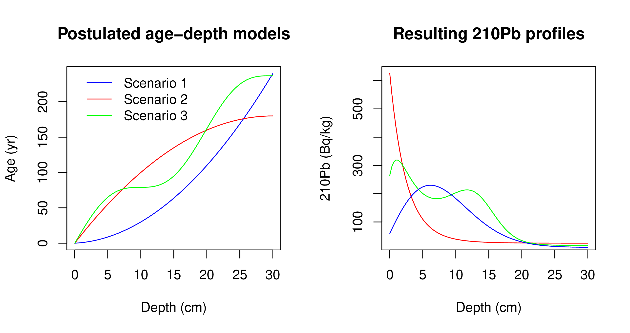
Figure 1: Simulated sedimentation scenarios with their corresponding Pb profiles. Left: Age-depth functions for the three different scenarios (Table 1). Right: Corresponding Pb activity profiles in relation to depth.1
Let be the true Pb concentration in the interval ̂x=[x−δ,x), given the age-depth function t(x) and parameters Φ and in each scenario. To simulate disturbances in the material, we can introduce scatter centred around the true value, , where is the amount of scatter for this variable (in this case ). Now, to replicate outliers, a shift from the true value () is defined, which occurs with a probability . This results in a new variable Θ' which is defined as

[Sorry. Ignored \begin{cases} ... \end{cases}]
. (7)
Finally, to simulate the uncertainty provided by the laboratory, we can define the simulated measurements as , where is the standard deviation reported by the laboratory. is defined as , where is the minimum standard deviation assigned to a measurement. This variable differs between laboratories,we use a default value of 1 Bq/kg. Finally, ε is the analytical uncertainty (default .01) and an error multiplier (default 1.5). The default parameters were set in accordance with Blaauw2018.
For this this study we created a data set for each of the three simulation by integrating in intervals of δ=1 cm, for depths from 0 to 30 cm where radioactive equilibrium was guaranteed (Aquino2018). The complete simulated Pb data sets can be found in https://github.com/maquinolopez/Paper_Simulations/tree/master/Code/Data.

4.2 Model Considerations
In order to create a comparison with minimal user interaction, each model was run automatically, with default settings. In the case of Plum, default settings were used in order to minimize user interaction. As for the default settings were used. As the CRS model (for both the CI-CRS and R-CRS) assumes that background (supported) Pb has been reached, in order to reduce user innervation, we decided to fix the last sample (30 cm depth) for every case. This step not only guarantees the consistent application of the CRS model, it also provides the model with a single bottom-most depth to be removed as it is common practice when using the CRS model. Conversely, as CRS model only models the excess Pb (the total Pb minus the supported Pb), when certain excess activities at depth fall below zero, the chronology will only be calculated up to that depth. Plum deals with this variable supported Pb variable automatically, as part of the inference. Because of this, Plum’s resulting chronology will always reaches 30 cm, as by default 1 cm sections are used for every simulation.
In the case of the supported Pb and in order to reduce the influence of this variable in the bias of the models, a constant level of supported Pb was assumed for both models, which coincides with the way the simulation were constructed. For the CRS model, the mean of the supported Pb measurements was calculated and then subtracted from the total Pb to obtain the excess Pb, as it is common practice when using the CRS model.
In order to provide an objective comparison, the bias of the true age-depth model (in yr), length of the 95% intervals (in yr) and coverage (bias over the standard deviation) were calculated (the coverage indicates the distance of modelled ages from the true value given the model’s own uncertainty). The main discussion will revolve around the coverage as it provide an intuitive measure of the accuracy a model by taking into account the levels of uncertainty provided by each model.

5 Model Comparison
To allow for a reasonable comparison between models, and to evaluate the effect that different amount of information may have on the accuracy and precision of Pb models, reflected in this study as the bias and coverage, the three simulated data sets previously described will be used. In order to reflect the effect of sample sizes, which depending on the budget of the project, the core could entirely sample or only a portion of it. A samples of size m is randomly generated provided a percentage of information, e.g. for a 20% information a dataset with 6 random 1-cm samples -out of a possible total 30 1-cm samples- is created. This sample was then used to create the chronology and calculate the bias, length of interval and coverage: 100 of these sub-datasets were created for different information percentages (from 10% to 95% at 5% intervals - i.e., 10%, 15%, 20%,...,95%). The complete dataset was also used (i.e 100% percentage of information sample, or fully sampled core). Once a dataset was created, both CRS models and Plum were applied (CIC and CF:CS were also applied and results shown on the appendix). Both sets of outputs were then compared against the true known age value, see Figure 2.

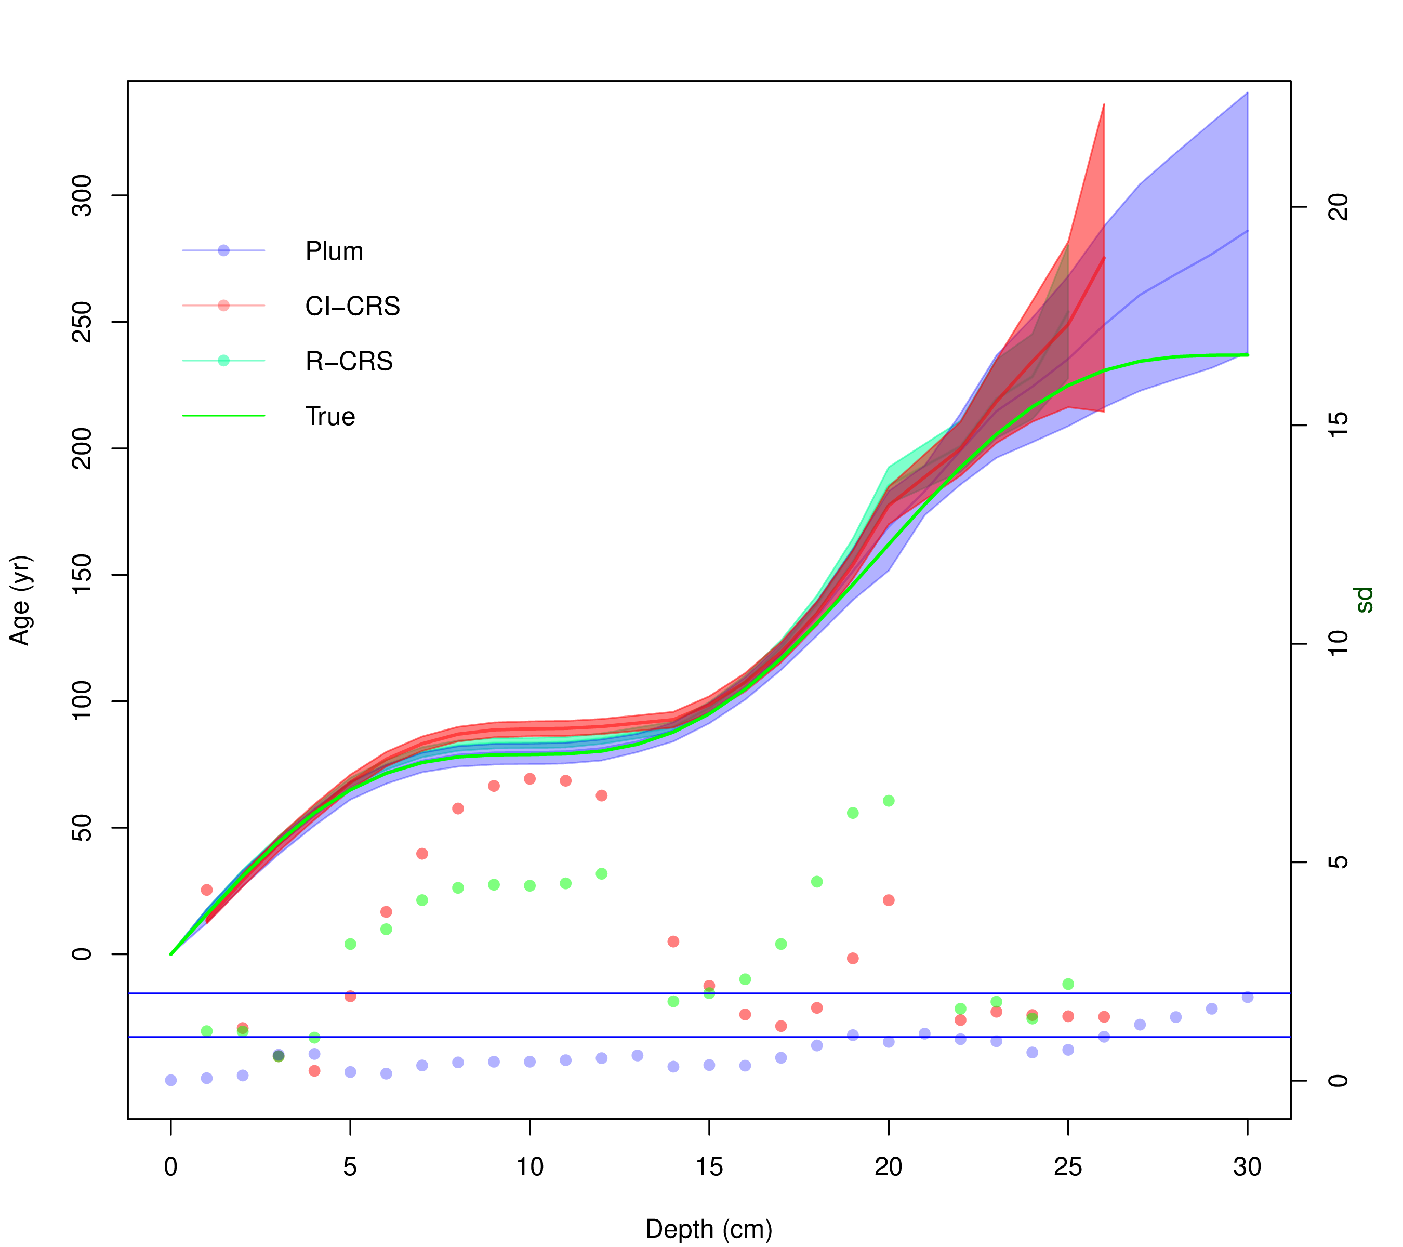
Figure 2: Comparison between Plum, R-CRS and CI-CRS model against the true age-depth model using 95% of the information percentage (using 1-cm samples). Lines show the age estimates with the 95% credible intervals (Plum) and the 95% confidence interval (CI-CRS). Dots show the coverage, i.e. the distance between the inferred age and the true age in relation to the standard error (the standard deviation in the case of the CI-CRS and the length of the confidence interval divided by 4 in the case of Plum). The vertical right axis shows how many standard deviations is each model from the true age.
Figure 2 shows a single “snapshot" an example of the comparison between the Pb models against the true value. As we are dealing with a total of n= 5333 simulations, in order to evaluate the overall precision and accuracy of both models, we decided to calculate the mean bias to the true age-depth model (in yr), the mean of length of the 95% intervals (in yr), as well as the mean coverage indicating the distance of modelled ages from the true value given the model’s own uncertainty at each depth.

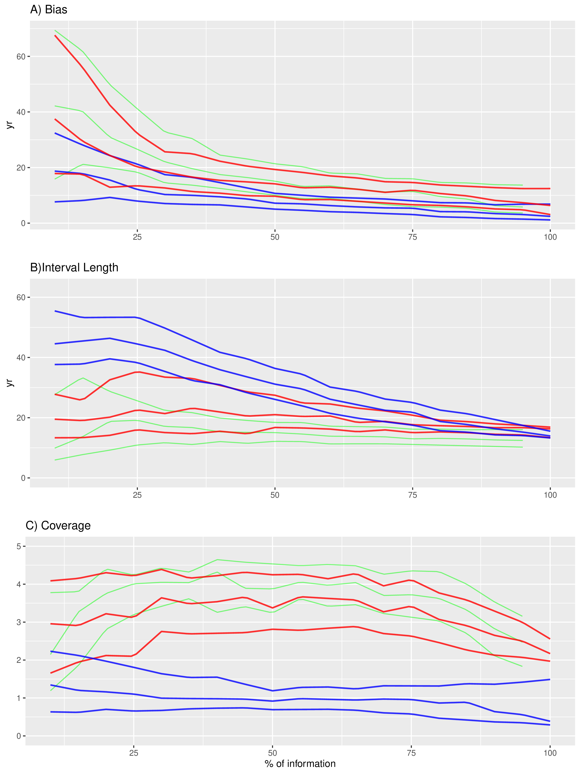
Figure 3: Top panel A) shows the bias between the modelled and true age of the CI-CRS (red), R-CRS (green) and Plum (blue). This panel shows how Plum provides a small bias in almost every scenario with both models improving their bias as more information is available. Middle panel B) shows the 95% confidence intervals. It is clear, from this panel, than the uncertainty provided by Plum is a lot bigger for low percentage of information and it constantly improves as more data is available, whereas the length of the intervals provided by the CI-CRS and R-CRS appear to stay constant regardless of the available information. Bottom panel C) shows the coverage, presenting the distance between the modelled age and the true age normalized divided by the standard deviation (in the case of Plum, the length of the 95% interval divided by 4). This panel presents a worrying situation where the CI-CRS and R-CRS model’s calculated standard deviation (on average) is incapable of capturing the true age. On the other hand, Plum’s credible intervals almost always capture the true age even when little information is available.
Figure 3 show results similar to those presented by Blaauw2018. The classical model (CI-CRS and R-CRS) at first appears to provide a similar results (similar biasses) to the Bayesian alternative (Plum), but at higher estimated precision, if we only consider at the length of the 95% interval. It is important to note that the CI-CRS and R-CRS models’ bias improves as more information is available. However, if we do not consider both the effects of both the bias and length of the interval together, the results are not favourable to the CI-CRS. To have a more realistic representation of how the models capture the true age-depth models relationship, we should observe the coverage. This variable shows the degree to which the average models contain the truth within their uncertainty intervals (normalized to one standard deviation). Any model with a coverage larger than two (two standard deviations) is incapable of capturing the true ages within its uncertainty intervals. This means that, while the CI-CRS and R-CRS estimates smaller uncertainties and its ages improve as more data is available, it does so at the cost of its accuracy and the improvements are not sufficient to capture the true age. It also appears that the length of the 95% interval and bias are not affected by how much information is provided to the CRS model.
On the other hand, Plum seems to provide increasingly accurate results as more information is added to the model. This again coincides with the results outlined by Blaauw2018. When we observe the regular bias (not normalized), we find that Plum provides a smaller bias in comparison to the CI-CRS and R-CRS models; this, in combination with slightly larger (more realistic) modelled uncertainties, results in more consistently accurate age-depth models that are capable of capturing the true values within their uncertainty intervals. This result supports the claim that Plum provides more realistic uncertainties compared those obtained by the CI-CRS and R-CRS. Another important statistic to take into account is that 87.86% (4686/5333) of Plum’s runs remain within the 2 standard deviations, opposed to 7.48% (399/5333) for the CI-CRS models. Furthermore, only 0.54% (29/5333) of the CI-CRS models runs remain under the 1 standard deviation, which is the most commonly reported interval when reporting CI-CRS results, with R-CRS providing very similar results. We can also observe a clear structure in the way that Plum increases its accuracy and precision to obtain a better chronology as more information is available, whereas the CI-CRS and R-CRS model does not appears to improve its ability to capture the true value from additional data, i.e it does not improve its coverage as more data is available. Since we obtained very similar results from both the CI-CRS and R-CRS, the discussion will now focus on the CRS in general taking the CI-CRS as its base for the following calculations.
These results are valid for the overall chronology (the mean bias, interval and coverage of the overall chronology). In order to evaluate whether certain models are better predicting ages at certain section of the sediment cores, we have to look at the coverage of every depth.

[Sorry. Ignored \begin{centering} ... \end{centering}]
Figure Error: Reference source not found shows the coverage of every simulation according to depth for both models. Plum shows a clear learning structure which depends on the information available to the model. The information percentage appears to be irrelevant to the coverage of the CI-CRS model, contrary to the results obtained by Plum. It is important to note that the inaccuracies of the CI-CRS model are not exclusive to any particular sections of the chronology; this is most likely driven by the small uncertainties estimated by the CI-CRS model.See below for a discussion of how Plum behaved in sedimentation simulation 2.

6 Discussion and Conclusions
This research focuses on exploring the uncertainty and precision of the most commonly used Pb dating methods (CRS and Plum). By using different scenarios, three different simulations were created. These simulations were then sub-sampled at different percentages of information in order to observe the effects that different sample sizes have on the resulting chronology. This experiment provided an objective comparison of the accuracy and precision of both methods.
The experiment was measured in two different level. For the first level, the overall accuracy and precision of the method were evaluated. The mean of the bias, length of the 95% confidence and credible intervals, as well as the coverage were measured. The second level focused on the ability of each model to capture the true value in their credible/confidence interval, and the coverage of every scenario per depth was calculated. These two comparisons provided a good picture of the difference in precision and accuracy between these methods.
From the overall accuracy (see Figure 3) it is clear that both the CRS model and Plum reduce their bias as more data becomes available, with the Bayesian method providing, on average, a smaller bias regardless of the sample size. On the subject of precision, the Bayesian method is providing much larger uncertainties when small sample sizes are used. It is only with 60%, or more, of the information that the length of the intervals becomes comparable. This is a consequence of the linear interpolation, between data points, used by the CRS method, in contraste to the Bayesian approach (Plum) using a proper statistical inference. As has been previously discussed by Aquino2020, the larger uncertainties provided by Plum are more realistic, and this experiment confirms the latter. Further evidence that these uncertainties are more sensible is that the length of the credible intervals becomes smaller as more data becomes available. On the other hand, the length of the confidence intervals provided by the classical model (CRS) remain almost constant at any sample size. Lastly, the coverage, which shows the capability of the model to capture the true values within their intervals, shows that the classical model (CRS) on average is incapable of capturing the true values within its 95% confidence interval. These results are especially worrisome considering that the Pb dating community rarely report 95% confidence intervals and instead tend to use only 65% confidence intervals (one standard deviation intervals) are reported. On the other hand, Plum’s coverages always remain ≤2, therefore guaranteeing that on average the true value is capture within its 95% credible intervals, even with small sample sizes. Plum’s coverages are constantly improving and reaching stability with 50%, or more, of information percentage. These experiments show that the Bayesian method, on average, provides more reliable results.
Because the coverage shows the capability of capturing the true value within its intervals, this variable can be used to conclude if any given method is better at estimating certain time period. Figure Error: Reference source not found presents the performance of both the CRS model and Plum for every simulated scenario. It appears that, the coverage of many of the CRS chronologies are >2 throughout the whole chronology, meaning that the model does not have a period of time for which it is more precise. Moreover, the CRS does not exhibits a clear learning pattern, where the coverage appears to be indifferent to the amount of information available. It appears that even high levels of information percentage provide coverages >2, in some cases closer to 4 for scenarios 2 and 3. Plum on the other hand, shows a structure where more data is reflected in improved models in scenarios 1 and 3. It is only at low levels of information where Plum’s coverage is >2. Scenario 2, on the other hand, presents a case where Plum is both incapable of capturing the true value, for depths deeper than 15 cm, and it appears that as more data becomes available the model provides worse results. This may be of concern if we do not recognized that this scenario is unrealistic as it presents an extreme change in the accumulation around 15 cm, which coincides with the depth at which the coverage becomes >2. It is also important to acknowledge that this experiment was performed using default settings. In a real-world scenario the user typically has some prior knowledge of the sedimentation process, about the site of interest, which could be incorporated as prior information to the model to improve the resulting chronology.
In conclusion, the use of the Bayesian age-depth models is preferred for the consistent construction of sediment chronologies, not only on radiocarbon-based chronologies as presented by Blaauw2018 but also in the more complex case of Pb as demonstrated by this research. While the classical approach provides reasonable results, regarding the bias, unfortunately the uncertainty quantification in these methods needs improvements as they do not rely on a proper statistical structure. In a real-world scenario, it is impossible to measure the true bias of a method and therefore a proper uncertainty quantification becomes extremely important. These results support the recommendations presented by Smith2001; Barsanti2020 where the CRS method, or any dating methodology, should be validated using independent dating methods markers.
Lastly, it is important to highlight the benefits of the Bayesian methods. From both Blaauw2018 and the present work, it is shown that Bayesian methods constantly improve as more data are added, the uncertainty associated to the method is realistic and coherent with the amount of information available. This leads to chronologies that are capable of capturing the true age in their credible intervals. The ability to capture the true value in the credible intervals becomes important when the problem is associated with decision making processes, as it provides a more realistic picture of the available knowledge of the process. Given that Pb dating is now widely-used in pollution, environmental and climate change studies, which potentially have a high impact on both policy making and public perception, realistic age estimates and uncertainties become extremely important.

7 Acknowledgments
The authors are partially founded by CONACYT CB-2016-01-284451 and COVID19 312772 grants and a RDCOMM grant. The corresponding author is founded by CONACYT through the postdoctoral residence program with CVU 489201.
References
[Appleby, 2008]Appleby, P. (2008). Three decades of dating recent sediments by fallout radionuclides: a review. The Holocene, 18(1):83–93.
[Appleby and Oldfield, 1978]Appleby, P. and Oldfield, F. (1978). The calculation of lead-210 dates assuming a constant rate of supply of unsupported 210pb to the sediment. Catena, 5(1):1–8.
[Appleby, 1998]Appleby, P. G. (1998). Dating recent sediments by Pb-210: Problems and solutions. Proc. 2nd NKS/EKO-1 Seminar, Helsinki, 2-4 April 1997, STUK, Helsinki, pages 7–24.
[Appleby, 2001]Appleby, P. G. (2001). Chronostratigraphic techniques in recent sediments. Tracking Environmental Change Using Lake Sediments: Basin Analysis, Coring, and Chronological Techniques, pages "171–203".
[Aquino-López et al., 2018]Aquino-López, M. A., Blaauw, M., Christen, J. A., and Sanderson, N. K. (2018). Bayesian analysis of 210pb dating. Journal of Agricultural, Biological and Environmental Statistics, 23(3):317–333.
[Aquino-López et al., 2020]Aquino-López, M. A., Ruiz-Fernández, A. C., Blaauw, M., and Sanchez-Cabeza, J.-A. (2020). Comparing classical and bayesian 210pb dating models in human-impacted aquatic environments. Quaternary Geochronology, 60:101106.
[Barsanti et al., 2020]Barsanti, M., Garcia-Tenorio, R., Schirone, A., Rozmaric, M., Ruiz-Fernández, A., Sanchez-Cabeza, J., Delbono, I., Conte, F., Godoy, J. D. O., Heijnis, H., Eriksson, M., Hatje, V., Laissaoui, A., Nguyen, H., Okuku, E., Al-Rousan, S. A., Uddin, S., Yii, M., and Osvath, I. (2020). Challenges and limitations of the 210pb sediment dating method: Results from an IAEA modelling interlaboratory comparison exercise. Quaternary Geochronology, 59:101093.
[Binford, 1990]Binford, M. W. (1990). Calculation and uncertainty analysis of dates for PIRLA project lake sediment cores. Journal of Paleolimnology, 3:253–267.X
[Blaauw and Christen, 2011]Blaauw, M. and Christen, J. A. (2011). Flexible paleoclimate age-depth models using an autoregressive gamma process. Bayesian Analysis, 6(3):457–474.
[Blaauw et al., 2018]Blaauw, M., Christen, J. A., Bennett, K., and Reimer, P. J. (2018). Double the dates and go for Bayes — impacts of model choice, dating density and quality on chronologies. Quaternary Science Reviews, 188:58–66.
[Bruel and Sabatier, 2020]Bruel, R. and Sabatier, P. (2020). serac: an r package for ShortlivEd RAdionuclide chronology of recent sediment cores. Journal of Environmental Radioactivity, 225:106449.
[Crozaz et al., 1964]Crozaz, G., Picciotto, E., and de Breuck, W. (1964). Antarctic snow chronology with pb210. Journal of Geophysical Research, 69(12):2597–2604.
[Goldberg, 1963]Goldberg, E. D. (1963). Geochronology with pb-210. Radioactive Dating, pages 121–131.
[Mustaphi et al., 2019]Mustaphi, C. J. C., Brahney, J., Aquino-López, M. A., Goring, S., Orton, K., Noronha, A., Czaplewski, J., Asena, Q., Paton, S., and Brushworth, J. P. (2019). Guidelines for reporting and archiving 210pb sediment chronologies to improve fidelity and extend data lifecycle. Quaternary Geochronology, 52:77–87.
[Robbins, 1978]Robbins, J. (1978). Geochemical and geophysical applications of radioactive lead. The biogeochemistry of lead in the environment, pages 285–393.
[Robbins and Edgington, 1975]Robbins, J. A. and Edgington, D. (1975). Determination of recent sedimentation rates in lake michigan using pb-210 and cs-137. Geochimica et Cosmochimica Acta, 39(3):285 – 304.
[Sanchez-Cabeza and Ruiz-Fernández, 2012]Sanchez-Cabeza, J. A. and Ruiz-Fernández, A. C. (2012). 210Pb sediment radiochronology: An integrated formulation and classification of dating models. Geochimica et Cosmochimica Acta, 82:183–200.
[Sanchez-Cabeza et al., 2014]Sanchez-Cabeza, J. A., Ruiz-Fernández, A. C., Ontiveros-Cuadras, J. F., Pérez Bernal, L. H., and Olid, C. (2014). Monte Carlo uncertainty calculation of 210Pb chronologies and accumulation rates of sediments and peat bogs. Quaternary Geochronology, 23:80–93.
[Smith, 2001]Smith, J. N. (2001). Why should we believe 210pb sediment geochronologies? Journal of Environmental Radioactivity, 55(2):121 – 123.

8 Supplementary Material
Data for each simulation and code used are hosted at: https://github.com/maquinolopez/Paper_Simulations

9 Appendix A
Bias, length of 95% confidence intervals and coverage of the CIC and CF:CS models. As it can be observe and as expected the bias of the CIC model (which can be consider the simples model) is much bigger when compare to any other alternative and it does not decrease as more data is available. The confidence interval remains regarles of the information available, and coverage is almost always above two, which means that the uncertainties are not sufficient to capture the true age-depth model. On the other hand the CF:CS model does decrease its bias as more data is available and after 60% to 70% this decrease does not seen improve. The length of the interval remains the same regarles of the information available and the coverage just like the CIC model is almost always above 2 meaning that the uncertainties are not sufficient.

[Sorry. Ignored \begin{centering} ... \end{centering}]

Centro de Investigación en Matemáticas (CIMAT), Jalisco s/n, Valenciana, 36023 Guanajuato, Gto, Mexico. email: aquino@cimat.mx
Corresponding author.
GEOTOP Research Centre, Université du Québec à Montréal, Montréal, Québec, H2X 3Y7, Canada. email: sanderson.nicole@uqam.ca
School of Natural and Built Environment, Queen’s University Belfast, Belfast, BT7-1NN, UK. email:maarten.blaauw@qub.ac.uk
Unidad Académica de Mazatlán, Instituto de Ciencias del Mar y Limnología, Universidad Nacional Autónoma de Mexico, 82040 Mazatlán, México email:jasanchez@cmarl.unam.mx
Unidad Académica de Mazatlán, Instituto de Ciencias del Mar y Limnología, Universidad Nacional Autónoma de Mexico, 82040 Mazatlán, México email:caro@ola.icmyl.unam.mx
Centro de Investigación en Matemáticas (CIMAT), Jalisco s/n, Valenciana, 36023 Guanajuato, Gto, Mexico. email: jac@cimat.mx

