
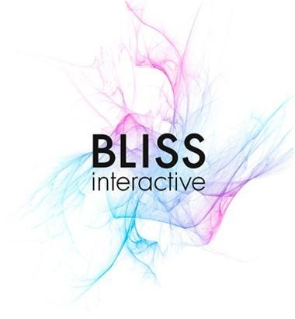
Ma Quoc Thai
(Front End Developer - Outsourcing/Offshoring )

184/22/7A Le Dinh Can St, Tan Tao Ward, Binh Tan District, HCM City.
169/7 Gia Phu St, 1 Ward, 6 District, HCM City.
Telephone: 083 762 5898 (Home); 090 66 777 98 (Mobile)
Email: maquocthai@gmail.com

Overview Profile

I started to work in 2006 - 2014: 8 years experience in IT
Since 2006 - 2011: I spent three main areas include: Graphic Designer, Web Graphic and Layout, Multimedia Design. (Learning and do working in same time. )
Since 2011 - 2014: I just made ​​a single keyword is HTML + CSS + JS Layout based on PSD Source file had from customers, which is BLISS INTERACTIVE.
Architecture HTML and CSS, basic Javascript almost 80% of the BLISS-interactive.net project.
Quality assurance requirements browsers.
Changing update customer changes the content changes, feature .....
These products and my customers very much and made famous in the world, focusing on France and the Netherlands.
For more information of our customers is one, see site: http://www.bliss-interactive.net/

View Design from history web and my Skill current in library from jsfiddle
https://googledrive.com/host/0B39EpG9mMRpaWjJKb2MtaDR0WjQ/index.htm

Key Technical Skills
Magento (only 1 project in 3 month )
PHPStorm
Github
Reponsive web

HTML/HTML4, XML, CSS/CSS3, Jquery
Photoshop
Dreamweaver
Parallax, Spritely for animation object.

Career Summary

12/2013 – 3/2014: 3 month
Bluecom
Position: Front-End developer
Skill: MAGENTO
Highlight Projects

http://toureiffel2.iron-forge.shanghai.bluecomcn.com/

11/2011 – 10/2013: 2 years
Bliss interactive company
Position: Front-End developer
Skill:
- HTML(include HTML5), CSS(include CSS3, animation css3), Javascript
- Javascript tools: Jquery, Modernizr..
- Technique responsive: Skeleton, Fixtext (for Text) ,jquery.picture.js (for Image) and Less.
- Making a web application on iphone.
- Making a web on all screen.
- Crossing browsers: IE 6+, Firefox, Chrome, Safari on Win, Mac, Mobile, iPad
- Others: Worpress, Joomla, Drupal, Ajax, CSS3pie, Google analytics, mail HTML,...
- Projects detail:
  - http://vn.linkedin.com/pub/thai-ma-quoc/26/ab2/317/

Projects:

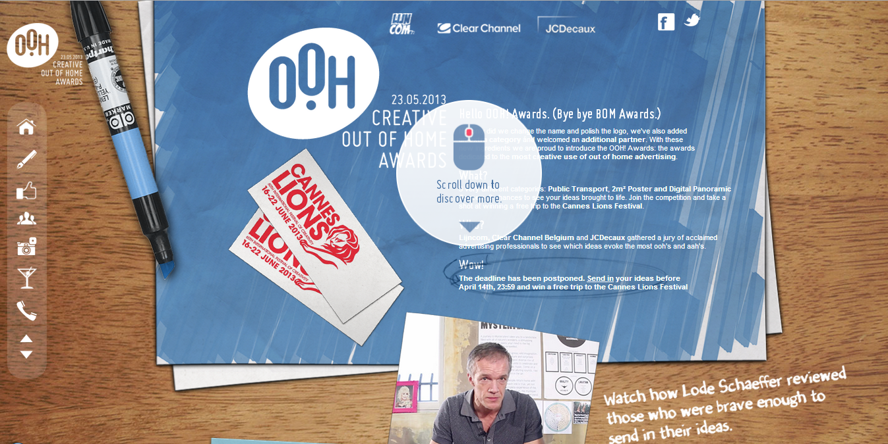

Client: Dallas
Link: http://oohawards.be/
Role: Front-end developer (html, css, javascript, (other - develop on iphone, ipad )).

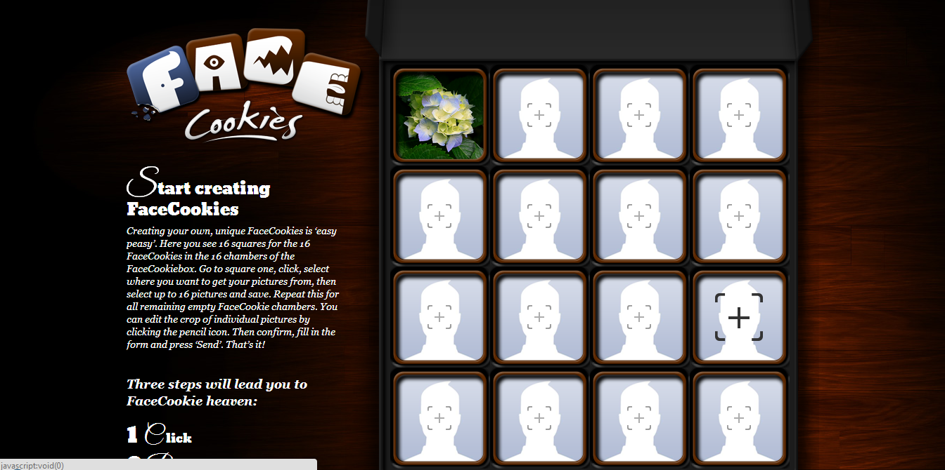

Client: Dallas
Link: http://facecookies.com/usibility/index.php
Role: Front-end developer (html, css,javascript).

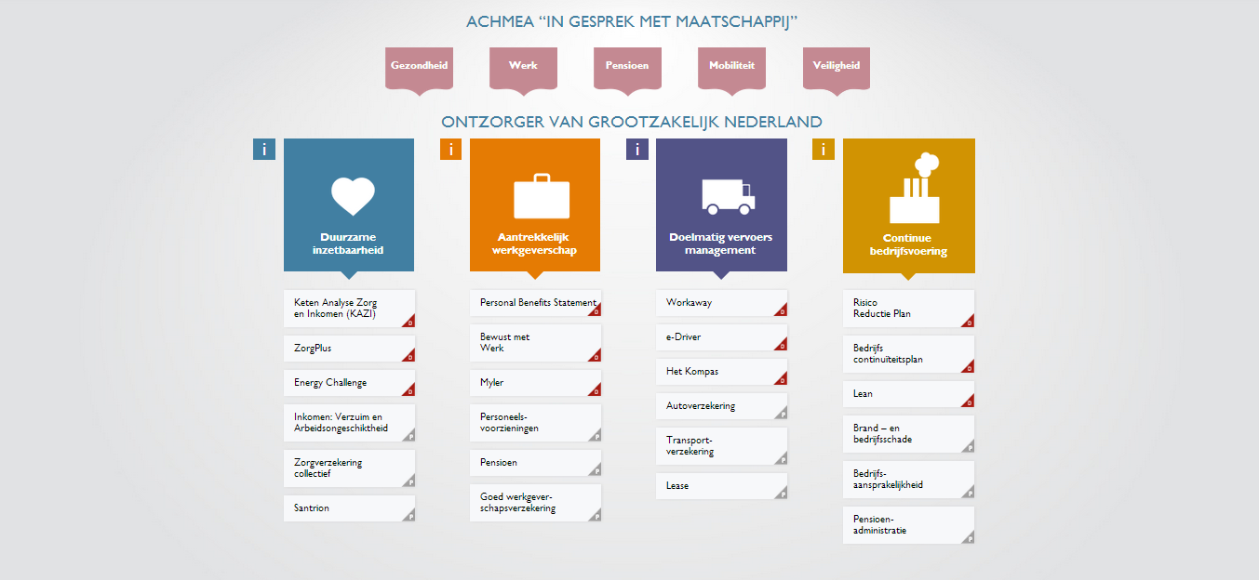

Client: Greenberry
Link: http://achmea.greenberry.nl/home.php
Role: Front-end developer (html, css, javascript, (other - develop on iphone, ipad )).
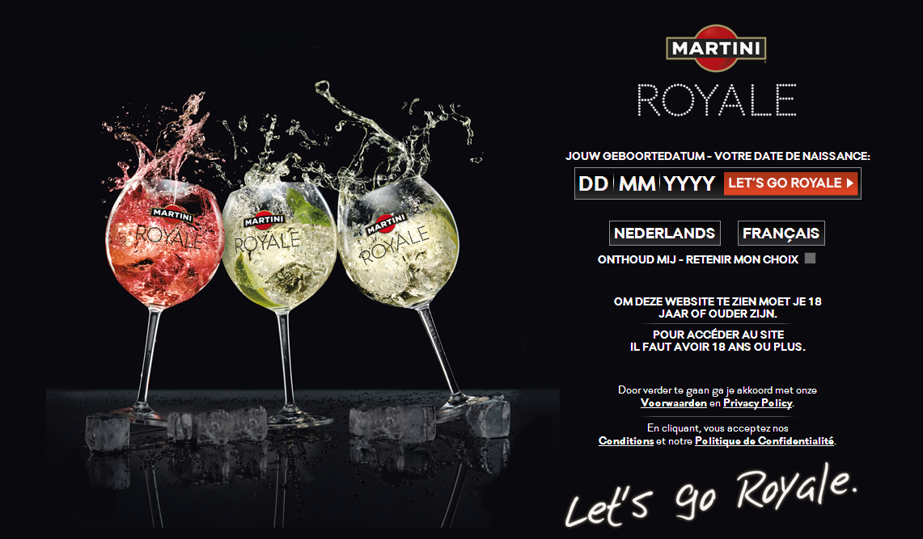

Client: MARTINI
Link: http://www.happiness-brussels.com/preview/MARTINI/MartiniRoyalMicrosite/www/agegate.php
Role: Front-end developer (html, css, javascript, (other - develop on iphone, ipad ).

Highlight Projects

http://perfectportfolio.be/
http://lexusparadisfiscal.be/
http://schweppes.be/
http://oohawards.be/
http://achmea.greenberry.nl/home.php
http://facecookies.com/usibility/index.php
http://www.happiness-brussels.com/preview/MARTINI/MartiniRoyalMicrosite/www/agegate.php
More detail : 85 -90% Project on introduce of BLISS-interactive.net (http://bliss-interactive.net/) or more 40 project I had done.

NIVEA serial from 2012 to 2013 : Winter Check (November 2011 )
Convert PSD to HTML.
Display quality assurance browser from IE7 or higher.
Use jquery.cycle.all.js Javascript ( http://jsfiddle.net/maquocthai/sDPRe/ )
Use ui.checkbox.js ( http://jsfiddle.net/maquocthai/FrYFM/ )
Use tab.js for FAQ and custom change background . ( http://jsfiddle.net/maquocthai/L3hA9/1/ )
Use hover map for site. ( http://jsfiddle.net/maquocthai/r4LfZ/ ) and use Popup Js for each map ( http://jsfiddle.net/maquocthai/r4LfZ/4/ )
Use jscrollpane.js to create Scroll basic: ( http://jsfiddle.net/maquocthai/qYxG8/1/ )
Use contentcarousel to Slider product: ( http://jsfiddle.net/maquocthai/Vjtu9/ )
NIVEA serial 2013 : Advantage (February 2012 – Present )
Use anythingslider Javascript and more. ( http://jsfiddle.net/maquocthai/f6eGT/1/ )
NIVEA serial from 2012 to 2013 : NIVEA for Men (July 2012 – Present )
Menu Main animation jquery ( http://jsfiddle.net/maquocthai/vR3QV/ )
Product Show animation boutique.js for product ( http://jsfiddle.net/maquocthai/hFL8K/ )
NIVEA serial from 2012: BirthdayContest form HTML basic (March 2012 )
NIVEA 2013 : FAQ Contact Form (September 2013 )
NIVEA serial from 2012: HealthCity form HTML basic (May 2012 )
NIVEA serial 2013 : RayonnezSite (December 2012 – Present )
NIVEA serial 2013 : NIVEA Summer Microsite (February 2013 )
Slider custom Product in page. (http://jsfiddle.net/maquocthai/5CG2z/ )
TRUVO serial from 2012 to 2013: goudengid Business Center (October 2012 )
TRUVO serial 2013: Urgent live Youtube embedded ( August 2013 )
Slider custom Banner in site. ( http://jsfiddle.net/maquocthai/4FAYh/6/ or http://jsfiddle.net/maquocthai/nnpmU/ )
Video Slider Custom - TRUVO ( http://jsfiddle.net/maquocthai/HQY68/ )
Toyota serial 2013 - Search Engine ( Destocking Search Engine Tool ) ( August 2013
Use jquery.livequery.js for choose and Animation hover Product.
( http://jsfiddle.net/maquocthai/38svn/1/ )
Use raphael.js and icarousel.js for Product ( http://jsfiddle.net/maquocthai/9uJGc/ )
Toyota serial 2012 - Hybrid platform 2012
Use animate js for text tittle on banner site in Jquery( http://jsfiddle.net/maquocthai/kzpY2/ GREENBERRY serial 2012 - HU VAN NU (March 2012 – Present )
Use and write Jquery dropbox for menu and sub menu container checkbox UI for site with combine. ( http://jsfiddle.net/maquocthai/L6U23/ )
GREENBERRY serial 2012 - 100 Ondernemerslessen - Centraal Beheer Achmea
May 2012
GREENBERRY serial 2012 - Centraal Beheer Vimezz landing page (March 2012 )
GREENBERRY serial 2012 - Marketing talent of the year ( May 2012 ) GREENBERRY serial 2012 - PostNL Social media site development ( October 2012 )
GREENBERRY serial 2012 - PostNL Pakketautomaat website ( November 2012)
GREENBERRY serial 2012 - Tevafootwea Snow Fall Prediction ( July 2012 )
GREENBERRY serial 2013 - GRE Achmea FullydynamicPresentationwithCMS ( January 2013 )
GREENBERRY serial 2013 - Rapportageportaa SBR Banken ( Feb 2013 – Present)
DAOUST - website Landing page ( March 2013 )
SAATCHI serial from 2013 - Wagner Pizza-001-Landing page ( March 2013 )
SAATCHI serial from 2012 - Wagner Pizza Party Site Development (Jan 2012)
SAATCHI 2013 - Perfect Portfolio Static Website Development (March 2013
BLISS IDENTITY - Internal job Bliss New Identity ( October 2012 )
TOYOTA - IQ STREET VIEW 2012 ( April 2012 )
Schweppes serial from 2012 - Schweppes Club of Good Taste ( May 2012 )
Schweppes serial from 2012 - Schweppes Orange ( June 2012 )
Schweppes serial from 2013 - Schweppes Belgium - New corporate website ( Ap- 2013
Schweppes serial from 2012 - Schweppes Coasters ( July 2012 – Present )
BKCP Bank 2012 - BKCP Banque - Bonus campaign ( May 2012 )
PIMKIE 2013 - Look book Google Map 2013 ( Jan 2013 )
DALLAS 2013 - DAL OOH Awards Site ( Mar 2013)
DALLAS 2013 - FaceCookies ( May 2013 )
Record Bank - AGING Application ( October 2012)
Doom Dickson - SIRE Tolerantie Campaign Oct 2012 ( Sep 2012)
DVV - Online Activation ( Jan 2013 )
HBI Calories WebSite ( May 2013)
TRUVO - See What You Miss3.0 ( May 2013)
Lexus - Company Car Tax Calculator ( May 2013 )
Lapperre - Foundation Web platform ( April 2013 )
Martini Royal Microsite - Let’s Go Royale ( June 2013 )

Strengths

- Technology of Front-End.
- Researching skill.
- English: reading and writing.
- Hard working, and work with team.

FREELANCER:

HTML5 :
- FINECUISINE : (link google driver backup – CLICK ) => Code FrontEnd.
- LAUXELUA : (link google driver backup – CLICK ) => Code FrontEnd.
- KOHTHAI
- http://chuahaiquang.com.vn/ (link google driver backup - Home - About )=> Design Graphic and Code FrontEnd – CMS Fullsite.)
Joomla:
- PHONGKHAMTIMMACH: (link google driver backup – CLICK ) => Design Graphic and Code FrontEnd, create template theme for Joomla.

Sorimachi Vietnam:
May 2011 –July 2011 for Sorimachi Vietnam Co., Ltd, (www.sorimachi.vn )
Web Designer – HTML – CSS designer – Javascript

Oct 2010 – April 2011 for Web Vien Dong Company (www.fet.vn )
Web Designer

- Vcomland.com.vn (link google driver backup - CLICK Home - article – finehome– international– ListNews- Newsdetail – project – Projectdetail – properties – realestatesearch - )=> Design Graphic and Code FrontEnd.
- Viendongtelecom.com.vn (link google driver backup - CLICK )=> Design Graphic and Code FrontEnd.
- Anttel.com.vn (link google driver backup - CLICK Home - About – Business – listnews – product - product detail - contact )=> Design Graphic and Code FrontEnd.
- TuThienMinhTam (link google driver backup - CLICK Design 01 – version Design 02: Home – About- Contact ) => Design Graphic
- Aba.com.vn (link google driver backup - CLICK) => Design Graphic and Code FrontEnd.
- http://trungtamhoanggia.com/ => Design Graphic and Code FrontEnd.

FREELANCER:
- MPCKIMLONG.com (link google driver backup - CLICK) => Code FrontEnd and use CMS create website
- http://www.thanhdathcm.vn/ => Code FrontEnd and use CMS create website
- http://duongdai.vn/ => Code FrontEnd and use CMS create website )
- KDI.vn (link google driver backup - CLICK) => => Code FrontEnd and use CMS create website
- DIAMOND-LOTTERY.com (link google driver backup - CLICK) => Code FrontEnd and use CMS create website
- QUOCTHAIDESIGNER: (link google driver backup - CLICK – product ) => Code FrontEnd, NOT YET.

- Layout Photoshop to XHTML + CSS + Jquery
- Use CMS (Content Management System only for Web Designer ) create website for guest, use XPath to show database. This CMS was base on XML, XSL,XPATH ASP. DHTML and CSS.

June 2010 – August 2010 for NEW LIGHT Company (www.rjcapitalgroup.com)
Web Designer
- Web Graphic > Layout Photoshop to XHTML + CSS + Jquery (run correct on all browser IE6, 7, 8 and Firefox and others )
- LAWSITE: (link google driver backup - CLICK – Home – Content ) => Design Graphic and Code FrontEnd.
- IVYBOUND : (link google driver backup - CLICK – Home) => Design Graphic and Code FrontEnd.

Design VALUEMD Company
- Using Vbulletin for www.valuemd.com , design themes, CSS (for new version) and continue.
- Design site structure for project, begin from plan to develop.

November 2008 – December 2009 for Digital Zen Joint Stock Company
Web Designer

- Web Graphic > Layout Photoshop to XHTML + CSS + Jquery (run correct on all browser IE6, 7, 8 and Firefox and others )
- Use CMS (Content Management System only for Web Designer ) create website for guest, use XPath to show database. This CMS was base on XML, XSL,XPATH ASP. DHTML and CSS.
- Using Vbulletin for www.valuemd.com , design themes, CSS (for new version) and continue.
- Design site structure for project, begin from plan to develop.

2007 - 2008 for “TỔ HỢP SÁNG TẠO VIETBOOKS”
Event Designer, Graphic designer, Multimedia designer.

- Use Adobe Premiere, edit sound by Adobe Audition, Cut Film, choose Effect create Film Introduce for company , event.
Use basic technique Video Copilot in Adobe After Effect create panel 30s TVC. Lac Viet company, Hong Hoi , hoctienganhnhanh.com.vn panel …
- Designer Graphic and skin video for Comunication TV: “The market 24 G”, “The market 365”
Final 2006 – first 2007 - for ASIASOFT company
Graphic designer

- Use Adobe Photoshop , design for project “Tam Quoc Chi” www.tqc.com.vn about web, bordure , card game, notebook, banner, advertising ….)
2006 - for DỊCH VỤ - THÔNG TIN - THƯƠNG MẠI THÁI QUANG Co. company
Web Graphic and layout, take care of guest.

- Use Adobe Photoshop design web template.
- Layout web by tag “<table ><tr><td></td></tr></table>” in past time.

Brandpowervietnam.com (disiable , not connect )
www.duhocando.com (disiable , not connect )
www.hoctienganhnhanh.com.vn (disiable , not connect )
www.fourspots.com (disiable , not connect )
www.tiepthiquangcaocuaban.vn (disiable , not connect )
www.tiepthi24h.vn (disiable , not connect )
www.tienthinh.com (disiable , not connect )

Portfolio about Event:

The dream of Vietnam 2007 - 2008

VietWill Company, VietBooks Corporation, HCM city, VietNam (2007-2008)

Vietnam ideal 2007- 2008

VietCopyright company, VietBooks Corporation, HCM city, VietNam (2007-2008)

Vietnam record 2007- 2008

VietKing company, VietBooks Corporation, HCM city, VietNam (2007-2008)

Business24G, The market 24G, The market 365 on live channel TV

VietBusiness company, VietBooks Corporation, HCM city, VietNam (2007-2008)

Portfolio about Film:

Business24G, The market 24G, The market 365 on live channel TV

VietBusiness company, VietBooks Corporation, HCM city, VietNam (2007-2008)

Education disability children – 5series

psychological science “School University teaching Hochiminh city”
- Learning education about Russian – English languages – 3 class
School University teaching Hochiminh city

Formal Qualifications

National Diploma in Graphic Design & Multimedia Art Design

University of Natural Sciences Information Technology, HCM city, VietNam (2007-2008)

Following attainment of my Leaving Certificate, I embarked on a National Diploma in Graphic Design & Multimedia to formalise both my design skills and my creative experience. Via mock client briefs, addressing realistic commercial projects, I studied web design, illustration and multimedia applications. The final examination of the Diploma consisted of an exhibition of project work (multimedia, CD-ROM and accompanying web page). A dissertation on an individually selected design topic was also completed and submitted.

