Multiple Probabilities of Direction: A Rationale for Prior odds Adjustment

Margherita Calderan¹, Filippo Gambarota², Enrico Toffalini¹, and Gianmarco Altoè²
¹Department of General Psychology, University of Padova
²Department of Developmental Psychology and Socialization, University of Padova

Author Note
Margherita Calderan  https://orcid.org/0009-0005-5668-5162
Filippo Gambarota  https://orcid.org/0000-0002-6666-1747
Enrico Toffalini  https://orcid.org/0000-0002-1404-5133
Gianmarco Altoè  https://orcid.org/0000-0003-1254-9528
Correspondence concerning this article should be addressed to Margherita Calderan, Department of General Psychology, University of Padova, Via Venezia 8, Padova 35131, Italy, Email: margherita.calderan@unipd.it

Abstract
In psychological research, Bayesian analyses are often summarized using posterior indices and then interpreted with conventional cutoffs across many parameters. The probability of direction (pd) is one such index, defined as the posterior probability that a parameter is greater or smaller than a null value. When pd is thresholded and used repeatedly, multiplicity becomes consequential but is rarely handled explicitly. Here, we examine the operating characteristics of pd under repeated use by leveraging its correspondence with the frequentist p-value under common settings. Simulations show that extreme pd can arise by chance and that misleading conclusions become more frequent as the number of tests increases. We further express pd in terms of posterior odds and propose prior odds adjustments that provide multiplicity control while preserving Bayesian coherence. To support practical implementation, we provide an R package that applies the proposed prior odds corrections.

Keywords: probability of direction, multiple testing, prior odds

Multiple Probabilities of Direction: A Rationale for Prior odds Adjustment
Over the past two decades, the proportion of articles reporting Bayesian analyses in psychology has increased considerably (Jevremov & Pajić, 2024; Pfadt et al., 2025; Van De Schoot et al., 2017). Unfortunately, this expansion has been accompanied by practices reminiscent of the “null ritual” in frequentist statistics, where widespread use was associated with automatic application rather than principled reasoning (Cohen, 1994; Gigerenzer, 2004). For instance, researchers sometimes treat Bayes factor thresholds (e.g., BF > 3) as dichotomous decision rules or claim that an effect “exists” because the posterior probability of a positive effect exceeds a conventional benchmark such as 95% (Heck et al., 2023; Hoijtink et al., 2016; Kelter, 2023; Kruschke, 2018; Tendeiro et al., 2024; Tendeiro & Kiers, 2019). While such summaries are convenient, their use as default cutoffs encourages all-or-none interpretations. When these binary judgments are applied repeatedly across many parameters, the issue of multiplicity arises.
In the frequentist framework, multiplicity is typically framed as Type I error (false-positive) problem: if each individual test is conducted at level $α$, the probability of at least one false positive increases with the number of tests. Classical approaches therefore control either the familywise error rate (the probability of at least one Type I error) or the false discovery rate (the expected proportion of false positives among rejected hypotheses) [REFs]. However, multiplicity concerns extend beyond false positives. When researchers examine many parameters and highlight the most extreme estimates, selection effects can produce exaggerated magnitudes (Altoè et al., 2020; Gelman & Tuerlinckx, 2000; Zwet & Cator, 2021). Bayesian shrinkage methods address these distortions by pulling extreme estimates toward more plausible values. Such shrinkage can arise through hierarchical models with partial pooling (Berry & Hochberg, 1999; Gelman et al., 2012, 2013; Kruschke, 2011) and/or through informative priors that reduce overestimation in low signal-to-noise settings (Dawid, 1994; Zwet & Gelman, 2022).
Regularization improves estimation, but it does not by itself calibrate repeated threshold-based decisions across many parameters. If the same cutoff is applied to many parameters (e.g., declaring an effect whenever posterior probability exceeds 0.95), the chance of at least one spurious finding can remain inflated, even if shrinkage reduces it. Bayesian approaches that directly target this issue typically rely on either simultaneous credible statements (Box & Tiao, 1992; Gelman & Tuerlinckx, 2000; Pruzek, 2016; Schnell et al., 2020) or priors on the hypothesis/model space that scale with the number of tested effects (Jeffreys, 1938; Scott & Berger, 2006; Scott & Berger, 2010; Westfall et al., 1997). Nevertheless, psychological researchers often conflate selection effects that distort estimates with the distinct problem of making many simultaneous decisions. As a result, shrinkage is sometimes treated as sufficient for multiplicity control (Chen et al., 2020; Erčulj & Štrumbelj, 2015; Hogeveen et al., 2022; Limbachia et al., 2021; Mathar et al., 2022).
Other justifications invokes the subjectivist interpretation of Bayesian inference, which treats posterior probabilities as rational degrees of personal belief (De Finetti, 2017; Edwards et al., 1963; Lindley, 1972; Rozeboom, 1960). However, this interpretation fits poorly with common psychological practice, where researchers typically apply default software priors (often weakly informative) rather than priors encoding substantive domain knowledge (Smid & Winter, 2020; Van De Schoot et al., 2017). When these priors are combined with sufficient data, Bayesian and frequentist procedures often converge to similar conclusions (Albers et al., 2018; Bernardo & Smith, 1994; Gelman et al., 2013). This convergence makes it both natural and useful to evaluate the frequentist operating characteristics of Bayesian decision rules under multiplicity.
Accordingly, we adopt a falsificationist perspective, which treats Bayesian procedures as tools to be calibrated rather than as solely expressions of belief (Box, 1980; Gelman & Hennig, 2017; Gelman & Shalizi, 2013; Mayo, 2018; Rubin, 1984). Here, we focus on the Probability of Direction (pd), a Bayesian index that can be mapped directly to the frequentist p-value in common settings (Berger & Sellke, 1987; Casella & Berger, 1987; Makowski et al., 2019; Marsman & Wagenmakers, 2017). This correspondence allows us to evaluate pd’s behavior under repeated use and to compare Bayesian and frequentist approaches to multiplicity control on common ground.
The paper proceeds in four steps. First, we introduce pd and make explicit its connection to the frequentist p-value, which provides a reference point for calibration. Second, we characterize pd’s null distribution and examine its multiple-testing behavior through simulations that quantify false-positive rates. Third, we relate pd to directional Bayes factors and formalize the role of prior odds. Finally, we present prior odds adjustments for multiplicity following Jeffreys (Jeffreys, 1938; see also Westfall et al., 1997), discuss implementation under dependence, and provide guidance for reporting both raw and multiplicity-adjusted pd.

Probability of direction and p-value
The probability of direction (pd) for continuous distributions can be defined as the maximum between the posterior probabilities that a parameter is greater or smaller than the null value:
$$pd=max\left(Pr\left(θ<θ_{null}∣y\right), Pr\left(θ>θ_{null}∣y\right)\right).$$
As proposed and popularized in applied Bayesian workflows [REFs], pd offers an intuitive summary of directional evidence by quantifying the proportion of posterior that lies on the dominant side (Makowski et al., 2019; Figure 1); it ranges from 0.50 (no directional preference) to 1 (all on one side). Because pd is a functional of the posterior, it inherits dependence on the full model specification (likelihood and prior), so its long-run error behavior is not a property of pd “in isolation” but of the overall Bayesian procedure that generates the posterior.

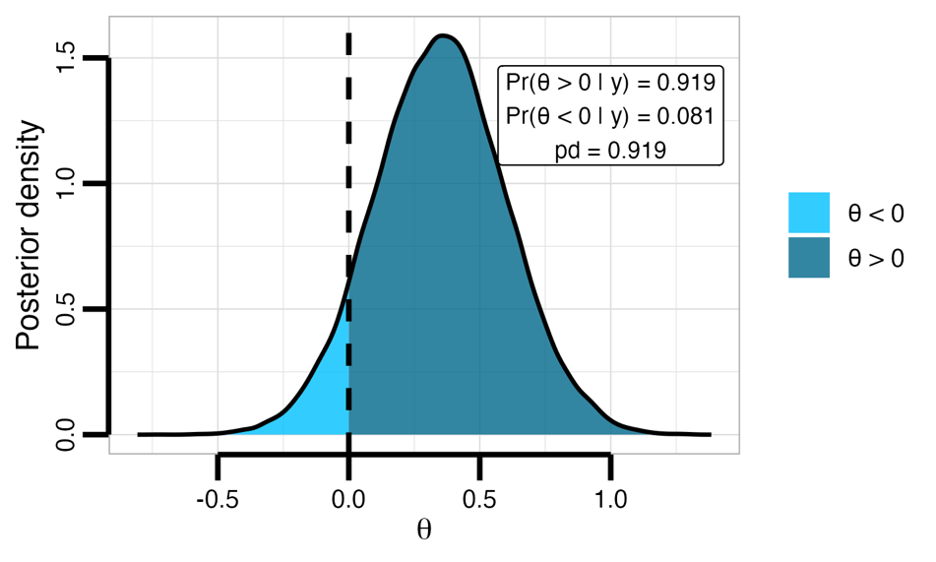

Figure 1. Posterior distribution with directional posterior mass on either side of 0 shown in different colors; the probability of direction (pd) is the larger of the two posterior probabilities.

A convenient starting point for calibration is the mapping between pd and the frequentist p-value. Under flat (or sufficiently diffuse symmetric) priors in typical hypothesis-testing scenarios (e.g., testing means), pd is simply the posterior on the dominant side of $θ_{null}$, which corresponds to the complement of the one-sided p-value (Casella & Berger, 1987; Marsman & Wagenmakers, 2017): $pd=max\left(Pr\left(θ<θ_{null}∣y\right),Pr\left(θ>θ_{null}∣y\right)\right)=1-p,$with the two-sided correspondence being $p_{two-sided}=2p=2\left(1-pd\right)$.

Probability of direction as a test of existence and direction
The pd can be embedded in a testing framework, where thresholding $pd>c$ yields a claim that an effect exists and has a particular sign. For example, when $pd>c$ supports $θ>0$, the posterior probability assigned to nonpositive values is bounded by
$$Pr\left(θ≤0∣y\right)<1-c,$$
and, analogously, when $pd>c$ supports $θ<0$, it follows that $Pr\left(θ≥0∣y\right)<1-c$.
This rule therefore does more than compare $H_{+}$ versus $H_{-}$: it also controls posterior mass in the null-or-opposite-sign region, ensuring that it remains below $1-c$. In particular, $Pr\left(θ≤0∣y\right)<1-c$ implies that 0 lies below the $1-c$-quantile of the posterior distribution (equivalently, the $1-c$-quantile is strictly positive). Consequently, the central credible interval bounded by the $1-c$ and $c$ quantiles excludes 0.
Finally, $c$ can be set so that the interval between the $1-c$ and $c$ posterior quantiles coincides with the usual equal-tailed $1-α$ central credible interval, whose endpoints are the $α/2$ and $1-α/2$ posterior quantiles. Equating endpoints gives $1-c=α/2$ and $c=1-α/2$; therefore $pd>c$ can be read as excluding 0 from a two-sided $100\left(1-α\right)\%$ central interval. With $α=0.05$, this yields $c=0.975$ (and $1-c=0.025$), mirroring the common two-sided 5% convention (Figure 2).

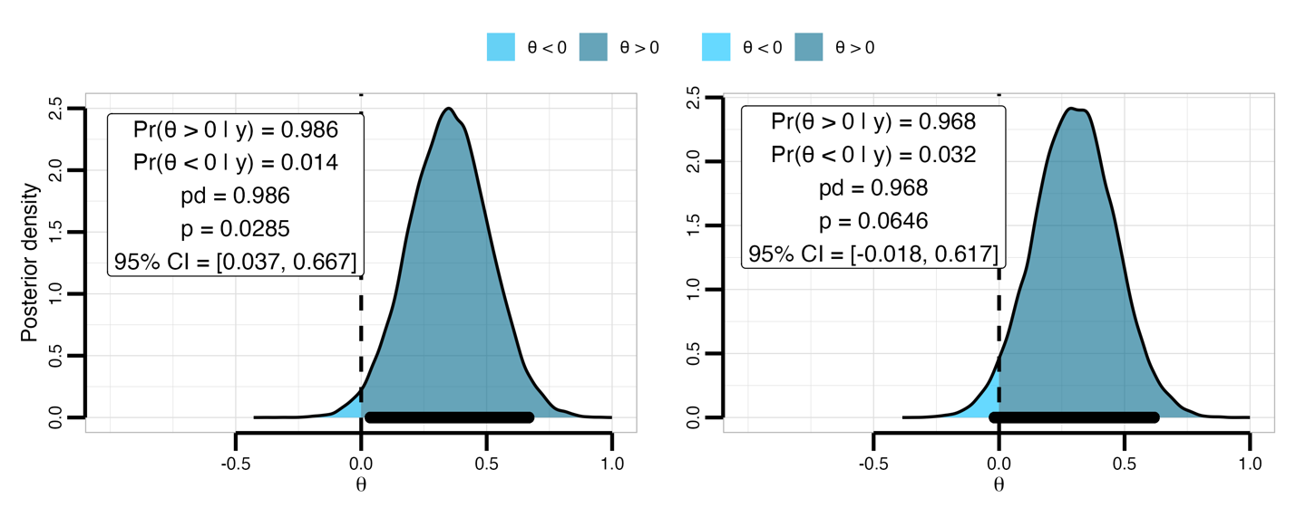

Figure 2. Posterior distributions illustrating the relationship between the probability of direction (pd) and credible-interval (CI), using c = 0.975 and $θ_{null}=0$.

Pure directional testing conditions on the assumption that $θ≠0$ and evaluates only the sign of the effect by comparing $H_{+}$ versus $H_{-}$; $H_{0}:θ=0$ is not among the hypotheses under consideration. In contrast, here we explicitly include $H_{0}$ and separates decisions about existence and direction (excluding zero) from decisions about direction (including zero). Error types follow directly from this distinction: a Type I error occurs when the true parameter lies in $H_{0}$ but $H_{0}$ is rejected in favor of $H_{+}$ or $H_{-}$.
Importantly, although we set $H_{0}:θ=θ_{null}=0$ throughout the manuscript for simplicity, $θ_{null}$ can be defined as the smallest effect size of interest (Lakens et al., 2018). The testing framework thus shifts from evaluating whether an effect differs from zero to whether it exceeds a substantively meaningful threshold.

Simulation
In our simulations we generate data under the global null (all $θ=0$) and we compute $Pr\left(pd>c∣θ=0\right)$. Operationally, this quantifies how often the procedure falsely excludes zero from the credible region (bounded by $1-c$ and $c$), that is, incorrectly concludes that an effect exists (with a particular sign) when the true parameter is zero. We conduct a Monte Carlo simulation in which, for each condition, we generated families of size $m∈\{1,2,5,10,20\}$, with $n∈\{30,50,100\}$ observations per dataset, and repeated the procedure $10,000$ times. In every replication, data were generated under the global null: each dataset had true mean $0$ and unit variance, $y∼N\left(0,1\right)$. Each dataset was analyzed using a conjugate normal model with known variance $σ^{2}=1$ and prior $θ∼N\left(0,τ^{2}\right)$, where $τ∈\{0.2,0.5,1,1.5,2\}$ spans skeptical to flat priors. We drew posterior samples of $θ$ from the resulting normal posterior and computed pd as $pd=max\left(Pr\left(θ>0∣y\right),Pr\left(θ<0∣y\right)\right)$ using these draws. For the frequentist comparison, we conducted two-sided one-sample $z$-tests.

Prior influence
Under the null hypothesis, two-sided p-values are uniformly distributed on $\left[0,1\right]$, and because pd can be mapped to the p-value, this implies a corresponding null reference behavior for pd on $\left[0.5,1\right]$ in the continuous case. However, because the pd is a posterior probability about the sign of $θ$, its null distribution is not determined by the likelihood alone: it can shift depending on how strongly the prior concentrates probability near 0 (i.e., how readily the prior “expects” near-null effects). Showing this prior dependence at $m=1$ makes the target of later multiplicity analyses explicit: even before any multiplicity is introduced, a fixed cutoff such as $pd>0.975$ does not have a universal “null meaning” across priors and sample sizes.
As shown in Figure 3, pd exhibits behavior broadly analogous to a p-value when samples are large and the prior places relatively little mass near 0. However, increasing prior skepticism (i.e., concentrating more prior mass around 0) reduces the Type I error rate.

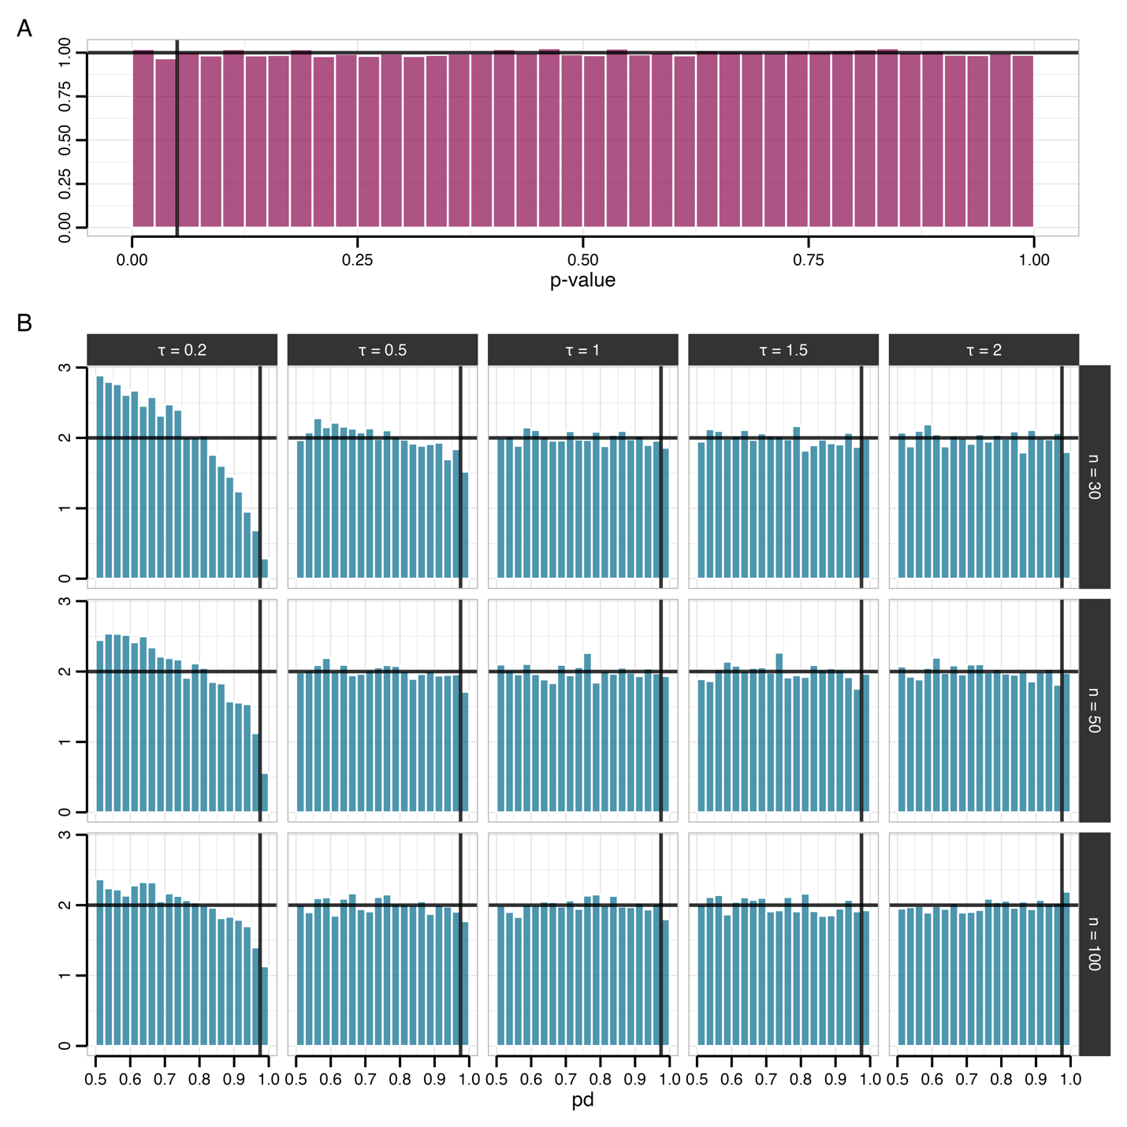

Figure 3. Null reference distributions for p-values and probability of direction. Panel A shows the histogram of two-sided one-sample z-test p-values from 10,000 replications under the global null ($θ=0$), with binwidth 0.025. Panel B shows the corresponding empirical distributions of the probability of direction (pd) computed from a conjugate normal posterior, stratified by sample size ($n=30,50,100$; rows) and prior scale ($θ∼N\left(0,τ^{2}\right)$ with $τ∈\{0.2,0.5,1,1.5,2\}$; columns). The vertical dashed line marks the commonly used evidential cutoff (pd = 0.975), which corresponds to a two-sided p-value of 0.05 under the standard conversion $p=2\left(1-pd\right)$.

Behavior under multiplicity
Building on this baseline, multiplicity can be introduced as a second, distinct mechanism: even when each individual test has only a small probability of producing an extreme pd under $H_{0}$, the probability that at least one among $pd_{1},…,pd_{m}$ is extreme increases with the number of tests $m$. We quantify this familywise error rate (FWER) behavior by estimating pd for families ranging from $m=1$ to $m=20$.
As expected, pd again behaves broadly analogously to the p-value when sample sizes are large and the prior places relatively little mass near 0 (Figure 4). By contrast, as the prior becomes more skeptical (i.e., increasingly concentrated around 0), the FWER decreases.

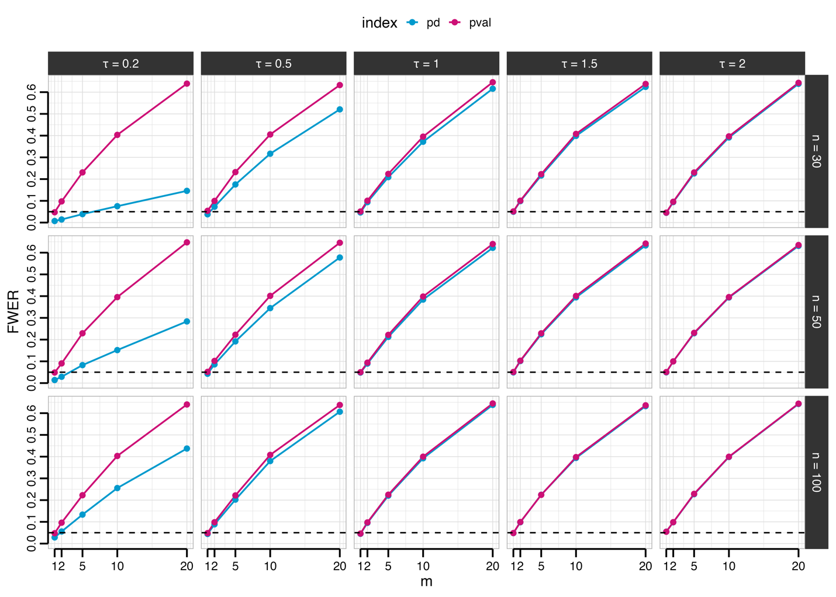

Figure 4. Familywise error rates under the global null for p-values and probability of direction. The figure shows the estimated familywise error rate (FWER), defined as the probability of at least one false positive across m tests, as a function of the number of tests (m), based on 10,000 replications under the global null ($θ=0$ for all tests). The pink curve corresponds to declaring at least one discovery when at least one two-sided one-sample z-test p-value < 0.05, whereas the blue curve corresponds to declaring at least one discovery when at least one pd > 0.975 under the conjugate normal Bayesian model. Rows vary the per-test sample size ($n=30,50,100$), and columns vary the prior scale ($θ∼N\left(0,τ^{2}\right)$ with $τ∈\{0.2,0.5,1,1.5,2\}$).

The results of this simulation imply that Type I error can, in principle, be reduced by adopting a more skeptical prior for the parameters within each individual model; however, this is unlikely to be the most appropriate way to address multiplicity. In particular, prior used to estimate a given parameter should be driven by substantive knowledge about that specific quantity, not by the mere fact that other hypotheses are being tested in parallel [REF]. For this reason, the approach proposed below focuses on adjusting between-model prior probabilities (i.e., prior odds across competing hypotheses), rather than modifying the within-model prior for any single parameter [REF].

Probability of direction, posterior odds, and prior odds adjustment

From posterior probabilities to posterior odds
To connect $pd$ to an evidential interpretation, consider the directional hypotheses $H_{+}:θ>0$ and $H_{-}:θ<0$. These hypotheses partition the parameter space based on the sign of $θ$. If the prior for $θ$ is continuous and symmetric about 0, then the two directions are equally plausible a priori: $Pr\left(H_{+}\right)=Pr\left(H_{-}\right)=1/2$.
Without loss of generality, assume the posterior favors $H_{+}$, so that $pd=Pr\left(H_{+}∣y\right)=Pr\left(θ>0∣y\right)$ (if the posterior instead favors $H_{-}$, we simply relabel the hypotheses), then the complement is given by $1-pd=Pr\left(θ≤0∣y\right)$. The posterior odds comparing these two hypothesis are therefore:
$$\frac{pd}{1-pd}=\frac{Pr\left(H_{+}∣y\right)}{Pr\left(H_{-}∣y\right)}.$$
Applying Bayes’ rule, these posterior odds can be decomposed into a Bayes factor and prior odds:
$$\frac{Pr\left(H_{+}∣y\right)}{Pr\left(H_{-}∣y\right)}={\text{BF}}_{+/-}×\frac{Pr\left(H_{+}\right)}{Pr\left(H_{-}\right)},$$
where $\text{BF}+/-$ quantifies the relative likelihood of the data under $H+$ versus $H_{-}$. Under prior symmetry, $\frac{Pr\left(H_{+}\right)}{Pr\left(H_{-}\right)}=1$, which yields $\frac{pd}{1-pd}={\text{BF}}_{+/-}$ (Casella & Berger, 1987; Marsman & Wagenmakers, 2017). Thus, the odds $\frac{pd}{\left(1-pd\right)}$ computed from posterior draws can be interpreted directly as evidence favoring $θ>0$ over $θ≤0$ (or $θ<0$ over $θ≥0$).

Multiplicity adjustment via post-hoc prior odds
When assessing a single directional claim under a symmetric prior centered at the null, $\frac{Pr\left(H_{+}\right)}{Pr\left(H_{-}\right)}=1$ encoding prior indifference. However, when m hypotheses are tested simultaneously, assigning prior probability $\frac{1}{2}$ to each directional claim implies a joint prior that rapidly concentrates probability on the event that at least one effect departs from 0. For instance, with $m=10$ the implied prior probability that all effects are not in the favored direction (i.e., in the opposite direction with zero included) is ${0.5}^{10}≈0.001$.
In this scenario, a principled way to address multiplicity is to decrease the prior odds assigned to any particular directional claim as a function of m, while leaving the the Bayes factor component unchanged. Because the analysis is symmetric in the sign of $θ$ and pd is defined as the posterior probability of the dominant direction, the same adjustment can be applied regardless of whether the posterior favors $θ>0$ or $θ<0$.
Concretely, let $Pr\left(H_{0_{m}}\right)$ and $Pr\left(H_{1_{m}}\right)$ denote the multiplicity-adjusted prior probabilities assigned to the favored direction and its complement, respectively (with $Pr\left(H_{0_{m}}\right)+Pr\left(H_{1_{m}}\right)=1$). The adjusted posterior odds are then:
$$\frac{pd_{\text{adj}}}{1-pd_{\text{adj}}}=\frac{pd}{1-pd}×\frac{Pr\left(H_{1_{m}}\right)}{Pr\left(H_{0_{m}}\right)},$$
so that, equivalently,
$$pd_{\text{adj}}=\frac{pd⋅Pr\left(H_{1_{m}}\right)}{pd⋅Pr\left(H_{1_{m}}\right)+\left(1-pd\right)⋅Pr\left(H_{0_{m}}\right)}.$$
Thus, the multiplicity adjustment acts through the prior odds factor $Pr\left(H_{1_{m}}\right)/Pr\left(H_{0_{m}}\right)$.

Choosing the prior odds
One common formalization (Jeffreys, 1938; Westfall et al., 1997) introduces a global null event $Q$ (all null hypotheses are true) and its complement $¬Q$ (at least one null is false), and assigns equal prior probability: $\text{Pr}\left(Q\right)=\text{Pr}\left(¬Q\right)=1/2$. Under independence and a common per-hypothesis probability $k$ that a null is false, this implies:
$${\left(1-k\right)}^{m}=0.5 ⇒ k=1-{0.5}^{1/m}.$$
As $m$ increases, the per-hypothesis prior probability $k=Pr\left(H_{1_{m}}\right)$ decreases (Figure 5), encoding increasing prior skepticism about any particular deviation from the null; correspondingly, $Pr\left(H_{0_{m}}\right)$ increases.
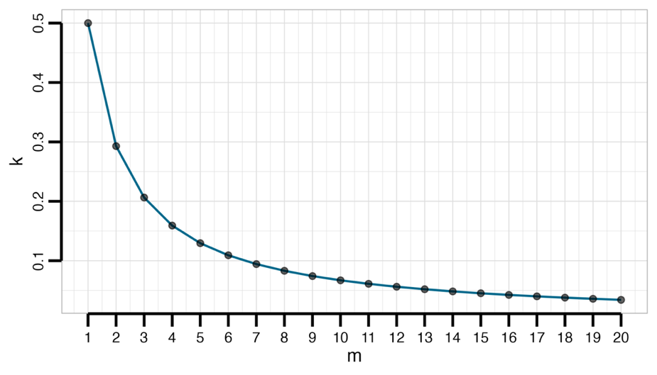

Figure 5. Per-hypothesis prior probability $k$ s a function of the total number of hypotheses $m$, with the overall prior probability of at least one effect fixed at $q=0.5$. The per-hypothesis prior is given by $k=1-{0.5}^{1/m}$.

In this simulation, we compare this method with the Šidák p-value adjustment ($p_{adj}=1-{\left(1-p\right)}^{m}$), which gives exact frequentist family-wise error rate control under independence.

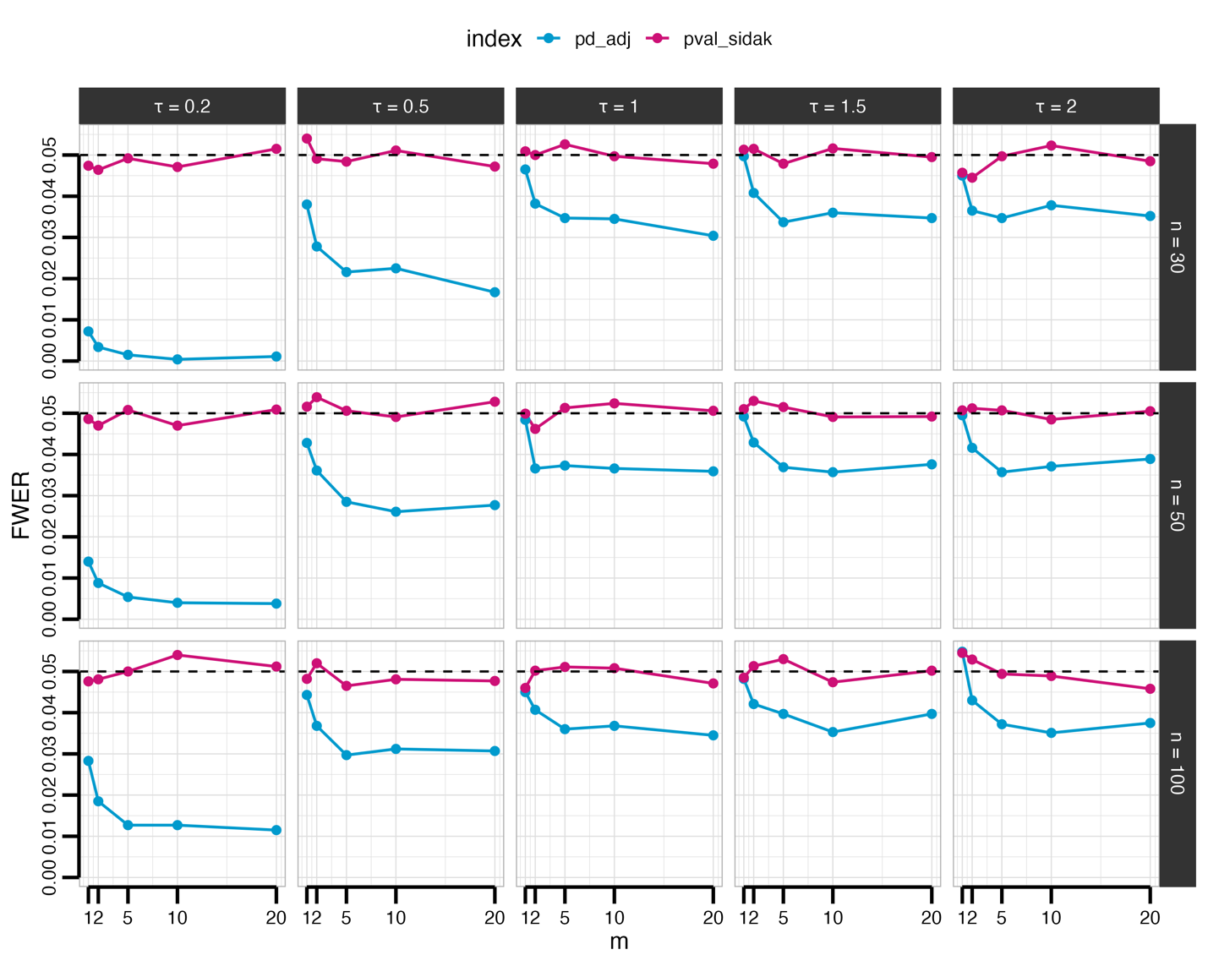

Figure 6. Familywise error rates under the global null for adjusted p-values and probability of direction. The figure shows the estimated familywise error rate (FWER), defined as the probability of at least one false positive across m tests, as a function of the number of tests (m), based on 10,000 replications under the global null ($θ=0$ for all tests). The red curve corresponds to declaring at least one discovery when at least one two-sided one-sample z-test p-value < 0.05, whereas the blue curve corresponds to declaring at least one discovery when at least one pd > 0.975 under the conjugate normal Bayesian model. Rows vary the per-test sample size ($n=30,50,100$), and columns vary the prior scale ($θ∼N\left(0,τ^{2}\right)$ with $τ∈\{0.2,0.5,1,1.5,2\}$).

While grounded in Bayesian prior odds logic, the procedure exhibits behavior similar to frequentist multiplicity correction, though it tends to be more conservative even when $n$ and $τ$ are large.
This procedure naturally allows to incorporate prior information based on background knowledge. Rather than fixing $Pr\left(H_{0}\right)=0.5$, researchers can specify their prior belief $q$ about the global null hypothesis, that is, the probability that all $m$ hypotheses are null. This global prior $q$ can be translated into a per-hypothesis prior probability $k$. Assuming independence across hypotheses, if each hypothesis is non-null with probability $k$, then the probability that all hypotheses are null is ${\left(1-k\right)}^{m}$. Prior knowledge guides the choice of $q$: when few or no real effects are expected, $q$ should be large (e.g., 0.5); when targeting well-established effects, $q$ can be smaller (e.g., 0.1). This leads to the general calibration:
$${\left(1-k\right)}^{m}=q ⇒ k=1-q^{1/m}.$$
However, with small $m$ and low $q$ values, this formula can paradoxically inflate rather than reduce posterior probabilities. This occurs when the per-hypothesis prior probability of the null hypothesis ($Pr\left(H_{0_{m}}\right)=q^{1/m}$) falls below 0.5, effectively favoring the alternative hypothesis. Because we conceive this adjustment as a safeguard against inflated false positives, it is crucial to ensure it never acts in the opposite direction. To this end, the procedure should include a safeguard: if $Pr\left(H_{0_{m}}\right)<0.5$, the original posterior probabilities should remain unmodified.
Once $q$ is fixed, the prior odds assigned to each individual hypothesis become a deterministic function of the family size $m$: larger families imply smaller $k$, and consequently a higher prior probability on the null for each test. To illustrate this dependence, we consider two data-generating regimes: a global-null scenario in which $θ_{1}=⋯=θ_{m}=0$, and an alternative scenario in which all but one effect are null ($θ_{1}=⋯=θ_{m-1}=0\text{, }θ_{m}=0.2$). We then repeat the previous simulation procedure with $τ=2$ and $n=50$, i.e. a setting in which pd and p-value behavior is broadly comparable, while varying only the number of tests $m∈\{1,2,3,4,5,10\}$ and the prior parameter $q∈\{0.50,0.40,0.30,0.20,0.10\}$.

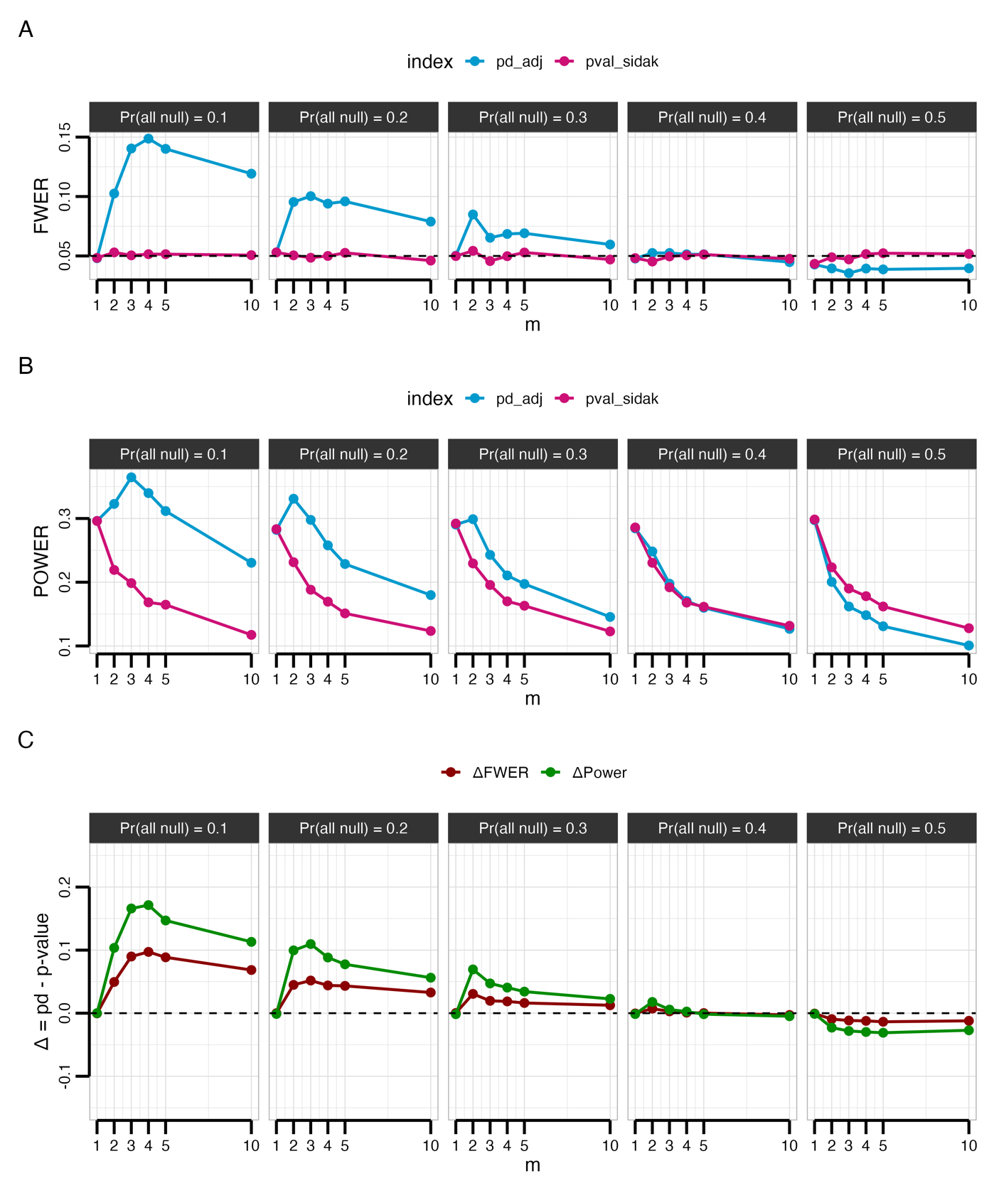Figure 7. Familywise error rate (Panel A), power (Panel B), and difference between method (Panel C) for adjusted p-values and probability of direction as a function of the number of tests ($m$) and prior $Pr\left(\text{all }θ=0\right)$. The Šidák-adjusted p-value curve (pink) declares at least one discovery when any two-sided one-sample z-test satisfies $p<0.05$, whereas the adjusted pd curve (blue) declares at least one discovery when any $pd>0.975$ under the conjugate normal Bayesian model. Panel C shows the difference (adjusted pd minus Šidák-adjusted p-value) for FWER (under the global null) and power (under the global alternative).

Across all values of $m$, Šidák-adjusted p-values maintain the family-wise error rate (FWER; Figure 7, Panel A) near the nominal level, but this control comes at the expense of diminished power (Figure 7, Panel B). By contrast, the adjusted pd procedure exhibits FWER and power trajectories that depend on the prior parameter $q$. For smaller values of $q$ ($q∈\{0.30,0.20,0.10\}$), the tradeoff is favorable: the increase in power is larger than the corresponding increase in FWER, implying gains relative to the loss of error control (Figure 7, Panel C). By contrast, $q=0.4$ yields FWER and power curves that closely mirror the Šidák adjustment across the full range of $m$, suggesting that this calibration allows the Bayesian adjustment to approximate classical strong FWER control (Figure 7).

Application

Discussion
Our simulations demonstrate that extreme pd values arise by chance with non-negligible frequency, and this problem compounds as researchers evaluate more parameters. To address this, the multiplicity adjustment proposed here accommodates researcher-specific prior information, which may be informed by previous studies, measurement reliability, or structured expert elicitation [REFs]. More generally, researchers can specify hypothesis-specific priors (or “classes” of hypotheses) with different global null probabilities, for example, distinguishing confirmatory hypotheses from exploratory ones.
An advantage of this procedure is its applicability to pd values computed from posterior distributions obtained under different models. While the most coherent approach analyzes all relevant data within a single joint model that explicitly represents dependence [REFs], this is not always feasible in practice, and researchers often report pd across multiple analyses within the same manuscript [REFs]. The procedure outlined here provides a flexible toolkit for such scenarios. Additionally, the approach naturally extends beyond point-null testing by evaluating directional certainty relative to a smallest effect size of interest, shifting emphasis from non-zero effects to substantively meaningful thresholds (Lakens et al., 2018).
The procedure does assume independence between hypotheses when allocating global null probability across m tests, treating each as providing independent evidence. When hypotheses are correlated through shared parameters, overlapping data structures, or measurement dependencies, this independence-based allocation overestimates the multiplicity penalty, yielding overly conservative adjustments. A practical solution is to replace the nominal m with an effective number $m_{\text{eff}}$ that reflects the dependence structure. This can be achieved, for example, by computing a correlation matrix among posterior distributions (e.g., from the same model) and deriving $m_{\text{eff}}$ via eigenvalue-based (Cheverud, 2001; Del Giudice, 2021; Li & Ji, 2005). Because $m_{\text{eff}}$depends on how correlations are defined and estimated, it should be treated as a sensitivity parameter rather than a fixed quantity.
For applied reporting, we recommend a two-tier strategy: first, report the unadjusted pd for each parameter to maintain transparency; second, report at least one multiplicity-adjusted measure using prior odds correction. As a baseline, researchers should present the conservative adjustment with $Pr\left(\text{all }θ=0\right)=0.4$, which represents a skeptical but defensible stance as it produces adjustments analogous to the Šidák correction for p-values. When domain knowledge justifies alternative priors, report both conservative and informed adjustments to demonstrate robustness across different assumptions.
Regardless of its limitations, we believe this procedure provides a principled approach to Bayesian multiplicity adjustment with meaningful implications for both interpretability and replicability of research findings.

References
Albers, C. J., Kiers, H. A., & Ravenzwaaij, D. van. (2018). Credible confidence: A pragmatic view on the frequentist vs Bayesian debate. Collabra: Psychology, 4(1).
Altoè, G., Bertoldo, G., Zandonella Callegher, C., Toffalini, E., Calcagnì, A., Finos, L., & Pastore, M. (2020). Enhancing statistical inference in psychological research via prospective and retrospective design analysis. Frontiers in Psychology, Volume 10 - 2019. https://doi.org/10.3389/fpsyg.2019.02893
Berger, J. O., & Sellke, T. (1987). Testing a point null hypothesis: The irreconcilability of p values and evidence. Journal of the American Statistical Association, 82(397), 112–122.
Bernardo, J. M., & Smith, A. F. M. (1994). Bayesian Theory (1st ed.). Wiley. https://doi.org/10.1002/9780470316870
Berry, D. A., & Hochberg, Y. (1999). Bayesian perspectives on multiple comparisons. Journal of Statistical Planning and Inference, 82(1), 215–227. https://doi.org/10.1016/S0378-3758(99)00044-0
Box, G. E. P. (1980). Sampling and bayes’ inference in scientific modelling and robustness. Journal of the Royal Statistical Society. Series A (General), 143(4), 383–430. http://www.jstor.org/stable/2982063
Box, G. E. P., & Tiao, G. C. (1992). Bayesian inference in statistical analysis (1st ed.). Wiley. https://doi.org/10.1002/9781118033197
Casella, G., & Berger, R. L. (1987). Reconciling bayesian and frequentist evidence in the one-sided testing problem. Journal of the American Statistical Association, 82(397), 106–111. https://doi.org/10.1080/01621459.1987.10478396
Chen, G., Taylor, P. A., Cox, R. W., & Pessoa, L. (2020). Fighting or embracing multiplicity in neuroimaging? Neighborhood leverage versus global calibration. NeuroImage, 206, 116320. https://doi.org/10.1016/j.neuroimage.2019.116320
Cheverud, J. M. (2001). A simple correction for multiple comparisons in interval mapping genome scans. Heredity, 87(1), 52–58. https://doi.org/https://doi.org/10.1046/j.1365-2540.2001.00901.x
Cohen, J. (1994). The earth is round (p $<$ .05). American Psychologist, 49(12), 997–1003. https://doi.org/10.1037/0003-066X.49.12.997
Dawid, A. P. (1994). Selection paradoxes of bayesian inference. Lecture Notes-Monograph Series, 24, 211–220.
De Finetti, B. (2017). Theory of Probability: A Critical Introductory Treatment (A. Machí & A. Smith, Eds.; 1st ed.). Wiley. https://doi.org/10.1002/9781119286387
Del Giudice, M. (2021). Effective dimensionality: A tutorial. Multivariate Behavioral Research, 56(3), 527–542.
Edwards, W., Lindman, H., & Savage, L. J. (1963). Bayesian statistical inference for psychological research. Psychological Review, 70(3), 193.
Erčulj, F., & Štrumbelj, E. (2015). Basketball shot types and shot success in different levels of competitive basketball. PLOS ONE, 10(6), 1–14. https://doi.org/10.1371/journal.pone.0128885
Gelman, A., Carlin, J. B., Stern, H. S., Dunson, D. B., Vehtari, A., & Rubin, D. B. (2013). Bayesian data analysis (3rd ed.). Chapman; Hall/CRC. https://doi.org/10.1201/b16018
Gelman, A., & Hennig, C. (2017). Beyond subjective and objective in statistics. Journal of the Royal Statistical Society Series A: Statistics in Society, 180(4), 967–1033. https://doi.org/10.1111/rssa.12276
Gelman, A., Hill, J., & Yajima, M. (2012). Why we (usually) don’t have to worry about multiple comparisons. Journal of Research on Educational Effectiveness, 5(2), 189–211. https://doi.org/10.1080/19345747.2011.618213
Gelman, A., & Shalizi, C. R. (2013). Philosophy and the practice of bayesian statistics. British Journal of Mathematical and Statistical Psychology, 66(1), 8–38. https://doi.org/https://doi.org/10.1111/j.2044-8317.2011.02037.x
Gelman, A., & Tuerlinckx, F. (2000). Type s error rates for classical and bayesian single and multiple comparison procedures. Computational Statistics, 15(3), 373–390. https://doi.org/10.1007/s001800000040
Gigerenzer, G. (2004). Mindless statistics. The Journal of Socio-Economics, 33(5), 587–606. https://doi.org/https://doi.org/10.1016/j.socec.2004.09.033
Heck, D. W., Boehm, U., Böing-Messing, F., Bürkner, P.-C., Derks, K., Dienes, Z., Fu, Q., Gu, X., Karimova, D., Kiers, H. A., et al. (2023). A review of applications of the bayes factor in psychological research. Psychological Methods, 28(3), 558.
Hogeveen, J., Mullins, T. S., Romero, J. D., Eversole, E., Rogge-Obando, K., Mayer, A. R., & Costa, V. D. (2022). The neurocomputational bases of explore-exploit decision-making. Neuron, 110(11), 1869–1879.e5. https://doi.org/10.1016/j.neuron.2022.03.014
Hoijtink, H., Kooten, P. van, & Hulsker, K. (2016). Why bayesian psychologists should change the way they use the bayes factor. Multivariate Behavioral Research, 51(1), 2–10.
Jeffreys, H. (1938). Significance tests when several degrees of freedom arise simultaneously. Proceedings of the Royal Society of London. Series A. Mathematical and Physical Sciences, 165(921), 161–198. https://doi.org/10.1098/rspa.1938.0052
Jevremov, T., & Pajić, D. (2024). Bayesian method in psychology: A bibliometric analysis. Current Psychology, 43(10), 8644–8654.
Kelter, R. (2023). How to choose between different bayesian posterior indices for hypothesis testing in practice. Multivariate Behavioral Research, 58(1), 160–188.
Kruschke, J. K. (2011). Bayesian assessment of null values via parameter estimation and model comparison. Perspectives on Psychological Science, 6(3), 299–312. https://doi.org/10.1177/1745691611406925
Kruschke, J. K. (2018). Rejecting or Accepting Parameter Values in Bayesian Estimation. Advances in Methods and Practices in Psychological Science, 1(2), 270–280. https://doi.org/10.1177/2515245918771304
Lakens, D., Scheel, A. M., & Isager, P. M. (2018). Equivalence testing for psychological research: A tutorial. Advances in Methods and Practices in Psychological Science, 1(2), 259–269. https://doi.org/10.1177/2515245918770963
Li, J., & Ji, L. (2005). Adjusting multiple testing in multilocus analyses using the eigenvalues of a correlation matrix. Heredity, 95(3), 221–227.
Limbachia, C., Morrow, K., Khibovska, A., Meyer, C., Padmala, S., & Pessoa, L. (2021). Controllability over stressor decreases responses in key threat-related brain areas. Communications Biology, 4(1), 42. https://doi.org/10.1038/s42003-020-01537-5
Lindley, D. V. (1972). Bayesian statistics a review. In Bayesian statistics (pp. 1–74). Society for Industrial; Applied Mathematics. https://doi.org/10.1137/1.9781611970654.ch1
Makowski, D., Ben-Shachar, M. S., Chen, S. H. A., & Lüdecke, D. (2019). Indices of effect existence and significance in the bayesian framework. Frontiers in Psychology, Volume 10 - 2019. https://doi.org/10.3389/fpsyg.2019.02767
Marsman, M., & Wagenmakers, E.-J. (2017). Three insights from a bayesian interpretation of the one-sided p value. Educational and Psychological Measurement, 77(3), 529–539. https://doi.org/10.1177/0013164416669201
Mathar, D., Erfanian Abdoust, M., Marrenbach, T., Tuzsus, D., & Peters, J. (2022). The catecholamine precursor tyrosine reduces autonomic arousal and decreases decision thresholds in reinforcement learning and temporal discounting. PLOS Computational Biology, 18(12). https://doi.org/10.1371/journal.pcbi.1010785
Mayo, D. G. (2018). Statistical inference as severe testing: How to get beyond the statistics wars. Cambridge University Press.
Pfadt, J. M., Bartoš, F., Godmann, H. R., Waaijers, M., Groot, L., Heo, I., et al. (2025, October 30). A methodological metamorphosis: The rapid rise of bayesian inference and open science practices in psychology. OSF Preprints. https://doi.org/10.31234/osf.io/ck3js_v1
Pruzek, R. M. (2016). An introduction to bayesian inference and its applications (pp. 305–334). Routledge.
Rozeboom, W. W. (1960). The fallacy of the null-hypothesis significance test. Psychological Bulletin, 57(5), 416–428. https://doi.org/10.1037/h0042040
Rubin, D. B. (1984). Bayesianly justifiable and relevant frequency calculations for the applied statistician. The Annals of Statistics, 12(4), 1151–1172. https://doi.org/10.1214/aos/1176346785
Schnell, P. M., Fiecas, M., & Carlin, B. P. (2020). credsubs : Multiplicity-adjusted subset identification. Journal of Statistical Software, 94(7). https://doi.org/10.18637/jss.v094.i07
Scott, J. G., & Berger, J. O. (2006). An exploration of aspects of bayesian multiple testing. Journal of Statistical Planning and Inference, 136(7), 2144–2162.
Scott, J. G., & Berger, J. O. (2010). Bayes and empirical-Bayes multiplicity adjustment in the variable-selection problem. The Annals of Statistics, 38(5), 2587–2619. https://doi.org/10.1214/10-AOS792
Smid, S. C., & Winter, S. D. (2020). Dangers of the defaults: A tutorial on the impact of default priors when using bayesian SEM with small samples. Frontiers in Psychology, Volume 11 - 2020. https://doi.org/10.3389/fpsyg.2020.611963
Tendeiro, J. N., & Kiers, H. A. (2019). A review of issues about null hypothesis bayesian testing. Psychological Methods, 24(6), 774.
Tendeiro, J. N., Kiers, H. A., Hoekstra, R., Wong, T. K., & Morey, R. D. (2024). Diagnosing the misuse of the bayes factor in applied research. Advances in Methods and Practices in Psychological Science, 7(1), 25152459231213371.
Van De Schoot, R., Winter, S. D., Ryan, O., Zondervan-Zwijnenburg, M., & Depaoli, S. (2017). A systematic review of bayesian articles in psychology: The last 25 years. Psychological Methods, 22(2), 217.
Westfall, P. H., Johnson, W. O., & Utts, J. M. (1997). A bayesian perspective on the bonferroni adjustment. Biometrika, 84(2), 419–427.
Zwet, E. van, & Cator, E. A. (2021). The significance filter, the winner’s curse and the need to shrink. Statistica Neerlandica, 75(4), 437–452. https://doi.org/10.1111/stan.12241
Zwet, E. van, & Gelman, A. (2022). A proposal for informative default priors scaled by the standard error of estimates. The American Statistician, 76(1), 1–9. https://doi.org/10.1080/00031305.2021.1938225

