A Prior-Odds Adjustment for the Probability of Direction in Multiple Testing

Margherita Calderan^{1,2}, Filippo Gambarota¹, Livio Finos^{3,4}, and Gianmarco Altoè¹
¹Department of Developmental Psychology and Socialization, University of Padova
²Department of General Psychology, University of Padova
³Department of Statistical Sciences, University of Padova
⁴Padova Neuroscience Center, University of Padova

Author Note
Margherita Calderan  https://orcid.org/0009-0005-5668-5162
Filippo Gambarota https://orcid.org/0000-0002-6666-1747
Livio Finos https://orcid.org/0000-0003-3181-8078
Gianmarco Altoè https://orcid.org/0000-0003-1154-9528
A previous version of this manuscript was posted as a preprint on PsyArXiv at https://osf.io/preprints/psyarxiv/8zwx2_v2.
Correspondence concerning this article should be addressed to Margherita Calderan, Department of Developmental Psychology and Socialization, University of Padova, Via Venezia 8, Padova 35131, Italy, Email: margherita.calderan@unipd.it

Abstract
The probability of direction ($pd$) is increasingly used in psychological research to summarize how strongly the posterior favors one direction of a parameter. Researchers often use $pd$ in a decision rule with a fixed threshold, such as .975, and when this rule is applied across many parameters, the probability of at least one wrong directional claim grows with the number of claims made. We apply to $pd$ the classical Bayesian response to multiplicity, a penalty on the prior odds of each claim that depends on the number of tests. Because the direction of a claim is known only after the data are seen, a claim is made only if it still holds when the prior odds of the claimed direction are lowered. This raises the threshold that $pd$ must exceed by an amount determined by an upper bound, set by the researcher, on the prior probability of the sign opposite to the claimed one. When the same bound applies to every parameter, it is also an upper bound on the expected proportion of parameters in the family that are not on the claimed side, null effects included. We evaluate the error rates and power of the rule in simulations that vary the sample size, the number of tests, and the bound, set below, at, or above the actual proportion of null effects. We also compare the rule with two other Bayesian multiple-comparison procedures: joint directional statements and simultaneous credible intervals. All three procedures are implemented in an accompanying R package.
Keywords: probability of direction, multiple testing, prior odds, robust Bayesian analysis, FDR
Word Count: 8117

A Prior-Odds Adjustment for the Probability of Direction in Multiple Testing
Over the past two decades, the use of Bayesian methods in psychological research has grown considerably (Jevremov & Pajić, 2024; Pfadt et al., 2025; van de Schoot et al., 2017). This expansion has, however, been accompanied by practices reminiscent of the “null ritual” in frequentist statistics, where widespread adoption gave way to automatic application rather than principled reasoning (Cohen, 1994; Gigerenzer, 2004). Researchers sometimes treat Bayes factor thresholds (e.g., BF > 3) as dichotomous decision rules, or claim that an effect “exists” because the posterior probability of a directional effect exceeds a conventional benchmark such as .975 (Heck et al., 2023; Hoijtink et al., 2016; Kelter, 2023; Kruschke, 2018; Tendeiro et al., 2024; Tendeiro & Kiers, 2019). Such cutoffs are convenient, but they encourage all-or-none interpretations, and when these binary judgments are applied repeatedly across many parameters they generate a multiplicity problem no different in kind from the one long recognized in frequentist statistics.
Frequentists developed methods to address this problem, controlling either the Family-Wise Error Rate (FWER; the probability of at least one false positive) or the False Discovery Rate (FDR; the expected proportion of false positives among rejected hypotheses) (Benjamini & Hochberg, 1995; Westfall & Young, 1993). These procedures address whether a spurious result enters the literature, but leave unresolved a subtler consequence of the same selection process. When researchers examine many parameters but highlight only the most extreme estimates, selection systematically inflates reported magnitudes (Altoè et al., 2020; Gelman & Carlin, 2014; van Zwet & Cator, 2021). Bayesian methods can mitigate this overestimation, pulling extreme estimates toward more plausible values through informative priors (Dawid, 1994; van Zwet & Gelman, 2022) and hierarchical modeling (Berry & Hochberg, 1999; Gelman et al., 2012, 2013; Kruschke, 2011). Magnitude bias and false-positive accumulation are, however, distinct problems. Shrinkage offers no guarantee about the error properties of a decision rule applied across many parameters: if the same cutoff is used repeatedly (e.g., claiming an effect whenever a posterior probability exceeds .975), the probability of spurious findings can remain substantial. Bayesian responses to this issue do exist, such as joint probability statements (Box & Tiao, 1992; Gelman & Tuerlinckx, 2000; Pruzek, 2016; Schnell et al., 2020) or priors over the hypothesis space that scale with the number of tests (Jeffreys, 1938; Scott & Berger, 2006; Scott & Berger, 2010; Westfall et al., 1997).
Here we focus on a decision rule based on the probability of direction ($pd$), which is increasingly used in psychological research (Ben-Artzi et al., 2022; Bramley & Ruggeri, 2022; Brissenden et al., 2023, 2024; Ciranka et al., 2026; Hochman et al., 2025; Makowski et al., 2020; Schurr et al., 2024; Stone-Sabali et al., 2024). The $pd$ is the posterior probability that a parameter lies in its dominant direction (Makowski et al., 2019; Shi & Yin, 2021), and a direction is claimed when $pd$ exceeds a fixed threshold (e.g., $pd>.95$ or $pd>.975$). We examine the frequentist operating characteristics of this rule and address the resulting multiplicity problem with the second strategy noted above, a penalty on the prior odds of each claim. This penalty is the classical Bayesian response to multiplicity, introduced by Jeffreys (1938) and developed by Westfall et al. (1997), and it underlies more recent Bayesian approaches to FDR control (Abraham et al., 2022; Efron et al., 2001; Guo & Heitjan, 2010; Scott & Berger, 2006; Scott & Berger, 2010; Storey, 2002, 2003) as well as the post hoc correction implemented in JASP (de Jong, 2019; van den Bergh et al., 2020).
To our knowledge, the penalty has not been applied to $pd$. Because the direction of a claim based on $pd$ is chosen by the data, the penalty cannot be attached to a direction fixed in advance; following the approach of robust Bayesian analysis (Berger, 1994), we therefore require each claim to hold under every prior in a class that lowers the prior odds of either direction. The resulting rule raises the threshold that $pd$ must exceed and depends on a single quantity, $π_{0}$: an upper bound, set by the researcher, on the prior probability that a parameter has the sign opposite to the one claimed. When the same bound is used for every parameter in a family, it is also an upper bound on the expected proportion of parameters in the family that are not on the claimed side, null effects included. A judgment about how many null effects the family could contain can therefore inform its choice; alternatively, the bound can be set by fixing the prior probability that no claim in the family is correct, in which case it grows with the number of tests.
The paper proceeds as follows. We begin by introducing $pd$ and examining its use as a test of an effect’s existence, then discuss how prior choice shapes its behavior and why more skeptical within-model priors alone cannot resolve the multiplicity problem. We then show how lowering the prior odds of each claim, in whichever direction it is made, raises the threshold that $pd$ must exceed, and how the same rule can be stated as the posterior probability of the claimed direction under the prior in the class most skeptical of it. We evaluate the rule through simulation, with values of $π_{0}$ below, equal to, and above the actual proportion of null effects, and compare it with two other Bayesian multiple-comparison procedures. A worked example using the accompanying R package (Calderan & Gambarota, 2026) follows, after which we conclude with a general discussion.

Probability of Direction
The probability of direction ($pd$) is a posterior summary that quantifies how strongly the posterior distribution favors one direction of a parameter $θ$ relative to a reference value $θ_{\text{null}}$ (Makowski et al., 2019). For a continuous posterior, it can be defined as the larger of the two one-sided posterior probabilities: $pd=max(Pr(θ<θ_{\text{null}}∣y), Pr(θ>θ_{\text{null}}∣y)),$ and it ranges from .50 (no directional preference) to 1 (all on one side). The $pd$ equals exactly the complement of the one-sided $p$-value when computed on the posterior of a location parameter in exponential-family models estimated under a uniform prior; under a broader class of priors, this correspondence holds approximately (Casella & Berger, 1987; Marsman & Wagenmakers, 2017; Shi & Yin, 2021).
In practice, the $pd$ is often used to summarize both the direction and existence of an effect. This interpretation is clearest when phrased as a decision rule $pd>c$: the posterior must assign more than $c$ probability mass to the side of $θ_{\text{null}}$ favored by the data. Setting $c=1−α/2$ is convenient because it bounds the posterior mass in the opposite tail by $α/2$. For concreteness, suppose the posterior favors positive values, so that $pd=Pr(θ>0∣y)$. An $α=.05$ implies $c=.975$, therefore the rule $pd>c$ requires that $Pr(θ≤0∣y)<.025$, placing less than 2.5% of posterior mass at or below $0$.

Figure 1
Relationship Between the Probability of Direction and the 95% Credible Interval
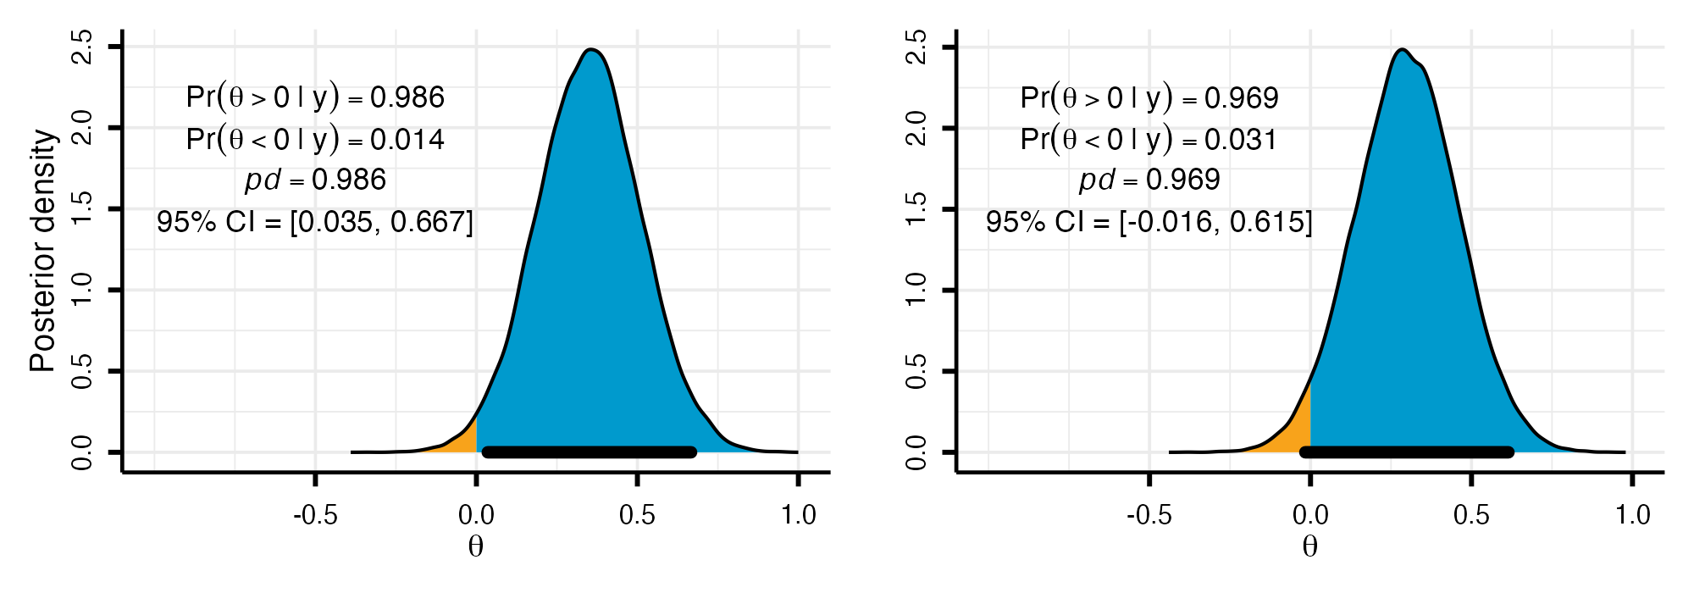
Note. Posterior distributions for two parameters, with $c=.975$ and $θ_{\text{null}}=0$. Shaded areas show the posterior mass below (orange) and above (blue) zero; the black bar is the 95% equal-tailed credible interval (CI).
As Figure 1 illustrates, observing $pd>.975$ is equivalent to excluding $0$ from the central 95% equi-tailed credible interval. When the credible interval excludes the null value, one can infer that the null is relatively implausible (Box & Tiao, 1992). Although we express the decision threshold as $c=1−α/2$ (with $α=.05$) and set $θ_{\text{null}}=0$ throughout for ease of exposition, neither choice is restrictive. The threshold $c$ can be set to any posterior probability cutoff, and $θ_{\text{null}}$ can take any non-zero value, which is particularly relevant when hypotheses involve a minimum effect of practical interest (Lakens et al., 2018).

Multiplicity Problem
When the true $θ$ is 0 and the prior is diffuse, $pd$ is approximately uniform on $[.5,1]$ across repeated samples (Figure 2, $τ≥1$), so the rule $pd>c$ with $c=1−α/2$ claims a direction for a null effect with probability about $α$. A skeptical prior, which concentrates its mass near $0$, shrinks $pd$ toward $.5$ and lowers this rate (Figure 2, $τ=0.2$). With $m$ tests, however, the probability that at least one of $pd_{1},…,pd_{m}$ exceeds $c$ still grows with $m$. The approach presented below addresses this by asking the researcher to specify how large the prior probability that a parameter has the sign opposite to the one claimed could be. When the same value is used for every parameter in a family, it is also an upper bound on the expected proportion of parameters in the family that are not on the claimed side, null effects included, so that researchers who use diffuse or weakly informative priors for estimation can take into account how many null effects the family could contain.

Figure 2
Distribution of the Probability of Direction When the Parameter Equals 0
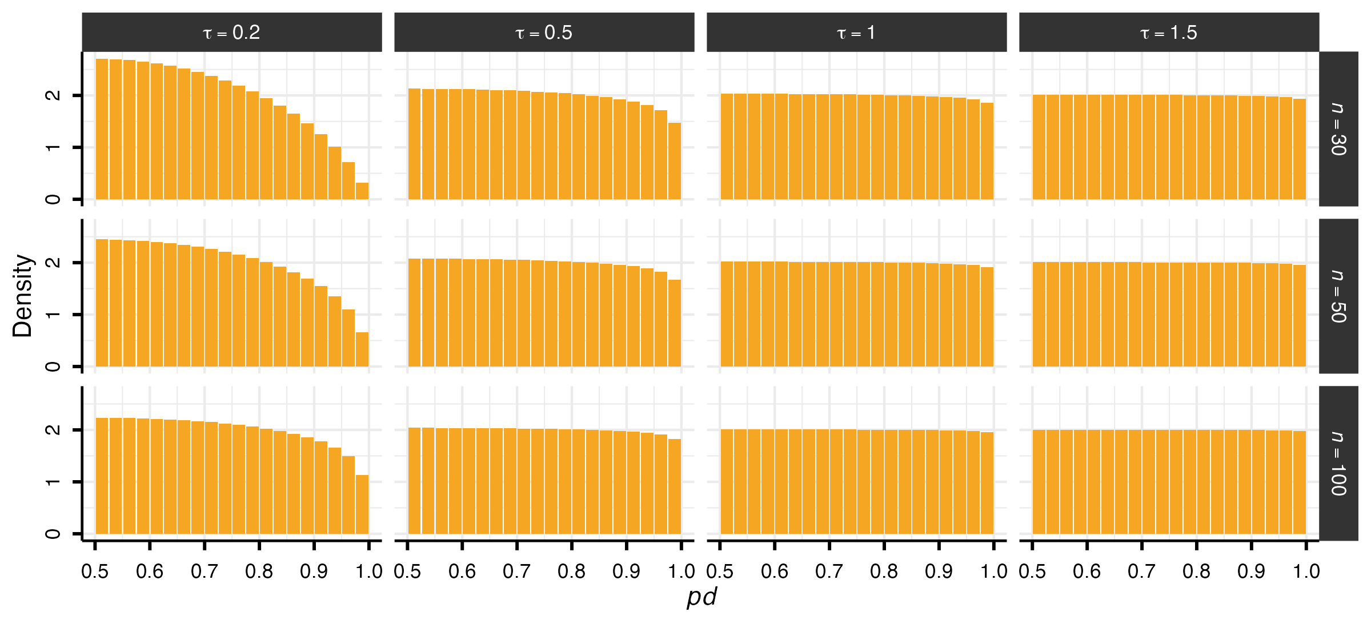
Note. Density of $pd$ across repeated samples when $θ=0$, for observations $y_{i}∼N(θ,1)$ and a normal prior $θ∼N(0,τ)$, by sample size $n$ (rows) and prior standard deviation $τ$ (columns). With a diffuse prior ($τ≥1$), $pd$ is approximately uniform on $[.5,1]$; a skeptical prior ($τ=0.2$) shrinks it toward $.5$, especially in small samples. Bin width = 0.025.

Penalizing the Prior Odds of a Directional Claim
The penalty acts on the prior odds of the two directions of a parameter, so we first write the rule $pd>c$ in terms of odds. Without loss of generality, we assume that the posterior favors positive values, so that the claim is $H_{+}:θ>0$ and its complement is $H_{−0}:θ≤0$. For a negative claim, the two sides are exchanged: the claim is $θ<0$ and its complement is $θ≥0$, which again contains $0$, and everything that follows holds in the same way.
We assume that the within-model prior, that is, the prior specified in the fitted model, is continuous and symmetric about $0$, as are normal priors centered on $0$ and, as a limit, flat priors. $H_{+}$ and $H_{−0}$ are then equally probable a priori, $Pr(H_{+})=Pr(H_{−0})=.5$, and the prior odds are one. The posterior odds then equal the Bayes factor, so that $pd/(1−pd)$ is the Bayes factor for $H_{+}$ against $H_{−0}$ (Marsman & Wagenmakers, 2017).
Because $pd>c$ is the same as $pd/(1−pd)>c/(1−c)$, the rule $pd>c$ accepts a directional claim whenever this Bayes factor exceeds $c/(1−c)$, with prior odds fixed at one. Consider now a family of $m$ tests, indexed by $i=1,…,m$, each concerning a parameter $θ_{i}$ with probability of direction $pd_{i}$; the claim licensed by $pd_{i}>c$ is that $θ_{i}$ lies on the side of $0$ favored by the posterior. The claim is wrong when $θ_{i}$ equals $0$ or lies on the other side.
Prior odds of one mean that each parameter has prior probability $.5$ of having the sign opposite to the one claimed. If the parameters are independent a priori, the prior probability that every parameter has the sign opposite to its claim, that is, that no claim in the family is correct, is therefore ${.5}^{m}$, which tends to zero as $m$ grows (for $m=10$, ${.5}^{10}≈.001$). Before any data are observed, the rule thus treats it as nearly certain that at least one claim in a large family is correct.
Following Jeffreys (1938) and Westfall et al. (1997), we penalize the prior odds of each claim in the family. In their setting, the penalized hypotheses are stated before the data. Here, instead, the direction of each claim is chosen by the posterior, so the penalty cannot be attached to one direction in advance. We therefore lower the prior probability of whichever direction is claimed, by changing how much probability the prior gives to each side of $0$ while keeping its shape on each side. For example, let the within-model prior of $θ_{i}$ be normal with mean $0$ and standard deviation $τ$, and let $N_{−}(0,τ)$ and $N_{+}(0,τ)$ denote this normal truncated to values at or below $0$ and to values above $0$, the regions of $H_{−0}$ and $H_{+}$. The within-model prior is then the equal mixture $.5 N_{−}+.5 N_{+}$, and for a value $π_{0}$ between $.5$ and $1$ the reweighted prior
$$π_{0} N_{−}(0,τ)+(1−π_{0}) N_{+}(0,τ)$$
gives $θ_{i}≤0$ probability $π_{0}$ and $θ_{i}>0$ probability $1−π_{0}$. The prior odds of $H_{+}$ are then $(1−π_{0})/π_{0}$ instead of one; with $π_{0}=.7$, for example, $.3/.7≈0.43$.
The researcher specifies $π_{0}$ before the data, and we consider the class $Γ$ of all priors obtained by reweighting the within-model prior in this way, with the probability of each sign of every $θ_{i}$ between $1−π_{0}$ and $π_{0}$. The within-model prior is one of the priors in $Γ$, and the bounds are the same for $θ_{i}>0$ and $θ_{i}<0$, so that, whichever sign is claimed, the prior probability of the opposite sign ranges from $1−π_{0}$ to $π_{0}$ across $Γ$. The class $Γ$ contains every split between the two extremes, not only the extremes, because a mixture of two priors in $Γ$ is again in $Γ$: the equal mixture of the two extremes, for example, is the within-model prior. Thus $π_{0}$ is an upper bound, set by the researcher, on the prior probability of either sign of a parameter, and in particular of the sign opposite to the one claimed. For example, with $π_{0}=.7$ the claimed sign can have prior probability as low as $.3$ across $Γ$, so the remaining $.7$ lies on the other side. With $π_{0}=.5$, $Γ$ contains only the within-model prior and no penalty is applied. Figure 3 shows the class for $π_{0}=.7$ and $π_{0}=.9$.

Figure 3
The Class of Priors for Two Values of $π_{0}$
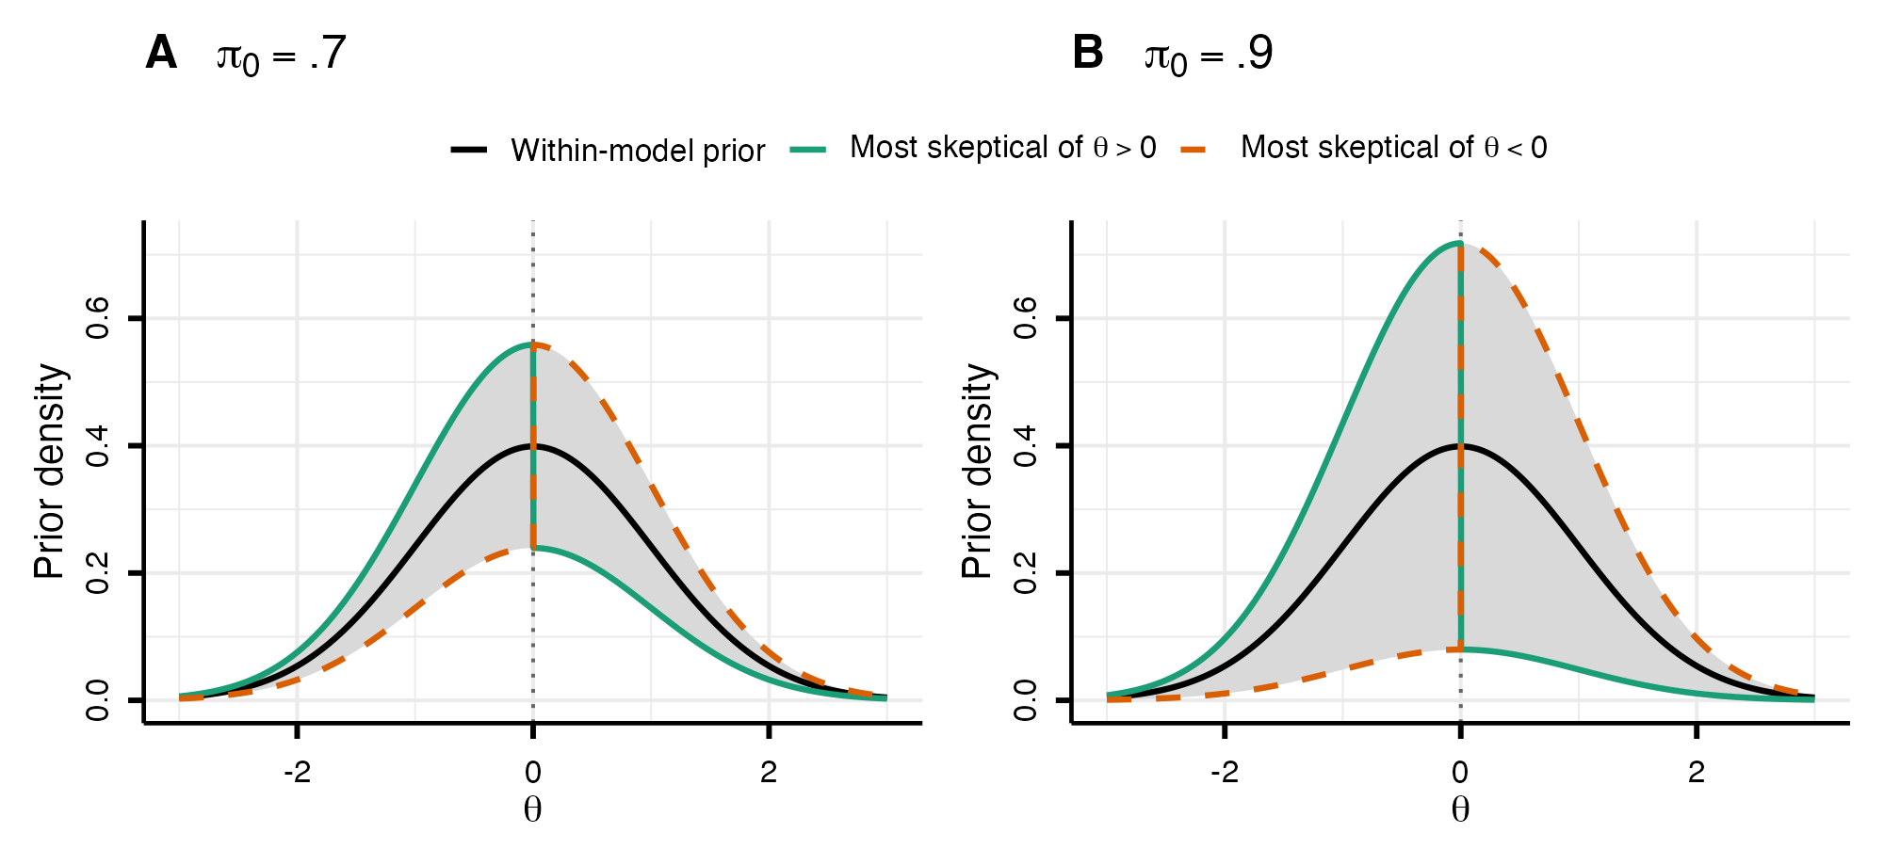
Note. The priors in $Γ$ reweight the two halves of the within-model prior, here $N(0,1)$ (black), keeping the shape of each half; every prior in $Γ$, including the within-model prior, lies within the grey band. Panel A: for $π_{0}=.7$, the prior probability of $θ>0$ lies between $.3$ and $.7$; the colored lines are the two extreme priors of the class, the one most skeptical of $θ>0$ (solid) and the one most skeptical of $θ<0$ (dashed). Panel B: the same for $π_{0}=.9$, for which the prior probability of $θ>0$ lies between $.1$ and $.9$. A larger $π_{0}$ gives a wider class. Only the extreme prior most skeptical of the claimed direction determines whether a claim is made.
The same $π_{0}$ is applied to every parameter in the family, which assumes that the parameters are exchangeable, an assumption we return to in the Discussion; $π_{0}$ can then be chosen in two ways. For exchangeable parameters, the prior probability that a parameter lies on a given side of $0$ equals the expected proportion of parameters in the family that lie on that side. The bound $π_{0}$ is therefore also an upper bound on the expected proportion of parameters that are not on the claimed side. Like a parameter of the opposite sign, a null effect, that is, a parameter equal to $0$, does not lie on the claimed side, so a judgment about how many null effects the family could contain can guide the choice of $π_{0}$: if up to 70% of the parameters could be null effects and the others are expected to have the claimed sign, the corresponding value is $π_{0}=.7$.
Alternatively, let $H_{0}$ denote the event that no claim in the family is correct. If the parameters are independent a priori, the largest prior probability of $H_{0}$ over $Γ$ is $π_{0}^{m}$, so that $π_{0}$ can be set for the family through $Pr(H_{0})$, with $π_{0}=Pr(H_{0})^{1/m}$. For a fixed $Pr(H_{0})$, $π_{0}$ increases with $m$, so that the class widens as the family grows: with $Pr(H_{0})=.5$, for example, $π_{0}$ is $.71$ for $m=2$, $.93$ for $m=9$, and $.97$ for $m=20$.

The Penalty as a Threshold on $pd$
Reweighting the two halves of the within-model prior leaves the likelihood unchanged, so the posterior under any prior in $Γ$ is the posterior under the within-model prior, reweighted on each side of $0$ by the same factors. When the posteriors of the $m$ parameters are independent, as for independent tests, the reweighting of the other parameters does not affect the posterior of $θ_{i}$. Since the posterior odds are the Bayes factor multiplied by the prior odds, the posterior odds of $H_{+}$ under a prior in $Γ$ are the Bayes factor $pd_{i}/(1−pd_{i})$, computed from the posterior under the within-model prior, multiplied by the prior odds of $H_{+}$ under that prior, so that the model does not need to be refitted. They are smallest under the prior in $Γ$ most skeptical of the claim, which gives $H_{+}$ prior probability $1−π_{0}$, where they equal
$$\frac{pd_{i}}{1−pd_{i}}×\frac{1−π_{0}}{π_{0}}.$$
The priors between the two extremes therefore never decide whether a claim holds under every prior in $Γ$. When the posteriors are correlated, reweighting the other parameters can lower the posterior probability of the claim further, so that its smallest value over $Γ$ is at or below this one.
We accept a claim only if its posterior probability exceeds $c$ under every prior in $Γ$. With independent posteriors, the smallest of these probabilities is the posterior probability of $H_{+}$ under the most skeptical prior,
$$pd_{\text{adj},i}=\frac{pd_{i} (1−π_{0})}{pd_{i} (1−π_{0})+(1−pd_{i}) π_{0}},$$
and under the same prior $H_{−0}$ has posterior probability $1−pd_{\text{adj},i}$, so that the two sum to one. A claim is accepted when $pd_{\text{adj},i}>c$, which is equivalent to requiring
$$pd_{i}>c^{*}, c^{*}=\frac{c π_{0}}{(1−c)(1−π_{0})+c π_{0}},$$
with $c^{*}>c$ whenever $π_{0}>.5$. The rule can therefore be stated either as the posterior probability $pd_{\text{adj},i}$ compared with $c$ or as $pd_{i}$ compared with the raised threshold $c^{*}$; the accompanying R package reports both. Because $c^{*}>.5$, at most one direction can satisfy this condition, namely the direction favored by the posterior. In what follows we use the rule $pd_{i}>c^{*}$, which is exact for independent posteriors and, with correlated posteriors, less stringent than the bound over $Γ$. $Γ$ and $c^{*}$ are set before the data and are the same for a positive and a negative claim; the data only decide which direction is claimed, and hence which prior in $Γ$ gives that claim the lowest probability, the prior under which $pd_{\text{adj},i}$ is computed. Taking the smallest posterior probability over a class of priors is the approach of robust Bayesian analysis (Berger, 1994). For one-sided hypotheses, Casella and Berger (1987) obtained such bounds over classes of priors symmetric about the null value, which keep the prior odds of the two directions at one; the class $Γ$ varies exactly these odds. Since $c^{*}$ increases with $π_{0}$, a larger $π_{0}$ requires stronger posterior evidence to claim a direction (Benjamin et al., 2017). Figure 4, Panel A, illustrates the rule for $π_{0}=.7$, for which $c^{*}=.989$: each bar spans the posterior probability of $θ>0$ across $Γ$, its left end is $pd_{\text{adj}}$, and the circle, its value under the within-model prior, lies inside the bar because that prior belongs to $Γ$. A parameter with $pd=.980$ exceeds $c=.975$ under the within-model prior but not under every prior in $Γ$ ($pd_{\text{adj}}=.955$), so no claim is made, whereas parameters with $pd=.990$ and $pd=.999$ are claimed. The bars are shorter for larger $pd$ because lowering the prior odds by the same factor changes a posterior probability close to 1 by less.

Figure 4
The Resulting Rule and Threshold
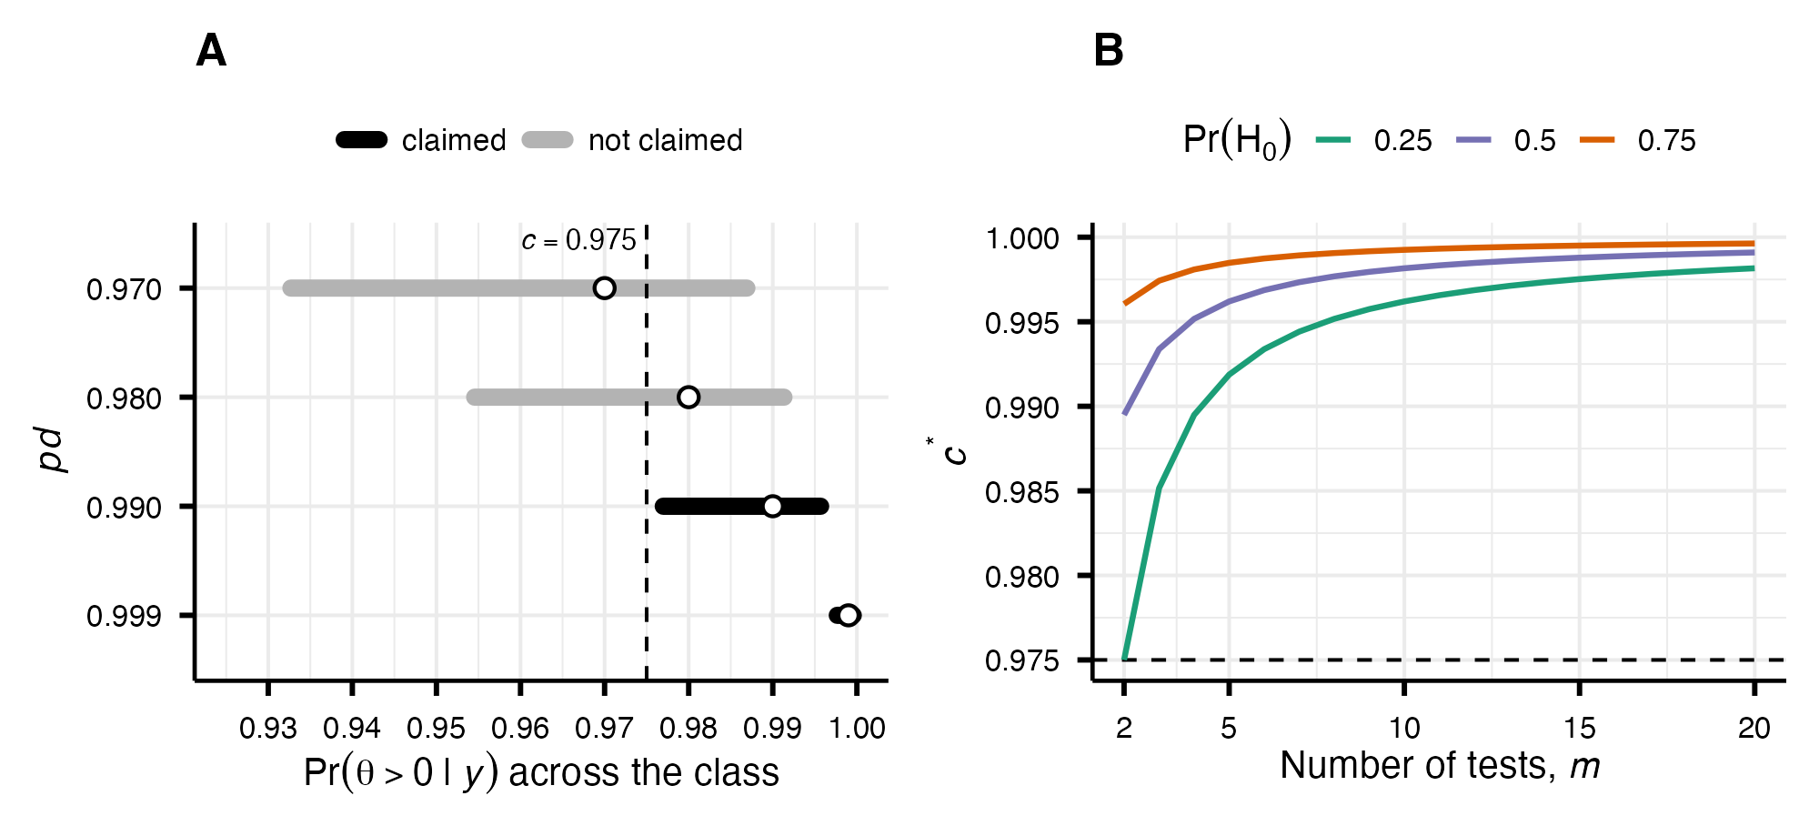
Note. Panel A: for four parameters and $π_{0}=.7$, the range of the posterior probability of $θ>0$ across $Γ$ (bars), whose left end is $pd_{\text{adj}}$, and its value under the within-model prior, $pd$ (circles). A claim is made only when the whole bar lies above $c=.975$ (dashed line), that is, when $pd_{\text{adj}}>c$, which is equivalent to $pd>c^{*}=.989$. Panel B: the threshold $c^{*}$ for $c=.975$ (dashed line) as a function of the number of tests $m$, for three values of the largest prior probability that no claim in the family is correct, $Pr(H_{0})$. Even large values of $π_{0}$ raise the threshold only within the upper few percent of the $pd$ range.
Values of $π_{0}$ near $.5$ are appropriate for confirmatory tests of parameters whose sign is well established, higher values for exploratory settings. When $π_{0}$ is set through a fixed $Pr(H_{0})$, larger families imply a larger $π_{0}$ and hence a higher threshold (Figure 4, Panel B).
When $m$ is small and $Pr(H_{0})$ is low, the implied $π_{0}$ can fall below $.5$. No prior can then give each sign a probability between $1−π_{0}$ and $π_{0}$, and the expression for $c^{*}$ would give a threshold below $c$, as if the prior odds favored each claim. We therefore set $π_{0}$ to $.5$ whenever it falls below this value, so that $Γ$ reduces to the within-model prior and the rule coincides with the unadjusted rule ($c^{*}=c$).
The penalty does not modify the posterior used for estimation, which is the one obtained under the within-model prior. The prior in $Γ$ that is most skeptical of a claim is not suited to estimation: since a continuous prior places no mass at $0$, lowering the prior probability of one sign moves mass to the other side of $0$ rather than to $0$ itself, so that the estimates of parameters near $0$ are pulled toward the side opposite to the claim and the posterior has a discontinuity at $0$.

Error Rates
The long-run error rates of the rule $pd>c^{*}$ depend on the true proportion of null effects in the family, which we denote $π_{\text{null}}$ to distinguish it from the specified $π_{0}$ that determines the threshold. A claim is wrong when the parameter lies in the complement of the claim, which contains $0$. The proportion of parameters that are not on the side favored by the posterior, which is the side that would be claimed, is therefore at least $π_{\text{null}}$, and close to $π_{\text{null}}$ when non-null effects are large relative to their standard errors. For non-null effects of $θ=0.3$ with unit-variance observations, the setting of the simulations below, it exceeds $π_{\text{null}}$ by at most $.025$ ($n=30$), $.008$ ($n=50$), and $.001$ ($n=100$), so that $π_{0}=π_{\text{null}}$ matches the actual proportion of parameters that are not on the claimed side, which $π_{0}$ bounds in expectation. A claim of the wrong sign is made only when, in addition, $pd$ exceeds the threshold, which is far rarer: for $θ=0.3$ and $n=30$, its probability is about $.0002$ even at the unadjusted threshold $c=.975$. Below, we refer to $π_{0}=π_{\text{null}}$ as a matched value, to $π_{0}<π_{\text{null}}$ as an underestimate, and to $π_{0}>π_{\text{null}}$ as a conservative value.
For a family of $m$ tests, let $R$ denote the number of claims made (rejections, in the terminology of multiple testing) and $V$ the number of false claims, that is, claims about null effects (claims of the wrong sign, far rarer as shown above, are not counted). The target error rate is the False Discovery Rate (FDR),
$$FDR=E​\left[\frac{V}{max(R,1)}\right],$$
where the $max(R,1)$ sets the ratio to zero when no claim is made (Benjamini & Hochberg, 1995). The FDR factorizes as the product of the positive False Discovery Rate (pFDR, Storey, 2003) and the probability of at least one claim, $FDR=pFDR×Pr(R>0)$. For a single test,
$$pFDR=\frac{π_{\text{null}} α}{π_{\text{null}} α+(1−π_{\text{null}})(1−β)},$$
where $α$ is the per-test Type I error rate and $1−β$ the power (Berger, 2023; Storey, 2003). Here $π_{0}$ enters only through $α$, via the threshold.
When the null distribution of $pd$ is uniform on $[.5,1]$, the per-test probability of claiming a direction for a null effect is $α^{*}=2(1−c^{*})$; under an informative skeptical prior, which shrinks the posterior toward $0$, this rate is even smaller (Figure 2). Since $α^{*}<α$, the adjustment lowers both factors: the pFDR, which increases with $α$, and $Pr(R>0)$, which falls as fewer claims are made. The FDR is therefore lower than under the unadjusted rule. For independent tests and a given $π_{0}$, the pFDR does not depend on $m$, so the family size affects the FDR only through $Pr(R>0)$, which increases with $m$. The error rates also depend on how $π_{0}$ relates to $π_{\text{null}}$: when $π_{0}<π_{\text{null}}$, the threshold is raised less than the proportion of null effects would require. The simulations below therefore vary both quantities.

Simulation Study
We conducted a fully crossed simulation study, with 10,000 replications per cell, to examine the rule with matched, underestimated, and conservative values of $π_{0}$. We varied the specified $π_{0}∈\{.50,.6,…,.9\}$, set directly and at the same value for every family size, which determines the threshold $c^{*}$; the expected proportion of null effects, $π_{\text{null}}∈\{.5,.6,…,1.0\}$; the family size $m∈\{4,8,10,20\}$; and the sample size $n∈\{30,50,100\}$. At each replication the number of true null effects ($θ_{i}=0$) was drawn from $Binomial(m,π_{\text{null}})$ and the remaining parameters set to $θ_{i}=0.3$; observations were generated as $y_{i}∼N(θ_{i},1)$, and the posterior obtained from a conjugate normal–normal model with $y_{i}∣θ∼N(θ,1)$ and prior $θ∼N(0,2)$. A directional claim was made when $pd>c^{*}$, with $c$ fixed at $.975$ throughout, and we evaluated the FDR, the FWER, and average power, the proportion of non-null effects for which a direction is claimed (Benjamini & Hochberg, 1995; Izmirlian et al., 2025). All values of $π_{0}$ were applied to the same replications. The value $π_{0}=.5$ corresponds to the unadjusted rule ($c^{*}=c$), and $π_{0}=π_{\text{null}}$ to a matched value. Claims are direction-agnostic, so a true null can be falsely claimed in either direction; with a preregistered direction, the per-test error rate at the same $c$ is halved.
Figure 5 shows the FDR resulting from our procedure across the grid. In the column $π_{0}=.5$, the unadjusted rule, the FDR inflates with the family size $m$ and the true proportion of null effects, $π_{\text{null}}$, reaching $.64$ when the family is large and most effects are null. Increasing $π_{0}$ brings the FDR under control: it is held low whenever the specified $π_{0}$ is at least the true proportion, and inflates only under substantial underestimation, when a small $π_{0}$ is paired with a large $π_{\text{null}}$ at large $m$. This control trades off power, which decreases as $π_{0}$ increases; because average power does not vary with $m$ (for fixed $π_{\text{null}}$ and $π_{0}$), we display $m=20$ as a representative condition (Figure 5).

Figure 5
False Discovery Rate and Power of the Prior-Odds Rule
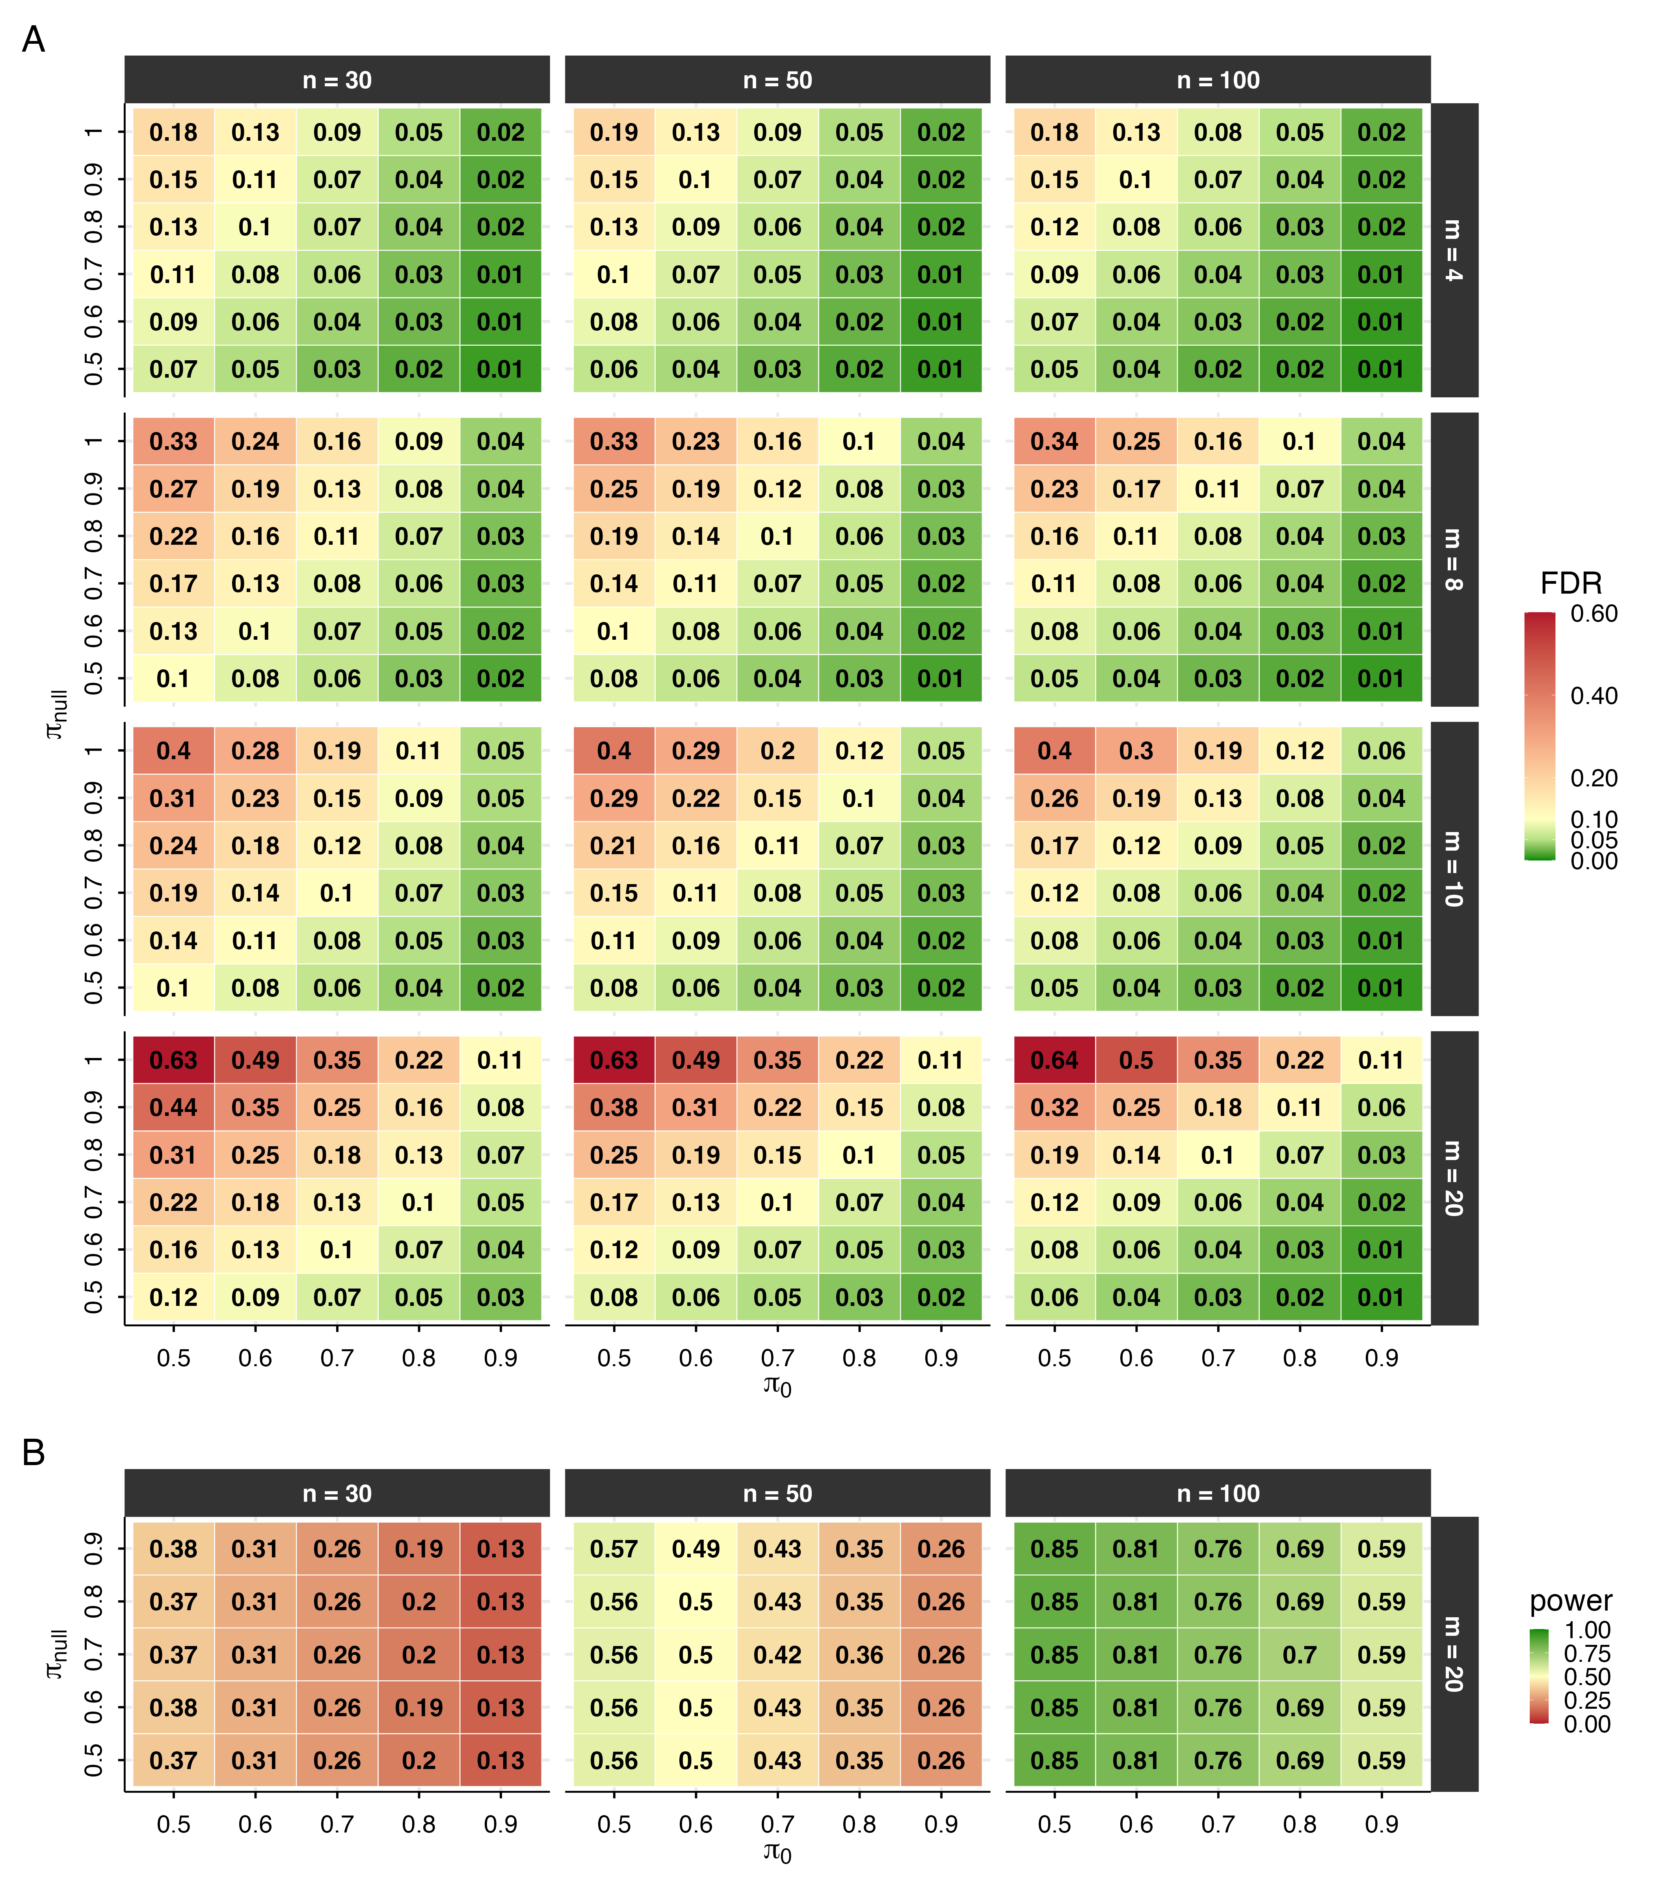
Note. False Discovery Rate (FDR, Panel A) and average power (Panel B) as a function of the specified $π_{0}$ (x-axis) and the true proportion of null effects, $π_{\text{null}}$ (y-axis), by family size $m$ (rows, Panel A) and sample size $n$ (columns). The column $π_{0}=.5$ is the unadjusted rule, where the prior odds are one and $c^{*}=c$; the diagonal $π_{0}=π_{\text{null}}$ is a matched $π_{0}$. Each cell is the empirical FDR or power over 10,000 replications.
Figure 6 shows the FWER of the same rule (for $n=50$, as a representative case). Unlike the FDR, the FWER is not held low by the per-test adjustment: for a fixed $π_{0}$, it grows with the family size $m$, reaching $.64$ for the unadjusted rule with a large family of mostly null effects. Increasing $π_{0}$ lowers it substantially, at $π_{0}=.9$ it stays at or below about $.10$. When $π_{0}$ is instead set through a fixed $Pr(H_{0})$, it increases with $m$, which largely offsets this growth.

Figure 6
Family-Wise Error Rate of the Prior-Odds Rule
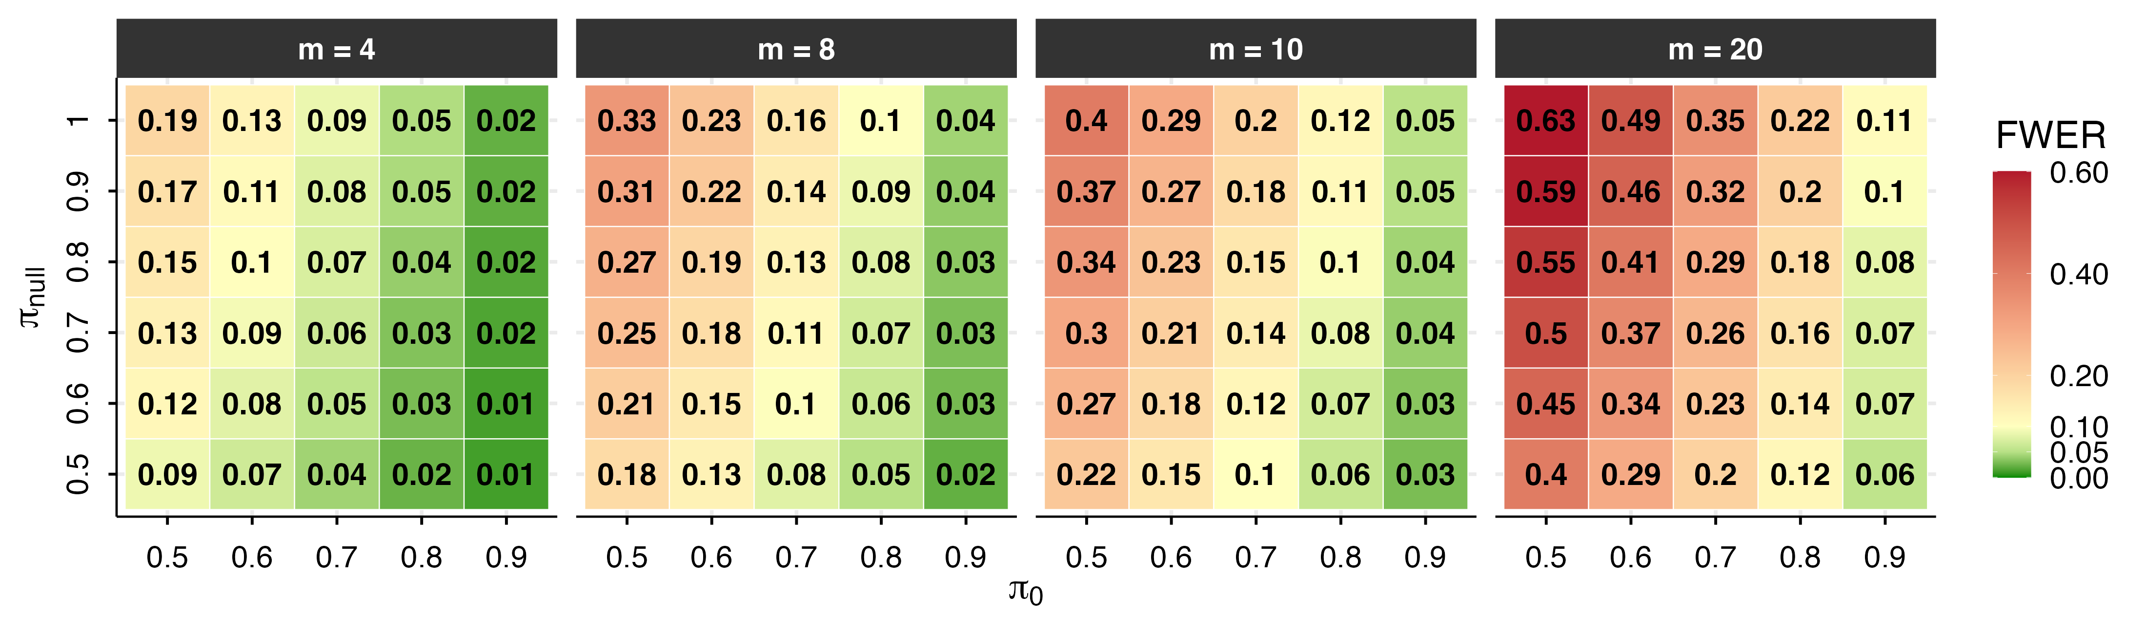
Note. Family-wise error rate (FWER) as a function of the specified $π_{0}$ (x-axis) and the true proportion of null effects, $π_{\text{null}}$ (y-axis), by family size $m$ (columns), with $n=50$. The column $π_{0}=.5$ is the unadjusted rule. Each cell is the empirical FWER over 10,000 replications. Because the per-test threshold targets the FDR, the FWER is reduced by larger $π_{0}$ but, for a fixed $π_{0}$, still grows with the family size $m$.

Comparison With Other Bayesian Methods
We compare the prior-odds rule with two Bayesian alternatives, which make different kinds of claims and limit different errors. The first, hereafter the joint directional rule, orders the directional claims by their posterior probability and accepts the largest set whose joint posterior probability is at least $1−α$ (Gelman & Tuerlinckx, 2000; Pruzek, 2016). Its output is a single one-sided statement about signs, that is “all accepted parameters lie in their claimed direction”, and the quantity it bounds is the familywise probability of a sign (Type S) error. The second, hereafter the simultaneous-band rule, computes credible intervals with $1−α$ joint coverage, meaning that with probability $1−α$ every interval contains its parameter, and claims a direction for a parameter whenever its interval excludes 0 (Box & Tiao, 1992; Schnell et al., 2016; Schnell et al., 2020). Since an interval that covers a truly null parameter cannot exclude it, the probability of any false claim is at most $α$. Both procedures act on the posterior alone, whereas the prior-odds rule combines the posterior with a penalty set by the researcher for the family under test.
No new data were simulated for the comparison: the three procedures were applied to the same replications of the simulation described above with $n=50$, for every family size $m$ and every true proportion of null effects, $π_{\text{null}}∈\{.5,…,1.0\}$. All procedures use $α=.05$: the prior-odds rule claims a direction when $pd>c^{*}$, or equivalently $pd_{\text{adj}}>c$ (with $c=1−α/2=.975$), the joint directional rule accepts directional claims as long as their joint posterior probability is at least $1−α=.95$, and the simultaneous-band rule claims a direction when the $95\%$ joint-coverage band excludes 0. The prior-odds rule is evaluated at each $π_{0}∈\{.5,…,.9\}$ (thresholds $c^{*}=.9750$, $.9832$, $.9891$, $.9936$, and $.9972$) under each value of $π_{\text{null}}$, so that matched, underestimated, and conservative values of $π_{0}$ are compared at every proportion of null effects; the other two procedures do not require $π_{0}$. Figure 7 reports FDR, FWER, and power for $m=4$ and $m=20$.
The simultaneous-band rule keeps the FWER, and hence the FDR, at the nominal level in all conditions, while its power decreases with family size, from about $.35$ at $m=4$ to $.18$ at $m=20$. The joint directional rule has power similar to the unadjusted rule (about $.56$ at $m=20$), but its error rates increase with the proportion of null effects: at $m=20$, its FDR rises from $.08$ at $π_{\text{null}}=.5$ to $.50$ at $π_{\text{null}}=.9$ and $.88$ when all effects are null. The joint rule bounds the posterior probability that at least one accepted sign is wrong; under a continuous prior, which assigns no mass to exactly null effects, this does not limit the proportion of null effects among the accepted claims.
The prior-odds rule lies between the two. Its class of priors also assigns no mass to null effects, but the bound $π_{0}$ counts them, since null effects are among the parameters that are not on the claimed side. When $π_{0}=π_{\text{null}}$ (outlined cells), its FDR at $m=20$ ranges from $.07$ to $.10$ across all proportions of null effects, whereas the FDR of the unadjusted rule increases from $.08$ to $.64$. Its power depends mainly on $π_{0}$ and little on $π_{\text{null}}$ or $m$, decreasing from about $.56$ for the unadjusted rule to $.26$ at $π_{0}=.9$. When $π_{0}<π_{\text{null}}$, the FDR increases gradually: at $π_{\text{null}}=.9$ and $m=20$, it is $.15$ for $π_{0}=.8$ and $.22$ for $π_{0}=.7$, compared with $.39$ for the unadjusted rule. When $π_{0}>π_{\text{null}}$, error rates are lower and power is reduced.
For independent tests, a $95\%$ simultaneous band is approximately equivalent to a per-test threshold on $pd$ of $1−[1−{.95}^{1/m}]/2$. This equals the threshold $c^{*}$ of the prior-odds rule with $π_{0}≈.80$ at $m=4$ and $π_{0}≈.95$ at $m=20$, and at $m=4$ the two rules give nearly identical results (Figure 7). The simultaneous band thus implies a value of $π_{0}$ that increases with $m$, which accounts for its loss of power in larger families. These values correspond to $Pr(H_{0})=π_{0}^{m}≈.41$ at $m=4$ and $.38$ at $m=20$: the band behaves like the prior-odds rule with $π_{0}$ set through a nearly fixed $Pr(H_{0})$, which raises $π_{0}$ as the family grows. In the prior-odds rule, the threshold depends on $m$ only through the specified $π_{0}$, so, for a fixed $π_{0}$, its power does not change with $m$, whereas its FDR does.
With a matched $π_{0}$, the FDR is not held at $.05$: at $π_{0}=π_{\text{null}}=.7$ and $m=20$ it is $.10$. This agrees with the decomposition given above. With $α^{*}=2(1−c^{*})=.0217$ and power of about $.43$, the pFDR is $.107$ and does not depend on $m$, while $Pr(R>0)$, estimated as $FDR/pFDR$, increases from $.45$ at $m=4$ to $.93$ at $m=20$. The rule therefore keeps the proportion of false claims among the claims made approximately constant, and the FDR increases with $m$ because at least one claim becomes more likely in larger families. A lower FDR requires a $π_{0}$ larger than the true proportion of null effects (Figure 5).
Which procedure to use thus depends on whether any false claim must be avoided (FWER) or only a small proportion of false claims is acceptable (FDR), on how much power can be given up, and on whether a value of $π_{0}$ can be specified. The prior-odds rule is the only one of the three that requires such a specification, and its error rates depend on whether the specified $π_{0}$ is at least the proportion of null effects, and, with $π_{0}$ set through a fixed $Pr(H_{0})$, it also limits the probability of any false claim, as the simultaneous band does.

Figure 7
Error Rates and Power of the Three Procedures
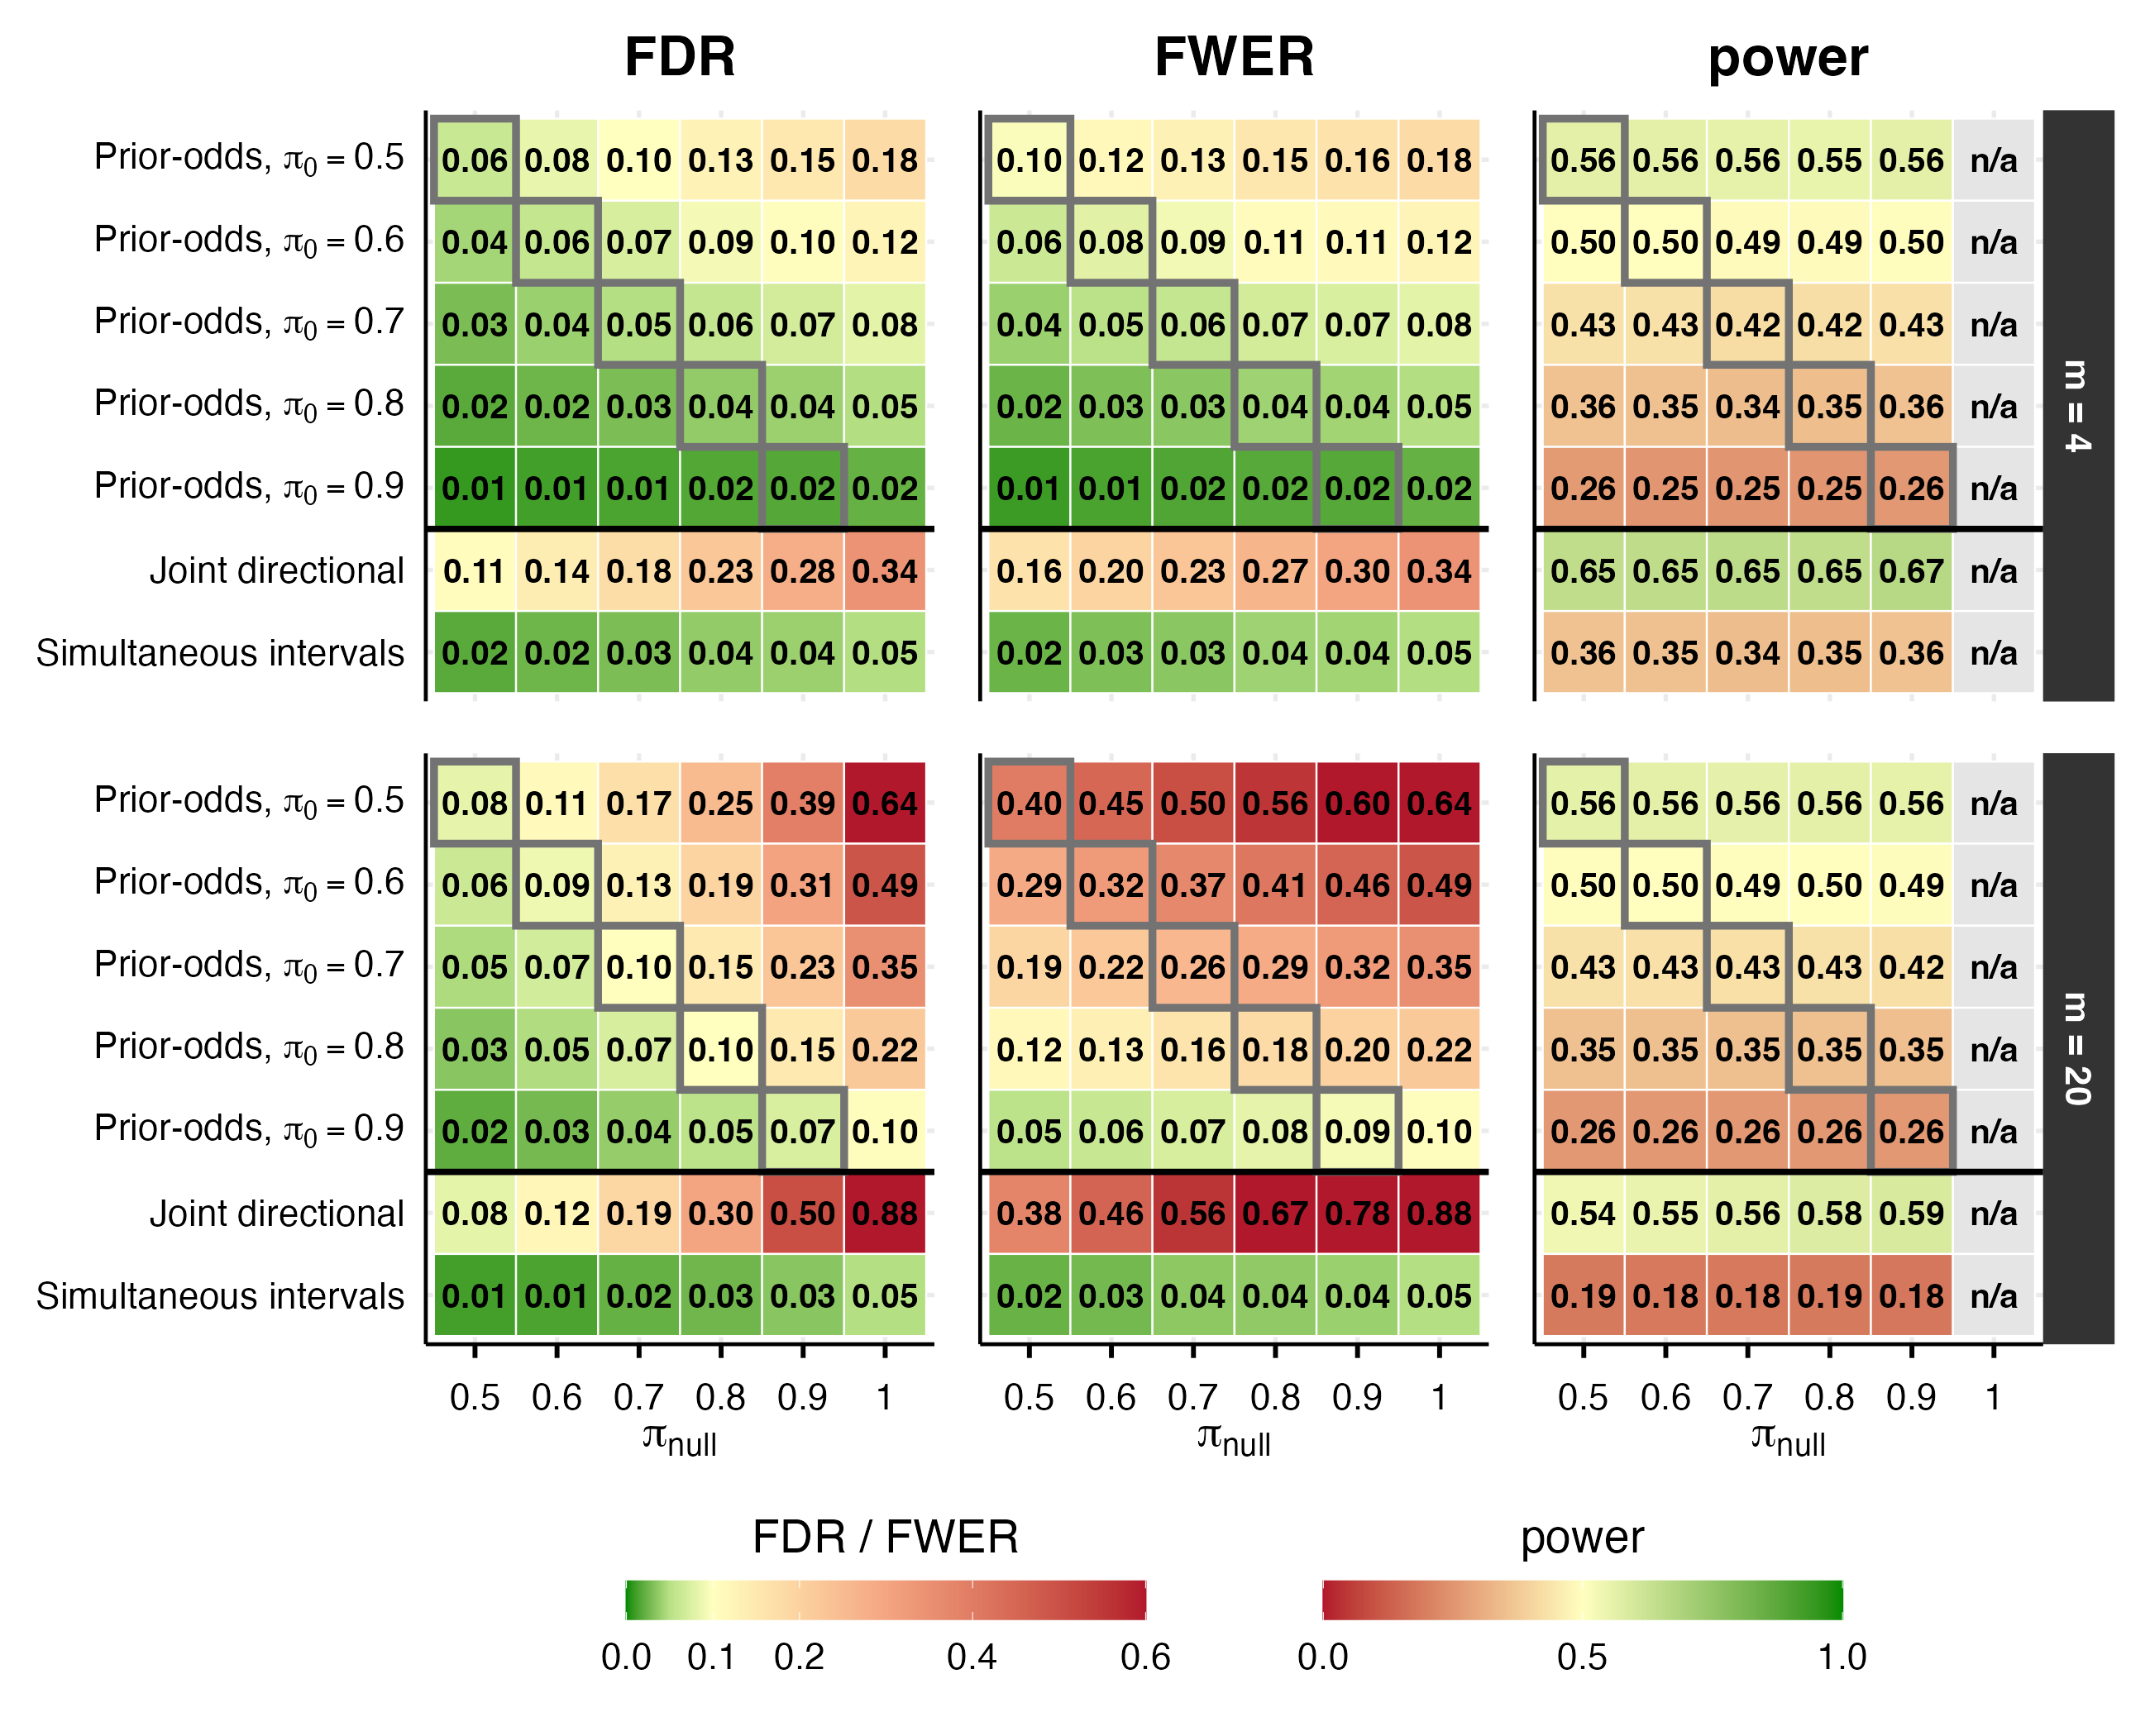
Note. False Discovery Rate (FDR), Family-Wise Error Rate (FWER), and average power as a function of the true proportion of null effects, $π_{\text{null}}$ (columns), for the smallest and largest families ($m=4$, $m=20$; panel rows), all at $α=.05$. Upper five rows of each block: the prior-odds rule ($pd>c^{*}$) with $π_{0}=.5,…,.9$, where $π_{0}=.5$ is the unadjusted rule ($c^{*}=c$); outlined cells mark $π_{0}=π_{\text{null}}$, with $π_{0}<π_{\text{null}}$ to their right and $π_{0}>π_{\text{null}}$ to their left. All procedures and values of $π_{0}$ are applied to the same replications. Lower two rows: the two other procedures, which do not require $π_{0}$ (joint statements at joint probability $.95$; 95% simultaneous credible intervals). Power is undefined when every effect is null (n/a). Each cell is the empirical rate over 10,000 replications ($n=50$); intermediate family sizes ($m=8,10$) lie between the two blocks shown.

Application: Worked Example With the R Package multibayes
The procedure is implemented in the multibayes R package. The core function, pd.adjust(), accepts either a matrix of posterior draws, from which $pd$ values are computed internally, or a vector of pre-computed $pd$ values. The penalty is specified in either of two ways: directly as the per-test value $π_{0}$, or as $Pr(H_{0})$, the largest prior probability that no claim in the family is correct, from which $π_{0}=Pr(H_{0})^{1/m}$ is recovered for parameters independent a priori, so that $π_{0}$ grows with the size of the family. The decision threshold may be given either as a $pd$ cutoff $c$ (argument threshold, default $.975$) or as a nominal per-test rate (argument alpha, with $c=1−α/2$).
The function prints a header with $m$, $π_{0}$, and the thresholds $c$ and $c^{*}$, followed by the posterior median, $pd$, and $pd_{\text{adj}}$ (pd.adj) of each parameter, and a short note on $pd_{\text{adj}}$. Setting order = TRUE sorts the hypotheses by $pd$, and direction = "greater" or "less" computes $pd$ as the one-sided posterior probability for a preregistered direction, to which the same threshold applies.
For this example, we use the openly available dataset from Lin et al. (2020), who investigated the effect of ego depletion on conflict resolution across four studies. In their paradigm, an initial high-demand (vs. low-demand) task was followed by a Stroop task. For simplicity, we focus on Study 1, which tested the effects of congruency and ego depletion (within subjects). The dataset is readily accessible via the afex package (Singmann et al., 2016) and was chosen for this reason; this example is not intended as a critique of the original work. This dataset includes data from 253 participants; for this example, we randomly selected 80 participants.
# install.packages("remotes")
remotes::install_github("mar-cald/multibayes")
library(multibayes); library(brms); library(dplyr)
data_stroop <- subset(afex::stroop, subset = study == 1 &
pno %in% sample(levels(pno), size = 80))|>
# remove useless levels id
dplyr::mutate(id = droplevels(pno)) |>
# select relevant variables
dplyr::select(id, condition, congruency, trialnum, acc, rt)|>
# previous cong
group_by(id, condition)|>
mutate(prev_cong = lag(congruency),
trial = scale(trialnum)[,1])|>
ungroup()|>
na.omit()
Given the repeated-measures structure of the data and the large number of trials per participant, we fit a multilevel generalized linear model using brms (Bürkner, 2017) on reaction time (RT) data. A lognormal model was specified with the default flat priors. A flat prior is improper, so the prior probability of each direction is not defined; we treat it as the limit of a normal prior centered on 0 whose standard deviation grows without bound, under which each direction has prior probability .5 and $pd/(1−pd)$ is the Bayes factor. We used them because they are the most common choice in applied work and the one in which the penalty matters most, not as a recommendation.
The model includes the effect of congruency (congruent vs. incongruent), previous congruency (congruent vs. incongruent), condition (depletion vs. control), and trial number (scaled within participant and condition). The sequential congruency effect was modeled as the interaction between congruency and previous congruency; the hypothesis that depletion amplifies the congruency effect over time was captured by the three-way congruency $×$ condition $×$ trial interaction. Following the common practice of reporting a $pd$ for every coefficient, we make a directional claim about each of the nine fixed effects, so that the family contains nine hypotheses (Table 1).
Although several of the theoretical hypotheses are directional (e.g., incongruent trials are expected to slow responses), we compute $pd$ as $max​\left(Pr(θ>0∣y), Pr(θ<0∣y)\right)$ for all hypotheses, as is common in applied work. When the direction of each parameter is specified in advance, the directional formulation can be used instead; it halves the per-test error rate at the same $c$, and the rule then corresponds to a single prior for each parameter, the member of $Γ$ most skeptical of the predicted direction, and $pd_{\text{adj}}$ is then the posterior probability under that single prior.

Table 1
Tested Hypotheses for Reaction Times
Hypothesis | $θ_{\text{null}}$
$H_{1}$: congruency effect | 0
$H_{2}$: previous congruency effect | 0
$H_{3}$: condition effect | 0
$H_{4}$: trial number effect | 0
$H_{5}$: congruency $×$ previous congruency interaction | 0
$H_{6}$: congruency $×$ condition interaction | 0
$H_{7}$: congruency $×$ trial interaction | 0
$H_{8}$: trial $×$ condition interaction | 0
$H_{9}$: congruency $×$ condition $×$ trial interaction | 0
Note. Hypotheses are evaluated on the log scale of the posterior.
We retained only correct trials preceded by a correct trial (i.e., error and post-error trials were excluded), yielding $5,965$ observations.
data_rt <- data_stroop |>
group_by(id) |>
filter(acc == 1 & lag(acc) == 1) |>
ungroup()
# set contrast
contrasts(data_rt$congruency) <- contr.sum(2)/2
contrasts(data_rt$prev_cong) <- contr.sum(2)/2
contrasts(data_rt$condition) <- contr.sum(2)/2
mod_rt <- brm(
formula = rt ~ 1 + congruency * prev_cong +
congruency * trial * condition +
(1 + congruency + prev_cong + trial + condition || id),
family = lognormal(), data = data_rt,
cores = 3, chains = 3, iter = 8000)
Since pd.adjust() computes $pd$ values automatically from a matrix of posterior draws, we extracted the relevant draws from the model.
draws_rt <- as.data.frame(mod_rt)
par_names <- colnames(draws_rt)[2:10]
draws_rt <- draws_rt[, par_names]
pd.adjust(draws = draws_rt, pi0 = 0.7, null.value = 0)
Prior-odds threshold for directional claims
m = 9, pi0 = 0.7, Pr(H0) = pi0^m = 0.0404
c = 0.975 (unadjusted; alpha = 0.05)
c* = 0.9891 (adjusted; alpha* = 0.0217)
alpha = 2(1 - c), the per-test rate if the null pd is uniform
null value = 0, direction = two.sided
Claim a direction when pd > 0.9891
median.est pd
b_congruency1 -0.1439 1.0000
b_prev_cong1 -0.0166 0.9803
b_trial 0.0119 0.9369
b_condition1 0.0063 0.6509
b_congruency1:prev_cong1 0.0223 0.9583
b_congruency1:trial -0.0033 0.7206
b_congruency1:condition1 -0.0166 0.9291
b_trial:condition1 0.0071 0.8936
b_congruency1:trial:condition1 -0.0028 0.5961
The function was called with $π_{0}=.7$, shown in the printed header. Under the within-model prior, each parameter has prior probability $.5$ of having the sign opposite to the one claimed; with $π_{0}=.7$ we consider it plausible that this probability is as high as $.7$. This reflects skepticism about most effects in the family, such as those of ego depletion, whose replicability has been questioned (Lin et al., 2020), rather than equal prior probabilities for the two directions. Because the nine parameters are independent a priori under the flat priors used here, $π_{0}=.7$ corresponds to $Pr(H_{0})={.7}^{9}≈.04$: the largest prior probability that none of the nine claims is correct is about 4%.
The header reports the resulting threshold: with the default $c=.975$, a directional claim requires $pd>c^{*}=.989$ or, equivalently, $pd_{\text{adj}}>.975$.
In this family, $2$ effects exceed $c$ and $1$ exceeds $c^{*}$. The congruency effect (b_congruency1, $pd=1.000$) exceeds both thresholds, whereas b_prev_cong1 ($pd=.980$, $pd_{\text{adj}}=.955$) exceeds $c$ but not $c^{*}$. None of the remaining effects exceeds either threshold; the largest among them are b_congruency1:prev_cong1 ($pd=.958$) and b_trial ($pd=.937$). Whether the previous-congruency effect is reported therefore depends on the value of $π_{0}$, and hence on how many of these nine effects the researcher judges could be null; the procedure requires this judgment to be stated explicitly. A researcher interested only in ego depletion would include in the family only the four effects involving condition, and $π_{0}$ would then be chosen for those four effects. In these data, none of them would be claimed under either threshold (largest $pd=.929$, for the congruency $×$ condition interaction).
A companion function, joint(), computes by default the joint posterior probability of the $k$ strongest directional claims, for each $k$:
joint(draws_rt, null.value = 0)
Joint directional statement
null value = 0, direction = two.sided
joint_cum: Pr(the top k claims all hold | y)
median.est pd joint_cum
b_congruency1 -0.1439 1.0000 1.0000
b_prev_cong1 -0.0166 0.9803 0.9803
b_congruency1:prev_cong1 0.0223 0.9583 0.9412
b_trial 0.0119 0.9369 0.8812
b_congruency1:condition1 -0.0166 0.9291 0.8191
b_trial:condition1 0.0071 0.8936 0.7340
b_congruency1:trial -0.0033 0.7206 0.5366
b_condition1 0.0063 0.6509 0.3532
b_congruency1:trial:condition1 -0.0028 0.5961 0.2232
The rows are sorted by decreasing $pd$, and the joint_cum column reports the posterior probability that the top $k$ claims hold simultaneously; a high value supports accepting that set of claims as a whole. Here the two strongest claims hold jointly with probability $.98$ and the three strongest with $.94$; the joint probability then declines as weaker claims are added, indicating how many of the leading effects can be reported as a jointly supported set.
Setting interval = TRUE returns simultaneous equi-tailed credible intervals instead:
joint(draws_rt, interval = TRUE)
Simultaneous credible intervals (joint coverage 0.95)
lower est upper
b_congruency1 -0.1915 -0.1439 -0.0970
b_prev_cong1 -0.0409 -0.0166 0.0066
b_trial -0.0101 0.0119 0.0344
b_condition1 -0.0419 0.0063 0.0554
b_congruency1:prev_cong1 -0.0125 0.0223 0.0567
b_congruency1:trial -0.0191 -0.0033 0.0124
b_congruency1:condition1 -0.0489 -0.0166 0.0154
b_trial:condition1 -0.0089 0.0071 0.0231
b_congruency1:trial:condition1 -0.0348 -0.0028 0.0280
Under this stricter criterion, only b_congruency1 excludes zero (simultaneous band $[−0.19,−0.10]$).

Discussion
The probability of direction ($pd$) is the posterior mass on the data-favored side of a reference null value, equivalently, the larger of the two one-sided posterior probabilities. When it is thresholded at a fixed cutoff, each directional claim is evaluated at prior odds of one under a symmetric within-model prior, which for a family of $m$ claims implies near-certainty that at least one of them is correct. Building on Jeffreys (1938; see also Westfall et al., 1997) and on Bayesian approaches to FDR control (Abraham et al., 2022; Efron et al., 2001; Guo & Heitjan, 2010; Scott & Berger, 2006; Scott & Berger, 2010; Stephens, 2017; Storey, 2002, 2003), the procedure presented here makes explicit, through a single quantity, $π_{0}$, how far the prior odds of each claim may be lowered, and translates it into the threshold $c^{*}$ or, equivalently, into $pd_{\text{adj}}$, the posterior probability of the claimed direction under the most skeptical prior, compared with $c$.
Estimation uses the posterior under the researcher’s prior; $π_{0}$ affects only which claims are made, and the probability $pd_{\text{adj}}$ reported for them, through the class of priors under which a claim must hold. The prior in this class that is most skeptical of a claim moves mass to the other side of $0$ rather than to $0$ itself and is not suited to estimation. A single prior that gives prior probability $π_{0}$ to the complement of a claim in either direction, $0$ together with the opposite sign, must place mass at $0$, as the two-group, or spike-and-slab, prior does (Scott & Berger, 2006; Scott & Berger, 2010). Such a prior does not require a direction, but it requires a proper prior on the non-null effects, and the resulting Bayes factors depend on the scale of that prior and can be difficult to estimate in complex models (Schad et al., 2023).
Specifying $π_{0}$ helps in two situations. Researchers who use diffuse within-model priors can take into account how many null effects the family may contain, without placing informative priors on individual parameters. Researchers who consider prior odds of one appropriate can state this choice by setting $π_{0}=.5$.
Related corrections have been implemented for specific testing contexts, such as post-hoc tests in JASP (de Jong, 2019; van den Bergh et al., 2020). The present procedure extends this logic to $pd$ and provides a general-purpose implementation for applied use, applicable directly to posterior draws or any posterior-derived $pd$, including cases where $pd$ values arise from multiple separate analyses within the same manuscript (Blondé et al., 2021; Ciranka et al., 2026). This raises the question of how to define the hypothesis family to which the correction applies (Hochberg & Tamhane, 1987; Shaffer, 1995). Although no universal consensus exists regarding what constitutes a family, we favor the criteria proposed by Westfall et al. (2011), where a family is a set of questions that “form a natural and coherent unit, [are] considered simultaneously in the decision-making process, and/or present a set over which one plays pick-the-winner”. Regardless of the chosen definition, authors should clearly specify their chosen family and explain how it serves the study’s substantive goals.
We further recommend that researchers justify their choice of $π_{0}$ by drawing on theory, expert elicitation, or domain expertise (O’Hagan, 2019), and report this justification. If the parameters in the family are exchangeable, $π_{0}$ is also an upper bound on the expected proportion of parameters in the family that are not on the claimed side, null effects included, so a judgment about how many null effects the family could plausibly contain can guide its choice. The simulations support this choice, since the FDR was held low whenever $π_{0}$ was at least the actual proportion of null effects, $π_{\text{null}}$. This value does not depend on the size of the family. If the aim is instead to limit the probability of any wrong claim in the family, and the parameters are independent a priori, $π_{0}$ can be set through $Pr(H_{0})$, the largest prior probability that no claim in the family is correct, so that $π_{0}=Pr(H_{0})^{1/m}$ increases with $m$, as the simultaneous credible band does implicitly. For applied reporting, we recommend stating $π_{0}$, $m$, the implied $Pr(H_{0})=π_{0}^{m}$, and $c^{*}$, together with the $pd$ and $pd_{\text{adj}}$ of every parameter in the family, so that readers can apply the threshold implied by a different value of $π_{0}$. When the appropriate value is uncertain, results can be reported for several values of $π_{0}$.
Although our approach derives from the Bayesian FDR literature, it differs from it in one respect: there, the proportion of null effects is typically given a prior distribution and estimated from the data, whereas here the user specifies $π_{0}$, for instance from a judgment about that proportion. The error properties of the rule therefore depend on how the specified $π_{0}$ relates to the actual proportion of null effects: a value below it increases the error rates gradually, while a larger value lowers them at the cost of power. Estimating the proportion of null effects from the data requires large families (Efron et al., 2001; Storey, 2002), larger than those typical of psychological studies. A researcher may also deliberately choose a larger $π_{0}$, reducing Type I errors at the cost of Type II errors.
Several limitations warrant attention. First, applying the same $π_{0}$ to every test assumes that the $m$ parameters are exchangeable. In many models this is not the case; for example, a main effect that motivated the study and a higher-order interaction included for completeness typically differ in prior plausibility. A common $π_{0}$ is then too strict for the more plausible claims and too lenient for the less plausible ones, and specifying the average $π_{0}$ does not preserve the overall error rate. In such cases the family can be divided into more homogeneous subsets, each with its own $π_{0}$, or a conservative common value can be used. Parameters on which no claim is based need not be included in the family. Allowing a separate $π_{0}$ for each test is a natural extension of the implementation.
Second, the rule does not provide evidence for a point null hypothesis. The procedure evaluates directional claims defined by inequalities (e.g., $θ>0$ vs. $θ≤0$), and while the complementary hypothesis includes the null value, that value receives no special status; not making a claim therefore reflects the absence of a directional discovery, not evidence in favor of $θ=0$. The prior-odds penalty applies a classical multiplicity strategy (de Jong, 2019; Jeffreys, 1938; Westfall et al., 1997) to $pd$; because it acts on the prior odds alone, it extends in principle to other Bayes factor approaches (Dienes, 2016; Heck et al., 2023; Ly et al., 2016; Morey & Rouder, 2011). When joint modeling is feasible, an alternative is to integrate evidence across hypotheses through joint posterior probabilities (Box & Tiao, 1992; Gelman & Tuerlinckx, 2000; Pruzek, 2016; Schnell et al., 2020).
Third, the procedure takes the posterior as given: if the model is misspecified, for instance by omitting random slopes, $pd$ overstates the evidence about the direction of each parameter, and raising the threshold does not correct this (Oberauer, 2022).
As Bayesian methods become increasingly common in psychological research, often in pragmatic workflows relying on default priors and fixed decision thresholds, the implications of multiplicity should be explicitly recognized. Additionally, although priors may be well-calibrated at the level of individual parameters, they do not by themselves account for multiplicity when many parameters are considered simultaneously. Ignoring this aspect leads fixed $pd$ thresholds to systematically overstate evidence for directional claims, especially as the number of tests grows. The procedure presented here addresses this by translating an upper bound, set by the researcher, on the prior probability that a parameter has the sign opposite to the one claimed into the threshold that $pd$ must exceed. It requires no refitting and can be applied to posterior draws from any model whose prior is symmetric about the null value.

Acknowledgments
We are grateful to Jelle Goeman, Giovanni Parmigiani and Enrico Toffalini for insightful comments and discussion throughout the development of this work. We also thank Laura Sità, Matteo Manente and two anonymous reviewers for helpful feedback on earlier versions of the manuscript. The multibayes package code was reviewed and debugged with the assistance of AI tools.

Open Practices Statement
The code to reproduce all simulations, figures, and the worked example is available in the multibayes repository on GitHub (https://github.com/mar-cald/multibayes) and on OSF (https://osf.io/q294m). The worked example uses openly available data from Lin et al. (2020), distributed with the afex R package (Singmann et al., 2016). No new data were collected, and the study was not preregistered.

Declarations

Funding
The authors received no funding for this work.

Conflicts of Interest/Competing Interests
The authors have no conflicts of interest to disclose.

Ethics Approval
Not applicable.

Consent to Participate
Not applicable.

Consent for Publication
Not applicable.

Availability of Data and Materials
The worked example uses openly available data from Lin et al. (2020), distributed with the afex R package (Singmann et al., 2016). No new data were collected.

Code Availability
The multibayes R package and the code to reproduce all simulations, figures, and the worked example are available on GitHub (https://github.com/mar-cald/multibayes) and OSF (https://osf.io/q294m).

Authors’ Contributions
Author roles were classified using the Contributor Roles Taxonomy (CRediT; https://credit.niso.org/) as follows — Conceptualization: M. Calderan and G. Altoè; Methodology: M. Calderan, F. Gambarota, and L. Finos; Software: M. Calderan and F. Gambarota; Writing - Original Draft: M. Calderan; Writing - Review & Editing: F. Gambarota, L. Finos, and G. Altoè; Visualization: M. Calderan; Supervision: L. Finos and G. Altoè. All authors approved the final version of the manuscript and agree to be accountable for the work.

References
Abraham, K., Castillo, I., & Roquain, É. (2022). Empirical Bayes cumulative l-value multiple testing procedure for sparse sequences. Electronic Journal of Statistics, 16(1), 2033–2081. https://doi.org/10.1214/22-EJS1979
Altoè, G., Bertoldo, G., Zandonella Callegher, C., Toffalini, E., Calcagnì, A., Finos, L., & Pastore, M. (2020). Enhancing statistical inference in psychological research via prospective and retrospective design analysis. Frontiers in Psychology, 10, 2893. https://doi.org/10.3389/fpsyg.2019.02893
Ben-Artzi, I., Luria, R., & Shahar, N. (2022). Working memory capacity estimates moderate value learning for outcome-irrelevant features. Scientific Reports, 12(1), 19677. https://doi.org/10.1038/s41598-022-21832-x
Benjamin, D. J., Berger, J. O., Johannesson, M., Nosek, B. A., Wagenmakers, E.-J., Berk, R., Bollen, K. A., Brembs, B., Brown, L., Camerer, C., Cesarini, D., Chambers, C. D., Clyde, M., Cook, T. D., De Boeck, P., Dienes, Z., Dreber, A., Easwaran, K., Efferson, C., … Johnson, V. E. (2017). Redefine statistical significance. Nature Human Behaviour, 2(1), 6–10. https://doi.org/10.1038/s41562-017-0189-z
Benjamini, Y., & Hochberg, Y. (1995). Controlling the false discovery rate: A practical and powerful approach to multiple testing. Journal of the Royal Statistical Society Series B: Statistical Methodology, 57(1), 289–300. https://doi.org/10.1111/j.2517-6161.1995.tb02031.x
Berger, J. O. (1994). An overview of robust Bayesian analysis. Test, 3(1), 5–124. https://doi.org/10.1007/BF02562676
Berger, J. O. (2023). Four types of frequentism and their interplay with Bayesianism. The New England Journal of Statistics in Data Science, 1, 126–137. https://doi.org/10.51387/22-NEJSDS4
Berry, D. A., & Hochberg, Y. (1999). Bayesian perspectives on multiple comparisons. Journal of Statistical Planning and Inference, 82(1), 215–227. https://doi.org/10.1016/S0378-3758(99)00044-0
Blondé, P., Makowski, D., Sperduti, M., & Piolino, P. (2021). In medio stat virtus: Intermediate levels of mind wandering improve episodic memory encoding in a virtual environment. Psychological Research, 85(4), 1613–1625. https://doi.org/10.1007/s00426-020-01358-5
Box, G. E. P., & Tiao, G. C. (1992). Bayesian inference in statistical analysis (1st ed.). Wiley. https://doi.org/10.1002/9781118033197
Bramley, N. R., & Ruggeri, A. (2022). Children’s active physical learning is as effective and goal-targeted as adults’. Developmental Psychology, 58(12), 2310–2321. https://doi.org/10.1037/dev0001435
Brissenden, J. A., Adkins, T. J., Hsu, Y. T., & Lee, T. G. (2023). Reward influences the allocation but not the availability of resources in visual working memory. Journal of Experimental Psychology: General, 152(7), 1825–1839. https://doi.org/10.1037/xge0001370
Brissenden, J. A., Scerbak, T., Albin, R. L., & Lee, T. G. (2024). Motivational vigor in Parkinson’s disease requires the short and long duration response to levodopa. Movement Disorders, 39(1), 76–84. https://doi.org/10.1002/mds.29659
Bürkner, P.-C. (2017). brms: An R package for Bayesian multilevel models using Stan. Journal of Statistical Software, 80(1), 1–28. https://doi.org/10.18637/jss.v080.i01
Calderan, M., & Gambarota, F. (2026). multibayes: Bayesian multiplicity adjustments. https://github.com/mar-cald/multibayes
Casella, G., & Berger, R. L. (1987). Reconciling Bayesian and frequentist evidence in the one-sided testing problem. Journal of the American Statistical Association, 82(397), 106–111. https://doi.org/10.1080/01621459.1987.10478396
Ciranka, S., Chevallier, C., & Nettle, D. (2026). Low socioeconomic status amplifies the perceived rarity of large rewards. Cognition, 270, 106409. https://doi.org/10.1016/j.cognition.2025.106409
Cohen, J. (1994). The earth is round (p $<$ .05). American Psychologist, 49(12), 997–1003. https://doi.org/10.1037/0003-066X.49.12.997
Dawid, A. P. (1994). Selection paradoxes of Bayesian inference. Lecture Notes-Monograph Series, 24, 211–220.
de Jong, T. (2019). A Bayesian approach to the correction for multiplicity. PsyArXiv preprint. https://doi.org/10.31234/osf.io/s56mk
Dienes, Z. (2016). How Bayes factors change scientific practice. Journal of Mathematical Psychology, 72, 78–89. https://doi.org/10.1016/j.jmp.2015.10.003
Efron, B., Tibshirani, R., Storey, J. D., & Tusher, V. (2001). Empirical Bayes analysis of a microarray experiment. Journal of the American Statistical Association, 96(456), 1151–1160. https://doi.org/10.1198/016214501753382129
Gelman, A., & Carlin, J. (2014). Beyond power calculations: Assessing Type S (sign) and Type M (magnitude) errors. Perspectives on Psychological Science, 9(6), 641–651. https://doi.org/10.1177/1745691614551642
Gelman, A., Carlin, J. B., Stern, H. S., Dunson, D. B., Vehtari, A., & Rubin, D. B. (2013). Bayesian data analysis (3rd ed.). Chapman & Hall/CRC. https://doi.org/10.1201/b16018
Gelman, A., Hill, J., & Yajima, M. (2012). Why we (usually) don’t have to worry about multiple comparisons. Journal of Research on Educational Effectiveness, 5(2), 189–211. https://doi.org/10.1080/19345747.2011.618213
Gelman, A., & Tuerlinckx, F. (2000). Type S error rates for classical and Bayesian single and multiple comparison procedures. Computational Statistics, 15(3), 373–390. https://doi.org/10.1007/s001800000040
Gigerenzer, G. (2004). Mindless statistics. The Journal of Socio-Economics, 33(5), 587–606. https://doi.org/10.1016/j.socec.2004.09.033
Guo, M., & Heitjan, D. F. (2010). Multiplicity-calibrated Bayesian hypothesis tests. Biostatistics, 11(3), 473–483. https://doi.org/10.1093/biostatistics/kxq012
Heck, D. W., Boehm, U., Böing-Messing, F., Bürkner, P.-C., Derks, K., Dienes, Z., Fu, Q., Gu, X., Karimova, D., Kiers, H. A., et al. (2023). A review of applications of the Bayes factor in psychological research. Psychological Methods, 28(3), 558–579. https://doi.org/10.1037/met0000454
Hochberg, Y., & Tamhane, A. C. (1987). Multiple comparison procedures (1st ed.). Wiley. https://doi.org/10.1002/9780470316672
Hochman, S., Havedanloo, R., Heysieattalab, S., & Soltanlou, M. (2025). How does language modulate the association between number and space? A registered report of a cross-cultural study of the spatial–numerical association of response codes effect. Journal of Experimental Psychology: General, 154(2), 305–324. https://doi.org/10.1037/xge0001653
Hoijtink, H., van Kooten, P., & Hulsker, K. (2016). Why Bayesian psychologists should change the way they use the Bayes factor. Multivariate Behavioral Research, 51(1), 2–10. https://doi.org/10.1080/00273171.2014.969364
Izmirlian, G., Sirota, L. A., Berger, V. W., & Kipnis, V. (2025). The fundamentals of multiplicity adjustment in biostatistics. JNCI Monographs, 2025(68), 10–13. https://doi.org/10.1093/jncimonographs/lgae050
Jeffreys, H. (1938). Significance tests when several degrees of freedom arise simultaneously. Proceedings of the Royal Society of London. Series A. Mathematical and Physical Sciences, 165(921), 161–198. https://doi.org/10.1098/rspa.1938.0052
Jevremov, T., & Pajić, D. (2024). Bayesian method in psychology: A bibliometric analysis. Current Psychology, 43(10), 8644–8654. https://doi.org/10.1007/s12144-023-05003-3
Kelter, R. (2023). How to choose between different Bayesian posterior indices for hypothesis testing in practice. Multivariate Behavioral Research, 58(1), 160–188. https://doi.org/10.1080/00273171.2021.1967716
Kruschke, J. K. (2011). Bayesian assessment of null values via parameter estimation and model comparison. Perspectives on Psychological Science, 6(3), 299–312. https://doi.org/10.1177/1745691611406925
Kruschke, J. K. (2018). Rejecting or accepting parameter values in Bayesian estimation. Advances in Methods and Practices in Psychological Science, 1(2), 270–280. https://doi.org/10.1177/2515245918771304
Lakens, D., Scheel, A. M., & Isager, P. M. (2018). Equivalence testing for psychological research: A tutorial. Advances in Methods and Practices in Psychological Science, 1(2), 259–269. https://doi.org/10.1177/2515245918770963
Lin, H., Saunders, B., Friese, M., Evans, N. J., & Inzlicht, M. (2020). Strong effort manipulations reduce response caution: A preregistered reinvention of the ego-depletion paradigm. Psychological Science, 31(5), 531–547. https://doi.org/10.1177/0956797620904990
Ly, A., Verhagen, J., & Wagenmakers, E.-J. (2016). Harold Jeffreys’s default Bayes factor hypothesis tests: Explanation, extension, and application in psychology. Journal of Mathematical Psychology, 72, 19–32. https://doi.org/10.1016/j.jmp.2015.06.004
Makowski, D., Ben-Shachar, M. S., Chen, S. H. A., & Lüdecke, D. (2019). Indices of effect existence and significance in the Bayesian framework. Frontiers in Psychology, 10, 2767. https://doi.org/10.3389/fpsyg.2019.02767
Makowski, D., Sperduti, M., Blondé, P., Nicolas, S., & Piolino, P. (2020). The heart of cognitive control: Cardiac phase modulates processing speed and inhibition. Psychophysiology, 57(3), e13490. https://doi.org/10.1111/psyp.13490
Marsman, M., & Wagenmakers, E.-J. (2017). Three insights from a Bayesian interpretation of the one-sided p value. Educational and Psychological Measurement, 77(3), 529–539. https://doi.org/10.1177/0013164416669201
Morey, R. D., & Rouder, J. N. (2011). Bayes factor approaches for testing interval null hypotheses. Psychological Methods, 16(4), 406–419. https://doi.org/10.1037/a0024377
Müller, P., Parmigiani, G., Robert, C., & Rousseau, J. (2004). Optimal sample size for multiple testing. Journal of the American Statistical Association, 99(468), 990–1001. https://doi.org/10.1198/016214504000001646
O’Hagan, A. (2019). Expert knowledge elicitation: Subjective but scientific. The American Statistician, 73(sup1), 69–81. https://doi.org/10.1080/00031305.2018.1518265
Oberauer, K. (2022). The importance of random slopes in mixed models for Bayesian hypothesis testing. Psychological Science, 33(4), 648–665. https://doi.org/10.1177/09567976211046884
Pfadt, J. M., Bartoš, F., Godmann, H. R., Waaijers, M., Groot, L., Heo, I., et al. (2025, October 30). A methodological metamorphosis: The rapid rise of Bayesian inference and open science practices in psychology. OSF Preprints. https://doi.org/10.31234/osf.io/ck3js_v1
Pruzek, R. M. (2016). An introduction to Bayesian inference and its applications (pp. 305–334). Routledge.
Rubin, D. B. (1984). Bayesianly justifiable and relevant frequency calculations for the applied statistician. The Annals of Statistics, 12(4), 1151–1172. https://doi.org/10.1214/aos/1176346785
Schad, D. J., Nicenboim, B., Bürkner, P.-C., Betancourt, M., & Vasishth, S. (2023). Workflow techniques for the robust use of Bayes factors. Psychological Methods, 28(6), 1404–1426. https://doi.org/10.1037/met0000472
Schnell, P. M., Fiecas, M., & Carlin, B. P. (2020). credsubs: Multiplicity-adjusted subset identification. Journal of Statistical Software, 94(7). https://doi.org/10.18637/jss.v094.i07
Schnell, P. M., Tang, Q., Offen, W. W., & Carlin, B. P. (2016). A Bayesian credible subgroups approach to identifying patient subgroups with positive treatment effects. Biometrics, 72(4), 1026–1036. https://doi.org/10.1111/biom.12522
Schurr, R., Reznik, D., Hillman, H., Bhui, R., & Gershman, S. J. (2024). Dynamic computational phenotyping of human cognition. Nature Human Behaviour, 8(5), 917–931. https://doi.org/10.1038/s41562-024-01814-x
Scott, J. G., & Berger, J. O. (2006). An exploration of aspects of Bayesian multiple testing. Journal of Statistical Planning and Inference, 136(7), 2144–2162. https://doi.org/10.1016/j.jspi.2005.08.031
Scott, J. G., & Berger, J. O. (2010). Bayes and empirical-Bayes multiplicity adjustment in the variable-selection problem. The Annals of Statistics, 38(5), 2587–2619. https://doi.org/10.1214/10-AOS792
Shaffer, J. P. (1995). Multiple hypothesis testing. Annual Review of Psychology, 46, 561–584. https://doi.org/10.1146/annurev.ps.46.020195.003021
Shi, H., & Yin, G. (2021). Reconnecting p-value and posterior probability under one- and two-sided tests. The American Statistician, 75(3), 265–275. https://doi.org/10.1080/00031305.2020.1717621
Singmann, H., Bolker, B., Westfall, J., & Aust, F. (2016). afex: Analysis of factorial experiments. https://CRAN.R-project.org/package=afex
Stephens, M. (2017). False discovery rates: A new deal. Biostatistics, 18(2), 275–294. https://doi.org/10.1093/biostatistics/kxw041
Stone-Sabali, S., Uanhoro, J. O., McClain, S., Bernard, D., Makari, S., & Chapman-Hilliard, C. (2024). Impostorism and psychological distress among college students of color: A moderation analysis of shame-proneness, race, gender, and race-gender interactions. Current Psychology, 43(4), 3632–3648. https://doi.org/10.1007/s12144-023-04579-0
Storey, J. D. (2002). A direct approach to false discovery rates. Journal of the Royal Statistical Society: Series B (Statistical Methodology), 64(3), 479–498. https://doi.org/10.1111/1467-9868.00346
Storey, J. D. (2003). The positive false discovery rate: A Bayesian interpretation and the q-value. The Annals of Statistics, 31(6), 2013–2035. https://doi.org/10.1214/aos/1074290335
Tendeiro, J. N., & Kiers, H. A. (2019). A review of issues about null hypothesis Bayesian testing. Psychological Methods, 24(6), 774–795. https://doi.org/10.1037/met0000221
Tendeiro, J. N., Kiers, H. A., Hoekstra, R., Wong, T. K., & Morey, R. D. (2024). Diagnosing the misuse of the Bayes factor in applied research. Advances in Methods and Practices in Psychological Science, 7(1), 25152459231213371. https://doi.org/10.1177/25152459231213371
van de Schoot, R., Winter, S. D., Ryan, O., Zondervan-Zwijnenburg, M., & Depaoli, S. (2017). A systematic review of Bayesian articles in psychology: The last 25 years. Psychological Methods, 22(2), 217–239. https://doi.org/10.1037/met0000100
van den Bergh, D., van Doorn, J., Marsman, M., Draws, T., van Kesteren, E.-J., Derks, K., Dablander, F., Gronau, Q. F., Kucharský, Š., Gupta, A. R. K. N., Sarafoglou, A., Voelkel, J. G., Stefan, A., Ly, A., Hinne, M., Matzke, D., & Wagenmakers, E.-J. (2020). A tutorial on conducting and interpreting a Bayesian ANOVA in JASP. L’Année Psychologique, 120(1), 73–96. https://doi.org/10.3917/anpsy1.201.0073
van Zwet, E., & Cator, E. A. (2021). The significance filter, the winner’s curse and the need to shrink. Statistica Neerlandica, 75(4), 437–452. https://doi.org/10.1111/stan.12241
van Zwet, E., & Gelman, A. (2022). A proposal for informative default priors scaled by the standard error of estimates. The American Statistician, 76(1), 1–9. https://doi.org/10.1080/00031305.2021.1938225
Ventz, S., & Trippa, L. (2015). Bayesian designs and the control of frequentist characteristics: A practical solution. Biometrics, 71(1), 218–226. https://doi.org/10.1111/biom.12226
Westfall, P. H., Johnson, W. O., & Utts, J. M. (1997). A Bayesian perspective on the Bonferroni adjustment. Biometrika, 84(2), 419–427. https://doi.org/10.1093/biomet/84.2.419
Westfall, P. H., Tobias, R. D., & Wolfinger, R. D. (2011). Multiple comparisons and multiple tests using SAS (2nd ed.). SAS Institute.
Westfall, P. H., & Young, S. S. (1993). Resampling-based multiple testing: Examples and methods for p-value adjustment. Wiley.
Zhang, Y., Trippa, L., & Parmigiani, G. (2019). Frequentist operating characteristics of Bayesian optimal designs via simulation. Statistics in Medicine, 38(21), 4026–4039. https://doi.org/10.1002/sim.8279

Although frequentist and Bayesian frameworks rest on different foundations, examining the frequentist operating characteristics of a Bayesian procedure (how it behaves over repeated use) is a well-established practice (Müller et al., 2004; Ventz & Trippa, 2015; Zhang et al., 2019). This perspective treats long-run performance as a useful diagnostic for Bayesian inference (Gelman et al., 2013; Rubin, 1984).
Under a continuous prior or posterior, the probability of any single value (e.g., $Pr(θ=0∣y)$) is 0; however, we retain the notation $H_{−0}$ to explicitly indicate that the hypothesis includes the point null value of zero.
The largest simulated value, $.055$ (all effects null, $m=8$), exceeds $.05$ because the band is estimated from 4,000 posterior draws, which makes it slightly narrower than the exact band; with exact posterior quantiles, the FWER in that condition is $.049$. With many parameters, simultaneous bands should therefore be computed from a large number of draws.

