model_ref3
Wesley J. Silva
September 27, 2019
Sumário
Heading 1 1
Heading 2 1
Heading 3 1
R Markdown 1
Heading 1 2
Options for tables 2
Including Plots 4
Heading 3 4
Heading 3 4

Heading 1

Heading 2

Heading 3

R Markdown
This is an R Markdown document. Markdown is a simple formatting syntax for authoring HTML, PDF, and MS Word documents. For more details on using R Markdown see http://rmarkdown.rstudio.com.
Text body This is an R Markdown document. Markdown is a simple formatting syntax for authoring HTML, PDF, and MS Word documents. For more details on using R Markdown see http://rmarkdown.rstudio.com.
- Bullets 1
- Bullets 1
  - Ident Bullets 1
- Numbered list
- Numbered list
  - Subnumbered list

Heading 1
When you click the Knit button a document will be generated that includes both content as well as the output of any embedded R code chunks within the document. You can embed an R code chunk like this:
summary(cars)
## speed dist
## Min. : 4.0 Min. : 2.00
## 1st Qu.:12.0 1st Qu.: 26.00
## Median :15.0 Median : 36.00
## Mean :15.4 Mean : 42.98
## 3rd Qu.:19.0 3rd Qu.: 56.00
## Max. :25.0 Max. :120.00
tb <- cars %>% head(5)

Options for tables

kable
library(pander);library(tibble);library(flextable)
## Warning: package 'tibble' was built under R version 4.0.5
knitr::kable(tb,format.args = list(digits = 2))
speed | dist
4 | 2
4 | 10
7 | 4
7 | 22
8 | 16

tibble
tibble(tb)
## # A tibble: 5 x 2
## speed dist
## <dbl> <dbl>
## 1 4 2
## 2 4 10
## 3 7 4
## 4 7 22
## 5 8 16

pander
pander(tb,caption = "Olá!",digits = 2,big.mark = ",")
Olá!
speed | dist
4 | 2
4 | 10
7 | 4
7 | 22
8 | 16

flextable
library(flextable)
tb %>% flextable()
speed | dist
4 | 2
4 | 10
7 | 4
7 | 22
8 | 16

Including Plots

Heading 3
You can also embed plots, for example:
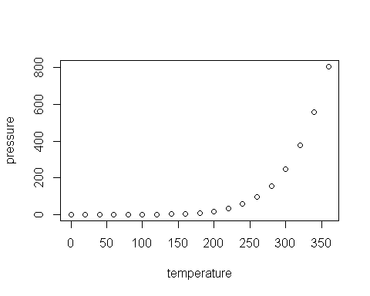

Heading 3
Note that the echo = FALSE parameter was added to the code chunk to prevent printing of the R code that generated the plot.

