Text Mining in R
Contents
PART 1. 2
a) A frequency plot of top 15 words 4
b) A word-cloud of 50 most common words 5
c) Social media usage during breakfast time (6-9 AM) 6
d) Usage per month 8
e) Top-10 words for source=’iPhone’ and source=’Media Studio’. 9
f) 5 words not used in the last six months of the data but frequently used in first six months 12
PART 2 Latent Dirichlet Allocation topic modelling 15
a) k=2 16
b) k=5 18
Analytical Conclusion 19
Bibliography 20

PART 1.

#install packages and load libraries
install.packages(c("wordcloud","RColorBrewer", "tm", "Tidyverse", "textstem",
"scales","topicmodels","LDAvis","servr"))

library(wordcloud)
library(RColorBrewer)
library(tm)
library(tidyverse)
library(textstem)
library(scales)
library(tidytext)
library(stringr)
library(lubridate)
library(ggplot2)
library(dplyr)
library(readr)
library(topicmodels)
library(LDAvis)
library(servr)
library(stringi)
library(quanteda)

#STEP 1 IMPORTING THE DATA
setwd("~/Data")
data_tweets <- read.csv("tweets_data.csv", header=T, sep=",", stringsAsFactors = F)

#removing retweets
ds_tweets <- data_tweets %>%
filter(!str_detect(text, "^RT"))

#STEP 2 CREATING THE CORPUS
text <- ds_tweets$text
docs <- Corpus(VectorSource(text))

#STEP 3 PRE PROCESSING THE DATA
docs <- docs %>%
tm_map(removeNumbers) %>%
tm_map(removePunctuation) %>%
tm_map(stripWhitespace)

remove_url <- function(x) gsub("http[^[:alpha:][:space:]]*","",x)
remove_num_punct <- function(x) gsub("[^[:alpha:][:space:]]*","",x)
removeSpecialChars <- function(x) gsub(".","",x)
removeSpecialChars <- function(x) gsub("[[:punct:]]","",x)
removeEmojis <- function(x) gsub("[^\x01-\x7F]","",x)

docs <- tm_map(docs,removeWords, c("amp","will","just","get",
"many","much","want","say","look","give",
"now","must","take","need","know","can",
"see","use","think","keep","tell",
"people","thank","year","thank","never","come",
"today","time","american","work",
"like","ever","one","day"))
docs <- tm_map(docs,content_transformer(tolower))
docs <- tm_map(docs,removeWords, stopwords("english"))
docs <- tm_map(docs,content_transformer(remove_url))
docs <- tm_map(docs,content_transformer(remove_num_punct ))
docs <- tm_map(docs, removeSpecialChars)
docs <- tm_map(docs, removeSpecialChars)
docs <- tm_map(docs, lemmatize_strings)
docs <- tm_map(docs, removeEmojis)

#STEP 4 CREATE A DOCUMENT TERM MATRIX
dtm <- TermDocumentMatrix(docs)
matrix <- as.matrix(dtm)

#STEP 5 TEXT ANALYSIS
words <- sort(rowSums(matrix),decreasing=TRUE)
df <- data.frame(word=names(words),freq=words)

#STEP 6 TEXT VISUALISATION

- A frequency plot of top 15 words
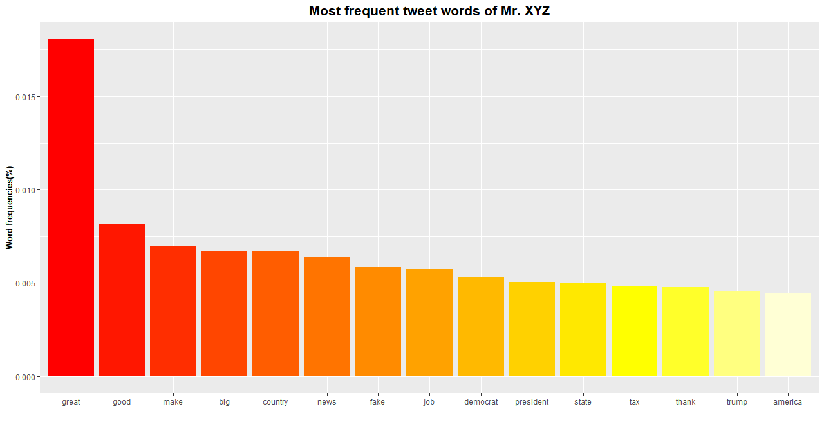
Frequency plot output part (a)
Source code:
#top 15 frequencies
total <- sum(df$freq)
df$frequency <- with(df,freq/total)
top_15 <- top_n(df,15,frequency)

ggplot(top_15,aes(x=reorder(word,-frequency),y=frequency))+
geom_bar(stat="identity") +
ggtitle("Most frequent tweet words of Mr. XYZ") +
theme(plot.title=element_text(face="bold",size=16, hjust=0.5)) +
labs(y= "Word frequencies(%)",x="") +
theme(axis.title.y=element_text(face="bold",size=10)) +
geom_col(fill=heat.colors(n=15))

- A word-cloud of 50 most common words
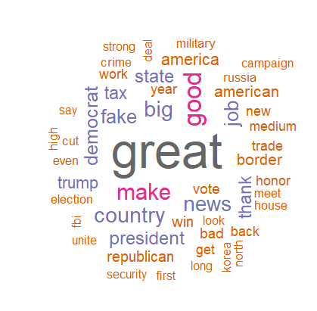
Word-cloud output part (b)
Source code:
set.seed(1234)
wordcloud(words = df$word,
freq=df$frequency,
min.freq = 1,
max.words = 50,
random.order = FALSE,
rot.per = 0.25,
colors = brewer.pal(11,"Dark2"))

- Social media usage during breakfast time (6-9 AM)
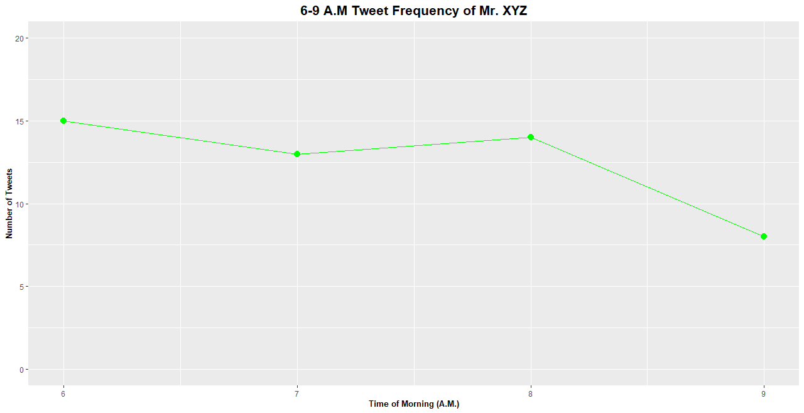
Frequency plot by hour output part (c)
Analytical findings:
From the first graph we see that Mr. XYZ is online during the breakfast period however considering this tweet data is over a 589 day period he is not a frequent morning user.
To dive deeper into the timeline of when Mr. XYZ was active in the morning a plot looking at the timeline of tweets during this period was created.
Source code:
#filtering 6-9 a.m. (inclusive of retweets)
hours_data <- strftime(data_tweets$date, format="%H")
hours_df <- as.data.frame(table(hours_data))
hours_df$hours_data <- as.numeric(hours_df$hours_data)
hours_df <- hours_df %>%
filter(hours_data >= 6,
hours_data <= 9)

ggplot(hours_df, aes(x=hours_data, y = Freq)) +
geom_point(size=5, shape=20, colour="green") +
geom_line(color="green")+
ggtitle("6-9 A.M Tweet Frequency of Mr. XYZ") +
theme(plot.title=element_text(face="bold",size=16, hjust=0.5)) +
labs(y="Number of Tweets", x="Time of Morning (A.M.)") +
theme(axis.title.y=element_text(face="bold",size=10)) +
theme(axis.title.x=element_text(face="bold",size=10)) +
ylim(0,20)

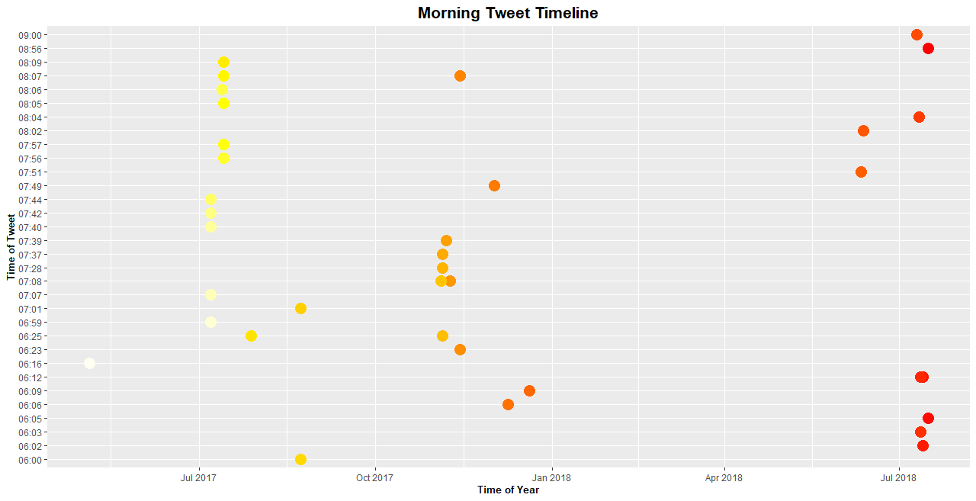
Frequency plot timeline output part (c)
Analytical findings:
The second graph displays in more detail the times of the year at which Mr. XYZ is more frequently tweeting between the hours of 6 to 9 a.m. As seen from the graph in the month of July for both 2017 and 2018 he is active between these times. Since Mr. XYZs twitter usage is predominantly politically motivated perhaps significant American political events happened at this time. This could possibly be related to the U.S independence day on the 4th of July, whom Trump, as president at the time had been previously criticized for politicizing the day (Waldstreicher, 2019).
Source code:
#seperate date and time column
data_tweets$Date <- as.Date(data_tweets$date)
data_tweets$Time <- format(as.POSIXct(data_tweets$date), format = "%H:%M")

time_df <- data_tweets%>%
filter(Time >= "06:00",
Time <= "09:00")

#further analysis
ggplot(time_df, aes(x=Date, y=Time)) +
geom_point(size=5, shape=19, colour=heat.colors(n=37)) +
ggtitle("Morning Tweet Timeline") +
theme(plot.title=element_text(face="bold",size=16, hjust=0.5)) +
labs(y="Time of Tweet", x="Time of Year") +
theme(axis.title.y=element_text(face="bold",size=10)) +
theme(axis.title.x=element_text(face="bold",size=10))

- Usage per month
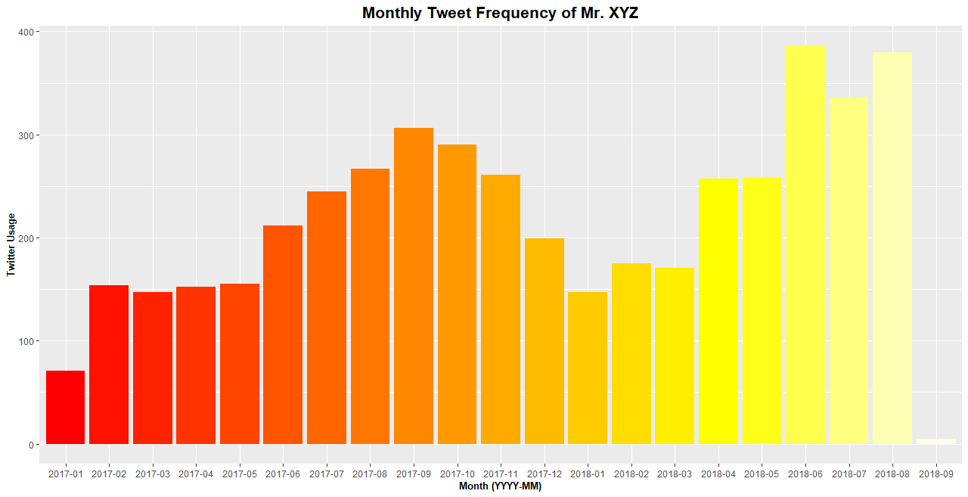
Usage plot output part (d)
Source code:
#filtering months (inclusive of retweets)
data_tweets$Date <- format(as.Date(data_tweets$Date), format = "%Y-%m")

#create dataframe with frequencies
months_df <- data_tweets %>%
mutate(Date) %>%
group_by(id, Date) %>%
mutate(frequency = n_distinct(id)) %>%
group_by(frequency,Date)

months_df <- months_df %>%
select(Date,frequency)%>%
group_by(frequency, Date)%>%
count(Date)

ggplot(months_df, aes(x=Date, y = n)) +
geom_bar(stat="identity")+
ggtitle("Monthly Tweet Frequency of Mr. XYZ") +
xlab("Month (YYYY-MM)") +
ylab("Twitter Usage")+
theme(plot.title=element_text(face="bold",size=16, hjust=0.5)) +
theme(axis.title.y=element_text(face="bold",size=10)) +
theme(axis.title.x=element_text(face="bold",size=10)) +
geom_col(fill=heat.colors(n=21))

- Top-10 words for source=’iPhone’ and source=’Media Studio’.
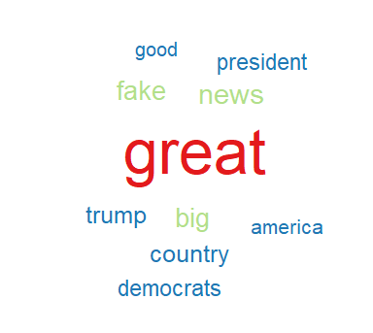
iPhone word-cloud output part (e)
Source code:
#filter iphone tweets
iphone_tweets <- ds_tweets %>%
filter(str_detect(source, "Twitter for iPhone"))

#STEP 2 CREATING THE CORPUS
iphone_text <- iphone_tweets$text
iphone_docs <- Corpus(VectorSource(iphone_text))

#STEP 3 PREPROCESSING THE DATA
iphone_docs <- iphone_docs %>%
tm_map(removeNumbers) %>%
tm_map(removePunctuation) %>%
tm_map(stripWhitespace)

iphone_docs <- tm_map(iphone_docs,content_transformer(tolower))
iphone_docs <- tm_map(iphone_docs,removeWords, stopwords("english"))
iphone_docs <- tm_map(iphone_docs,removeWords, c("amp","will","just","get",
"many","much","want","say","look","give",
"now","must","take","need","know","can",
"see","use","think","keep","tell",
"people","thank","year","thank","never","come",
"today","time","american","work",
"like","ever","one","day"))
iphone_docs <- tm_map(iphone_docs,content_transformer(remove_url))
iphone_docs <- tm_map(iphone_docs,content_transformer(remove_num_punct ))
iphone_docs <- tm_map(iphone_docs, removeSpecialChars)
iphone_docs <- tm_map(iphone_docs, removeSpecialChars)
iphone_docs <- tm_map(iphone_docs, removeEmojis)
iphone_docs <- tm_map(iphone_docs, lemmatize_strings)

#STEP 4 CREATE A DOCUMENT TERM MATRIX
iphone_dtm <- TermDocumentMatrix(iphone_docs)
iphone_matrix <- as.matrix(iphone_dtm)

#STEP 5 TEXT ANALYSIS
iphone_words <- sort(rowSums(iphone_matrix),decreasing=TRUE)
iphone_df <- data.frame(word=names(iphone_words),freq=iphone_words)

#STEP 6 TEXT VISUALISATION
set.seed(1234)
wordcloud(words = iphone_df$word,
freq=iphone_df$freq,
min.freq = 1,
max.words = 10,
rot.per = 0,
random.order = FALSE,
colors = brewer.pal(6,"Paired"))
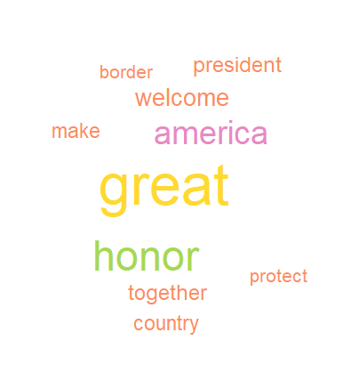
Media Studio word-cloud output part (e)
Analytical findings:
Tweet words from both sources are evidently in favour of the American president at that time, Donald Trump. From the Media Studio tweet words, the words ‘make’, ‘America’, and ‘great’ suggest frequent tweets of Trumps slogan “Make America great again” (Barry, 2016) While the iPhone tweet words include ‘fake’, and ‘news’ another frequent slogan termed by Donald Trump. Therefore, from this analysis it is very likely that both accounts are managed by the same person due to the common political views.
Source code:
#filtering media studio tweets
studio_tweets <- ds_tweets %>%
filter(str_detect(source, "Media Studio"))

#STEP 2 CREATING THE CORPUS
studio_text <- studio_tweets$text
studio_docs <- Corpus(VectorSource(studio_text))

#STEP 3 PREPROCESSING THE DATA
studio_docs <- studio_docs %>%
tm_map(removeNumbers) %>%
tm_map(removePunctuation) %>%
tm_map(stripWhitespace)

studio_docs <- tm_map(studio_docs,content_transformer(tolower))
studio_docs <- tm_map(studio_docs,removeWords, stopwords("english"))
studio_docs <- tm_map(studio_docs,removeWords, c("amp","will","just","get",
"many","much","want","say","look","give",
"now","must","take","need","know","can",
"see","use","think","keep","tell",
"people","thank","year","thank","never","come",
"today","time","american","work",
"like","ever","one","day"))
studio_docs <- tm_map(studio_docs,content_transformer(remove_url))
studio_docs <- tm_map(studio_docs,content_transformer(remove_num_punct ))
studio_docs <- tm_map(studio_docs, removeSpecialChars)
studio_docs <- tm_map(studio_docs, removeSpecialChars)
studio_docs <- tm_map(studio_docs, removeEmojis)
studio_docs <- tm_map(studio_docs, lemmatize_strings)

#STEP 4 CREATE A DOCUMENT TERM MATRIX
studio_dtm <- TermDocumentMatrix(studio_docs)
studio_matrix <- as.matrix(studio_dtm)

#STEP 5 TEXT ANALYSIS
studio_words <- sort(rowSums(studio_matrix),decreasing=TRUE)
studio_df <- data.frame(word=names(studio_words),freq=studio_words)

#STEP 6 TEXT VISUALISATION
wordcloud(words = studio_df$word,
freq=studio_df$freq,
min.freq = 1,
max.words = 10,
rot.per = 0,
random.order = FALSE,
colors = brewer.pal(6,"Set2"))

- 5 words not used in the last six months of the data but frequently used in first six months

Word-cloud output part (f)
Analytical findings:
Note: ICYMI – In Case You Missed It
The high frequency of ‘obamacare’ and ‘ocare’ further supports the possible politically motivated tweets against democratic previous president Barrack Obama whose presidential term ended in January of 2017 (BBC, 2017).
Additionally, the word ‘karen’ most likely references to Karen Handel, a republican party member who became the first female republican to be elected to congress from Georgia, after narrowly defeating her democratic opponent in mid-2017 (Fausset & Martin, 2017).
Source code:
#filter first 6 months tweets
min(ds_tweets$date)

first_tweets <- ds_tweets %>%
filter(date >= as.Date("2017-01-20"),
date <= as.Date("2017-07-20"))

#STEP 2 CREATING THE CORPUS
first_text <- first_tweets$text
first_docs <- Corpus(VectorSource(first_text))

#STEP 3 PREPROCESSING THE DATA
first_docs <- first_docs %>%
tm_map(removeNumbers) %>%
tm_map(removePunctuation) %>%
tm_map(stripWhitespace)

first_docs <- tm_map(first_docs,content_transformer(tolower))
first_docs <- tm_map(first_docs,removeWords, stopwords("english"))
first_docs <- tm_map(first_docs,removeWords, c("amp","will","just","get",
"many","much","want","say","look","give",
"now","must","fakenews","weekly","take","need","know","can",
"see","use","think","keep","tell",
"people","thank","year","thank","never","come",
"today","time","american","work",
"like","ever","one","day"))
first_docs <- tm_map(first_docs,content_transformer(remove_url))
first_docs <- tm_map(first_docs,content_transformer(remove_num_punct ))
first_docs <- tm_map(first_docs, removeSpecialChars)
first_docs <- tm_map(first_docs, removeEmojis)
first_docs <- tm_map(first_docs, lemmatize_strings)

#STEP 4 CREATE A DOCUMENT TERM MATRIX
first_dtm <- TermDocumentMatrix(first_docs)
first_matrix <- as.matrix(first_dtm)

#STEP 5 TEXT ANALYSIS
first_words <- sort(rowSums(first_matrix),decreasing=TRUE)
first_df <- data.frame(word=names(first_words),freq=first_words)

#filter last 6 months tweets
max(ds_tweets$date)

last_tweets <- ds_tweets %>%
filter(date <= as.Date("2018-09-01"),
date >= as.Date("2018-03-01"))

#STEP 2 CREATING THE CORPUS
last_text <- last_tweets$text
last_docs <- Corpus(VectorSource(last_text))

#STEP 3 PREPROCESSING THE DATA
last_docs <- last_docs %>%
tm_map(removeNumbers) %>%
tm_map(removePunctuation) %>%
tm_map(stripWhitespace)

last_docs <- tm_map(last_docs,content_transformer(tolower))
last_docs <- tm_map(last_docs,removeWords, stopwords("english"))
last_docs <- tm_map(last_docs,removeWords, c("amp","will","just","get",
"many","much","want","say","look","give",
"now","must","take","need","know","can",
"see","use","think","keep","tell",
"people","thank","year","thank","never","come",
"today","time","american","work",
"like","ever","one","day"))
last_docs <- tm_map(last_docs,content_transformer(remove_url))
last_docs <- tm_map(last_docs,content_transformer(remove_num_punct ))
last_docs <- tm_map(last_docs, removeSpecialChars)
last_docs <- tm_map(last_docs, removeEmojis)
last_docs <- tm_map(last_docs, lemmatize_strings)

#STEP 4 CREATE A DOCUMENT TERM MATRIX
last_dtm <- TermDocumentMatrix(last_docs)
last_matrix <- as.matrix(last_dtm)

#STEP 5 TEXT ANALYSIS
last_words <- sort(rowSums(last_matrix),decreasing=TRUE)
last_df <- data.frame(word=names(last_words),freq=last_words)

#remove common words
old_words <- first_df %>%
filter(!(first_df$word %in% last_df$word))

#STEP 6 TEXT VISUALISATION
set.seed(1234)
wordcloud(words = old_words$word,
freq=old_words$freq,
min.freq = 1,
max.words = 5,
random.order = FALSE,
rot.per = 0,
colors = brewer.pal(8,"Paired"))

PART 2 Latent Dirichlet Allocation topic modelling

ap_lda <- LDA(dtm, k = 2, control = list(seed = 1234))
ap_topics <- tidy(ap_lda, matrix = "beta")

ap_top_terms <- ap_topics %>%
group_by(topic) %>%
slice_max(beta, n = 10) %>%
ungroup() %>%
arrange(topic, -beta)

df_title <- data.frame(doc_id=row.names(ds_tweets),
text=ds_tweets$text)

#STEP 2 CREATING THE CORPUS
post1_docs=Corpus(DataframeSource(df_title))

#STEP 3 PREPROCESSING THE DATA
cor1 <- tm_map(post1_docs, stripWhitespace)
post1_docs <- tm_map(post1_docs,content_transformer(tolower))
post1_docs <- tm_map(post1_docs,removeWords, stopwords("english"))
post1_docs <- tm_map(post1_docs,removeWords, c("amp","will","just","get",
"many","much","want","say","look","give",
"now","must","take","need","know","can",
"see","use","think","keep","tell",
"people","thank","year","thank","never","come",
"today","time","american","work",
"like","ever","one","day", "https"))
post1_docs <- tm_map(post1_docs,content_transformer(remove_url))
post1_docs <- tm_map(post1_docs,content_transformer(remove_num_punct ))
post1_docs <- tm_map(post1_docs, removeSpecialChars)
post1_docs <- tm_map(post1_docs, removeEmojis)
post1_docs <- tm_map(post1_docs, removeNumbers)
post1_docs <- tm_map(post1_docs, removePunctuation)
post1_docs <- tm_map(post1_docs, lemmatize_strings)

#STEP 4 CREATE A DOCUMENT TERM MATRIX
post1_dtm <- DocumentTermMatrix(cor1)

# eliminating empty rows
rowTotals <- apply(post1_dtm , 1, sum)
post1_dtm <- post1_dtm[rowTotals> 0, ]

#STEP 5 TEXT ANALYSIS

k=2
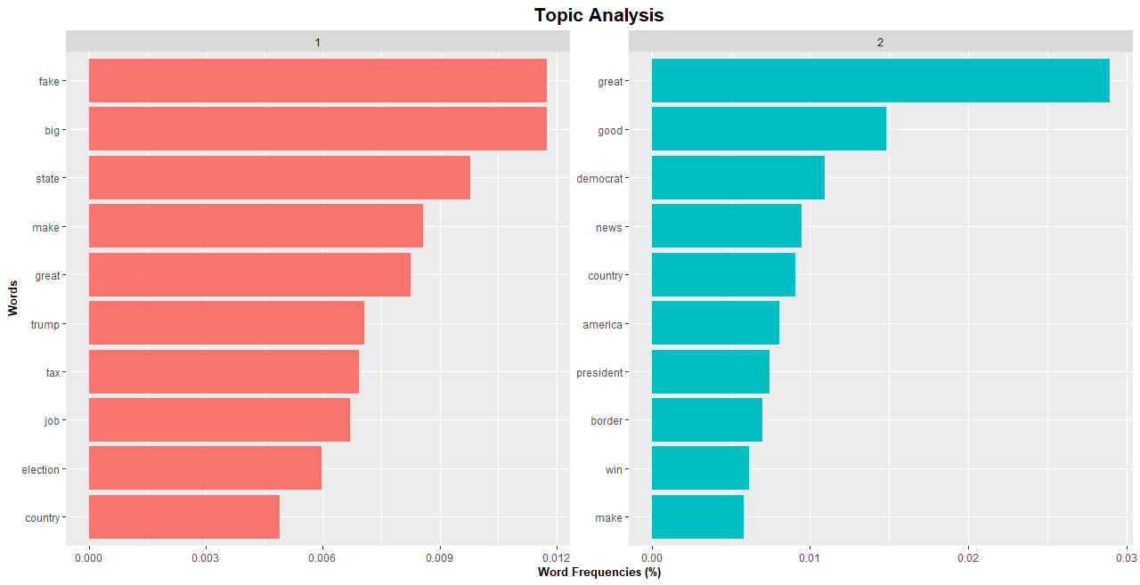
Word-cloud output part (a)
Analytical findings:
Looking at Topic 1 the frequent words seem to be surrounding the issue of the presidential election since ‘election’ and ‘trump’ are among those most frequent. The higher frequency of ‘tax’ could also be related to Trumps 2017 corporate tax-cuts (Kane, 2021). Therefore these tweets could be surrounding the aftermath of the 2016 election, and presidential promises made by Donald Trump, which the user seems to be in favour of given the high frequency of the word ‘great’.
On the other hand, for Topic 2 these tweets may be more critical. Words like ‘democrat’ suggest criticism from the twitter user, and ‘border’ inferring tweets about the border between Mexico and the U.S (BBC, 2019).
In summary comparing the two topics, the first topic seems to be in praise for Trumps election campaign and actions whereas the second topic seems to be more catered towards demanding action and criticism of the other political parties, namely Trumps opposition, the democratic party.

Source code:
#2 CLUSTERS, k=2
ap_lda <- LDA(post1_dtm, k = 2, control = list(seed = 1234))
ap_topics <- tidy(ap_lda, matrix = "beta")

ap_top_terms <- ap_topics %>%
group_by(topic) %>%
slice_max(beta, n = 10) %>%
ungroup() %>%
arrange(topic, -beta)

#STEP 6 TEXT VISUALISATION
ap_top_terms %>%
mutate(term = reorder_within(term, beta, topic)) %>%
ggplot(aes(beta, term, fill = factor(topic))) +
geom_col(show.legend = FALSE) +
facet_wrap(~ topic, scales = "free") +
scale_y_reordered() +
ggtitle("Topic Analysis") +
ylab("Words") +
xlab("Word Frequencies (%)")+
theme(plot.title=element_text(face="bold",size=16, hjust=0.5)) +
theme(axis.title.y=element_text(face="bold",size=10)) +
theme(axis.title.x=element_text(face="bold",size=10))

b) k=5
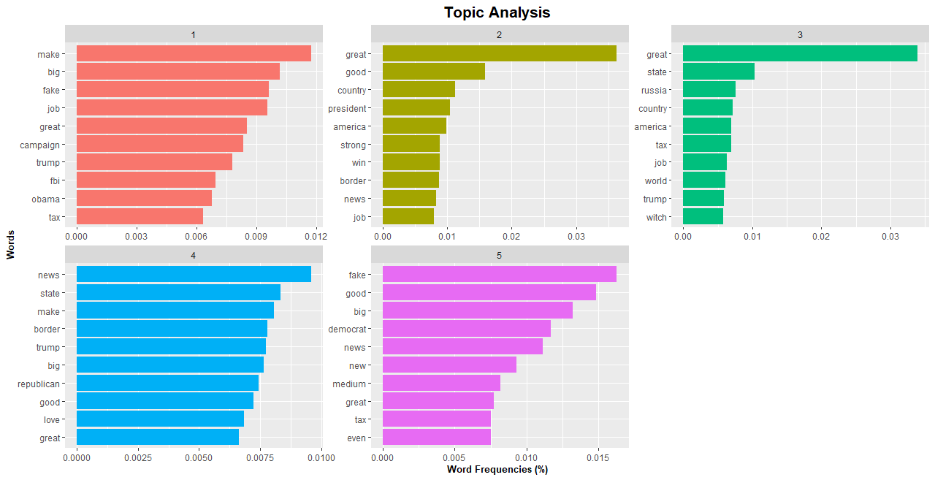
Word-cloud output part (b)
Analytical findings:
Looking at Topic 1 the frequent words seem to be surrounding the presidential campaign and support for Donald Trump since ‘campaign’, ‘trump’, ‘make’, ‘America’, and ’great’ are included. The words ‘obama’ and ‘fbi’ further support this given the FBI interference in the 2016 election with the Hillary Clinton email scandal, Trumps opposition (CBS, 2016).
Moving on to Topic 2, the words here seem to be in praise of Trump since words included are ‘president’, ‘strong’, ‘good’ and ‘win’.
Topic 3 on the other hand, seems to be tweets surrounding the issues of global politics and namely Russia including ‘Russia’ and ‘world’.
Topic 4 indicates that the user is a supporter of the republicans, the American political party with words ‘republican’, ‘good’ and ‘love’.
Lastly Topic 5 indicates news surrounding the democratic party with words ‘democrat’ and ‘new’ and ‘news’. From previous examination of Mr. XYZs tweets it is possible these tweets could be politically critical in nature.
In summary, the first topic patterns suggest words surrounding the presidential election, the second topic suggests support for Donald Trump as president, the third topic suggests discussion surrounding global issues, the fourth topic suggests support for the republican party and the final topic suggests urgent news surrounding the democratic party.
Comparing the 2 and 5 clusters it is clear more distinct topics can be found in the 5 topic analysis whereas the 2 topic analysis is much broader.

Source code:

ap_lda_2 <- LDA(post1_dtm, k = 5, control = list(seed = 1234))
ap_topics_2 <- tidy(ap_lda_2, matrix = "beta")

ap_top_terms_2 <- ap_topics_2 %>%
group_by(topic) %>%
slice_max(beta, n = 10) %>%
ungroup() %>%
arrange(topic, -beta)

#STEP 6 TEXT VISUALISATION
ap_top_terms_2 %>%
mutate(term = reorder_within(term, beta, topic)) %>%
ggplot(aes(beta, term, fill = factor(topic))) +
geom_col(show.legend = FALSE) +
facet_wrap(~ topic, scales = "free") +
scale_y_reordered() +
ggtitle("Topic Analysis") +
ylab("Words") +
xlab("Word Frequencies (%)")+
theme(plot.title=element_text(face="bold",size=16, hjust=0.5)) +
theme(axis.title.y=element_text(face="bold",size=10)) +
theme(axis.title.x=element_text(face="bold",size=10))

Analytical Conclusion
From analysis of My. XYZs tweets, it is evident that Mr. XYZ uses his twitter accounts predominantly for political motivation, therefore suggesting he is a frequent news source for American politics. However, given the nature of the words in his tweets the news sources he provides seems to be biased in nature towards support of the Republican party and previous president Donald Trump.

Bibliography
Barry, S., 2016. What made Trump's 'Make America Great Again' slogan so powerful?. [online] TheJournal.ie. Available at: <https://www.thejournal.ie/trump-slogan-make-america-great-again-3071552-Nov2016/> [Accessed 26 April 2021].
BBC News. 2017. How Obama spent his last day. [online] Available at: <https://www.bbc.com/news/av/world-us-canada-38699742> [Accessed 27 April 2021].
Bbc.co.uk. 2019. Why does Donald Trump want to build a wall?. [online] Available at: <https://www.bbc.co.uk/newsround/46811167> [Accessed 28 April 2021].
Cbsnews.com. 2016. Hillary Clinton email case reopened. [online] Available at: <https://www.cbsnews.com/video/hillary-clinton-email-case-reopened/> [Accessed 28 April 2021].
Kane, P., 2021. Republicans view 2017 tax law the way Democrats view Obamacare: As a signature achievement they will fight to keep. [online] Washington Post. Available at: <https://www.washingtonpost.com/powerpost/biden-republicans-tax-cuts/2021/04/29/b9e21b54-a877-11eb-8d25-7b30e74923ea_story.html> [Accessed 30 April 2021].
Martin, J. and Fausset, R., 2017. Karen Handel Wins Georgia Special Election, Fending Off Upstart Democrat (Published 2017). [online] Nytimes.com. Available at: <https://www.nytimes.com/2017/06/20/us/politics/karen-handel-georgia-special-election.html> [Accessed 30 April 2021].
Waldstreicher, D., 2019. The Fourth of July Has Always Been Political. [online] The Atlantic. Available at: <https://www.theatlantic.com/ideas/archive/2019/07/before-trump-fourth-july-was-already-political/593332/> [Accessed 19 April 2021].

