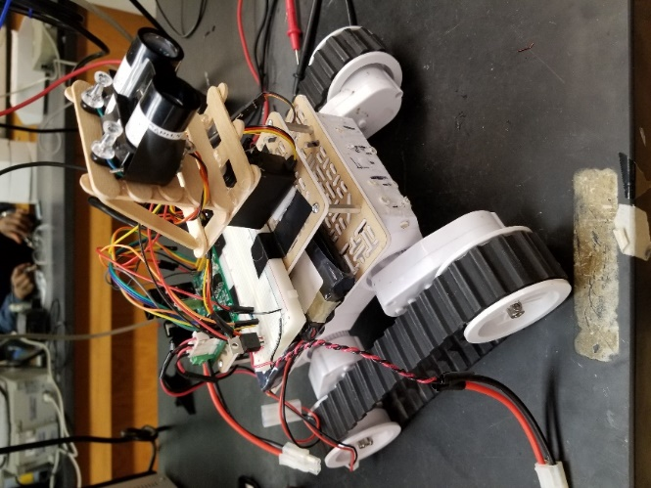

Figure 1: Assembled System [1]

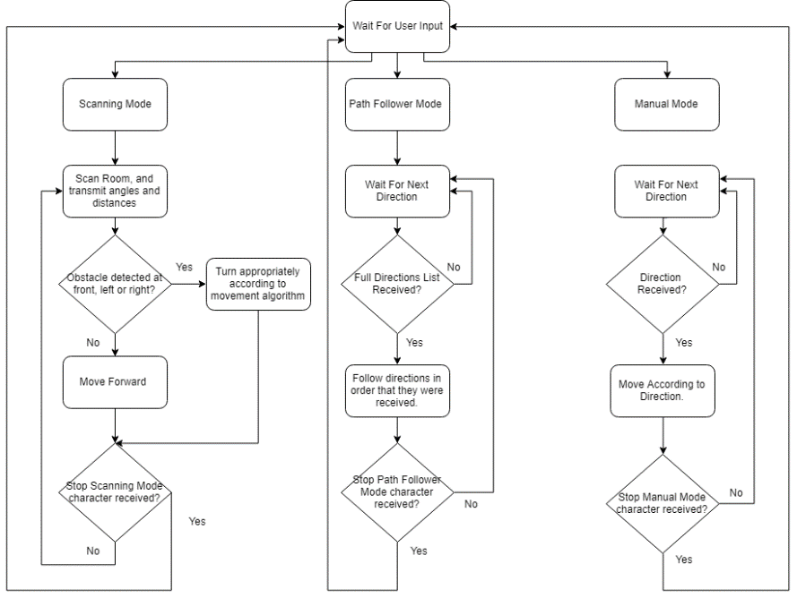

Figure 2: Overall Code Flowchart [2]

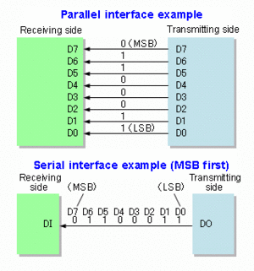

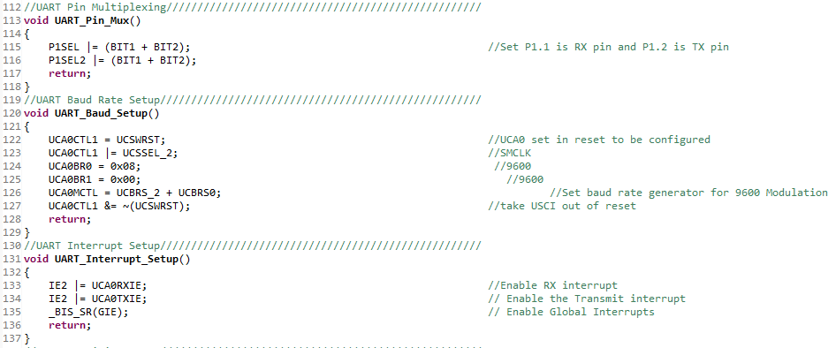Figure 3: Serial Communication Diagram [3]

Figure 4: UART Code [4]

1. LIDAR Sensor Interfacing

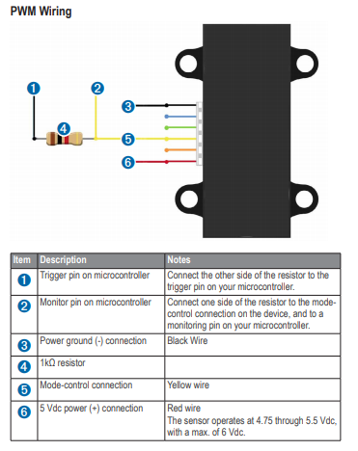

Figure 5: LIDAR Wiring Diagram [5]

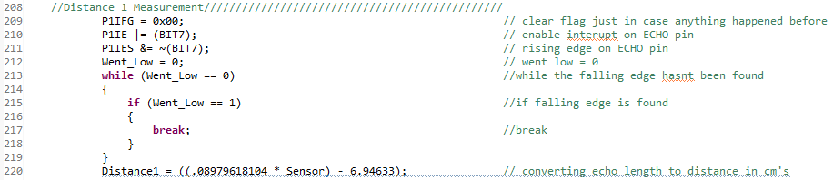

Figure 6: LIDAR Distance Code [6]

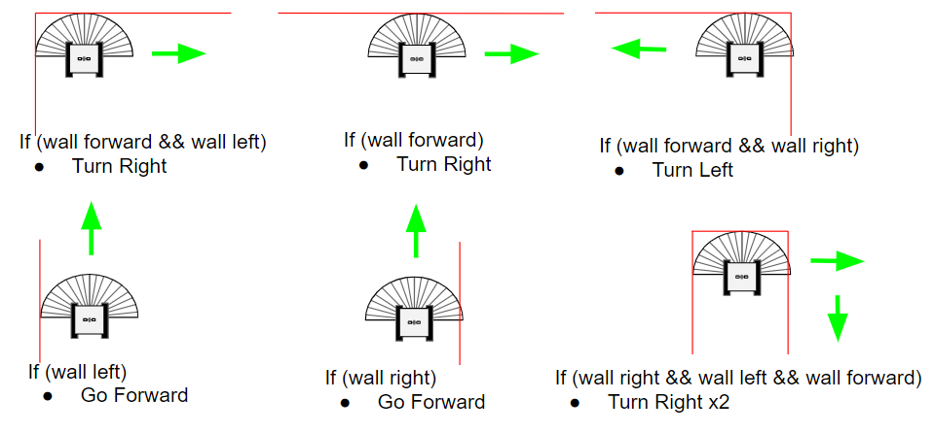4. Rover Movement Code

Figure 7: Movement Algorithm [7]

1. Scanning Mode

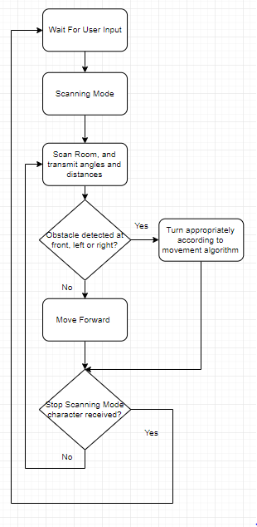

Figure 8: Scanning Mode Flow Chart [8]

1. Path Follower Mode

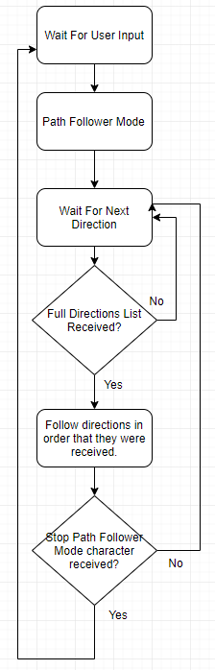

Figure 9: Path-Follower Mode Flow Chart [9]

1. 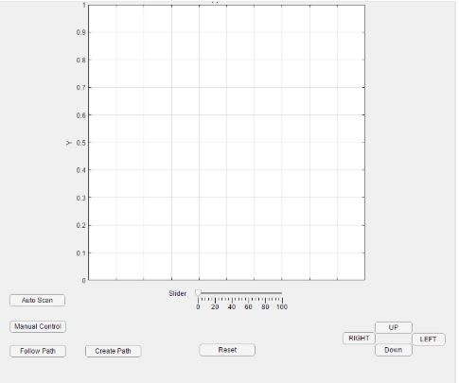GUI Design

Figure 10: GUI Prototype [10]

8. Hardware Setup

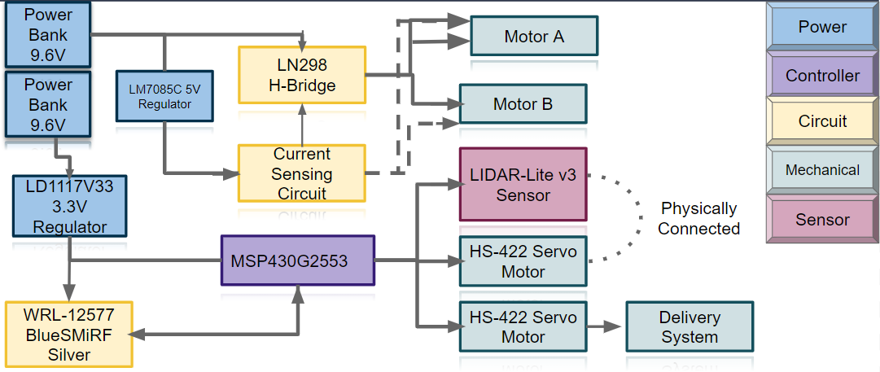

Figure 11: Hardware Flow Chart [11]

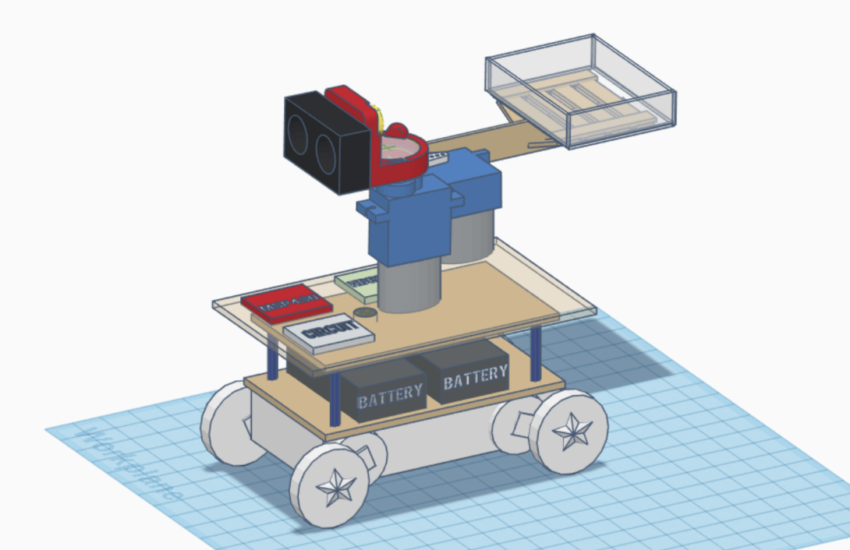

Figure 12: 3D Model Final Design [12]

1. Tzapin, Cindy. Laboratory Notes, 21 October 2018.
2. Salinas, Weston. Self-Made, 21 October 2018.
3. "Serial communication", *En.wikipedia.org*, 2018. [Online]. Available: https://en.wikipedia.org/wiki/Serial_communication. [Accessed: 21- Oct- 2018].
4. Salinas, Weston. Self-Made, 21 October 2018.
5. *Static.garmin.com*, 2018. [Online]. Available: https://static.garmin.com/pumac/LIDAR_Lite_v3_Operation_Manual_and_Technical_Specifications.pdf. [Accessed: 21- Oct- 2018].
6. Salinas, Weston. Self-Made, 21 October 2018.
7. Salinas, Weston. Self-Made, 21 October 2018.
8. Salinas, Weston. Self-Made, 21 October 2018.
9. Salinas, Weston. Self-Made, 21 October 2018.
10. Martinez, Mario. Previous Presentation, 21 October 2018.
11. Gajadhar, Kirina. Previous Presentation, 21 October 2018.
12. Tzapin, Cindy. Previous Presentation, 21 October 2018.