
Acoustic Camera User Manual

Neil Ryan

July 11, 2014
1 Introduction

An acoustic camera operates similarly to an infrared camera, but instead of seeing heat sources, an acoustic camera sees sound intensity. This is done by delay-and-sum beamform- ing - delaying signals based on the travel time of sound to a given reference point, then summing the signals. For reference, our coordinate system is thus: the positive x-axis along the width of the microphone array, increasing from left to right when facing the source (facing the same direction as the microphones), the positive y-axis along the height of the microphone array, increasing from bottom to top, and the positive z-axis as a line perpen- dicular to the plane of the microphone array and the plane of the source, increasing from the array plane to the source plane. The origin is defined on a case by case basis.

2 Hardware Setup

The needed hardware includes 30 microphones (Behringer Measurement condenser ECM8000),
four recording systems that can hold eight microphones each (Presonos FireStudio Project), four firewire cables, 30 microphone cables and a computer with a firewire connection.

As a note, feel free to go against recommendations made, but there may be some lost efciency or accuracy in processing.

Start by inserting each of the 30 microphones into the holes in the PVC apparatus, and securing each with an O-ring. Then, connect the microphones to the recording systems. When facing the potential source (i.e. the same directions as the microphones record from), the bottom left microphone is designated as "microphone 1"(see figure 1,2). Connect mi- crophone 1 to the first channel in the first recording system (the top one in our setup). Microphone 2 is located immediately to the right of microphone 1 (again, when facing the potential source), and should be connected to channel 2 in first recording system. Micro- phone 3 is located to the right of microphone 2, and so on. If our array is six microphones wide, then microphone 7 would be located directly above microphone 1. Pictures of our setup are included at the end.

Next, daisy-chain the recording systems via firewire cables. Connect the computer to the first recording system, the first recording system to the second, the second recording sys- tem to the third, and the third to the fourth. Then, turn on the systems and adjust the sensitivities for the microphones so that there is a perceptible diference between silence and the source. The sensitivities do not need to be the same. If a light on one of the recording systems is blinking blue and red, this means that the clock is not synced across the systems. If this happens, turn everything of and on again. The lights should all be blue before proceeding (see figure 3).

1
3 Recording

After everything is connected and turned on, open Audacity or an alternative recording program (Audacity is recommended). In Audacity, you should be able to select "PreSonos FireStudio" as the source for input. The output source is irrelevant. Set the number of channels to the highest possible, and try recording. It is likely that there will be some channels without any recorded sound. For our setup, the PreSonos FireStudio has the capacity to record from 10 channels, but we only attached eight microphones to each sys- tem, leading to 10 empty channels. Figure out which microphones correspond to which channel in Audacity by setting the sensitivity on microphone 2 of the first system, mi- crophone 3 of the second system, microphone 4 of the third system, and microphone 5 of the fourth system (the fourth system should only have six microphones connected in the 30 microphone setup), to zero. Then, try recording again. In our case, microphones 1-8 were on channels 21-28, microphones 9-16 were on channels 31-38, microphones 17-24 were on channels 1-8, and microphones 25-30 were on channels 11-16. The number of channels can be adjusted for storage efciency (in our case, moving from recording 40 channels to 38).

After recording the source, run Audacity's "Export Multiple" tool. Save all channels, using naming by "numbering after file name prefix" (with or without the empty channels, it is faster and less space efcient to keep them) with a prefix of "m", preferably in an empty directory. If the microphones correspond to the same channels that ours did, there is a tool in the GUI to quickly import this data into Matlab. If not, importMics.m will need to be modified slightly to fit your needs. See the section on the Data Input Screen.

4 Matlab GUI

4.1 Introduction
The graphical user interface (GUI) has four diferent windows, a window to input param-
eters (dataInput), a window to select only some of the microphones to process data from (micSelect), a window to view a single shot of data (graphAnalysis), and a window to pro- cess multiple shots of data into a movie (movieAnalysis). To run the GUI, run dataInput.m and follow the controls inside the GUI.

4.2 Data Input Window
The data input window is an interface for the user to input the variables necessary to run
either the graph analysis or movie analysis window. The variable meanings are explained
below:
Mic Separation - the distance between any two adjacent microphones in the array, which must be consistent throughout. Give as an integer in inches.
Temperature - the temperature of the room where testing is done (to get an exact speed of sound). Give as an integer in degrees Fahrenheit.
Sampling freq - the sampling frequency of the recording system. Give as an integer in

2
Hertz.
Array Width - how many microphones wide the array is. Give as an integer. Array Height - how many microphones high the array is. Give as an integer.
x0,y0 - the coordinates of the bottom left corner of the source plane of interest. Give as integers in inches.
x1,y1 - the coordinates of the top right corner of the source plane of interest. Give as integers in inches.
zp - the z coordinate of the source plane of interest. Give as an integer in inches.
xa,ya,za - the x,y, and z coordinates of the bottom left (BL) microphone of the array when facing the source plane. Give as integers in inches.
X Resolution - the desired resolution of the x-axis resulting image. In other words, for
x0 = 0, x1 = 100, an X resolution of 5 would give processing every five inches. Naturally, a
lower resolution means more processing time. Give as an integer.
Y Resolution - the desired resolution of the y-axis resulting image. In other words, for
y0 = 0, y1 = 100, an Y resolution of 5 would give processing every five inches. Naturally, a
lower resolution means more processing time. Give as an integer.

The Load Mic Data button loads the signals from the microphone array, either as a .mat file or as raw wave files from an Audacity export (see section 3 - Recording). In the former case, .mat file must contain a matrix called signals, where the first column of the matrix corresponds to the data from microphone 1, the second column corresponds to the data from microphone 2, etc. See section 2 - Hardware Setup for a description of the micro- phone numberings. Loading signals from an Audacity export compiles this array from the raw wave data, saves it as a matrix called signals in a user defined location, then deletes the raw wave data. To use this without modifying importMics.m, it is requried that the files have been numbered with a "m" prefix (m-01.wav,m-02.wav,etc). Copy the wave data into another location if it needs to be saved.

The Save State button saves the current values of variables that have been inputed, in- cluding microphone data in a .mat file with a user defined name, in a user defined directory. A value must be assigned to at least one variable to use.

The Load State button loads values of variables from a .mat creates with the Save State button.

The Select Mics, To Image Pan, and To Movie buttons move to the micSelect, graph- Analysis and movieAnalysis windows, respectively. See sections 4.2-4.4 for descriptions of those windows. Moving to the micSelect window requires that xa,ya,Mic Separation, Array Width, and Array Height be given values, and that mic data has been loaded. Moving to the graphAnalysis or movieAnalysis windows requires that all variables be set, and mic data loaded. It is recommended that there be relatively few samples of audio for the graphAnal- ysis tool and relatively many samples of audio for the movieAnalysis, to give an appropriate amount of information for the processing time spent.

3
4.3 Mic Select Window
The mic select window lets the user only use some of the microphones for processing. To
use this tool, the variables xa, ya, mic separation, array width, array height, and signals (mic data matrix) be set. In our case, since the array holds a maximum of 30 microphones, array width must equal 6, array height must equal 5 (since those are the dimensions of our array), and there must be data from 30 microphones in the signals matrix. If other variables have been entered, their values will be stored while the user is on this window.

To select microphones, simply click the buttons of the corresponding microphones. The setup of the toggles is oriented as if the user were facing the source (behind the array). The user must select a single rectangle of microphones, with an area larger than 1. The Clear button de-selects all microphones.
The Continue button adjusts the variables xa, ya, array width, array height, and the sig- nals matrix to fit the selection, and returns the user to the data input window with those values inputed.

4.4 Graph Analysis Window (Image Pan Tool)
The graph analysis tool lets the user pan around their source plane of interest.
The Pan Up and Pan Down shift the y coordinates (y0, y1) up or down, respectively.
The Pan Left and Pan Right buttons shift the x coordinates (x0, x1), left and right,
respectively.
The Increase Depth and Decrease Depth buttons increase or decrease the zp coordinate,
respectively.
The Reset to Original button returns coordinates of the source plane of interest to their original values.
The View Current Plane Coordinates button outputs the coordinates of the current
source plane of interest to the console in the form:

[x0, y0, zp]
[x1, y1, zp]
The pop-up menu labeled Standard lets the user pick between graphing the standard out-
put, or the output with the average of all points subtracted from every point (Subtracted Avg).
The pop-up menu labeled Jet lets the user pick between color schemes for the graph.
The Export Image button lets the user save the current image as a .jpg, .png, or .bmp file.
The Select New Data button returns the user to the data input window with the option of saving the values of all variables.
Note: The program reprocesses every time a pan button is pressed. Signals with fewer samples means the processing time will be faster.
The tick marks along the graph correspond to the x and y coordinates of the source plane, when the numbers along the marks are multiplied by the respective resolution.

4
4.5 Movie Analysis Screen
The movie analysis tool lets the user view the source as a movie.
Frames per Second - the number of movie frames that will be processed per second. More frames per second means more processing time. Give as an integer.
The desired frames per second must be entered before creating the movie. The Create Movie button creates and stores the movie data.
The Play button cycles through the movie frames at inputed frames per second, with the time of the current frame displayed below the axis.
Play 2x speed and Play 1/2 Speed play the movie twice and half as fast, respectively. With all three of these, pressing them again pauses the movie. The user must pause at one speed before starting at another speed.
When the movie is paused, the user can press the Stop button, returning to the first movie frame.
The Rewind button cycles through the frames at the inputed frames per second, in reverse. Pressing it again while rewinding pauses the rewind.
Pressing the Repeat On toggle makes playback return to the beginning upon reaching the final frame when playing at any of the three speeds (normal, double, half).
When the movie is not playing or rewinding, the user can change the Jet pop-up menu, changing the color scheme of the movie, or the Contour pop-up menu, changing the type of graph displayed (Contour or Surf).
The Select New Data button returns to the data input window, with the option of saving the variable state.
The Export to AVI button saves the movie in a user designated location with a user defined filename.

5
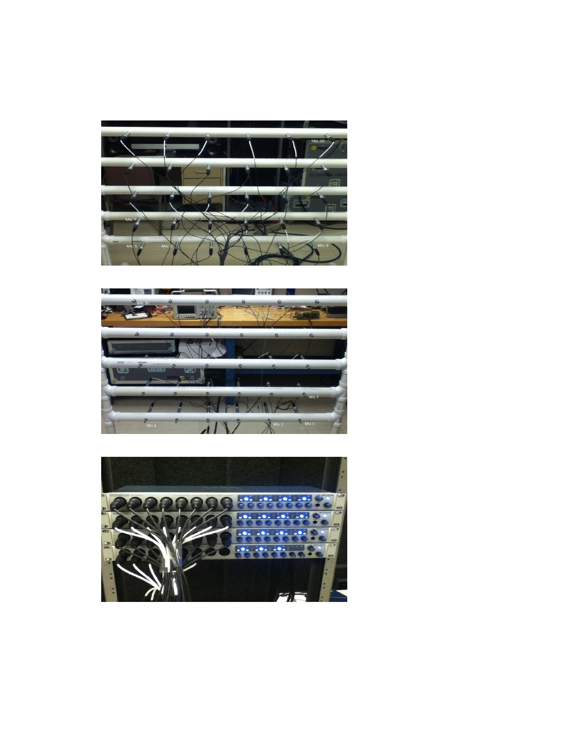
5 Our Setup

Figure 1: The back of our
array

Figure 2: The front of our
array

Figure 3: Readied record-
ing systems

6

