Smart Pet Feeder

Candidate: Damșa Andra-Miruna, Tămășilă Mara
Session: June 2026

- INTRODUCTION
1.1 Reasoning for choosing the subject
We chose this project because both team members own indoor pets and were interested in finding a simpler and more efficient way to manage their feeding schedules. When we discovered the Smart Pet Feeder concept, we saw it as an opportunity to develop a practical solution to a real-life problem while applying the IoT technologies and concepts studied throughout the course.
1.2 Introduction of project
The Smart Pet Feeder is an IoT-based system designed to help pet owners manage their pets' feeding routines. The project combines automated feeding, sensor-based monitoring, and a web application to provide an easy and reliable way of controlling and monitoring the feeder. In addition, the system also includes an AI-powered nutrition consultant that analyzes pet characteristics such as species, breed, age and weight in order to generate some personalized feeding recommandations for the pet owners.
2.SYSTEM DESIGN
2.1 Technologies and tools
This section covers the main technologies and components used to build the Smart Pet Feeder, along with the reasoning behind each choice.
1. React was used to build the web-based user interface. Its component-based structure keeps the frontend organised and easy to maintain, and since it handles asynchronous state updates well, it's a natural fit for displaying live sensor data.
2. Flask was picked as the backend framework because it's lightweight, straightforward to work with, and easy to extend with plugins and additional modules. Together with React, it keeps the development process simple while still leaving room to add more advanced features down the line [2].
3. Firebase Realtime Database was chosen as the main data store because it syncs data across multiple clients in real time and integrates cleanly with both Python and JavaScript , which made it a practical choice given the project's stack.
4. AWS IoT Core serves as the MQTT message broker, handling secure communication between the cloud backend and the physical device. It supports TLS encryption and X.509 certificate-based authentication, making it a dependable and secure option for device messaging.
5. MQTT (Message Queuing Telemetry Transport) is a lightweight publish/subscribe protocol built with constrained IoT environments in mind. Its minimal bandwidth usage and topic-based message routing make it well suited for passing sensor data and control commands between components [2]. In practice, devices publish messages to specific topics while other clients subscribe to those topics, which allows for efficient and scalable communication across the system [3].
6. Raspberry Pi 5 was chosen as the edge computing device for its affordability, built-in GPIO support, and ability to connect with multiple sensors and communication modules at the same time [2].
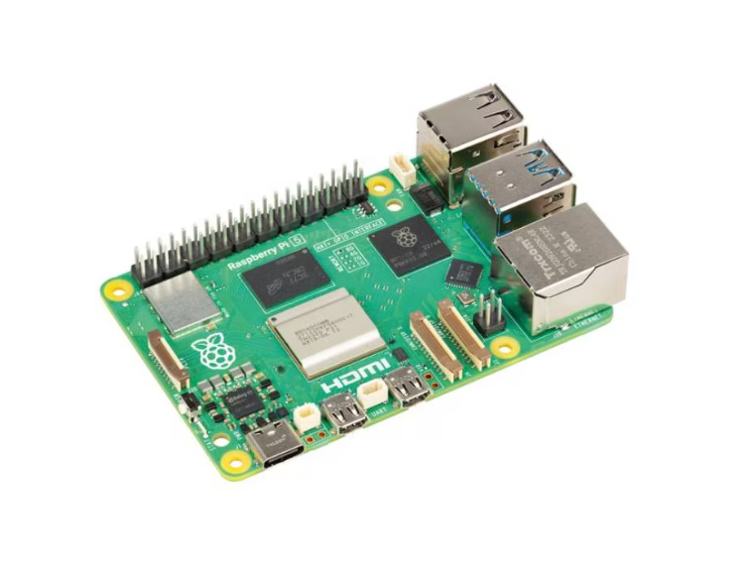
7.ESP32 takes care of low-level servo control, thanks to its hardware PWM support and the fact that it can interface directly with the Raspberry Pi over a USB serial connection.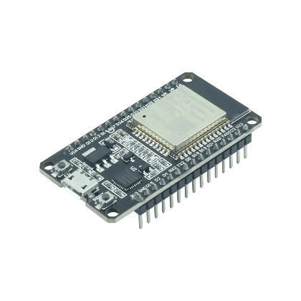
8.HX711 is a 24-bit analog-to-digital converter designed for use with load cells. It was selected for its reliability and accuracy in weight measurement, which is essential for features like portion control and inventory monitoring [1].
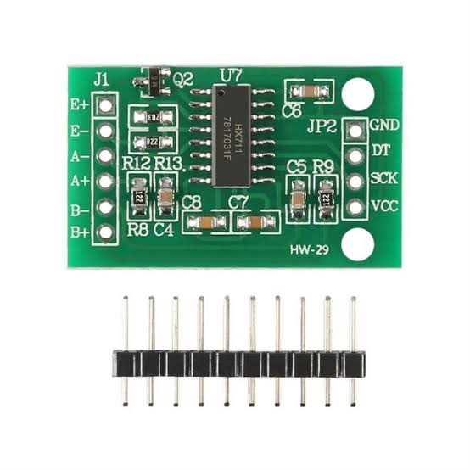
9. AWS EC2 provides the cloud instance where both the Flask API and the bridge.py service are hosted, offering a scalable and accessible environment for deployment.
2.2 Software arhitecture
The software architecture of the Smart Pet Feeder describes the organization of the software components that enable communication between the web application, cloud services, and IoT device. The purpose of this architecture is to define the responsibilities of each software module, explain how data is processed and exchanged throughout the system.
The Smart Pet Feeder is based on an Internet of Things (IoT) architecture that combines edge devices, cloud services, and a web-based user interface. Sensor data collected by the hardware components is transmitted through AWS IoT Core and processed by backend services hosted on an Amazon EC2 instance. The processed information is stored in a Firebase Realtime Database, which serves as the central data repository for the application. Through a web dashboard, users can monitor the feeder status, configure feeding schedules, remotely trigger food dispensing actions, and interact with an AI-powered nutrition consultant capable of generating personalized feeding recommendations based on the pet's characteristics.
Figure 1 presents the overall system design and highlights the communication paths between the different layers of the system, including the client layer, application layer, cloud services layer, edge computing layer, and hardware layer.

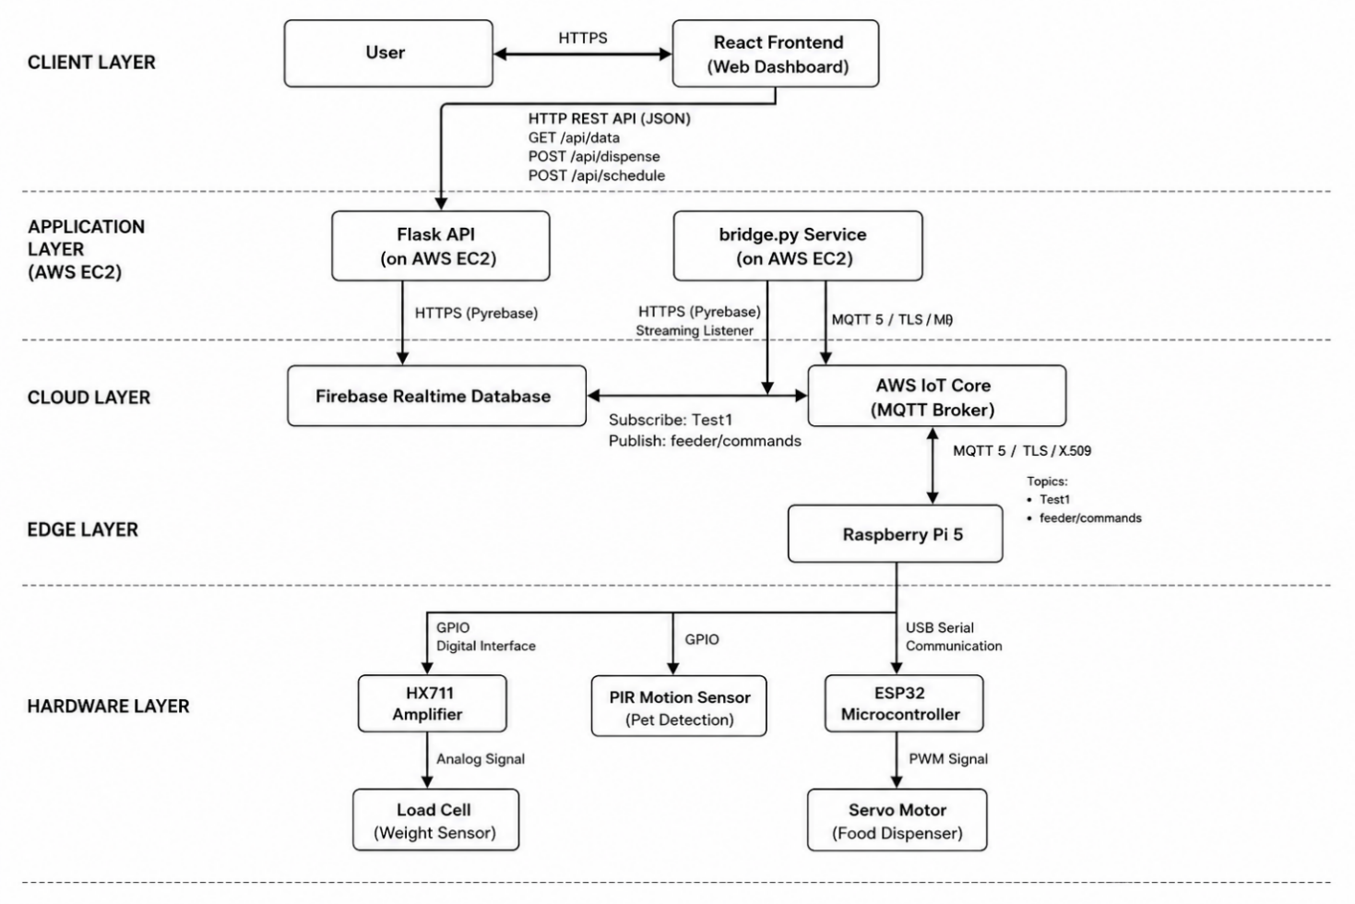
Figure 1. System Design Details
At the client layer, users interact with the system through a React-based web dashboard. Communication between the user and the dashboard is performed over HTTPS, allowing users to monitor food levels, view pet activity, configure feeding schedules, manually trigger feeding actions. The dashboard also provides access to the AI Nutrition Consultant, where users can submit information about their pet, including species, breed, age, and weight. The generated recommendations are displayed directly within the interface and can be compared against the pet's measured food consumption. The React frontend communicates with the Flask API hosted on an AWS EC2 instance through REST API endpoints that exchange data in JSON format.
The application layer consists of two independent backend services running on the EC2 instance: the Flask API and the bridge.py service. The Flask API acts as the interface between the web application and the cloud database. Using the Pyrebase library, it communicates with the Firebase Realtime Database through HTTPS requests, retrieving live sensor data, historical records, and feeding schedules, while also storing user-created schedules, feeding commands, and AI-generated pet profiles containing recommended daily food intake, feeding frequency, and breed-specific health considerations.
The bridge.py service serves as the communication bridge between the cloud infrastructure and the IoT device. Through the Pyrebase library, it continuously exchanges information with Firebase, storing incoming sensor readings, maintaining historical records, monitoring user commands, and checking configured feeding schedules. Although both backend services use Firebase, they do not communicate directly with each other; instead, Firebase acts as the intermediary layer for data exchange.
The cloud layer contains Firebase Realtime Database and AWS IoT Core.Firebase functions as the central repository for all application data, including live feeder status, historical measurements, schedules, feeding commands, and AI-generated pet profiles. These profiles store nutritional recommendations generated by the AI consultant and remain available across application sessions.AWS IoT Core operates as the MQTT broker responsible for secure communication between the cloud and the Raspberry Pi.
The bridge.py service connects to AWS IoT Core using the AWS IoT Device SDK for Python v2 and communicates through the MQTT 5 protocol secured with TLS encryption and X.509 certificate authentication. Sensor data is received through the MQTT topic Test1, while feeding commands are transmitted through the feeder/commands topic.
The edge layer is represented by a Raspberry Pi 5, which acts as the gateway between the cloud services and the physical feeder hardware. The Raspberry Pi publishes sensor readings to AWS IoT Core and subscribes to feeding commands generated by the application. Once a command is received, the Raspberry Pi forwards it to the ESP32 microcontroller through a USB serial connection.
2.3 Hardware arhitecture
As illustrated in Figure 1, the hardware architecture of the Smart Pet Feeder consists of a Raspberry Pi 5 (2 GB), an ESP32 microcontroller responsible for servo control, a load cell connected to an HX711 amplifier for food level monitoring, a PIR HC-SR501 motion sensor for pet detection, and a servo motor used for food dispensing. These components work together to provide the sensing, processing, and actuation capabilities required for the operation of the feeder.
The Raspberry Pi is the central component of the hardware architecture, with all other components either directly connected to it or communicating through it. It is responsible for collecting sensor data, communicating with cloud services, receiving commands from the application, and coordinating the overall operation of the feeder.
The servo motor is directly connected to the ESP32 microcontroller, which is specifically responsible for controlling the motor's movement during the food dispensing process. The ESP32 is connected to the Raspberry Pi through a USB-to-USB-C cable, allowing the two devices to exchange commands and status information.
The load cell is used to monitor the food level inside a small 3D-printed support integrated into the feeder. When weight is applied to the load cell, its internal strain gauges deform slightly, causing a change in electrical resistance. This produces a very small analog voltage signal, usually measured in millivolts (mV). Since this signal is too weak to be accurately processed directly by the Raspberry Pi, the HX711 amplifier module is used. The HX711 first amplifies the signal and then converts it into a high-resolution 24-bit digital value that can be interpreted by the system. In this way, the load cell and HX711 work together to translate physical weight measurements into digital data that can be processed and displayed by the application.
Finally, a PIR (Passive Infrared) sensor is used to detect the presence of a pet near the feeder. The sensor contains a Fresnel lens that divides the monitored area into multiple detection zones and focuses infrared radiation onto the sensing element. When a warm object, such as a pet, moves across these zones, the amount of infrared radiation reaching the sensor changes rapidly. These changes are detected by the sensor and interpreted as movement, allowing the system to identify when a pet approaches the feeding area and generate the corresponding notifications.
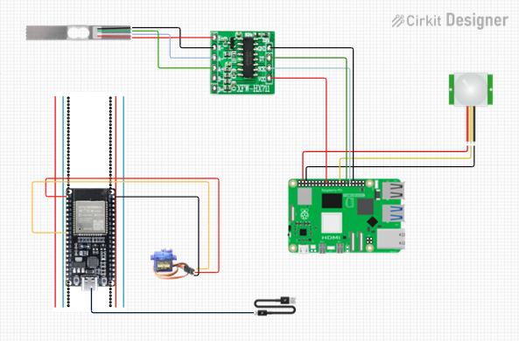
Figure 2 . Hardware connection diagram
These are the hardware connections :
- Servo Motor connected to ESP32 the following way:
- VCC to pin 1 ( 3V )
- GND to pin 38 ( GND )
- Signal to pin 9 ( GIOP 25 or ADC 18 )

- ESP32 connected to RaspberryPi through USB to USB-C
- Load cell connected to HX711 amplifier :
- Red VCC to + E
- Black GND to - E
- White ( signal ) to – A
- Green ( signal ) to + A

- Amplifier HX711 to RaspberryPi :
- GND to Pin 34 ( GND )
- DT to Pin 29 ( GPIO 29 )
- SCK to Pin 31 ( GPIO 31 )
- VCC to Pin 17 ( 3.3 V )

- Pir connection to RaspberryPi :
- VCC to Pin4 ( 5V )
- Signal to Pin 26 ( GPIO7)
- GND to Pin 6 ( GND )
2.4 Flow of the system
The Hardware to Web communication flow is responsible for transmitting sensor information collected by the Smart Pet Feeder to the web application, allowing users to monitor the current state of the system in real time. The information transmitted through this communication path consists of two values: the current food level and the pet detection status.
The Raspberry Pi continuously acquires sensor information every 2 seconds. During each acquisition cycle, the load cell reading is converted into a food percentage value, while the PIR sensor provides the pet detection status as a Boolean value (true or false). The collected information is then combined into a JSON payload generated by the sensor_readings.py module. A typical payload has the following structure: { "food_percentage": 68.4,"pet_detected": true}.

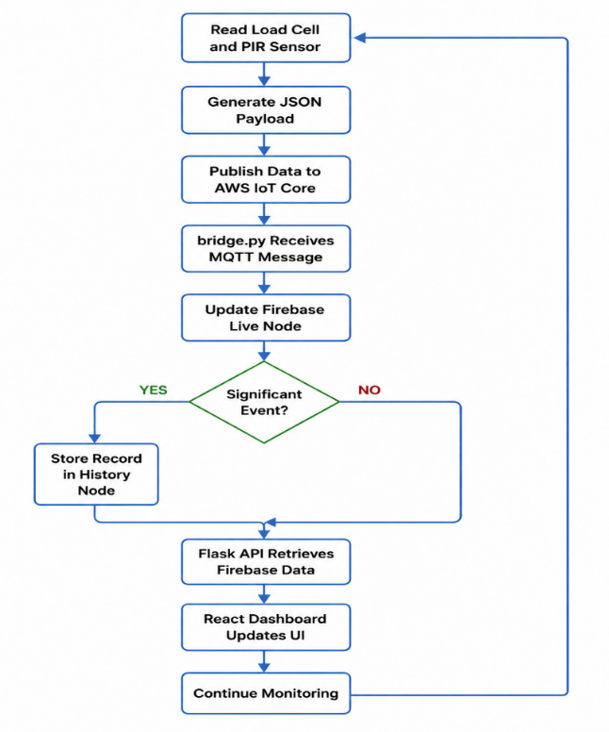
Figure 3 . Hardware to Web Flow of Application
Once the payload has been generated, the Raspberry Pi publishes the information to AWS IoT Core using the MQTT protocol . This communication is handled by the mqtt5_x509.py script, which establishes a secure MQTT connection using TLS encryption and X.509 certificate authentication. Sensor data is published every 2 seconds to the MQTT topic Test1.
AWS IoT Core acts as a message broker and receives all messages published to the Test1 topic. The messages are transmitted in JSON format and are immediately forwarded to subscribed clients. In the current implementation, the bridge.py service subscribes to the same topic and therefore receives every sensor message generated by the Raspberry Pi.
After receiving a message from AWS IoT Core, the bridge.py service decodes the JSON payload and extracts the values associated with the food percentage and pet detection status. The information is then prepared for storage within Firebase Realtime Database.
The bridge stores hardware information inside the feeder_status branch of Firebase. Two database nodes are used for this purpose:
- feeder_status/live
- feeder_status/history
The live node stores the most recent sensor reading received from the Raspberry Pi. Each new message overwrites the previous contents of this node, ensuring that it always reflects the current state of the feeder.
The history node stores timestamped records representing important feeder events. Initially, every sensor reading was stored in the database; however, this approach produced an excessive number of records due to the small fluctuations naturally generated by the load cell. To address this issue, a filtering mechanism was implemented within the bridge service. Historical records are now created only when significant events occur, such as initial system startup, pet detection events, or noticeable changes in the measured food level. Each historical record contains the sensor values together with a timestamp, allowing the system to maintain a chronological history of feeder activity.
After the information has been stored in Firebase, it becomes available to the Flask backend application through the /api/data endpoint. When this endpoint is called, the Flask API retrieves information from the feeder_status/live, feeder_status/history, and feeder_status/schedule nodes. The retrieved data is then processed and converted into a structured JSON response.
In addition to returning the latest feeder status, the Flask API generates datasets used by the web dashboard. Historical food-level measurements are transformed into data for the "Inventory Over Time" chart, while pet detection events are grouped by date to calculate daily visit statistics.
The final JSON response is transmitted from the Flask API to the React frontend through the GET /api/data endpoint. The web application periodically requests updated information every 5 seconds using asynchronous HTTP requests. After receiving the response, the dashboard updates the displayed food level, pet activity information, feeding schedules, and statistical charts.
The Web to Hardware communication flow is responsible for transmitting feeding commands generated by the user or by the scheduling system to the physical feeder hardware. Within the Smart Pet Feeder, food dispensing can be triggered through three different mechanisms: manual feeding, scheduled feeding, and pet-assisted feeding. Although these triggers originate from different sources, they ultimately converge into the same command execution pathway.
The first feeding mechanism is manual feeding. When the user presses the "Dispense Food Now" button within the web application, the React frontend invokes the handleDispense() function, which sends an HTTP POST request to the Flask backend through the /api/dispense endpoint.
The second feeding mechanism is scheduled feeding. Users can configure feeding times through the scheduling interface available within the web application. When a new schedule is created, the React frontend sends an HTTP POST request to the /api/schedule endpoint containing the selected feeding time. The Flask API stores this information inside the feeder_status/schedule node of Firebase Realtime Database.
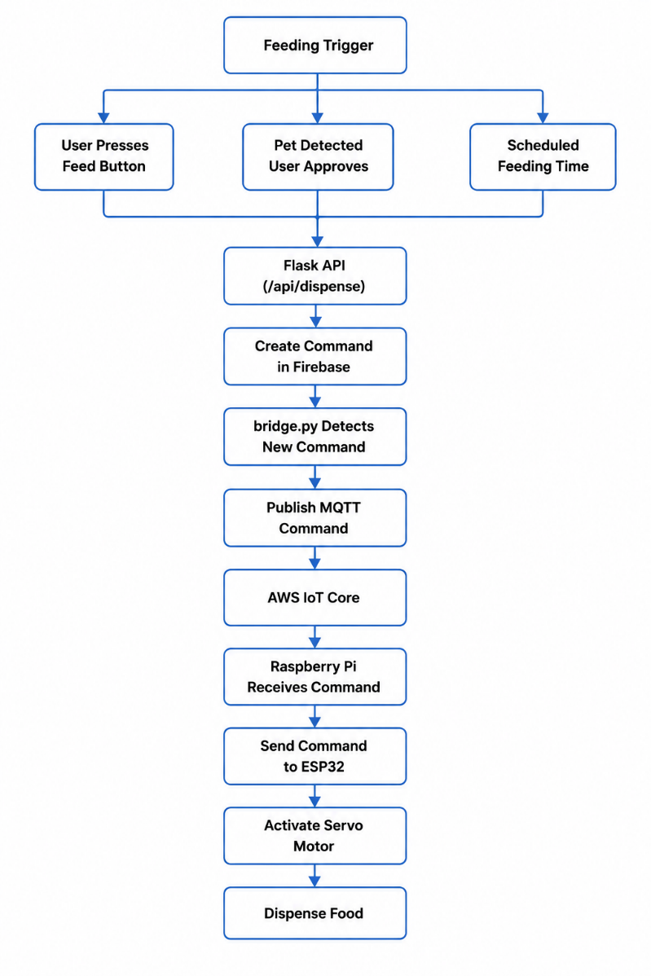
Figure 4 . Web to Hardware flow
The bridge.py service continuously monitors these schedules and compares them against the current system time. Whenever the current time matches one of the configured feeding times, a feeding command is automatically generated.
The third feeding mechanism is pet-assisted feeding. When the PIR sensor detects the presence of a pet near the feeder, the information is transmitted through the Hardware to Web communication path and eventually reaches the React dashboard. If the value of pet_detected becomes true, the application displays the notification "Pet is waiting!" together with an "Approve Feeding" button. When the user presses this button, the same handleDispense() function used for manual feeding is executed, resulting in the same command generation process.
Regardless of the trigger source, the feeding request reaches the Flask API through the /api/dispense endpoint. After receiving the request, the Flask backend creates a command object and stores it inside the commands node of Firebase Realtime Database. The generated command contains the requested action, a trigger flag, and a timestamp identifying when the request was issued.
The bridge.py service continuously monitors the commands node using a Firebase streaming listener. When a new command is detected and the trigger flag is set to true, the service generates the following JSON payload: {"feed_command": true}.
The command is then published to AWS IoT Core through the MQTT topic feeder/commands.
AWS IoT Core receives the MQTT message and forwards it to all subscribed devices. The Raspberry Pi subscribes to the feeder/commands topic through the mqtt5_x509.py application and therefore immediately receives the feeding request.
After receiving the MQTT message, the Raspberry Pi decodes the JSON payload and verifies that the value of feed_command is set to true. The command is then forwarded to the ESP32 microcontroller through the USB serial connection established between the two devices. The Raspberry Pi sends the text command: DISPENSE.
Upon receiving this command, the ESP32 activates the servo motor using a PWM control signal. The servo rotates the dispensing mechanism, releasing food into the bowl before returning to its initial position.
3. IMPLEMENTATION
Regarding the implementation process of the system, we choose to use Python programming language because of its simplicity and many libraries that could be used for both the hardware and software implementations. The files with the most importance, and the ones that are going to be touched in this chapter are considered to be sensor_readings.py, mqtt5_x509.py, bridge.py, app.py, App.tsx.
3.1 Hardware implementations details
With major importance regarding the hardware implementation, sensor_readings.py is responsible for collecting and processing data from the two sensors used in the system: the PIR sensor and the load cell. The code snippet shown in Figure 5 highlights the way in which the values from the load cell are read and interpreted.
Since the values read by the Raspberry Pi can sometimes be inaccurate or affected by small fluctuations, we decided to take five measurements at a time and treat them as a single reading. This is achieved by reading five consecutive values from the sensor, storing them in a list, and then calculating their average. The resulting average value is considered the actual measurement, as it helps reduce noise and improve the stability of the readings.
To obtain the final food weight value, we first subtract the weight of the bowl placed on top of the load cell, as the load cell was calibrated with the bowl already attached. After that, the calibration factor is applied to convert the raw sensor output into a human-readable value expressed in grams.
Additionally, there is a small peculiarity in our implementation. During assembly, the load cell was unfortunately mounted upside down, which caused the measured values to be negative. To correct this issue, we simply multiplied the readings by -1, allowing the system to work with positive values and ensuring that the displayed measurements accurately represent the amount of food present in the feeder.
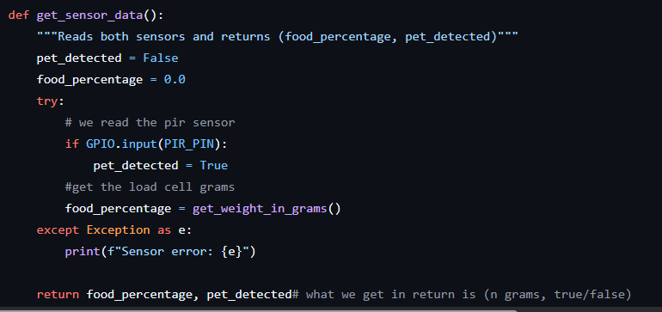
Figure 5 . Sensor readings file code snippet
Another important code snippet from the sensor_readings.py file is the one shown in Figure 6, which highlights the function named get_sensor_data(). In this function, we define the format in which the information is sent from the hardware component to the cloud. More specifically, the load cell reading is converted into a food weight value expressed in grams and transmitted under the field name food_percentage. This name originates from an earlier implementation and was kept unchanged to maintain compatibility across the system. We also send a true/false value indicating whether the pet has been detected by the PIR sensor.
The next file of high importance is mqtt599.py, which contains the code responsible for establishing the connection between the hardware and AWS IoT Core. The code fragment shown in Figure 7 is responsible for transmitting sensor information from the Raspberry Pi to AWS IoT Core. The sensor values are obtained by calling the get_sensor_data() function implemented in sensor_readings.py, stored in two appropriately named variables, food_pct and pet_status, then converted from a Python dictionary into JSON format and published to the Test1 topic configured for the pet feeder.
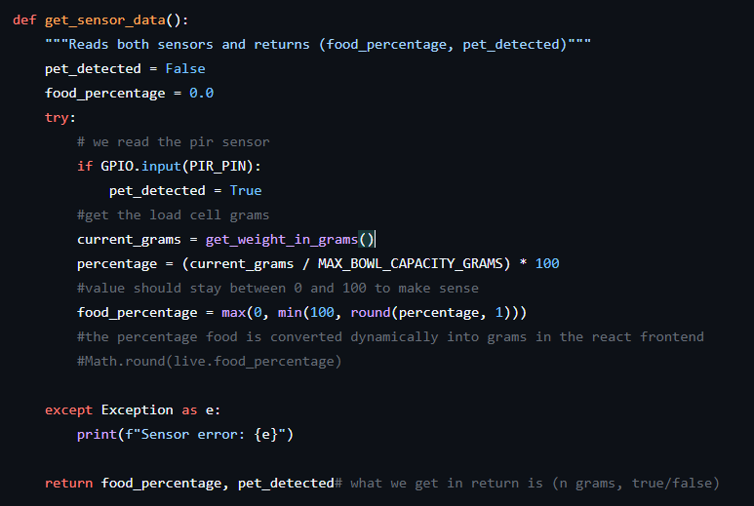
Figure 6 . Get sensor data function implementation

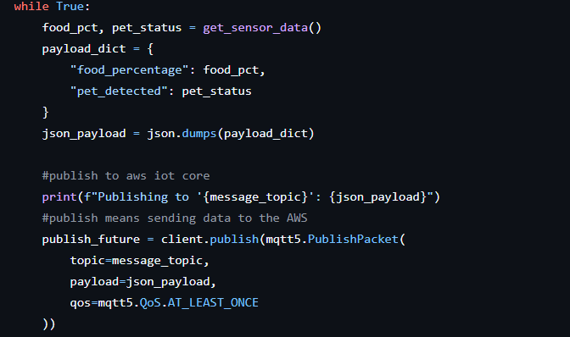
Figure 7 . Connection between hardware and AWS IoT Core
Figure 8 presents the reverse communication pathway, from the web application to the hardware component. When a message arrives under the feeder/commands topic, the Raspberry Pi decodes it and verifies whether a feeding command has been requested. If the command is valid, the Raspberry Pi sends the text command dispense to the ESP32 microcontroller through USB serial communication. The ESP32 then generates a PWM signal that controls the servo motor, causing it to rotate and release food into the bowl.

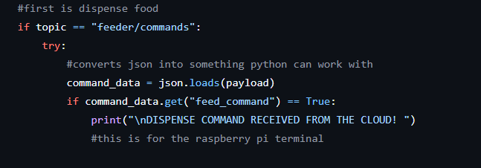
Figure 8 . Reverse communication from Web to hardware
3.2 Cloud implementation details
Moving on to the next important file, bridge.py, this file is responsible for connecting to Firebase, allowing us to both store information and retrieve the data required by the application.
In Figure 9, the presented code is executed whenever a new MQTT message arrives from AWS IoT Core. The received JSON payload is decoded, and the food level together with the pet detection status are extracted. These values are then stored in the live node, which is continuously overwritten with the newest values, always representing the current state of the feeder.
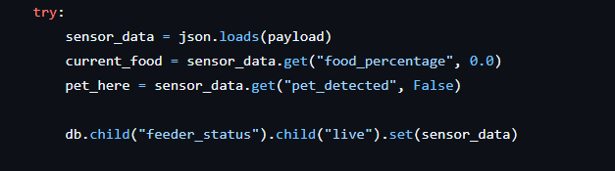
Figure 9 . Data saved in firebase inside bridge.py file

In order to avoid excessive data growth, Figure 10 presents the implemented filtering algorithm through which the history node is updated with new sensor readings only when a significant change occurs. We store the initial startup state of the system, and after that, the history node is updated only when the pet is detected or when there is a substantial change in the amount of food present in the bowl. Any other changes are monitored but are not stored in the database. This specific node is later used to generate statistics and charts within the web application.
This last important code fragment from bridge.py handles food dispensing requests originating from the web application (Figure 11). When the user presses the "Dispense Food" button, the Flask API creates a command inside the Firebase commands node. The bridge service continuously monitors this node and immediately detects the update. A corresponding MQTT command is then generated and published to AWS IoT Core, allowing the Raspberry Pi to receive the request and forward it to the ESP32. After the command is sent, the trigger value is reset to prevent duplicate executions.
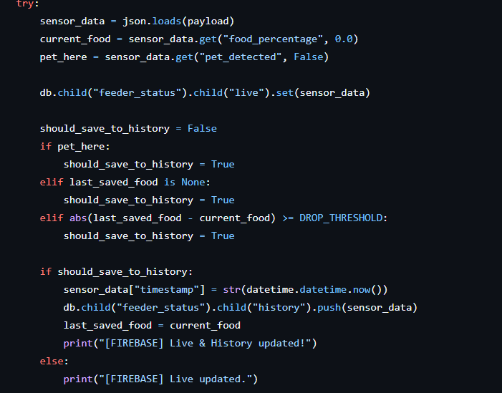
Figure 10 . Changes in how data is saved in firebase
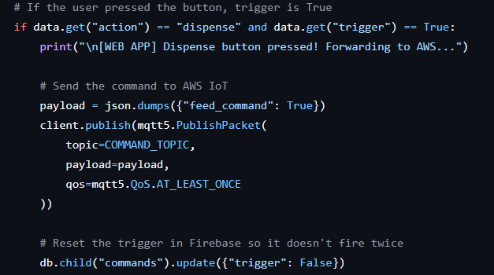
Figure 11 . Creation of new node in the database for the reverse communication
3.3 Software Implementation details
Figure 12 presents a code fragment from the app.py file. This code retrieves the information required by the web application from Firebase. The latest sensor readings are obtained from the live node, historical feeder events are retrieved from the history node, and the configured feeding schedules are loaded from the schedule node. These values are then sent to the frontend, where they are processed and visualized for the user.
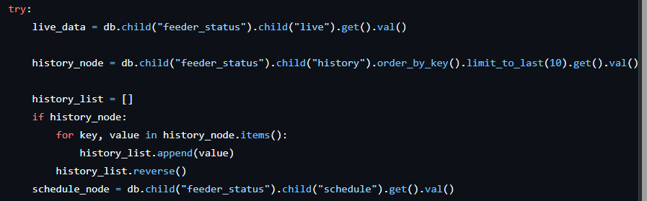
Figure 12 . Retrieve data from Firebase
Figure 13 presents the endpoint that is executed whenever the user presses the "Dispense Food" button in the web interface. Instead of communicating directly with the hardware, the backend creates a command object and stores it inside the Firebase commands node. The bridge service detects this update and forwards the command through AWS IoT Core to the Raspberry Pi, which then relays it to the ESP32 and ultimately triggers the servo motor to dispense food.
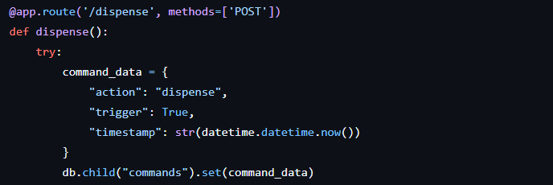
Figure 13 . Dispense command endpoint
The endpoint shown in Figure 14 allows users to configure automatic feeding times. The selected feeding time is received from the web interface and stored in the Firebase schedule node. The bridge service periodically monitors this node and automatically generates a feeding command whenever the current time matches one of the configured schedules, ensuring that food is dispensed at the specified times without requiring user intervention.
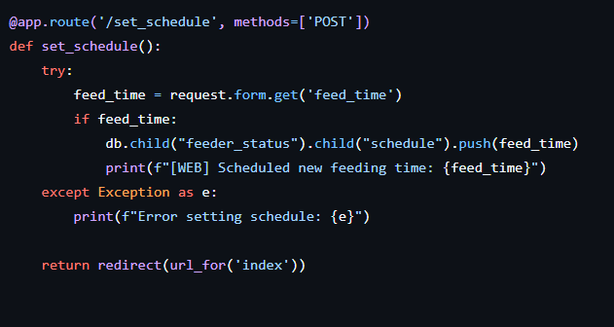
Figure 14 . Schedule endpoint creation
This last important implementation, shown in Figure 15, is from the App.tsx file. In this figure, we have highlighted two important parts: the place where the data received from the /api/data endpoint is stored and the mechanism through which this data is fetched from Firebase via the backend. The retrieved information is then used to update the user interface and display the current state of the feeder in real time.
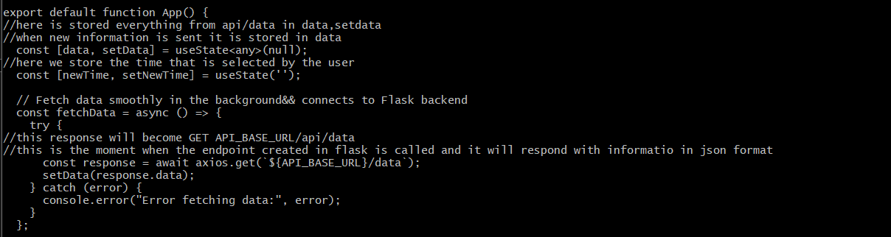
Figure 15 . App.tsx
5. AI Technology
To go beyond simple automated feeding, an AI-powered nutrition consultant was built into the Smart Pet Feeder. Its purpose is to generate personalised feeding recommendations based on the pet's individual characteristics and to help owners keep track of their pet's daily food intake.
The consultant is implemented as a dedicated Flask API endpoint and uses a Large Language Model (LLM) to produce its recommendations. Recent advances in LLMs have made it possible to build intelligent agents that can take on specific roles and respond accordingly, opening up new possibilities for personalised decision-support tools and conversational assistants [4]. Unlike conventional feeders that rely purely on fixed schedules, this solution tailors its recommendations to the pet's profile : species, breed, age, and weight.
When a user opens the AI Nutrition Consultant section of the dashboard, they're presented with a short form asking for four details: pet type, breed, age, and weight. These values are collected by the React frontend and sent to the Flask backend via an HTTP POST request to the /api/ai-consultant endpoint.
Once the request arrives, the Flask API dynamically builds a prompt using the pet's details. This approach was inspired by research showing that system prompts shape the role an LLM takes on and directly influence how it behaves during interactions, and that giving the model a specific professional role tends to produce better results than using a generic prompt [4]. The prompt instructs the model to act as a veterinary nutrition specialist and return a structured JSON response containing:Recommended daily food intake (grams per day):
- Recommended daily food intake (grams per day)
- Recommended number of daily feedings
- Breed-specific health considerations
The backend logic responsible for gathering the user's input and constructing the prompt is shown in Figure 16.
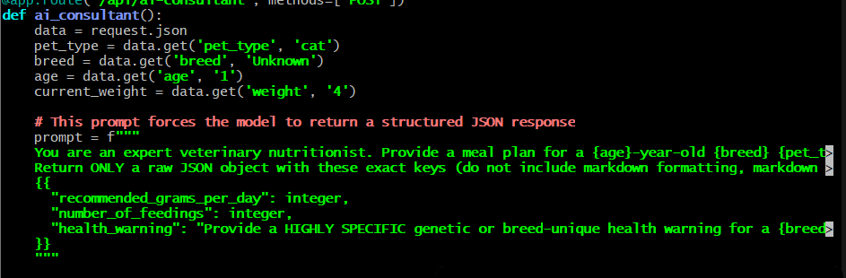
Figure 16 App.py Ai implementation
The prompt is then sent to the GPT-4o-mini model via the OpenAI API. To keep frontend processing straightforward, the model is instructed to return only a structured JSON object. Prompt design was treated carefully throughout, as prior research has shown that LLM output quality is highly sensitive to how prompts are worded and what contextual instructions are included [4]. This approach removes the need to parse unstructured natural language and ensures compatibility with the web dashboard.
Once the response comes back, the JSON object is validated and saved to the feeder_status/pet_profile node in Firebase Realtime Database. Storing it there means the recommendation persists between sessions and remains accessible even after a page refresh.
The recommendation is also immediately returned to the React frontend and displayed to the user. The dashboard shows the suggested daily food quantity, the recommended number of feedings, and any breed-specific health notes generated by the model. Presenting this information in natural language makes it easier for users to understand an advantage that's widely associated with LLM-based agents and intelligent decision-support systems [5].
Beyond generating recommendations, the AI consultant is also connected to the feeder's monitoring system to track the pet's actual daily food consumption.
Historical sensor data stored in Firebase is periodically fetched by the React app through the /api/data endpoint. The frontend then analyses the food-level history to calculate how much food has been consumed throughout the day. It does this by comparing consecutive load cell readings and identifying drops in the measured food quantity each decrease is interpreted as food the pet has eaten and added to the running total.
The core logic behind this calculation look like this:
if (previousWeight !== null && currentWeight < previousWeight) { totalConsumed += (previousWeight - currentWeight); }
The result is the total amount of food consumed during the current day.
This figure is then compared against the AI-generated recommendation stored in the pet profile. If the measured consumption exceeds the recommended daily intake, the application automatically flags an overfeeding warning.
This turns the AI consultant from a basic recommendation tool into an active decision-support component one that monitors feeding behaviour over time and alerts owners when their pet may be eating too much.
By combining live sensor data with AI-generated nutritional guidance, the Smart Pet Feeder offers a more personalised and health-conscious feeding experience than traditional automated systems.

6. TESTING
6.1 TESTING SCENARIOS
Testing is considered to be the final stage of the development process and it is important for verifying the functionality of the system that we implemented, and also if the initial requirements of the system were satisfied or not [2]. During the implementation period of our project, there were several smaller stages in which the system was developed incrementally. We chose to implement the system step by step, ensuring that each component was working properly before moving on to the next one. During this process, we also tested each individual module as soon as it was implemented.
So, the first test we performed was related to the servo motor. Initially, we simply programmed the servo motor using an ESP32 and managed to make it work successfully. However, we encountered several issues. The servo operated correctly when the ESP32 was connected directly, but as soon as the ESP32 was placed on the breadboard, the servo stopped working properly. This represented our first major problem, since we could not leave the ESP32 unsupported and connected "in the air" permanently.
To solve this issue, we tried multiple approaches. We changed the breadboard and also attempted to connect the servo motor to a Raspberry Pi. The second option proved to be the least successful. Once connected to the Raspberry Pi, the servo motor started jittering continuously. This behavior was caused by power supply and signal stability issues. Servo motors require a stable power source and clean PWM control signals. The Raspberry Pi's GPIO pins are not designed to directly provide the current required by many servos, which can result in voltage drops, unstable control signals, excessive vibration, and erratic movements. In our case, the servo motor was receiving an unstable power supply, causing it to shake uncontrollably and potentially overheat. We came very close to permanently damaging the servo due to this issue.
As a result, we adopted a different solution. We obtained a new breadboard, mounted the ESP32 correctly, and managed to achieve stable operation. Because of the jittering and power-related problems encountered with the Raspberry Pi, we ultimately decided to keep the servo motor connected directly to the ESP32, which provided more reliable control and better overall performance.
Moving on to the cloud component, our initial implementation focused solely on establishing communication with AWS IoT Core. At first, sensor information was transmitted every five seconds and stored directly in Firebase. However, we quickly realized that this approach was inefficient because it generated a very large amount of data, resulting in unnecessary storage consumption within Firebase.
To address this problem, we removed part of the previously stored data and designed a new strategy. We created a "live" node that always stores only the latest sensor readings. Every new measurement overwrites the previous one, ensuring that only the most recent state of the system is available in real time. For the "history" node, which stores historical records and later became extremely important for the dashboards we developed, data is recorded only when significant events occur. Examples of such events include the detection of the pet near the feeder or a substantial increase or decrease in the measured food quantity compared to the previous reading. This approach greatly reduced storage requirements while still preserving all important information for later analysis.
For the web application, our initial implementation relied on simple HTML pages generated through the Flask API. This solution was functional but far from ideal. The interface refreshed every two seconds, creating a poor user experience and making certain operations, such as adding feeding schedules, difficult to manage. As the project evolved, we migrated the frontend to React. This change significantly improved the application's responsiveness and usability. The React-based interface performs controlled updates approximately every five seconds, providing more accurate and smoother real-time data visualization while offering a much more modern and user-friendly experience. After this transition, the web interface no longer presented the issues encountered during the initial Flask implementation.
6.2 MEASUREMENTS AND RESULTS
For this part, in terms of measurements, we have two dashboards in our web application. One dashboard shows the amount of food present each day. The charts display the recorded food levels over a day, at specific hours (Figure 17).
We also have another dashboard that displays the daily pet visits, showing how many times per day the pet was detected in the vicinity of the feeder (Figure 18).
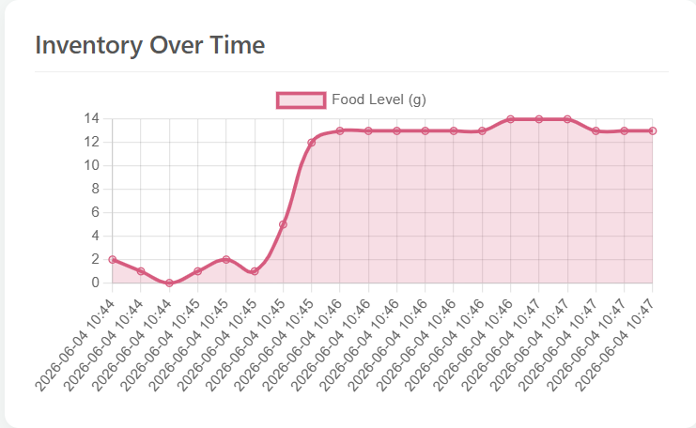
Figure 17 . Food over time Dashboard
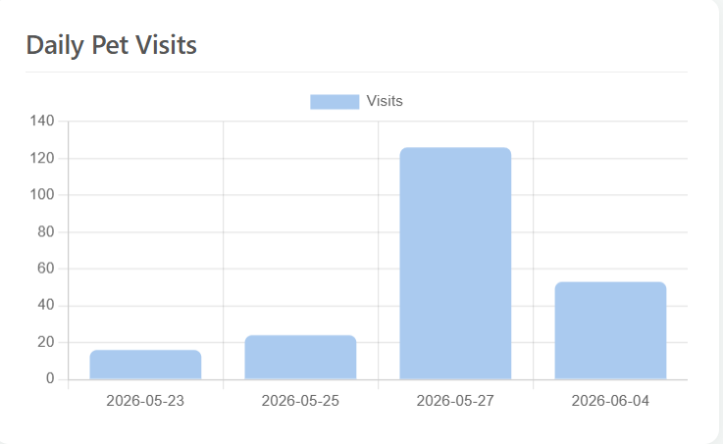
Figure 18 . Daily Pet Visits Dashboard
7. IMPROVMENTS AND CONCLUSIONS
One potential improvement of the current system would be to reduce the reliance on HTTP communication between the frontend and backend services. Although HTTP was selected due to its simplicity, widespread adoption, and compatibility with REST architectures, studies have shown that HTTP introduces higher bandwidth consumption and communication overhead compared to protocols specifically designed for IoT environments, such as MQTT [3]. Future versions of the system could explore the use of MQTT-based communication between software components to provide more efficient real-time updates and reduce network overhead.
A possible future improvement of the AI Nutrition Consultant would be to make its recommendations more personalized by considering additional health-related information about the pet. In the current implementation, recommendations are generated based on the pet's type, breed, age, and weight. Future versions could also take into account factors such as activity level, medical conditions, allergies, and previous feeding history. This would allow the AI system to provide more accurate nutritional recommendations and more detailed health warnings tailored to the specific needs of each pet. The AI could also continuously monitor the pet's eating habits and adjust its recommendations over time, helping owners maintain a healthier feeding routine and detect potential health concerns at an earlier stage.
7.1 CONCLUSION
This project successfully developed a Smart Pet Feeder that combines IoT technologies, cloud services, and a web-based dashboard to automate and monitor pet feeding. The system allows users to remotely dispense food, configure feeding schedules, monitor food levels, and receive real-time feeder information.
In addition, an AI-powered Nutrition Consultant was integrated to generate personalized feeding recommendations and detect potential overfeeding based on actual food consumption. The completed system demonstrates how IoT and artificial intelligence can be combined to improve pet care while providing a solid foundation for future enhancements and smarter feeding management.

References:
[1] O. E. Castillo-Arceo, R. U. Renteria-Flores, and P. C. Santana-Mancilla, "Design and Development of a Smart Pet Feeder with IoT and Deep Learning," Eng. Proc., vol. 82, no. 1, p. 63, Nov. 2024, doi: 10.3390/ecsa-11-20487.[Scholar]
[2] Bachelor’s Degree programme in Information Technology 2022 Shanker Bhattarai A SMART PETFEEDER Powered by PWA and Raspberry PI BACHELOR’S | ABSTRACT TURKU UNIVERSITY OF APPLIED SCIENCES Degree programme In Information Technology 2022 | 39 pages
[3] N. Naik, "Choice of Effective Messaging Protocols for IoT Systems: MQTT, CoAP, AMQP and HTTP," in 2017 IEEE International Systems Engineering Symposium (ISSE), Vienna, Austria, 2017, pp. 1–7, doi: 10.1109/SysEng.2017.8088251.
[4] M. Zheng, J. Pei, and D. Jurgens, “Is ‘A Helpful Assistant’ the Best Role for Large Language Models? A Systematic Evaluation of Social Roles in System Prompts,” University of Michigan, Ann Arbor, MI, USA, 2024.
[5] L. Wang, C. Ma, X. Feng, Z. Zhang, H. Yang, J. Zhang, Z. Chen, J. Tang, X. Chen, Y. Lin, W. X. Zhao, Z. Wei, and J. Wen, “A Survey on Large Language Model Based Autonomous Agents,” Frontiers of Computer Science, vol. 18, no. 6, 2024.

