**Hondamatic CDI Kit Instructions**

**Welcome**

Thank you for your purchase of the Hondamatic CDI Kit. This kit is applicable to the following bikes: CB400A, CM400A, and CM450A series. It will NOT work for the manual versions of this bike.

**Package Contents**

Check the package for the following contents:

* Wiring harness.
* CDI Printed Circuit Board (PCB).
* Package of components.

Check the package of components for the following, each bag will be individually labelled:

* C1 Capacitor – 2.2uF @400VDC. Non-polarized.
* C2 Capacitor – 0.1uF @50VDC. Non-polarized.
* TH1 Thermistor – 200 Ohm at room temperature.
* TH2 Thermistor – 100 Ohm at room temperature.
* R3 and R4 Resistors – 470 Ohm.
* R5 Resistor – 200 Ohm.
* R6 Resistor – 68 Ohm.
* R7 and R10 Resistors – 150 Ohm.
* R8 and R12 Resistors – 10 Ohm.
* R11 Resistor – 100 Ohm.
* R9, R13, R14 and R15 Resistors – 1 KOhm.
* D1 through D4, D10 through D13 Diodes (8 total) – 1N4002.
* D5-D9 Diodes (5 total) – 1N4004.
* D14 Diode – 400V 3A.
* TR1 SCR – 500V 12A.
* TR2 and TR3 SCRs – 600V 4A.

If anything is missing, email me [fhsapone@gmail.com](mailto:fhsapone@gmail.com) to get a replacement.

**Tools Required**

* 25-35W Soldering Iron, or a soldering iron capable of temperature adjustment. **DO NOT USE A SOLDERING GUN OR EXTREMELY HIGH WATTAGE IRON. YOU WILL DESTROY THE SCRs AND DIODES!**
* Tinner’s such as MG 8342 flux. **DO NOT USE ‘PLUMBERS FLUX’.**
* Rosin core solder. **DO NOT USE ACID CORE/’PLUMBERS SOLDER’.**
* Heat gun.
* Wire strippers capable of working with 18-gauge wire.
* Wire cutters.
* Drill with 7/8-inch drill bit for mounting hole of the grommet.
* A case of your choice for mounting the PCB. It’s recommended to use a potting compound rated for electronics once you have verified the unit works. **DO NOT USE RTV AS A POTTING COMPOUND.**

**Pin Assignments**

* P1 – Blue.
* P2 – Black with White Tracer.
* P3 – Yellow.
* P4 – Green Coil (two pin connector).
* P5 – Green Harness (six pin connector).
* P6 – White.
* P7 – Orange.
* P8 – Brown.
* P9 – Light Blue.
* P10 – Green with White Tracer.
* P11 – Pink.

**Instructions**

Working slowly, solder each component individually. You will need to save the large capacitor (C2) for last as it needs to fit over the diodes. Each component corresponds to a number on the circuit board. For example, from the bag labelled R5 there will be R5 labelled on the board. Insert the component in place where it is on the PCB then solder it in place and trim the excess leads with your wire cutters.

**Instructions (continued)**

The diodes are polarized and must be placed accordingly or you will fry them. There is a white line on the diode and on the PCB. Make sure they line up and the polarity will be correct.

The SCRs also need placed in their proper positions. Pin 1 is always the farthest from the left when looking at the SCR with the numbers (not the backside of the heatsink) facing you. On the PCB you will see square pads where the SCRs go. The square pad is always Pin 1.

The thermistors, SCRs, and C2 also contain heat shrink tubing. This is to prevent them from shorting out other components. For the thermistors, use the smaller tubing on the leads of the component and use your heat gun to shrink it over the leads. Solder the thermistor into place, trim the excess leads, then use the large tubing provided over the entire thermistor and use your heat gun to shrink it over the entire thermistor. For the SCRs, solder the SCR in place, you will have to bend the pins slightly in order to place them on the board. Trim the excess on the leads and place the tubing over the SCR, making sure to cover the metal sink tab. Use your heat gun to shrink it over the entire SCR.

When you have soldered all components and C2 remains there is only one place left for it to go. Use the provided heat shrink tubing to place it on each lead as close to the capacitor as possible and use your heat gun to shrink it over the leads. Solder it into place, as close to the PCB as you can, and trim the leads. For reference, one pad is located to the left of D7 (when viewed from the bottom) and the other is located above the large diode, D14. A picture is attached below, highlighted yellow and circled red for the locations of these pads (board is reversed to show bottom of the board for clarity):  
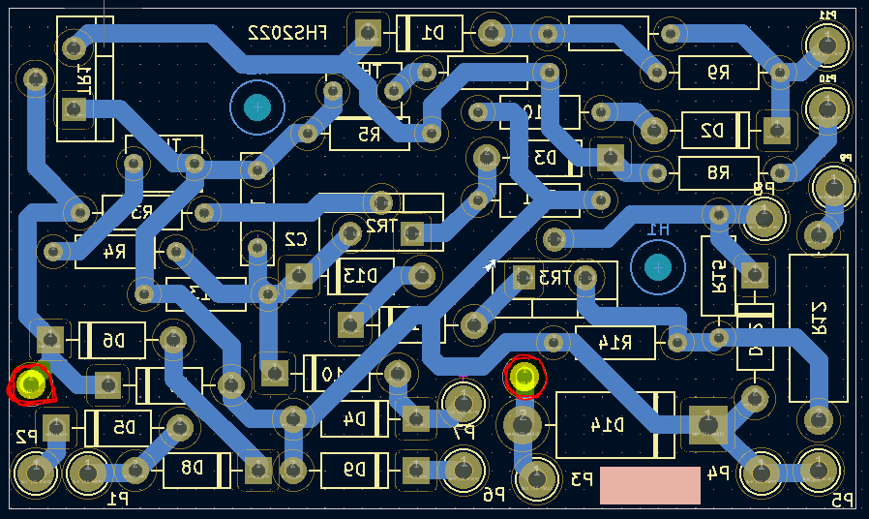

**Instructions (continued)**

When you have finished soldering all the components trim back the lengths of the wire on the harness with the side close to the grommet about a quarter inch. Twist the exposed end of the copper and from the top of the PCB feed them through and solder from the bottom.

Now that everything is solder it’s time to double check your work. Pay particular attention to the polarity of the diodes and SCRs. Check the smaller diodes to be sure they are the right kind. If you put the smaller 1N4002s where 1N4004s should be they will fry. Check for any solder blobs/bridging and for any cold solder joints. If you used flux clean the bottom of the PCB with 90% or higher alcohol to remove traces of any flux.

Once you are satisfied that everything is wired up correctly and the board is clean and free of any soldering defects plug it in and go for a ride!

**Troubleshooting**

If you plug it in and still fail to have spark, check over your work for any kind of soldering defects such as solder blobs/bridging over pads. Correct these defects with a desoldering braid, a desolder bulb, etc. Check to make sure each wire from the harness is in the correct through hole pad on the PCB. Each pad is labelled on the silkscreen. Check that the polarity of the diodes and SCRs are correct. Check that the components are in their right places. If you have found that you have connected something incorrectly and it still does not work after you have corrected it then you likely have fried the SCRs. Email me [fhsapone@gmail.com](mailto:fhsapone@gmail.com) for replacements.

If you are still having issues, you can measure out the board with a DVM. The following page has instructions on how to do this: <https://www.vintagehondatwins.com/forums/showthread.php?5687-CB400A-CM400A-CM450A-Hondamatic-CDI-resistance-test-from-FSM> . Please take note to use a fresh battery in your DVM to take these readings. If one side is way off, do not panic, reverse the leads and see if it reads correctly. If readings come up incorrect then there is likely a wiring mistake, fried component, or defective component.

If the resistance reading from the CDI comes back good then you likely have a problem with your Stator, Ignition Coil, Change Relay, Ignition Switch or Kill Switch. The following page has instructions on how to test this: <https://www.vintagehondatwins.com/forums/showthread.php?5757-Ignition-Diagnosis-for-CB-CM-400-450-Automatic-Trans-1978-1983> .

If you still have problems and would like to send the CDI back for warranty, please email me [fhsapone@gmail.com](mailto:fhsapone@gmail.com). For other problems please refer to the Vintage Honda Twins Forums for help at <https://www.vintagehondatwins.com/forums> .

**Credits**

This project would not have been successful without the help from the following people:

* **Blair M.** – Reviewing schematics and lending EE knowledge.
* **T. W. Wolfgang** – Reviewing schematics and lending EE knowledge.
* **Mike B.** – Supplying additional broken CDIs, partially completed schematic for CDI.
* **Robert L.** – Supplying partially completed schematic for Change Relay.
* **Steven Myers** of [Bearish Cases](https://www.bearishcases.com/) – CAD work for casing.
* **PrimesTurmoil** – 3D printing.
* **Jim O’Brien** ([LongDistanceRider](https://www.vintagehondatwins.com/forums/member.php?4-LongDistanceRider" \t "_blank)) and **Tom** ([ancientdad](https://www.vintagehondatwins.com/forums/member.php?2-ancientdad" \t "_blank)) from [VHT](https://www.vintagehondatwins.com/forums/forum.php) – Support.