**Cell Cycle:**

The cell cycle is a 4-stage process consisting of Gap 1 (G1), S-Phase (Synthesis), Gap 2 (G2) and M-Phase (Mitosis). An active human cell will undergo these steps as it grows and divides. After completing the cycle, the cell either starts the process again from G1 or exits the cycle through G0.

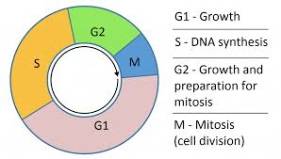

Now notice the “M”, the “M-phase” of the cell cycle itself has four parts. The famous four parts of Mitosis:

Prophase; Metaphase; Anaphase; Telophase (See below).

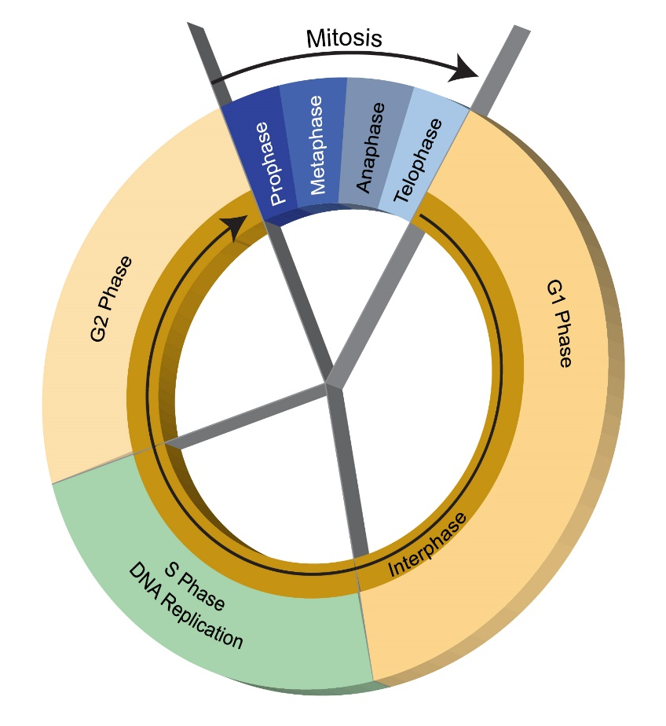

I will always have to be very careful as to how I word my questions not to confuse

the four steps of the cell cycle and the four parts of mitosis.

__________________________________________________________________________________________

A brief look at just Mitosis:

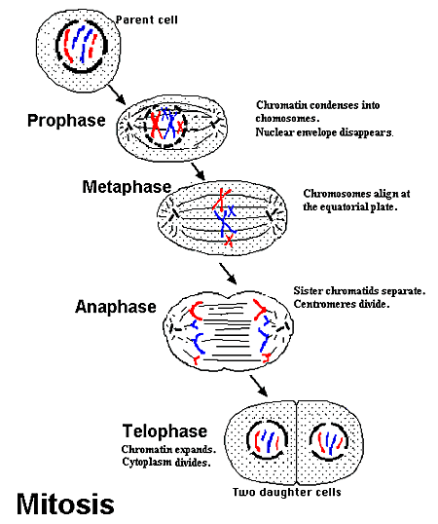

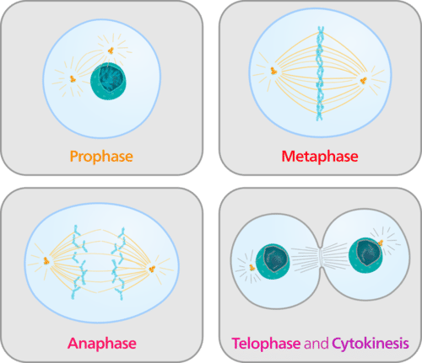

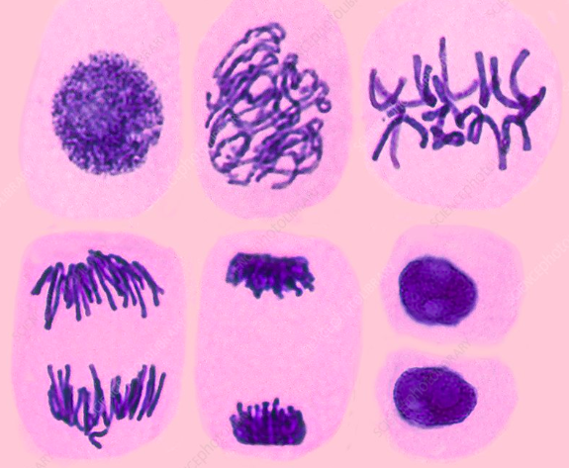

Can you tell which stage each cell’s nucleus is at in the photos above?

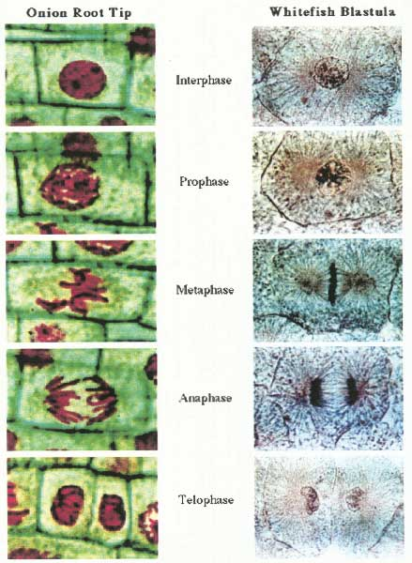

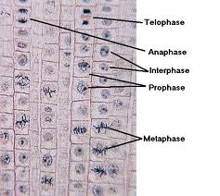

The above slide was taken looking at the famous General Biology Laboratory: Use of the Microscope where a student looks under the microscope at an onion’s root tip. It is rapidly growing, that onion’s root tip, and so it is guaranteed to show a lot of onion root tip cells undergoing mitosis.

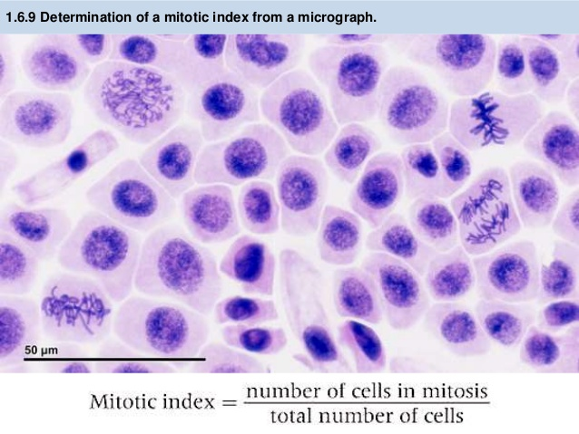

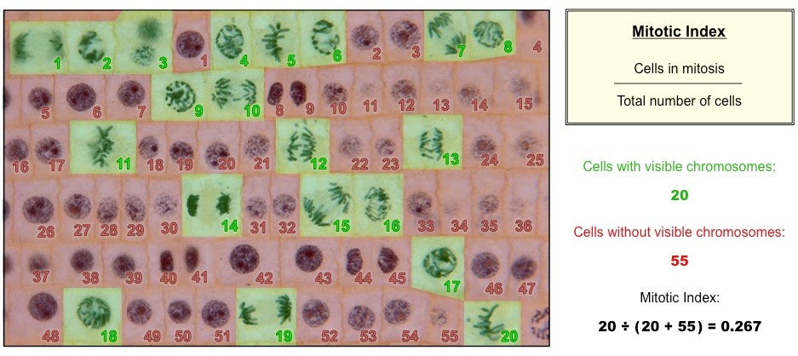

The Mitotic Index is important when considering ‘Cancer’.

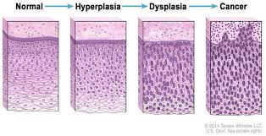

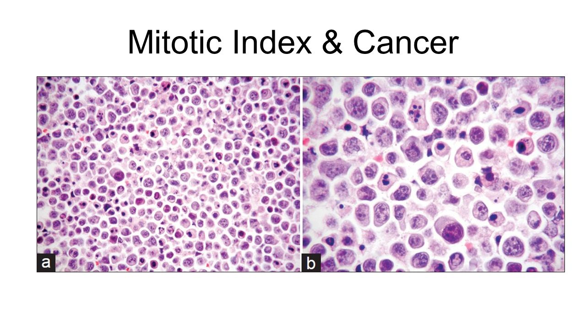

__________________________________________________________________________________________

Back to the Cell Cycle.

Let’s add ‘Cytokinesis’ to the Cell Cycle.

Cytokinesis is the part of the cell division process during which the cytoplasm of a single eukaryotic cell divides into two daughter cells.

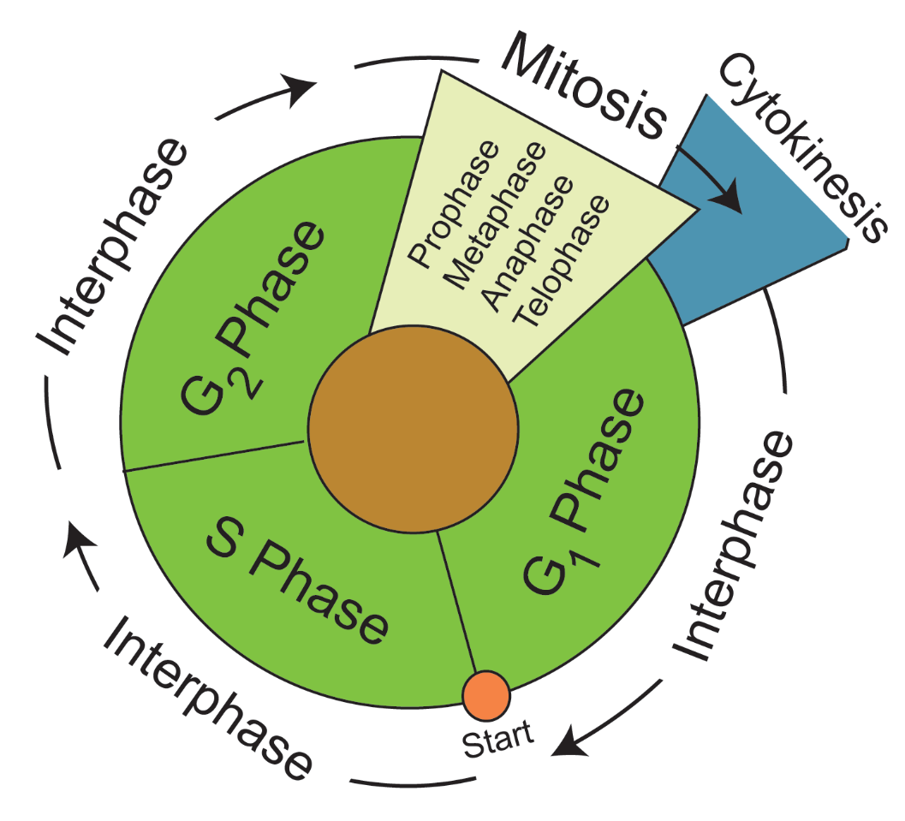

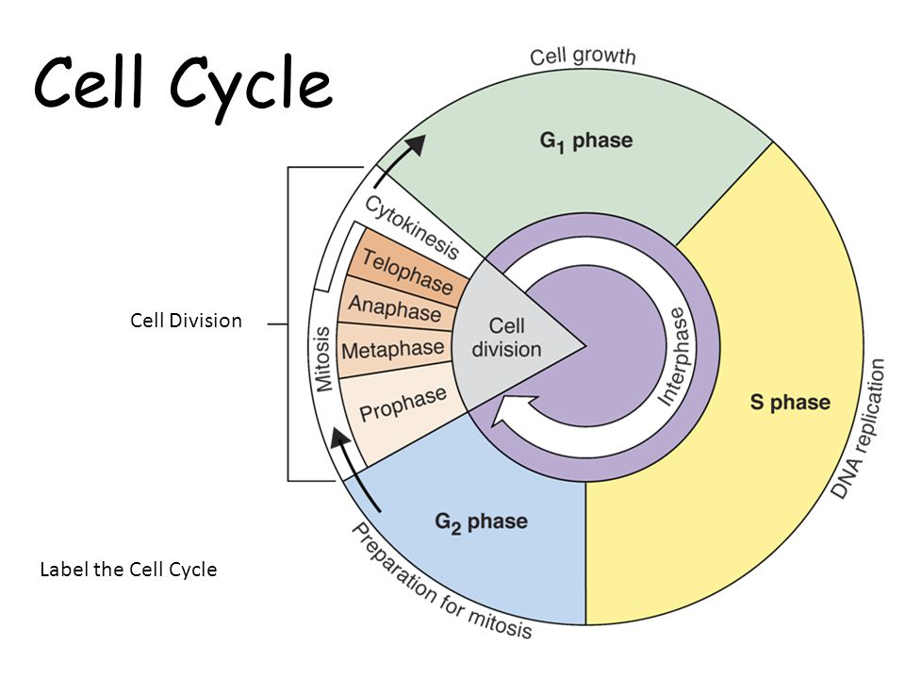

Interphase is the sum of G1 + S-Phase + G2 (everything that is not Mitosis).

Let’s add G0 (G-Zero) phase.

The **G0** phase (referred to the G zero phase) or resting phase is a period in the cell cycle in which cells exist in a quiescent state. **G0** phase is viewed as an extended G1 phase, where the cell is neither dividing nor preparing to divide.

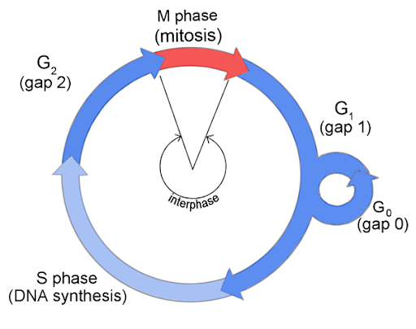

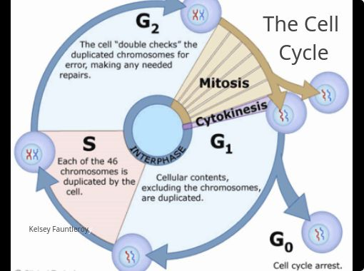

The End.