Que 1) Plot a histogram,

10, 13, 18, 22, 27, 32, 38, 40, 45, 51, 56, 57, 88, 90, 92, 94, 99

Que 2) In a quant test of the CAT Exam, the population standard deviation is known to be 100. A sample of 25 tests taken has a mean of 520. Construct an 80% CI about the mean.

Que 3) A car believes that the percentage of citizens in city ABC that owns a vehicle is 60% or less. A sales manager disagrees with this. He conducted a hypothesis testing surveying 250 residents & found that 170 residents responded yes to owning a vehicle.

1. State the null & alternate hypothesis.
2. At a 10% significance level, is there enough evidence to support the idea that vehicle owner in ABC city is 60% or less.

Que 4) What is the value of the 99 percentile?

2,2,3,4,5,5,5,6,7,8,8,8,8,8,9,9,10,11,11,12

Que 5) In left & right-skewed data, what is the relationship between mean, median & mode?

Draw the graph to represent the same.

**SOLUTION:**

Q.NO1: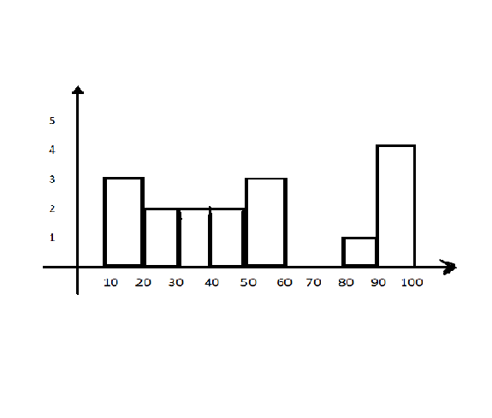

Q.NO2:

GIVEN:

s.d = 100 n = 25 mean = 520

sol:

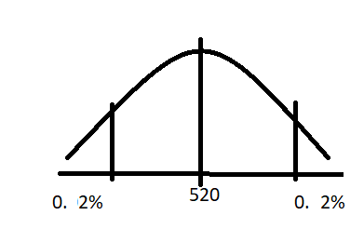

Since n<30 t- test is done

t alpha/2=1.711

Lower fence=520-1.711(100/5)

=520 – 1.711*20

=520-34.22

=485.78

Higher fence = 520+1.711(100/5)

=520 +1.711*20

=520+34.22

=554.22

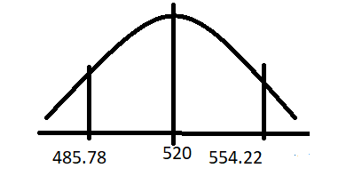

Q.NO:3

Mean= 60%

n=250 s.d=170

null hypothesis <= 60%

alternate hypothesis > 60%

alpha= 1-0.1

= 0.9

Z score = x-u/sigma/n^1/2

n=15.81

Q.NO 4:

2,2,3,4,5,5,5,6,7,8,8,8,8,8,9,9,10,11,11,12

=99/100*(21)

=0.99*21

=20.79 or 20th index = 12

Q.NO 5:

Left skewed:

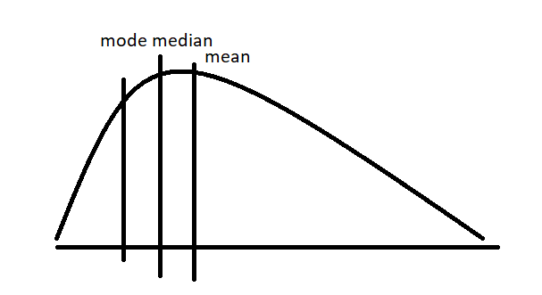

Right skewed:

