Article
Regulator-in-the-Loop Compliance Screening: Graph-Grounded LLM Agents with a Continuously Calibrated Benchmark for EU Marketing Law
Alexios Kaponis ^{1 *}, and Manolis Maragoudakis ²
Academic Editor: Firstname Lastname
Received: date
Revised: date
Accepted: date
Published: date
Copyright: © 2026 by the authors. Submitted for possible open access publication under the terms and conditions of the Creative Commons Attribution (CC BY) license.
¹ Department of Informatics, Ionian University, Corfu, Greece; alexios.kaponis@ionio.gr
² Department of Informatics, Ionian University, Corfu, Greece; mmarag@ionio.gr
* Correspondence: alexios.kaponis@ionio.gr; Tel.: +30 6982465410
Abstract
Market-surveillance authorities face a growing volume of digital marketing content spanning video, social-media, influencer, and AI-generated or synthetic media, whose compliance with EU consumer and digital law cannot be assessed manually at scale. We present a deployed decision-support system that screens marketing campaigns against the Unfair Commercial Practices Directive, the General Data Protection Regulation, the Digital Services Act and the AI Act using large-language-model agents grounded in a curated legal knowledge graph. The system enforces closed-world citation grounding: findings may reference only provisions retrieved from the graph, are validated against it, and are anchored to authentic legal text through CELLAR and ELI identifiers. Around the engine we build a regulator-in-the-loop calibration methodology combining a human-reviewed gold benchmark of 52 campaigns, an adversarial adjudicator for disputed citations, and a distillation step that converts confirmed errors into human-approved calibration rules. On the frozen benchmark, the deployed configuration recovered 95 of 97 must-find provisions on first-run scoring, met the minimum risk level in 51 of 52 campaigns, missed no gold-relevant routing, and produced one false positive across seven compliant controls. On a pre-designated 15-campaign holdout, calibration reduced unexpected actionable findings from 44 to 5 while preserving 1.000 provision recall and 15/15 risk calibration, and improved run-to-run stability from 0.745 to 0.833. We release the benchmark, knowledge graph and calibration corpus. The benchmark explicitly covers contemporary multimedia and AI-mediated advertising scenarios, including video and influencer advertising, deepfake endorsements, AI-retouched promotional content, virtual influencers, undisclosed chatbots, and emotion-optimised advertising. Beyond automated legal screening, the framework contributes a trustworthy governance layer for multimedia content by connecting digital-media evidence and campaign representations to grounded, human-reviewable regulatory findings across consumer-protection, data-protection, platform, and AI-specific obligations.
Keywords: multimedia content governance; AI-generated media; synthetic media; digital advertising; legal natural language processing; large language model agents; GraphRAG; human-in-the-loop; market surveillance

1. Introduction
Consumer-protection and digital-market enforcement in the EU rests on four instruments with overlapping reach into marketing practice: the UCPD (2005/29/EC) with its Annex I blacklist [12], the GDPR (2016/679) for data-driven marketing [13], the DSA (2022/2065) for platform-mediated advertising and dark patterns [14], and the AI Act (2024/1689) for AI-generated and AI-mediated persuasion [15]. Enforcement capacity has not scaled with content volume: coordinated CPC sweeps repeatedly find high violation rates in areas such as dark patterns, influencer disclosure and environmental claims [19–21], yet each sweep covers only hundreds of traders, manually.
Large language models are an obvious candidate for first-line screening, but their known failure modes are disqualifying in an enforcement context in their raw form: fabricated or imprecise legal citations, unstable verdicts, and reasoning that stretches provisions beyond their addressees (for example, applying platform obligations to advertisers). An authority cannot act — or even triage — on findings whose legal anchors may not exist.
From a multimedia perspective, contemporary marketing is no longer confined to static textual advertisements. Commercial persuasion is distributed across video platforms, social-media posts, influencer content, interface designs, synthetic audiovisual material, AI-retouched imagery, virtual personas, and conversational agents. These media forms create not only detection and representation problems, but also a downstream governance problem: once relevant content characteristics have been observed or extracted, they must be interpreted against overlapping legal obligations in a manner that is traceable and suitable for human review. This paper addresses that governance layer. Rather than proposing a new image, audio, or video feature extractor, we investigate how heterogeneous digital-media evidence and campaign metadata can be transformed into grounded regulatory findings through graph-constrained LLM agents and regulator-supervised calibration.
This paper makes three claims. First, hallucination-resistant screening is an architecture property, not a model property: we constrain LLM agents to cite only provisions they have retrieved from a curated knowledge graph, validate every citation post-hoc against that graph, and resolve each provision to authentic text in the Publications Office CELLAR repository. Second, the scarce resource in this domain is not model capability but calibrated legal judgement, and it can be captured systematically: we couple a human-reviewed benchmark with an adversarial adjudication aid and a lesson-distillation step that converts recurring human-confirmed errors into general prompt-level calibration rules — a loop a single domain expert can operate from a web interface. Third, such a loop can remain honest: we make the train/test-contamination risk explicit and adopt discipline (generality constraints on rules, held-out cases) that preserves the benchmark’s value as measurement.
For the multimedia community, these contributions can be summarised as a trustworthy content-governance layer for digital and AI-mediated advertising. The framework (i) operationalises regulatory screening over campaign representations derived from online media, including platform metadata and spoken-video transcripts; (ii) provides a benchmark containing synthetic-media and AI-mediated advertising phenomena such as deepfake endorsements, AI-retouched promotional content, virtual influencers, and undisclosed conversational agents; and (iii) connects detected or described media practices to authoritative regulatory provisions through an auditable graph-grounded reasoning process. The contribution therefore lies not in low-level multimedia feature extraction, but in the reliable interpretation, governance, and human-in-the-loop assessment of multimedia-derived evidence.
We describe the deployed system, the benchmark and its review methodology, and the calibration loop in Section 2, and report the evaluation in Section 3. The benchmark, knowledge graph, and calibration corpus will be made publicly available upon publication.
This ingestion stage also defines the present system boundary with respect to multimedia processing. For video-based campaigns, the compliance engine reasons over textual and contextual representations of the media object—such as title, channel information, description, spoken transcript, provenance, and campaign metadata—rather than directly extracting visual or acoustic features from raw frames or waveforms. The architecture is therefore compatible with upstream computer-vision, speech, deepfake-detection, or multimodal representation models: their outputs can be incorporated as additional evidence fields before regulatory reasoning. This separation between media understanding and regulatory interpretation makes the compliance layer modality-agnostic while preserving explicit provenance for the evidence supplied to the legal agents.

1.1. Related Work
LLMs for legal analysis. Recent work has demonstrated the applicability of large language models (LLMs) to legal reasoning, including statutory interpretation, legal judgment prediction, contract analysis, and legal question answering. LegalBench introduced one of the largest benchmark suites for legal reasoning, comprising 162 expert-designed tasks spanning multiple areas of legal practice and showing that current LLMs exhibit strong but uneven legal reasoning capabilities [1]. However, most existing benchmarks evaluate general legal reasoning rather than regulatory compliance screening grounded in authoritative legal sources.
Legal hallucination and grounded citation. A major challenge remains the tendency of LLMs to hallucinate legal citations. Dahl et al. demonstrated that state-of-the-art models frequently fabricate judicial decisions or incorrectly cite legal authorities even when responding to seemingly straightforward legal questions [2]. In regulatory enforcement, such behaviour is unacceptable because fabricated or legally inapplicable provisions may mislead investigators. Unlike open-ended legal question answering, our system performs provision-level compliance screening under mandatory grounding, requiring every reported finding to reference a provision retrieved from a curated legal knowledge graph and validated before appearing in the final report.
Retrieval and graph-augmented generation. Retrieval-Augmented Generation (RAG) anchors responses to external knowledge sources to overcome some limitations of parametric language models [11]. More recently, GraphRAG extends this paradigm by exploiting graph structure to retrieve semantically connected information, thus improving multi-hop reasoning on large document collections [3]. In particular, graph-based retrieval has been shown useful in domains where relations between concepts are as important as concepts themselves.
Our contribution is not a novel retrieval algorithm but rather a closed-world citation architecture. Hybrid lexical retrieval combined with graph expansion identifies candidate legal provisions, while the knowledge graph simultaneously defines the complete set of admissible citations, validates provision identifiers, and provides provenance links to official EUR-Lex texts. Consequently, hallucinated or cross-regulation citations cannot propagate into the final compliance report.
Computational consumer protection. Much of the automated consumer-protection research has been aimed at the detection of individual scams. Mathur et al. showed that dark patterns are widely used on ~11,000 shopping websites [4]. Similarly, CLAUDETTE introduced machine-learning techniques to identify potentially unfair contractual clauses in consumer contracts [5]. Other work has studied deceptive advertising [9,10], environmental claims [8] and influencer disclosures using specialized datasets and task-specific classifiers.
Our work is significantly different from these approaches. Rather than focusing on one regulatory instrument or deceptive practice, the proposed system performs mul-ti-regulation routing across UCPD, GDPR, DSA and AI Act, producing provision-level findings with evidence quotations, official legal references and remediation recommendations suitable for regulatory review.
Human-in-the-loop evaluation and self-improvement. Recent work has investigated the use of LLMs as evaluators of other LLM outputs. Although LLM judges often correlate well with human preferences, systematic biases — including verbosity bias, positional bias and self-enhancement bias — remain well documented [6]. Consequently, legal compliance assessment continues to require expert human oversight.
Rule-based steering offers an alternative mechanism for improving model behaviour. Constitutional AI demonstrated that explicit written principles can guide model self-critique and revision without modifying model parameters [7]. Our calibration framework adopts the transparency advantages of explicit rules while differing fundamentally in governance. Calibration rules are generated only as candidate recommendations, reviewed and approved by a human legal expert, version-controlled, and injected into specialist prompts without altering model weights.
Because calibration rules originate from benchmark errors, benchmark contamination becomes a methodological concern. To preserve evaluation integrity, rules are restricted to transferable legal principles rather than case-specific facts, held-out benchmark cases remain excluded from rule generation, and benchmark performance is reported before and after every approved calibration update.

2. Materials and Methods

2.1. Legal Knowledge Graph
The corpus is a curated graph of the four regulations: regulation nodes, provision nodes (40 at time of writing: articles and Annex I item with summarised obligations, severity hints and retrieval keywords) and marketing-concept nodes (16: e.g. urgency and scarcity claims, hidden advertising, deep fakes), connected by CONTAINS, GOVERNED_BY, REFERENCES and RELATED_TO edges (117 edges). Concept nodes function as the bridge between campaign language and legal language: a countdown timer in the campaign matches the urgency and scarcity concept lexically, who’s GOVERNED_BY edges lead to UCPD Annex I point 7 and related provisions.
Each provision carries its CELEX number; European Legislation Identifiers (ELI) [23] and article-anchored EUR-Lex links are derived mechanically, and document metadata is verified at display time against the Publications Office CELLAR SPARQL endpoint [22]. Analyses never depend on CELLAR availability; anchoring is a provenance property of the report. A semi-automatic ingestion pipeline (CELLAR fetch → article segmentation → LLM-assisted summarisation → human-reviewed proposal merge) extends the corpus to further acts. The four instruments are represented in their consolidated form, including the amendments introduced by the Omnibus Directive [16]; the Empowering Consumers Directive [17], whose greenwashing additions to the Annex I blacklist apply from September 2026, is a priority for ingestion. Provision summaries were drafted against the Commission’s UCPD guidance notice [18] where it addresses the practice in question.

2.2. Agentic Analysis Pipeline
A campaign (title, free-text brief, channels, audience, markets, AI/personalisation flags, optional provenance URL) is processed in three stages, all streamed live to the user:
- Triage. A supervisor agent characterises the campaign (detected practices, audience signals, AI/personal-data involvement) and routes the plausibly engaged regulations. Routing is deliberately inclusive — the cost asymmetry between a wasted specialist run and an unexamined violation dictates it.
- Specialist agents. One agent per routed regulation investigates in a tool-use loop over three read-only graph tools (hybrid BM25+graph search, 1-hop expansion, provision fetch), then submits a structured verdict through a forced tool call: status, notes, and findings each carrying provision id, severity (5-point scale anchored to legal categories: critical = blacklisted practice present, …), rationale, verbatim evidence quote and remediation. Citation validation then drops any finding whose provision id does not exist in the graph, is not a provision node, or belongs to another regulation — hallucinated anchors cannot reach the report.
- Synthesis. A final agent merges verdicts into an overall risk level, executive summary and prioritised remediation plan.
Two engineering properties matter for enforcement use: a deterministic retrieval-only fallback runs when no model credentials are configured (and doubles as an ablation baseline), and scraped third-party content is wrapped as material under analysis — data, never instructions — to resist prompt injection from surveilled content.

2.3. Surveillance Ingestion
Beyond self-submission, a surveillance mode retrieves public marketing content: YouTube search and direct-URL analysis via a commercial scraping API, assembling title, channel, description and spoken transcript (with a preferred-language → source-default → English fallback chain) into a campaign submission with recorded provenance. This shifts the system from an advertiser self-check tool to an authority-side screening instrument.
This ingestion stage also defines the present system boundary with respect to multimedia processing. For video-based campaigns, the compliance engine reasons over textual and contextual representations of the media object—such as title, channel information, description, spoken transcript, provenance, and campaign metadata—rather than directly extracting visual or acoustic features from raw frames or waveforms. The architecture is therefore compatible with upstream computer-vision, speech, deepfake-detection, or multimodal representation models: their outputs can be incorporated as additional evidence fields before regulatory reasoning. This separation between media understanding and regulatory interpretation makes the compliance layer modality-agnostic while preserving explicit provenance for the evidence supplied to the legal agents.

2.4. Benchmark

2.4.1. Design
The benchmark consists of 52 marketing and digital compliance campaigns organised into three evaluation tiers: 19 tier 1, 17 tier 2 and 16 tier 3. The frozen gold set contains 97 must-find provisions and 7 compliant controls. Fifteen campaigns, including 2 controls and 26 must-find provisions, were designated as a held-out split before any calibration rule was written and were excluded from calibration-rule distillation. The tier construction and provenance otherwise follow the design described below: T1 enforcement-inspired, T2 dataset-adapted, and T3 synthetic, including compliant controls and near-miss cases that probe over-enforcement.
Each case pairs a campaign with gold labels: regulations triage must route; provision ids findings must cite (must-finds); acceptable extras — defensible citations that are neither required nor penalised, absorbing legitimate legal ambiguity into an explicit annotation category rather than noise; a minimum overall risk; and the compliant flag. All provision ids are validated against the knowledge graph, and must-finds must belong to routed regulations.

2.4.2. Metrics
Per run we score: gold-provision recall (a must-find counts at any severity); unexpected actionable findings (severity ≥ medium outside must-finds ∪ extras) reported per case rather than averaged away, since each is either an engine error or a gold-label gap; false positives on compliant controls; risk calibration (overall risk ≥ gold minimum; controls must come back clean); routing recall (missed routings only — over-routing is by design); and, across repeated runs, stability (mean pairwise Jaccard of finding sets).

2.4.3. Review Tooling
Label quality is the bottleneck, so review is first-class in the deployed application: a benchmark UI lists cases with their labels, provision pickers populated from the graph (invalid ids are unrepresentable), one-click promotion between must-find and extra, per-case test runs against the live engine with a gold-vs-outcome comparison, and persisted run outcomes. For every disputed citation the reviewer sees the engine’s own rationale and evidence quote, and can request a second opinion: an independent, deliberately adversarial adjudicator prompt tests the citation on three questions — scope (does the provision govern the conduct?), addressee (does the obligation bind the campaign’s operator, e.g. platform duties vs advertisers?) and support (is there concrete textual basis?) — returning must-find/acceptable-extra/reject with reasoning. The adjudicator is an aid, not an authority: nothing enters the gold labels without a human click, and we discuss its shared-blind-spot risk in Section 3.3. Figures 1–3 show the interface in its working states — authoring gold labels for a case whose run agrees with them, adjudicating the unexpected citations of a run that deviates, and examining a single disputed citation together with the second opinion returned for it.
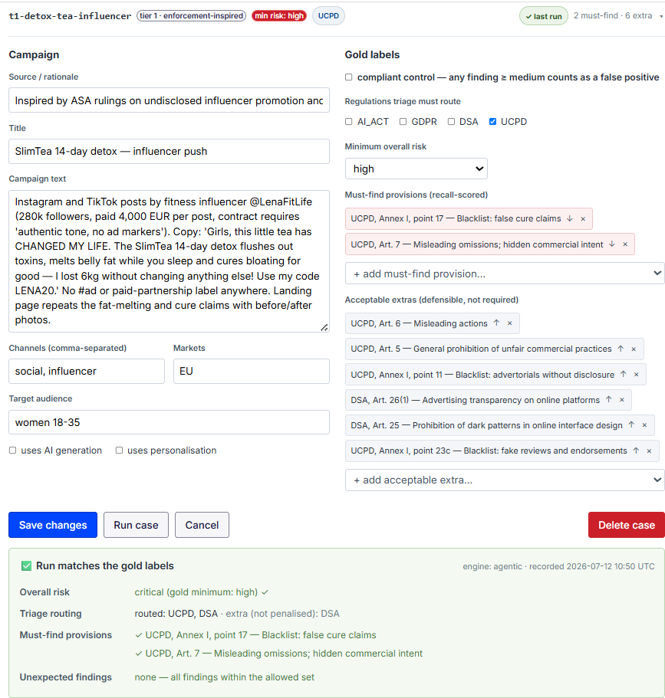
Figure 1. Case editor in the benchmark UI (t1-detox-tea-influencer). Gold labels are authored against provision pickers populated from the knowledge graph, so invalid provision ids are unrepresentable; citations move between the must-find and acceptable-extra sets with a single action. The lower panel shows the persisted outcome of the most recent run against the live engine, comparing assigned risk, triage routing and cited provisions with the gold labels — here a run in agreement with them.
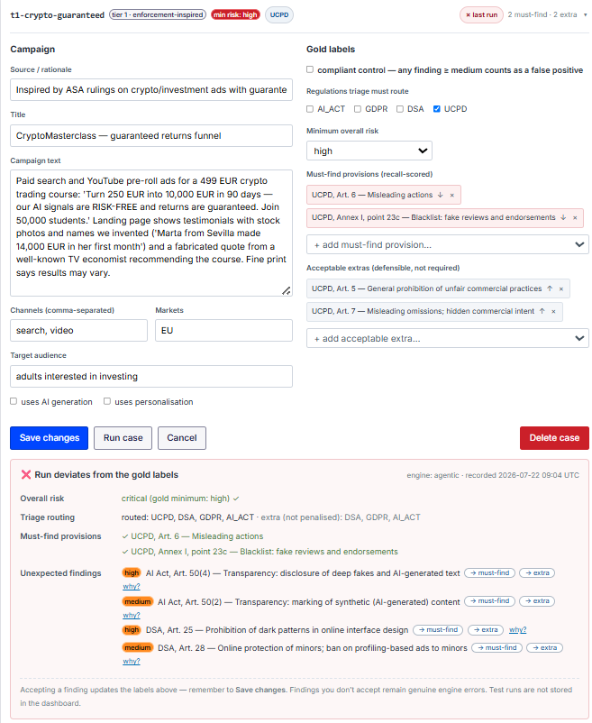
Figure 2. Adjudication of a deviating run (t1-crypto-guaranteed). The engine cited four provisions outside the must-find and acceptable-extra sets; each is presented with its severity and a why? link exposing the engine’s rationale and evidence quote, and can be promoted to must-find or to acceptable-extra with a single action. Findings the reviewer does not accept remain genuine engine errors and are scored as such, so the deviation counts reported here reflect adjudicated outcomes rather than raw engine output.
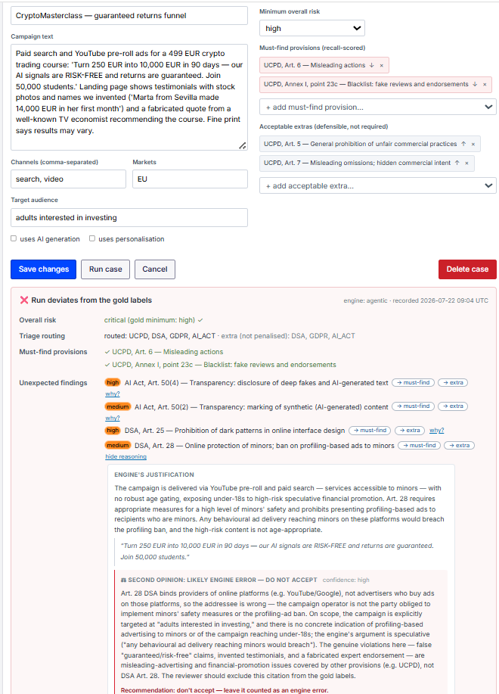
Figure 3. Adjudication of a single disputed citation (t1-crypto-guaranteed, DSA Art. 28). Expanding a finding exposes the engine’s justification together with the verbatim evidence quote on which it rests, and beneath it the independent second opinion. Here the adjudicator rejects the citation on the addressee axis — Article 28 binds providers of online platforms, not the advertiser operating the campaign — and returns do not accept with a recommendation to score the finding as an engine error. This is the error family that the seed calibration rules of Section 2.5 target.

2.5. Calibration: Learning from Reviewed Mistakes
Model weights are fixed; learning happens at the prompt layer through calibration rules — short, general legal principles injected into the specialist agents’ system prompts (globally or per regulation). Rules originate two ways: written directly by the reviewer, or distilled: a proposer model receives the corpus of benchmark deviations (over-citations with adjudication verdicts, missed must-finds, control false positives) and drafts at most five candidate rules for recurring patterns, under hard constraints — general principles only; no case ids, brand names or campaign facts; no duplication of existing rules. Every proposal requires explicit human approval; the approved rule set is a versioned, human-readable artifact (e.g., from our deployment: “DSA platform obligations (Arts. 25, 26, 28) are addressed to providers of online platforms, not to advertisers whose campaigns merely run on a platform”).
Contamination discipline. A benchmark the engine learns from can no longer measure what it taught. We keep the loop honest by (i) the generality constraint above — rules must transfer to unseen campaigns, memorised answers are prohibited and auditable since rules are plain text; (ii) growing the set and designating held-out cases that never feed rule distillation; and (iii) reporting before/after scorecards for every calibration change, so claimed improvements are attributable and reversible.

3. Results

3.1. Evaluation Protocol
All configurations were evaluated on the same frozen gold set of 52 campaigns (19 tier 1, 17 tier 2, 16 tier 3), comprising 97 must-find provisions and 7 compliant control campaigns, with three independent runs per campaign. All language-model configurations used Claude Opus 4.8 served through the Amazon Bedrock European cross-region inference profile (eu.anthropic.claude-opus-4-8); configuration A uses no language model. Runs were executed server-side by the deployed instance itself, which checkpoints each completed analysis to persistent storage, so each configuration is evaluated as a single indivisible unit rather than assembled from partial client sessions.
Fifteen of the 52 campaigns (including 2 controls and 26 must-find provisions) were designated as a held-out split before any calibration rule was written and were excluded by construction from rule distillation. Configuration D is reported on this split and is compared against configuration C restricted to the same 15 campaigns; the two runs differ only in whether the approved calibration rules were injected into the specialist agents' prompts.
Scoring conventions: a must-find provision counts as found if cited at any severity; unexpected findings are actionable citations (severity ≥ medium) outside the union of must-find and defensible-extra provisions; a control campaign counts as a false positive if any actionable finding is returned or the overall risk reaches medium; stability is the mean pairwise Jaccard similarity of the three runs' finding sets. Per-campaign metrics other than stability are computed from the first run, with the remaining runs used for the stability measure.
Run provenance. Each reported configuration is tied to an archived evaluation job and case-set hash for reproducibility. Configuration A corresponds to job A-20260808-114736 (engine: heuristic; no LLM; case set: bb48530e65e048b9); configuration B to B-20260808-114752 (engine: agentic-unvalidated; model: eu.anthropic.claude-opus-4-8; case set: bb48530e65e048b9); configuration C (full benchmark) to C-full-20260813-071439 (engine: agentic; model: eu.anthropic.claude-opus-4-8; case set: bb48530e65e048b9); configuration C (holdout) to C-holdout-20260813-083740 (engine: agentic; model: eu.anthropic.claude-opus-4-8; case set: 54ff841181b4621b); and configuration D to D-20260813-091230 (engine: agentic; model: eu.anthropic.claude-opus-4-8; case set: 54ff841181b4621b).
Table 1. Evaluation of the four configurations on the gold benchmark (52 campaigns, 97 must-find provisions, 7 compliant controls; three runs per campaign). Configurations C (holdout) and D are evaluated on the 15 held-out campaigns (2 controls, 26 must-find provisions) excluded from calibration-rule distillation; D is therefore compared against the C (holdout) row, not the full set. Arrows mark the desirable direction. Provision recalls counts must-find provisions cited at any severity; unexpected findings are actionable (≥ medium) citations outside the must-find and defensible-extra sets; stability is the mean pairwise Jaccard of finding sets across the three runs; invalid citations are those the validation layer removes (unknown identifiers or cross-regulation citations), zero by construction in A, C and D.
Configuration | Provision  recall ↑ | Unexpected  /case ↓ | FP on  controls ↓ | Risk calib. ↑ | Stability ↑ | Latency/case | n | Invalid citation
A retrieval-only | 0.515 | 303 (5.83) | 7/7 | 34/52 | 1.000 | <1 s | 52 | 0
B agentic, no citation validation | 1.000 | 154 (2.96) | 1/7 | 51/52 | 0.756 | 58.6 s | 52 | 1
C agentic, deployed default | 0.979 | 162 (3.12) | 1/7 | 51/52 | 0.745 | 54.7 s | 52 | 0
C deployed default (holdout) | 1.000 | 44 (2.93) | 0/2 | 15/15 | 0.745 | 58.6 s | 15 | 0
D deployed default + calibration (holdout) | 1.000 | 5 (0.33) | 0/2 | 15/15 | 0.833 | 52.5 s | 15 | 0

3.2. Benchmark Performance
The frozen evaluation replaces the earlier July single-run summary. Configuration C is the deployed default, while configurations A and B provide architectural ablations and configuration D tests the approved calibration rules on a pre-designated 15-campaign holdout. The aggregate results are reported in Table 1; Table 2 retains a compact configuration-C summary.
Table 2. Aggregate performance of configuration C (agentic engine with graph-citation validation) on the frozen 52-case benchmark. Point metrics use first-run scoring; stability uses all available repeated runs. The exact-agreement row is retained for traceability but is not reported by the supplied frozen scorecard.
Metric | Result | Reading
Gold-provision recall | 0.979 (95/97) | First-run score; runs 2 and 3 recover the two omitted AI Act provisions
Risk calibration | 51/52 (98.1%) | One campaign rated below the gold minimum risk
Missed routings | 0 (100%) | No gold-relevant regulation was left unrouted
False positives on controls | 1/7 (14.3%) | One compliant control raised an actionable data-protection finding
Exact benchmark agreement | Not reported | The frozen scorecard supplied for this revision does not report this legacy metric
Unexpected actionable findings | 162 (3.12/case) | Actionable citations outside must-finds and defensible-extra provisions

First-run recall over must-find provisions was 0.979: 95 of the 97 must-find provisions distributed across the 52 cases were retrieved and cited, and every reported citation survived validation against the knowledge graph. Routing was likewise complete, indicating that the triage agent’s characterisation of practices, audience signals, AI involvement and personal-data processing was sufficient to establish regulatory scope without omission. Risk calibration held in 51 of 52 cases, and 38 cases (73.1%) reproduced the gold outcome exactly.
The headline result for the architectural claim of Section 1 is the pairing of complete recall with zero surviving invalid citations. Because a specialist agent can only submit a finding against a provision it has retrieved, and because citations outside the routed regulation are dropped at validation, the failure mode of a fabricated provision reference does not appear in the run. The residual error budget is therefore concentrated entirely in over-detection and in risk-level assignment, both of which are visible to the reviewer.

3.2.1. The Reasoning Layer, Not Retrieval, Produces Usable Assessments
Configuration A isolates the GraphRAG retrieval layer. It locates roughly half of the required provisions (recall 0.515) but is unusable as a screening instrument: it returns 303 unexpected actionable findings (5.8 per campaign) and flags all seven compliant control campaigns. Its perfect stability (1.000) simply reflects determinism, not quality. Retrieval establishes which provisions are topically related to a campaign; deciding whether a provision is actually engaged — and by this addressee, on these facts — is what the agentic layer contributes. Adding it (configuration C) roughly doubles recall, halves the over-flagging rate, and takes control false positives from 7/7 to 1/7.
Because this configuration is deterministic, it also serves as a cross-check on the measurement apparatus: an independent replication executed five days later on a separate instance, scored through the command-line harness rather than the in-application runner, reproduced the deployment run exactly — identical matched, missed and unexpected provision sets, risk verdicts and control outcomes on all 52 campaigns (bench/results/A-20260813-153304-*). The two scoring paths and the two label copies are therefore in exact agreement.

3.2.2. The Deployed Configuration
Configuration C recovers 95 of 97 must-find provisions (0.979) with complete triage recall — no gold-relevant regulation was left unrouted in any of the 52 campaigns — passes risk calibration on 51 of 52 campaigns, and returns a mean latency of 54.7 s per campaign. Two observations deserve care.
First, the two apparently missed provisions are a scoring artifact rather than a capability gap. Both are AI Act Article 5 prohibitions on t3-emotion-optimized-ads, the benchmark's hardest case (a platform-side system inferring emotional state, engaging all four instruments). The first run of that campaign omitted them; runs 2 and 3 cited both, correctly attributed. Scored on a majority or union of the three runs, configuration C also reaches recall 1.000. We report the first-run figure because it is the conservative single-shot number a user would experience, but the sensitivity is worth stating: for this architecture, run-to-run variance on genuinely hard multi-instrument cases is a larger effect than any systematic omission.
Second, the single control false positive is a borderline data-protection judgement rather than an over-reading of the marketing claims: the system raised lawful-basis and objection findings on a compliant campaign's e-mail programme. Notably, configuration B produced exactly one control false positive as well, but on a different control campaign — indicating a general tendency to over-attach GDPR provisions where a campaign mentions e-mail or personalisation, rather than a defect specific to one case. This is precisely the failure mode the calibration rules target (§3.2.4).

3.2.3. Citation Validation Contributes Integrity, Not Precision
Configuration B disables the post-hoc validation that drops citations to unknown identifiers or to another regulation's provisions. Across all 156 analyses it produced exactly one invalid citation: a knowledge-graph concept node (c-emotion-targeting) cited as though it were a UCPD provision. The validation layer is therefore cheap insurance rather than a major quality contributor — because the specialists reach provisions through graph tools that return only real provision nodes, invalid citations are rare before validation ever runs. We report this as a negative result: the ablation does not show validation improving recall, precision, or calibration, and the over-flagging rates are similar between B and C (2.96 vs 3.12 unexpected findings per campaign). Its value is that a single fabricated legal citation in a regulator-facing report is a disproportionate failure, and the guarantee it provides is absolute rather than probabilistic.

3.2.4. Calibration Transfers to Unseen Cases
Configuration D is the study's clearest result. On the 15 held-out campaigns, injecting the 15 human-approved calibration rules reduced unexpected actionable findings from 44 to 5 — an 89% reduction, from 2.93 to 0.33 per campaign — while recall remained at 1.000, both controls remained clean, risk calibration remained 15/15, and run-to-run stability improved from 0.745 to 0.833.
A citation-level comparison of the two runs shows that 39 unexpected citations were removed, none were added, and no must-find provision was lost. The removals track the content of the rules rather than being diffuse suppression: 12 DSA platform-obligation citations were withdrawn from advertiser-side campaigns, 12 GDPR citations were withdrawn where no processing or consent defect was shown, 9 general-clause redundancies were eliminated where a specific blacklist item already captured the conduct, and 6 AI Act citations were withdrawn where no AI system was actually deployed. The most pronounced case, an advertisement impersonating an official government notice, fell from 11 unexpected citations to 1.
Two aspects make this more than a prompt-engineering result. The rules were distilled only from deviations observed on the 37 calibration-visible campaigns, and the 15 evaluation campaigns were designated before any rule was written; the improvement therefore measures transfer to unseen benchmark cases rather than direct fitting. The rules are general legal principles concerning scope, addressee and specificity: they never reference a campaign, brand, or benchmark answer. The observed improvement therefore reflects greater doctrinal discipline rather than memorisation of the held-out cases.
The five surviving unexpected citations are defensible-but-unrequired readings rather than errors of law (for instance, consent-quality provisions on an aggressive retargeting programme) and are candidates for reclassification as defensible extras under a second annotation pass. Residual precision headroom is therefore smaller than the raw count suggests.

3.3. Threats to Validity
Single-annotator gold labels. The gold labels were drafted with model assistance and reviewed by one domain expert. Inter-annotator agreement is not yet measured, so residual unexpected citations may conflate engine error with label incompleteness. Stored raw outputs allow re-scoring against revised labels without re-running inference.
Single model and provider. All language-model figures reported here are for Claude Opus 4.8 served through Amazon Bedrock. Whether the calibration transfer replicates on other model families or providers remains untested.
Benchmark scale and provenance. The frozen benchmark contains 52 campaigns. Tier-1 cases are inspired by real enforcement actions, but the campaigns are synthetic reconstructions rather than sampled live advertising; external validity to noisy authentic campaign material therefore remains open.
First-run scoring and incomplete repetitions. Point metrics other than stability use the first of three runs. Majority or union scoring would raise configuration C's provision recall from 0.979 to 1.000. Configurations C (full) and C (holdout) also had transient infrastructure failures in one or two case-runs (154/156 and 44/45 completed), although every campaign retained at least two scored runs and no campaign is absent from any reported row.
Calibration contamination and shared blind spots. The 15-campaign holdout was designated before calibration-rule writing and excluded from rule distillation, which materially strengthens the transfer claim. It does not establish independence from the benchmark design or base model, and the adjudicator shares the same model family as the specialist agents; human approval therefore remains the final safeguard.
Jurisdictional scope. The legal graph covers four EU-level instruments. National transpositions of the UCPD, sector-specific advertising rules and Member State supervisory practice remain outside the graph, so a campaign screened as compliant against this corpus is not thereby compliant in every Member State.

4. Discussion
The system is a screening prioritiser, not an assessor: its output ranks material for qualified human review, and every design choice (provision anchoring, verbatim evidence quotes, EUR-Lex links, explicit engine labelling) serves reviewability rather than autonomy. Legal limitations bound its competence: it sees only the submitted text, not the factual truth of claims (the true-scarcity control probes exactly this boundary); severity is a triage heuristic, not a sanction gradation; and the four-instrument scope, while covering the marketing core, omits sectoral rules (the ingestion pipeline and the promotion path from graph context to a fifth specialist are the designed extension route). The calibration loop’s central open question is longitudinal: whether rule accumulation remains monotonic as the rule set grows, or begins to interact (rule conflicts, prompt dilution) — the versioned rule corpus makes this measurable.
An important direction for extension is native multimodal evidence extraction. The present deployment reasons primarily over textual, contextual, and provenance representations of campaigns, including spoken transcripts for retrieved video content, rather than directly analysing image pixels, video frames, or acoustic signals. Integrating dedicated multimedia models could therefore extend the evidence layer to automatically surface visually or acoustically expressed regulatory signals—for example, synthetic-media indicators, disclosure overlays, visually presented scarcity claims, or characteristics of AI-manipulated promotional material. The graph-grounded compliance architecture would remain downstream of these detectors, converting their outputs into provision-level regulatory hypotheses subject to citation validation and human review. This establishes a natural interface between multimedia content analysis and accountable regulatory decision support.

4.1. Ethical and Deployment Considerations
The deployment analyses marketing campaign content rather than consumer-level data. Campaign text is processed through the configured model endpoint, with the reported language-model experiments using Claude Opus 4.8 served through the Amazon Bedrock European cross-region inference profile. Analyses are executed server-side by the deployed instance and checkpointed to persistent storage. The system is intended as a decision-support screening instrument rather than an autonomous compliance assessor, with its outputs requiring qualified human review. The benchmark campaigns are synthetic reconstructions, including an enforcement-inspired tier, rather than reproduced or sampled live advertising content.

5. Conclusions
We presented a deployed, graph-grounded agentic screening system for EU marketing-law compliance and, as the primary contribution, a regulator-in-the-loop methodology that turns expert review into a gold benchmark, an adjudicated error corpus and a versioned set of general calibration rules. On the frozen evaluation, the deployed configuration reaches 0.979 first-run provision recall with complete triage routing, while the held-out calibration experiment reduces unexpected actionable findings from 44 to 5 without loss of recall or risk calibration and improves stability from 0.745 to 0.833. Closed-world validation contributes a structural citation-integrity guarantee even though its measured effect on aggregate precision is small. For multimedia research, the system demonstrates how outputs and representations derived from contemporary digital media can be connected to an auditable governance layer rather than terminating at content classification or detection. The benchmark's deepfake, AI-retouched, virtual-influencer, chatbot, video-advertising, and AI-mediated persuasion scenarios provide concrete test cases for this connection between multimedia content understanding and regulatory interpretation. Future integration with native vision, audio, and multimodal models would allow the same grounded reasoning architecture to operate directly on richer evidence extracted from multimedia content. The remaining limitations - annotation uncertainty, benchmark scale, model dependence and jurisdictional scope - define the next validation steps before broader deployment.
Author Contributions: Conceptualization, A.K. and M.M.; methodology, A.K. and M.M.; software, A.K. and M.M.; validation, A.K. and M.M.; formal analysis, A.K. and M.M.; investigation, A.K. and M.M.; data curation, A.K.; writing—original draft preparation, A.K. and M.M.; writing—review and editing, A.K. and M.M.; Supervision, M.M.; visualization, A.K. All authors have read and agreed to the published version of the manuscript.
Funding: This research received no external funding.
Institutional Review Board Statement: Not applicable.
Informed Consent Statement: Not applicable.
Data Availability Statement: Every reported evaluation number derives from an archived artifact. For each configuration, bench/results/holds the scorecard, the machine-readable per-campaign results, and the raw engine outputs; Table 1 is generated from those files by bench/make_table1.py. Re-scoring a stored run against revised labels requires no inference: python bench/run.py --rescore bench/results/<job>-reports.jsonl. The gold set (bench/cases.jsonl), the held-out split (bench/holdout.json), the approved calibration rules (knowledge/calibration.json), and the knowledge graph (knowledge/) are all versioned; each result file records the model identifier and a hash of the case set against which it was scored. Public repository/DOI details will be added upon release.
Acknowledgments: During the preparation of this manuscript, the authors used Claude (Anthropic) for the purposes of drafting and editing assistance and, as described in Section 2, as the inference engine underlying the system under study. The authors have reviewed and edited the output and take full responsibility for the content of this publication.
Conflicts of Interest: The authors declare no conflicts of interest. The views expressed are purely those of the authors and may not in any circumstances be regarded as stating an official position of the European Commission.

Abbreviations
The following abbreviations are used in this manuscript:
AI Act | Regulation (EU) 2024/1689 laying down harmonised rules on artificial intelligence
BM25 | Best Matching 25 lexical ranking function
CELEX | Communitatis Europeae Lex, the document identifier of EUR-Lex
CELLAR | Common metadata repository of the Publications Office of the European Union
CPC | Consumer Protection Cooperation Network
DSA | Regulation (EU) 2022/2065, Digital Services Act
ELI | European Legislation Identifier
GDPR | Regulation (EU) 2016/679, General Data Protection Regulation
GraphRAG | Graph-based retrieval-augmented generation
LLM | Large language model
RAG | Retrieval-augmented generation
SPARQL | SPARQL Protocol and RDF Query Language
UCPD | Directive 2005/29/EC, Unfair Commercial Practices Directive

Appendix A
The following supplementary material accompanies the manuscript and is provided through the repository identified in the Data Availability Statement: (A.1) the benchmark case format and the full gold set; (A.2) the agent prompts for the triage, specialist, synthesis, adjudicator and lesson-proposer roles, together with the tool schemas; (A.3) the calibration rule corpus with provenance for each rule; (A.4) scorecards for every configuration reported in Table 1 and instructions for the evaluation harness; and (A.5) knowledge-graph statistics with the CELLAR and ELI anchoring details for each provision node.

References
- Guha, N.; Nyarko, J.; Ho, D.E.; Ré, C.; Chilton, A.; Narayana, A.; Chohlas-Wood, A.; Peters, A.; Waldon, B.; Rockmore, D.N.; et al. LegalBench: A Collaboratively Built Benchmark for Measuring Legal Reasoning in Large Language Models. In Advances in Neural Information Processing Systems 36 (NeurIPS 2023), Datasets and Benchmarks Track; 2023.
- Dahl, M.; Magesh, V.; Suzgun, M.; Ho, D.E. Large Legal Fictions: Profiling Legal Hallucinations in Large Language Models. J. Leg. Anal. 2024, 16, 64–93. https://doi.org/10.1093/jla/laae003.
- Edge, D.; Trinh, H.; Cheng, N.; Bradley, J.; Chao, A.; Mody, A.; Truitt, S.; Metropolitansky, D.; Ness, R.O.; Larson, J. From Local to Global: A Graph RAG Approach to Query-Focused Summarization. arXiv 2024, arXiv:2404.16130.
- Mathur, A.; Acar, G.; Friedman, M.J.; Lucherini, E.; Mayer, J.; Chetty, M.; Narayanan, A. Dark Patterns at Scale: Findings from a Crawl of 11K Shopping Websites. Proc. ACM Hum. -Comput. Interact. 2019, 3, art. 81, 1–32. https://doi.org/10.1145/3359183.
- Lippi, M.; Pałka, P.; Contissa, G.; Lagioia, F.; Micklitz, H.-W.; Sartor, G.; Torroni, P. CLAUDETTE: An Automated Detector of Potentially Unfair Clauses in Online Terms of Service. Artif. Intell. Law 2019, 27, 117–139. https://doi.org/10.1007/s10506-019-09243-2.
- Zheng, L.; Chiang, W.-L.; Sheng, Y.; Zhuang, S.; Wu, Z.; Zhuang, Y.; Lin, Z.; Li, Z.; Li, D.; Xing, E.P.; et al. Judging LLM-as-a-Judge with MT-Bench and Chatbot Arena. In Advances in Neural Information Processing Systems 36 (NeurIPS 2023), Datasets and Benchmarks Track; 2023.
- Bai, Y.; Kadavath, S.; Kundu, S.; Askell, A.; Kernion, J.; Jones, A.; Chen, A.; Goldie, A.; Mirhoseini, A.; McKinnon, C.; et al. Constitutional AI: Harmlessness from AI Feedback. arXiv 2022, arXiv:2212.08073.
- Stammbach, D.; Webersinke, N.; Bingler, J.A.; Kraus, M.; Leippold, M. Environmental Claim Detection. In Proceedings of the 61st Annual Meeting of the Association for Computational Linguistics (Volume 2: Short Papers), Toronto, Canada, 9–14 July 2023; pp. 1051–1066. https://doi.org/10.18653/v1/2023.acl-short.91.
- Zeng, E.; Wei, M.; Gregersen, T.; Kohno, T.; Roesner, F. Polls, Clickbait, and Commemorative $2 Bills: Problematic Political Advertising on News and Media Websites Around the 2020 U.S. Elections. In Proceedings of the 21st ACM Internet Measurement Conference (IMC ’21), 2021; pp. 507–525. https://doi.org/10.1145/3487552.3487850.
- Zeng, E.; Kohno, T.; Roesner, F. What Makes a “Bad” Ad? User Perceptions of Problematic Online Advertising. In Proceedings of the 2021 CHI Conference on Human Factors in Computing Systems (CHI ’21), 2021; art. 361, pp. 1–24. https://doi.org/10.1145/3411764.3445459.
- Lewis, P.; Perez, E.; Piktus, A.; Petroni, F.; Karpukhin, V.; Goyal, N.; Küttler, H.; Lewis, M.; Yih, W.; Rocktäschel, T.; et al. Retrieval-Augmented Generation for Knowledge-Intensive NLP Tasks. In Advances in Neural Information Processing Systems 33 (NeurIPS 2020); 2020; pp. 9459–9474.
- Directive 2005/29/EC of the European Parliament and of the Council of 11 May 2005 concerning unfair business-to-consumer commercial practices in the internal market (Unfair Commercial Practices Directive). OJ L 2005, 149, 22–39. CELEX:32005L0029.
- Regulation (EU) 2016/679 of the European Parliament and of the Council of 27 April 2016 on the protection of natural persons with regard to the processing of personal data and on the free movement of such data (General Data Protection Regulation). OJ L 2016, 119, 1–88. CELEX:32016R0679.
- Regulation (EU) 2022/2065 of the European Parliament and of the Council of 19 October 2022 on a Single Market for Digital Services (Digital Services Act). OJ L 2022, 277, 1–102. CELEX:32022R2065.
- Regulation (EU) 2024/1689 of the European Parliament and of the Council of 13 June 2024 laying down harmonised rules on artificial intelligence (Artificial Intelligence Act). OJ L, 12 July 2024. CELEX:32024R1689.
- Directive (EU) 2019/2161 of the European Parliament and of the Council of 27 November 2019 as regards the better enforcement and modernisation of Union consumer protection rules (Omnibus Directive). OJ L 2019, 328, 7–28. CELEX:32019L2161.
- Directive (EU) 2024/825 of the European Parliament and of the Council of 28 February 2024 as regards empowering consumers for the green transition. OJ L, 6 March 2024. CELEX:32024L0825.
- European Commission. Commission Notice—Guidance on the Interpretation and Application of Directive 2005/29/EC Concerning Unfair Business-to-Consumer Commercial Practices in the Internal Market. OJ C 2021, 526, 1–129.
- European Commission and National Consumer Protection Authorities. Screening of Websites for “Dark Patterns” and Other Unfair Practices; Consumer Protection Cooperation (CPC) Network Coordinated Sweep: Brussels, Belgium, 2023.
- European Commission and National Consumer Protection Authorities. Sweep on Social Media Influencers and Hidden Advertising; Consumer Protection Cooperation (CPC) Network: Brussels, Belgium, 2024.
- European Commission and National Consumer Protection Authorities. Sweep on Online Environmental Claims (Greenwashing); Consumer Protection Cooperation (CPC) Network: Brussels, Belgium, 2021.
- Publications Office of the European Union. CELLAR: Common Metadata Repository and SPARQL Endpoint. Available online: https://op.europa.eu/en/web/cellar (accessed on 30 July 2026).
- Publications Office of the European Union. European Legislation Identifier (ELI)—Technical Specification. Available online: https://eur-lex.europa.eu/eli-register/about.html (accessed on 30 July 2026).
Disclaimer/Publisher’s Note: The statements, opinions and data contained in all publications are solely those of the individual author(s) and contributor(s) and not of MDPI and/or the editor(s). MDPI and/or the editor(s) disclaim responsibility for any injury to people or property resulting from any ideas, methods, instructions or products referred to in the content.

