## Loading libraries

library(ggplot2)

## Loading data For the first experiment

library(readxl)  
Data_Mean_128_16_first <- read_excel("Data_first_experiment_128_16/Data_Mean_128_16_first.xlsx")  
Data_128_16_first <- read_excel("Data_first_experiment_128_16/Data_128_16_first.xlsx")

## Plotting the data together with the linear regression

ggplot(Data_Mean_128_16_first, aes(ID, MT)) +  
 geom_point() +  
 geom_smooth(method='lm')

## `geom_smooth()` using formula = 'y ~ x'

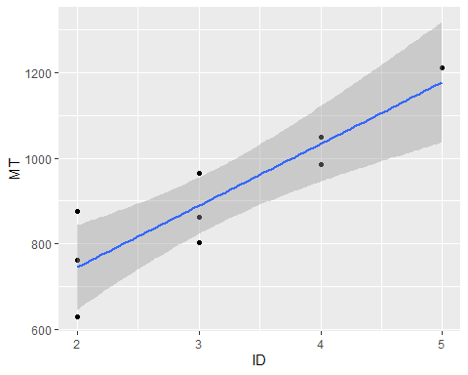

#### we can see little impact from ID TO MT, Let us go with linear model summary to see more details.

## Linear modelling

model1 <- lm(MT~ID, data = Data_Mean_128_16_first)  
summary(model1)

##   
## Call:  
## lm(formula = MT ~ ID, data = Data_Mean_128_16_first)  
##   
## Residuals:  
## Min 1Q Median 3Q Max   
## -115.0 -48.4 16.6 33.4 132.0   
##   
## Coefficients:  
## Estimate Std. Error t value Pr(>|t|)   
## (Intercept) 456.60 91.14 5.010 0.00155 **  
## ID 144.20 27.90 5.168 0.00130 **  
## ---  
## Signif. codes: 0 '***' 0.001 '**' 0.01 '*' 0.05 '.' 0.1 ' ' 1  
##   
## Residual standard error: 83.2 on 7 degrees of freedom  
## Multiple R-squared: 0.7923, Adjusted R-squared: 0.7626   
## F-statistic: 26.7 on 1 and 7 DF, p-value: 0.001299

#### Similary to Fitts’ law says, ID does seem to have an impact on the movement time.

#### Also, the R2=0.869 reported by the [experimental software](http://ergo.human.cornell.edu/FittsLaw/FittsLaw.html) and the R2=0.7923 I find here, are different , but they are close to each other , but this for mean data not for Raw.

par(mfrow=c(2,2));plot(model1);par(mfrow=c(1,1))

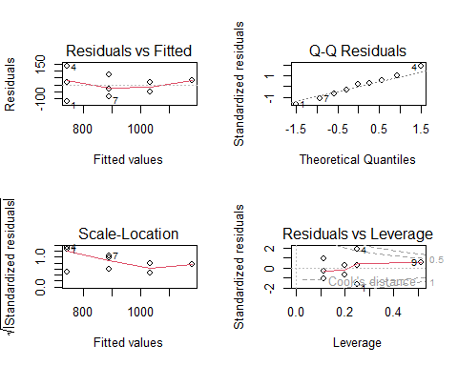

#### we can see from the residuLs VS Fitted there s no clear pattern (if i really undersant the pattern from this graph :) ),

#### so we will not reject this model , and we can consider it good , also the pvalue it is inder 0.05 .

#### note this data for the mean not the raw.

#### now , same steps but for Raw Data.

ggplot(Data_128_16_first, aes(ID, MT)) +  
 geom_point() +  
 geom_smooth(method='lm')

## `geom_smooth()` using formula = 'y ~ x'

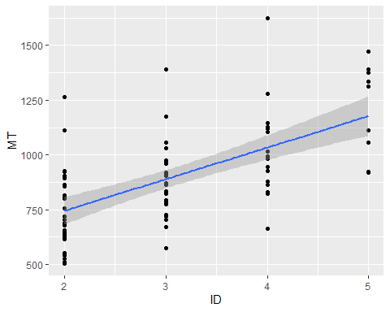

#### Here the we confuse more because the impact doesnt appear that much and we have more variablity between the points.

model2 <- lm(MT~ID, data = Data_128_16_first)  
summary(model2)

##   
## Call:  
## lm(formula = MT ~ ID, data = Data_128_16_first)  
##   
## Residuals:  
## Min 1Q Median 3Q Max   
## -369.22 -129.17 -24.19 110.83 590.78   
##   
## Coefficients:  
## Estimate Std. Error t value Pr(>|t|)   
## (Intercept) 457.11 68.59 6.665 3.25e-09 ***  
## ID 144.03 21.00 6.858 1.39e-09 ***  
## ---  
## Signif. codes: 0 '***' 0.001 '**' 0.01 '*' 0.05 '.' 0.1 ' ' 1  
##   
## Residual standard error: 187.8 on 79 degrees of freedom  
## Multiple R-squared: 0.3732, Adjusted R-squared: 0.3653   
## F-statistic: 47.04 on 1 and 79 DF, p-value: 1.393e-09

#### From the summary we can see the R-squared is smaller for Raw data ,that mean there are alot of residuals are not explained by the model.

## Plotting the residuals vs fitted.

par(mfrow=c(2,2));plot(model2);par(mfrow=c(1,1))

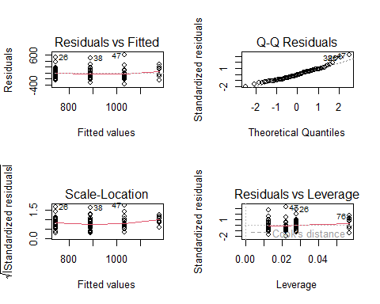

#### From the ploting graph we cant see there is a real impact from ID on MT , but for the model we can see the fitted vs residuals we cant reject the model and we can see the p value less than 0.05 which is good so we can go with this model ,but the movement values will not just depend on ID , there are factors like the device we use , the age of person , how much he concetrate , does he did somthing else while he doing the experiment , does he use mouse or something else.

## Second Experiment , with same steps from above.

library(readxl)  
Data_Mean_12_6_second <- read_excel("Data_second_experiment_12_6/Data_Mean_12_6_second.xlsx")  
Data_12_6_second <- read_excel("Data_second_experiment_12_6/Data_12_6_second.xlsx")

ggplot(Data_Mean_12_6_second, aes(ID, MT)) +  
 geom_point() +  
 geom_smooth(method='lm')

## `geom_smooth()` using formula = 'y ~ x'

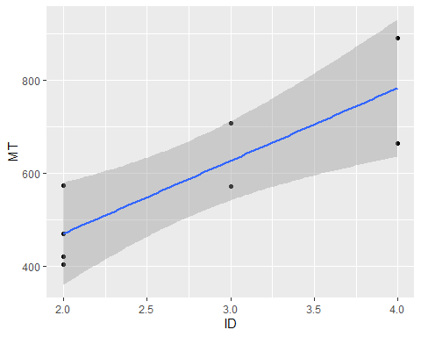

#### we cant see the real impact of ID on MT.

model3 <- lm(MT~ID, data = Data_Mean_12_6_second)  
summary(model3)

##   
## Call:  
## lm(formula = MT ~ ID, data = Data_Mean_12_6_second)  
##   
## Residuals:  
## Min 1Q Median 3Q Max   
## -119.77 -58.38 -24.64 86.38 107.23   
##   
## Coefficients:  
## Estimate Std. Error t value Pr(>|t|)   
## (Intercept) 158.50 115.23 1.375 0.21813   
## ID 156.32 40.12 3.896 0.00802 **  
## ---  
## Signif. codes: 0 '***' 0.001 '**' 0.01 '*' 0.05 '.' 0.1 ' ' 1  
##   
## Residual standard error: 94.09 on 6 degrees of freedom  
## Multiple R-squared: 0.7167, Adjusted R-squared: 0.6695   
## F-statistic: 15.18 on 1 and 6 DF, p-value: 0.008018

#### The R-squared bigger than we get from the software 0.640,becuase we reduce the data,still we will not reject the

#### model,since we have p-value less than 0.05 and there is impact for ID on MT without forgetting the impact for other

#### factors.

par(mfrow=c(2,2));plot(model3);par(mfrow=c(1,1))

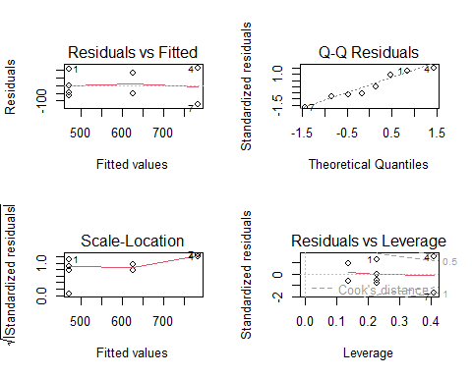

#### Also from this graph residual vs fitted so we cant see the pattern so we cant reject the model , and there is a little impact from the ID on th MT but As I said above there are another factors.

#### Now for Raw Data,

ggplot(Data_12_6_second, aes(ID, MT)) +  
 geom_point() +  
 geom_smooth(method='lm')

## `geom_smooth()` using formula = 'y ~ x'

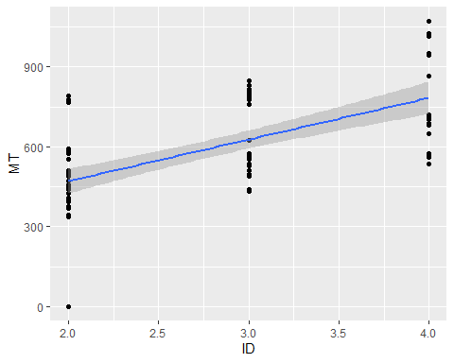

model4 <- lm(MT~ ID, data = Data_12_6_second)  
summary(model4)

##   
## Call:  
## lm(formula = MT ~ ID, data = Data_12_6_second)  
##   
## Residuals:  
## Min 1Q Median 3Q Max   
## -470.92 -100.05 -22.92 112.08 321.08   
##   
## Coefficients:  
## Estimate Std. Error t value Pr(>|t|)   
## (Intercept) 158.67 60.87 2.607 0.0109 *   
## ID 156.13 21.08 7.405 1.25e-10 ***  
## ---  
## Signif. codes: 0 '***' 0.001 '**' 0.01 '*' 0.05 '.' 0.1 ' ' 1  
##   
## Residual standard error: 149.1 on 79 degrees of freedom  
## Multiple R-squared: 0.4097, Adjusted R-squared: 0.4022   
## F-statistic: 54.83 on 1 and 79 DF, p-value: 1.246e-10

#### The R-sequared smaller than above (Mean Data)and smaller than we get from the software which was 0.640,

#### Note:maybe because we reduce the number of points so the R-squared wasnt accurate in mean Data, and was bigger.

par(mfrow=c(2,2));plot(model4);par(mfrow=c(1,1))

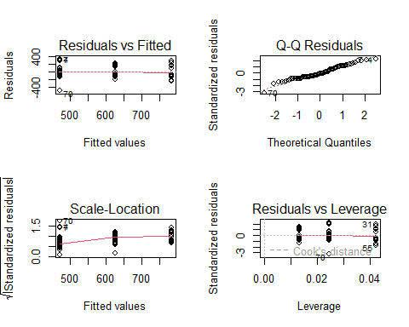

#### We can’t reject the model here, there are another factors have impact on the movement related to the human and the device.

#### Note:also there is important thing , which is we don’t know how they are calculate the R-squared in their software.