“Intelligent Student Record Search System”
Project Report submitted for the partial fulfilment of grade for the course
Data Structures and Algorithms -3 (25CS2103E)
in
DEPARTMENT OF COMPUTER SCIENCE ENGINEERING
by
JAISWAL : 2520030135
HRUDAY DEEPAK : 2520030138
Team Number: 1
Section: 8
Under the Guidance of
Dr. S. Vinay Kumar
Associate Professor
Department of Computer Science and Engineering


2026-27

DEPARTMENT OF COMPUTER SCIENCE ENGINEERING
Declaration
The Project Report entitled “Intelligent Student Record Search System” is a record of Bonafide work of JAISWAL – 2520030135, HRUDAY DEEPAK – 2520030138 submitted in partial fulfillment for the award of B. Tech in Computer Science and Engineering. The results embodied in this report have not been copied from any other departments/University/Institute.

JAISWAL – 2520030135
HRUDAY DEEPAK – 2520030138

DEPARTMENT OF COMPUTER SCIENCE ENGINEERING
CERTIFICATE
This is to certify that the mini project based report entitled “Intelligent Student Record Search System” is a bonafide work done and submitted by JAISWAL – 2520030135 and HRUDAY DEEPAK – 2520030138 in partial fulfillment of the requirements for the award of the degree of BACHELOR OF TECHNOLOGY in Department of Computer Science Engineering, during the academic year 2026-27.
Signature of the Guide Signature of the HOD
(Dr. S. Vinay Kumar)
Signature of the External Examiner
ACKNOWLEDGEMENT
We express our sincere gratitude to our project guide, Dr. S. Vinay Kumar, Associate Professor, Department of Computer Science and Engineering, for his valuable guidance, constant encouragement and timely suggestions throughout the course of this project. His insights into data structures and algorithms helped us choose the right techniques for building an efficient record search system, and his feedback at every stage helped us improve the quality of our work.
We are thankful to Dr. P. Venkateshwara Rao, Associate Professor and Head of the Department of Computer Science and Engineering, for providing the facilities, laboratory resources and a supportive academic environment that made it possible to complete this project successfully. We also thank all the faculty members of the department for their cooperation and support.
Finally, we thank our parents, friends and classmates for their encouragement and motivation. Their support kept us focused and enthusiastic until the completion of this work.

JAISWAL – 2520030135
HRUDAY DEEPAK – 2520030138
ABSTRACT
The Intelligent Student Record Search System is a smart and user-friendly system developed to efficiently store, manage, and retrieve student information. Traditional methods of maintaining student records involve paperwork and manual searching, which can be time-consuming, inefficient, and prone to errors. This system provides a centralized digital platform for managing important student details such as student ID, name, department, course, attendance, marks, and academic performance.
The system enables authorized users such as administrators and faculty members to quickly search and access student records using multiple search criteria. It supports operations such as adding, updating, deleting, viewing, and searching student information while maintaining data accuracy and security. The intelligent search feature reduces the time required to locate specific records and improves the overall efficiency of student data management.
The proposed system minimizes manual work, reduces paperwork, improves record accuracy, and provides faster access to academic information. It can also be enhanced with database management, data analytics, and artificial intelligence to provide advanced search capabilities and meaningful insights into student performance. Overall, the Intelligent Student Record Search System offers a reliable, secure, and efficient solution for modern educational institutions.
TABLE OF CONTENTS
Chapter No. | Title | Contents | Page No.
 | Acknowledgement
 | Abstract
 | Table of Contents
 | List of Figures
1 | Introduction | 1.1 Overview  1.2 Problem Statement  1.3 Scope of the Project  1.4 Objectives  1.5 Importance and Applications  1.6 Methodology  1.7 Organization of the Report | 1-4
2 | System Requirements | 2.1 Functional Requirements  2.2 Non-Functional Requirements  2.3 Hardware and Software Requirements  2.4 Review of Existing Systems  2.5 Use Cases  2.6 Feasibility Study  2.7 Assumptions and Constraints | 5-8
3 | System Design | 3.1 High-level Architecture Diagram  3.2 Description of each Layer  3.3 Search Workflow  3.4 Data Structures Selected  3.5 Database Design  3.6 Data Flow Diagram  3.7 Use Case Diagram  3.8 Sequence Diagram  3.9 Design Alternatives Considered | 9-14
4 | Implementation | 4.1 Module-wise Implementation  4.2 Front-end Logic  4.3 API Integration  4.4 Security and Data Validation  4.5 User Interface Design  4.6 Error Handling  4.7 Testing Strategy | 15-20
5 | Results | 5.1 Experimental Setup  5.2 Search by Student ID  5.3 Search by Name Prefix  5.4 Marks Range Query  5.5 Summary of Search Performance  5.6 Functional Test Results  5.7 Memory Usage and Build Time  5.8 Fuzzy Search Accuracy  5.9 Overall Discussion | 21-27
6 | Challenges & Limitations | 6.1 Issues faced during Development  6.2 Solutions Applied  6.3 Limitations of the System  6.4 Privacy and Ethical Considerations | 28-29
7 | Conclusion & Future Work | 7.1 Conclusion  7.2 Future Work  7.3 Skills learned during Development | 30-30
 | Appendix A | A.1 Prototype source code  A.2 Sample queries and output | 31-33
 | References | Books, papers, tutorials and documentation sites used | 34-34
LIST OF FIGURES
1.1 Traditional manual method versus the proposed system 1
3.1 High-level architecture of the Intelligent Student Record Search System 9
3.2 Flow chart of the search process 10
3.3 Example of a Trie storing student names 11
3.4 Entity-relationship diagram of the database 12
3.5 Data flow diagram of the system 13
3.6 Use case diagram 13
3.7 Sequence diagram of a name search 14
4.1 Wireframe of the proposed user interface 19
5.1 Search by Student ID: linear scan versus hash index 22
5.2 Search by name prefix: linear scan versus Trie 22
5.3 Marks range query: linear scan versus binary search 23
5.4 Memory used by the prototype 25
5.5 Fuzzy search accuracy for different numbers of typing errors 26

1. INTRODUCTION

1.1 Overview
Every educational institution depends on student records. Details such as the student ID, name, department, course, attendance, marks and overall academic performance are needed every day by administrators, examination cells and faculty members. In many institutions these records are still kept in paper files, registers or loosely organised spreadsheets. Finding one student's record in such a collection means scanning many entries by hand, which is slow, tiring and easy to get wrong. As the number of students grows every year, the problem only gets worse.
The Intelligent Student Record Search System is a software solution that stores student data in a centralised digital database and lets authorised users find any record in a fraction of a second. The word “intelligent” refers to how searching is done. Instead of comparing the query with every record one by one, the system builds in-memory indexes using classic data structures: a hash table for exact student-ID lookup, a Trie (prefix tree) for name search and auto-suggestion, and a sorted array with binary search for marks-range queries. When a user mistypes a name, an edit-distance based fuzzy matcher still returns the closest records. The difference between the traditional approach and the proposed approach is shown in Fig. 1.1.
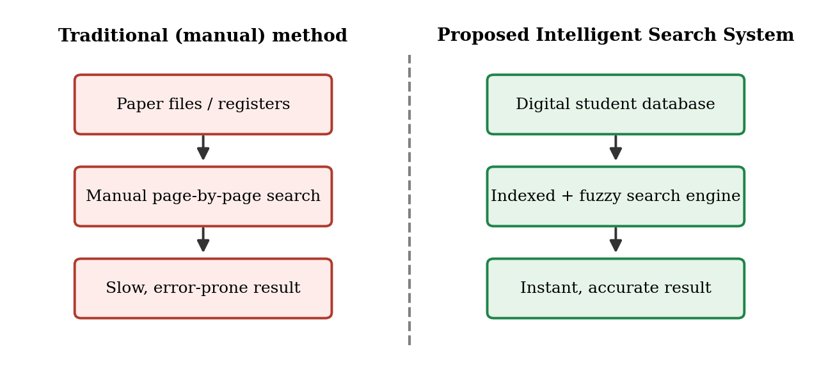
Fig. 1.1 Traditional manual method versus the proposed system
This project is carried out as part of the course Data Structures and Algorithms-3. It shows how the choice of the right data structure changes the cost of a real-world task from linear time to near-constant or logarithmic time [1], [2]. The rest of this report is organised as follows. Chapter 2 lists the requirements and reviews existing approaches. Chapter 3 describes the architecture, the data structures and the database design. Chapter 4 explains the implementation using pseudocode. Chapter 5 presents the experimental results. Chapter 6 discusses challenges and limitations, and Chapter 7 concludes the report with future work.

1.2 Problem Statement
Manual and spreadsheet based student record management suffers from the following problems:
- Searching for a single record requires scanning many pages or rows, so the time taken grows with the number of students.
- Data is duplicated across several files, which leads to inconsistent and outdated information.
- A small spelling mistake in a name or a missing ID digit makes the record hard to locate.
- There is no proper access control, so sensitive academic data can be seen or changed by anyone who has the file.
- Producing a simple report, such as all students of a department with marks above a threshold, takes a lot of manual effort.
The problem addressed by this project is therefore to design and develop a secure, centralised student record system with fast and flexible search, so that any authorised user can retrieve the required information quickly and accurately.

1.3 Scope of the Project
The system is intended for use inside an educational institution by two types of users: administrators and faculty members. Within this scope it provides the following:
- Storage of student details: ID, name, department, course, attendance, marks and grade.
- Add, update, delete and view operations on student records.
- Search by student ID, by name (including partial names and spelling mistakes), by department and course, and by marks range.
- Role based login so that only authorised users can modify records.
- A performance study that compares the indexed search methods with a simple linear scan.
Features such as online fee payment, timetable management, and integration with the university's examination software are outside the scope of this version. Possible extensions are discussed in Section 7.2.

1.4 Objectives
The main objectives of the project are:
- To build a centralised digital platform for storing and managing student records.
- To reduce the time needed to find a record by using suitable data structures such as hash tables, Tries and binary search.
- To support multiple search criteria in a single, easy-to-use interface.
- To tolerate typing errors in names using approximate string matching.
- To protect data through authentication, role based access and input validation.
- To measure and report the actual performance gain of the proposed search methods.

1.5 Importance and Applications
Quick access to student information is more than a convenience. During admissions, examinations, scholarship processing and placement drives, staff must find individual records many times a day, often under time pressure. A delay or a wrong match can cause a student to miss a deadline, or lead to a wrong decision being taken on incomplete data. A fast and accurate search system therefore improves the quality of administration as well as saving time.
The ideas used in this project are not limited to student records. The same combination of a hash index, a Trie and a sorted index can be applied wherever large numbers of records must be searched by an identifier, by a partial name or by a numeric range. Typical applications are:
- Colleges and universities: administrative offices, examination sections and departmental offices.
- Schools and coaching institutes that maintain student and fee records.
- Libraries (member and book records), hospitals (patient records) and training centres.
- Any small organisation that currently depends on spreadsheets for contact or membership lists.

1.6 Methodology
The project was carried out in the following phases. Each phase produced an output that was used in the next phase.
- Requirement analysis: The problems of manual record keeping were studied, and the functions and quality requirements of the system were listed (Chapter 2).
- Design: The layered architecture, the data structures and the database tables were designed, and diagrams such as the data flow diagram, ER diagram and use case diagram were drawn (Chapter 3).
- Implementation: The algorithms were written in pseudocode and then coded in a Python prototype (Chapter 4 and Appendix A).
- Testing and evaluation: The prototype was checked with functional test cases and then measured for speed, memory use and fuzzy-search accuracy (Chapter 5).
- Documentation: The work was documented in this report, together with its challenges, limitations and scope for future work.

1.7 Organization of the Report
The content of each chapter is summarised in Table 1.1.
Table 1.1 Organization of the report
Chapter | Content
Chapter 1 | Introduction: background, problem statement, scope, objectives, importance and methodology.
Chapter 2 | System requirements: functional and non-functional requirements, hardware and software, review of existing systems, use cases and feasibility.
Chapter 3 | System design: architecture, layers, search workflow, data structures, database, DFD, use case and sequence diagrams.
Chapter 4 | Implementation: module-wise pseudocode, user interface, API, security, error handling and testing strategy.
Chapter 5 | Results: speed, memory and accuracy measurements and functional test results.
Chapter 6 | Challenges faced, solutions applied and limitations.
Chapter 7 | Conclusion, future work and skills learned.
Appendix | Source code of the prototype and sample output.

2. SYSTEM REQUIREMENTS
This chapter specifies what the system must do and how well it must do it. It also lists the hardware and software needed, and briefly reviews existing approaches to student record management and the gaps that this project tries to fill.

2.1 Functional Requirements
The functional requirements describe the functions that the system performs.
- FR1 – User login: Administrators and faculty members log in with a username and password. The system identifies the role of the user after login.
- FR2 – Add student record: An administrator can add a new student with ID, name, department, course, attendance and marks. The ID must be unique.
- FR3 – Update student record: An administrator can edit any field of an existing record. Faculty members can update only attendance and marks.
- FR4 – Delete student record: An administrator can delete a record. The deletion is stored in an audit log.
- FR5 – Search by student ID: The system returns the exact record for a given ID.
- FR6 – Search by name: The system supports full and partial names (prefix search) and suggests matching names while the user types.
- FR7 – Fuzzy search: When no exact match is found, the system returns the closest names within a small edit distance.
- FR8 – Filter by department/course and marks range: The user can list all students of a department or course, and all students whose marks fall in a given range.
- FR9 – View and sort results: Search results are shown in a table that can be sorted by name, ID or marks.
- FR10 – Report/Export: The current result list can be exported as a CSV file.

2.2 Non-Functional Requirements
Table 2.1 Non-functional requirements
Attribute | Requirement
Response time | ID, prefix and range searches must return in under 100 ms for up to 100,000 records; the fuzzy fallback should return in under 500 ms for 10,000 records.
Usability | A new user should be able to perform a search without training; the interface uses a single search box and simple filters.
Scalability | The indexes must handle growth from a few hundred to a few lakh records without redesign.
Reliability | Data must not be lost on restart; indexes are rebuilt from the database at start-up.
Security | Passwords are stored as salted hashes; every request is checked against the user's role; all inputs are validated.
Accuracy / Integrity | Student IDs are unique; marks must be between 0 and 100; indexes and database are always updated together.
Maintainability | The code is divided into independent modules (authentication, records, indexing, search) so that each can be changed separately.
Portability | The application runs on Windows, Linux or macOS and is accessed using any modern web browser.

2.3 Hardware and Software Requirements
Table 2.2 Hardware and software specifications
Item | Specification
Processor | Intel Core i3 (or equivalent) or higher
RAM | 4 GB minimum (8 GB recommended)
Storage | 500 MB of free disk space
Operating system | Windows 10/11, Ubuntu 20.04 or later, or macOS
Programming language | Python 3.10 or later
Web framework | Flask
Database | SQLite 3
Front end | HTML5, CSS3 and JavaScript
Browser | Google Chrome, Microsoft Edge or Mozilla Firefox (latest versions)
Tools | Visual Studio Code, Git, Python libraries: matplotlib (graphs)

2.4 Review of Existing Systems
Student information is traditionally maintained in paper registers. These are simple and cheap, but searching is manual and records are easily damaged or lost. The next step is the use of spreadsheets such as Microsoft Excel. Spreadsheets allow filtering and sorting, but they are not designed for multi-user access, they offer no real access control, and a lookup is still a linear scan of rows when formulas or filters are used on large sheets.
Full Student Information Systems (SIS) and ERP packages offer wide functionality, but they are large, costly to set up and often provide only basic keyword search. Relational databases give indexed access through B-tree indexes [3], and information retrieval systems use inverted indexes for text search [4]. However, these general tools do not by themselves give typo-tolerant name search with instant prefix suggestions, which are very useful for a clerk who only remembers part of a student's name.
The gaps identified are: (i) slow, linear searching in manual and spreadsheet based systems, (ii) no tolerance for spelling errors, (iii) weak access control, and (iv) lack of a clear measurement of how much faster indexed search is. The proposed system fills these gaps by combining a simple database with purpose-chosen in-memory data structures [1], [2] and approximate string matching [5], [6].

2.5 Use Cases
The two types of users and the main use cases are shown in Fig. 3.6 in the next chapter. Table 2.3 describes the important use cases in detail.
Table 2.3 Description of the main use cases
ID | Use case | Actor | Description
UC1 | Login | Admin, Faculty | The user enters a username and password. On success the home page for the user's role is shown; on failure an error message is displayed and the attempt is logged.
UC2 | Search by ID | Admin, Faculty | The user enters a 10-digit ID. The system returns the matching record or a “not found” message.
UC3 | Search by name | Admin, Faculty | The user types a full or partial name. Suggestions appear while typing. If nothing matches, the closest names are shown.
UC4 | Filter records | Admin, Faculty | The user selects a department, course or marks range and receives the list of matching students.
UC5 | Add record | Admin | The administrator enters the details of a new student. The system validates them, rejects duplicate IDs and saves the record.
UC6 | Update record | Admin, Faculty | The administrator can edit any field; a faculty member can edit only marks and attendance.
UC7 | Delete record | Admin | The administrator removes a record after confirmation. The action is stored in the audit log.
UC8 | Export results | Admin, Faculty | The current list of results is downloaded as a CSV file.

2.6 Feasibility Study
- Technical feasibility: All the techniques needed (hash tables, Tries, binary search, edit distance) are standard and are available in common programming languages. Python, Flask and SQLite are free and run on ordinary computers, so no special technology is required.
- Economic feasibility: The system is built entirely with open-source software and runs on the hardware already available in a department office. There is no licence cost, and the time saved by staff is the main benefit.
- Operational feasibility: The interface is a single web page with a search box, which is similar to the search engines that users already know. Little training is needed, and the system can run alongside the existing records during the changeover.
- Schedule feasibility: The work was divided into phases that could be completed within the course period, as shown in Table 2.4.
Table 2.4 Project schedule
Week | Activity | Output
Weeks 1–2 | Topic selection, problem study and requirement analysis | Requirement list
Weeks 3–4 | Study of data structures; selection of techniques; design of architecture and database | Design diagrams
Weeks 5–7 | Implementation of indexes, search functions and record management | Working prototype
Week 8 | Testing and performance measurement | Test and result tables
Weeks 9–10 | Report writing, review and submission | Project report

2.7 Assumptions and Constraints
- The student ID is a unique 10-digit number and does not change during the programme.
- The records of one institution fit in the memory of a single computer (up to a few lakh records).
- Users access the system from inside the institution's network.
- The performance study uses generated data, because real student data is confidential.
- The system depends on the correctness of the data entered by the staff; it can validate the format but not the truth of the data.

3. SYSTEM DESIGN

3.1 High-level Architecture Diagram
The system follows a layered architecture, as shown in Fig. 3.1. Each layer has one clear responsibility and talks only to the layer directly above or below it. This keeps the design simple and makes it easy to test and modify each part.
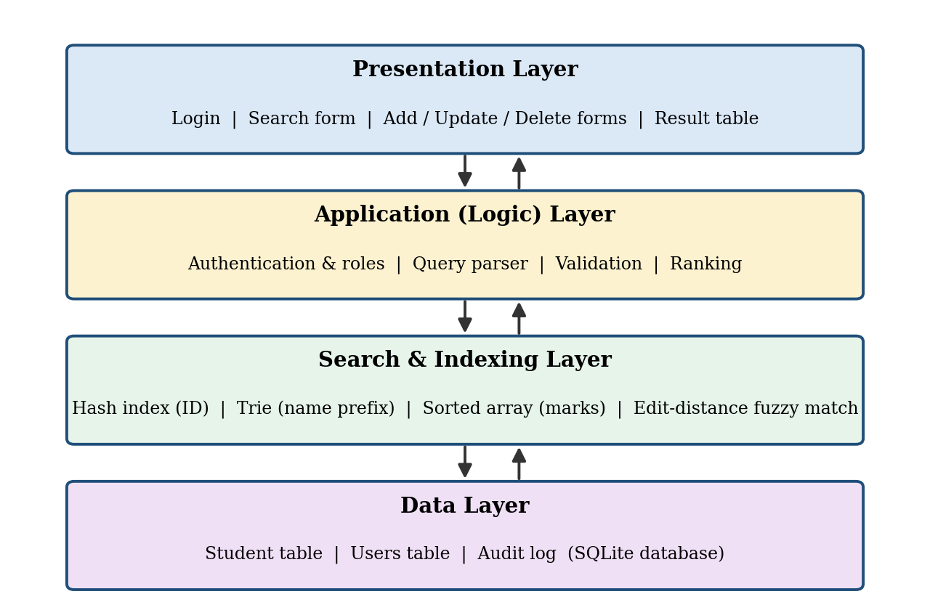
Fig. 3.1 High-level architecture of the Intelligent Student Record Search System

3.2 Description of each Layer
- Presentation Layer: This is the web interface seen by the user. It contains the login page, the search form with a single search box and filters, the forms for adding and updating records, and the result table. It sends requests to the application layer and displays the response.
- Application (Logic) Layer: This layer authenticates users, checks their role, validates all inputs, decides what type of search the user wants (the query parser), and ranks the results before sending them back.
- Search and Indexing Layer: This is the heart of the system. It keeps three in-memory indexes: a hash table that maps student ID to record, a Trie built on student names, and a list of (marks, ID) pairs sorted by marks. It also contains the edit-distance function used for fuzzy matching. The indexes are built when the system starts and are updated whenever a record changes.
- Data Layer: A SQLite database permanently stores the Students table, the Users table and an Audit log. It is the single source of truth. If the application is restarted, all indexes are rebuilt from this database.

3.3 Search Workflow
The flow of a search request is shown in Fig. 3.2. After login, the user types a keyword. The query parser decides the type of search: a numeric string of the ID length is treated as an ID search, a text string as a name search, and the format “marks 80-90” as a range query. The matching index is then used. If nothing is found, the fuzzy matcher is invoked with an edit distance of at most 2. The final records are fetched, ranked and displayed.
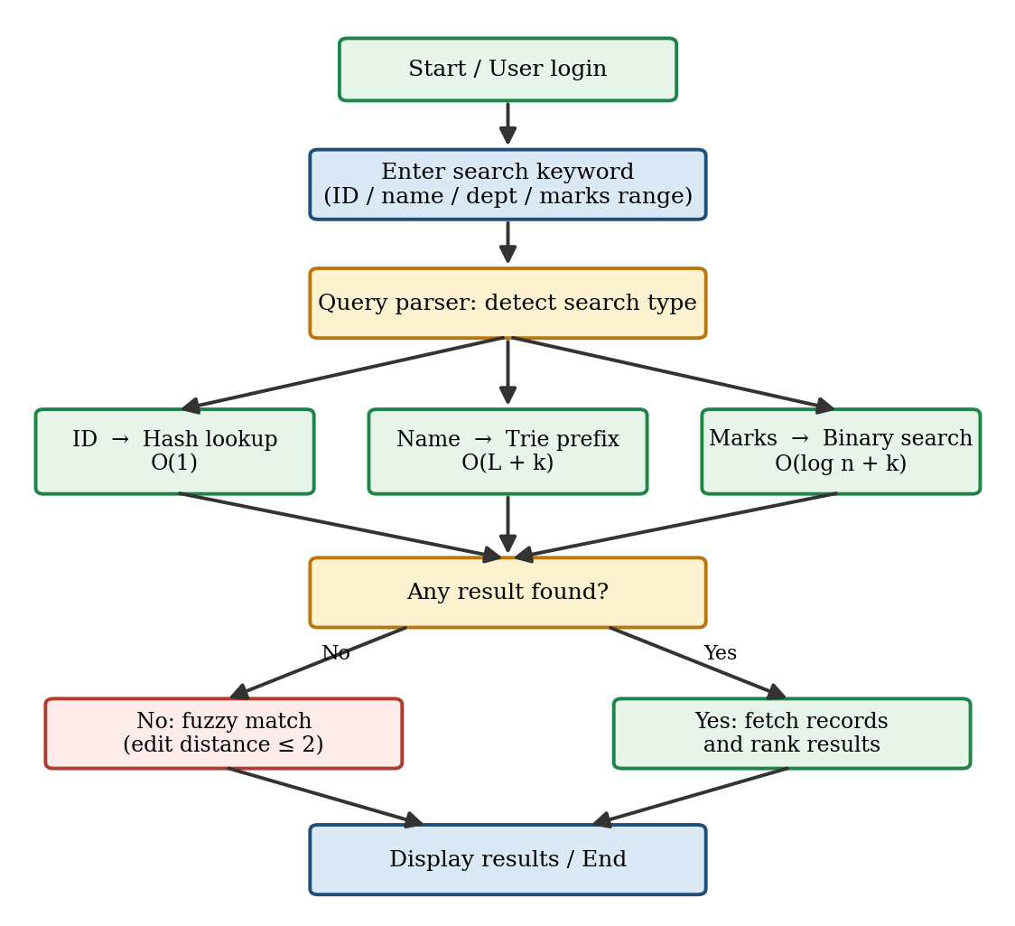
Fig. 3.2 Flow chart of the search process

3.4 Data Structures Selected
The choice of data structure for each search type is the main design decision of this project. Table 3.1 summarises the choices and the reasons for them. Here n is the number of records, L is the length of the search key and k is the number of matching records.
Table 3.1 Data structures chosen for each search type
Search type | Data structure | Time complexity | Reason for choice
Student ID (exact) | Hash table | O(1) average | IDs are unique and always searched for equality.
Name (prefix / suggestions) | Trie | O(L + k) | Time depends on the length of the key and not on n; natural for auto-complete.
Marks range | Sorted array + binary search | O(log n + k) | Range queries need ordered data; binary search finds the boundaries quickly.
Misspelt names | Edit distance (dynamic programming) | O(L1 × L2) per name | Measures how many edits separate two strings [5].
Baseline (manual style) | Linear scan | O(n) | Used only for comparison in Chapter 5.

A Trie stores strings character by character along the edges of a tree, so all names with a common prefix share the same path from the root [6]. Fig. 3.3 shows a small Trie. Starting from the root and following the characters of the prefix leads directly to the node from which all matching names can be collected, without looking at any non-matching name.
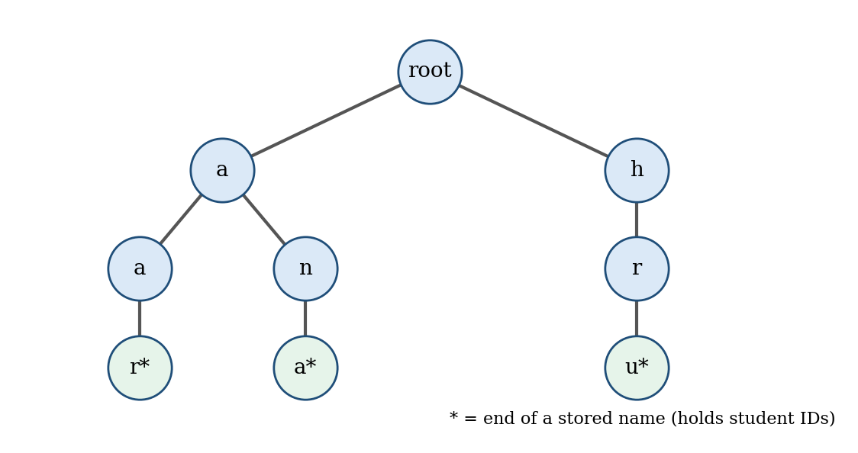
Fig. 3.3 Example of a Trie storing student names
The system inserts every name as a whole and also word by word, so that a user can search by first name or by surname. The edit distance between two strings is the minimum number of insertions, deletions and substitutions needed to turn one into the other [5]. It is calculated using dynamic programming.

3.5 Database Design
Two main tables and one audit table are used. The structure of the Students table is given in Table 3.2 and that of the Users table in Table 3.3.
Table 3.2 Structure of the Students table
Field | Type | Description
student_id (PK) | TEXT / INTEGER | Unique 10-digit student ID, e.g. 2520030135
name | TEXT | Full name of the student
department | TEXT | Department, e.g. CSE
course | TEXT | Course or programme
attendance | REAL | Attendance percentage (0–100)
marks | REAL | Marks or aggregate percentage (0–100)
grade | TEXT | Grade derived from marks

Table 3.3 Structure of the Users table
Field | Type | Description
user_id (PK) | INTEGER | Unique identifier of the user
username | TEXT | Login name (unique)
password_hash | TEXT | Salted hash of the password; the plain password is never stored
role | TEXT | ADMIN or FACULTY

The relationships between the tables are shown in the entity-relationship diagram in Fig. 3.4. Every change made by a user is recorded in the Audit_Log table, which refers to the user who made the change and to the student record that was affected. This gives a full history of who changed what and when.
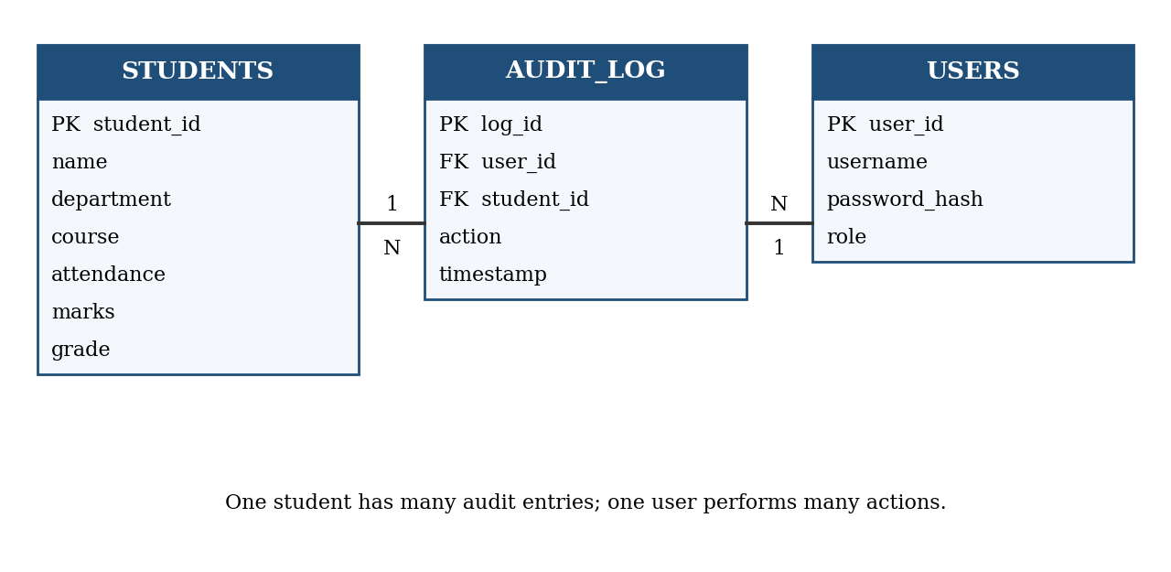
Fig. 3.4 Entity-relationship diagram of the database

3.6 Data Flow Diagram
The data flow diagram in Fig. 3.5 shows how data moves through the system. The user interacts with three main processes. The Authenticate process checks the username and password against the Users database. The Manage Records process writes changes to the Student database and, at the same time, updates the in-memory indexes. The Search Engine process answers queries by reading from the indexes, and returns the results to the user. The database is used only for permanent storage and for rebuilding the indexes at start-up.
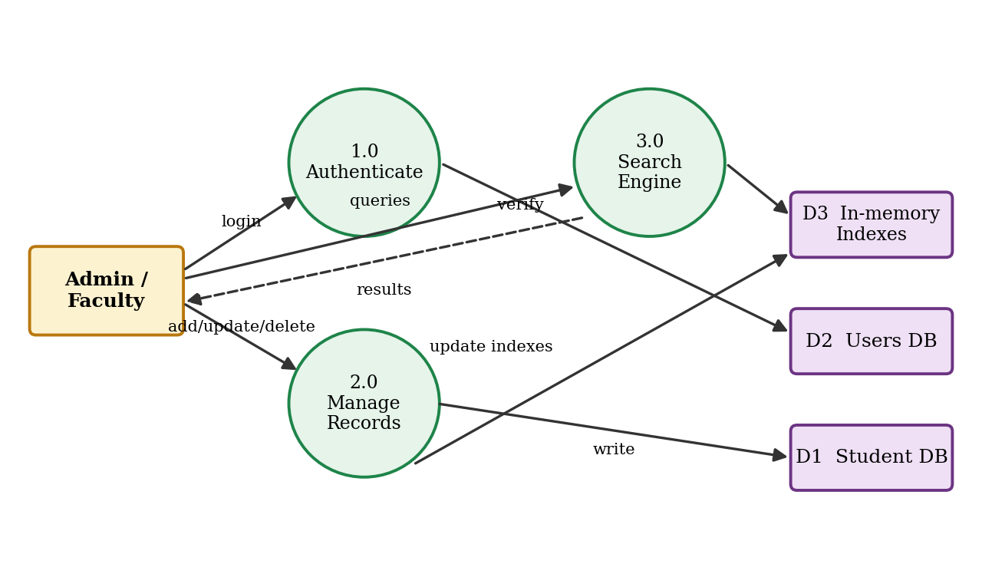
Fig. 3.5 Data flow diagram of the system

3.7 Use Case Diagram
Fig. 3.6 shows the use cases of the two actors. The administrator can use all the functions, including adding and deleting records. The faculty member can log in, search, filter, update marks and attendance, and export results, but cannot add or delete records. The detailed description of each use case was given in Table 2.3.
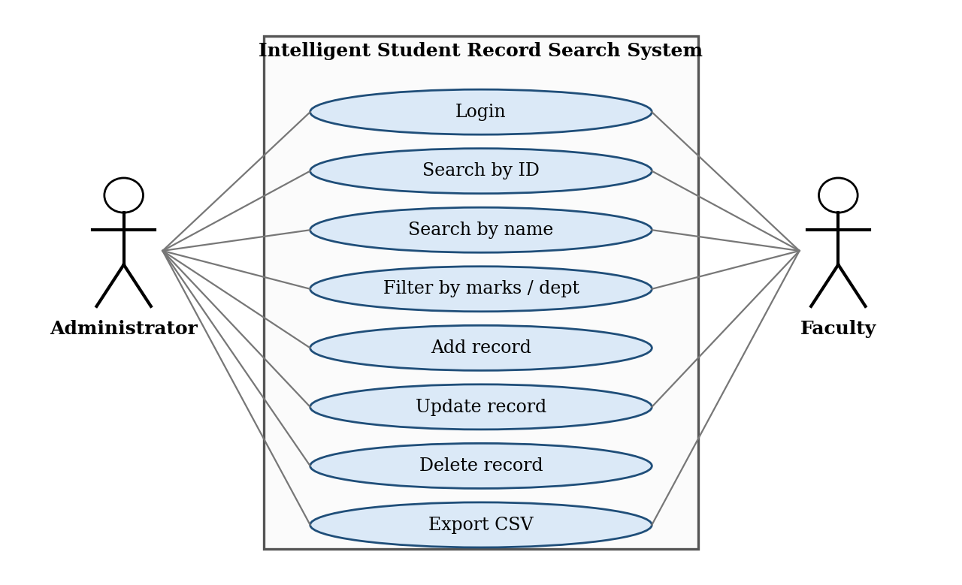
Fig. 3.6 Use case diagram

3.8 Sequence Diagram
The sequence diagram in Fig. 3.7 shows the messages exchanged when a user types a name prefix in the search box. The browser sends the prefix after a short delay. The Flask API checks the role of the user and validates the input, then asks the search engine to look up the prefix in the Trie. The matching IDs are returned, the records are fetched and ranked, and a list in JSON format is sent back to the browser, which redraws the result table.
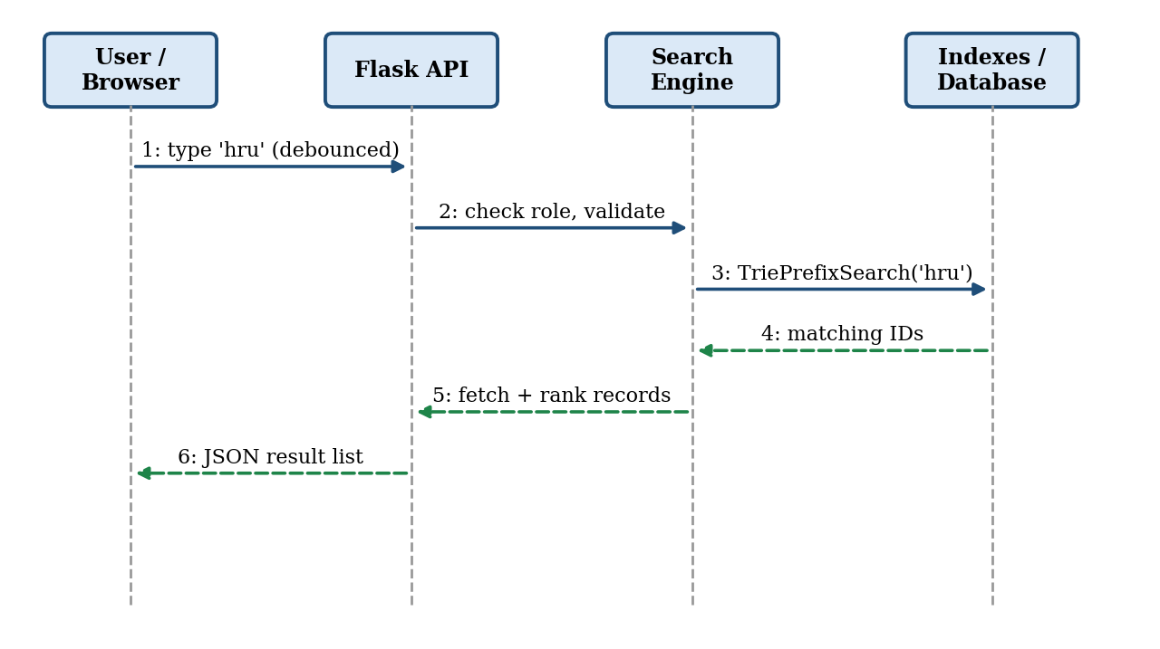
Fig. 3.7 Sequence diagram of a name search

3.9 Design Alternatives Considered
Several other data structures could have been used. Table 3.4 compares the main alternatives with the final choice and gives the reasons for the decision.
Table 3.4 Alternatives considered and reasons for the final choice
Need | Alternative | Reason it was not chosen / chosen
ID lookup | Binary search tree / sorted array | O(log n) per lookup; the hash table is O(1) on average and ID order is not needed. Hash table chosen.
Name search | Linear scan with starts-with | Time grows with n (Chapter 5). Trie chosen.
Name search | Sorted array of names + binary search | Works for prefixes but is costly to update, and cannot easily index each word of a name. Trie chosen.
Marks range | Balanced tree (AVL / B-tree) | Faster inserts, but more complex. Sorted array chosen for simplicity; tree kept as future work.
Persistent storage | Flat files / CSV | No integrity checks and no multi-user safety. SQLite chosen.
Fuzzy search | Soundex / phonetic codes | Handles only similar-sounding names, not general typing mistakes. Edit distance chosen.

4. IMPLEMENTATION
This chapter explains the implementation of the system using pseudocode. The system is divided into five modules: Authentication, Record Management, Index Builder, Search Engine and Reporting. The pseudocode below is written in a language independent style; the working prototype used for the performance study in Chapter 5 was written in Python.

4.1 Module-wise Implementation

Index Builder Module
When the application starts, all records are read from the database and the three indexes are built. The time taken is O(n log n) because of the sort.
Algorithm 4.1 BuildIndexes
BuildIndexes(records):
idIndex <- empty HashMap
nameTrie <- empty Trie
marksList <- empty list
for each record r in records:
idIndex[r.id] <- r
TrieInsert(nameTrie, lowercase(r.name), r.id)
append (r.marks, r.id) to marksList
sort marksList by marks
return idIndex, nameTrie, marksList

Search Engine Module
The search engine contains one function for each search type. Search by ID is a single hash table lookup:
Algorithm 4.2 SearchByID
SearchByID(idIndex, id):
if id exists in idIndex:
return idIndex[id]
return NOT_FOUND

For name search, every character of the name is inserted into the Trie, and the student ID is stored at each node along the path. A prefix search simply walks down the Trie using the characters of the prefix:
Algorithm 4.3 TrieInsert and TriePrefixSearch
TrieInsert(trie, key, id):
node <- trie.root
for each character c in key:
if c not in node.children:
node.children[c] <- new TrieNode()
node <- node.children[c]
add id to node.ids

TriePrefixSearch(trie, prefix):
node <- trie.root
for each character c in prefix:
if c not in node.children:
return empty list
node <- node.children[c]
return node.ids

For marks range queries the pairs are already sorted, so binary search is used to locate the start and the end of the required range:
Algorithm 4.4 MarksRangeSearch
MarksRangeSearch(marksList, low, high):
start <- LowerBound(marksList, low) // first marks >= low
end <- UpperBound(marksList, high) // first marks > high
return IDs in marksList[start .. end-1]

LowerBound(list, x):
lo <- 0 ; hi <- length(list)
while lo < hi:
mid <- (lo + hi) / 2
if list[mid].marks < x: lo <- mid + 1
else: hi <- mid
return lo

If the Trie returns no result, the fuzzy matcher compares the query with the stored names using the Levenshtein edit distance [5] and returns the names whose distance is at most 2:
Algorithm 4.5 FuzzySearch
EditDistance(a, b):
create table D[0..len(a)][0..len(b)]
for i <- 0 to len(a): D[i][0] <- i
for j <- 0 to len(b): D[0][j] <- j
for i <- 1 to len(a):
for j <- 1 to len(b):
cost <- 0 if a[i] = b[j] else 1
D[i][j] <- min(D[i-1][j] + 1, // deletion
D[i][j-1] + 1, // insertion
D[i-1][j-1] + cost) // substitution
return D[len(a)][len(b)]

FuzzySearch(names, query, maxDist = 2):
result <- empty list
for each name in names:
if EditDistance(lowercase(name), query) <= maxDist:
add name to result
sort result by distance
return result

Record Management Module
Whenever a record is added, updated or deleted, the database and all three indexes must be changed together so that they never disagree.
Algorithm 4.6 AddRecord and DeleteRecord
AddRecord(user, r):
if user.role != ADMIN: return ACCESS_DENIED
if not Validate(r): return INVALID_INPUT
if r.id in idIndex: return DUPLICATE_ID
insert r into database
idIndex[r.id] <- r
TrieInsert(nameTrie, lowercase(r.name), r.id)
insert (r.marks, r.id) into marksList at sorted position
write 'ADD r.id by user' to audit log

DeleteRecord(user, id):
if user.role != ADMIN: return ACCESS_DENIED
r <- idIndex[id]
delete r from database and from idIndex
remove id from the Trie path of r.name
remove (r.marks, id) from marksList
write 'DELETE id by user' to audit log

Authentication Module
Algorithm 4.7 Login
Login(username, password):
u <- database lookup of username
if u is NULL: return FAIL
if Hash(password + u.salt) != u.hash: return FAIL
create session with u.role
return SUCCESS

4.2 Front-end Logic
The front end is a single page built with HTML, CSS and JavaScript. It contains a search box, a drop-down to choose the filter (ID, name, department, marks range), and a result table. While the user types a name, the page sends the typed prefix to the server after a short delay (debounce of about 250 ms) and shows the suggestions returned by the Trie below the search box. This avoids sending a request for every keystroke. The state of the page, that is the current query, the filter and the result list, is kept in a JavaScript object, and the result table is redrawn from this object each time a response arrives. Clicking on a column heading sorts the displayed list without contacting the server again.

4.3 API Integration
The browser communicates with the Flask back end through a small REST API that exchanges data in JSON format. The endpoints are listed in Table 4.1.
Table 4.1 REST API endpoints
Method | Endpoint | Purpose | Role allowed
POST | /api/login | Authenticate the user | All
GET | /api/student/<id> | Search by student ID | Admin, Faculty
GET | /api/search?name=<prefix> | Prefix / fuzzy name search | Admin, Faculty
GET | /api/search?min=<a>&max=<b> | Marks range query | Admin, Faculty
POST | /api/student | Add a new record | Admin
PUT | /api/student/<id> | Update a record | Admin (all fields); Faculty (marks, attendance)
DELETE | /api/student/<id> | Delete a record | Admin
GET | /api/export | Download results as CSV | Admin, Faculty

4.4 Security and Data Validation
Student data is sensitive, so security is built into every module. Passwords are never stored in plain text; only salted hashes are saved. Every API call checks the role of the logged-in user before doing any work, as shown in Algorithms 4.6 and 4.7. All inputs are validated on both the client and the server: the student ID must be unique and of the correct length, marks and attendance must lie between 0 and 100, and text fields are cleaned. Database queries use parameters instead of string concatenation to prevent SQL injection. Finally, every change to a record is written to the audit log with the user name and the time.

4.5 User Interface Design
The user interface is designed to be simple, so that a clerk can use it without training. Fig. 4.1 shows the layout of the main page. A single search box accepts an ID, a name or a marks range written as “marks 80-90”. The query parser decides the type of search, so the user does not have to choose it. Suggestions from the Trie appear below the box as the user types. The results are shown in a table that can be sorted by clicking on a column heading, and the buttons for adding a student and exporting the list are placed at the top and bottom of the page.
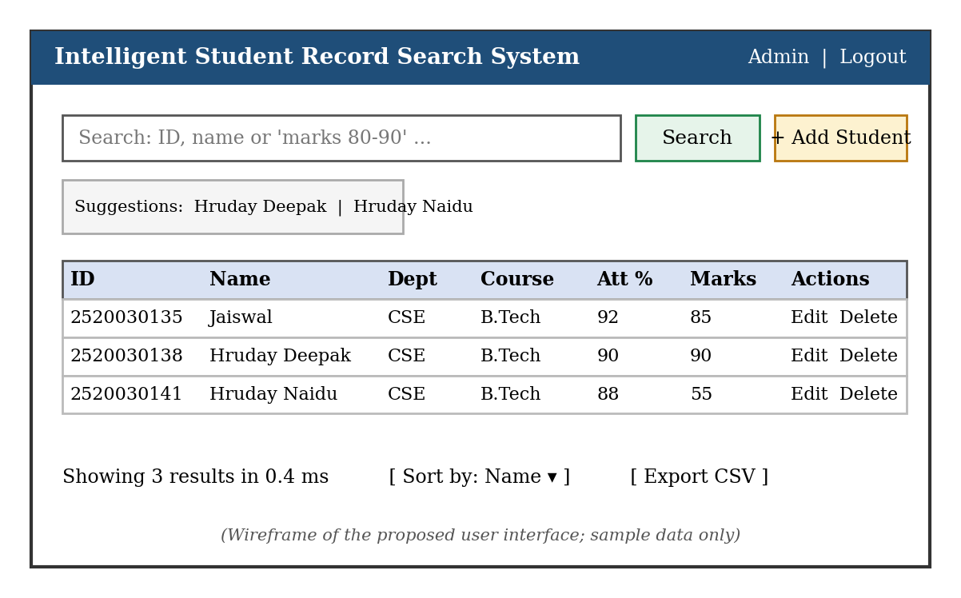
Fig. 4.1 Wireframe of the proposed user interface
The buttons for editing and deleting appear only to users who have the permission for those actions. Messages for the user, such as “No record found” or “Marks must be between 0 and 100”, are displayed in plain language near the field concerned.

4.6 Error Handling
The system checks for errors at every layer and returns a clear status code to the caller. The main errors and their handling are given in Table 4.2.
Table 4.2 Error conditions and system response
Condition | Status returned | Action taken
Wrong username or password | LOGIN_FAILED | Access refused; attempt written to the log.
User lacks permission | ACCESS_DENIED | Action refused; no data changed.
Marks or attendance outside 0–100, or empty name | INVALID_INPUT | Record not saved; message shown beside the field.
Student ID already present | DUPLICATE_ID | Record not saved; existing record shown.
ID not present in the database | NOT_FOUND | “No record found” message; fuzzy suggestions if a name was given.
Database not reachable | DB_ERROR | Operation cancelled; the error is logged and the user is asked to try again.

4.7 Testing Strategy
Testing was done at three levels. First, each function of the search engine (add, delete, update, ID search, prefix search, range search and fuzzy search) was tested separately with small inputs for which the correct answer was known. Second, the functions were tested together to check that the database and the three indexes stay consistent after a series of additions, updates and deletions. Third, the speed and memory use of the system were measured with generated data of increasing size.
As an additional check, the results of the Trie search and of the binary-search range query were compared with the results of a simple linear scan on 5,000 generated records, for 200 random name prefixes and 100 random marks ranges. The indexed methods and the linear scan returned exactly the same set of students every time. The results of the functional tests are given in Section 5.6 and the performance measurements in the other sections of Chapter 5.

5. RESULTS

5.1 Experimental Setup
To find out how much the chosen data structures improve search, a prototype of the search engine was implemented in Python and tested with randomly generated student records of the form (ID, name, department, marks). The number of records was increased from 1,000 to 100,000. For each size, three types of query were run both with the proposed structure and with a simple linear scan, which behaves like manual searching of every record:
- Search by student ID: hash index versus linear scan.
- Search by name prefix (“aar”): Trie versus linear scan using a starts-with test.
- Marks range query (80 to 90): sorted array with binary search versus linear scan.
Each query was repeated many times and the average time per query was recorded in milliseconds. For the name search the prototype indexed each full lowercase name, and the Trie result was verified to contain exactly the same number of matches as the linear scan. The Trie and the binary search return student IDs, or positions in the sorted list, so the cost of reading the full records is not included. The timings were measured on a development laptop and may differ on other machines, but the trend is expected to remain the same.
Table 5.1 Average time per query (in milliseconds) for different numbers of records
Records | ID: linear | ID: hash | Prefix: linear | Prefix: Trie | Range: linear | Range: binary
1,000 | 0.026 | 0.00005 | 0.101 | 0.00017 | 0.032 | 0.00050
5,000 | 0.110 | 0.00004 | 0.567 | 0.00030 | 0.176 | 0.00214
10,000 | 0.415 | 0.00008 | 1.88 | 0.00037 | 0.556 | 0.00721
50,000 | 1.66 | 0.00006 | 7.35 | 0.00066 | 2.22 | 0.030
100,000 | 5.36 | 0.00012 | 18.47 | 0.00093 | 5.83 | 0.066

5.2 Search by Student ID
Fig. 5.1 shows the time for an ID search. The linear scan grows steadily with the number of records, from about 0.026 ms for 1,000 records to about 5.36 ms for 100,000 records. The hash index stays almost flat at roughly 0.0001 ms or less, which is consistent with its expected O(1) behaviour.
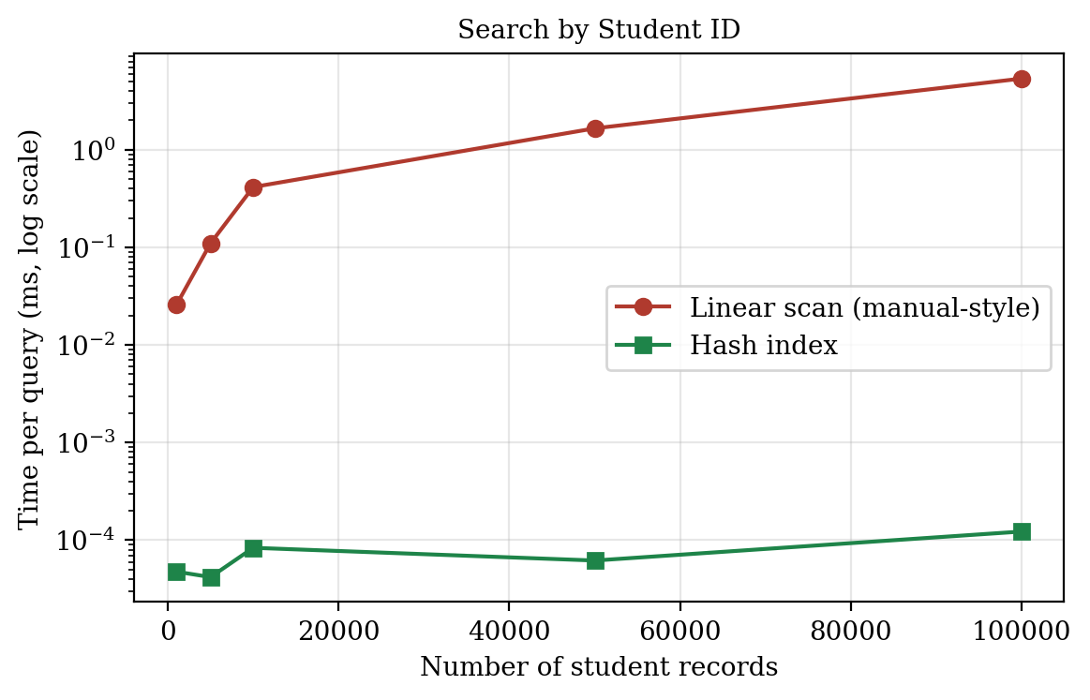
Fig. 5.1 Search by Student ID: linear scan versus hash index

5.3 Search by Name Prefix
Name prefix search is the most expensive operation for the linear scan, because every name has to be converted and compared. It took about 18.47 ms at 100,000 records. The Trie answered the same query in about 0.0009 ms (Fig. 5.2). The Trie's time depends mainly on the length of the prefix, not on the number of stored records, so it is well suited to auto-suggestion while the user types.
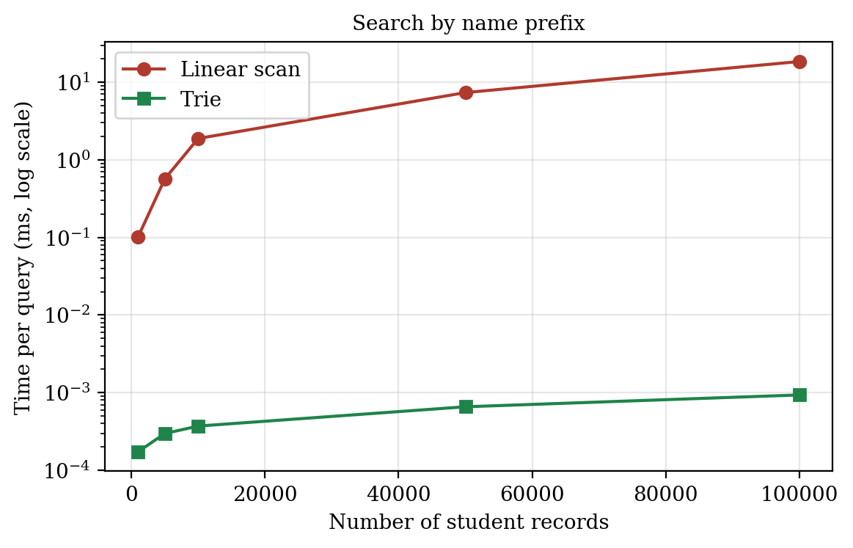
Fig. 5.2 Search by name prefix: linear scan versus Trie

5.4 Marks Range Query
For the marks range query, binary search on the sorted list needed about 0.066 ms at 100,000 records, against about 5.83 ms for the linear scan (Fig. 5.3). The gain here is smaller than for ID and prefix search because the range query still has to return all k matching students, and k grows with n. Even so, the indexed method is much faster.
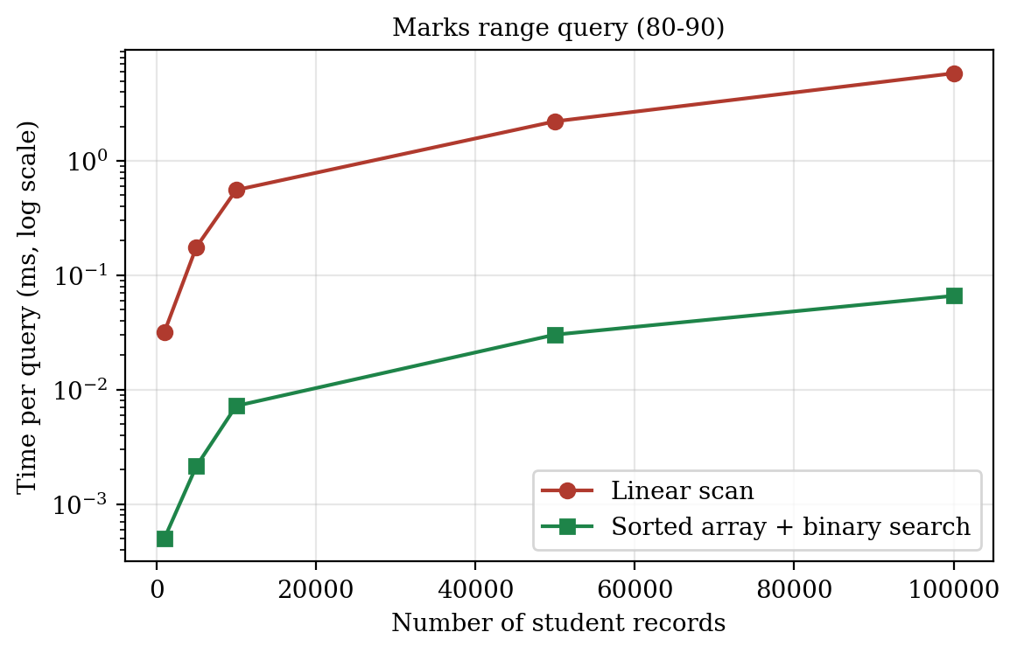
Fig. 5.3 Marks range query: linear scan versus binary search

5.5 Summary of Results
Table 5.2 Improvement at 100,000 records
Search type | Linear scan (ms) | Indexed (ms) | Approximate speed-up
Student ID | 5.36 | 0.00012 | 43,740 times
Name prefix | 18.47 | 0.00093 | 19,781 times
Marks range (80–90) | 5.83 | 0.0661 | 88 times

The results confirm the theory discussed in Chapter 3. Searching with a linear scan takes time proportional to the number of records, while the hash table, the Trie and binary search remain fast as the data grows. All three indexed searches finished well under the 100 ms response-time requirement set in Section 2.2, even for 100,000 records. The price paid for this speed is extra memory for the indexes and some extra work on every insert and delete, which is discussed in Chapter 6.

5.6 Functional Test Results
The prototype was tested with the 15 test cases listed in Table 5.3. Each test was run against the prototype and its actual outcome was compared with the expected outcome. All the test cases passed. In addition, the consistency check described in Section 4.7 (200 prefix queries and 100 range queries on 5,000 records) showed no difference between the indexed results and the linear scan.
Table 5.3 Functional test cases and results
No. | Test case | Input | Expected result | Result
1 | Add valid record | id=2520030135, Jaiswal, marks 85 | OK | Pass
2 | Add second record | id=2520030138, Hruday Deepak, marks 90 | OK | Pass
3 | Reject duplicate ID | id=2520030135 again | DUPLICATE_ID | Pass
4 | Reject invalid marks | marks = 120 | INVALID_INPUT | Pass
5 | Search by ID (found) | 2520030138 | Hruday Deepak | Pass
6 | Search by ID (absent) | 2520000000 | Empty result | Pass
7 | Name prefix | hru | 2 records (Hruday ...) | Pass
8 | Surname search | jaiswal | 1 record | Pass
9 | Fuzzy search | jaiswall (typo) | Jaiswal returned | Pass
10 | Fuzzy search (2 edits) | hrudy deepk | Hruday Deepak returned | Pass
11 | Marks range | marks 80-95 | Records with marks 80-95 only | Pass
12 | Update marks re-indexes | Jaiswal 85 -> 60 | Not in 80-95; in 55-65 | Pass
13 | Delete record | delete 2520030138 | Removed from all 3 indexes | Pass
14 | Faculty cannot delete | role=FACULTY, delete | Access denied | Pass
15 | Faculty can update marks | role=FACULTY, update_marks | Allowed | Pass

5.7 Memory Usage and Build Time
Indexes make searching faster, but they use additional memory and take time to build. Fig. 5.4 compares the memory used for the plain records with the memory used for the records together with the three indexes, and Table 5.4 gives the figures together with the time needed to build the indexes when the system starts.
Table 5.4 Memory use and index build time
Records | Records only (MB) | Records + indexes (MB) | Build time (s)
10,000 | 1.9 | 28.9 | 0.20
50,000 | 9.6 | 120.3 | 1.46
100,000 | 19.2 | 279.9 | 3.65

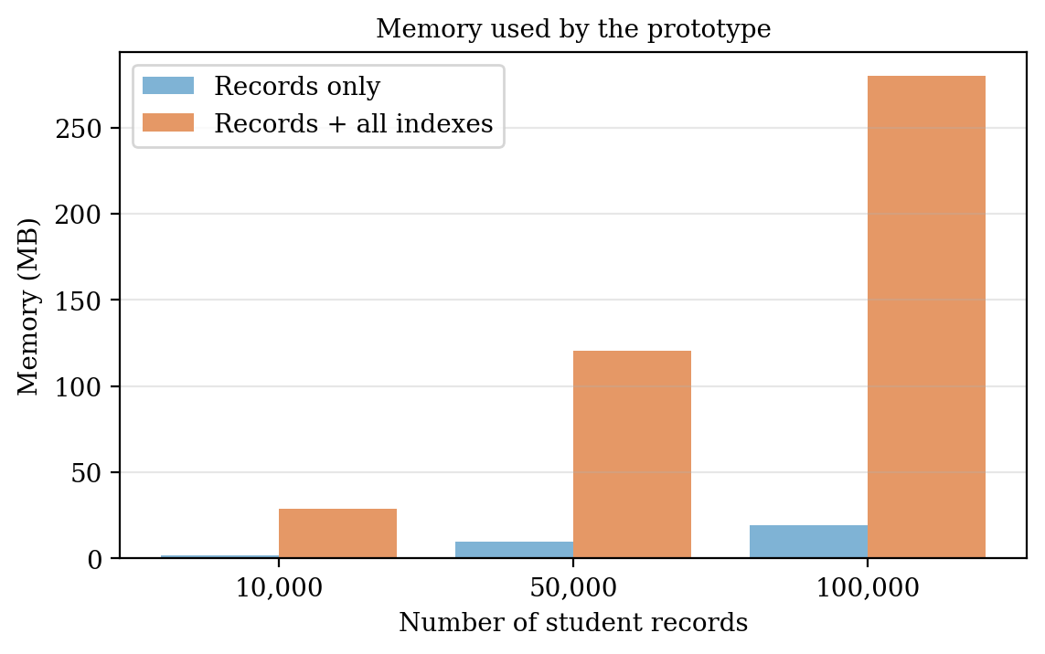
Fig. 5.4 Memory used by the prototype
Memory grows linearly with the number of records. At 100,000 records the prototype used about 280 MB, which is acceptable for an ordinary computer but is much larger than the plain records. Most of the extra memory is used by the Trie, because every node keeps the set of student IDs that pass through it. The build time of about 3.6 s for 100,000 records is paid only once, when the system starts. Memory-saving ideas, such as storing the IDs only at the end of each name, are given in Section 7.2.

5.8 Fuzzy Search Accuracy
To check how well the fuzzy search recovers from typing mistakes, 150 students were chosen at random from 10,000 generated records. For each student, the first name was changed by 1, 2 or 3 random errors (a letter replaced, removed or inserted), and the changed name was given as the query with a maximum edit distance of 2. Fig. 5.5 shows the percentage of cases in which the correct student was found.
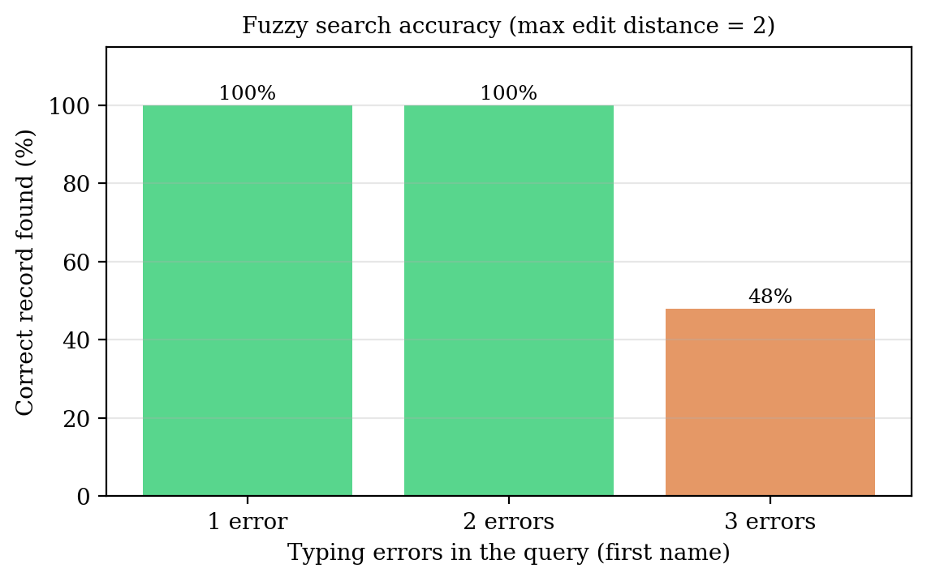
Fig. 5.5 Fuzzy search accuracy for different numbers of typing errors
The correct student was found in 100% of the cases with one error and 100% with two errors, which is expected because the allowed edit distance is 2. With three errors the success rate fell to 48%, since some of the changed names are then too far from the original. A more important observation is the time taken. The fuzzy matcher compares the query with every name, so it needs about 181 ms per query for 10,000 students. This is acceptable for an occasional fallback search, but it is far slower than the indexed searches. For this reason the system uses fuzzy matching only when the exact and prefix searches find nothing, and faster approximate-matching methods are suggested as future work.

5.9 Overall Discussion
Table 5.5 summarises how the proposed system compares with the traditional methods, based on the study carried out in this project.
Table 5.5 Comparison of record-keeping approaches
Feature | Paper register | Spreadsheet | Proposed system
Search by ID | Manual, slow | Filter / find; linear | Hash index, near-instant
Search by partial name | Manual | Filter; linear | Trie, near-instant
Spelling mistakes | Not handled | Not handled | Fuzzy matching
Marks range query | Manual | Filter; linear | Binary search
Access control | Locked cupboard | File password only | Role based login
Audit trail | None | Limited | Audit log table
Data consistency | Duplicates likely | Duplicates possible | Unique ID enforced

Overall, the experiments show that choosing a suitable data structure for each type of query gives a very large reduction in search time. The functional tests show that the operations behave correctly, including the rejection of wrong input and the permission checks. The measurements also show the cost of this approach: higher memory use, a build time at start-up, and a slow fuzzy search. These points are discussed further as limitations in Chapter 6.

6. CHALLENGES & LIMITATIONS

6.1 Issues faced during Development
- Keeping the database and the three indexes consistent when a record is added, edited or deleted, especially when the name or marks change.
- Deleting a name from the Trie without breaking the paths shared with other names.
- Fuzzy matching against every name is slow if the list of names is large.
- Names are written in different ways: capital and small letters, extra spaces, initials before or after the surname.
- Choosing realistic test data and a fair way to measure query time.

6.2 Solutions Applied
- All changes go through a single record management function that updates the database first and then each index, and the indexes are fully rebuilt from the database whenever the application starts.
- Each Trie node keeps the list of student IDs passing through it, so an entry can be removed by walking the path of the old name and deleting the ID from each node.
- The fuzzy matcher is called only when the exact and prefix searches return nothing, and only names of similar length are compared.
- Names are converted to lowercase, trimmed and indexed word by word before they are stored or searched.
- Records were generated randomly with a fixed seed so that the tests are repeatable, and each query was repeated many times to get an average.

6.3 Limitations of the System
- All indexes are held in memory, so very large data sets (many millions of records) would need more RAM or a disk-based index.
- Storing IDs at every Trie node speeds up prefix search but uses more memory than a plain Trie.
- Sorted-array insertion takes O(n) time, so a very high rate of marks updates would be better served by a balanced tree.
- The performance study used synthetic data and a single machine; results on real institutional data may differ.
- Fuzzy search checks only spelling similarity and does not understand the meaning of a query.
- The fuzzy search compares the query with every name and took about 200 ms per query for 10,000 records, so it is suitable only as an occasional fallback.

6.4 Privacy and Ethical Considerations
Student records contain personal and academic information, so the system must be used responsibly. Only authorised staff should be given accounts, and each person should have only the permissions needed for his or her work. The audit log allows any change to be traced to a user. Real student data should not be used for testing; for this reason the performance study in this report uses generated records. The institution using the system should also follow the data protection rules that apply to it, keep regular backups of the database, and delete the records that it is no longer required to keep.

7. CONCLUSION & FUTURE WORK

7.1 Conclusion
This project designed and developed an Intelligent Student Record Search System that replaces slow manual searching with a centralised, secure and fast digital system. By using a hash table for ID lookup, a Trie for name search and suggestions, a sorted array with binary search for marks ranges, and edit distance for spelling mistakes, the system answers each type of query in a small fraction of the time needed for a linear scan. In the experiments with up to 100,000 records, the indexed methods were roughly 90 times to more than 40,000 times faster than a linear scan for the tested queries, and the indexed searches stayed within the response-time target (the fuzzy fallback was slower, see Chapter 5).
The project also showed the practical importance of data structures and algorithms. The same task, finding a record, can have very different costs depending on how the data is organised, and the right choice becomes more valuable as the data grows.

7.2 Future Work
- Replace the sorted array with a balanced tree (AVL or B-tree) so that inserts and range queries are both efficient.
- Use a disk-based or distributed index for very large institutions, and add a student login to view own marks and attendance.
- Reduce memory use by storing IDs only at word endings or by using a compressed Trie, and speed up fuzzy search with an n-gram index or an edit-distance search that walks the Trie.
- Use data analytics and machine learning to predict at-risk students and to give insight into academic performance trends.
- Add natural language search (for example “CSE students with marks above 85”), a mobile application, and integration with the institution's examination software.

7.3 Skills learned during Development
- Selecting and implementing suitable data structures (hash tables, Tries, binary search, dynamic programming) and checking their complexity with experiments.
- Database design with SQLite, REST APIs with Flask, secure coding, teamwork, and presenting technical results with tables and graphs.

APPENDIX A

A.1 Prototype source code
The following Python code (file isrs.py) is the prototype of the search engine that was used for the functional tests and for the measurements reported in Chapter 5.
Listing A.1 isrs.py
"""Intelligent Student Record Search System - search engine prototype."""
import bisect

class TrieNode:
__slots__ = ("children", "ids")
def __init__(self):
self.children = {}
self.ids = set()

class Trie:
def __init__(self):
self.root = TrieNode()
def insert(self, key, rid):
node = self.root
for ch in key:
node = node.children.setdefault(ch, TrieNode())
node.ids.add(rid)
def remove(self, key, rid):
node = self.root
for ch in key:
node = node.children.get(ch)
if node is None:
return
node.ids.discard(rid)
def prefix(self, p):
node = self.root
for ch in p:
node = node.children.get(ch)
if node is None:
return set()
return set(node.ids)

def edit_distance(a, b):
prev = list(range(len(b) + 1))
for i in range(1, len(a) + 1):
cur = [i] + [0] * len(b)
for j in range(1, len(b) + 1):
cost = 0 if a[i - 1] == b[j - 1] else 1
cur[j] = min(prev[j] + 1, cur[j - 1] + 1, prev[j - 1] + cost)
prev = cur
return prev[-1]

class StudentIndex:
def __init__(self):
self.by_id = {} # hash index
self.trie = Trie() # name index (whole name + each word)
self.marks = [] # sorted list of (marks, id)

@staticmethod
def _keys(name):
n = name.lower().strip()
return {n} | set(n.split())

def validate(self, r):
return (isinstance(r.get("id"), int)
and r.get("name", "").strip() != ""
and 0 <= r.get("marks", -1) <= 100
and 0 <= r.get("attendance", -1) <= 100)

def add(self, r):
if not self.validate(r):
return "INVALID_INPUT"
if r["id"] in self.by_id:
return "DUPLICATE_ID"
self.by_id[r["id"]] = r
for k in self._keys(r["name"]):
self.trie.insert(k, r["id"])
bisect.insort(self.marks, (r["marks"], r["id"]))
return "OK"

def delete(self, rid):
r = self.by_id.pop(rid, None)
if r is None:
return "NOT_FOUND"
for k in self._keys(r["name"]):
self.trie.remove(k, rid)
self.marks.remove((r["marks"], rid))
return "OK"

def update_marks(self, rid, new_marks):
r = self.by_id.get(rid)
if r is None or not 0 <= new_marks <= 100:
return "INVALID_INPUT"
self.marks.remove((r["marks"], rid))
r["marks"] = new_marks
bisect.insort(self.marks, (new_marks, rid))
return "OK"

def search_id(self, rid):
return self.by_id.get(rid)

def search_prefix(self, p):
ids = self.trie.prefix(p.lower().strip())
return [self.by_id[i] for i in sorted(ids)]

def search_range(self, lo, hi):
a = bisect.bisect_left(self.marks, (lo, -1))
b = bisect.bisect_right(self.marks, (hi, float("inf")))
return [self.by_id[i] for _, i in self.marks[a:b]]

def search_fuzzy(self, q, max_dist=2):
q = q.lower().strip()
out = []
for r in self.by_id.values():
for w in self._keys(r["name"]):
if abs(len(w) - len(q)) > max_dist:
continue
d = edit_distance(w, q)
if d <= max_dist:
out.append((d, r))
break
return [r for _, r in sorted(out, key=lambda t: t[0])]

def search(self, q):
"""Query parser: ID, marks range, prefix, then fuzzy fallback."""
q = q.strip()
if q.isdigit() and len(q) == 10:
r = self.search_id(int(q)); return [r] if r else []
if q.lower().startswith("marks"):
lo, hi = q.split()[1].split("-")
return self.search_range(float(lo), float(hi))
res = self.search_prefix(q)
return res if res else self.search_fuzzy(q)

ROLES = {"ADMIN": {"add", "update", "delete", "search"},
"FACULTY": {"update_marks", "search"}}
def allowed(role, action):
return action in ROLES.get(role, set())

A.2 Sample queries and output
The following queries were run on the prototype with six sample records. The output shown is the actual result returned by the prototype.
Table A.1 Sample queries and results
Query | Result (ID, name, marks)
2520030138 | 2520030138, Hruday Deepak, 90
hru | 2520030138, Hruday Deepak, 90  2520030150, Hruday Naidu, 55
jaiswall | 2520030135, Jaiswal, 85
marks 80-95 | 2520030135, Jaiswal, 85  2520030138, Hruday Deepak, 90  2520030147, Aarav Sharma, 91
ananya | 2520030141, Ananya Rao, 72

REFERENCES
[1] T. H. Cormen, C. E. Leiserson, R. L. Rivest and C. Stein, Introduction to Algorithms, 4th ed. Cambridge, MA, USA: MIT Press, 2022.
[2] R. Sedgewick and K. Wayne, Algorithms, 4th ed. Boston, MA, USA: Addison-Wesley, 2011.
[3] R. Elmasri and S. B. Navathe, Fundamentals of Database Systems, 7th ed. Hoboken, NJ, USA: Pearson, 2016.
[4] C. D. Manning, P. Raghavan and H. Schütze, Introduction to Information Retrieval. Cambridge, U.K.: Cambridge Univ. Press, 2008.
[5] V. I. Levenshtein, “Binary codes capable of correcting deletions, insertions, and reversals,” Soviet Physics Doklady, vol. 10, no. 8, pp. 707–710, 1966.
[6] E. Fredkin, “Trie memory,” Communications of the ACM, vol. 3, no. 9, pp. 490–499, 1960.
[7] G. Navarro, “A guided tour to approximate string matching,” ACM Computing Surveys, vol. 33, no. 1, pp. 31–88, 2001.
[8] Python Software Foundation, “bisect – Array bisection algorithm,” Python 3 Documentation. [Online]. Available: https://docs.python.org/3/library/bisect.html
[9] SQLite Consortium, “SQLite Documentation.” [Online]. Available: https://www.sqlite.org/docs.html
[10] Pallets Projects, “Flask Documentation.” [Online]. Available: https://flask.palletsprojects.com/

