A CASE-STUDY BASED REPORT
ON
Credential Stuffing Attack Detection Using Gradient Boosting Machine and Isolation Forest

Submitted in partial fulfilment of the requirements for the Course
MACHINE LEARNING
BACHELOR OF TECHNOLOGY
A.Y.: 2026–27

BY
Hruday Deepak — 2520030138
B. Surya Prakash Reddy — 2520030145
K. Aasritha — 2520030178

Under the Esteemed Guidance of
G. Ravinder
Associate Professor, Department of CSE
Department of Computer Science and Engineering

INDEX
- Abstract
- 1. Introduction
- 1.1 Background
- 1.2 Motivation for the Project
- 1.3 Overview of the Work Carried Out
- 1.4 Scope and Responsible-Use Statement
- 2. Problem Statement
- 2.1 Case-Study Scenario
- 2.2 Central Case-Study Question
- 2.3 Formal Problem Definition
- 2.4 Objectives that Guide the Study
- 2.5 Assumptions and Limitations
- 3. Dataset and Exploratory Data Analysis
- 3.1 About the Dataset
- 3.2 Purpose of EDA
- 3.3 Preparation Steps Actually Performed / Planned
- 3.4 EDA Exploration – Implementation
- 3.5 Summary of EDA Findings
- 4. Algorithm Selection and Implementation
- 4.1 Gradient Boosting Machine
- 4.2 Isolation Forest
- 4.3 Hybrid Risk Score and Detection Flow
- 4.4 Evaluation Metrics
- 5. Conclusion
- References
Note: Dataset summaries and dashboard scores in this report are reproduced from the supplied project report and presentation. Performance values identified as sample/demo are not presented as independently verified training results.

ABSTRACT
Cybersecurity is a critical concern for online platforms because user accounts and sensitive information are continuously targeted by automated attacks. Credential stuffing is a threat in which attackers reuse username–password pairs stolen in earlier data breaches to attempt access to other services. This case study describes a machine-learning-based detection approach using Gradient Boosting Machine (GBM) and Isolation Forest. Login/session data is prepared and examined, and behavioral and network-related indicators—such as login frequency, failed-login ratio, IP reputation, request rate, timing regularity, proxy/datacenter IP and new-device status—are considered. GBM is used as a supervised classifier for labeled attack patterns, while Isolation Forest identifies unusual observations without requiring attack labels. The supplied project report describes 9,537 login sessions, 10 input columns and 44.7% attack-labeled sessions. The report also contains sample dashboard metrics for Isolation Forest, GBM and a hybrid score; these are explicitly treated here as demonstration values, not verified results from a new model-training run. The case study illustrates how supervised classification and anomaly detection can support login monitoring, suspicious-session flagging and stronger authentication decisions.
Keywords: Credential stuffing, cybersecurity, machine learning, Gradient Boosting Machine, Isolation Forest, anomaly detection.

1. INTRODUCTION

1.1 Background
Online services store personal information, financial data and account credentials. Attackers may obtain username–password combinations from a previous breach and automatically test those combinations against unrelated websites. This is called credential stuffing. It takes advantage of password reuse and can lead to account takeover, privacy violations, financial loss and reputational damage.
The activity can be difficult to identify because a successful attempt may use a valid password. Attackers may distribute requests across IP addresses, rotate proxies or slow down their attempts to resemble ordinary users. Login frequency, failed-login behavior, username diversity, timing patterns, device information and IP reputation can provide additional signals.

1.2 Motivation for the Project
Traditional controls such as rate limits, CAPTCHA, blocklists and fixed thresholds remain useful, but they may miss distributed or low-volume attacks and may also flag legitimate users. The project is motivated by the need to combine learned attack patterns with detection of unusual behavior. GBM and Isolation Forest provide complementary approaches for this purpose.

1.3 Overview of the Work Carried Out
- Review the supplied login/session dataset description and identify relevant login and network features.
- Prepare the data by checking schema and values, handling missing or invalid entries, and encoding categorical fields where needed.
- Use GBM for supervised classification of labeled login sessions.
- Use Isolation Forest to identify unusual login behavior as an anomaly-detection signal.
- Compare models using precision, recall, F1-score and ROC-AUC, alongside accuracy where measured.
- Present the detection concept as a dashboard-oriented workflow that can flag suspicious login sessions.

1.4 Scope and Responsible-Use Statement
The scope is academic investigation of login-traffic detection using machine learning. A flagged session should be treated as a risk signal, not proof that a user is malicious. In a real deployment, alerts should be reviewed alongside contextual evidence, and responses may include step-up authentication, rate limiting or analyst review. Access logs should be minimized, protected and retained only as necessary. The supplied demo results must not be treated as production guarantees.

2. PROBLEM STATEMENT

2.1 Case-Study Scenario
Consider an online platform that receives many login attempts. Some users make ordinary mistakes, while automated attackers test previously leaked credentials across many accounts. Attackers may generate repeated failures, try distinct usernames from one source, make requests at a high rate or show regular timing. The platform needs to identify risky sessions without unnecessarily blocking genuine users.

2.2 Central Case-Study Question
How can GBM and Isolation Forest be combined to identify login sessions that may represent credential stuffing, while balancing attack detection with false alarms?

2.3 Formal Problem Definition
Given a login session or an IP activity window represented by behavioral and network features x, estimate whether the activity is legitimate or suspicious. GBM learns a mapping from labeled examples to a predicted class or probability. Isolation Forest assigns an anomaly signal based on how easily a record can be isolated from other observations. These signals may be combined into a hybrid risk score r(x), which is compared with a decision threshold to produce an alert.
The supplied material describes the intended output as a risk score and alert/flag decision that can support blocking or additional authentication. The exact hybrid-score formula and threshold are not specified in the supplied documents.

2.4 Objectives that Guide the Study
- Prepare and inspect login-session data for credential-stuffing detection.
- Identify behavioral and network indicators associated with suspicious activity.
- Apply a supervised GBM classifier to labeled login sessions.
- Apply Isolation Forest for unsupervised anomaly detection.
- Compare the detection approaches using standard evaluation metrics.
- Illustrate feature importance, confusion-matrix analysis and dashboard alerts.
- Support safer authentication decisions while considering false-positive risks.

2.5 Assumptions and Limitations
- The report describes 9,537 sessions and 10 input columns; the underlying raw CSV was not separately supplied in the materials reviewed for this case study.
- The supplied materials describe both input-column examples and additional engineered behavioral features; the exact final training schema should be confirmed from the implementation.
- The model-comparison and confusion-matrix values are labeled as sample/demo values in the supplied report.
- Results depend on label quality, feature quality, class balance, threshold choice and how well the data represents real login traffic.
- Anomaly detection may flag unusual legitimate activity, and supervised learning may miss attack patterns absent from training data.

3. DATASET AND EXPLORATORY DATA ANALYSIS

3.1 About the Dataset
The supplied project report describes a demonstration dataset of 9,537 login sessions with 10 input columns. The presentation lists example columns such as packet size, protocol, login attempts, session duration, encryption, IP reputation, failed logins, browser and unusual-time access. The report’s dashboard description also uses engineered behavioral features including attempts per minute, distinct usernames tried, failed-login ratio, timing regularity, proxy/datacenter IP and new-device status.
Dataset property | Value stated in supplied report
Login sessions | 9,537
Input columns | 10
Attack-labeled sessions | 44.7%
Normal sessions | 55.3%
Detection methods | GBM + Isolation Forest
Tools | Python, Pandas, scikit-learn; GBM/LightGBM tooling
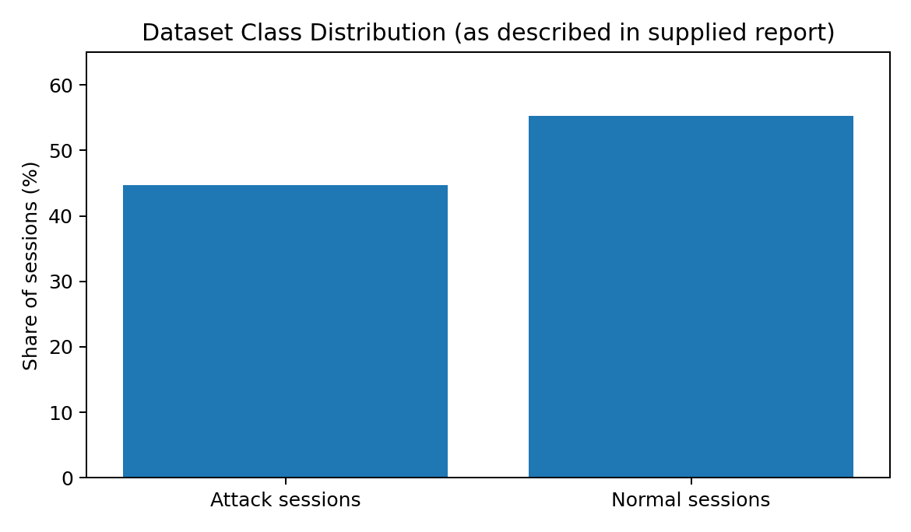
Figure 1. Class distribution as reported in the supplied project materials.

3.2 Purpose of EDA
Exploratory Data Analysis (EDA) helps check the structure, completeness and distribution of the data before modeling. For this case, EDA is intended to compare normal and attack-labeled sessions, inspect login-attempt and failure patterns, review class balance, and identify features that may help distinguish automated activity from ordinary usage.

3.3 Preparation Steps Actually Performed / Planned
The supplied report describes the following preprocessing workflow. Because the raw CSV and a reproducible training log were not included as separate files, these are documented as the project’s stated preparation steps rather than independently re-executed operations.
- Inspect session records and validate the input schema.
- Handle missing or invalid values before training.
- Encode categorical values such as protocol, browser and encryption.
- Derive behavioral indicators from login frequency and failure patterns.
- Scale or normalize features only where required by the chosen model.
- Separate training and testing data to reduce data leakage.
- Prepare labels for supervised GBM training and use unlabeled behavioral data for anomaly detection.

3.4 EDA Exploration – Implementation
The supplied report states that attack sessions have higher average login activity and more failed logins than normal sessions. The reported averages are shown below.
Measure | Normal sessions | Attack sessions
Average login attempts per session | 3.54 | 4.64
Average failed logins per session | 1.18 | 1.94
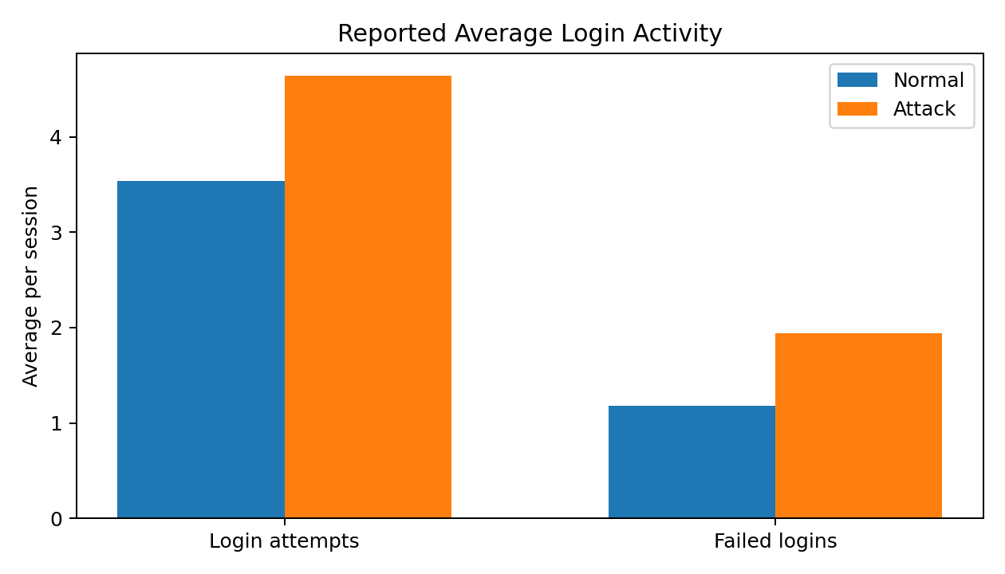
Figure 2. Reported average login attempts and failed logins per session.
These differences suggest that login volume and repeated failures may be useful signals. They are not sufficient on their own: legitimate users can also make repeated mistakes, and attackers may intentionally keep activity low.

3.5 Summary of EDA Findings
- Attack-labeled sessions account for 44.7% of the dataset described in the report, while normal sessions account for 55.3%.
- The reported mean login-attempt count is higher for attack sessions (4.64) than for normal sessions (3.54).
- The reported mean failed-login count is higher for attack sessions (1.94) than for normal sessions (1.18).
- Request rate, distinct usernames, failed-login ratio, timing regularity and IP/device context are proposed as useful features.
- The figures are summaries from the supplied project materials; raw-data-level verification was not possible from the files provided.

4. ALGORITHM SELECTION AND IMPLEMENTATION

4.1 Gradient Boosting Machine (GBM)
GBM is a supervised learning method that builds an ensemble of decision trees in sequence. Each new tree helps correct errors made by the existing ensemble. For this project, GBM learns from labeled login sessions and predicts whether a session resembles known normal or credential-stuffing activity.
The supplied dashboard highlights distinct usernames and login attempts per minute as the strongest displayed features, followed by failed-login ratio and timing regularity. This feature ranking is reported as dashboard output and should be verified against the final trained model before being used as a definitive explanation.

4.2 Isolation Forest
Isolation Forest is an unsupervised anomaly-detection algorithm. It repeatedly partitions feature space; observations that are easier to isolate are treated as more unusual. In the login-security setting, this can help surface rare patterns even when a specific attack label is unavailable. An anomaly is not automatically malicious, so alerts need thresholds and contextual review.

4.3 Hybrid Risk Score and Detection Flow
The project describes combining the GBM output and Isolation Forest signal into a hybrid risk score. This is intended to consider both familiar labeled attack patterns and unusual behavior. The supplied materials do not specify the exact mathematical combination, calibration procedure or alert threshold, so these details should be recorded from the implementation before claiming a reproducible hybrid model.
Stage | Purpose
1. Login/session data | Collect login and network-related records.
2. Preprocessing | Validate schema, handle missing values and encode categories.
3. Feature engineering | Derive request rate, failure ratio, username diversity and contextual indicators.
4. GBM | Classify records using labeled attack examples.
5. Isolation Forest | Generate an anomaly signal for unusual records.
6. Hybrid score and alert | Combine model signals and flag sessions above a configured risk threshold.
7. Evaluation | Measure precision, recall, F1-score, ROC-AUC and other applicable metrics.

4.4 Evaluation Metrics
Metric | Meaning in this project
Accuracy | Proportion of all sessions classified correctly.
Precision | Among sessions flagged as attacks, the proportion that are actual attacks.
Recall | Among actual attack sessions, the proportion detected by the model.
F1-score | Harmonic mean of precision and recall; balances missed attacks and false alarms.
ROC-AUC | Measures how well the model ranks attack sessions above normal sessions across thresholds.

4.5 Sample/Demo Model Comparison
The supplied report explicitly says the web dashboard’s comparison values are sample test results and should be replaced by measured values from the final training run. The values below are reproduced only to document the supplied demonstration.
Model | Precision | Recall | F1-score | ROC-AUC
Isolation Forest | 0.81 | 0.88 | 0.84 | 0.92
GBM | 0.95 | 0.93 | 0.94 | 0.98
Hybrid | 0.97 | 0.96 | 0.965 | 0.99
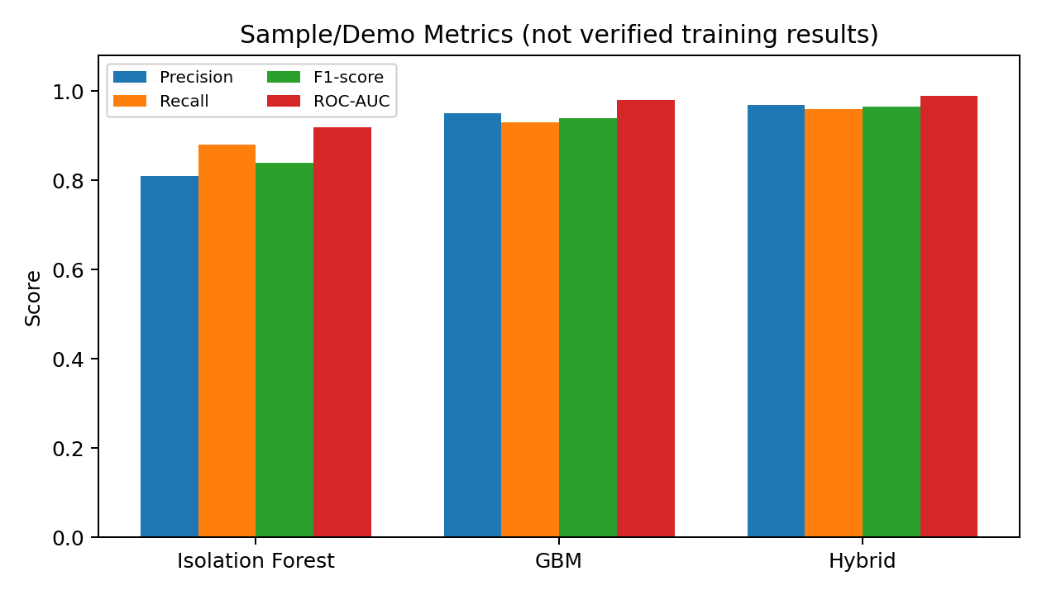
Figure 3. Sample/demo metrics reproduced from the supplied report; not independently verified training results.
Within the sample dashboard, the hybrid detector has the highest displayed precision, recall, F1-score and ROC-AUC. This comparison is illustrative only and does not establish that the hybrid model outperforms the alternatives on a newly trained or independently tested dataset.

4.6 Confusion Matrix Note
The supplied report lists a sample hybrid confusion matrix containing 9,812 true negatives, 38 false positives, 21 false negatives and 529 true positives. The same report explicitly identifies these as sample values. Their total does not match the separately described dataset size of 9,537 sessions, so the values should not be combined with the dataset summary or presented as results from the same test set without clarification. A final report should replace them with the confusion matrix produced by the actual test run.

5. CONCLUSION
This case study describes a machine-learning approach for detecting credential stuffing using Gradient Boosting Machine and Isolation Forest. GBM learns from labeled login behavior, while Isolation Forest contributes a signal for unusual activity. A hybrid risk score is proposed to combine these complementary outputs and help surface suspicious sessions. The supplied project materials report a dataset description of 9,537 sessions and EDA summaries showing higher average login attempts and failed-login counts for attack-labeled sessions. Sample dashboard metrics suggest a promising hybrid approach, but they are not verified experimental results. The next step is to train and evaluate the models reproducibly on the actual dataset, document the split and thresholds, and replace demonstration figures with measured results.

REFERENCES
- Credential Stuffing Attack Detection Using GBM and Isolation Forest, supplied project abstract, academic year 2026–27.
- Credential Stuffing Attack Detection Using Gradient Boosting Machine and Isolation Forest, supplied project report.
- Credential Stuffing Cybersecurity, supplied Machine Learning project presentation.

Signature of the Team Members: ____________________ ____________________ ____________________
Course Instructor / Guide: ____________________

