A PROJECT REPORT ON
CREDENTIAL STUFFING ATTACK DETECTION USING
GRADIENT BOOSTING MACHINE AND ISOLATION FOREST
Project report submitted in partial fulfilment of the requirements for the Course
MACHINE LEARNING
BACHELOR OF TECHNOLOGY
In
A.Y.: 2026-27
By
Hruday Deepak — 2520030138
B.Surya Prakash Reddy — 2520030145
K.Aasritha — 2520030178
Under the Esteemed Guidance of
G.Ravinder
Associate Professor, CSE
Department of Computer Science and Engineering

Abstract
Cybersecurity is a critical concern for online platforms because user accounts and sensitive information are continuously targeted by automated attacks. Credential stuffing is a major threat in which attackers reuse stolen username-password pairs from previous breaches to attempt unauthorized access to multiple accounts. This project presents a machine-learning-based detection system using Gradient Boosting Machine (GBM) and Isolation Forest. The system prepares login and network-related data, extracts behavioral features such as login frequency, failed-login ratio, IP reputation and timing regularity, and applies both supervised and unsupervised detection. GBM learns labeled attack patterns, while Isolation Forest detects unusual behavior without requiring attack labels. A hybrid risk score combines the two model outputs for stronger detection. The supplied project demonstration contains 9,537 login sessions, 10 input columns and 44.7% sessions labeled as attacks. Sample evaluation values in the supplied web application report Precision 0.95, Recall 0.93, F1-score 0.94 and ROC-AUC 0.98 for GBM, while the hybrid detector reports 0.97, 0.96, 0.965 and 0.99 respectively. These values are explicitly identified in the application as sample/demo results rather than measured results from a newly trained model.
Keywords: Credential Stuffing, Cybersecurity, Gradient Boosting Machine, Isolation Forest, Anomaly Detection, Machine Learning

1. Introduction

1.1 Purpose of the Project
Credential stuffing exploits password reuse rather than a weakness in the authentication algorithm itself. Attackers obtain credential pairs from earlier data breaches and replay them against banking, shopping, social media and other services. Because the credentials may be valid, simple password checks cannot reliably distinguish the attacker from the genuine account holder.
The purpose of this project is to build an intelligent login-monitoring approach that can identify suspicious patterns in real time. The project combines a supervised GBM classifier, an unsupervised Isolation Forest detector and a hybrid risk score so that known attack patterns and unusual new patterns can both be considered.

1.2 Problem Statement
The problem is formulated as a binary login-traffic classification and anomaly-detection task. For each login session or IP activity window, the system analyzes behavioral and network-related features and determines whether the activity is likely to be legitimate or associated with credential stuffing. The expected output is a risk score and an alert/flag decision that can support blocking or additional authentication.

1.3 Existing Methods and Disadvantages
Traditional defenses include password policies, IP rate limiting, CAPTCHA challenges, blocklists and manually defined thresholds. These controls remain useful, but fixed rules can be bypassed by distributed bots, proxy rotation and low-and-slow login attempts. They can also create false positives when genuine users share network addresses or repeatedly fail authentication.
A machine-learning approach can learn combinations of login frequency, username diversity, failure behavior, timing regularity and IP reputation. The supplied project specifically uses GBM for known labeled patterns and Isolation Forest for unusual behavior, allowing the system to address both supervised and unsupervised detection.

1.4 Proposed System
The proposed pipeline begins with login/session data, performs cleaning and feature preparation, extracts behavioral indicators, applies GBM and Isolation Forest, and then combines their scores into a hybrid risk score. Suspicious sessions are surfaced through the web dashboard as alerts. The supplied HTML implementation describes features including attempts per minute, distinct usernames per IP, failed-login ratio, timing regularity, proxy/datacenter IP and new-device status.

1.5 Research Objectives
- Prepare and inspect a login-session dataset for credential-stuffing detection.
- Identify behavioral and network-related features associated with malicious login activity.
- Implement a supervised Gradient Boosting Machine classifier.
- Implement an unsupervised Isolation Forest anomaly detector.
- Combine model scores into a hybrid risk score for improved detection.
- Evaluate the detection approach using precision, recall, F1-score and ROC-AUC.
- Visualize model performance, feature importance and confusion-matrix results.
- Provide a dashboard-oriented design for real-time security monitoring.

2. Literature Survey
The project materials emphasize machine learning for cybersecurity, especially the complementary roles of supervised classification and unsupervised anomaly detection. For the present academic report, the literature survey is framed around these two methodological themes rather than claiming unverified paper-specific results.
Study Theme | Data | Method | Main Value | Limitation
Supervised learning for login attack detection | Labeled authentication records | GBM / boosted trees | Learns recurring malicious patterns | Requires representative labels
Unsupervised anomaly detection | Mostly normal authentication traffic | Isolation Forest | Can identify rare and unusual behavior | Threshold selection is important
Behavioral login analytics | Session and IP activity | Rate, failure and diversity features | Captures attack behavior beyond passwords | Features can drift over time
Hybrid security scoring | Multiple model outputs | Weighted score / ensemble | Combines complementary signals | Needs calibration and validation
Real-time security dashboards | Streaming or recent login events | Rules + ML alerts | Supports analyst response | Operational latency matters

3. Methodology

3.1 Proposed System Flow
Login/session data → Data cleaning → Feature engineering → Train/test data → GBM + Isolation Forest → Hybrid risk score → Alert / block → Evaluation

3.2 Dataset Description
The supplied project presentation describes a dataset containing 9,537 login sessions and 10 input columns. The columns include packet size, protocol, login attempts, session duration, encryption, IP reputation, failed logins, browser and unusual-time access. The presentation reports that 44.7% of the sessions are labeled as attacks. The web demonstration further uses behavioral features such as attempts per minute, distinct usernames, failed-login ratio, timing regularity, proxy/datacenter IP and new-device status.
Dataset Property | Value
Login sessions | 9,537
Input columns | 10
Attack-labeled sessions | 44.7%
Normal sessions | 55.3%
Models | GBM + Isolation Forest
Tools | Python, Pandas, scikit-learn, LightGBM/GBM
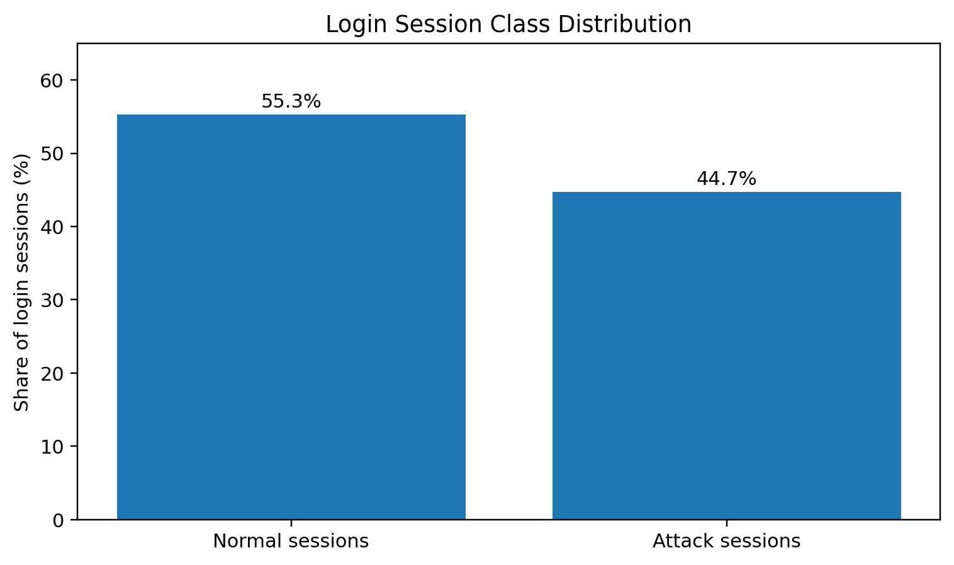
Figure 1. Class distribution of login sessions based on the supplied project data.
The class distribution shows that attack sessions form a substantial portion of the supplied demonstration dataset. Class distribution should still be checked carefully in any production dataset because detection metrics can change significantly when the attack prevalence changes.

3.3 Experimental Setup
- Operating system: Windows 10/11 or Ubuntu Linux.
- Programming language: Python 3.
- Development environments: Jupyter Notebook, Google Colab or Visual Studio Code.
- Data-processing libraries: Pandas and NumPy.
- Machine-learning libraries: scikit-learn and GBM/LightGBM tooling.
- Visualization: Matplotlib; the supplied web interface uses Chart.js for browser-based dashboard charts.

3.4 Data Preprocessing
- Inspect login/session records and validate the input schema.
- Handle missing or invalid values before model training.
- Encode categorical fields such as protocol, browser and encryption.
- Derive behavioral indicators from login frequency and failure patterns.
- Normalize or scale variables where required by the selected model.
- Separate training and testing data to avoid leakage.
- Prepare labels for supervised GBM training and retain unlabeled behavior for anomaly detection.

3.5 Exploratory Data Analysis
The supplied presentation reports that attack sessions show higher average login activity and higher failure counts than normal sessions. The following chart reproduces those supplied summary values.
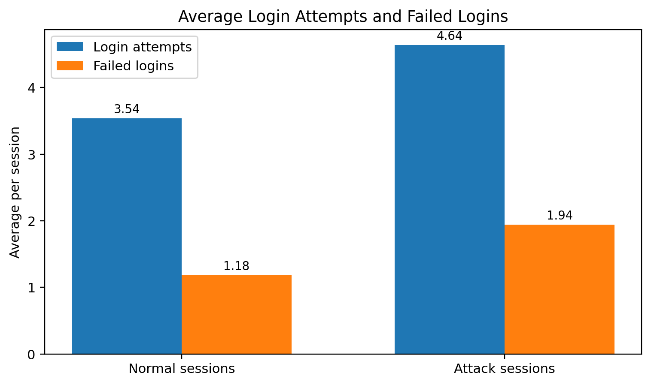
Figure 2. Average login attempts and failed logins per session.

3.6 Feature Engineering and Feature Selection
The dashboard implementation uses six core traffic features for prediction: login attempts per minute, distinct usernames tried, failed-login ratio, timing regularity, known proxy/datacenter IP and new-device status. The analytics view additionally displays an Isolation Forest score as a model-derived signal. These variables capture volume, account diversity, authentication failure behavior, automation regularity and network/device context.

3.7 Model Building and Training
Gradient Boosting Machine is used as the supervised model. It learns patterns from labeled normal and attack sessions and is intended to perform strongly on attack behavior represented in the training data. Isolation Forest is used as an unsupervised anomaly detector; it isolates observations that are rare or unusual compared with normal traffic. The hybrid detector combines the two model scores, giving a final risk score that can be used for alerting.

3.8 Model Evaluation
The project evaluates detection quality using Precision, Recall, F1-score and ROC-AUC. Precision indicates how many flagged sessions are actual attacks, Recall indicates how many actual attacks are detected, F1-score balances precision and recall, and ROC-AUC summarizes ranking quality across thresholds. Accuracy can also be reported, but precision and recall are particularly important for security detection because both missed attacks and excessive false alarms have operational consequences.

4. Results and Discussion

4.1 Preprocessing and Data Observations
The supplied project materials identify 9,537 sessions and 10 input columns. The exploratory summary indicates that attack sessions have higher average login attempts (4.64) than normal sessions (3.54), and higher average failed logins (1.94) than normal sessions (1.18). These differences support the use of behavioral login features.

4.2 Model Performance
The web application's Analytics page explicitly labels the model-comparison values as sample test results. Therefore, the values below are included as demonstration results and should be replaced by measured results from the final training run before treating the report as an experimental evaluation.
Model | Accuracy | Precision | Recall | F1-score | ROC-AUC
Isolation Forest | — | 0.81 | 0.88 | 0.84 | 0.92
GBM | — | 0.95 | 0.93 | 0.94 | 0.98
Hybrid | — | 0.97 | 0.96 | 0.965 | 0.99
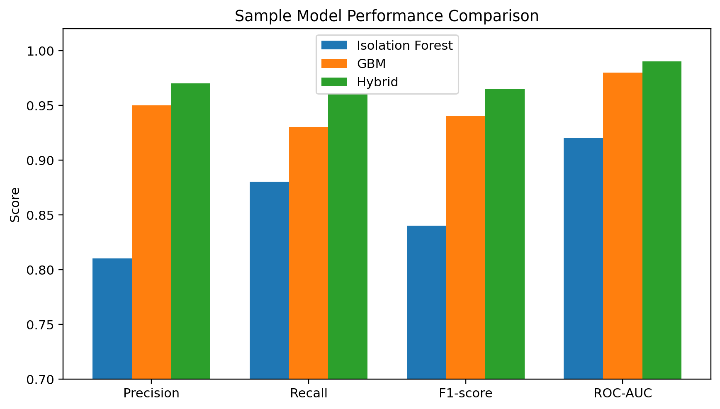
Figure 3. Sample comparison of Isolation Forest, GBM and Hybrid detection metrics.

4.3 Feature Importance
The supplied dashboard ranks distinct usernames and login attempts per minute as the two strongest displayed features, followed by failed-login ratio and timing regularity. This is consistent with the idea that credential stuffing generates repeated login attempts across many accounts and often produces machine-like behavior.
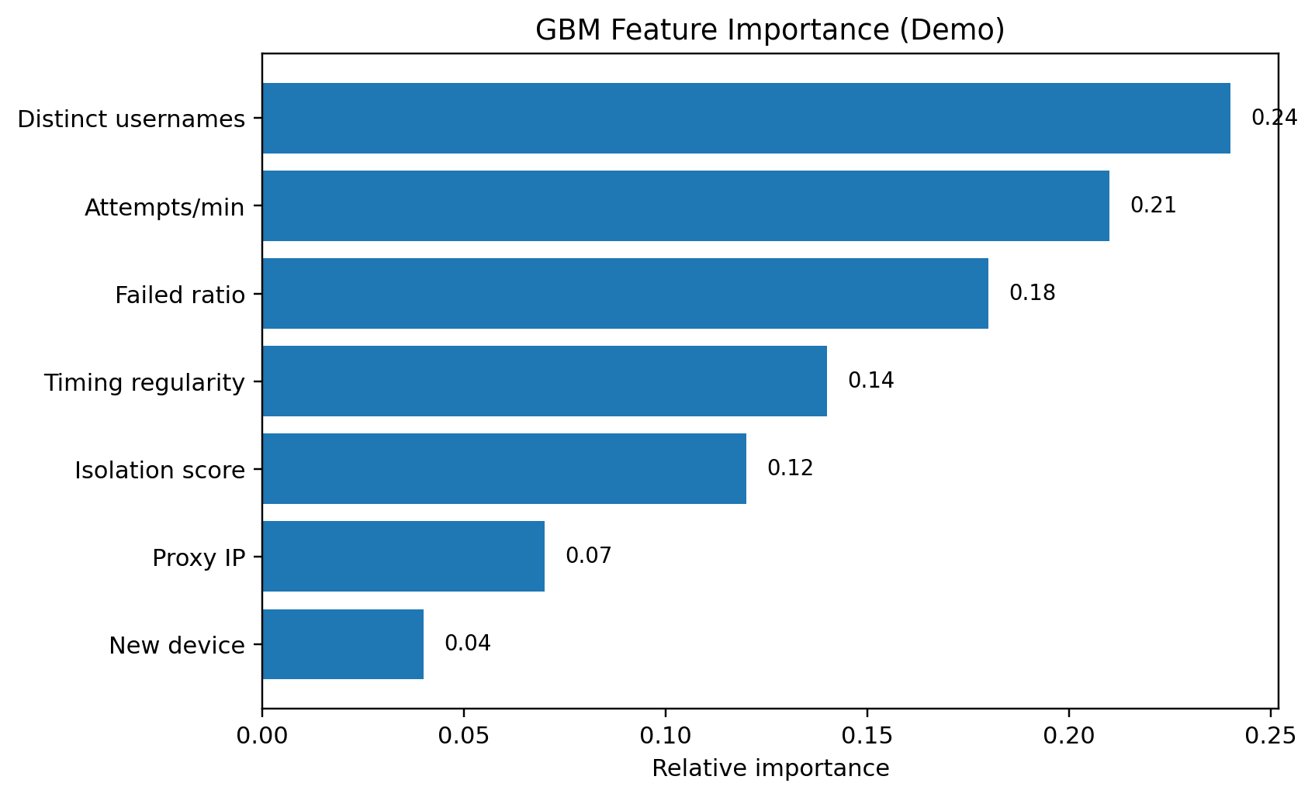
Figure 4. GBM feature importance shown in the supplied analytics dashboard.

4.4 Confusion Matrix Analysis
The supplied dashboard provides a sample confusion matrix for the hybrid detector: 9,812 true negatives, 38 false positives, 21 false negatives and 529 true positives. The relatively small false-positive count in this demonstration indicates few normal sessions were flagged, while the true-positive count shows that many attack sessions were detected. Because the dashboard explicitly labels the matrix as a sample, these values should not be interpreted as final trained-model measurements.
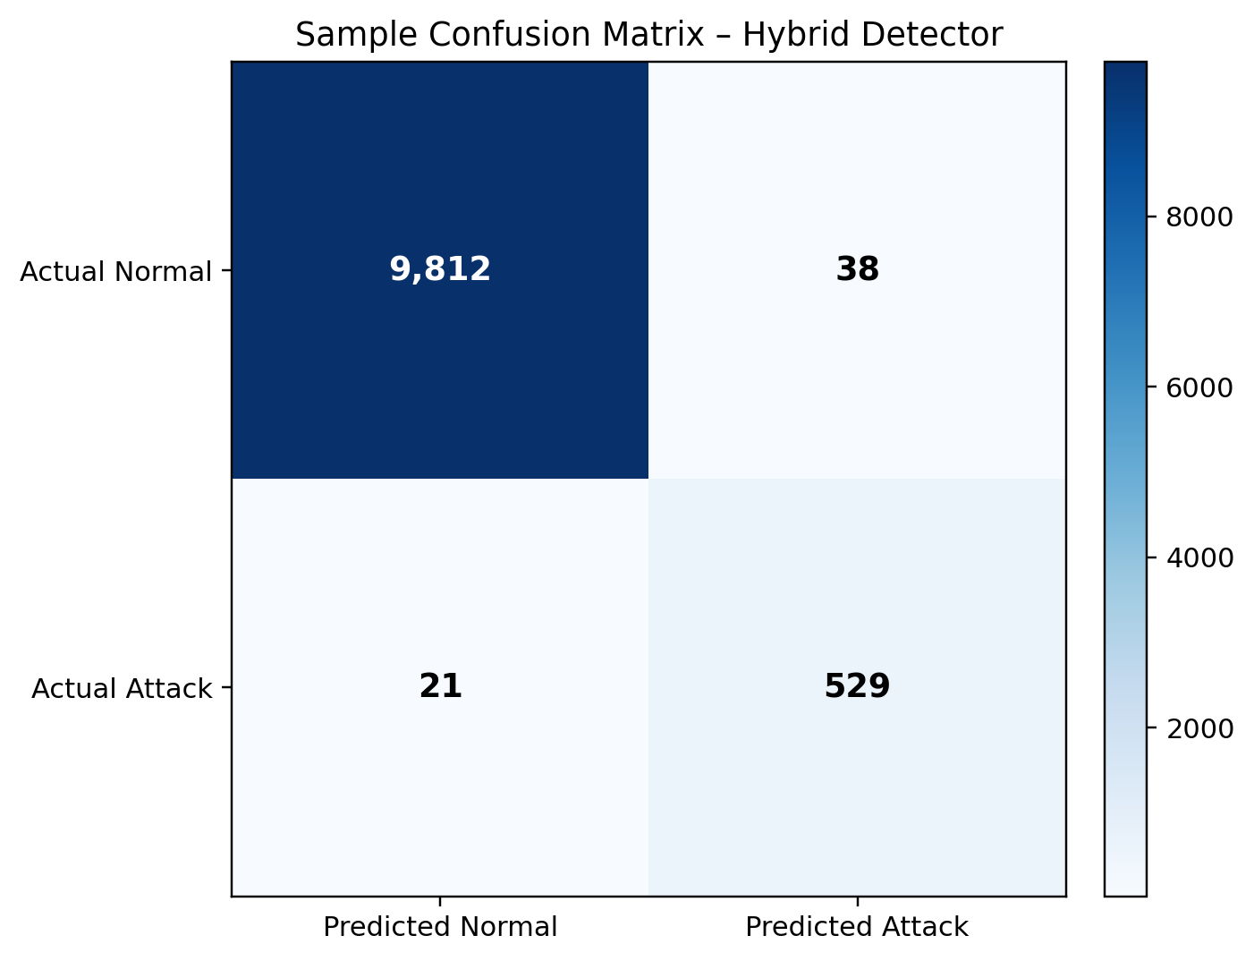
Figure 5. Sample confusion matrix for the hybrid detector.

4.5 Discussion
- GBM provides strong supervised discrimination when labeled attack patterns are available.
- Isolation Forest contributes anomaly detection for rare or previously unseen behavior.
- The hybrid score combines complementary signals and, in the supplied demo, gives the strongest displayed metrics.
- Distinct username diversity and request rate are important indicators of credential-stuffing behavior.
- False positives must be controlled because legitimate users can also produce repeated failures.
- Final conclusions should be based on a reproducible training run using the project dataset, not only the browser demonstration.

5. Conclusion
This project presents a machine-learning-based approach for detecting credential stuffing attacks using Gradient Boosting Machine and Isolation Forest. The system focuses on login behavior rather than relying only on static rules. The supplied project materials demonstrate a complete monitoring concept with login data, feature engineering, two detection models, a hybrid risk score, alerting and analytics. The sample dashboard results show that the hybrid approach can combine the strengths of supervised and unsupervised detection. The project therefore provides a useful academic demonstration of how machine learning can strengthen authentication monitoring and reduce the time needed to identify suspicious login activity.

6. Future Work
- Train and validate the models on a larger, diverse and independently collected credential-stuffing dataset.
- Replace sample dashboard metrics with reproducible test-set results from the final trained models.
- Tune decision thresholds to balance attack recall and false-positive rate.
- Use temporal and IP-reputation features from real authentication logs.
- Evaluate additional ensemble and deep-learning approaches.
- Add explainable-AI techniques to show why an individual login was flagged.
- Implement real-time streaming inference and automated response actions.
- Monitor model drift as attacker behavior and legitimate traffic patterns change.
- Perform external validation before any production deployment.

7. References
[1] Project presentation: Credential Stuffing Detection Using LightGBM/GBM and Isolation Forest, supplied with this report.
[2] Project web application: Credential Stuffing Detection dashboard (HTML/Chart.js), supplied with this report.
[3] Project abstract: Credential Stuffing Attack Detection Using GBM and Isolation Forest, supplied with this report.
[4] Project report template: ML Project Report – Team 1, supplied with this report.

Appendix A – Dashboard and Implementation Notes
The supplied HTML dashboard includes pages for login, dashboard monitoring, login records, attack simulation, ML prediction, analytics and alerts. The analytics section contains charts for model comparison, GBM feature importance, a sample confusion matrix and attacking-country summaries. The source code itself states that the comparison, feature importance and confusion-matrix figures are sample values for the demo and should be replaced with results from actual training. This distinction is preserved in this report.

