An Najah National University
Faculty of Engineering

Computer Engineering

Networks 1 project

Prepared By:
Abdalruhman Atout /12217898
Marah Sirhed/12216999
Supervised By:
Dr. Saed Tarapiah

Introduction
In our project ,we coded Peer to Peer Application that runs on a Network using Java. It includes 2 parts : in the first part, we implemented peer to peer chat using UDP protocol .in the second part, the peers connected on TCP server to give the client a list of active users to chat with , but the chatting remains using UDP protocol (the peers act as TCP clients) . the projects consists of various features starting from sending messages , archiving, deleting messages and transferring file between peers. With the help of the TCP server to provide active peers to chat with.

Part one
In this part, we did Peer-to-peer Application Chatting using Java UDP Socket Programming. In order for two peers to chat with each other , we determined the source and destination IP address and port number for each peer.
we found the IP address for each device using cmd
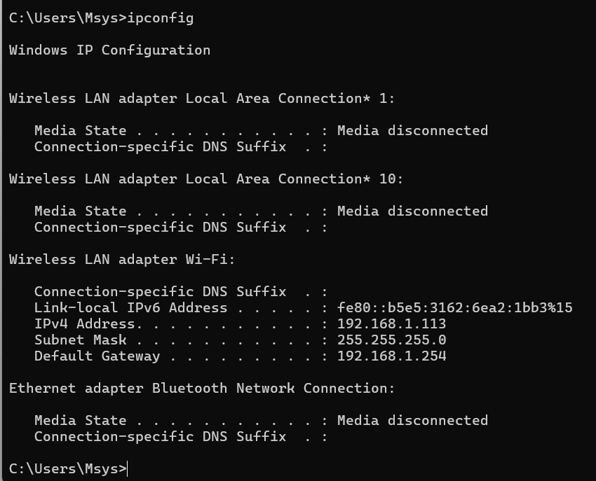

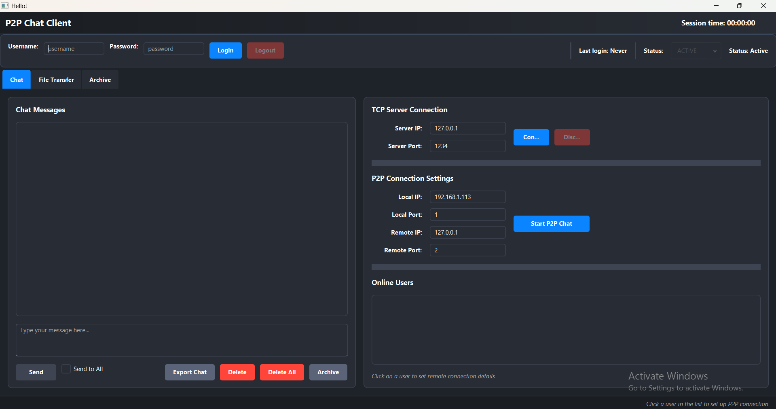
Starting with the first GUI , the peer to peer chatting
it consists of 3 tabs : (file transfer tab will be explained in part 2 )
Chat : you start by entering the local IP address and port for the sender ,the remote IP and port for the receiver then press on start P2P chat.
you can send messages , delete them , archive them for 2 minutes (they will be moved to the archive tab) and export the chat (downloads the chat as a txt file), the buttons left are for the second part.

When you press on P2P chat and the connection is established successfully , it gives you this alert window on both sides(sender and receiver)
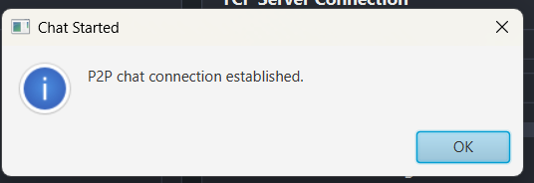
Now we start sending messages , the sender is named (you) and the receiver is named (Remote).
We Added the timestamp for each exchanged message (for both sent and received) ● Yellow color for sent messages ● Orange color for received messages
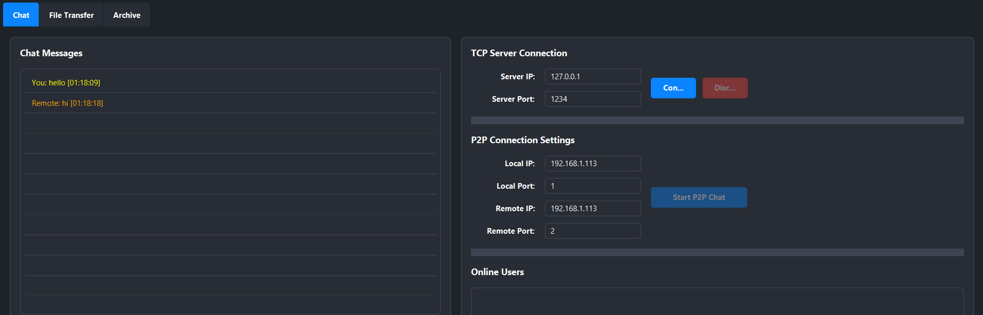
Sender side:

Receiver side:
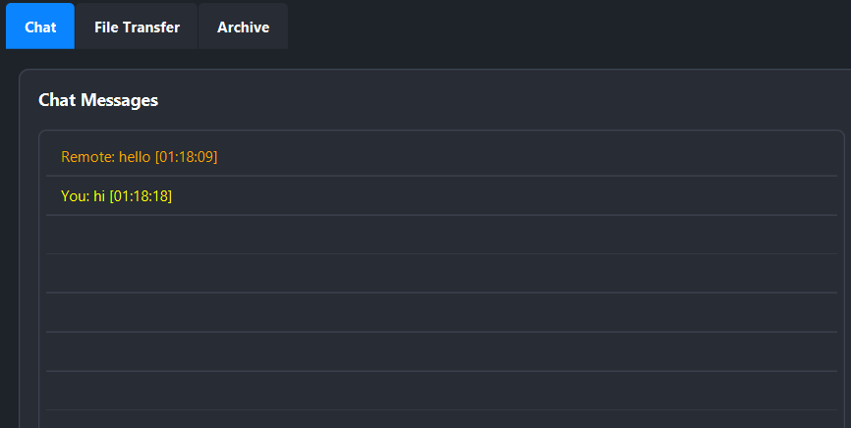

We did an extra requirement which is export chat that takes the chat and store it as txt file on the laptop.
when you press on export chat button :
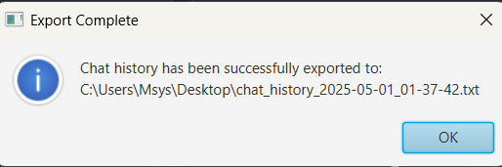
the txt file content:
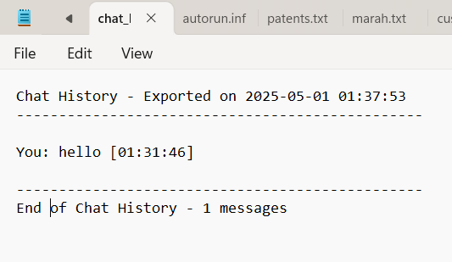
it shows the messages sent and received with timestamp and the number of messages sent and received.

Archive: the deleted messages are archived (moved to archive tab) , after 2 minutes, they will be automatically removed.
Each archived message can be recovered/ restored if selected by the user to be restored using restore selected button.
next to each message there’s a timer for it , so each message is deleted separately from another messages.
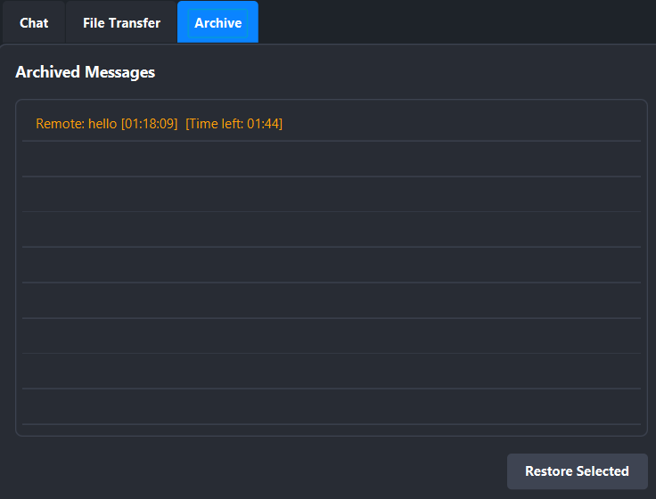
Another example:
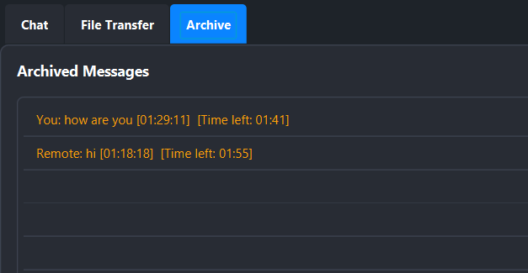
Finally in this part , we created a log file that records all activities done on the program.
Here’s the log file location after the execution
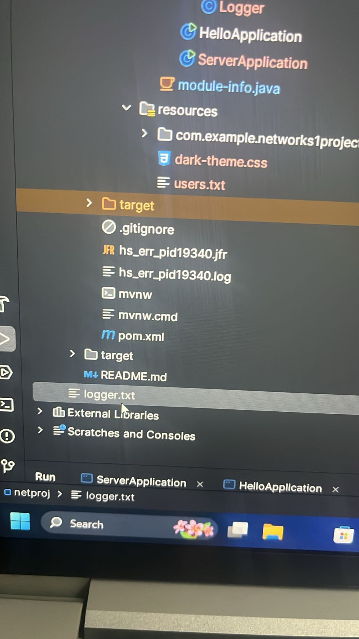
an example of the file’s content:
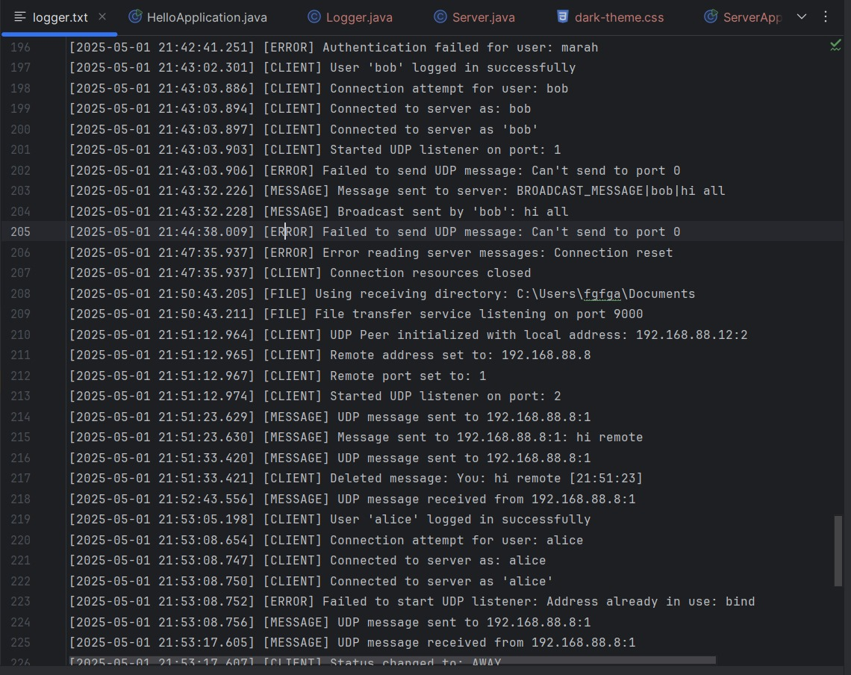

Part two
In this part we applies TCP Java Socket programming, we added TCP server and TCP Clients to the Application(the UDP peers). The Server keeps a list of UDP clients involved in the Chatting and sends a message to each TCP client in the Active Chatting but the actual chatting remains peer-to-peer. But the User chooses which Client to talk to from the List Provided by the Server.
Server GUI , the server is connected on port:1234,
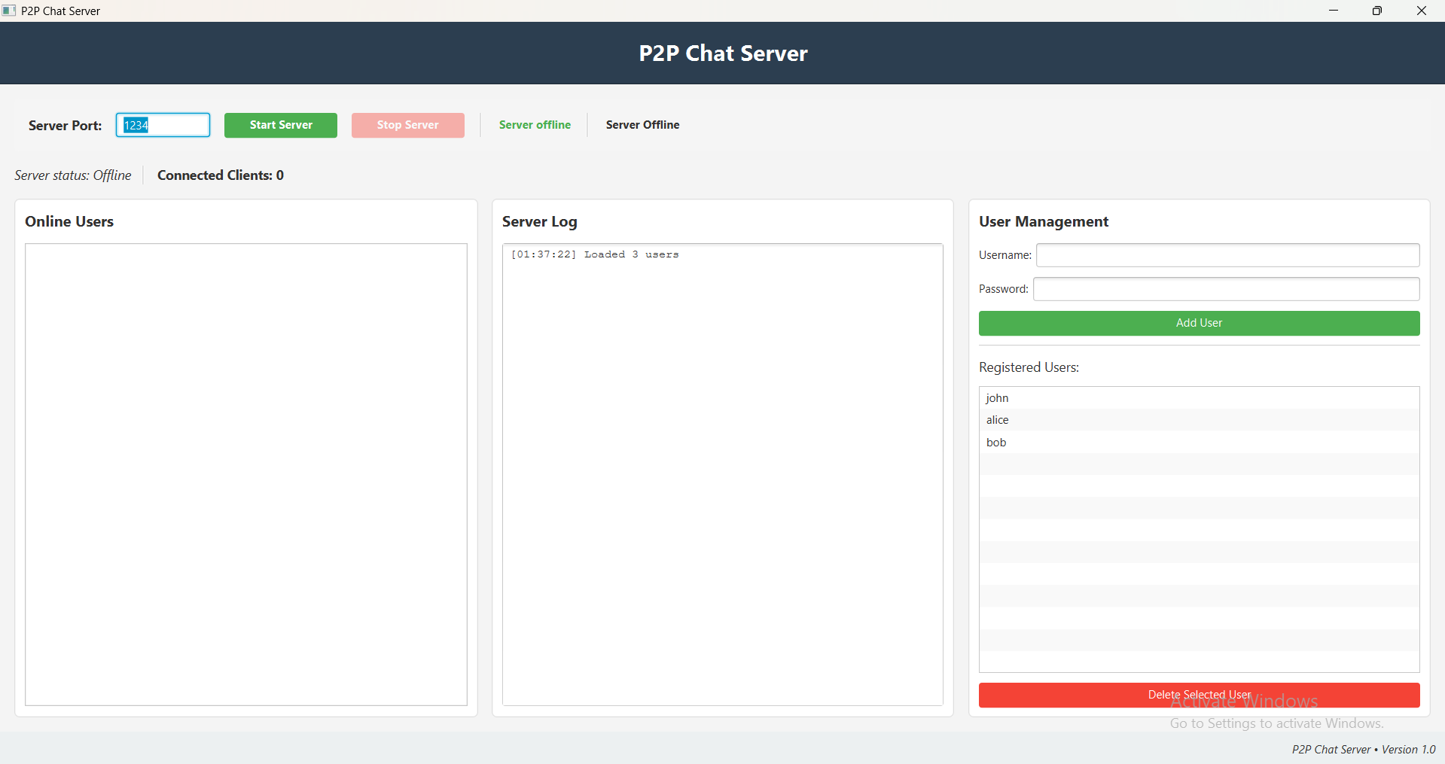
We added a file at the TCP server side, which contains the credential for users, login information as user name and password as follows:
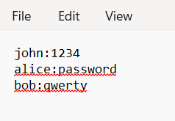

When you press start server button,it loads the users from the file and starts recording the up time , and how many clients are connected
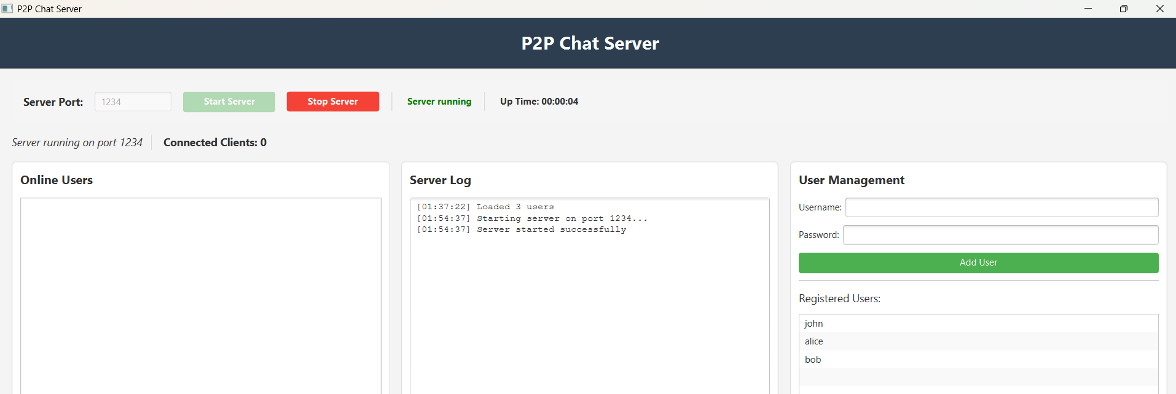
we can add users to the server using add user button : (here we added sami)
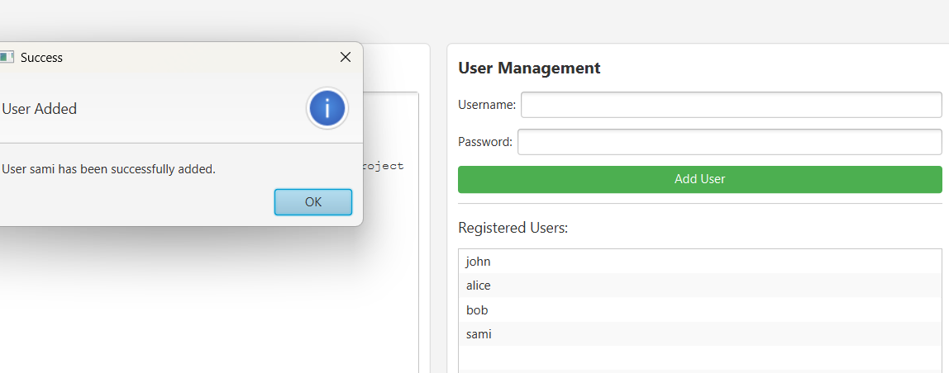
it is not allowed to add similar usernames.

trying to add another username named sami:
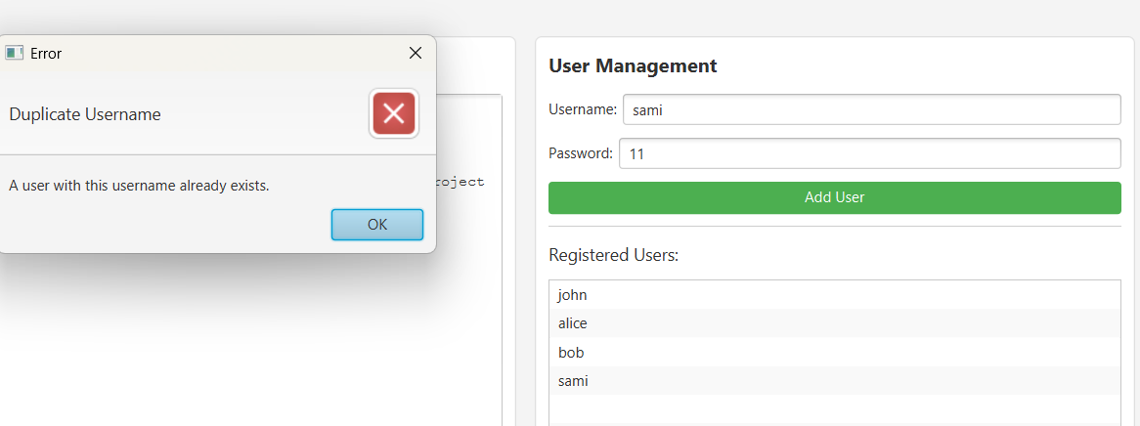
on the other hand we can delete any user , it asks before deletion
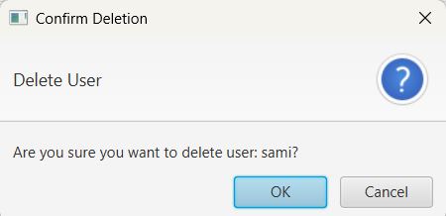
trying to log in (TCP client) as sami on the chatting GUI [after deletion]
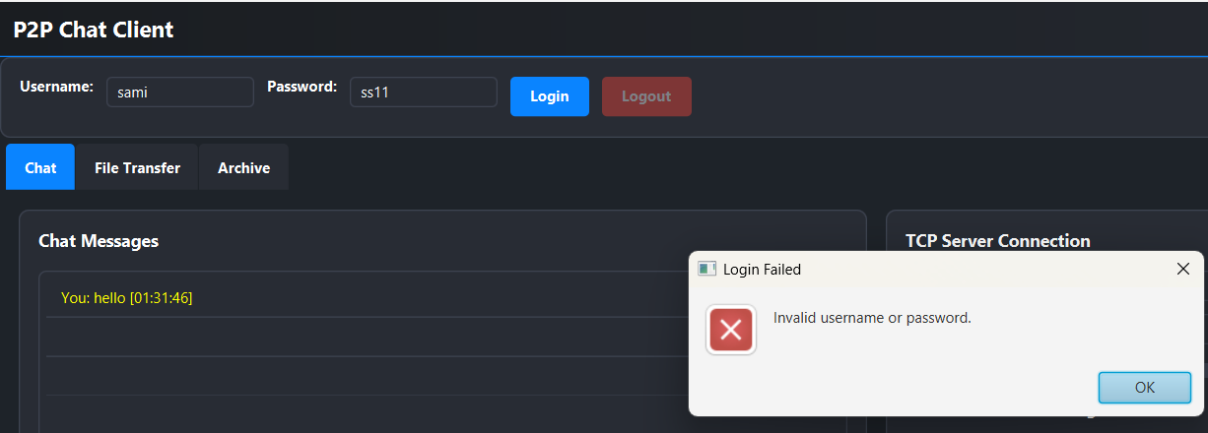

we log in and log out to the server on the chatting GUI by entering the username, password, server’s IP and port.
logging in as john
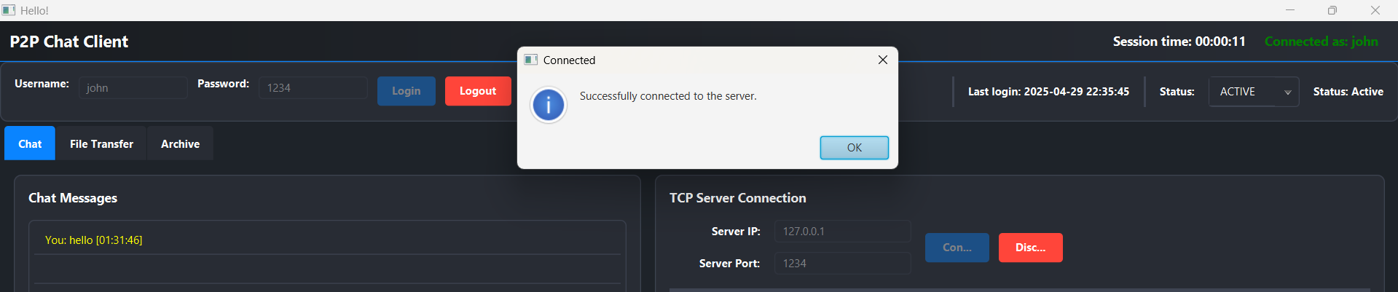

We added the online users next to its corresponding IP and port number.
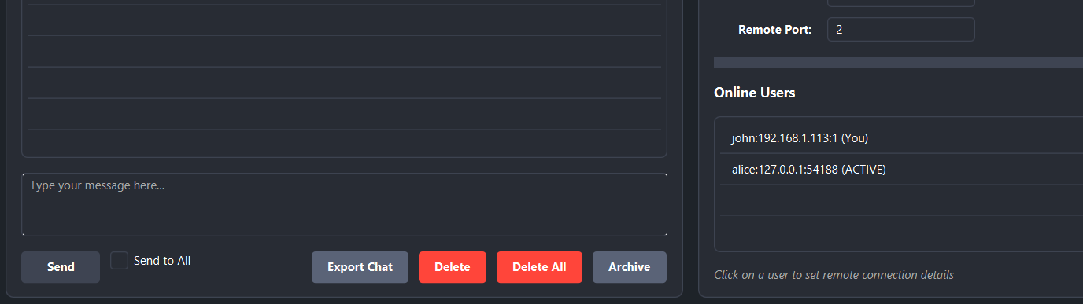
We did the send to all option that sends the message to all the active clients on the server.(the message labeled broadcast)
example:
on Alice’s side:
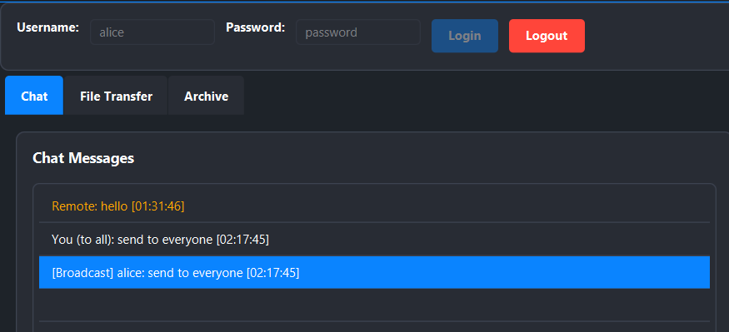
On John’s side:
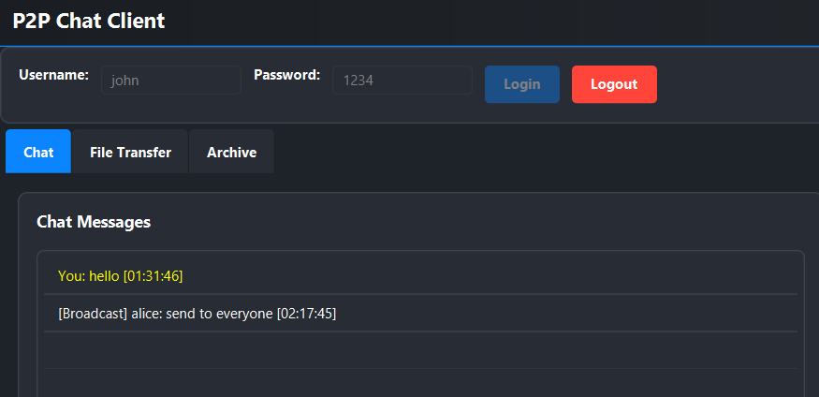

- Each peer can set its status(active,busy,away)and the other peers can know the status of other peers.
- We added timer at each peer, if the peer not active for than 30 seconds, the status will be changed automatically to: away . Any event on keyboard, mouse will change the status from away to active.
- We displayed last successful login time after login for each client.
- We displayed Time Elapsed after login as session time.
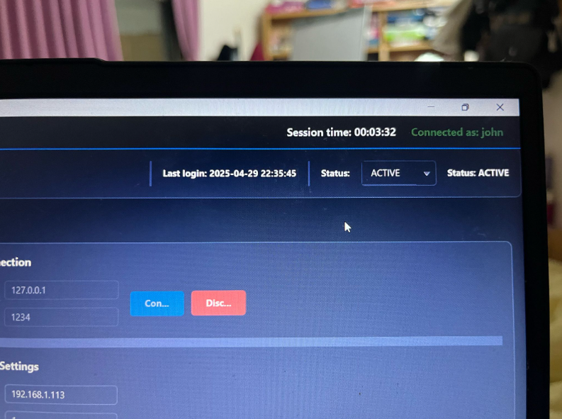

After 30 seconds , the status changes to AWAY.
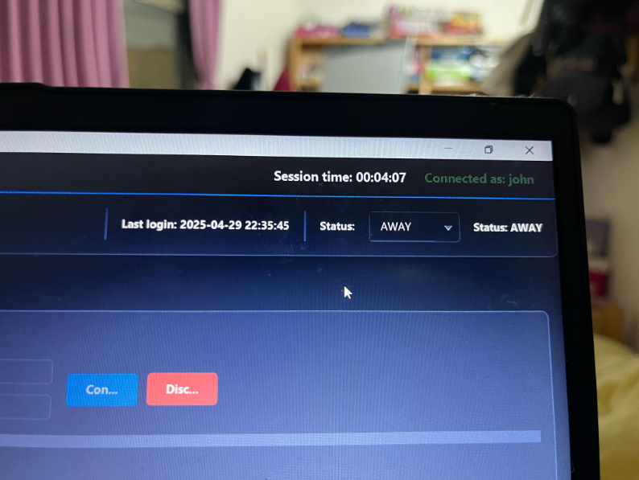
the pics taken like this clearly shows that no event occurred on the device such as screenshotting the screen or moving the mouse
The server side, after doing all of the operations above:
- Server log : that records the activities done on the server.
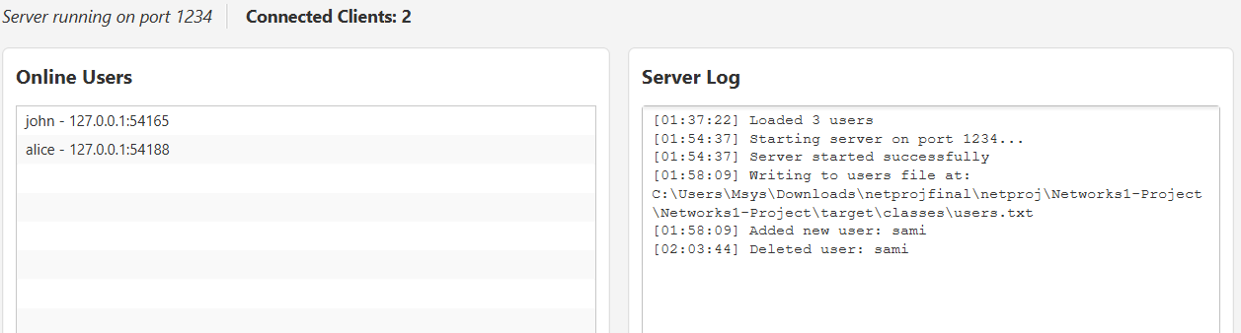
- Online users: shows the username and IP address for online users.

- File transfer between peers connected on the server:
We did this feature as a tab in each peer GUI named as File Transfer , with these details:
- Exploring the file location on the local storage at the sender side which is labeled as receiving directory.
- sitting (C:\) as a default receiving/storing location at the receiving peer and could be changed by the receiving node.
- Showing statistics on both peers (Sender and Receiver) such as:
- File’s name
- File’s size
- the total number of packets being sent/received
- Transfer Time
- Transfer Rate
- Avg Packet Delay
- delay Jitter

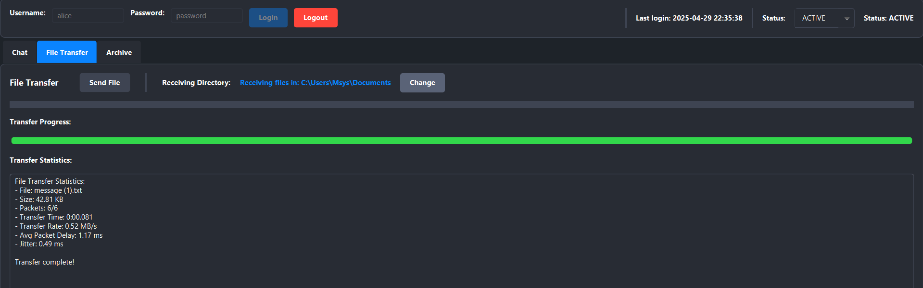
here’s from the sender side:

here’s from the receiver side:
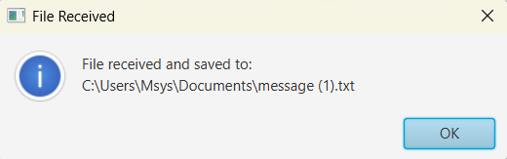

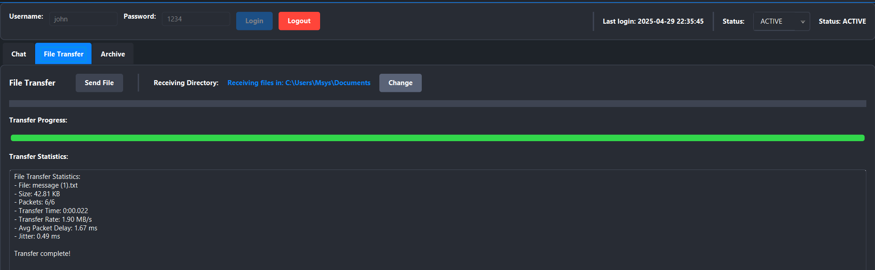

Conclusion
In this project , we learned how to implement peer to peer chatting using UDP
JAVA programming ) and connecting with server using TCP (JAVA programming) ,in addition to chatting, we implemented the file transferring between the peers .
the application of this project is similar to skype and other chatting apps so it helped us to understand the transport layer protocols deeply.

