*Maral Jamali*

*Senior Data Scientist :-D | Alert Analytics*

*Sentiment Analysis*

iPhone & Galaxy Comparison

# Project Overview

We are working with a government health agency to create a suite of smart phone medical apps for use by rescue groups in developing countries. This suite of apps will enable the aid workers to manage local health conditions by facilitating communication with medical professionals. The project will be developed to be compatible with only one smartphone model and our team of data scientists have been asked to analyze sentiment towards smartphone online. We have been asked to collect and analyze data and suggest the model that has a better reputation among users online.

We examined the positive and negative attitudes toward these devices on the web and share our findings in this report.

# Methodology

Our team of annotators labeled a sample of sentiments and ranked them from Very negative to very positive. The categories and their rankings are as follows:

|  |  |  |  |  |  |  |
| --- | --- | --- | --- | --- | --- | --- |
| Rank | 0 | 1 | 2 | 3 | 4 | 5 |
| Sentiment | Very Negative | Negative | Somewhat Negative | Somewhat Positive | Positive | Very Positive |

We trained four classification models based on the manually labeled dataset. The models were KNN, Random Forest, Decision Tree, and SVM. We evaluated our models based on two common measures of Kappa and Accuracy and found that Random Forest is more reliable for this analysis. We then analyzed the 20,000 sentiment instances based on this model. The following charts show that our confidence in this study is between 75-80%.

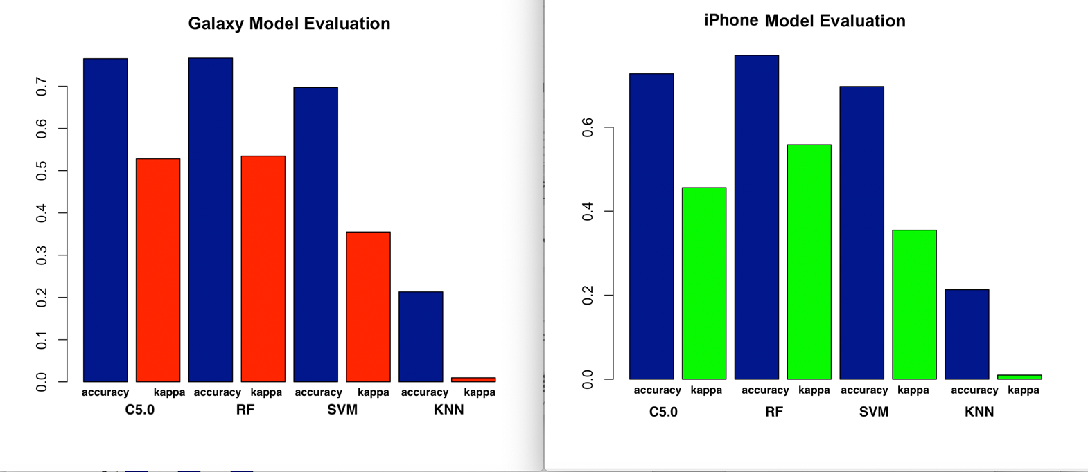

# Confidence

|  |  |  |
| --- | --- | --- |
| Smart Phone Model | Accuracy | Kappa |
| **iphone** | 0.7704370 | 0.5571068 |
| **Galaxy** | 0.7667269 | 0.5346264 |

# Findings

Around 55% of iOS users had a positive experience with their device. The number of satisfied users is 56% for Galaxy users. Interestingly, this study shows less than 1% difference between users’ opinion about iPhone and Galaxy. iPhone’s negative reviews are about 1% higher than those of Galaxy.

|  |  |  |  |  |
| --- | --- | --- | --- | --- |
| Sentiment Rank | # of iPhone sentiments | # of Galaxy Sentiments | % of All - iPhone | % of All - Galaxy |
| 0 very negative | 9852 | 975 | 40.79% | 40.37% |
| 1 negative | 4 | 57 | 0.02% | 0.24% |
| 2 somewhat negative | 809 | 717 | 3.35% | 5.90% |
| 3somewhat positive | 1366 | 1426 | 5.66% | 1.66% |
| 4 positive | 388 | 401 | 1.61% | 48.87% |
| 5 very positive | 11735 | 11803 | 48.58% |  |

# Conclusion

Based on this study, the majority of sentiments are either very negative or very positive. User’s sentiments towards their devices are very similar regardless of the model of their smartphones. Galaxy ranks slightly higher, as it has more positive reviews and fewer negative reviews. We tried multiple models and various feature engineering techniques and didn’t find a statistically significant difference between sentiments toward these devices. It’s important to note that users tend to share their experience online when they feel strongly about the product. Therefore, it’ not far from our expectations to find the number of very negative and very positive reviews are much higher than the moderate ones.