

Software Engineering, CS385T- Project

Title: Wahaj

Contents

Chapter 1 4

System descriptions 4

The development Process model used 4

System Requirements 5

Functional Requirements 5

Non-Functional Requirements 7

Chapter 2 8

Context Diagram 8

System Use-case Diagram with description 9

Use case scenario (Primary +secondary) 13

Use case 1 Login 13

Use case 2 Search for item 13

Use case 3 Purchase item 14

Use case 4 Retrieve 14

Chapter 3 15

System Class Diagram 15

Sequence Diagrams 16

Sequence diagram for Login 16

Sequence diagram for Purchase item 17

Sequence diagram for Retrieve 18

Chapter 4 19

Activity Diagram 19

Activity Diagram for Login 19

Activity Diagram for Purchase item 20

Activity Diagram for Retrieve 21

State Diagram 22

State Diagram for Purchase item 22

Chapter 5 23

Architecture Diagram 23

User Interface, Implementation and Testing 5

Logo 5

Paper prototype 6

User Interface 8

List the topmost important and frequent tasks for your system: 16

How our app will be an improvement for users 17

Implementation 17

Usability Testing 17

Usability Analysis 22

Conclusion 22

# Chapter 1

## **Abstract**

Our main goal from the **Wahaj** application is to create a program that facilitates the enthusiasts and lovers of art with quick and easy access to the arts in the areas near them in a simple and easy way. We observe there are many people travel the world to acquire a single work of art because they cannot meet their needs in their home cities' arts. Also, there are a lot of artists who need social support. Our application helps you if you're seeking a unique artist or product. You can order any product and it will be delivered to your home. The program provides a platform for competition among the artists based on the shown works, which will boost the artist's popularity.

## **System descriptions**

**Wahaj** serves as a bridge between the arts and crafts and as a gathering place for both customers and professional artists. The basic aim of the system is to offer a platform where customers can connect with professional artists in accordance with their requirements. They can also schedule special orders and get online consultations. Therefore, the application provides a competitive platform between the artists according to their exhibited works.

The application aims to provide services in the entire Middle East region.

We can say that this is one of the important applications that make it easier for customers and artists alike, from the customer's perspective to find the best product, and from the artist's perspective to broaden the scope of their work and increase their revenue.

In addition, our experts offer you useful tips and courses, and these will be especially important to you as they will help enhance your skills.

Online consultations with art experts are also provided to respond to various requests from clients, discuss their problems and assist them in resolving them through expert guidance.

## The development Process model used.

The development Process model used is Incremental model.

We chose this model because:

1. It will create our system as soon as possible.
2. It will help reduce the cost of adapting to changing customer requirements.
3. It is more flexible than other models and is suitable for big projects like our project.
4. It is easier to get customer feedback on the work that has been done.

## *System Requirements*

### Functional Requirements

#### User Requirements

1. The customers and services providers shall create an account for logging into the application at any time.
2. The customers shall be able to search about arts, crafts, and courses.
3. The customers shall be able to view all products and courses.
4. The customers shall be able to book courses and buy products.
5. The customers shall pay online once they have finished chosen the products.
6. The customers shall have option to track their order.
7. The customers shall be able to any retrieve product.
8. The customers and the services providers shall be able to view the history of their orders through the application.
9. The customers shall be able to consultations with services providers.
10. The customers shall be able to rate the service providers and products.

#### System Requirements

* 1. The customer and artist should create a unique username and password with a minimum of 8 characters, including at least one capital letter, one small letter, and one symbol.
  2. The customer and artist should be able to activate an account using a link sent to the email, then it will store her account in the system.
  3. When the customer and artist log in to the system, check the username and password if they are correct. It will log successfully if it is not correct, and there is a message error.
  4. The customer can search for an artist by their name or by their social media account.
  5. A filter option may contain:
     1. The type of art either artwork or crafts.
     2. Sort prices by choosing any of the two: high-to-low or low-to-high, or by sorting the rate for the artist from the highest rating to the lowest.
     3. New or exclusive products.
  6. The customer can view all the artworks, crafts, and courses.
  7. You should implement a home page that display all categories.
  8. After that, you should implement the user interface in the form of unique pages, a single page for each category.
  9. If the course has expired, do not display the course to the customer, and if the product is sold out, do not display that product to the customer.
  10. Booking should be made for future courses.
  11. When a customer books a course, there are two possibilities:
      1. If the chosen seats, of course, are available, the seat is booked for the customer.
      2. If the chosen seats are not available, a suggestion for a similar course will be posted.
  12. When a customer buys a product there are two possibilities:
      1. If the chosen product is available, it will be added to the cart.
      2. If the chosen product is not available, a suggestion for a similar product will be posted.
  13. The last step to purchasing the product or booking a course is payment, A payment consists of the following details:
      1. Payment by credit card.
      2. Item type (artwork, craft, course).
      3. Number of Items selected to pay for.
  14. The customer must show all the details of their order from the point of view of the delivery company and keep track of the time.
      1. Display the name of the delivery company which will deliver the order.
      2. Display the time of every update.
      3. Display every update (processing – in Transit – Delivered).
  15. When the customer wants to retrieve an item, it must meet two conditions:
      1. The item purchased date does not exceed two weeks (14 days).
      2. Promise no damage to the item.
  16. The customer can see a list of all the products that are ordered in their profile after logging in.
      1. The list contains all the details about the orders such as the ID of the order, type of item, and price.
  17. The service provider can see a list of all the sold items.
      1. the list contains all the details of the products such as quantity, price, and special orders.
  18. When a customer would like online consultation, we offer it five days a week from 8 a.m. to 8 p.m.
  19. The duration of the consultation is 15 minutes.

10.1. The Customers can rate the service provider and products by selecting the lowest - possible score (one star) or the highest possible score (five stars).

10.2. The customer can write a description of their opinion of the products.

10.3. Each product rating must be listed next to the product name and the product opinion - under the product so that other customers can see the rating before purchasing the - product.

10.4. When a customer searches for a service provider, you must include the rating next to - their name and the opinion under their name.

### Non-Functional Requirements

**Usability**

1. **The system should be user-friendly.**

1.1. The system needs to be understandable, and the customer can easily enter the request and select services at any time.

1.2. The software interface must be clear and easy to use (at least 10 help frames).

**Security**

1. **The system needs to be safe and secure.**
   1. Customers and service provider information must be fully protected, such that the system should not permit unauthorized users to disclose user information.
   2. The system should have attack resistance.
   3. Penetration testing and vulnerability assessment should be performed annually.

**Maintainable**

1. **The system should be capable of maintenance.**
   1. The system must be easily maintained, and new versions easily installed.
   2. The code should be easily understandable by a new customer. Hence, for all bugs and problems, the application needs to be updated and fixed by someone who has not seen it before with a minimum of effort.
   3. The number of versions and updates should be documented and followed up as proper.

**Portable**

1. **The system should be portable.** 
   1. It should be possible to install the application on all types of devices and operational systems (OS).

**Efficiency**

1. **The system should be effective (space, speed).**
   1. The system should be effective in serving multiple high-speed customers simultaneously (100 users/ 1 sec).
   2. The system should not misuse RAM (no more than 80MB).

**Reliability**

1. **The system should be dependable and accessible throughout the day.**
   1. The system should be always available (24 hours a day, 7 days a week) to serve customers more quickly than always for reservations and inquiries.
   2. The system should be arranged to reduce user errors (not to exceed 2 min/day).

# Chapter 2

## Context Diagram

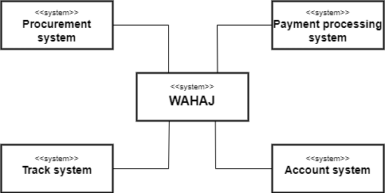

## 

## System Use-case Diagram with description:

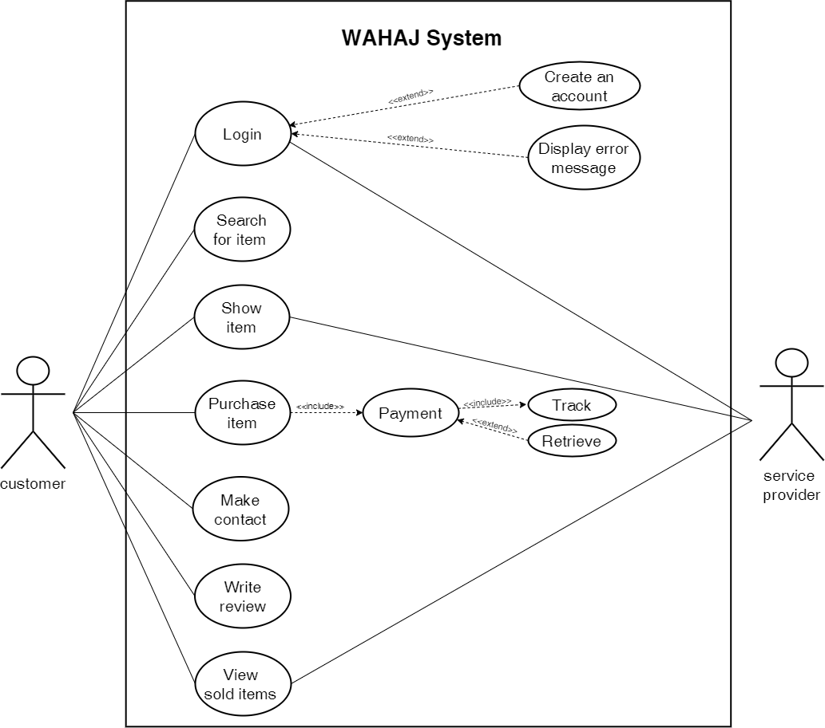

|  |  |
| --- | --- |
| WAHAJ System: Login | |
| Actor | Customer, Services providers |
| Description | Customers and service providers must first create an account (Username, Password, and Email), then receive a link to their email to verify the user, and then login each time using their username and password. |
| Data | Username, password, Email |
| Stimulus | Press Login button |
| Response | Login in application |
| Comments | The customers and service providers should create a unique username and password with a minimum of 8 characters, including at least one capital letter, one small letter, and one symbol |

|  |  |
| --- | --- |
| WAHAJ System: Search for an item | |
| Actor | Customer |
| Description | The customer can search for specific items by artist name or by artist social media account |
| Data | The artist's name, artist's social media account |
| Stimulus | Press the search button |
| Response | Display an artist's name and their items (courses, products) |
| Comments | The customer can use filter options |

|  |  |
| --- | --- |
| WAHAJ System: Show item | |
| Actor | Customer |
| Description | Either customer or services provider can view all the categories of the items |
| Data | Item information |
| Stimulus | Press item button |
| Response | Show the category list |
| Comments | Do not display both courses and products when they are sold out or expired |

|  |  |
| --- | --- |
| WAHAJ System: Purchase item | |
| Actor | Customer |
| Description | The customer can buy an item with either artwork, crafts, or consultants.Then the customer must pay to confirm the purchase. |
| Data | Item information |
| Stimulus | Press add to cart |
| Response | Display two options: Continue or View cart |
| Comments | If the chosen item is not available, a suggestion for a similar item will be posted. |

|  |  |
| --- | --- |
| WAHAJ System: Payment | |
| Actor | Customer |
| Description | The last step to purchasing the product or booking a course is payment, so the customer must determent Product type (artwork, craft, course). Number of products. |
| Data | Item type (artwork, craft, course), Number of items and price |
| Stimulus | Press checkout button |
| Response | Payment confirmation |
| Comments | The pay process will finish in 7 mins |

|  |  |
| --- | --- |
| WAHAJ System: Track | |
| Actor | Customer |
| Description | The customer should be able to see all the details about tracking their order |
| Data | Order ID, delivery ID |
| Stimulus | Press track my order button |
| Response | Display the name of the delivery company, each update, and is time |
| Comments | The customer must be on the order page that he wants to track |

|  |  |
| --- | --- |
| WAHAJ System: Retrieve | |
| Actor | Customer |
| Description | The customers can retrieve products they ordered from Services providers |
| Data | Order ID |
| Stimulus | Press retrieve button |
| Response | Display the message Operation completed successfully |
| Comments | The product purchased date must not exceed two weeks (14 days) and the product must not be damaged |

|  |  |
| --- | --- |
| WAHAJ System: Make Contact | |
| Actor | Customer, services providers |
| Description | The customer can get online consultations from Services providers about anything they want to know and they can also take some advice |
| Data | The artist's name, artist's social media account |
| Stimulus | Press consultation button |
| Response | Display a consultation page of the chosen service provider |
| Comments | The duration of the consultation is 15 minutes |

|  |  |
| --- | --- |
| WAHAJ System: Write review | |
| Actor | Customer |
| Description | Customers can rate the service provider and items by selecting the lowest possible score (one star) or the highest possible score (five stars) and can write a review about the items. |
| Data | The artist's name, artist's social media account |
| Stimulus | Press the review button |
| Response | Display the review on the service provider profile |
| Comments | The Customer can write a review only one time for each service provider and item |

|  |  |
| --- | --- |
| WAHAJ System: View sold items | |
| Actor | Customer, services provider |
| Description | The customer can see a list of previous orders. The list contains all the details about the orders, such as the ID of the order, type of items, and price. And the service provider can see a list of all the sold items. The list contains all the details of the items, such as quantity, price, and special orders. |
| Data | Username, password |
| Stimulus | Press view orders button |
| Response | Display a list of all previous orders |
| Comments | **The customer and service provider must be logged in.** |

## Use case scenario (Primary +secondary)

### Use case 1 : Login

**GOAL:** To login in application

**ACTORS:** Customer, Services providers

**Precondition:** Customer and services providers must have an account

**Main Success Scenario:**

1. The system requests that the customer entertheir usernames and password.
2. Customer and service providers insert their usernames and password.
3. System will verify the account and logs the customer into the application.

### Postcondition: The system confirms login for customers and service providers.

### Extensions:

### 2a. The customer and service provider account does not registered in the application.

### The system fails to log in.

### Does not have an account.

### The system will send an error message and requests the user to sign up for the application.

### Use case 2: Search for item

### GOAL: To search for a specific item

### ACTORS: Customer

### Precondition: Customer login into their account

### Main Success Scenario:

### Customer will search for an artist.

### Display an artist's name and her items.

**Postcondition:** Update the list of artists

**Extensions:**

1a. Customer does not find the artist's (name or social media account)

### Use case 3: Purchase item

**GOAL:** To Purchase items

**ACTORS:** Customer

**Precondition:** Customer login to her account and has enough money to pay.

**Main Success Scenario:**

1. Customer Select a category.
2. System displays a list of items.
3. Customer selects a particular item.
4. System checking for available items.
5. Customer should pay.
6. System displays the invoice details.
7. System update quantity of the item.

**Postcondition:** The purchase and payment confirmation successfully.

**Extensions:**

4a. item is not available: The purchase cannot be made

### Use case 4: Retrieve

### GOAL: To retrieve an item

**ACTORS:** customer

**Main Success Scenario:**

1. Customer will log in.
2. The customer opens the list of his previous orders.
3. The customer selects the order from which he wants to retrieve specific items
4. The Customer requests to retrieve an item.
5. The system verifies the conditions necessary to retrieve the request are met.
6. The system returns the amount paid.

**Postconditions:** The System confirms the retrieved item and reverses a transaction.

**Extensions:**

3a.The necessary conditions do not verify: The retrieval cannot be made.

# Chapter 3

## Diagram Description automatically generatedSystem Class Diagram

## Sequence Diagrams

### 

### Sequence diagram for Login

### Sequence diagram for Purchase item

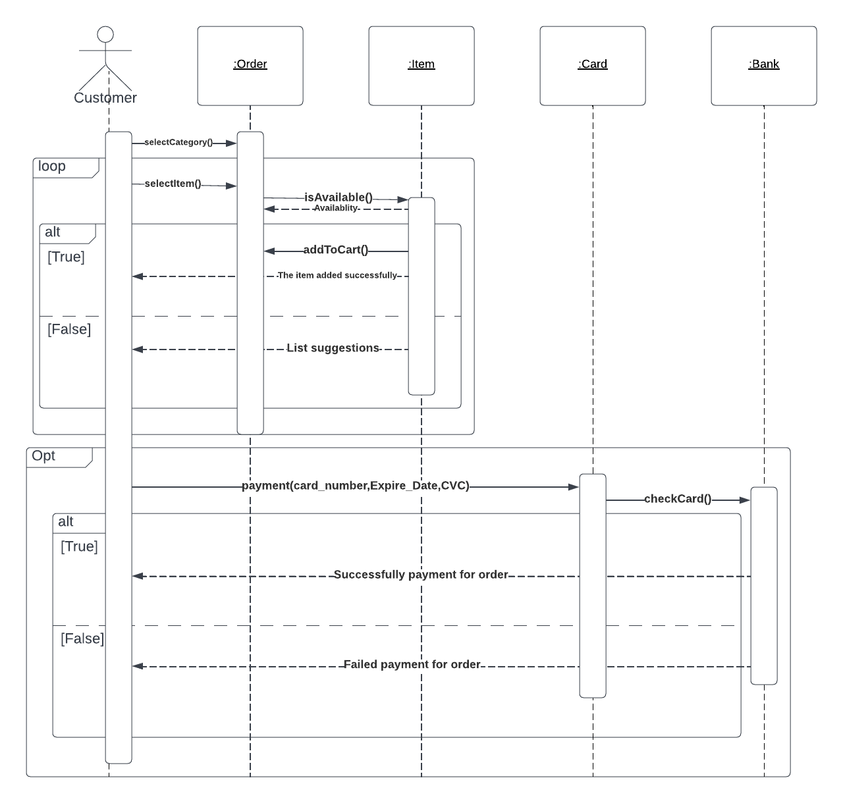

### Sequence diagram for Retrieve

# Chapter 4

## Activity Diagram

### Activity Diagram for Login

### 

### Activity Diagram for Purchase item

## 

### Activity Diagram for Retrieve

## State Diagram

### State Diagram for Purchase item

# 

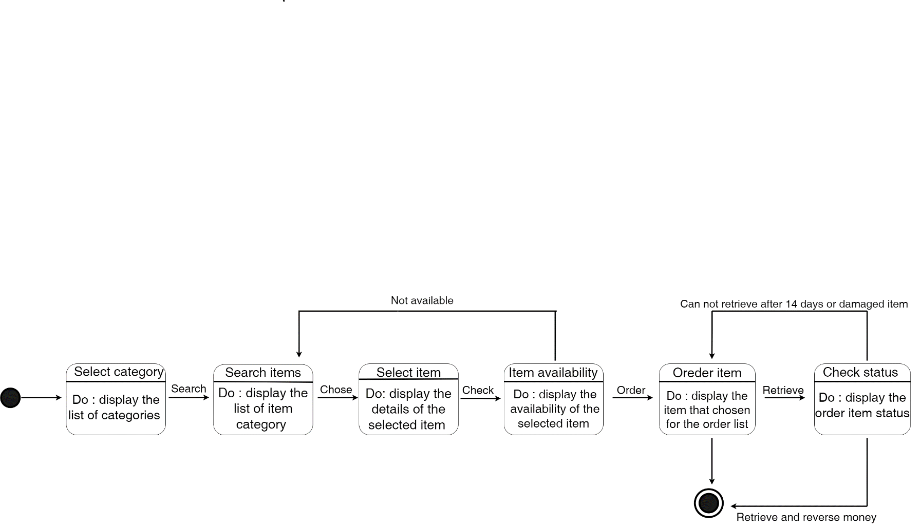

# Chapter 5

## Architecture Diagram

c

WAHAJ Application Interface

Application management Verification management

User interface management

Search items buy item pay online

View items retrieve item track order

Authentication Verification Servers Database

Monitoring & Controlling

Mobile app operating systems (IOS, Android)

We chose to use layered architecture because it supports our incremental development of subsystems in different layers. Additionally, it allows us to replace or add new facilities without significantly affecting the other layers (only adjacent layers will be affected). It will also improve our system's dependability and security.

## **User Interface, Implementation and Testing**

## **Logo**



The Wahaj logo refers to space, which is filled with clouds, stars, and planets. Therefore, just as in space, clouds are used in our logo. When we are looking for any star, we use a telescope to find it. We treat art and artists as if they were stars in space that we can see through a telescope. Users of our application will have the impression that they are traveling through space, with the products serving as the stars. In our logo, we've used baby pink and green to give the customer a sense of luxury, comfort, and creativity. In order to strengthen the Arabic language, we also write Wahaj in Arabic.

## **Paper prototype**

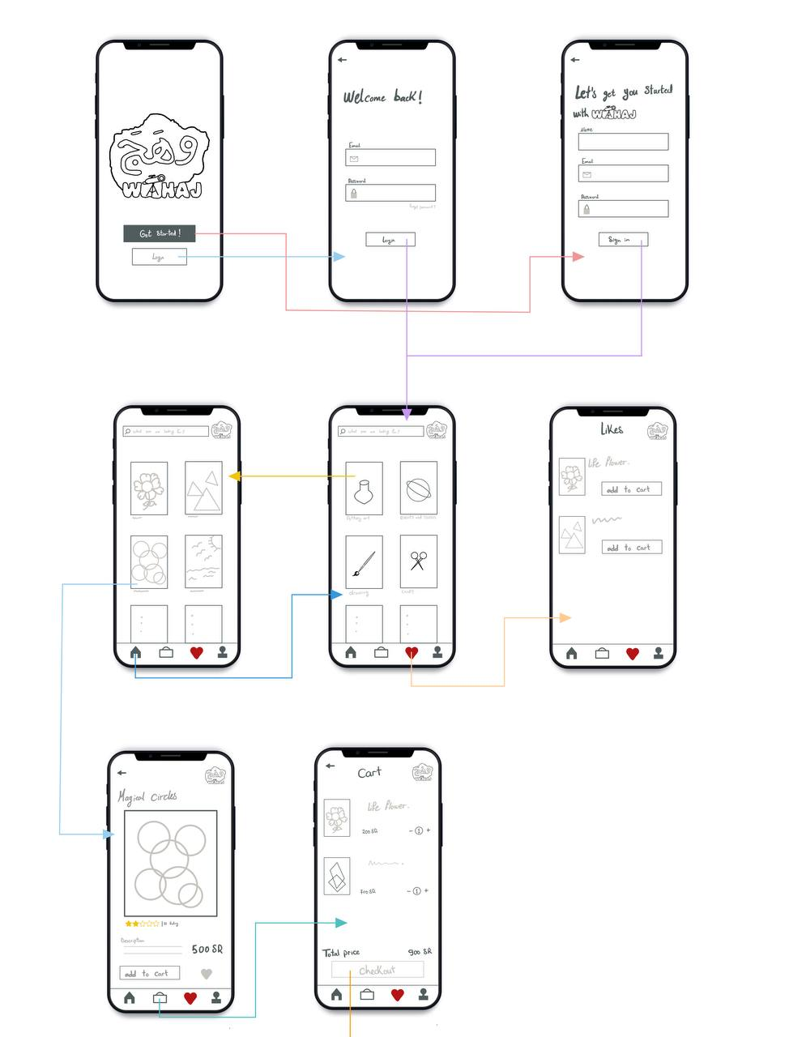

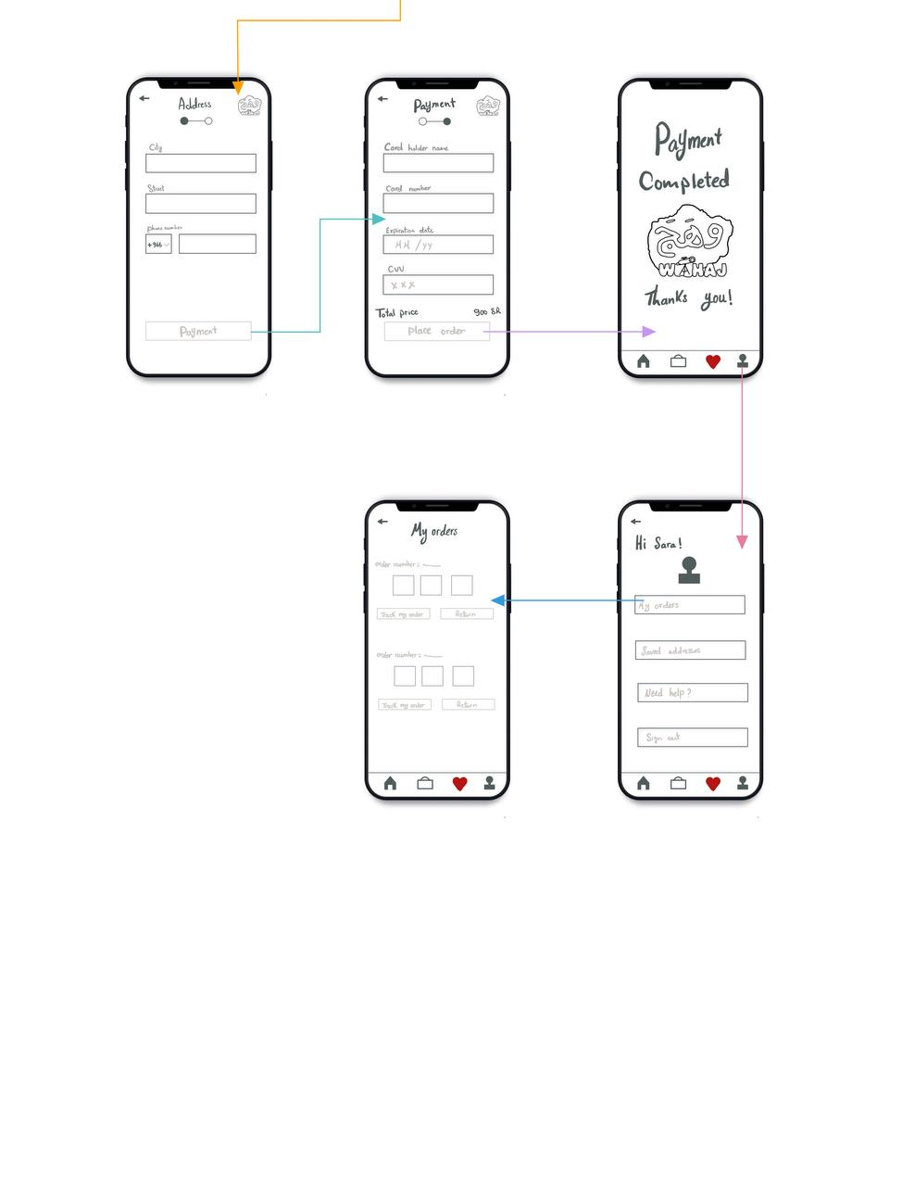

## **User Interface**

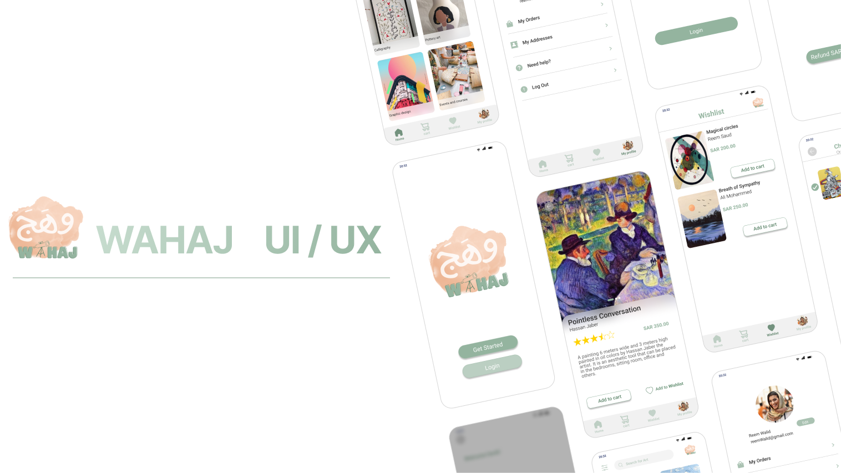

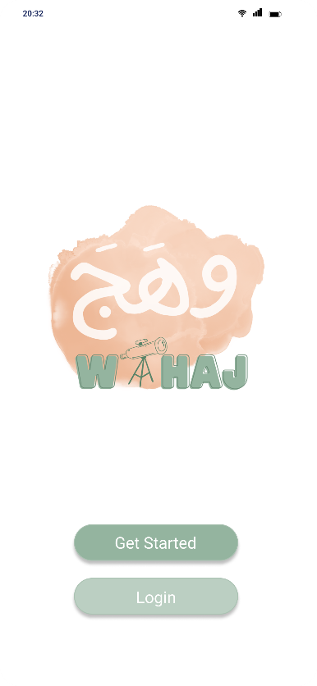

**First Interface:**

The started interface will show when the user opens the application for first time.

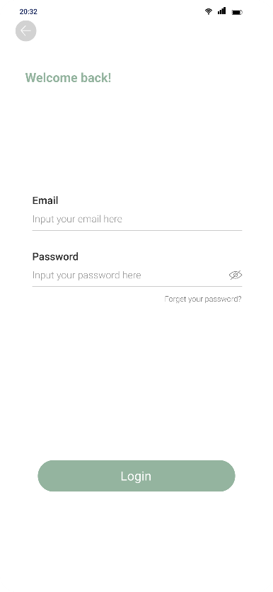

**Second Interface:**

The Login interface will appear and the user must enter the username and password to login.

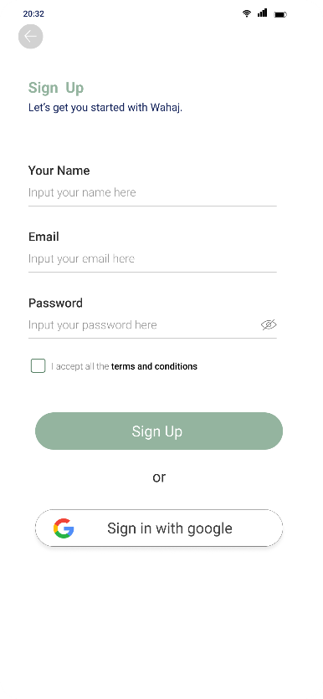

**Third Interface:**

The Signup interface it’s the registration page and the user should enter his/her information and click sign up button, after that the user will be able to login.

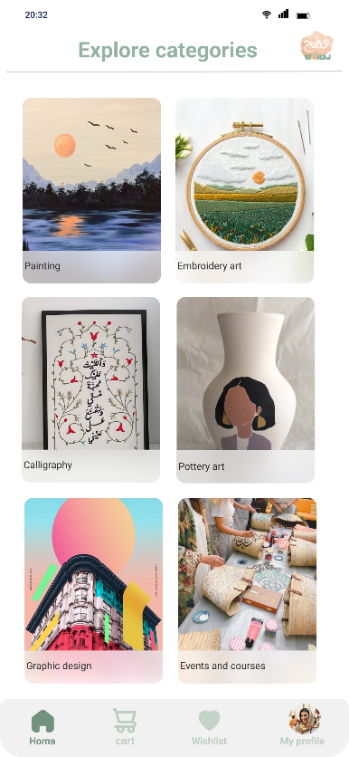

**Fourth Interface:**

The Explore categories interface it’s the home page and the user should select the category he/she want to look and click on it , after that the user will be able to go inside that category.

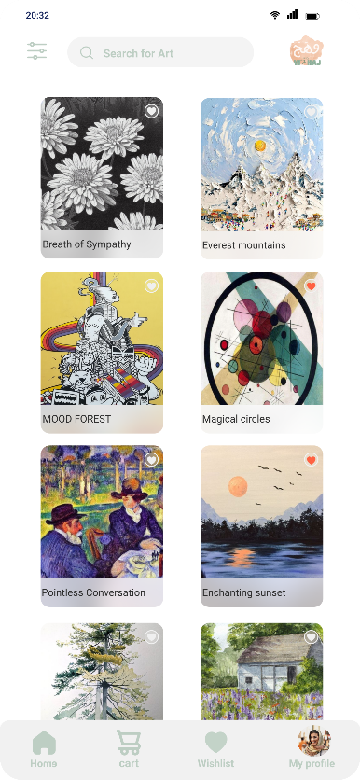

**Fifth Interface:**

When the user inter inside the category that he/she selected this page will apper and contains all that is within this category.

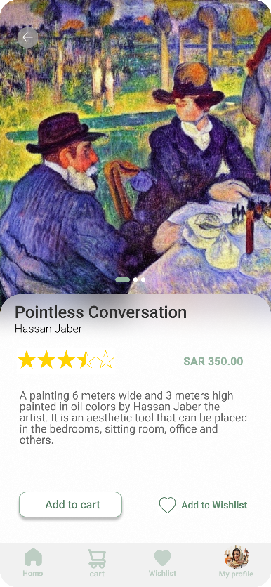

**Sixth Interface:**

If the user want to read about some item all has to do is click on this item then the item details page will appear to the user .

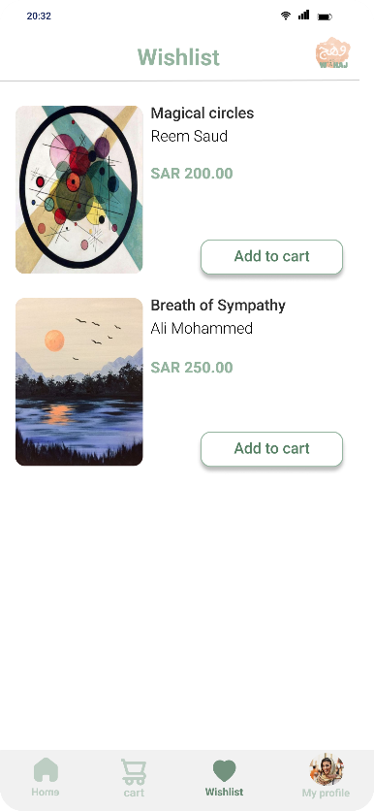

**Seventh Interface:**

This is page that is going to be displayed once you click on Wishlist icon to see favorite products and their details.

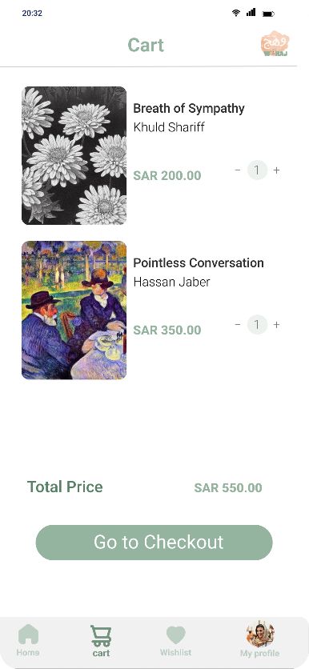

**Eighth Interface:**

This cart interface will be displayed after clicking the ‘cart’ icon from the bar at the bottom of the screen. The interface will show what items the user added to the cart and the amount next to each item (which can be changed). The interface will also show the total price of items and have a ‘checkout’ button that will take the user to the checkout page.

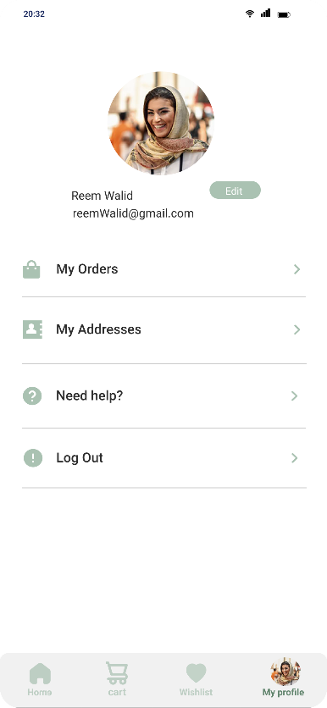

**Ninth Interface:**

The profile interface appears when click on my profile icon, which permit the user to edit his\her personal information, click on my order section to appear its interface, and ask about any help by click on need help section.

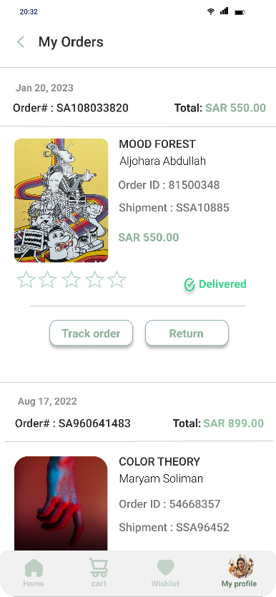

**Tenth Interface:**

This is page that is going to be displayed once you click on My Orders section from profile interface, which the user can see his\her orders, click on track order to track his\her orders, and go to return interface by click on return button.

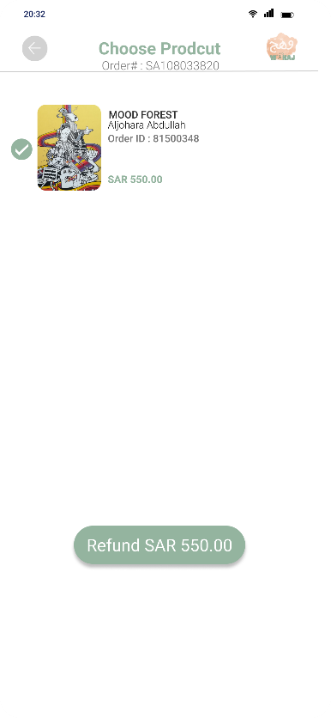

**Eleventh Interface:**

After clicking the ‘return’ button, you will be directed to this page. The order number will be displayed at the top of the screen, and the items will be displayed under it with a ‘check button’ on the left of each of item, once pressed will turn green.The bottom of the page will have a ‘Refund’ button with the price of the checked items.

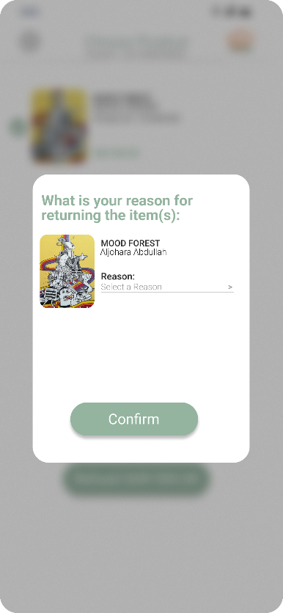

**Twelfth Interface:**

This interface will appear after clicking ‘Refund’ from the previous interface. This interface will show the items and prompt the user to choose a reason for returning the items. And lastly, the ‘confirm’ button will confirm the return/refund.

صورة تحتوي على نص, لقطة شاشة

تم إنشاء الوصف تلقائياً

**Thirteenth Interface:**

The payment interface it’s the page the user should enter his/her information about the card and click payment button.

صورة تحتوي على نص, لقطة شاشة, التصميم

تم إنشاء الوصف تلقائياً

**Fourteenth Interface:**

The address interface it’s the page in the user should enter his/her information and click payment button, after that the user will be able buy the product.

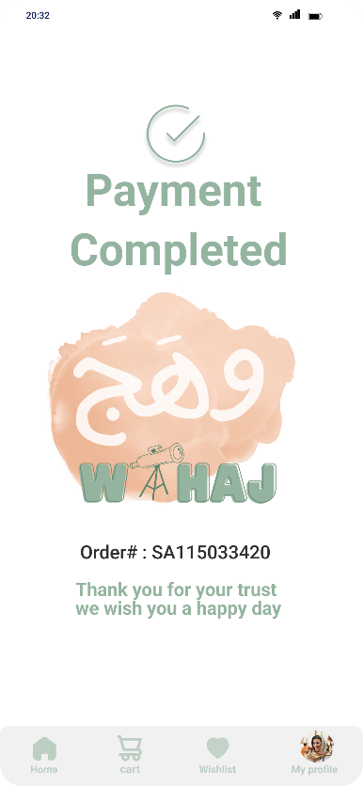

**Fifteenth Interface:**

The payment completed interface it’s the page show user the process of payment is successful and some information about like number of order.

If you want to try by QR code.



## **List the topmost important and frequent tasks for your system:**

1. **Logging in:** The purpose of logging in is to enter a certain page, website or application that is inaccessible to trespassers.
2. **Logging out:** Log out signifies the end of a login session for an application or website. Log out also signifies sign off, sign out, or logoff on a computer or web page.
3. **sign up:** Bysigning up, an individual creates an account on an online service, usually a website, by simply supplying an email address and a password.
4. **forget password:** many users forget password so forget password is a technique that allows to the user to enter your email address then change the password after the verification.
5. **Make an online conversation:** The user can hold a conversation with the artist he wants whenever and wherever he wants to request consultations or inquiries regarding the available courses, or also to request the artist's individual opinions on personal works and many others.
6. **Make an order:** The user will be able to search for services before selecting the items she /he wants. Additionally, the customer can choose the color and shape he wants for the product he would like to order and specify the date of delivery of this product.
7. **Payment Options:** Cash on Delivery, PayPal, or Apple Pay are available for the customer's convenience.

## **How our app will be an improvement for users:**

Our application has helped save the customer's time so that when he wants to order a piece of art, or book one of the events or courses we provide, this only takes a few minutes. Our application also helped to save the customer's effort by delivering his request wherever he wants and at the time that suits him. If he wants to order the special piece of art, this service is available in our application, and if he wants to call or chat with the artist is also available in our application

(Customer satisfaction is our goal).

## **Implementation**

We employed the application prototyping platform (figma) as well as the collaborative design interface tool in this project. Figma, everyone strives to achieve a common objective. originally created for mobile device prototype.

## **Usability Testing**

User1(Maram):

|  |  |  |  |  |
| --- | --- | --- | --- | --- |
| Task name | Task Time | Number of Errors | Comments | Suggestion to improve Task Design |
| 1. User Signup | 35s | 0 | It’s clear end help the user | None |
| 2. User Login | 10s | 0 | It's clear end help the user | None |
| 3. Browse Homepage . and select categories | 16s | 0 | Simple design and easy to select by user | It is better to make the interface more intuitive and fun to work with |
| 4. Move between main . screens | 4s | 0 | Fast and easy to move between items | None |
| 5. See product details | 5s | 1 | Good design to see all details about product | None |
| 6. Add to Wishlist | 3s | 0 | Quick to add product to wishlist | None |
| 7. Add to Cart | 7s | 0 | Fast and easy | Setting option available for user to choose quantity |
| 8. Checkout | 6s | 0 | Fast and easy | Increase the available payment methods for Users |
| 9. Go to profile page | 2s | 0 | User can easy see the profile page and it’s good design | None |
| 10. Retrieve an item | 9s | 1 | it is not clear to the user to be easily selected | make the process easier and faster to the user |

User2(Raghad):

|  |  |  |  |  |
| --- | --- | --- | --- | --- |
| Task name | Task Time | Number of Errors | Comments | Suggestion to improve Task Design |
| 1. User Signup | 60s | 2 | Easy to login | Giving more options to link the account |
| 2. User Login | 5s | 1 | The task is easy to the user | Put a password as a second option |
| 3. Browse Homepage . and select categories | 4s | 0 | Quick and easy to identify | None |
| 4. Move between main . screens | 7s | 0 | Simple | None |
| 5. See product details | 9s | 1 | Quick contains all the details | Improve design |
| 6. Add to Wishlist | 4s | 0 | Nice Easy to add | None |
| 7. Add to Cart | 4s | 2 | Nice Easy to add | None |
| 8. Checkout | 15s | 0 | The buttons are helpfully and make process easy | None |
| 9. Go to profile page | 6s | 0 | good design | Put more information |
| 10. Retrieve an item | 40s | 0 | not clear | Reduce processes |

User3(Taif):

|  |  |  |  |  |
| --- | --- | --- | --- | --- |
| Task name | Task Time | Number of Errors | Comments | Suggestion to improve Task Design |
| 1. User Signup | 30 sec | 0 | The task is easy and clear | None |
| 2. User Login | 10 sec | 0 | Abbreviated and fast | None |
| 3. Browse Homepage . and select categories | 16 sec | 0 | Nice and helpfully | Good to change the design to be more organized and clearer |
| 4. Move between main . screens | 7 sec | 0 | Simple and quick | None |
| 5. See product details | 13 sec | 0 | Good design | Better to add more information about the products |
| 6. Add to Wishlist | 4 sec | 0 | Simple, helpful, and user friendly | None |
| 7. Add to Cart | 4 sec | 0 | Clear and quick | None |
| 8. Checkout | 40 sec | 0 | Done successfully and easy | Better to add more options for payment like cash |
| 9. Go to profile page | 7 sec | 0 | Easily accessible page | None |
| 10. Retrieve an item | 50 sec | 1 | Not clear, took a long time to be acceptable | Change to a simpler and clear one |

User4(Thamra):

|  |  |  |  |  |
| --- | --- | --- | --- | --- |
| Task name | Task Time | Number of Errors | Comments | Suggestion to improve Task Design |
| 1. User Signup | 50 sec | 0 | The task is easily and smoothly | None |
| 2. User Login | 20 sec | 0 | The task done successfully | None |
| 3. Browse Homepage . and select categories | 15 sec | 0 | The interface is user friendly | Change categories font to be bigger |
| 4. Move between main . screens | 20 sec | 0 | Good organized | None |
| 5. See product details | 30 sec | 0 | Nice! the user see a description and rate for the product | Change back button color |
| 6. Add to Wishlist | 5 sec | 0 | Easy to add any product to the Wishlist | None |
| 7. Add to Cart | 5 sec | 0 | Easy to add any product to the Cart | None |
| 8. Checkout | 45 sec | 0 | The buttons are helpfully to complete the checkout | Add various choices for payment |
| 9. Go to profile page | 10 sec | 0 | Clear and user friendly | None |
| 10. Retrieve an item | 30 sec | 1 | Took a little time to figure it out | Put tutorial for new users |

User5(Walaa):

|  |  |  |  |  |
| --- | --- | --- | --- | --- |
| Task name | Task Time | Number of Errors | Comments | Suggestion to improve Task Design |
| 1. User Signup | 23 sec | 0 | It was an easy task. | None |
| 2. User Login | 15 sec | 1 | It was clear and simple. But I wrote my name instead of the email. | It should allow the option of user’s name or email. |
| 3. Browse Homepage . and select categories | 8 sec | 0 | The images shown in the Homepage helped with understanding the category. | None |
| 4. Move between main . screens | 2 sec | 0 | Icons were precise with the task expected. | None |
| 5. See product details | 24 sec | 0 | Easy and straightforward. | The prices should be shown on the outside of the product, not only inside the details. |
| 6. Add to Wishlist | 13 sec | 0 | Simple and easy. | None |
| 7. Add to Cart | 19 sec | 1 | There was no way to specify the amount. | There should be a prompt that asks you how many. |
| 8. Checkout | 17 sec | 0 | Easy and straightforward with no confusion. | There should be an option to pay with cash. |
| 9. Go to profile page | 7 sec | 0 | The icon was easy to identify. | None |
| 10. Retrieve an item | 27 sec | 1 | Straightforward, but there was too much information to understand at the end (on the confirmation screen). | Reason for return should be an open question, not restricted by options.  The “3 days” on the end should be another color. |

## **Usability Analysis**

The greatest issue users encountered while dealing with the system is when trying to ‘return an item’. The interface is complicated, and the process is tedious and takes too long.

With the rest of the tasks, users didn't face errors, but the suggestions provided are noteworthy. ‘Browsing through homepage’ users suggested that the interface should be more organized and fun, and fonts should be bigger. ‘See product detail’ should have more information about the product. ‘checkout’ should provide more payment methods.

The rest of the tasks were done without issues and had overall positive feedback.

With all this considered, the system is not perfect, but also not bad. Most users had less than 70% of misunderstandings, so it is safe to say that the system -to some extent- is usable.

## **Conclusion**

Finally, our goals always seek to achieve customer satisfaction and facilitate the life of the customer. In the future, we will seek to further develop and expand the scope of our project to be able to reach every place around the world. It is also feasible to implement a feature that sends customers notifications when their favorite artwork is available.