Project
  - Deadline: Wednesday 04/12/2024@ 23:59
[Total Mark for this Project is 14]

Introduction to Databases
DS350

Student Details:
Name: Asma Abdulqader  Name: Maram Bawazir  Name: Nadeen Alshammari  Name: Miad Alzhrani |  | ID: 220043599  ID: 220018729  ID: 220049011  ID: 210052413

Instructions:
- You must submit two separate copies (one Word file and one PDF file) using the Assignment Template on Blackboard via the allocated folder. These files must not be in compressed format.
- It is your responsibility to check and make sure that you have uploaded both the correct files.
- Zero mark will be given if you try to bypass the SafeAssign (e.g., misspell words, remove spaces between words, hide characters, use different character sets, convert text into image or languages other than English or any kind of manipulation).
- Email submission will not be accepted.
- You are advised to make your work clear and well-presented. This includes filling your information on the cover page.
- You must use this template, failing which will result in zero mark.
- You MUST show all your work, and text must not be converted into an image, unless specified otherwise by the question.
- Late submission will result in ZERO mark.
- The work should be your own, copying from students or other resources will result in ZERO mark.
- Use Times New Roman font for all your answers.

Project Instructions
- You can work on this project as a group (minimum 3 and maximum 4 students). Each group member must submit the project individually with all group member names mentioned in the cover page.
- This project worth 14 marks and will be distributed as in the following:
  - Identify the entity types, attributes, keys. (2 marks)
  - Identify the relationship and cardinalities. (2 marks)
  - Draw the ERD. (2 marks)
  - Schemas before Normalization. (1.5 marks)
  - Schemas after Normalization. (1.5 marks)
  - Create the tables. (1.5 marks)
  - Populate your tables with at least 5 rows. (1.5 marks)
  - Execute the requested sample queries. (2 marks)
- Each student must submit one report about his/her chosen Project via the Blackboard (Email submission will not be accepted which will be awarded ZERO marks)
- Screenshots for answering SQL questions (f, g, and h).
- You are advised to make your work clear and well presented; marks may be reduced for poor presentation. This includes filling your information on the cover page.
- You MUST show all your work, and text must not be converted into an image, unless specified otherwise by the question.
- Late submission will result in ZERO marks being awarded.
- The work should be your own, copying from students or other resources will result in ZERO marks.

Online Bookstore Management System
Learning Outcome(s):

LO 4
Design a database starting from the conceptual design to the implementation of database schemas.

LO 3

Create Entity-Relationship model, Relational model, and write SQL queries.

Consider an online bookstore that sells a variety of books to customers. The bookstore requires a database system to manage its inventory, customer orders, shipping information, and book details. The data requirements for the system are outlined below:
1. Book Inventory Management:
- Each book in the inventory is identified by a unique ISBN, title, author, genre, publication date, price, and quantity available.
- The system tracks the stock levels of each book and alerts when the stock is low.
- It maintains information on book categories and subcategories for easy classification.
2. Customer Order Processing:
- Customers can place orders for books by providing their details such as name, shipping address, contact number, and email.
- The system records each customer's order history, including the books purchased, order date, and total amount.
- It generates invoices for each order and tracks the payment status.
3. Shipping and Delivery:
- The system manages shipping information, including the shipping address, delivery status, and tracking number.
- It calculates shipping costs based on the customer's location and the weight of the books in the order.
- It provides estimated delivery dates and updates customers on the order status.
4. Book Details and Reviews:
- The system stores detailed information about each book, including a brief description, cover image, ratings, and reviews.
- Customers can rate and review books they have purchased, which helps in recommending books to other customers.
- It tracks popular books, best sellers, and new arrivals for marketing and promotion purposes.
5. Customer Accounts and Preferences:
- Customers can create accounts on the platform to manage their orders, wish lists, and preferences.
- The system stores customer preferences such as favorite genres, authors, and recommendations based on past purchases.
- It allows customers to update their account information, password, and communication preferences.

By implementing a robust database system for the online bookstore, the management can efficiently handle book inventory, customer orders, and enhance the overall shopping experience for book enthusiasts.

Online Bookstore Management System

- Fill the table below with all the Entities based on the given requirements:

Entity Type | Attributes of the Entity | Key
Book | ISBN, title, author, genre, publication date, price, quantity available, description, cover image | ISBN (Primary Key)
Inventory | ISBN, stock level, alert threshold | ISBN (Foreign Key)
Customer | Customer ID, name, shipping address, contact number, email, favorite genres, favorite authors, communication preferences | Customer ID (Primary Key)
Order | Order ID, customer ID, order date, total amount, payment status | Order ID (Primary Key)
Order Item | Order ID, ISBN, quantity, unit price | Order ID, ISBN (Composite Key)
Shipping | Shipping ID, order ID, shipping address, delivery status, tracking number, shipping cost, estimated delivery date | Shipping ID (Primary Key), Order ID (Foreign Key)
Review | Review ID, customer ID, ISBN, rating, review text | Review ID (Primary Key), Customer ID (Foreign Key), ISBN (Foreign Key)
Category | Category ID, category name | Category ID (Primary Key)
Wishlist | Wishlist ID, customer ID, ISBN | Wishlist ID (Primary Key), Customer ID (Foreign Key), ISBN (Foreign Key)

b) Fill the table below with all the relationship type based on the given requirements.
Relationship Type | Entities Connected by the Relationship Type | Cardinality | Relationship Attribute
Customer Orders | Customer - Order | One-to-Many  (1:M) | Customer ID, Order ID
Order Contains | Order - Book | Many-to-Many  (M:M) | Order ID, ISBN, quantity, unit price
Book Reviews | Book - Review | One-to-Many  (1:M) | ISBN, Review ID, rating, review text
Belongs To | Book - Category | Many-to-One  (M:1) | ISBN, Category ID
Wishlist Item | Customer - Book (Wishlist) | Many-to-Many  (M:M) | Wishlist ID, Customer ID, ISBN
Shipping For | Shipping - Order | One-to-One  (1:1) | Shipping ID, Order ID, tracking number, delivery status

EXPLAIN:
Customer Orders: An individual can make MANY purchases within the system, where each purchase is associated with exactly ONE individual.

Order Contains: A purchase can encompass Many books, and each book can appear in MULTIPLE distinct purchases. This illustrates a many-to-many relationship, which requires a junction table (Order_Books) to organize these associations effectively.

Book Reviews: An individual can submit Many critiques for various books they have acquired. Nonetheless, each critique is composed by JUST ONE individual.

Belongs To: Each book can be categorized into Many groups, and each group can comprise SEVERAL books, forming a many-to-many connection that usually necessitates a junction table (Book_Category).

Wishes For: An individual can express interest in Many books, while the same book may be desired by SEVERAL different individuals. This connection also calls for a junction table (Wishlist) to efficiently manage these associations.

Shipping For: Each purchase has ONE corresponding shipping record that monitors how and where the purchase is delivered. Each shipping record is tied to ONLY ONE purchase, indicating a one-to-one connection.

- Draw the ER Diagram
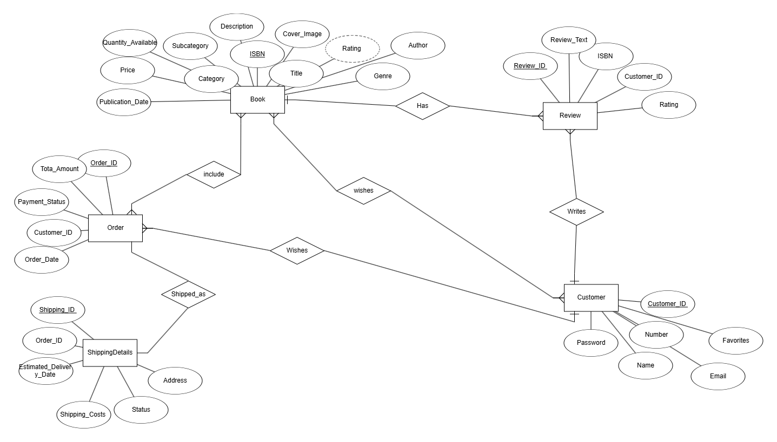

- Tables before the normalization
Unnormalized Table Example:
Schema Name | Schema Attribute | Keys
Book | ISBN  Title  Author  Genre  Publication_Date  Price  Quantity_Available  Category  Subcategory  Description  Cover_Image  Rating (derived attribute) | ISBN (Primary Key)
Order | Order_ID  Customer_ID (Foreign Key)  Order_Date  Tota_Amount  Payment_Status | Order ID (Primary Key)  Customer_ID (Foreign Key)
Order_Books  (Junction Table) | Order_ID (PK + FK)  ISBN (PK + FK)  Quantity | Order_ID (PK + FK)  ISBN (PK + FK)
Review | Review_ID (Primary Key)  ISBN (Foreign Key)  Customer_ID (Foreign Key)  Rating  Review_Text | Review_ID (Primary Key)  ISBN (Foreign Key)  Customer_ID (Foreign Key)
ShippingDetails | Shipping_ID (Primary Key)  Order_ID (Foreign Key)  Address  Status  Shipping_Costs (derived attribute)  Estimated_Delivery_Date | Shipping_ID (Primary Key)  Order_ID (Foreign Key)
Wishlist  (Junction Table) | Customer_ID (PK + FK)  ISBN (PK + FK) | Customer_ID (PK + FK)  ISBN (PK + FK)
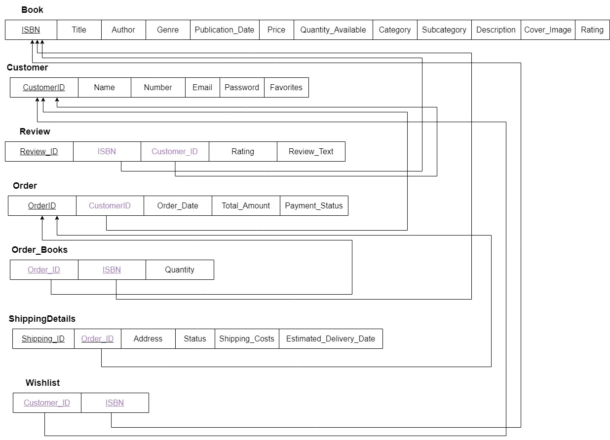

Step 1: 1NF
To meet the standards for 1NF:
1. All attributes must be indivisible and must rely on the key.
2. Any attributes that contain multiple values should be organized into their own relation, ensuring that all attributes are connected to the key.
The schema complies with 1NF requirements since it lacks any attributes with multiple values.

Step 2: 2NF
To achieve 2NF:
1. The schema should already conform to 1NF.
2. There must be no partial functional dependencies (FDs), meaning all non-key attributes should be entirely dependent on the primary key (no partial FDs), indicating that every attribute relies on the complete key.
The schema is already in 2NF because there are no partial functional dependencies present.

Step 3: 3NF
To qualify for 3NF:
1. The schema must already satisfy 2NF.
2. There should be no transitive dependencies, meaning all non-key attributes must directly depend on the primary key (no transitive dependencies). This implies that all attributes depend solely on the key, with no non-key attribute determining another non-key attribute.
3. Derived attributes are not permitted, as they can create transitive dependencies.

These problems occur in three scenarios:
Book: The Subcategory field is reliant on the non-primary attribute Category, forming a transitive dependency. This is expressed as:
ISBN → Category → Subcategory
Or broken down into:
ISBN → Category
Category → Subcategory
ISBN → Subcategory (Transitive dependency)
Fix: To eliminate this, move Subcategory from the Book table and place it in a new table alongside its determinant, Category_ID. Keep Category_ID in the Book table as a foreign key. To make Category_ID a valid foreign key, it must also serve as the primary key in its own separate table.
ShippingDetails: The Shipping_Costs field is a calculated value derived from other fields. Including such attributes in the database increases redundancy and should be avoided.
Fix: Delete the Shipping_Costs field from the ShippingDetails table.
Book: The Rating field is also a computed value that depends on other fields. Storing it in the database leads to unnecessary duplication of information.
Fix: Remove the Rating field from the Book table.
- Tables after the normalization

Schema Name | Schema Attribute | Keys
Book | ISBN  Title  Author  Genre  Publication_Date  Price  Quantity_Available  Category (Foreign Key)  Subcategory (Foreign Key)  Description  Cover_Image  Rating (derived attribute) | ISBN (Primary Key)  Category_ID (Foreign Key)  Subcategory_ID (Foreign Key)
Category_Table  (Table to fix 3NF) | Category_ID (Primary key)  Category_Name | Category_ID (Primary key)
Subcategory_Table  (Table to fix 3NF) | Subcategory_ID (Primary key)  Category_ID (Foreign Key)  Subcategory_Name | Subcategory_ID (Primary key)  Category_ID (Foreign Key)
Order | Order_ID  Customer_ID (Foreign Key)  Order_Date  Tota_Amount  Payment_Status | Order ID (Primary Key)  Customer_ID (Foreign Key)
Order_Books  (Junction Table) | Order_ID (PK + FK)  ISBN (PK + FK)  Quantity | Order_ID (PK + FK)  ISBN (PK + FK)

Customer | Customer_ID (Primary Key)  Name  Number  Email  Password  Favorites | Customer_ID (Primary Key)
Review | Review_ID (Primary Key)  ISBN (Foreign Key)  Customer_ID (Foreign Key)  Rating  Review_Text | Review_ID (Primary Key)  ISBN (Foreign Key)  Customer_ID (Foreign Key)
ShippingDetails | Shipping_ID (Primary Key)  Order_ID (Foreign Key)  Address  Status  Shipping_Costs (derived attribute)  Estimated_Delivery_Date | Shipping_ID (Primary Key)  Order_ID (Foreign Key)
Wishlist  (Junction Table) | Customer_ID (PK + FK)  ISBN (PK + FK) | Customer_ID (PK + FK)  ISBN (PK + FK)
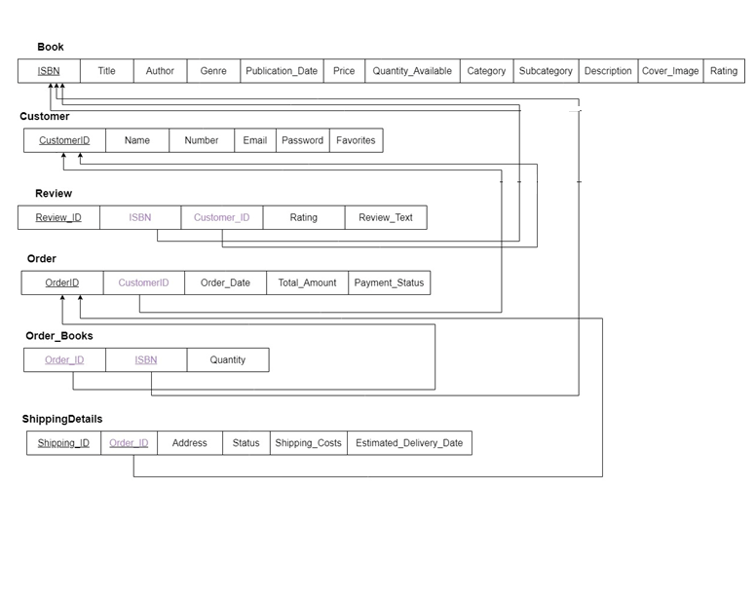
- Create the normalized tables and populate them with at least 10 rows.
1 -- Populate Category_Table
INSERT INTO Category_Table (Category_Name) VALUES
('Fiction'),
('Non-Fiction'),
('Science'),
('History'),
('Mystery'),
('Romance'),
('Fantasy'),
('Biography'),
('Self-Help'),
('Children');

-- Populate Subcategory_Table
INSERT INTO Subcategory_Table (Category_ID, Subcategory_Name) VALUES
(1, 'Thriller'),
(1, 'Drama'),
(2, 'Health'),
(2, 'Travel'),
(3, 'Physics'),
(3, 'Biology'),
(4, 'Ancient'),
(5, 'Detective'),
(6, 'Love Stories'),
(7, 'Magic');

-- Populate Book Table
INSERT INTO Book (ISBN, Title, Author, Genre, Publication_Date, Price, Quantity_Available, Category_ID, Subcategory_ID, Description, Cover_Image) VALUES
('978-1-23456-789-0', 'The Silent Patient', 'Alex Michaelides', 'Fiction', '2023-02-01', 15.99, 100, 1, 1, 'A psychological thriller', 'Cover1.jpg'),
('978-1-23456-789-1', 'Becoming', 'Michelle Obama', 'Non-Fiction', '2023-03-01', 20.00, 50, 2, 1, 'A memoir by the former First Lady', 'Cover2.jpg'),
('978-1-23456-789-2', 'A Brief History of Time', 'Stephen Hawking', 'Science', '2024-01-15', 18.50, 75, 3, 1, 'An exploration of the universe', 'Cover3.jpg'),
('978-1-23456-789-3', 'The Great Gatsby', 'F. Scott Fitzgerald', 'Fiction', '2024-04-10', 10.99, 120, 1, 2, 'A classic novel of the Roaring Twenties', 'Cover4.jpg'),
('978-1-23456-789-4', 'Educated', 'Tara Westover', 'Non-Fiction', '2023-05-20', 25.00, 90, 2, 2, 'A memoir about family and education', 'Cover5.jpg'),
('978-1-23456-789-5', 'Harry Potter and the Sorcerer’s Stone', 'J.K. Rowling', 'Fantasy', '2024-05-01', 30.00, 60, 1, 1, 'A young wizard’s journey begins', 'Cover6.jpg'),
('978-1-23456-789-6', 'The Catcher in the Rye', 'J.D. Salinger', 'Fiction', '2023-06-15', 22.99, 110, 1, 2, 'A story of teenage angst', 'Cover7.jpg'),
('978-1-23456-789-7', 'Where the Crawdads Sing', 'Delia Owens', 'Fiction', '2023-07-20', 12.99, 95, 1, 1, 'A mystery set in the marshes of North Carolina', 'Cover8.jpg'),
('978-1-23456-789-8', 'Beartown', 'Fredrik Backman', 'Fiction', '2024-06-05', 14.50, 80, 1, 2, 'A novel about a town obsessed with hockey', 'Cover9.jpg'),
('978-1-23456-789-9', 'Atomic Habits', 'James Clear', 'Self-Help', '2023-08-30', 21.99, 70, 2, 1, 'An easy & proven way to build good habits', 'Cover10.jpg');

-- Populate Customer Table
INSERT INTO Customer (Name, Number, Email, Password, Favorites) VALUES
('Ali Ahmed', 'Number1', 'ali1@example.com', 'Password1', 'Favorite1'),
('Fatima Al-Mansour', 'Number2', 'fatima2@example.com', 'Password2', 'Favorite2'),
('Mohammed Khan', 'Number3', 'mohammed3@example.com', 'Password3', 'Favorite3'),
('Sara Youssef', 'Number4', 'sara4@example.com', 'Password4', 'Favorite4'),
('Omar Saeed', 'Number5', 'omar5@example.com', 'Password5', 'Favorite5'),
('Aisha Hussain', 'Number6', 'aisha6@example.com', 'Password6', 'Favorite6'),
('Hassan Ali', 'Number7', 'hassan7@example.com', 'Password7', 'Favorite7'),
('Noura Khaled', 'Number8', 'noura8@example.com', 'Password8', 'Favorite8'),
('Zainab Noor', 'Number9', 'zainab9@example.com', 'Password9', 'Favorite9'),
('Yusuf Ibrahim', 'Number10', 'yusuf10@example.com', 'Password10', 'Favorite10');

-- Populate Review Table (ensure customers have rated books)
INSERT INTO Review (ISBN, Customer_ID, Rating, Review_Text) VALUES
('978-1-23456-789-0', 1, 5, 'An incredible read!'),
('978-1-23456-789-1', 2, 4, 'Very inspiring.'),
('978-1-23456-789-2', 3, 5, 'A must-read for science lovers.'),
('978-1-23456-789-3', 4, 3, 'Good, but not great.'),
('978-1-23456-789-4', 5, 5, 'Life-changing!'),
('978-1-23456-789-5', 6, 4, 'Magical and wonderful.'),
('978-1-23456-789-6', 7, 2, 'Didn’t live up to the hype.'),
('978-1-23456-789-7', 8, 5, 'Beautifully written.'),
('978-1-23456-789-8', 9, 4, 'Engaging story.'),
('978-1-23456-789-9', 10, 3, 'Helpful tips but some were obvious.');

-- Populate Order Table
INSERT INTO `Order` (Customer_ID, Order_Date, Total_Amount, Payment_Status) VALUES
(1, '2023-10-01 10:00:00', 29.99, 'Paid'),
(2, '2023-10-02 11:00:00', 19.99, 'Paid'),
(3, '2023-10-03 12:00:00', 39.99, 'Unpaid'),
(1, '2023-10-04 13:00:00', 49.99, 'Paid'),
(1, '2023-10-05 14:00:00', 59.99, 'Paid'),
(2, '2023-10-06 15:00:00', 69.99, 'Pending'),
(3, '2023-10-07 16:00:00', 79.99, 'Paid'),
(4, '2023-10-08 17:00:00', 89.99, 'Unpaid'),
(5, '2023-10-09 18:00:00', 99.99, 'Paid'),
(6, '2023-10-10 19:00:00', 9.99, 'Paid');

-- Populate Order_Books (Junction Table)
INSERT INTO Order_Books (Order_ID, ISBN, Quantity) VALUES
(1, '978-1-23456-789-0', 1),
(1, '978-1-23456-789-1', 2),
(1, '978-1-23456-789-3', 1),
(1, '978-1-23456-789-5', 1),
(2, '978-1-23456-789-2', 1),
(2, '978-1-23456-789-4', 1),
(3, '978-1-23456-789-6', 1),
(4, '978-1-23456-789-7', 1),
(5, '978-1-23456-789-8', 1),
(6, '978-1-23456-789-9', 1);

-- Populate ShippingDetails Table
INSERT INTO ShippingDetails (Order_ID, Address, Status, Estimated_Delivery_Date) VALUES
(1, 'Address1', 'Shipped', '2023-10-01'),
(2, 'Address2', 'In Transit', '2023-10-02'),
(3, 'Address3', 'Delivered', '2023-10-03'),
(4, 'Address4', 'Pending', '2023-10-04'),
(5, 'Address5', 'Shipped', '2023-10-05'),
(6, 'Address6', 'In Transit', '2023-10-06'),
(7, 'Address7', 'Delivered', '2023-10-07'),
(8, 'Address8', 'Pending', '2023-10-08'),
(9, 'Address9', 'Shipped', '2023-10-09'),
(10, 'Address10', 'In Transit', '2023-10-10');

-- Populate Wishlist Table (for customers with wish lists)
INSERT INTO Wishlist (Customer_ID, ISBN) VALUES
(1, '978-1-23456-789-0'),
(1, '978-1-23456-789-1'),
(1, '978-1-23456-789-2'),
(2, '978-1-23456-789-1'),
(2, '978-1-23456-789-3'),
(3, '978-1-23456-789-0'),
(3, '978-1-23456-789-2'),
(4, '978-1-23456-789-3'),
(4, '978-1-23456-789-4'),
(5, '978-1-23456-789-2');

Write the necessary SQL statements to create the tables.
-- Customer Table
CREATE TABLE Customer (
CustomerID INT PRIMARY KEY,
FirstName VARCHAR(50),
LastName VARCHAR(50),
ShippingAddress VARCHAR(255),
ContactNumber VARCHAR(20),
Email VARCHAR(100),
Password VARCHAR(100),
CommunicationPreferences VARCHAR(255)
);

-- Book Table
CREATE TABLE Book (
ISBN VARCHAR(20) PRIMARY KEY,
Title VARCHAR(255),
Author VARCHAR(100),
Genre VARCHAR(50),
PublicationDate DATE,
Price DECIMAL(10, 2),
QuantityAvailable INT,
Description TEXT,
CoverImage VARCHAR(255)
);

-- Category Table
CREATE TABLE Category (
CategoryID INT PRIMARY KEY,
CategoryName VARCHAR(100)
);

-- Subcategory Table
CREATE TABLE Subcategory (
SubcategoryID INT PRIMARY KEY,
CategoryID INT,
SubcategoryName VARCHAR(100),
FOREIGN KEY (CategoryID) REFERENCES Category(CategoryID)
);

-- Order Table
CREATE TABLE OrderTable (
OrderID INT PRIMARY KEY,
CustomerID INT,
OrderDate DATE,
TotalAmount DECIMAL(10, 2),
PaymentStatus VARCHAR(50),
FOREIGN KEY (CustomerID) REFERENCES Customer(CustomerID)
);

-- OrderItem Table
CREATE TABLE OrderItem (
OrderID INT,
ISBN VARCHAR(20),
Quantity INT,
UnitPrice DECIMAL(10, 2),
PRIMARY KEY (OrderID, ISBN),
FOREIGN KEY (OrderID) REFERENCES OrderTable(OrderID),
FOREIGN KEY (ISBN) REFERENCES Book(ISBN)
);

-- Shipping Table
CREATE TABLE Shipping (
ShippingID INT PRIMARY KEY,
OrderID INT UNIQUE,
ShippingAddress VARCHAR(255),
DeliveryStatus VARCHAR(50),
TrackingNumber VARCHAR(50),
ShippingCost DECIMAL(10, 2),
EstimatedDeliveryDate DATE,
FOREIGN KEY (OrderID) REFERENCES OrderTable(OrderID)
);

-- Review Table
CREATE TABLE Review (
ReviewID INT PRIMARY KEY,
CustomerID INT,
ISBN VARCHAR(20),
Rating INT,
ReviewText TEXT,
FOREIGN KEY (CustomerID) REFERENCES Customer(CustomerID),
FOREIGN KEY (ISBN) REFERENCES Book(ISBN)
);

-- Wishlist Table
CREATE TABLE Wishlist (
CustomerID INT,
ISBN VARCHAR(20),
PRIMARY KEY (CustomerID, ISBN),
FOREIGN KEY (CustomerID) REFERENCES Customer(CustomerID),
FOREIGN KEY (ISBN) REFERENCES Book(ISBN)
);
- Insert at least five rows into each table.
Customer Table:
INSERT INTO Customer VALUES
(1, 'Alice', 'Smith', '123 Maple Street', '555-1234', 'alice@example.com', 'password1', 'Email'),
(2, 'Bob', 'Johnson', '456 Oak Avenue', '555-5678', 'bob@example.com', 'password2', 'SMS'),
(3, 'Carol', 'Williams', '789 Pine Road', '555-9012', 'carol@example.com', 'password3', 'Email'),
(4, 'David', 'Brown', '321 Elm Street', '555-3456', 'david@example.com', 'password4', 'Email'),
(5, 'Eve', 'Davis', '654 Cedar Lane', '555-7890', 'eve@example.com', 'password5', 'SMS');

Book Table:
INSERT INTO Book VALUES
('978-0-123456-47-2', 'The Great Adventure', 'John Doe', 'Fiction', '2024-01-15', 19.99, 50, 'An exciting adventure book.', 'image1.jpg'),
('978-0-123456-48-9', 'Learning SQL', 'Jane Smith', 'Education', '2023-11-20', 29.99, 30, 'A comprehensive guide to SQL.', 'image2.jpg'),
('978-0-123456-49-6', 'Cooking 101', 'Chef Goodfood', 'Cooking', '2022-05-10', 24.99, 20, 'Beginner recipes for home cooks.', 'image3.jpg'),
('978-0-123456-50-2', 'Mystery in the Night', 'Ann Mystery', 'Fiction', '2024-03-01', 15.99, 40, 'A thrilling mystery novel.', 'image4.jpg'),
('978-0-123456-51-9', 'Science Facts', 'Dr. Science', 'Science', '2023-12-05', 34.99, 25, 'Interesting science facts.', 'image5.jpg');

Category Table:
INSERT INTO Category VALUES
(1, 'Fiction'),
(2, 'Non-Fiction'),
(3, 'Education'),
(4, 'Cooking'),
(5, 'Science');

OrderTable:
INSERT INTO OrderTable VALUES
(1001, 1, '2024-01-20', 39.98, 'Paid'),
(1002, 2, '2024-01-22', 19.99, 'Pending'),
(1003, 3, '2024-01-25', 24.99, 'Paid'),
(1004, 1, '2024-02-10', 15.99, 'Paid'),
(1005, 4, '2024-02-15', 34.99, 'Paid');

OrderItem Table:
INSERT INTO OrderItem VALUES
(1001, '978-0-123456-47-2', 1, 19.99),
(1001, '978-0-123456-48-9', 1, 19.99),
(1002, '978-0-123456-49-6', 1, 19.99),
(1003, '978-0-123456-49-6', 1, 24.99),
(1004, '978-0-123456-50-2', 1, 15.99),
(1005, '978-0-123456-51-9', 1, 34.99);

Shipping Table:
INSERT INTO Shipping VALUES
(2001, 1001, '123 Maple Street', 'Shipped', 'TRACK1001', 5.00, '2024-01-25'),
(2002, 1002, '456 Oak Avenue', 'Processing', 'TRACK1002', 5.00, '2024-01-27'),
(2003, 1003, '789 Pine Road', 'Delivered', 'TRACK1003', 5.00, '2024-01-30'),
(2004, 1004, '123 Maple Street', 'Shipped', 'TRACK1004', 5.00, '2024-02-15'),
(2005, 1005, '321 Elm Street', 'Shipped', 'TRACK1005', 5.00, '2024-02-20');

Review Table:
INSERT INTO Review VALUES
(3001, 1, '978-0-123456-47-2', 5, 'Amazing book!'),
(3002, 2, '978-0-123456-49-6', 4, 'Very informative.'),
(3003, 3, '978-0-123456-49-6', 4, 'Great recipes!'),
(3004, 1, '978-0-123456-50-2', 5, 'Loved the mystery.'),
(3005, 4, '978-0-123456-51-9', 3, 'Interesting facts.');

Wishlist Table:
INSERT INTO Wishlist VALUES
(1, '978-0-123456-51-9'),
(2, '978-0-123456-48-9'),
(3, '978-0-123456-47-2'),
(4, '978-0-123456-50-2'),
(5, '978-0-123456-49-6');
- Write queries to find the following:
- List the first and last names of customers who have purchased more than three books.
- List all books’ ids and titles published since 1/1/2024.
- List all customers who have rated books (First and last name, customer id).
- Find all customers who have purchased books in the "Fiction" genre.
- List all customers who have books in their wish list.
- Find all customers who have purchased books and reviewed them.

- List the first and last names of customers who have purchased more than three books.

SELECT C.FirstName, C.LastName
FROM Customer C
JOIN OrderTable O ON C.CustomerID = O.CustomerID
JOIN OrderItem OI ON O.OrderID = OI.OrderID
GROUP BY C.CustomerID, C.FirstName, C.LastName
HAVING SUM(OI.Quantity) > 3;

2. List all books’ IDs and titles published since 1/1/2024.
SELECT ISBN, Title
FROM Book
WHERE PublicationDate >= '2024-01-01';

3. List all customers who have rated books (First and last name, customer ID).
SELECT DISTINCT C.FirstName, C.LastName, C.CustomerID
FROM Customer C
JOIN Review R ON C.CustomerID = R.CustomerID;

4. Find all customers who have purchased books in the "Fiction" genre.
SELECT DISTINCT C.FirstName, C.LastName, C.CustomerID
FROM Customer C
JOIN OrderTable O ON C.CustomerID = O.CustomerID
JOIN OrderItem OI ON O.OrderID = OI.OrderID
JOIN Book B ON OI.ISBN = B.ISBN
WHERE B.Genre = 'Fiction';

5. List all customers who have books in their wish list.
SELECT DISTINCT C.FirstName, C.LastName, C.CustomerID
FROM Customer C
JOIN Wishlist W ON C.CustomerID = W.CustomerID;

- Find all customers who have purchased books and reviewed them.
SELECT DISTINCT C.FirstName, C.LastName, C.CustomerID
FROM Customer C
JOIN OrderTable O ON C.CustomerID = O.CustomerID
JOIN OrderItem OI ON O.OrderID = OI.OrderID
JOIN Review R ON C.CustomerID = R.CustomerID AND OI.ISBN = R.ISBN;

