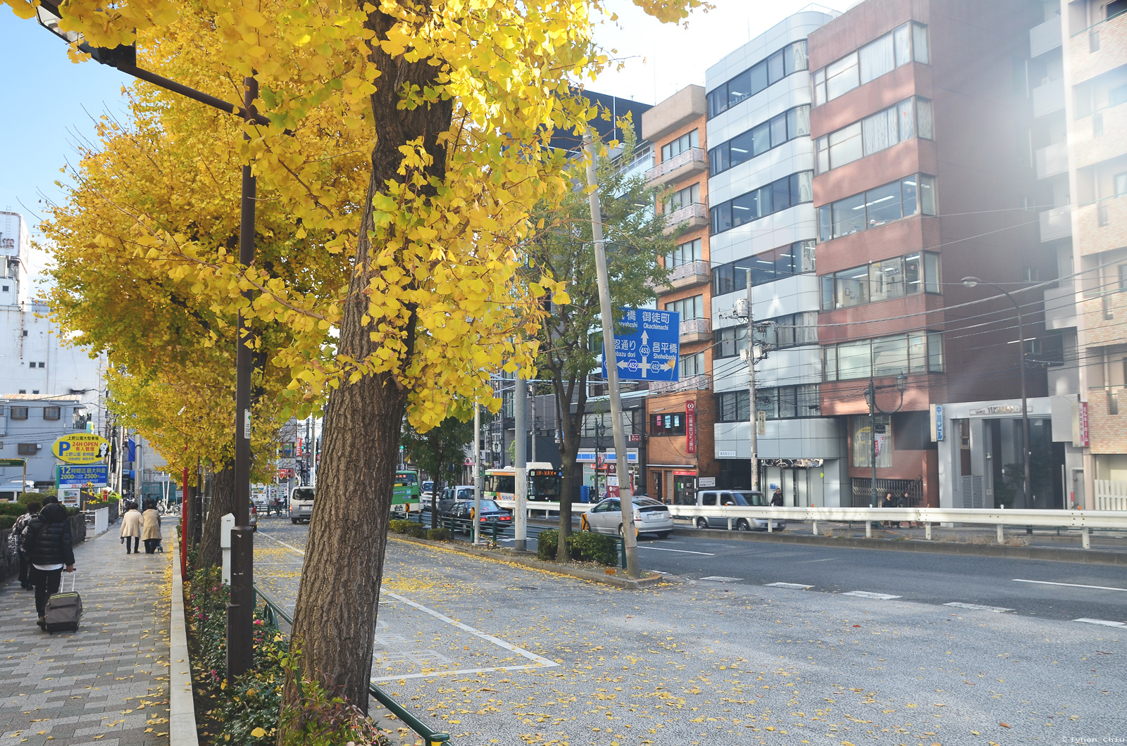

City street with short building,road,white bar,trees,parking place,

Farsight:high building

