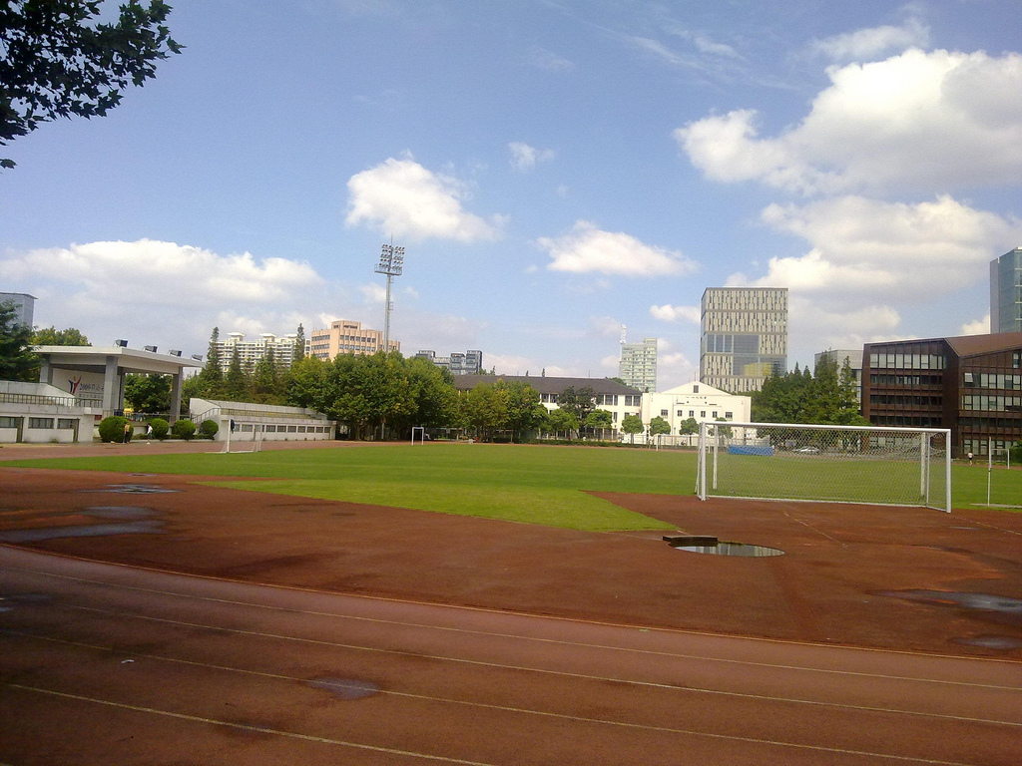

School playground with rails,football ground

Farsight: School buildings

