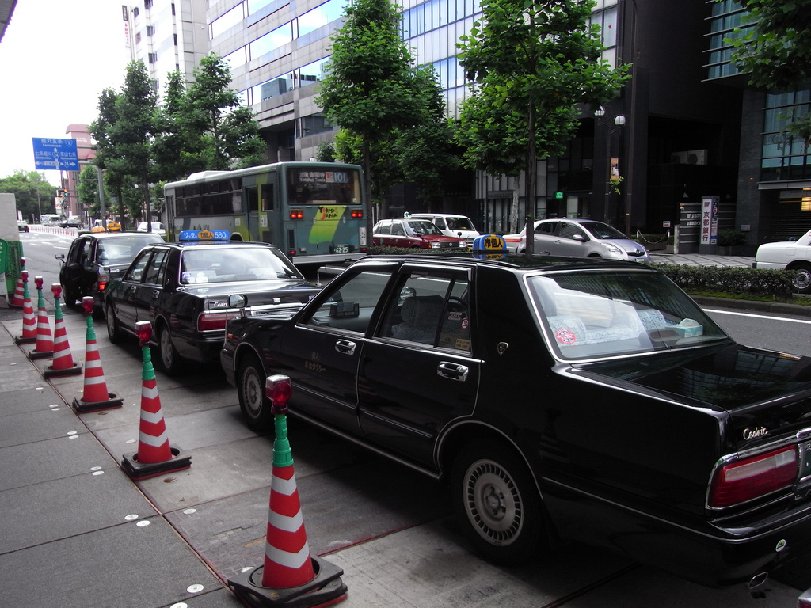

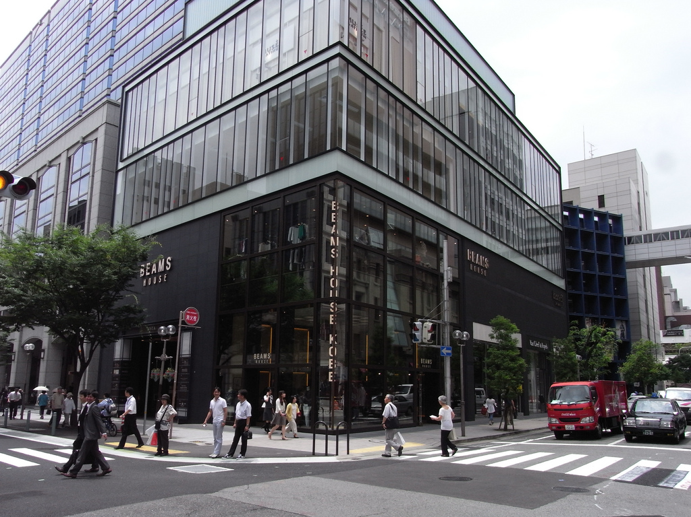

City center road with high building,trees,lights,walkway,zebra crossing,guard barrel
Farsight: none

