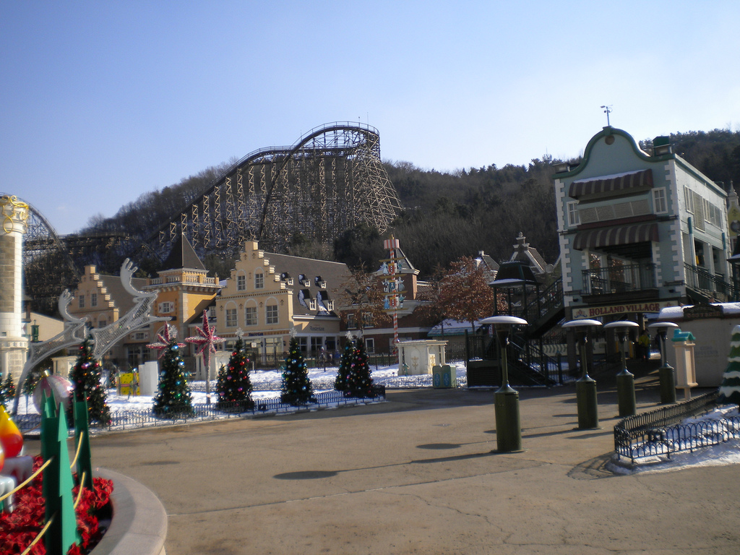

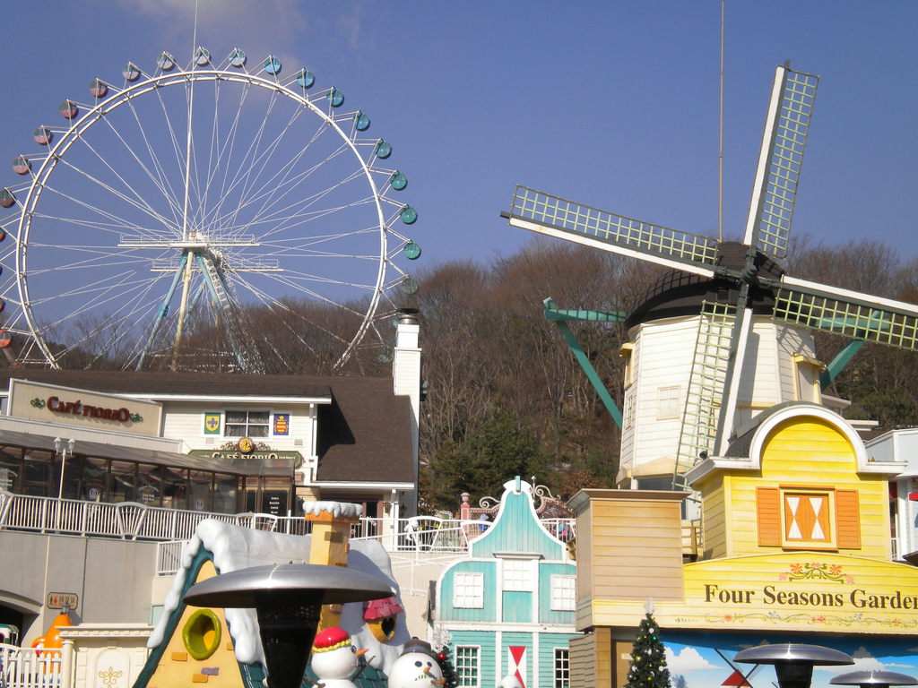

amusement park’s road with bushs and small car shop that sells ballon

Farsight: Roller Coaster and Ferris wheel

