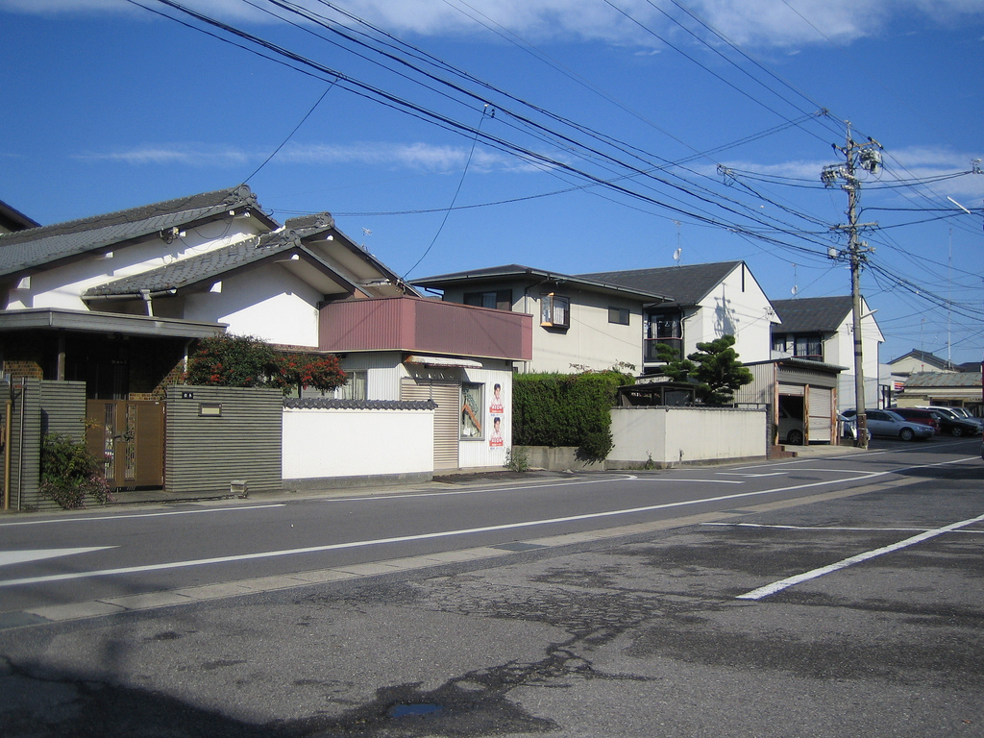

House street with telegraph pole,bush,cars and small pack rubish

Farsight: sky

