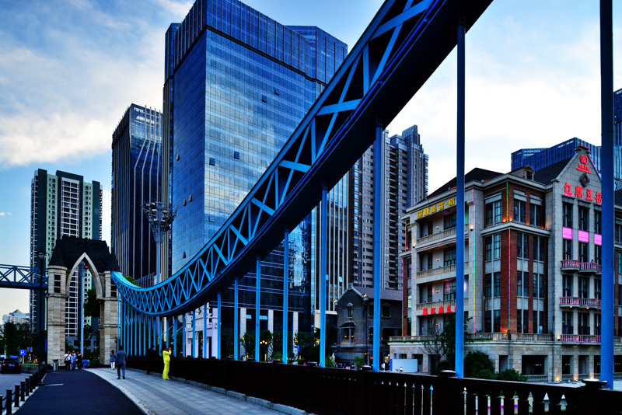

Bridge

A bridge in city with building on both sides.has walkway can car way

Far sight:city building on both riversides

