第七周Python实验报告

**学号**：117060400110 **姓名**：蒙柳双

**班级**：17应用统计学1班 **指导老师**：林卫中老师

**实验目的：**

1. 理解并会使用递归函数，运用递归函数知识去解决各种问题
2. 会使用python123进行写代码并且完整提交
3. 对tatetime时间日期库的理解与正确运用
4. 会根据不同条件将七段数码管时钟进行不同的改编

**实验要求**：

1. 会使用递归函数将字符串反转
2. 登录http:/www.python123.io完成“函数”单元练习
3. 编写 课本程序练习题5.7
4. 根据各种要求绘制属于自己特色的七段数码管时钟

**实验内容步骤：**

**字符串反转：**

**核心代码：**

**（1）**

def reverse(s):

if s == "" :

return s

else:

return s[-1] + reverse(s[0:-1])

str = input("请输入一个字符串：")

print(reverse(str))

**或**

**(2)**

def reverse(s):

n = len(s)

if s == 1 :

return s

else:

return reverse(s[n//2:0]) + reverse([0:n//2])

str = input("请输入一个字符串：")

print(reverse(str))

**实验结果：**

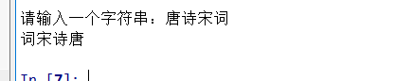

注：

自己会经常出现的错误：

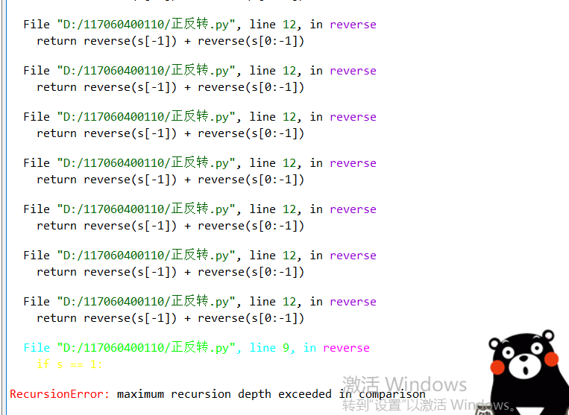

**斐波拉契数列**

**核心代码：**

def fib(n):

if n < 0:

print("Error")

elif n == 0:

return 0

elif n == 1:

return 1

else:

return fib(n-1) + fib(n-2)

n = int(input("请输入一个数："))

for i in range(1,n+1):

i = i + 1

print(fib(i))

**实验结果：**

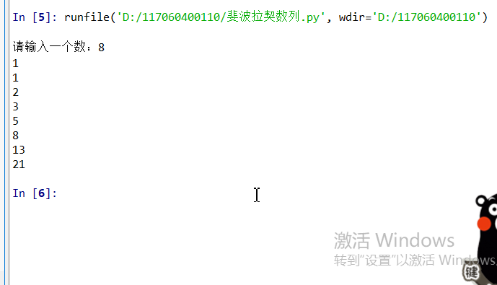

写代码过程出现的错误：

错误代码：

def fib(n):

if n < 0:

print("Error")

elif n == 0:

return 0

elif n == 1:

return 1

else:

return fib(n-1) + fib(n-2)

n = int(input("请输入一个数："))

for i in range(1,n+1):

print(fib(n))

错误结果：

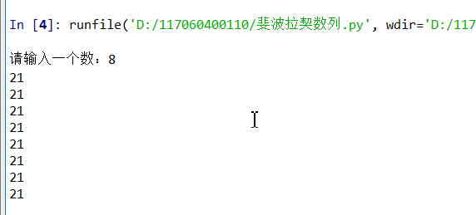

**程序练习5-7**

**汉诺塔**

一次只能移动一个盘子、盘子只能在三个标杆之间移动、更大的盘中不能放在放在更小的盘子上面。

**核心代码：**

def hanoli(a,b,c,n):

if n == 1:

print(a + "-->" + b)

else:

hanoli(a,b,c,n-1)

hanoli(a,c,b,1)

hanoli(b,a,c,n-1)

hanoli("a","b","c",n)

**实验结果：**

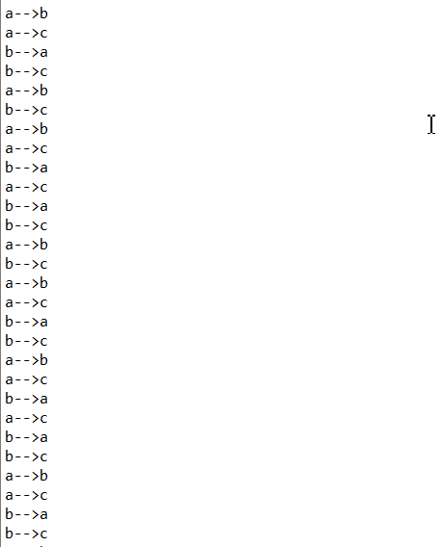

**七段数码管**

1. **绘制七段数码管（每个字不同颜色）**

**核心代码：**

import turtle,datetime

strcol = ['red','blue','yellow','gold','violet','purple','green','darkgreen','grey','orange']

def drawGap():

turtle.penup()

turtle.fd(5)

def drawLine(draw):

drawGap()

turtle.pendown() if draw else turtle.penup()

turtle.fd(40)

drawGap()

turtle.right(90)

def drawDigit(d):

turtle.pencolor(strcol[d])

drawLine(True) if d in [2,3,4,5,6,8,9] else drawLine(False)

drawLine(True) if d in [0,1,3,4,5,6,7,8,9] else drawLine(False)

drawLine(True) if d in [0,2,3,5,6,8,9] else drawLine(False)

drawLine(True) if d in [0,2,6,8] else drawLine(False)

turtle.left(90)

drawLine(True) if d in [0,4,5,6,8,9] else drawLine(False)

drawLine(True) if d in [0,2,3,5,6,7,8,9] else drawLine(False)

drawLine(True) if d in [0,1,2,3,4,7,8,9] else drawLine(False)

turtle.left(180)

turtle.penup()

turtle.fd(20)

def drawDate(date):

turtle.pencolor("red")

for i in date:

if i == '-':

turtle.write('年',font=("Arial",18,"normal"))

turtle.pencolor("green")

turtle.fd(40)

elif i == '=':

turtle.write('月',font=("Arial",18,"normal"))

turtle.pencolor("blue")

turtle.fd(40)

elif i == '+':

turtle.write('日',font=("Arial",18,"normal"))

else:

drawDigit(eval(i))

def main():

turtle.setup(800,350,200,200)

turtle.penup()

turtle.fd(-350)

turtle.pensize(5)

drawDate(datetime.datetime.now().strftime('%Y-%m=%d+'))

turtle.hideturtle()

main()

**实验结果：**

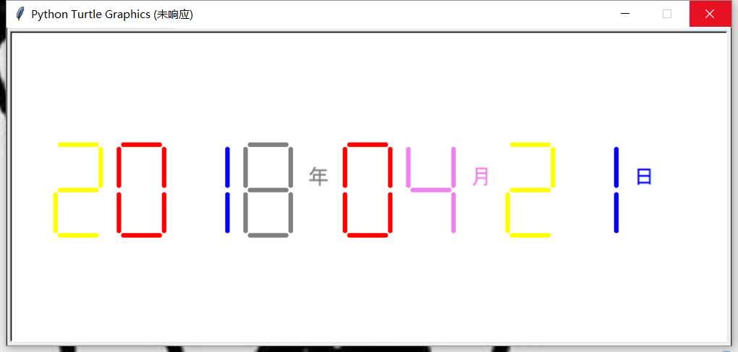

1. **绘制每单段数码管的不同颜色**

**核心代码：**

import turtle,datetime

def drawGap():

turtle.penup()

turtle.fd(5)

def drawLine(draw):

drawGap()

turtle.pendown() if draw else turtle.penup()

turtle.fd(40)

drawGap()

turtle.right(90)

def drawDigit(d):

drawLine(True) if d in [2,3,4,5,6,8,9] else drawLine(False)

turtle.pencolor("red")

drawLine(True) if d in [0,1,3,4,5,6,7,8,9] else drawLine(False)

turtle.pencolor("orange")

drawLine(True) if d in [0,2,3,5,6,8,9] else drawLine(False)

turtle.pencolor("purple")

drawLine(True) if d in [0,2,6,8] else drawLine(False)

turtle.pencolor("blue")

turtle.left(90)

drawLine(True) if d in [0,4,5,6,8,9] else drawLine(False)

turtle.pencolor("yellow")

drawLine(True) if d in [0,2,3,5,6,7,8,9] else drawLine(False)

turtle.pencolor("green")

drawLine(True) if d in [0,1,2,3,4,7,8,9] else drawLine(False)

turtle.pencolor("pink")

turtle.left(180)

turtle.penup()

turtle.fd(20)

def drawDate(date):

turtle.pencolor("red")

for i in date:

if i == '-':

turtle.write('年',font=("Arial",18,"normal"))

turtle.pencolor("green")

turtle.fd(40)

elif i == '=':

turtle.write('月',font=("Arial",18,"normal"))

turtle.pencolor("blue")

turtle.fd(40)

elif i == '+':

turtle.write('日',font=("Arial",18,"normal"))

else:

drawDigit(eval(i))

def main():

turtle.setup(800,350,200,200)

turtle.penup()

turtle.fd(-350)

turtle.pensize(5)

drawDate(datetime.datetime.now().strftime('%Y-%m=%d+'))

turtle.hideturtle()

main()

或

import turtle,datetime

strcol = ['red','blue','yellow','pink','orange','purple','green']

def drawGap():

turtle.penup()

turtle.fd(5)

def drawLine(draw):

drawGap()

turtle.pendown() if draw else turtle.penup()

turtle.fd(40)

drawGap()

turtle.right(90)

def drawDigit(d):

drawLine(True) if d in [2,3,4,5,6,8,9] else drawLine(False)

turtle.pencolor(strcol[0])

drawLine(True) if d in [0,1,3,4,5,6,7,8,9] else drawLine(False)

turtle.pencolor(strcol[1])

drawLine(True) if d in [0,2,3,5,6,8,9] else drawLine(False)

turtle.pencolor(strcol[2])

drawLine(True) if d in [0,2,6,8] else drawLine(False)

turtle.pencolor(strcol[3])

turtle.left(90)

drawLine(True) if d in [0,4,5,6,8,9] else drawLine(False)

turtle.pencolor(strcol[4])

drawLine(True) if d in [0,2,3,5,6,7,8,9] else drawLine(False)

turtle.pencolor(strcol[5])

drawLine(True) if d in [0,1,2,3,4,7,8,9] else drawLine(False)

turtle.pencolor(strcol[6])

turtle.left(180)

turtle.penup()

turtle.fd(20)

def drawDate(date):

turtle.pencolor("red")

for i in date:

if i == '-':

turtle.write('年',font=("Arial",18,"normal"))

turtle.pencolor("green")

turtle.fd(40)

elif i == '=':

turtle.write('月',font=("Arial",18,"normal"))

turtle.pencolor("blue")

turtle.fd(40)

elif i == '+':

turtle.write('日',font=("Arial",18,"normal"))

else:

drawDigit(eval(i))

def main():

turtle.setup(800,350,200,200)

turtle.penup()

turtle.fd(-350)

turtle.pensize(5)

drawDate(datetime.datetime.now().strftime('%Y-%m=%d+'))

turtle.hideturtle()

main()

**实验结果：**

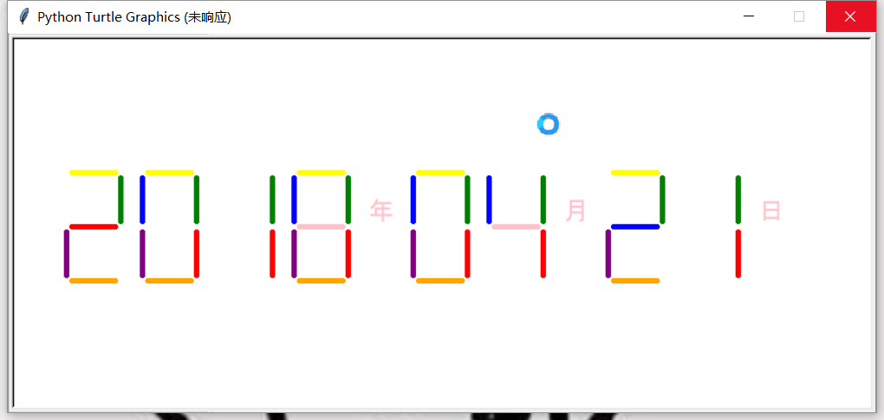

1. **绘制每单段数码管随机颜色**

**核心代码：**

**import turtle,datetime,random**

**def drawGap():**

**turtle.penup()**

**turtle.fd(5)**

**def drawLine(draw):**

**drawGap()**

**r = random.randint(0,255)**

**g = random.randint(0,255)**

**b = random.randint(0,255)**

**turtle.pencolor((r,g,b))**

**turtle.pendown() if draw else turtle.penup()**

**turtle.fd(40)**

**drawGap()**

**turtle.right(90)**

**def drawDigit(d):**

**drawLine(True) if d in [2,3,4,5,6,8,9] else drawLine(False)**

**drawLine(True) if d in [0,1,3,4,5,6,7,8,9] else drawLine(False)**

**drawLine(True) if d in [0,2,3,5,6,8,9] else drawLine(False)**

**drawLine(True) if d in [0,2,6,8] else drawLine(False)**

**turtle.left(90)**

**drawLine(True) if d in [0,4,5,6,8,9] else drawLine(False)**

**drawLine(True) if d in [0,2,3,5,6,7,8,9] else drawLine(False)**

**drawLine(True) if d in [0,1,2,3,4,7,8,9] else drawLine(False)**

**turtle.left(180)**

**turtle.penup()**

**turtle.fd(20)**

**def drawDate(date):**

**turtle.pencolor("red")**

**for i in date:**

**if i == '-':**

**turtle.write('年',font=("Arial",18,"normal"))**

**turtle.pencolor("green")**

**turtle.fd(40)**

**elif i == '=':**

**turtle.write('月',font=("Arial",18,"normal"))**

**turtle.pencolor("blue")**

**turtle.fd(40)**

**elif i == '+':**

**turtle.write('日',font=("Arial",18,"normal"))**

**else:**

**drawDigit(eval(i))**

**def main():**

**turtle.setup(800,350,200,200)**

**turtle.colormode(255)**

**turtle.penup()**

**turtle.fd(-350)**

**turtle.pensize(5)**

**drawDate(datetime.datetime.now().strftime('%Y-%m=%d+'))**

**turtle.hideturtle()**

**main()**

**实验结果：**

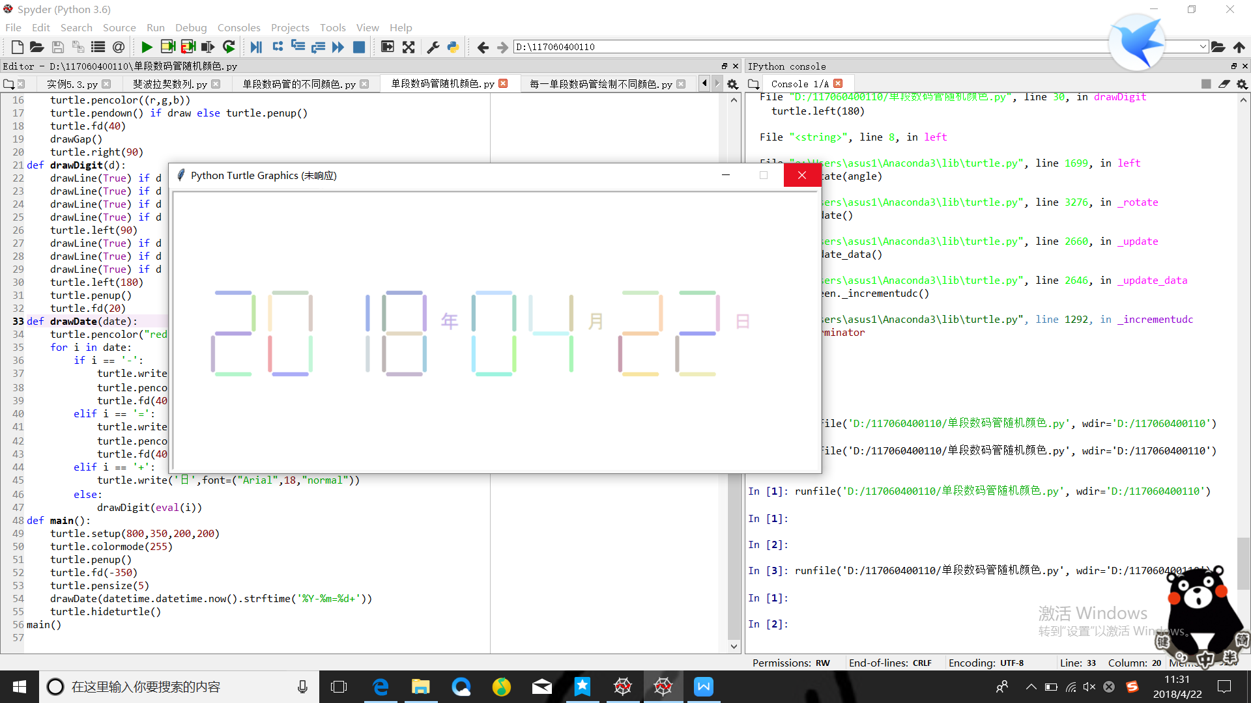

**实验总结：**

1. 通过此次的练习，我理解了什么是递归函数，而且掌握了如何使用递归函数去练习题目
2. 了解了什么是datetime库，并且绘制了属于自己的七段数码管时钟
3. 但是对于用递归函数去解决汉诺塔问题还是有一定难度的