第十五周Python实验报告（周五）

**学号**：117060400110 **姓名**：蒙柳双

**班级**：17应用统计学1班 **指导老师**：林卫中

**实验目的：**

1. 通过综合练习来提高自己的读写代码的能力
2. 通过爬取自己朋友圈的资料，了解自己的微信的好友的男女比例，微信好友所在的省份情况，同时了解个性签名的情况
3. 通过爬取朋友圈，爬取一些自己感兴趣的，提高兴趣去学习代码
4. 在此之前要了解词云，并且还会知道在，安装

**实验要求：**

1. 上课不玩手机
2. 要认真编码并且思考

3.实在不会的就向老师求助

**实验内容步骤：**

**1登陆朋友圈**

**核心代码：**

import itchat

**#登录朋友圈**

def login():

itchat.login()

friends=itchat.get_friends(update=True)[0:]

return friends

friends = login()

**实验结果：**

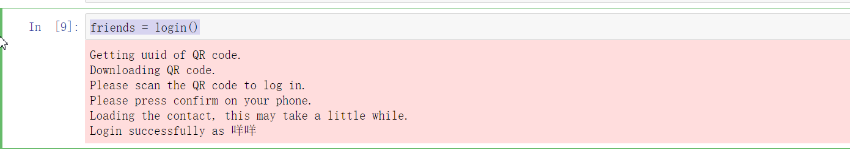

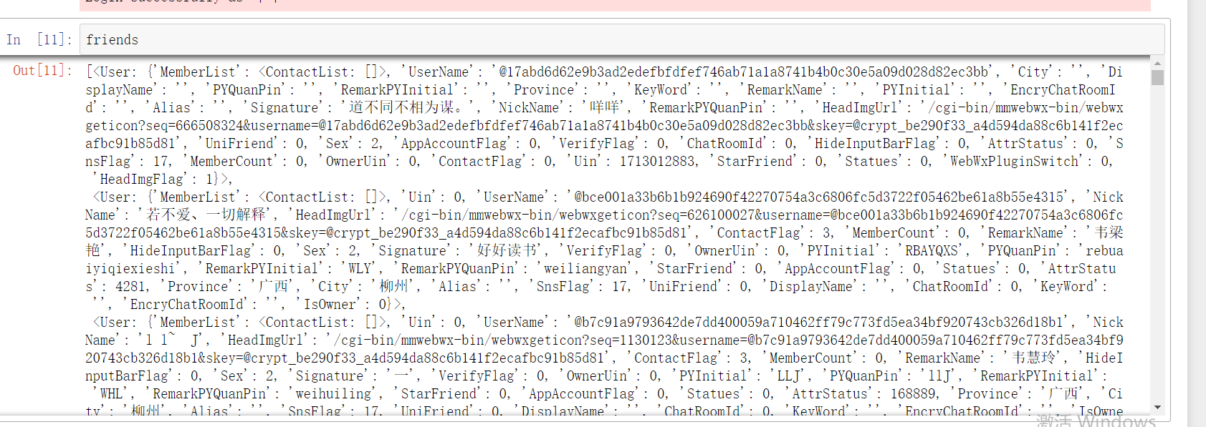

**2.获取朋友圈信息**

**核心代码:**

**#获取朋友圈数据**

def get_var(var, friends):

variable = []

for i in friends:

value = i[var]

variable.append(value)

return variable

1. **分析朋友圈的性别比例**

**核心代码：**

**#朋友圈性别比例**

import itchat

import numpy as np

import matplotlib.pyplot as plt

import matplotlib as mpl

import re

import jieba

import PIL.Image as Image

def analyseGender(friends):

male=female=other=0

sexes = get_var('Sex', friends)

for sex in sexes:

if sex == 1:

male += 1

elif sex == 2:

female += 1

else:

other += 1

total = len(friends[1:])

malecol = round( float(male)/total * 100, 2)

femalecol = round( float(female)/total * 100, 2)

othercol = round( float(other)/total * 100, 2)

print('男性好友：{:.2f}%%'.format( malecol))

print('女性好友：{:.2f}%%'.format( femalecol))

print('不明性别好友：{:.2f}%%'.format( othercol))

#plot code

mpl.rcParams['font.sans-serif']=['SimHei']

mpl.rcParams['axes.unicode_minus'] = False

map = {

'Male':(malecol, '#7199cf'),

'Female': (femalecol, '#4fc4aa'),

'other': (othercol, '#e1a7a2')

}

fig = plt.figure( figsize=(5,5))

ax = fig.add_subplot(111)

ax.set_title( '朋友圈性别')

xticks = np.arange(3) + 0.15

bar_width = 0.5

names = map.keys()

values = [ x[0] for x in map.values()]

colors = [ x[1] for x in map.values()]

#柱状图

bars = ax.bar( xticks, values, width=bar_width, edgecolor='none')

ax.set_ylabel('比例')

ax.set_xlabel('性别')

ax.grid()

ax.set_xticks( xticks)

ax.set_xticklabels( names)

ax.set_xlim( [bar_width/2 - 0.5, 3 - bar_width/2])

ax.set_ylim( [0, 100])

for bar, color in zip( bars, colors):

bar.set_color( color)

height = bar.get_height()

plt.text( bar.get_x(), bar.get_height()/4.+ height, '{:.2f}%'.format( float(height)))

plt.show()

#饼状图

fig1 = plt.figure( figsize=(5,5))

ax = fig1.add_subplot(111)

ax.set_title('饼图')

labels = ['{}\n{}%'.format(name, value) for name, value in zip( names, values)]

ax.pie(values, labels=labels, colors=colors)

plt.show()

analyseGender(friends)

**实验结果：**

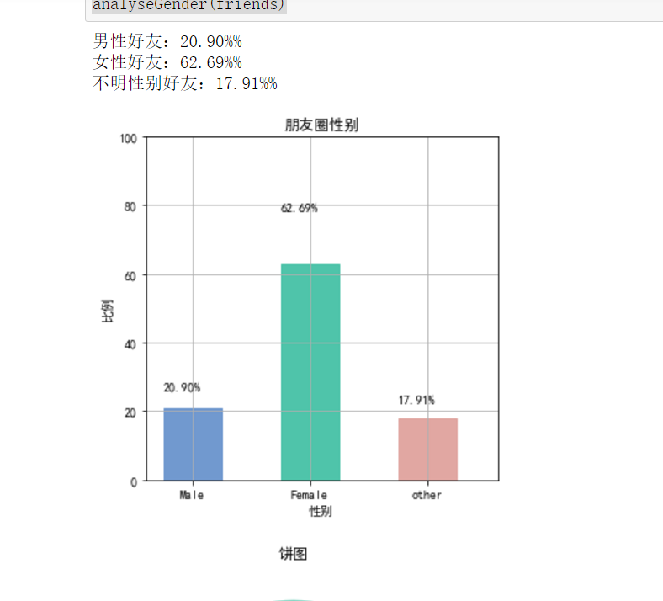

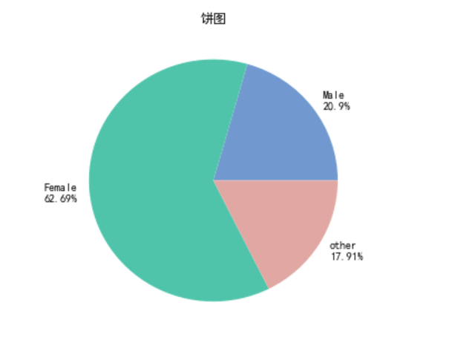

1. **分析朋友圈的朋友所在的省市**

**核心代码：**

import itchat

import numpy as np

import matplotlib.pyplot as plt

import matplotlib as mpl

import re

import jieba

import PIL.Image as Image

def analyseProvince(friends):

provlist = get_var('Province', friends)

provdict = {}

for p in provlist:

provdict[p] = provdict.get(p,0) + 1

provdict = sorted(provdict.items(), key= lambda x : x[1], reverse=True)

#画图

figpro = plt.figure(figsize=(10,5))

axpro = figpro.add_subplot(111)

axpro.set_title('省份')

xticks = np.linspace(0.5,20,10)

bar_width = 0.8

pros= []

values = []

count = 0

for d in provdict:

pros.append(d[0])

values.append(d[1])

count += 1

if count >= 10:

break

colors = ['#FFEC88', '#FFE4C4','#FFC125','#FFB6C1','#CDCDB4','#CDC8B1','#CDB79E','#CDAD00','#CD96CD',\

'#CD853F']

bars = axpro.bar( xticks, values, width=bar_width, edgecolor='none')

axpro.set_ylabel('人数')

axpro.set_xlabel('省份')

axpro.grid()

axpro.set_xticks( xticks)

axpro.set_xticklabels(pros)

axpro.set_xlim(0,20)

axpro.set_ylim([0,100])

for bar, color in zip( bars, colors):

bar.set_color(color)

height = bar.get_height()

plt.text( bar.get_x()+bar.get_width()/4., height, '{}'.format(height))

plt.show()

analyseProvince(friends)

**实验结果：**

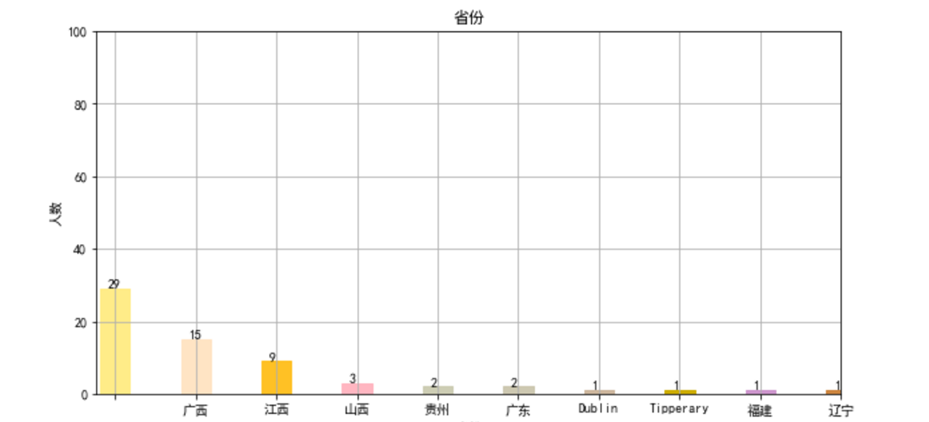

1. **分析朋友所在的省市**

**核心代码：**

import itchat

import numpy as np

import matplotlib.pyplot as plt

import matplotlib as mpl

import re

import jieba

import PIL.Image as Image

from wordcloud import WordCloud, ImageColorGenerator

def drawWordcloudPlot(counts):

coloring = np.array(Image.open("D:/alice_color.png"))

wc = WordCloud(background_color="white",

max_words=2000,

mask=coloring,

max_font_size=500,

random_state=42,

scale=2,

font_path="c:/Windows/Fonts/SimHei.ttf")

wc.generate_from_frequencies(counts)

image_colors = ImageColorGenerator(coloring)

plt.imshow(wc)

plt.axis("off")

plt.savefig('friendSign.jpg')

plt.show()

def analyseSignature(friends):

signatures = get_var('Signature', friends)

siglist = []

for sign in signatures:

sign = sign.strip().replace("span", "").replace("class", "").replace("emoji", "")

rep = re.compile("lf\d+\w*|[<>/=]")

sign = rep.sub("", sign)

siglist.append(sign)

text = "".join(siglist)

wlist = jieba.cut(text, cut_all=True)

counts = {}

for word in wlist:

if len(word) == 1:

continue

else:

counts[word] = counts.get(word, 0) + 1

wdict = {}

i = 0

for d in counts.items():

if d[1] > 0:

wdict[d[0]] = d[1]

drawWordcloudPlot(wdict)

analyseSignature(friends)

**实验结果：**

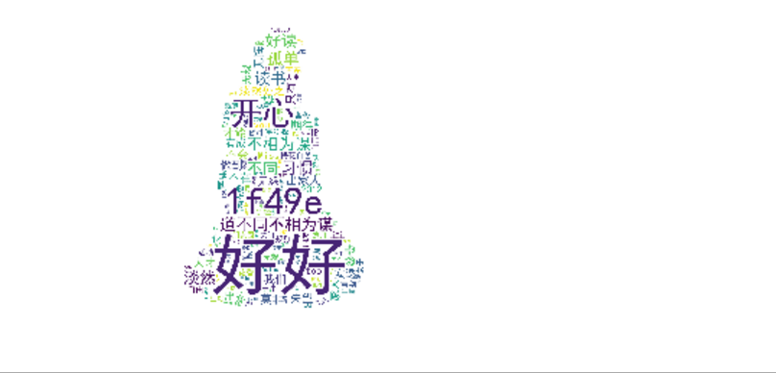

1. **整个爬取微信朋友圈的代码：**

**核心代码：**

import itchat

import numpy as np

import matplotlib.pyplot as plt

import matplotlib as mpl

import re

import jieba

import PIL.Image as Image

from wordcloud import WordCloud, ImageColorGenerator

#登录朋友圈

def login():

itchat.login()

friends=itchat.get_friends(update=True)[0:]

return friends

#获取朋友圈数据

def get_var(var, friends):

variable = []

for i in friends:

value = i[var]

variable.append(value)

return variable

#朋友圈性别比例

def analyseGender(friends):

male=female=other=0

sexes = get_var('Sex', friends)

for sex in sexes:

if sex == 1:

male += 1

elif sex == 2:

female += 1

else:

other += 1

total = len(friends[1:])

malecol = round( float(male)/total * 100, 2)

femalecol = round( float(female)/total * 100, 2)

othercol = round( float(other)/total * 100, 2)

print('男性好友：{:.2f}%%'.format( malecol))

print('女性好友：{:.2f}%%'.format( femalecol))

print('不明性别好友：{:.2f}%%'.format( othercol))

#plot code

mpl.rcParams['font.sans-serif']=['SimHei']

mpl.rcParams['axes.unicode_minus'] = False

map = {

'Female':(malecol, '#7199cf'),

'Male': (femalecol, '#4fc4aa'),

'other': (othercol, '#e1a7a2')

}

fig = plt.figure( figsize=(5,5))

ax = fig.add_subplot(111)

ax.set_title( '朋友圈性别')

xticks = np.arange(3) + 0.15

bar_width = 0.5

names = map.keys()

values = [ x[0] for x in map.values()]

colors = [ x[1] for x in map.values()]

#柱状图

bars = ax.bar( xticks, values, width=bar_width, edgecolor='none')

ax.set_ylabel('比例')

ax.set_xlabel('性别')

ax.grid()

ax.set_xticks( xticks)

ax.set_xticklabels( names)

ax.set_xlim( [bar_width/2 - 0.5, 3 - bar_width/2])

ax.set_ylim( [0, 100])

for bar, color in zip( bars, colors):

bar.set_color( color)

height = bar.get_height()

plt.text( bar.get_x(), bar.get_height()/4.+ height, '{:.2f}%'.format( float(height)))

plt.show()

#饼状图

fig1 = plt.figure( figsize=(5,5))

ax = fig1.add_subplot(111)

ax.set_title('饼图')

labels = ['{}\n{}%'.format(name, value) for name, value in zip( names, values)]

ax.pie(values, labels=labels, colors=colors)

plt.show()

def analyseProvince(friends):

provlist = get_var('Province', friends)

provdict = {}

for p in provlist:

provdict[p] = provdict.get(p,0) + 1

provdict = sorted(provdict.items(), key= lambda x : x[1], reverse=True)

#画图

figpro = plt.figure(figsize=(10,5))

axpro = figpro.add_subplot(111)

axpro.set_title('省份')

xticks = np.linspace(0.5,20,10)

bar_width = 0.8

pros= []

values = []

count = 0

for d in provdict:

pros.append(d[0])

values.append(d[1])

count += 1

if count >= 10:

break

colors = ['#FFEC88', '#FFE4C4','#FFC125','#FFB6C1','#CDCDB4','#CDC8B1','#CDB79E','#CDAD00','#CD96CD',\

'#CD853F']

bars = axpro.bar( xticks, values, width=bar_width, edgecolor='none')

axpro.set_ylabel('人数')

axpro.set_xlabel('省份')

axpro.grid()

axpro.set_xticks( xticks)

axpro.set_xticklabels(pros)

axpro.set_xlim(0,20)

axpro.set_ylim([0,100])

for bar, color in zip( bars, colors):

bar.set_color(color)

height = bar.get_height()

plt.text( bar.get_x()+bar.get_width()/4., height, '{}'.format(height))

plt.show()

def drawWordcloudPlot(counts):

coloring = np.array(Image.open("E:/baidupic/alice_color.png"))

wc = WordCloud(background_color="white",

max_words=2000,

mask=coloring,

max_font_size=500,

random_state=42,

scale=2,

font_path="c:/Windows/Fonts/SimHei.ttf")

wc.generate_from_frequencies(counts)

image_colors = ImageColorGenerator(coloring)

plt.imshow(wc)

plt.axis("off")

plt.savefig('friendSign.jpg')

plt.show()

def analyseSignature(friends):

signatures = get_var('Signature', friends)

siglist = []

for sign in signatures:

sign = sign.strip().replace("span", "").replace("class", "").replace("emoji", "")

rep = re.compile("lf\d+\w*|[<>/=]")

sign = rep.sub("", sign)

siglist.append(sign)

text = "".join(siglist)

wlist = jieba.cut(text, cut_all=True)

counts = {}

for word in wlist:

if len(word) == 1:

continue

else:

counts[word] = counts.get(word, 0) + 1

wdict = {}

i = 0

for d in counts.items():

if d[1] > 0:

wdict[d[0]] = d[1]

drawWordcloudPlot(wdict)

friends = login()

analyseGender(friends)

analyseProvince(friends)

analyseSignature(friends)

实验总结：

1. 爬取朋友圈的目的并不主要在想要了解自己的朋友圈，而是这个学习的过程
2. 爬取朋友圈是一个综合性比较强的内容，对于自己以前所学的内容都有使用到，所以最重要的是将整个代码读懂
3. 通过这实验也了解到词云是什么，是干什么用的。