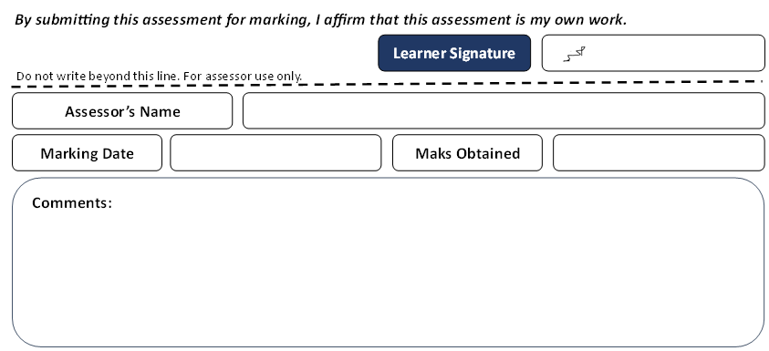

IT7001 Group Project

Maram Shubbar 202305590, Fatema Maitham 202304661, Husain Abbas 202201389,
Hasan Ayoob 202300024, and Haider Albari 202204369
Department of ICT, Bahrain Polytechnic University
IT7001: System Analysis and Design
Dr. Karim Mohammed
19 December 2024

Contents
1 Request for Systems Services 4
2 MS Project file 5
3 Ishikawa Diagram 8
4 List of functional and non-functional requirements 9
5 Actor Glossary+ Use Case Glossary 14
6 Analysis Use Case Model Diagram for whole system 22
7 Analysis Use Case narrative for “Request Donation” 23
8 Analysis Use Case narrative for “Request Volunteers” 25
9 Analysis Use Case narrative for “Create New Project” 27
10 Analysis Use Case narrative for “Task Assignment for Volunteers” 29
11 Analysis Use Case narrative for “Registration/Sign-up” 31
12 Activity Diagram for “Project Execution Narrative” 33
13 Cost/Benefit Analysis 34
14 Sequence Diagram for “Project Execution Narrative” 36
15 User Interface Design for covering use cases 37
16 Interview Form 50
17 Log Files 52
18 Individual Report 62
18.1 Maram Shubbar_202305590 62
18.2 Fatema Maitham_202304661 64
18.3 Hussain Abbas_202201389 66
18.4 Hasan Ayoob_202300024 67
18.5 Haider Albari_202204396 69
19 References 71

Request for Systems Services
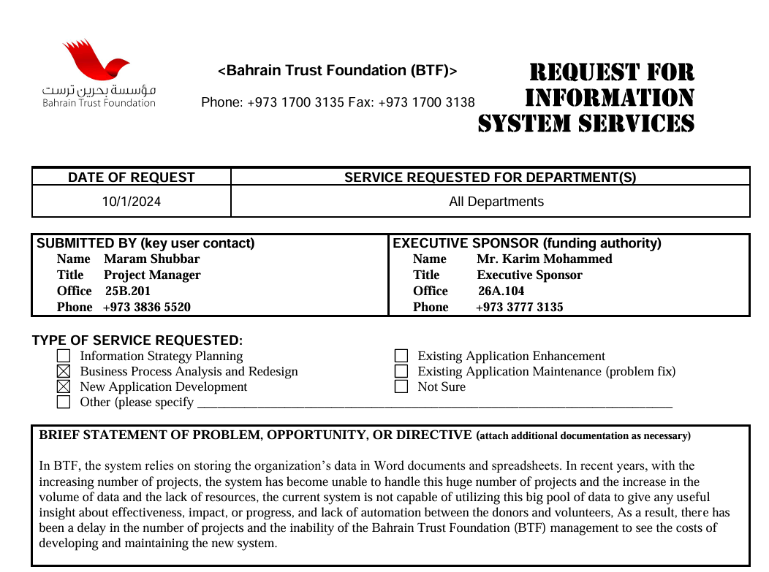
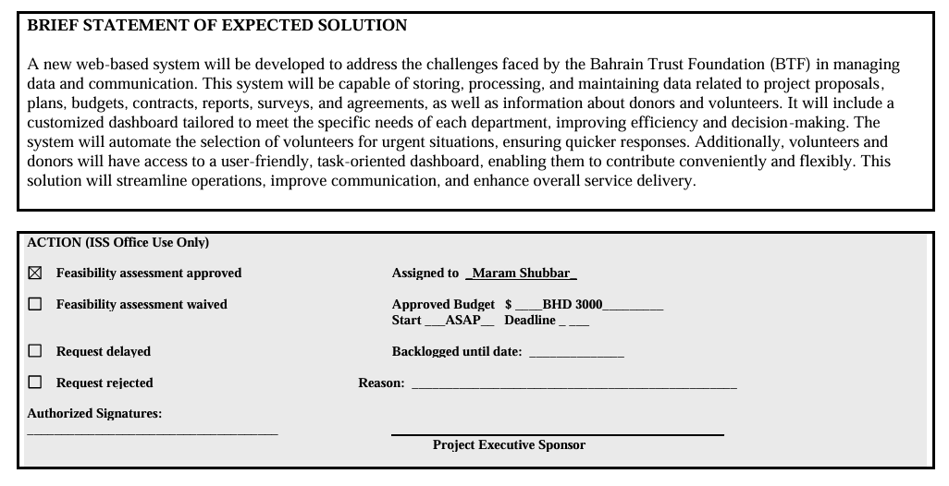

MS Project file
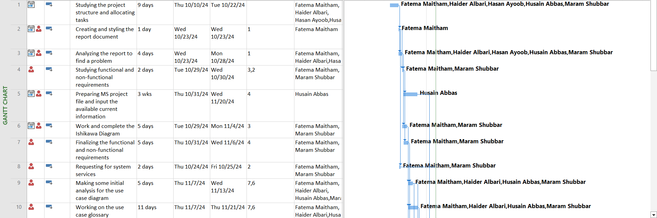
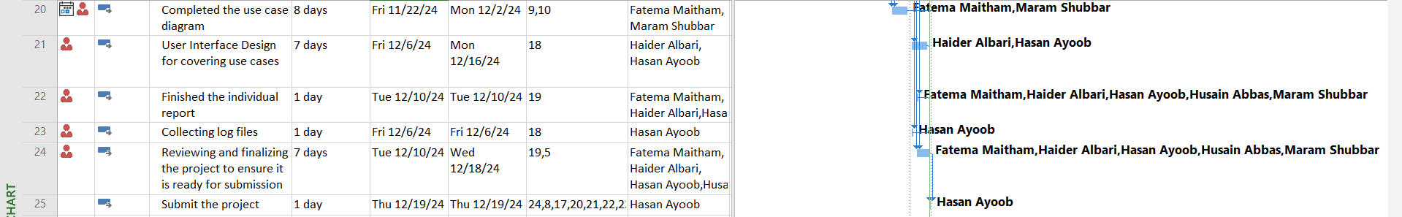
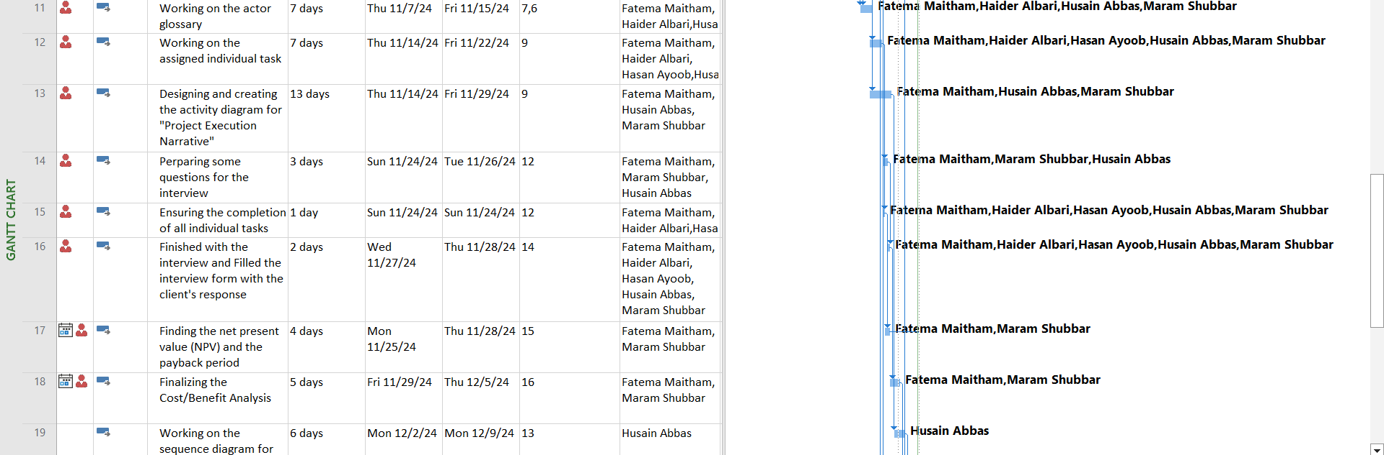

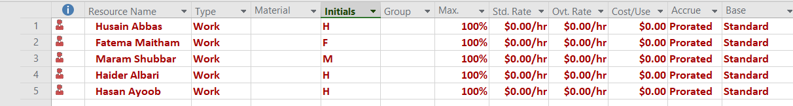
Resources Sheet

Ishikawa Diagram

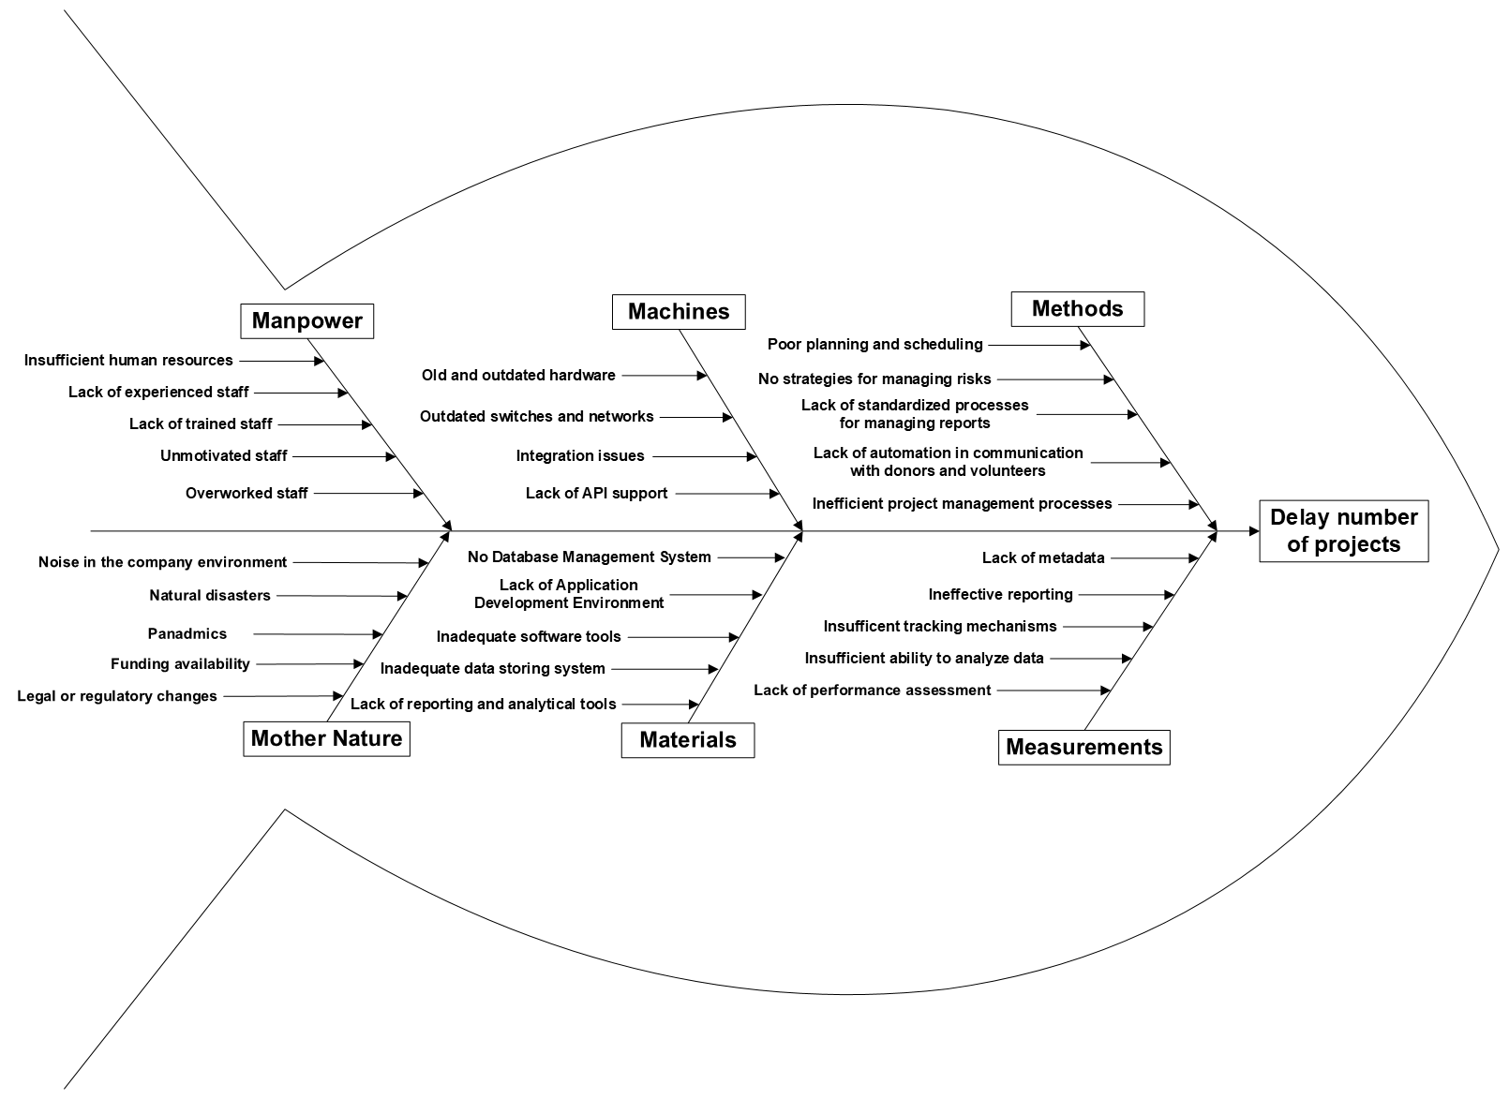

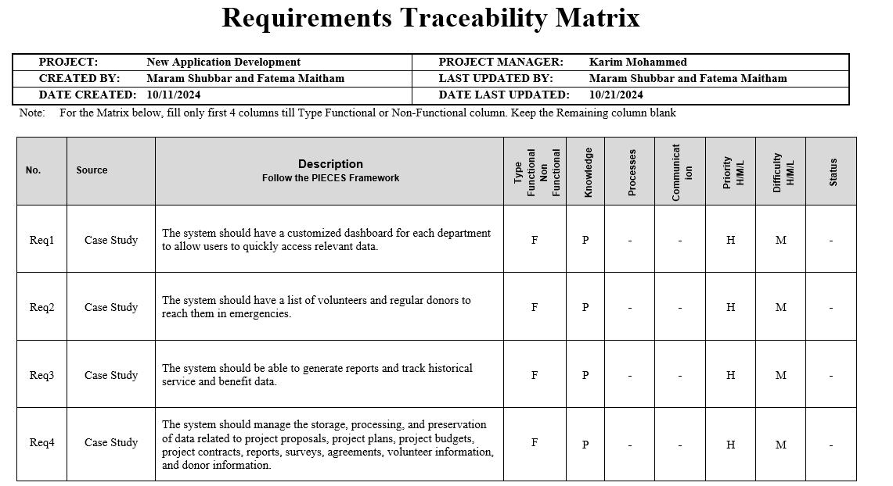
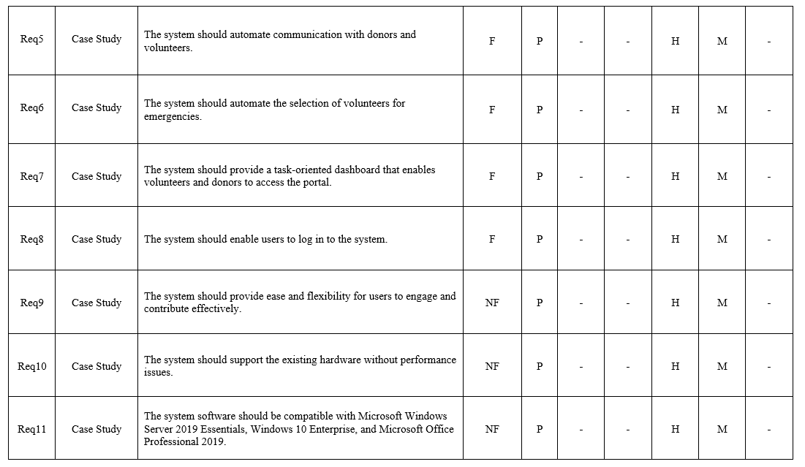
List of functional and non-functional requirements
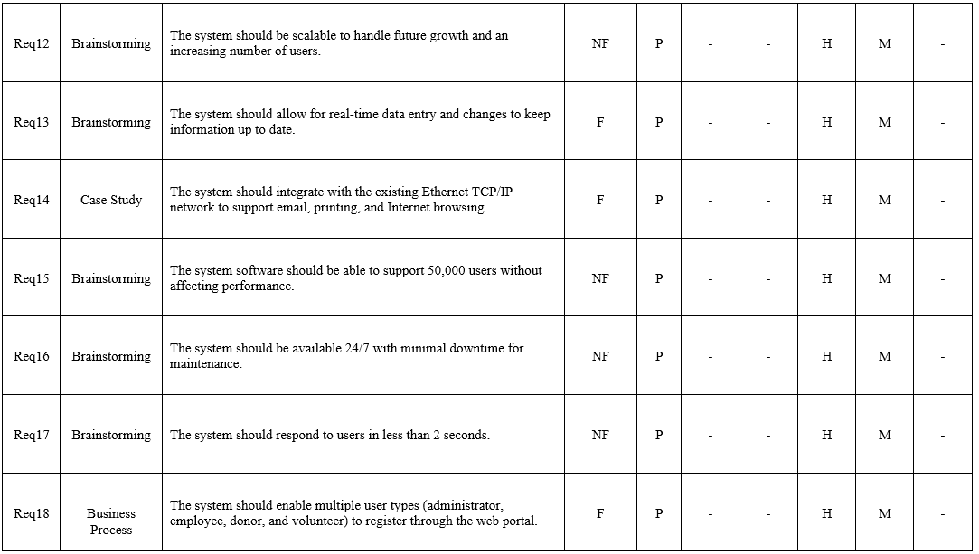
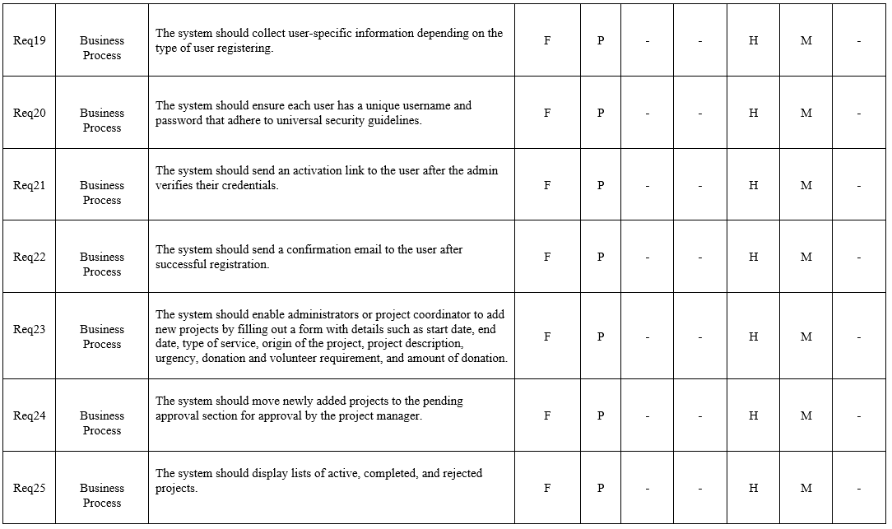
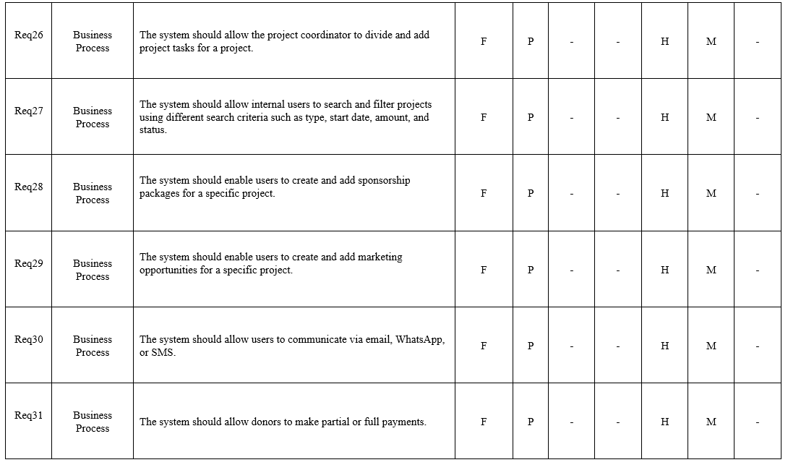
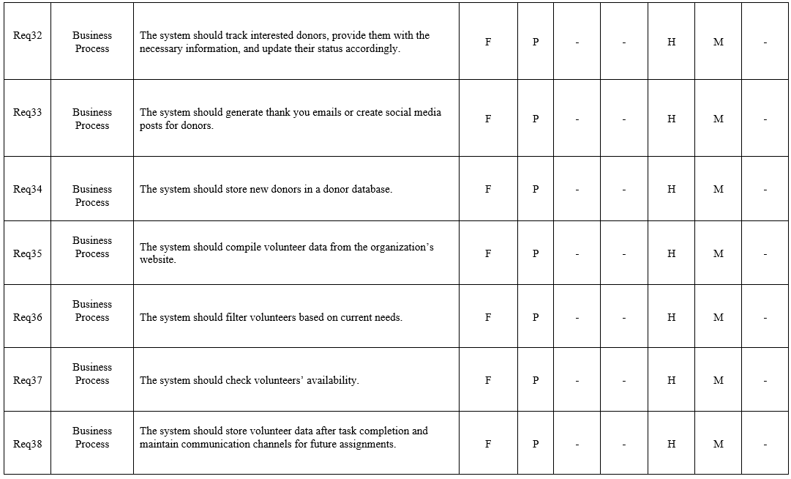
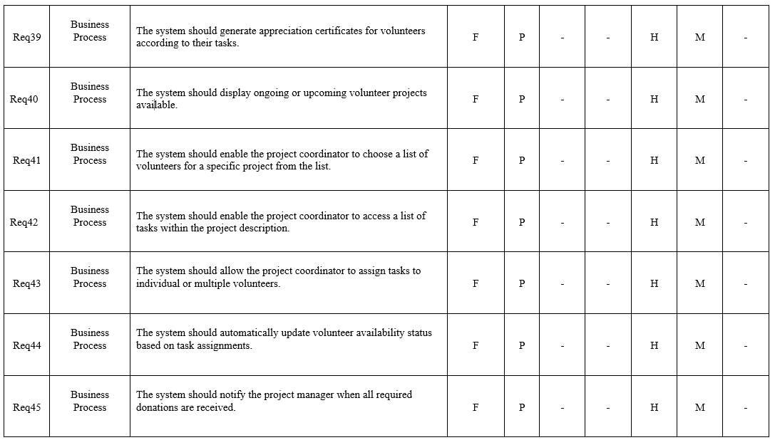
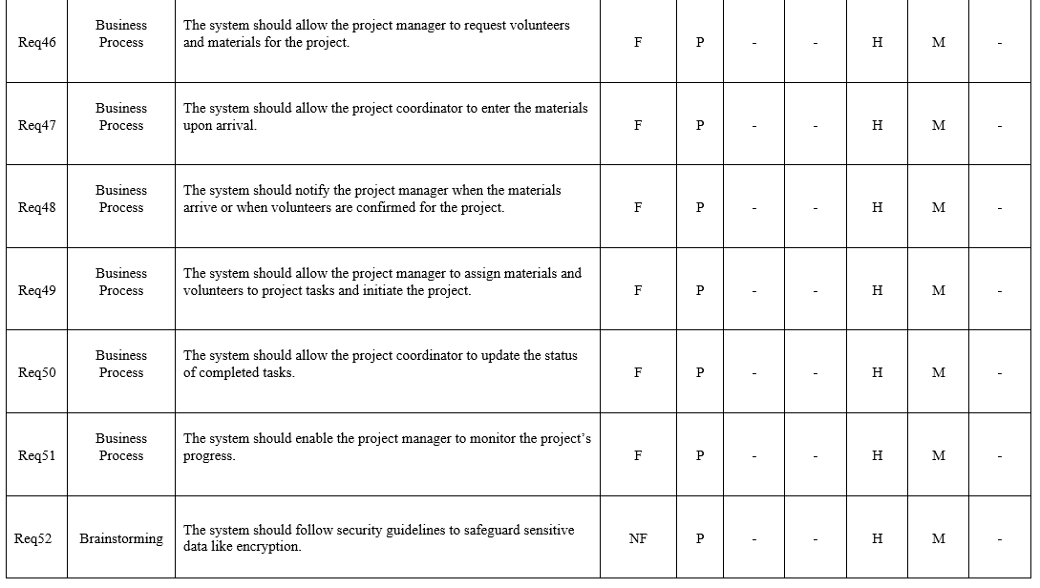
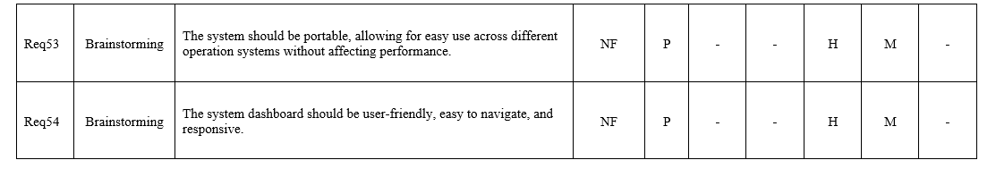

Actor Glossary+ Use Case Glossary

Use-Case Glossary
Use-Case Name | Use-Case Description | Participating  Actors and Roles
Register Users | This use case describes the event of enabling all types of users to register through the web portal. | User
View Account Details | This use case describes the event of the user viewing their account details, including personal information, preferences, and settings. | User
Verify User Credentials and Send Activation Link | This use case describes the event of verifying users’ credentials and sending an activation link. | User  Project Manager
Validate User Input | This use case describes the event of validating user input during account creation or password change. | User  Project Manager
Send Confirmation Email | This use case describes the event of sending a confirmation email after a successful registration process. | Project Manager
Login Users | The use case describes the event of logging users to the system. | User
Forget Password | The use case describes the event of a user forgetting their login credentials. | User
Provide Customized Dashboard | This use case describes the event of providing a customized dashboard for different users to display both current and urgent projects, along with a suggestive list of potential donors and volunteers. | User  Project Manager
Provide Task-Oriented Dashboard | This use case describes the event of providing donors and volunteers with task-oriented dashboards that allow them to access, engage with available tasks and opportunities, and contribute to their time at their pace. | Donor  Volunteer  Project Manager
Manage Projects | This use case describes the event of allowing authorized users to manage the entire lifecycle of projects, including creation, task assignment, progress tracking, and completion, ensuring proper project management, from creation to completion. | Project Manager
Add New Project | This use case describes the event of adding a new project by filling in a form with details such as project start date, type of service, origin of the project, project description, start and end dates, urgency, donation required, volunteer required, and amount of donation. | Project Manager  Project Coordinator
Approve New Project | This use case describes the event of approving the newly added projects in the pending approval list after conducting the necessary verification. | Project Manager
List Projects | This use case describes the event of listing active, completed, or rejected projects. | Project Manager  Project Coordinator
 | This use case describes the event of adding and dividing project tasks to the system for the project. | Project Coordinator  Project Manager
  Add and Divide Project Task
Search and Filter Project | This use case describes the event of searching and filtering projects by various criteria such as type, start date, amount, status, etc. | Project Manager  Project Coordinator
Automate Communication with Donors | The use case describes the event of automating communication with donors by sending project updates, payment confirmations, and fundraising requests through email or SMS. | Project Manager
Prepare Donors List | This use case describes the event of preparing a target list of donors. | Donor  Project Manager
Create and Add Sponsorship Packages | This use case describes the event of the project coordinator or project administrator creating and adding a sponsorship package to a specific project. | Project Manager  Project Coordinator
Create and Add Marketing Opportunities | This use case describes the event of creating or adding a marketing opportunity to a specific project. | Project Manager  Project Coordinator
Communicate with Donors | The use case describes the event of communication with potential donors through email, WhatsApp, and SMS to request donations. | Project Manager  Donor
Make Payments | The use case describes the event of making partial or full payments by donors. | Donor
Follow-up with Donors | The use case describes the event of following up with interested donors, providing them with the necessary information, and updating their status accordingly. | Donor  Financial Accountant
Send Thank You Emails or Posts | This use case describes the event of sending thank you emails or creating social media posts for donors. | Media Team
Store Donors Data | This use case describes the event of storing new donor data in the donors' database. | Administrative officer
Automate Communication with Volunteers | The use case describes the event of automating communication with volunteers by sending reminders, updates, and task assignments using email and SMS to engage and contribute effectively. | Project Coordinator
Gather Volunteer Data | This use case describes the event of gathering volunteer data from the website. | Project Coordinator  Volunteer
Filter Volunteers | This use case describes the event of filtering volunteers based on current project requirements. | Project Coordinator  Volunteer
Check Volunteer Availability | This use case describes the event of checking the availability of volunteers for new tasks or projects. | Project Coordinator
Communicate with Volunteers | This use case describes the event of calling volunteers to confirm their availability. | Project Coordinator  Volunteer
Store Volunteers Data | This use case describes the event of storing volunteers' data after completing tasks and maintaining communication channels for future assignments. | Project Coordinator
Send Appreciation Certificates | This use case describes the event of sending appreciation certificates to volunteers according to their tasks. | Project Coordinator
Assign Tasks to Volunteers | This use case describes the event of assigning tasks to individual or multiple volunteers. | Project Coordinator
Display Available Volunteer Projects | This use case describes the event of displaying available ongoing or upcoming volunteer projects. | Project Coordinator
Select Volunteers | This use case describes the event of selecting volunteers for a specific project from the volunteers' list. | Project Coordinator
Update Volunteer Availability Status | This use case describes the event of updating the availability of volunteers. | Project Coordinator
Execute Projects | This use case describes the event of executing a project once it has received all necessary donations. | Project Manager
Send Notifications to Project Administrator | This use case describes the event of sending notifications to the project manager when all donations are received or volunteers are found. | Project Manager
Manage Volunteers | This use case describes the event of managing volunteers for projects. | Project Manager
Request Volunteers | This use case describes the event of requesting volunteers needed for the project. | Project Manager  Administrative officer
Assign Volunteers | This use case describes the event of the project administrator assigning volunteers to specific project tasks. | Project Manager
Manage Materials | This use case describes the event of managing materials for projects. | Project Manager
Order Materials | This use case describes the event of ordering materials for projects and notifying administrators when there are delays or issues. | Project Manager
Notify About Material Arrival | This use case describes the event of notifying the project administrator when materials arrive. | Project Manager
Enter materials | This use describes the event of the project coordinator entering the materials into the system. | Project Coordinator
Assign Materials | This use case describes the event of the project administrator assigning materials to specific project tasks. | Project Manager
Update Task Status | This use case describes the event of the project coordinator updating the status of completed tasks. | Project Manager  Project Coordinator
Monitor Progress | This use case describes the event of monitoring the progress of the project. | Project Manager
Integrate Network Services | The use case describes the event of the system integrating with the existing Ethernet TCP/IP network to support email, printing, and Internet browsing. | Administrative officer  Project Manager  Project Coordinator  Financial Accountant  Media Team
Access Portal | This use case describes the event of enabling the donors and volunteers to access the portal with a task-oriented dashboard to contribute easily. | Donor  Volunteer
Emergency Communication with Donors and Volunteers | This use case describes the event of maintaining a list of donors and volunteers to reach for them in emergencies. | Project Coordinator
Generate Reports | The use case describes the event of generating reports and tracking historical services and benefits data. | Project Manager  Project Coordinator
Communicate with Users | This use case describes the event of the user sending messages or notifications to other users within the system or platform. | User
Manage Account | This use case describes the event of a user managing their account settings. | User
Manage Profile Security | This use case describes the event of managing user profile security settings, including updating security questions, enabling account recovery options, enabling multi-factor authentication, and reviewing account activity, | User
Enable Multi-Factor Authentication | This use case describes the event of the user enabling multi-factor authentication to enhance account security by requiring an extra verification step. | User
Enable Encryption | This use case describes the event of the user enabling encryption for their account to secure sensitive data and communications. | User
Update Profile Information | This use case describes the event of a user updating personal details. | User
Manage Profile Picture | This use case describes the event of a user managing their profile picture. | User
Add Profile Picture | This use case describes the event of a user adding a profile picture to their account. The user can upload a new image from their device to represent their profile. | User
Delete Profile Picture | This use case describes the event of a user deleting their current profile picture. The user removes the image, returning it to a default profile picture. | User
Change Profile Picture | This use case describes the event of a user changing their profile picture. The user selects a new image from their device to replace the existing profile picture. | User
Change Privacy Settings | This use case describes the event of a user changing their privacy settings in the system. | User

Actor Glossary
Actor Name | Description
User | Individuals interact with the system for various purposes, including registration, account management, viewing account details, and accessing personalized dashboards. Users may include managers, coordinators, financial accountants, administrative officers, donors, volunteers, and the media team who access the system to manage their profiles, view available projects, or engage with opportunities provided by the platform.
Project Manager (Administrator) | Oversees technical and administrative aspects of projects, validates proposals, assigns resources, monitors progress, and communicates with stakeholders.
Project Coordinator | Responsible for managing all activities related to tracking project progress, extending outreach to potential trainees or volunteers, organizing and following up on training activities, assigning tasks to volunteers, coordinating with donors, and ensuring timely completion of projects.
Financial Accountant | Responsible for handling all financial tasks, including budgeting, tracking expenditures, documenting financial activities, preparing regular monthly and quarterly reports, and supporting resource allocation. Also, the financial accountant performs validation duties to ensure proper financial management of BTF’s projects.
Administrative officer | Responsible for managing office logistics, coordinating external employee affairs, maintaining records, and assisting with financial tasks.
Donor | The user with the privilege of donating, who provides financial or material contributions to support BTF’s projects and may participate in sponsorship programs.
Volunteer | The user with the privilege of volunteering, who supports projects by offering time and skills without compensation and assists in administrative tasks as needed.
Media Team | The department that manages social media platforms, designs and manages content to engage audiences, and prepares social media strategies to promote BTF’s projects to potential sponsors. The team also creates and implements promotional films and marketing campaigns to raise awareness and highlight the impact of BTF’s projects, attracting donors.

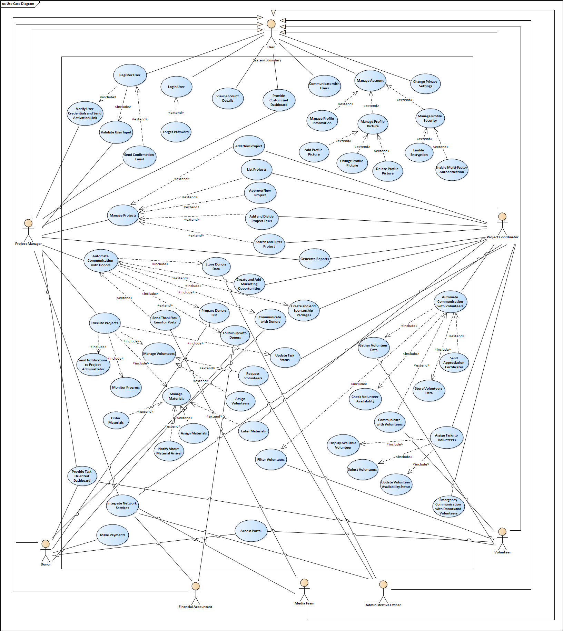
Analysis Use Case Model Diagram for whole system

Analysis Use Case narrative for “Request Donation”

< Donation Management System>
Author (s): Hussain Abbas Date: 6/12/2024
Version: 2.0

USE CASE NAME: | Request Donation |  | USE CASE TYPE
USE CASE ID: | 001 |  | Business Requirements:
PRIORITY: | High |  | System Analysis:  System Design:
SOURCE: | Case study
ACTORS | Donors
STAKEHOLDERS: | Project Coordinator, Project Manager (Administrator)
DESCRIPTION: | Analyzing and processing donor contributions through the system for active projects requiring funding.
PRE-CONDITION: | The donors Must be register in system.
TRIGGER: | A donor initiates the process by selecting a project requiring funding from the system's dashboard.
TYPICAL COURSE | Actor Action | System Response
OF EVENTS (FLOW OF ACTIVITIES): | Step 1: Login. | Step 2: System authenticates the donor’s account.
 | Step 3: Select the project. | Step 4: Show the sponsorship package and any associated marketing opportunities for the project.
 | Step 5: Select the sponsorship package and if prefer any marketing opportunities. | Step 7: Confirm the selected.
 | Step 8: Add payment details | Step 9: Display a confirmation pop-up to ensure the donor intends to proceed with the payment.
 | Step 10: Confirmation of payment | Step 11: Validate the donor details.
 | Step 12: Receive confirmation and acknowledgment. | Step 13: Send thank message throw SMS.
 |  | Step 14: Save the data in the db.
ALTERNATE COURSES (EXCEPTION CONDITIONS): | 2: Invalid Login Credentials:  2.1: Displays an error message and prompts for re-entry/
11: Invalid payment details:
11.1: Displays an error message and prompts for re-entry.
11.2: three times the user will get banned.
13: The number is out of services:
13.1: use the two steps of register emails and number to reset the user details.
10: full funded project:
10.1 : Notifies the donor and suggests other active projects.
10: Payment Gateway Failure:
10.2: Logs the error and notifies the donor to retry later.
CONCLUSION: | In conclusion, the "Request Donation" use case facilitates smooth communication between donors and the Bahrain Trust Foundation’s platform for financing ongoing projects. By incorporating features such as authentication, project selection, payment handling, and recognition, the system provides a straightforward donation process.
POST-CONDITION: | 1-Donation recorded in the system. 2-
BUSINESS RULES | Sponsorship packages must align with the project budget requirements.
IMPLEMENTATION CONTRAINTS AND SPECIFICATIONS
ASSUMPTIONS: | - All active projects and sponsorship packages are accurately listed and up to date in the system.  - The project which is full payment is automatically removed.
OPEN ISSUES: | 1- Should there be a maximum for the payment? 2- How does the system interact with donors who prefer anonymity?

Analysis Use Case narrative for “Request Volunteers”

<Volunteers Management System>
Author (s): Fatema Maitham Date: 1/12/2024
Version: 2.1

USE CASE NAME: | Request Volunteers |  | USE CASE TYPE
USE CASE ID: | REQ-VOL-01 |  | Business Requirements:
PRIORITY: | High |  | System Analysis:  System Design:
SOURCE: | Bahrain Trust Foundation Case Study
ACTORS | Project Coordinator  Volunteer
STAKEHOLDERS: | Project Coordinator
DESCRIPTION: | This use case describes the process of requesting volunteers for specific projects and automating communication with them.
PRE-CONDITION: | -The project coordinator must be logged in the system.  -The project coordinator must have a valid account and permissions.
TRIGGER: | The project coordinator initiates a request for volunteers for a specific project.
TYPICAL COURSE | Actor Action | System Response
OF EVENTS (FLOW OF ACTIVITIES): | Step 1: The project coordinator selects a project that requires volunteers. | Step 2: The system gathers volunteer data from the website.
 | Step 3: The project coordinator specifies the volunteer criteria based on project requirements. | Step 4: The system filters the volunteers based on criteria.
 |  | Step 5: The system checks each volunteer’s availability or sends automated messages (email, SMS, or call) to volunteers with the assignment details and requests confirmation.
 | Step 6: The volunteer receives the request and confirms their availability. | Step 7: The system updates their status to ‘assigned’ and assigns them to the project.
 |  | Step 8: The system stores this data for future reference and maintains communication channels with volunteers for future assignments.
 |  | Step 9: After task completion, the system generates and sends appreciation certificates to volunteers.
ALTERNATE COURSES (EXCEPTION CONDITIONS): | Step 4a: If no volunteers meet the specified criteria, the system notifies the project coordinator to update the criteria.
 | Step 5a: If all filtered volunteers are unavailable, the system notifies the project coordinator to search or update the criteria.
Step 6a: If a volunteer declines the request, the system automatically moves to the next volunteer.

Step 6b: If a volunteer does not respond within the specified timeframe, the system automatically moves to the next volunteer.
CONCLUSION: | The system effectively automates volunteer communication, ensuring an efficient process for BTF to engage volunteers for its projects. It manages preferences, availability and task completion. By automating communication with volunteers, the system enhances coordination, reduces manual efforts, and ensures timely task allocation.
POST-CONDITION: | -The system maintains a record of volunteer participation for future reference.  -The system logs and updates volunteers' communication preferences upon their approval.
BUSINESS RULES | -Volunteers can only be assigned to a project if they are available and confirmed availability.  -Volunteers must receive appreciation certificates after the completion of their tasks.
IMPLEMENTATION CONTRAINTS AND SPECIFICATIONS | -The system should integrate with the organization's existing website and communication channels (email, SMS, WhatsApp).  -The system must support filtering and sorting volunteer data efficiently.
ASSUMPTIONS: | -Project Coordinators are trained to use the system effectively.  -Volunteer data in the system is accurate and up to date.
OPEN ISSUES: | -How will the system protect volunteer personal data?  -How will the system handle increased volunteer data?

Analysis Use Case narrative for “Create New Project”

< Project Management System>
Author (s): Maram Shubbar Date: December 2, 2024
Version: 2.1
USE CASE NAME: | Create New Project |  | USE CASE TYPE
USE CASE ID: | CP-UC02 |  | Business Requirements:
PRIORITY: | High |  | System Analysis:  System Design:
SOURCE: | Bahrain Trust Foundation Case Study
ACTORS | Project Coordinator, Project Manager (Administrator)
STAKEHOLDERS: | Users, Project Coordinator, Project Manager (Administrator)
DESCRIPTION: | This use case outlines how an Administrator or Project Coordinator creates a new project in the system. Once the project is created, it is submitted to the Project Manager for approval. After approval, the system updates and shows the project's status.
PRE-CONDITION: | -The user (Project Manager or Project Coordinator) must be logged into the system.  -The user (Project Manager or Project Coordinator) must have appropriate permissions to add new projects.
TRIGGER: | The Project Manager or Coordinator initiates the creation of a new project in the system.
TYPICAL COURSE | Actor Action | System Response
OF EVENTS (FLOW OF ACTIVITIES): | Step 1: The project manager or coordinator navigates to the Add New Project page. | Step 2: The system provides a form for entering project details, including the project start date, type of service, origin of the project, project description, start and end dates, urgency level, donation requirement (Yes/No), volunteer requirement (Yes/No), and the required donation amount.
 | Step 3: The project manager or coordinator fills in the project details (start date, type of service, origin, description, urgency, donation and volunteer requirements, donation amount). | Step 4: The system ensures the input is complete and correct, like validating date formats and required fields.
 | Step 5: The project manager or coordinator submits the form. | Step 6: The system confirms the project submission and displays a success message.
 |  | Step 7: The system displays the newly added project in the Pending Approval list.
 | Step 8: The Project Manager or Project Coordinator views the new project in the Pending Approval list to confirm its awaiting Project Manager approval.
 | Step 9: The Project Manager approves the project. | Step 10: The system updates the project status to Active, removes it from the Pending Approval list, and adds it to the Active Projects list.
ALTERNATE COURSES (EXCEPTION CONDITIONS): | Step 4a: If the Project Manager or Project Coordinator enters incomplete or incorrect details for the project (like missing required fields or wrong date formats), the system will ask them to fix or complete the missing information before they can submit it.
 | Step 6a: If something goes wrong in the system while submitting the project (like a technical issue or failure to save the data), the system will show an error message. The Project Manager or Project Coordinator will then be asked to try submitting again after fixing the issue.
Step 10a: If the project is rejected, the system updates its status to Rejected and sends a notification to the Project Coordinator and Project Manager. The notification includes the rejection reason, instructions for revision, and a link to the rejected project page.

Step 10b: If the project is rejected and requires revision, the system allows the Project Coordinator and Project Manager to update the project details. Once revised, the status is updated to Pending Approval for further review.
CONCLUSION: | Once approved, the project status is set to Active, and tasks are assigned by the Project Coordinator. If rejected, the status is updated to Rejected, and notifications with rejection details are sent to the Project Coordinator and Project Manager. The system also enables internal users to search and filter projects by type, dates, amount, urgency, or status.
POST-CONDITION: | -The project is added to the system with the status updated (Active/Rejected), and notifications are sent to relevant stakeholders.  -The system updates the categorized project lists (Active, Completed, or Rejected) for internal users.  -Internal users can search and filter projects using criteria such as type, start date, end date, amount, status (Active, Completed, Rejected), and urgency.  -The Project Coordinator can now divide and assign tasks to the project.
BUSINESS RULES | -Only authorized users (Project Manager or Coordinator) are allowed to create projects.  -The project must be fully approved by the Project Manager before tasks can be added.  - All required project details must be filled in before submission.  - Projects must be reviewed and approved before becoming active.
IMPLEMENTATION CONSTRAINTS AND SPECIFICATIONS | -Only users with appropriate permissions can add new projects or approve them.  -The system must validate input fields for correctness (proper date formats and all required fields must be filled out).
ASSUMPTIONS: | -The system is functional and can correctly handle data validation and project status updates.  -The user has the necessary access privileges to create and manage projects.
OPEN ISSUES: | - How should the system handle incomplete or incorrect project information after submission but before approval?  - How should the system notify the Project Coordinator and Manager if a project is rejected or requires revision?

`

Analysis Use Case narrative for “Task Assignment for Volunteers”

<Task Assignment Management System>
Author (s): Haider Albari Date: 6/12/2024
Version: 2.0

USE CASE NAME: | Task Assignment for Volunteers |  | USE CASE TYPE
USE CASE ID: | ATMUC-01 |  | Business Requirements:
PRIORITY: | High |  | System Analysis:  System Design:
SOURCE: | Bahrain Trust Foundation Operational Needs
PRIMARY ACTOR: | Project Coordinator
DESCRIPTION: | This use case describes the process of assigning specific tasks to volunteers for a project. The project coordinator selects volunteers, reviews project tasks, and assigns them to appropriate individuals or groups. The system tracks volunteer assignments and updates their availability.
PRE-CONDITION: | - The volunteer must be registered in the system and approved by the administrator.  - The project must exist in the system with tasks defined and verified.  - Volunteers must have their availability and skillsets updated in the system.
TRIGGER: | A new project task assignment request is initiated by the project coordinator for an active or upcoming project.
TYPICAL COURSE | Actor Action | System Response
 | 1. Project Coordinator logs into the system and selects an active or future project. | 2. System displays the project details and associated tasks.
OF EVENTS: | 3. Coordinator views the list of available volunteers. | 4. System fetches and filters volunteer data based on skillsets, past performance, and availability.
 | 5. Coordinator selects tasks to assign to individual volunteers or groups. | 6. System allows batch or individual task assignments for selected volunteers.
 | 7. Coordinator confirms the assignments. | 8. System updates volunteer availability and records task assignment in the database.
 | 9. Notifications are sent to assigned volunteers with task details. | 10. System ensures delivery of notifications and logs communication history.
ALTERNATE COURSES: | 1. If no suitable volunteers are available:  1.1 The system suggests expanding the search criteria or reaching out to unassigned volunteers.  - The coordinator can post a general task request to the volunteer pool.
2. If tasks require changes post-assignment:
2.1 The coordinator can reassign tasks, and the system notifies affected volunteers of the updates.
3. If a volunteer declines the assignment:
  - The system updates their status and notifies the coordinator to assign the task to someone else.
CONCLUSION: | The task assignment process concludes with all tasks assigned to volunteers, and their availability statuses updated in the system. Notifications ensure that volunteers are informed of their assignments.
POST-CONDITION: | - Volunteer task assignments are logged.  - Volunteer availability is updated.  - Notifications are sent to all relevant stakeholders.
BUSINESS RULES | - Volunteers cannot be assigned to tasks if their availability is already set as "engaged."  - Tasks can be assigned to multiple volunteers if they are collaborative in nature.  - The system must log all changes and communications for audit purposes.
ASSUMPTIONS: | - The volunteer database contains up-to-date information on skills and availability.  - Task descriptions are detailed and clear for assignment.  - Volunteers are notified through both email and SMS for critical tasks.
OPEN ISSUES: | - How will conflicts in volunteer availability be resolved if tasks overlap?  - Is there a limit on the number of tasks a volunteer can handle simultaneously?

Analysis Use Case narrative for “Registration/Sign-up”

<Registration Assignment Management System>
Author (s): Hasan Ayoob Date: 6/12/2024
Version: 2.0
USE CASE NAME: | Registration/Sign Up |  | USE CASE TYPE
USE CASE ID: | BTFUC-0 |  | Analysis Use case:
PRIORITY: | High
SOURCE: | Bahrain Trust Foundation Requirements
PRIMARY ACTOR: | User (Admin, Employee, Donor, Volunteer)
DESCRIPTION: | This use case describes the process for users (Admin, Employee, Donor, Volunteer) to register or sign up on the Bahrain Trust Foundation web portal to access personalized dashboards and services.
PRE-CONDITION: | User must exist.  The system is operational and the message “Welcome ...etc.” is displayed  and ready for user input. The user must have internet access.
TRIGGER: | The customer approaches the ATM and inserts their bank card.
 | Actor | System
TYPICAL COURSE OF EVENTS: | Step 1: User opens the registration page.
 |  | Step 2: The system displays a welcome message or introductory prompt explaining the purpose of the registration process.
 | Step 3: User selects the user type (e.g., Donor, Volunteer, Employee) and fills in required details.
 |  | Step 4: The system displays the registration form with fields based on user type and validates the entered information.
 | Step 5: User fills and then submits the registration form.
 |  | Step 6: The system generates a unique username, stores the user data securely, and notifies the admin for verification.
 |  | Step 7: The system sends a registration verification request to Admin.
 | Step 8: Admin verifies the user credentials.
 |  | Step 9: Upon successful verification, the system sends an activation link to the user's registered email.
 | Step 10: User clicks the activation link in their email.
 |  | Step 11: The system confirms activation and displays a “Registration Successful” message.
ALTERNATE COURSES: | Step 3a, If the card is not valid (it can be an Employee ID Card) the system displays the “Invalid Card” message, ejects the card and terminates the used case.
Step 3b: If the card expired, the system ejects the card and displays the massage
'Card expired, please contact your bank,'
 | Step 7a: If the PIN Is invalid, the system displays the message Invalid PIN, please try again', If the PIN is Incorrect for the third time, the ATM eats the card, informs the customer to contact the bank and terminates the used case.
CONCLUSION: | The use case concludes when the user’s registration process is complete, their account is activated, and they are able to log in and access their customized dashboard.
POST-CONDITION: | The user account is successfully registered, activated, and available for system login. The system securely stores the user details.
BUSINESS RULES | All users must have a unique username and password following universal security guidelines.  Registration activation requires Admin verification.  An email activation link expires within 24 hours of being sent.
ASSUMPTIONS: | By default, an Admin user exists in the system at the time of its creation.  The user’s email is valid and accessible for activation link delivery.
OPEN ISSUES: | Should there be automated verification for certain user types (e.g., donors) without Admin intervention?

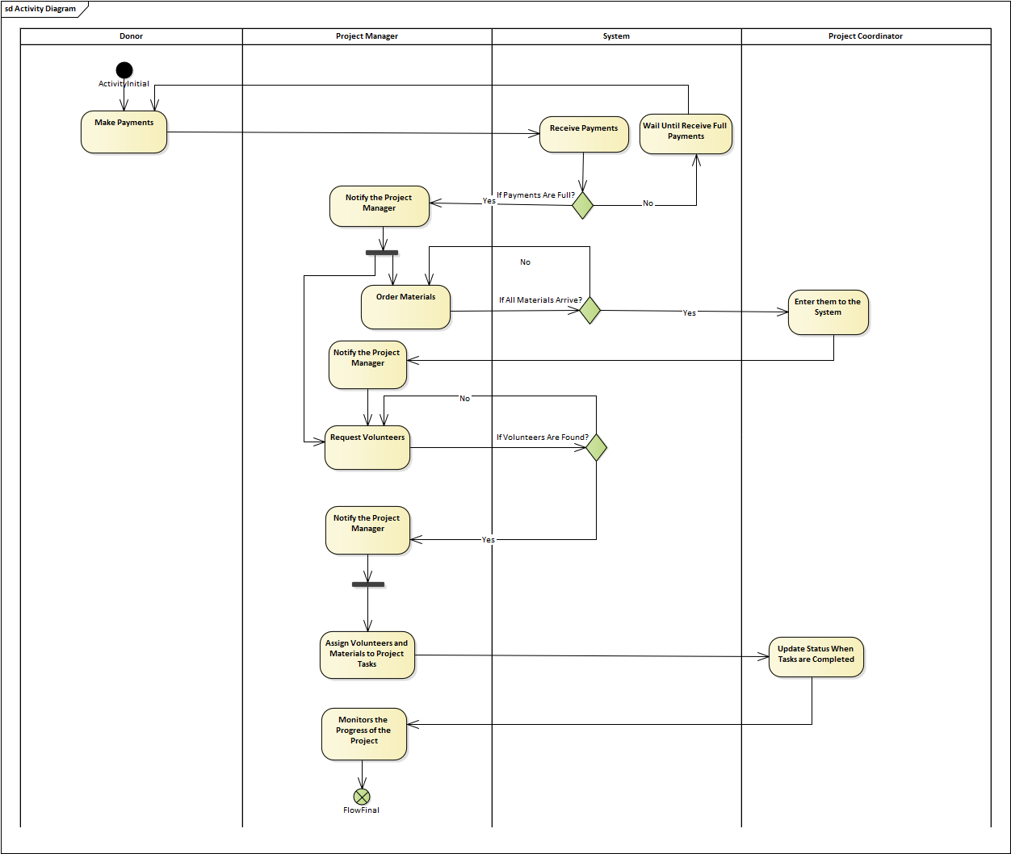
Activity Diagram for “Project Execution Narrative”

Cost/Benefit Analysis

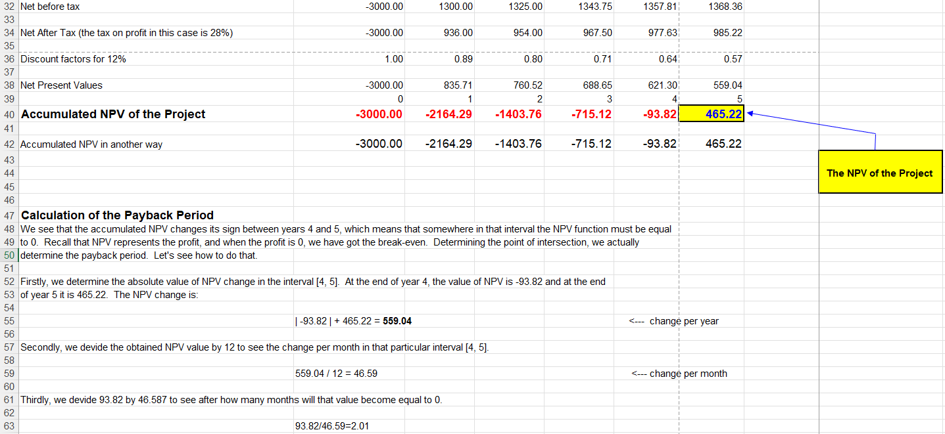
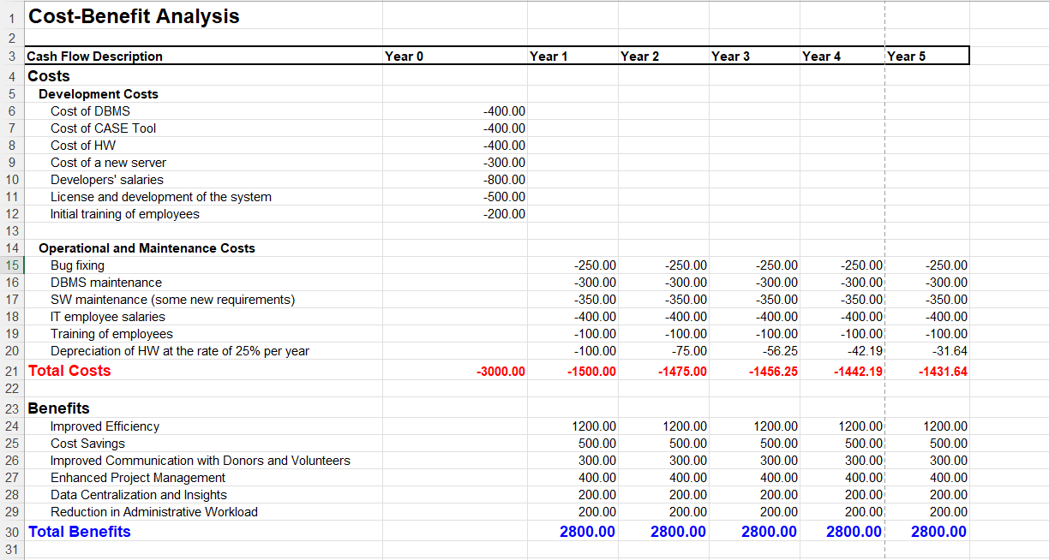

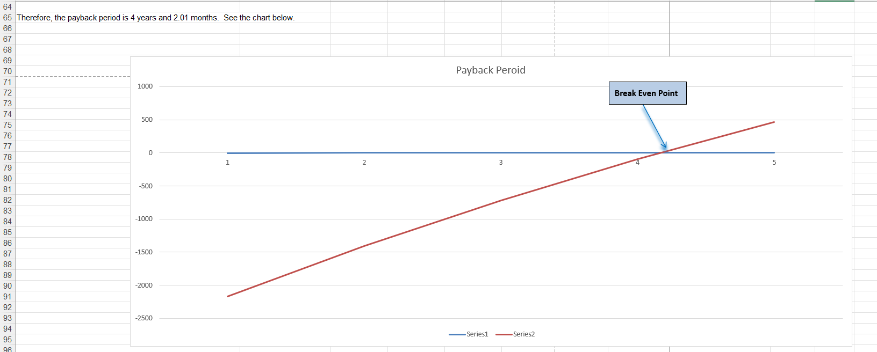

Sequence Diagram for “Project Execution Narrative”

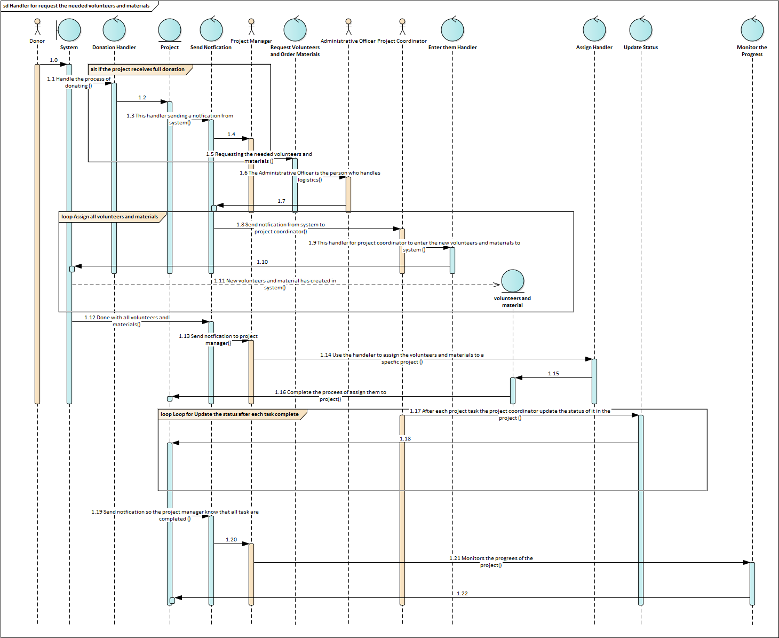

User Interface Design for covering use cases

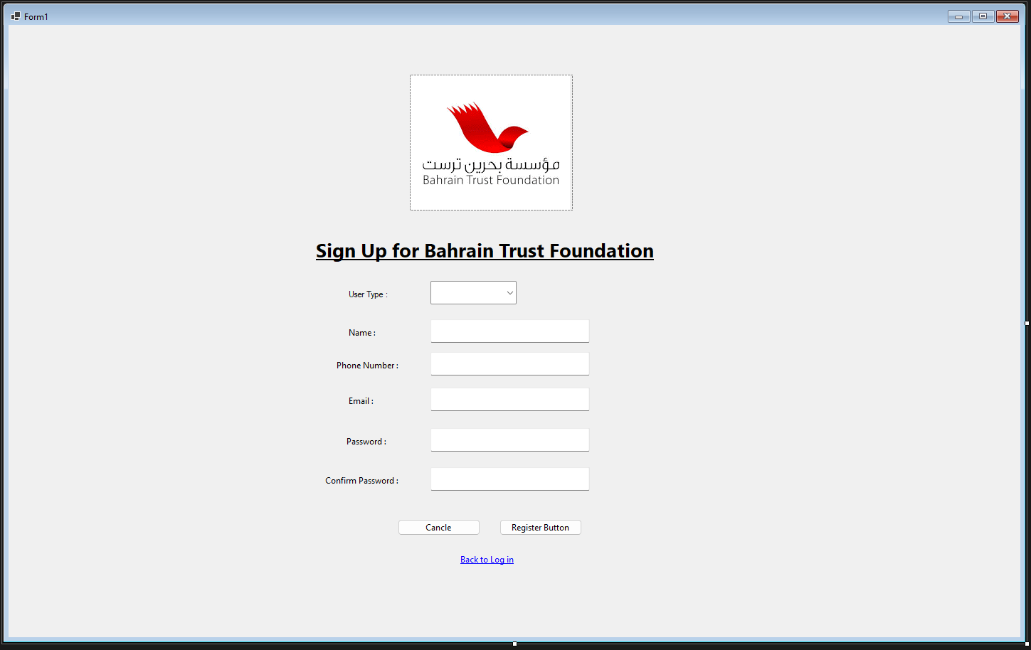

Form
Name: Sign up for Bahrain Trust Foundation
Use Case Implemented: “Registration/Sign up”
User Inputs:
- User Type (ComboBox): The user chooses his role from the options which are: Admin, Employee, Donor, Volunteer.
- Name (Text Box): The user writes his/her name in the text box field.
- Phone Number (Text Box): The user enters his number in the text box (Must be 8 digits).
- Email (Text Box): The user enters his/her email address (Must adhere the email address format “example@gmail.com”.
- Password (Text Box): The user enters his/her password in the text box (The password does not show on screen).
- Confirm Password: The user enters the password again (must match the previous password).
- Cancel (Button): When pressed the registration process is canceled all the input fields will reset to blank.
- Register (Button): When all information validated and then submitted and the process is finished.
- Back to Log in (Link): When pressed the user will be redirected to the login page.
Outputs:
(The register button is pressed and all information is valid): Registration Successful and the user is redirected to the Login page where he needs to login again.
(The register button is pressed and information is invalid): Registration Unsuccessful if there is a problem with the input and the user needs to input the information again.
(Cancel button is pressed): Resetting the page.
(Back to Login in is pressed): Redirection to Log in page.

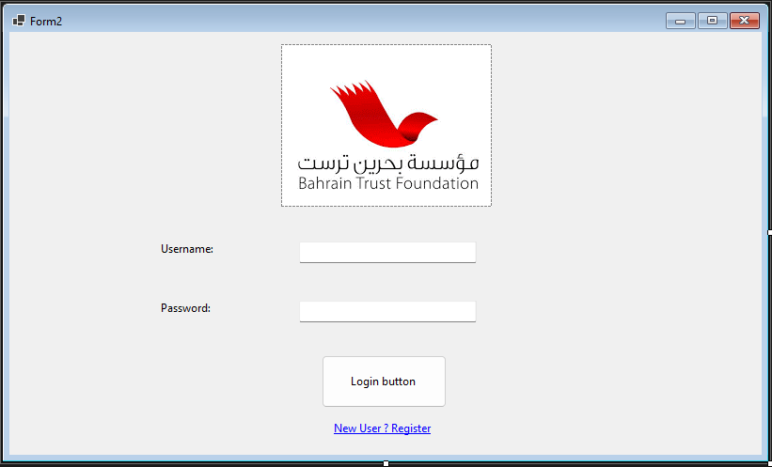

Form Name: Login to Bahrain Trust Foundation
Use Case Implemented: “Registration/Sign up”
User Inputs:
- Username (Text Box): The user writes his/her name in the text box field.
- Password (Text Box): The user enters his/her password in the text box (The password does not show on screen).
- Login (Button): when pressed all information validated and then The user will be redirected to the dashboard form (if the process is successful and the credentials are correct)
- New User ? Register (Link): When a new user press the link he/she will be redirected to the register page.
Outputs:
(The Login button is pressed, and all information is valid): Login Successful and the user is redirected to the Dashboard page.
(The Login button is pressed, and information is invalid): Registration Unsuccessful “there is a problem with the input” and the user needs to input the information again.
(Link is pressed): Redirection to register page.

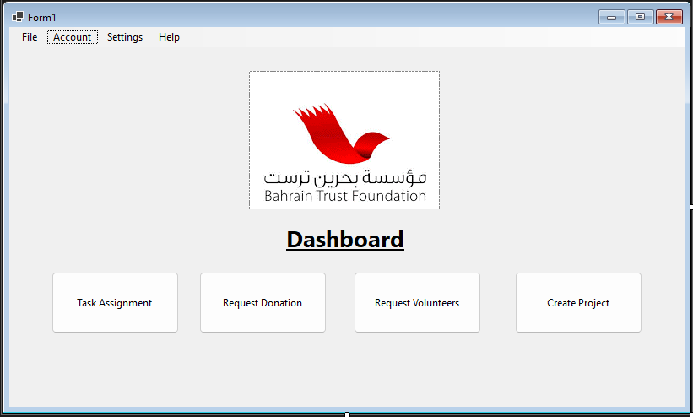

Form Name: Dashboard
Use Case Implemented: “Registration/Sign up”
User Inputs along with the outputs:
- Task Assignment (Button): Redirection to Task assignment page.
- Request Donation (Button): Redirection to Request Donation page.
- Request Volunteers (Button): Redirection to Request Volunteers page.
- Create Project (Button): Redirection to Create Project page.
*Note: The permission to be redirected to the certain page will be dependent on the type of user as unauthorized user will not have the button show to them.

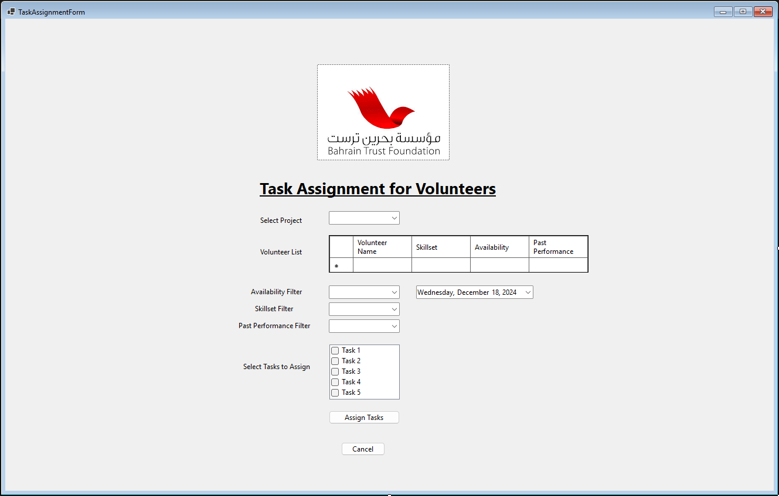

Form Name: Task Assignment for Volunteers
Use Case Implemented: “Task Assignment for Volunteers”
User Inputs:
- Select Project (ComboBox): The user chooses the project name from the options shown.
- Volunteers List (Datagrid): The list of volunteers are shown with/without the applied filters.
- Availability Filter (ComboBoxes & DatePicker): The user chooses the Availability status from the options (Available , Not Available) & The required date for the task.
- Skillset Filter (ComboBox): The user chooses the skillset level from the options provided.
- Past Performance Filter (ComboBox): The user chooses the performance level from the options provided.
- Availability Filter (ComboBox): The user chooses the project name from the options shown.
- Select Task to Assign (CheckedListBox): The user checks the specific tasks he would like to assign for the volunteers.
- Assign Tasks (Button): when pressed all information validated and then submitted and the process is finished.
- Cancel (Button): When pressed the registration process is canceled and the user goes back to the dashboard page.
Outputs:
(The Assign Tasks button is pressed, and all information is valid): Assignment is Successful, and the user is redirected to the dashboard page.
(Cancel button is pressed): Redirection to the dashboard page.

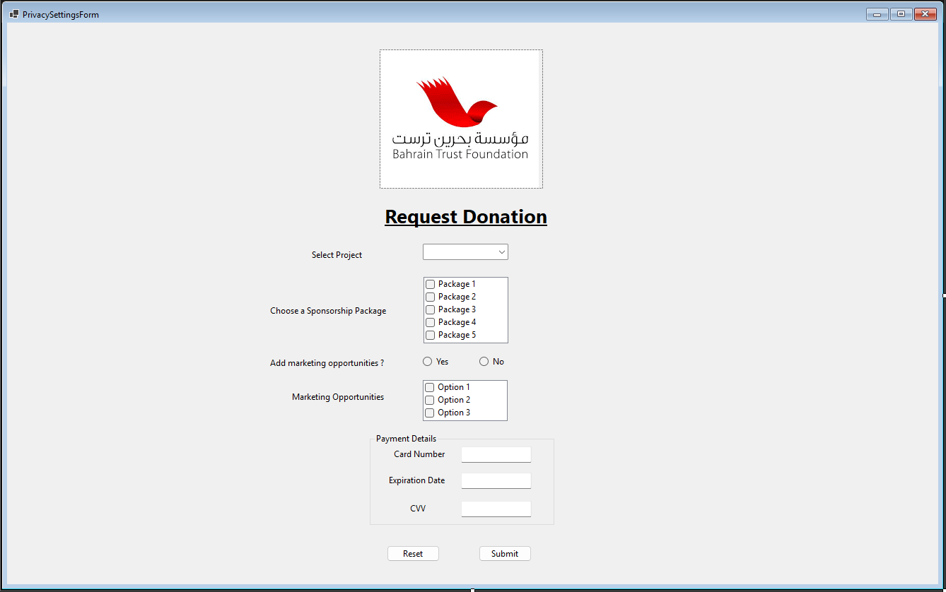

Form Name: Request Donation
Use Case Implemented: “Request Donation”
User Inputs Along with the outputs:
- Select Project (ComboBox): The user chooses the project name from the options shown.
- Choose a Sponsorship Package (CheckedListBox): The user checks the packages he/she would like to choose.
- Add marketing opportunities (Radio buttons): The user chooses either Yes or No.
- Marketing Opportunities (CheckedListBox): The user checks the options he/she would like to choose.
- Payment Details (3 Text Boxes): The user enters his/her Card Number, Expiration Date, and CVV in the text boxes labeled.
- Reset (Button): When pressed all fields will be reset and the user needs to input the information again.
- Submit (Button): when pressed all request information validated and then submitted to the finance department to complete the rest of the process.

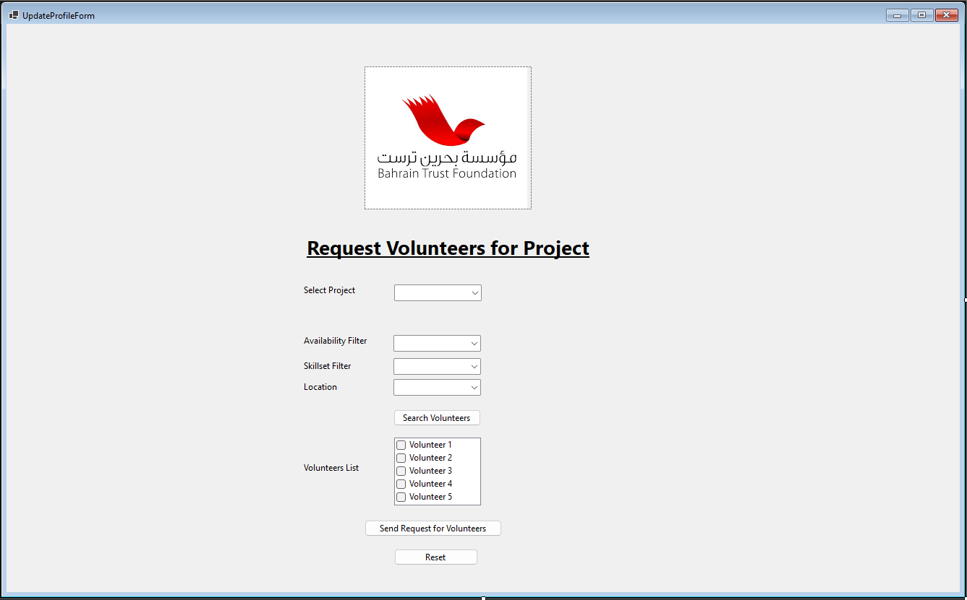

Form Name: Request Volunteers for Project
Use Case Implemented: “Request Volunteers for Project”
User Inputs Along with the outputs:
- Select Project (ComboBox): The user chooses the project name from the options shown.
- Availability Filter (ComboBoxes): The user chooses the Availability status from the options (Available , Not Available).
- Skillset Filter (ComboBox): The user chooses the skillset level from the options provided.
- Location Filter (ComboBox): The user chooses the location from the options provided.
- Availability Filter (ComboBox): The user chooses the project name from the options shown.
- Search (Button): When pressed, the search process begin with the applied filers above and the results shown in the volunteers check list below.
- Volunteers List (CheckedListBox): The user checks the volunteers he/she would like to request for the project.
- Send Request for volunteers (Button): when pressed a request is sent to the chosen volunteers. The user will be redirected to the dashboard waiting for volunteers confirmation.
- Reset (Button): When pressed all fields will be reset and the user needs to input the information again.

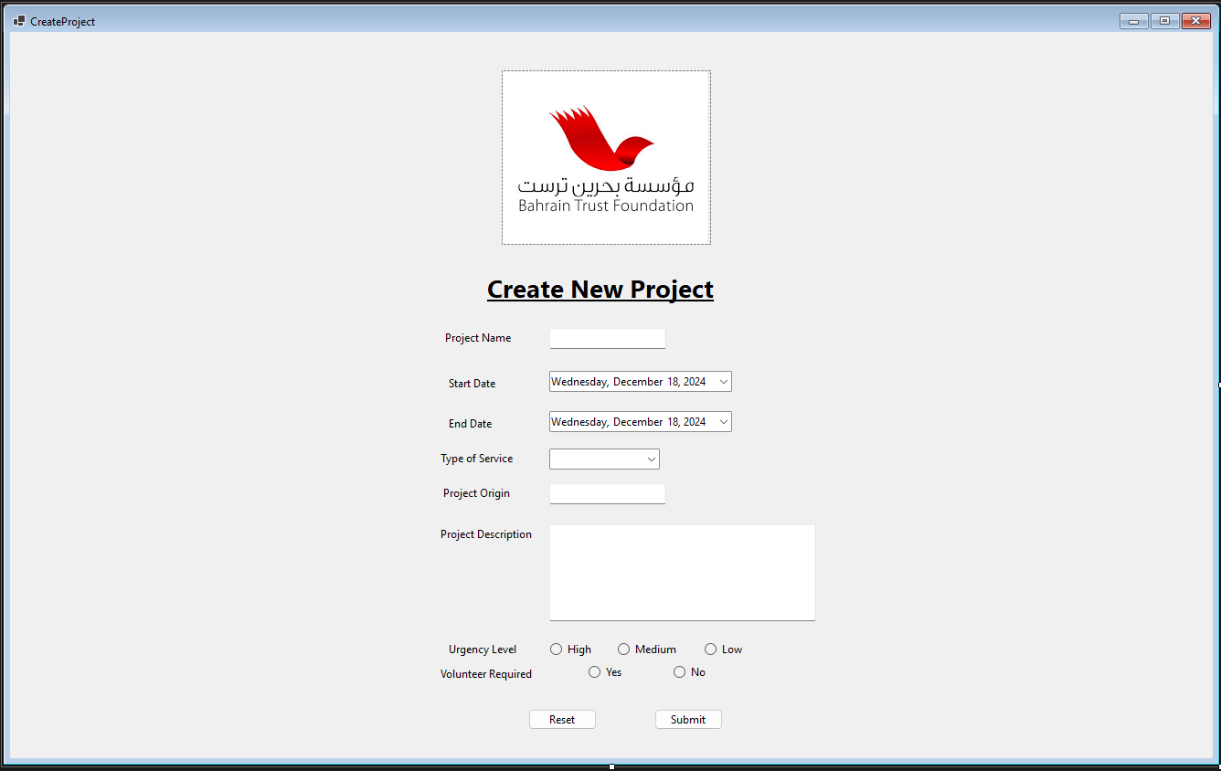

Form Name: Create New Project
Use Case Implemented: “Create New Project”
User Inputs Along with the outputs:
- Select Project (ComboBox): The user chooses the project name from the options shown.
- Start Date (DatePicker): The user chooses the start date from a calendar.
- End Date (DatePicker): The user chooses the End date from a calendar.
- Type of service (ComboBox): The user chooses the type of service from the options shown.
- Project Origin (Text Box): The user writes the project origin in the text box.
- Project Origin (Multiline Text Box): The user writes the project description in the text box.
- Urgency Level (Radio buttons): The user chooses the from level option (High, Medium, Low).
- Volunteer Required (Radio buttons): The user chooses if a volunteer is required for the project either Yes or No.
- Submit (Button): when pressed the project request is submitted for confirmation. The user will be redirected to the dashboard.
- Reset (Button): When pressed all fields will be reset and the user needs to input the information again.

Interview Form

Interviewee: Mr. Karim Mohammed
Date: 11/14/2024
Time: 10:30 am
Place: Bahrain Polytechnic, Building 20 Campus B 20.210
Subject: Systems Analysis and Design - IT7001
Time Allocated | Interviewer questions and objective | Interviewee  Response
1 - 2 minutes | - We are Maram Shubbar, Fatema Maitham, Husain Abbas, Hasan Ayoob, and Haider Albari, and our role is to implement your new system.  - We sincerely appreciate you taking the time to meet with us today. Your contributions are crucial to the success of this process.  - The purpose of this interview is to discuss your expectations and insights for the development of a new system.
2 minutes | Question1: How do you plan to maintain and update the system after it is launched? | He will give us the stated money budget yearly for system maintenance and updates, and we will be responsible for maintaining and updating the system.
2 minutes | Question2: When do you expect the new system to be fully implemented? | Within 6 months.
2 minutes | Question3: Who is sponsoring or funding the development of this new system? | The CEO of Bahrain Trust Foundation company, Mr. Karim Mohammed.
2 minutes | Question4: What are the values for the task rate and the discount factor? | The task rate is 28% and the discount factor is 12%.
3 minutes | Question5: Are there specific measures in place to ensure the security and confidentiality of users' personal information within the new system? | Each user will have a unique User ID and password, and their account will be created automatically when they click.
3 minutes | Question6: Which database management system (DBMS) software will be chosen for the new system? | The frontend will be developed using Visual Studio, and SQL Server will be used as the database management system. All existing data, currently stored on paper, should be securely migrated into the database.
1 - 2 minute | - Thank you, Mr. Karim Mohammed, for your valuable cooperation and the insights you’ve shared with us today.  - We will provide you with a copy of a letter summarizing the key points discussed during this interview for your reference.  - If you have any questions, please feel free to reach out to us at any time.
18 minutes | Time allocated for questions and objectives
25 minutes | Time allocated for interview

Log Files

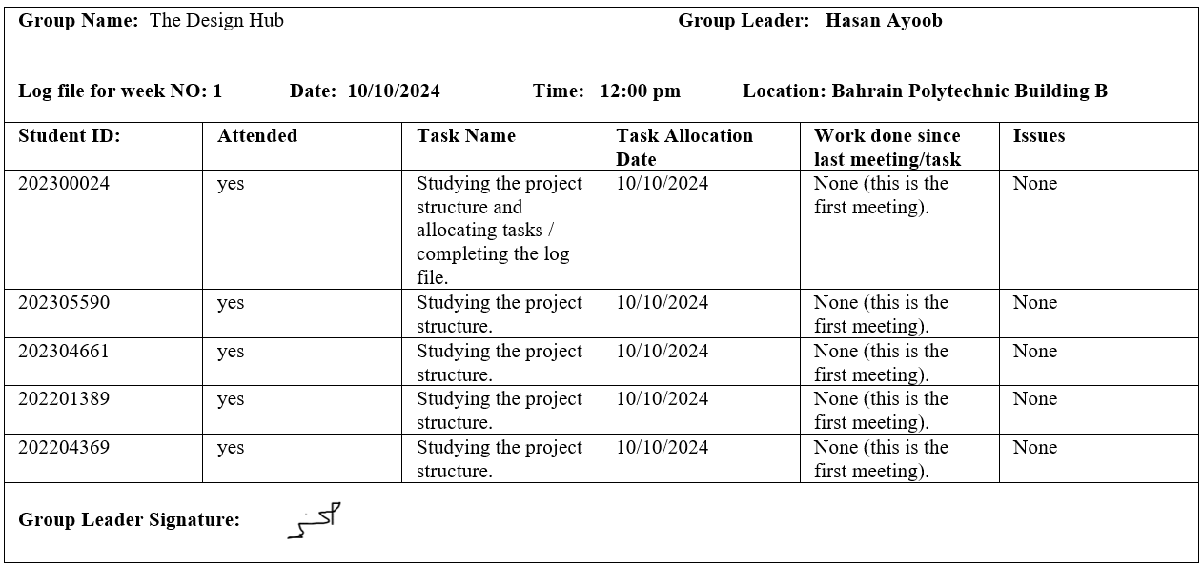

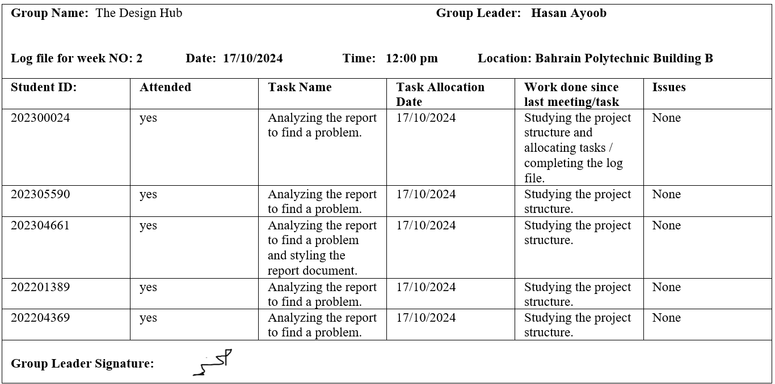
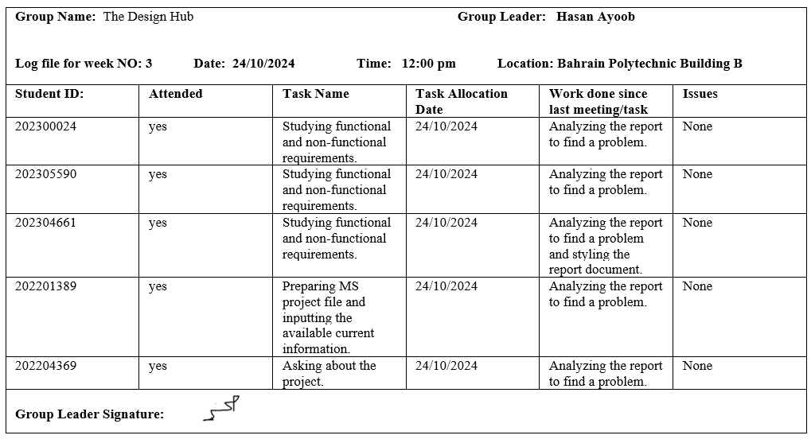

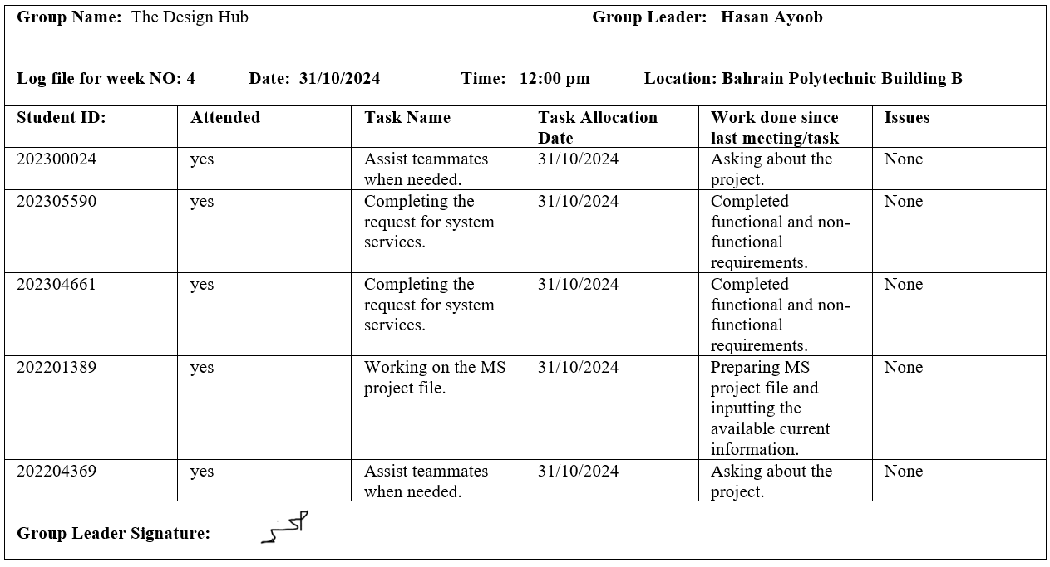

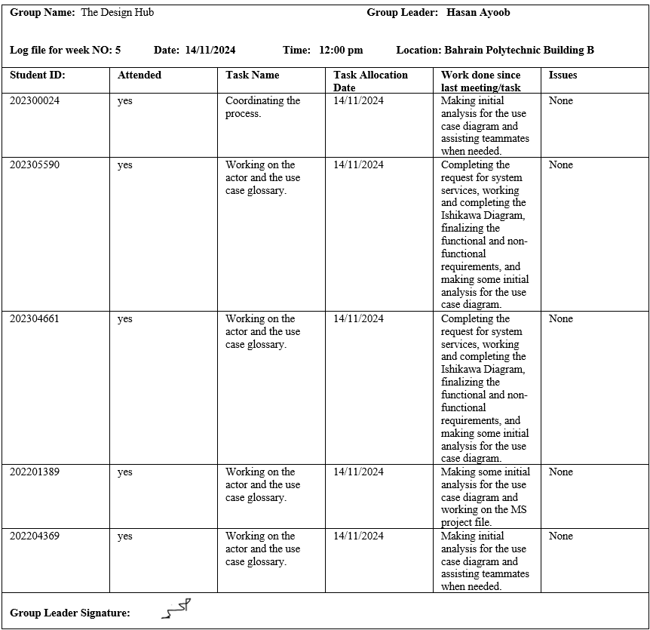

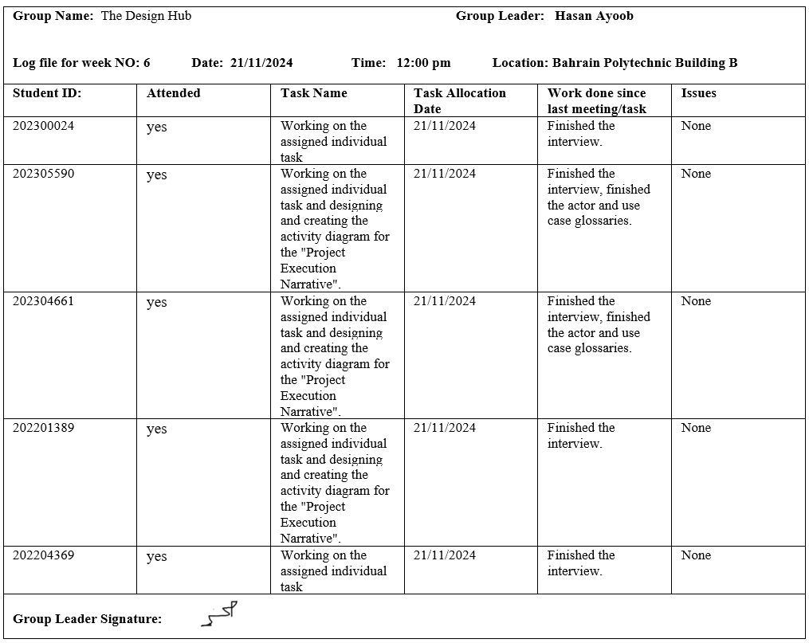

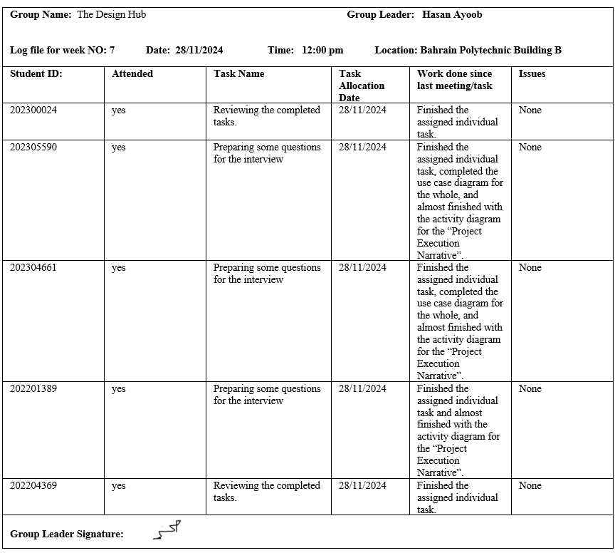

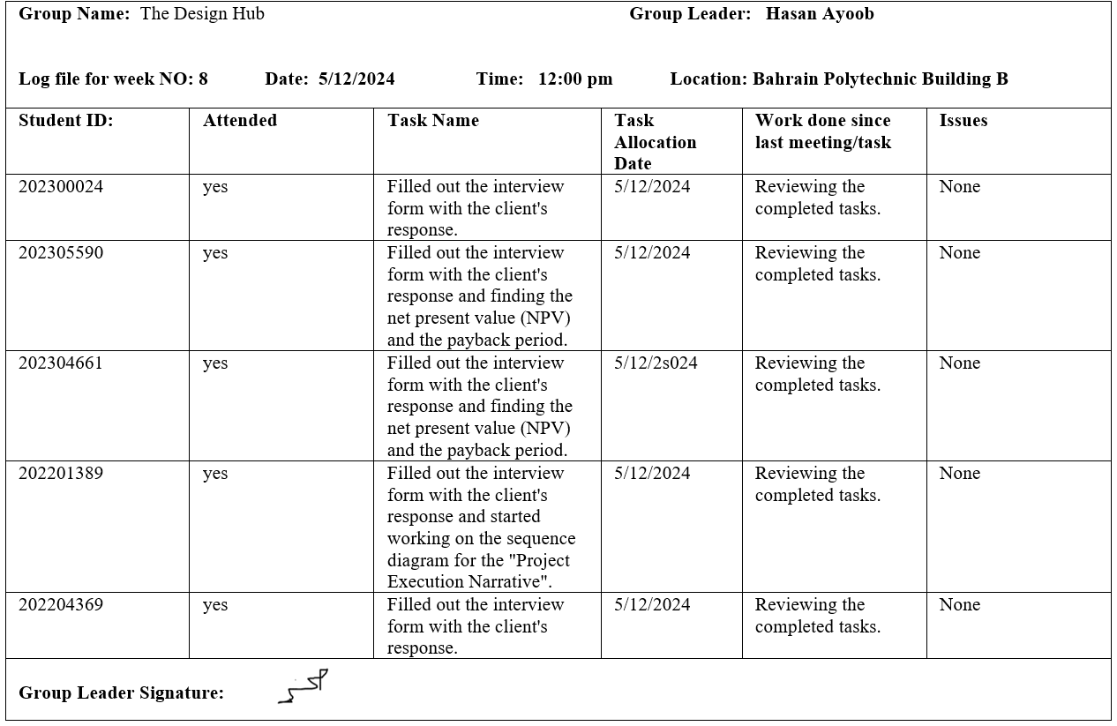

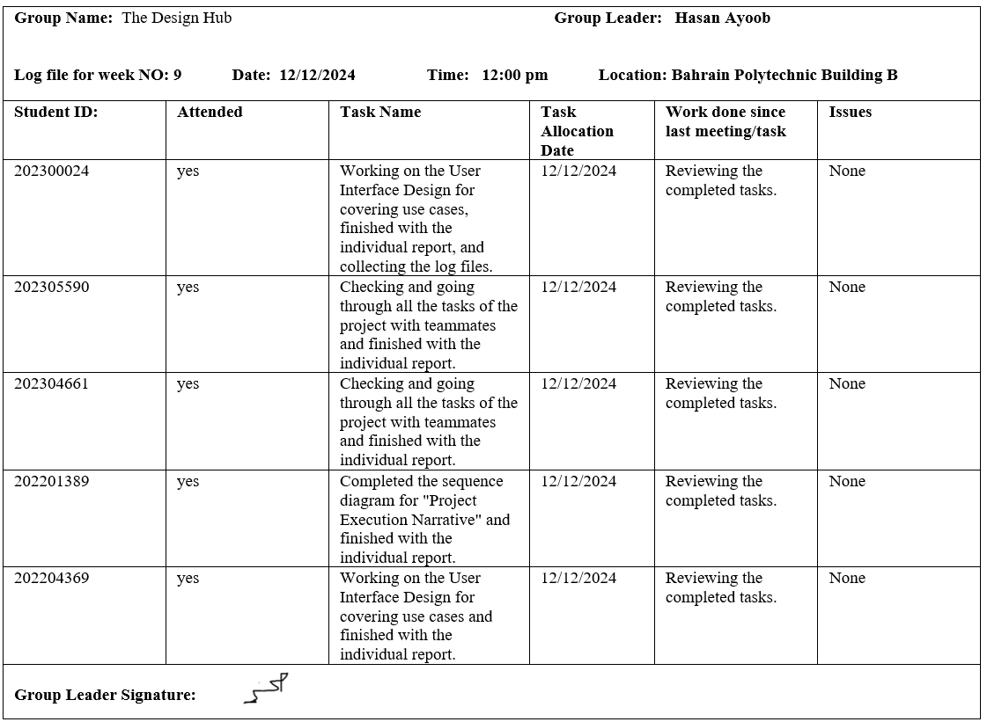

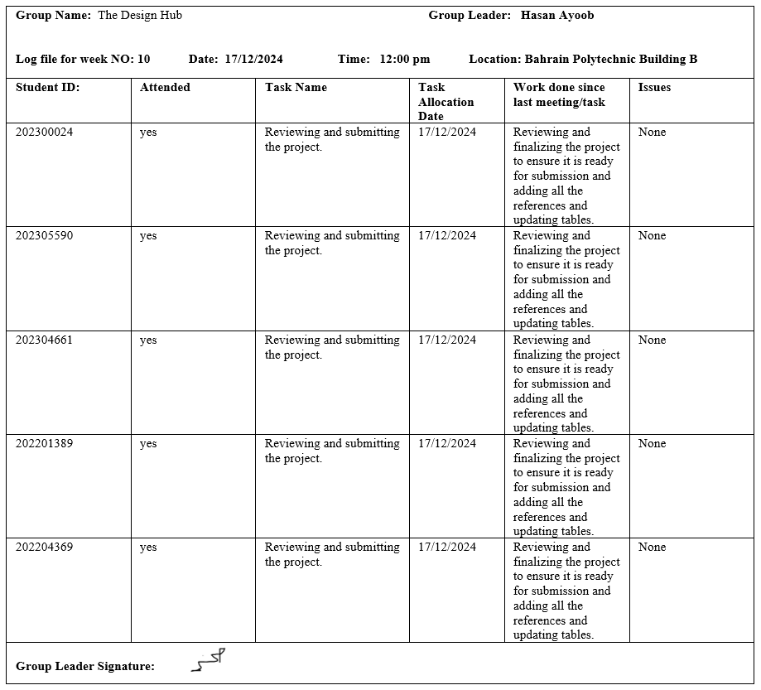

Individual Report

Maram Shubbar_202305590

This project has presented a mix of challenges and learning opportunities over the past three months. The project comprised three phases: information gathering, analysis, and design. Although every stage had obstacles, each phase provided growth.

We found gathering information difficult. My partner and I struggled to comprehend the project and required multiple readings of the case study to understand its complexities. Defining the project's objectives and completing the Request for Systems Services form were demanding tasks. Using the Ishikawa diagram to identify the primary issue was another difficulty, as the case study presented multiple problems. We identified the most crucial issue after consideration. The amount of functional and non-functional requirements was over 50, which was a rewarding achievement.

The analysis phase presented challenges. Tasks were divided among team members. However, this approach proved ineffective because of differing perspectives, making it difficult to integrate the work. Recognizing this, we shifted to a collaborative approach, requiring coordination in a virtual environment. We divided the workload into smaller sections and reviewed them. This strategy enabled us to complete the phase.

During the design phase, some group members could not take part in earlier meetings and focused on user interface design. The team agreed on this arrangement during later stages. The sequence diagram task was assigned to a team member with expertise in that area, and the group reviewed and refined the final output.

Reflecting on the project has provided me with a deeper understanding of the challenges we faced. Sommerville (2015) underscores defining requirements, a challenge we experienced during the information-gathering phase. Boehm's (1988) Spiral Model emphasizes iterative improvement, aligning with our strategy of revisiting and refining our work. Although I occasionally felt discouraged by difficulties, conquering them inspired me to keep going and advance my abilities. To enhance my work, I used slides and YouTube channels to improve my understanding and execution. To enhance team cooperation next time, I would use better planning resources and establish more goals. Each phase's challenges resulted in rework and delays, but incremental refinement produced better outputs.

Despite challenges, this project has enhanced my skills in systems analysis and design, and I learned how to use Enterprise Architect and Visio. To overcome obstacles, future projects can profit from implementing agile approaches, better time management, and strengthening communication tools. The lessons learned will inform my approach to future projects and contribute to my growth.

Fatema Maitham_202304661

I faced distinct challenges while gathering, analyzing, and designing the requirements. The requirements were unclear during the information-gathering process, making it difficult to understand the client’s needs. We scheduled an interview with the client to clarify their requirements and make sure of alignment with the project’s objectives. This allowed us to prevent misunderstandings and keep on schedule.

In the analysis phase, I found it difficult to distinguish between functional and non-functional requirements. By studying Moodle materials, conducting research, and reviewing online examples, I gained a deeper understanding and ensured that each requirement was correctly classified, allowing the system to meet both the user’s needs and performance expectations. Sommerville (2011) emphasizes prizing distinguishing between functional requirements (what the system must do) and non-functional (how the system must perform) requirements.

The design phase also presented challenges in creating use case and activity diagrams to represent complex interactions. These difficulties caused delays in the project. However, we started early and handled our time, allowing us to complete the project on schedule. Use case modeling is essential for elucidating system functioning and guaranteeing that all user interactions are recorded, according to Cockburn (2001). To resolve this, we held collaborative sessions through Microsoft Teams and gathered feedback from team members, it enhanced the user experience and helped to improve the diagrams.

Throughout the project, I gained technical and analytical skills that enhanced my understanding of systems analysis and design, in using tools like Enterprise Architect and Visio. I learned how to request approval for a new project, create an Ishikawa diagram, and analyze functional and non-functional requirements for the entire system, and I felt accomplished after completing this task. The most challenging yet rewarding part was translating business requirements into a use-case model system, as it required flexibility and attention to detail. I became more comfortable conducting formal interviews and crafting thorough use case narratives, and I learned to value going over the case study again to make sure nothing was missed. This project helped me enhance my time management skills while balancing various tasks. If I had the chance to do it again, I would allocate more time to the design phase, as this project has improved my understanding of systems analysis and design, and I will apply these lessons to strengthen my skills and contribute to the success of future projects.

Hussain Abbas_202201389

I faced multiple issues while working on this project. While information gathering, it was a headache to gather data for multiple tasks, and the hardest part of the project begin in splitting tasks, handling programs that needed to be done on campus and specially in campus B and making meetings with group members. Many of the members had conflicting in there schedules, and some members didn’t take the responsibility to attend the meetings. These issues impacted the deadlines, that was why we didn’t submit before a week before the deadline. However, we managed to overcome these challenges by working in meetings without full group attendance and assigning tasks to absent members and for the programs problem we have no other choice except go to campus and work. This project taught me many important things, some related to system analysis and design and others on a personal level. Regarding subject learnings, I learned how to analyze the brief to create a use case narrative, which can then develop into activity and sequence diagrams, because we learned this in project. I also now have some experience in using programs, such as MS Project and Enterprise Architect. For the personal level, this project taught me how to collaborate with a team facing conflicts in schedule, which made meetings hard to make. I realize we had some mistakes in task scheduling, leading to unfair works amount among members. If I were to do this project again, I would ensure tasks were split equally from the start of project, so everyone had a fair share of the workload. Some resources really helped me complete my tasks, such as YouTube tutorials: https://youtu.be/pCK6prSq8aw, the moodle page, and discussions with group members. These tools were crucial in navigating challenges and delivering the final output within the deadline. Overall, the project was a huge impact on my experience that improved my technical and collaboration skills.

Hasan Ayoob_202300024

During the project phases, such as information gathering, analysis, and design, there were many challenges that made me push my limits and adapt to new circumstances. During the information gathering phase, the most challenging task was to determine the functional and non-functional requirements of the project. Initial requirements were ambiguous and not well-organized; these caused confusion and delay. For this, I had to re-read the project case study a number of times, ask my colleagues, and consult requirements elicitation literature for clarity. One particularly helpful resource was Software Requirements: Objects, Functions, and States by Davis (2005), which provided insights into structuring functional and non-functional requirements. By following its principles, I was able to address the ambiguity, organize the requirements effectively, and create a solid foundation for subsequent deliverables such as the actor and use case glossaries.

The difficulties arose in the analysis phase, especially when developing use case narratives for "Sign in/Registration" and contributing to the case model diagram for the whole system. It was challenging to break down these processes while aligning the system's outputs with user requirements. I overcame these challenges by focusing on one element at a time and gradually refining each narrative and diagram. Although this took more time, it ensured that the deliverables were accurate and clear.

The design phase brought in its own challenges, most especially with the user interface. In the first place, I have limited experience in UI tools, so my initial designs were incomplete and lacked details. To improve, I explored design principles through tutorials and experimented with prototype tools. Slowly, I refined the designs and developed intuitive user interfaces that met key system specifications.
Looking back on this experience, I realized how important iterative development and systematic planning are. I initially underestimated the time required for system analysis, which impacted my schedule. However, I was able to regain control by prioritizing feedback and breaking the work into smaller phases. In the future, I would spend more time gathering requirements and validating designs early to avoid rework.

This project taught me the importance of flexibility and user-oriented development. The approach helped me get past obstacles and further improved the quality of my deliverables. Iterative refinement played a major role in problem fixing and improving my work. Overall, this experience deepened my understanding of systems design and analysis, and I've gained valuable skills that I can continue to improve in future projects.

Haider Albari_202204396

Issues Encountered and Resolutions
The information collection, analysis, and design stages of the project presented a number of difficulties. The lack of clarity in the requirements was a significant problem, especially when separating functional from non-functional demands. At first, this uncertainty caused delays and required more team meetings for explanation. I addressed this by referring to additional material and facilitating group discussions, which improved our comprehension and alignment.

Handling the intricacy of drawing diagrams like the Ishikawa and use case diagrams was another challenge. These necessitated a thorough comprehension of customer interactions and system needs. Iterative refinement and peer reviews ensured that the diagrams met expectations, but this took more time and impacted other tasks. For instance, the "Project Execution Narrative" activity and sequence diagrams have to be significantly modified because of the project's changing scope.

Finally, there were technological challenges in combining the cost-benefit analysis with Net Present Value (NPV) computations. By using financial modeling tools and consulting other sources, I was able to overcome these obstacles and ensure accurate outcomes. Deliverables were briefly impacted by these problems, but fixing them improved the project's overall quality.

Reflection and Learning
I gained important knowledge about systems analysis and design throughout this assignment. At first, I didn't realize how iterative system design is. I learned the value of flexibility and comprehensive documentation via several updates. Since use case narratives and activity diagrams are essential to successful system modeling, mastering their creation and validation proved very fruitful.

In order to expedite job distribution and deadline monitoring, I also became proficient in utilizing collaborative tools and procedures, such as performing peer reviews and utilizing project management software. I acknowledge, though, that several bottlenecks may have been avoided with improved time management. I want to give early-stage requirement validation greater attention and devote more effort to contingency planning in subsequent projects.

Conclusions and Future Exploration
This research demonstrated how important iterative design and effective communication are to the development of systems. Examining scholarly publications and industry best practices revealed methods for resolving uncertainty and enhancing system design procedures. In order to improve my skills as a systems analyst, I want to expand my understanding of advanced modeling approaches and stakeholder engagement tactics in the future.

This experience has strengthened my grasp of the fundamentals of systems analysis and design while prepared me for increasingly challenging tasks by overcoming obstacles and embracing lifelong learning.

References

Barry Boehm. (1988). A spiral model of software development and enhancement (1st ed.). IEEE Computer, vol. 21, no. 5, pp. 61-72.
https://www.uio.no/studier/emner/matnat/ifi/nedlagte-emner/INF5700/h08/undervisningsmateriale/BoehmSpiralModel.pdf

Cockburn. (2001). Writing Effective Use Cases (1st ed.). Addison Wesley.
https://www.ifi.uzh.ch/dam/jcr%3A00000000-25a0-3d08-0000-00000ce96422/weuc_extract.pdf

Davis, A. M. (2005). Software requirements: Objects, functions, and states. Pearson Education.
https://archive.org/details/softwarerequirem0000davi/page/n9/mode/2up

Lucid Software. (2018, August 27). How to Make a UML Sequence Diagram [Video]. YouTube.
https://www.youtube.com/watch?v=pCK6prSq8aw

Sommerville. (2016). Software engineering (10th ed.). Pearson Education.
https://api.pageplace.de/preview/DT0400.9781292096148_A26661611/preview-9781292096148_A26661611.pdf

TutorialsPoint. (n.d.). System Analysis and Design - Overview. Retrieved from
https://www.tutorialspoint.com/system_analysis_and_design/system_analysis_and_design_overview.htm

