6.1 Meaning of Interrupting the ATmega328 Microcontroller
(1) Interrupting the ATmega328 Microcontroller means:
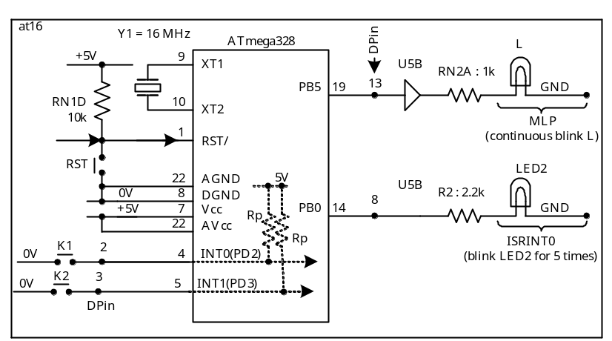(a) Telling the MCU to suspend (not stop) what it has been doing (the main line program, MLP). For example: The MCU has been continuously blinking the LED (L) of the Arduino Learning Kit (Fig-6.1).

Figure-6.1: Diagram to explain meaning of interrupting the MCU

The command by which we tell the MCU to suspend the MLP is given in the form of voltage logic, and it is applied on Pin-4 of the MCU. This command signal is known as Interrupting Signal or Interrupt Request Signal (IRQ). In Fig-6.1, the IRQ-signal is applied using a switch (K1); it is called Interrupting Device. The trigger level of the IRQ-signal is Active Low. It could be Rising Edge, Active High, or Falling Edge of a pulse. The internal pull-up resistor (Rp) keeps Pin-4 at LH-state. As the user presses down and releases K1, a momentary LL-signal appears at Pin-4. The MCU detects this change and immediately gets interrupted. The interrupt associated with Pin-4 has a symbolic name called INT0 (interrupt type 0). PD2 is the port-line that has been used to work as interrupt line. The direction of PD2-line must be input with internal pull-up enabled (connected).

The ATmega328 has another physical pin (Pin-5) which can also receive IRQ-signal from external source. The interrupt associated with Pin-5 is INT1 (interrupt type 1). As the IRQ-signal is coming from external hardware device, we call it Hardware Interrupt Signal (HWI).

The ATmega328 can also be interrupted from outside by toggling the logic level of one or more of its physical pin. This is known as Pin-change Interrupt.
(b) The MCU goes to the side job (the interrupt sub routine, ISR). Let us designate this side job with the symbolic name ISRINT0 (ISR due to INT0 interrupt). For example: The MCU blinks LED2 (connected at PB0-line) only for 5 times.
(c) The MCU will finish the ISRINT0, and then it will resume the MLP.

(2) The interrupt process of Step-1 can be described by the following diagram (Fig-6.2) which is known as Interrupt Process Diagram (IPD).
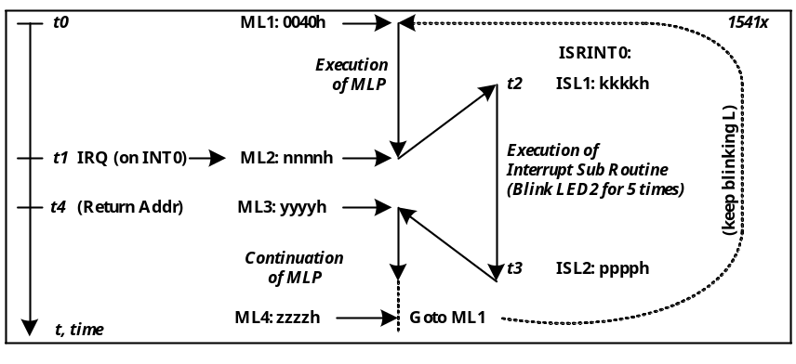

Figure-6.2: Interrupt Process Diagram for INT0

- Assume that the MLP has been uploaded into Code Memory (Flash) starting at location 0040h. The symbolic name of this location is ML1 (Label 1 of MLP). The ISRINT0 has also been uploaded into flash starting at an arbitrary location of kkkkh. The MLP has begun execution at time, t₀.
- At time t₁, the MLP has arrived at label ML2 and during the execution of the instruction of this label, the MCU has received IRQ-signal at its INT0-pin. If IRQ-signal would not be present, the MCU would continue its MLP by executing the next instruction at label ML3. The label ML3 is known as Return Address from which the MCU will resume MLP after returning from ISRINT0.
- As the IRQ-signal has arrived, the MCU will finish the current instruction of label ML2; it will save the return address (the numerical value yyyyh of ML3) onto a special block of internal SRAM known as Stack Memory or simply Stack.
- The MCU will jump to the beginning address (kkkkh with label ISL1) of ISRINT0 and will begin the execution of the ISR at time t₂. Just after the arrival at the ISRINT0, the user may save some important data onto Stack by executing push instruction.
- At time t₃, the MCU will finish the execution of the ISRINT0; it is now ready to return to the MLP. The MCU will first retrieve the important data from Stack by executing pop instruction and then the MCU will execute reti (return from interrupt) instruction to retrieve return address (yyyyh of ML3) from the Stack.
- MCU will resume the execution of MLP at label ML3 and it will happen at time t₄.
- At label ML4, the MCU will jump back to label ML1 in order to continue the blinking process of LED (L).

