6.2 The Interrupt Vector and its relation with the Beginning Address of the ISR
(1) In Section-6.1, we have seen that the interrupt process is involved with two jobs: MLP and ISR. The MCU keeps executing the MLP (blinking L). When an interrupt occurs, the MCU is forced to suspend the MLP, and then it jumps to the ISR. Now, the question: how does the MCU know the beginning address of the ISR, which the used has arbitrarily assigned? In this Section, we will explore this issue and other concepts of interrupt.
(2) The Memory Map of Fig-6.3 shows storage scenario of MLP and ISR. The boundary addresses for various blocks of memory spaces are arbitrarily chosen except for Interrupt Vector Space and Boot Loader Space which are almost fixed.
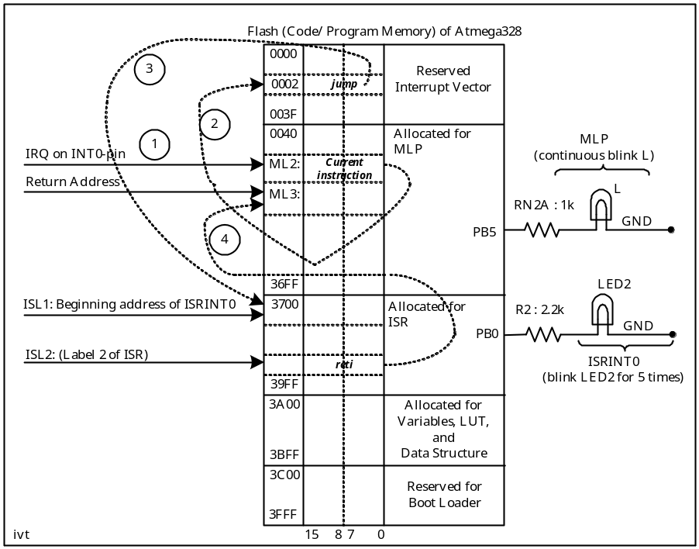

Figure-6.3: Memory Map showing the storage of MLP and ISR

(3) In Assembly Language Programming, we can fix the beginning address of MLP and ISRINT0 at desired locations using the directives .org 0x0040 and .org 0x3700. In HL Programming, similar things are done; but, beyond the knowledge of the programmer. To understand the role of Interrupt Vector for helping the MCU to reach at the beginning address of ISRINT0, we will keep attention on values of the addresses of Fig-6.3.
(4) In the MLP, the MCU is busy in blinking the LED (L); the IRQ-signal may arrive at any time. This is known as asynchronous arrival of the IRQ-signal. There is absolutely no timing relationship between the stepping of the MLP instructions and the activation of the external interrupting device (K1 in Fig-6.1).
(5) Upon arrival of the IRQ-signal, as we will see in later sections, the MCU does suspend the MLP and goes to the ISRINT0 to blink LEDR2. The question: how does the MCU know the value (3700h) of the beginning address of ISRINT0, which the user has keyed at his own choice?
(6) The answer to the question of Step-5 is here. The architecture of the ATmega328 dictates that the MCU will make an automatic jump to location 0002h whenever an IRQ-signal (assuming that the interrupt gates are closed!, Fig-6.4) arrives at its INT0-pin. The MCU is transferring program control to a known memory location; it can be compared with the concept of traditional vector (a directed line with an arrow head→). The number 0002h is termed as Interrupt Vector. It is an interrupt vector as it has appeared due to the presence of an interrupt signal. In ATmega328, there is an interrupt vector for every interrupt. The ATmega328 supports as many as 26 interrupts. The memory block known as Interrupt Vector Space (Fig-6.3) of the flash has been kept aside to accommodate the interrupt vectors of all these 26 interrupts.
(7) Now, the user (the programmer) knows the location 0002h; he also knows the value of the beginning address of his ISRINT0, which is 3700h. During initialization, the user can comfortably establish the link between these two locations by inserting the ‘jmp 0x3700’ instruction at location 0x0002.

