6.3 Internal Structure of INT0 Interrupt Logic
ATmega328 can be made to appear as a smart machine when it is efficiently trained thorough programming. It has many features which can be conditioned to provide various functions according to the needs of the users. Among all these features, the ability of the MCU to make quick response to external and internal interrupts is seen as its most sophisticated faculty. The HLL Programming Language hides to the users (programmers) many of the internal hardware details of the MCU. As a result, the programmer faces extreme difficulties to correct a malfunctioning program in a situation where multiple peripheral devices are engaged in data exchange through nested interrupts. In this section, we will explore the internal hardware details of INT0-interrupt (Fig-6.4) in order to formulate methodology for smooth development of program for an interrupt process.

(1) Conceptual View of the internal hardware details of INT0-interrupt is depicted in Fig-6.4.
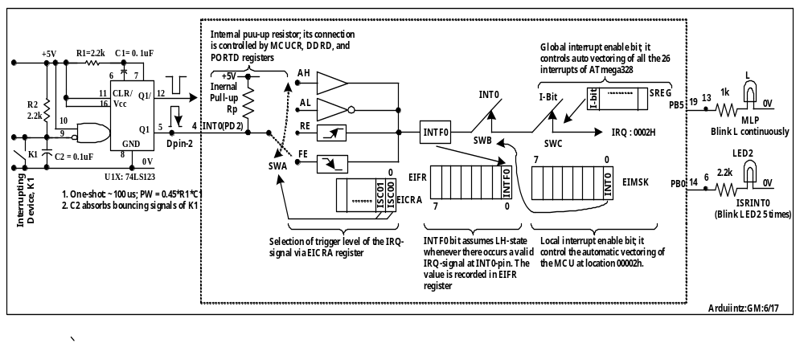

Figure-6.4: Internal structure of INT0 interrupt of ATmega328

(2) In Fig-6.4, we have interfaced the interrupting device (K1) through a one-shot IC of type 74LS123. This is to avoid multiple generation of IRQ-signal which the switch K1 will create once it is pressed down. A mechanical key like K1 makes hundreds of to-and-fro movements (bouncing) before it settles to its final open/close position. The insertion of U1X (74LS123) ensures that the INT0-pin will always receive only one clean, sharp, and short-duration (about 100 µs) interrupt pulse.
(3) The IRQ-signal from Pin-5 of U1X enters at DPin-2 (Digital Pin 2) of the Arduino. The DPin-2 is solidly connected with Pin-4 (INT0/PD2-pin) of the ATmega328 via PCB track.
(4) The interrupt logic can be programmed to detect any one of the following four characteristics of the incoming IRQ-signal: Low level, Rising Edge, High Level, and Falling Edge. The programming is done by putting appropriate data (described in the data sheet) into the EICRA (External Interrupt Control Register A) of the MCU.
(5) To detect Low Level or falling Edge of the IRQ-signal, the internal or external pull-up resistor must be connected. The internal pull-up is enabled with the help of MCUCR- , DDRD-, and PORTD-registers of the MCU.
(6) To detect High Level or Rising Edge of the IRQ-signal, the internal or external pull-up resistor must remain disconnected; instead, an external pull-down resistor (about 5k) must be connected with the INT0-pin.
(7) Whenever an IRQ-signal arrives at the INT0-pin, it is always detected by the interrupt logic circuit and its presence is recorded by putting LH in the INTF0 (Interrupt-0 Flag) bit of the EIFR-register (External Interrupt Flag Register) under the following conditions:
(a) If the trigger level of the IRQ-signal is Low or High, then the INTF0-bit will remain at LH-state as long as the IRQ-signal remains active. This means that the active level of the IRQ-signal is not latched.
(b) If the trigger level of the IRQ-signal is Falling Edge or Rising Edge, then the INTF0-bit will remain at LH-state even at the absence of IRQ-signal. This means that the active level of the IRQ-signal is latched.
(8) The MCU on behalf of the user can deliver services to the interrupter by looking at the INTF0-bit. This is known as Polling Interrupt. In this case, the user has to clear the INTF0-bit manually (using instruction) by putting LH back into this bit.
(9) The MCU can also deliver services to the interrupter being interrupted by the INTF0-bit. This will happen (MCU will be interrupted) if the INT0- and I-switches are kept in closed conditions during initialization. Upon interruption, the MCU automatically jumps to location 0x0002 (the vector location) from which it is again directed to jump at the beginning of ISRINT0 subroutine (Interrupt Sub Routine due to INT0 interrupt). This process of delivering services through interrupt is known as Vector Interrupt. During vectored interrupt, the INTF0-bit is automatically cleared when the MCU arrives at the ISRINT0.
(10) The INT0-switch corresponds to a bit-0 of the EIMSK (External Interrupt mask Register) register. This bit controls the automatic vectoring of the INT0-interrupt only. This bit is known as local interrupt enable/disable switch/gate.
(11) The I-switch corresponds to bit-7 of the SREG (Status Register) register of the MCU. It controls auto vectoring of all the 26 interrupts of the ATmega328. This bit is known as global interrupt switch/gate.
(12) Upon entering into the ISRINT0, the MCU disables all interrupts by putting LL at the I-bit of the SREG-register. The local interrupt bit remains unaffected.
(13) After finishing the ISRINT0 and before making a return to MLP, the MCU enabled the global interrupt by putting LH at the I-bit of the SREG-register. The MCU is again ready to response to interrupts.
(15) IO Registers involved in the Operation of INT0-interrupt
(a) EICRA : External Interrupt Control register A : It selects trigger level of IRQ-signal.
(b) EIFR : External Interrupt Flag Register : It records the status of the arrival of IRQ-signal
(c) EIMSK : External Interrupt Mask Register : It controls open/close of INT0-switch.
(d) SREG : Status Register : It control open/close condition of I-switch.
(e) MCUCR: MCU Control Register : Controls open/close of internal pull-up
DDRD : Data Direction Register for PORTD : Controls open/close of internal pull-up
PORTD : Port-D Register : Controls open/close of internal pull-up
(15) Although the above statements are specifically made referring to INT0 interrupt for clarity and brevity, they are equally and generally applicable for all kinds of polled/vectored interrupts.

