6.4 Development of Program for Functional Check of INT0-interrupt
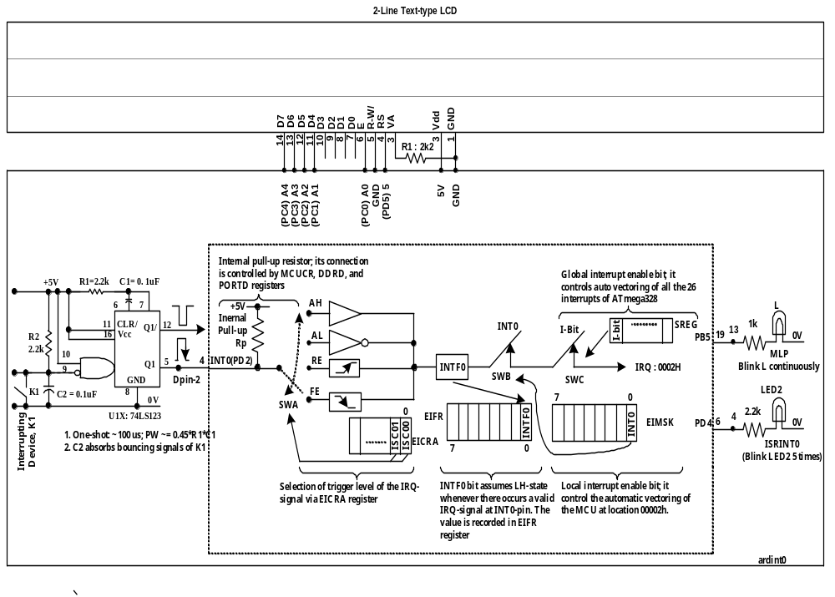Refer to Fig-6.5 shown below; MLP program is designed to blink LED (L) continuously. The ISRINT0 program will blink LED2 only for 5 times. The K1 is the interrupting device. The LCD panel is added to monitor MCU-registers’ values at different phases of the executing interrupt process.

Figure-6.5: Arduino UNO based set up for functional check of INTO interrupt

(1) Text/Pseudo/Mixed Codes
Void setup()
{
L11: Establish link between Interrupt Vector Address (0x0002) of INT) with its routine (ISRINT0)
IRQ → INT0 → INTF0 → 0x0002 → ISRINT0
.org 0x0002
rjmp ISRINT0

- The codes of the ISRINT0 routine come after the codes of setup() and loop() functions; the assembler can always compute the numerical value of the offset of ISR subroutine. During final phase of assembly, the symbolic name ISRINT0 is replaced by the numerical value of this offset. Upon interruption, the MCU has no difficulty to reach at the interrupt sub routine.

- In HLL programming, the above task of L11 is carried out by declaring the ISRINT0 as a function with a pre-defined name and argument: ISR(INT0_vect). During compilation time, the compiler understands that the stated subroutine (ISR) will be called upon when there is an interrupt on the INT0-pin whose interrupt vector is 0x0002.
- In HLL Programming, the task L11 can also be carried out by declaring another kind of function whose three arguments are passed as symbolic names. These symbolic names have pre-defined meanings; the meanings are transformed into executable binary numbers during compilation time. The function:
attachInterrupt (arg1, arg2, arg3);
(i) arg1 : digitalPinToInterrupt(2) ; the function says that the ‘Digital Pin 2’ of Arduino, which is solidly connected with INT0(PD2/Pin-4)-line of the ATmega will work as interrupt line for Interrupt Type 0. And accordingly, the PD2-line will work as input-line with internal pull-up resistor connected.

(ii) arg2 : ISRINT0(); the function carries its name after the name of the user declared-defined interrupt sub routine. This says that the function referred by arg2 will always be linked with the interrupt vector (0x0002) of the interrupt type (here INT0) declared in arg1.

(iii) arg3 : Trigger level of the IRQ-signal (AL, RE, AH, or FE). The compiler knows the meanings of these symbolic names and assigned appropriate values into the controlling registers of the MCU.
//----------------------------------------------------------------------------------------------------------------------------
L12: Initialize LCD as needed (LCD type and Cursor Position)
//-------------------------------------------------------------------------------------------------------------------------------------- L13: Configure PD2-line (with internal pull-up) to work as interrupt line for INT0 interrupt
L14: Select trigger level of IRQ-signal (Falling Edge)
L15: Close local INT0-switch for auto vectoring to ISRINT0
L16: Close global I-switch for auto vectoring to ISRINT0
//-----------------------------------------------------------------------------------------------------------------------------
L17: Set direction of PB5-line as output to drive L of MLP
L18: Set direction of PD4-line as output to drive LED2 of ISR(INT0_vect)
//-----------------------------------------------------------------------------------------------------------------------------
}

Void loop()
{
L21: ON LED (L)
L22: Insert 1-sec Time Delay
L23: OFF LED (L)
L24: Insert 1-sec Time Delay
}

ISRI(INT0_vect)
{
L31: Enable global interrupt via I-switch // with this delay() function will not work here
//------------------------------------------------------------
L32: ON LED2
L33: Insert 1-sec Time Delay
L34: OFF LED2
L35: Insert 1-sec Time Delay
L36: Repeat Step-L32 to L35 for 4 times more.
//------------------------------------------------------------
L37: Return to Main Line Program (MLP)
}

P642 (2) Arduino Coding-A for the program codes of Step-1
#include <LiquidCrystal.h>
//LiquidCrystal lcd(RS, E, D4, D5, D6, D7); //declaration of LCD wiring function
LiquidCrystal lcd (5, A0, A1, A2, A3, A4); //definition of LCD wiring function

Void setup()
{
//Task of L11 is done by declaring ISR(INT0_vect) function at the end of loop() function

lcd.begin(16, 2); //L12: 16x2 LCD ; 2-line; each line has
lcd.setCursor(1, 0); //L12: DP1 postion of TopLine

//----- the following six lines connects internal pull-up with PD2-line------------------
DDRD = B11111011; //L13: PD2 as input; value has come from data sheet
bitSet(PORTD, 2); //L13:
bitClear(MCUCR, 4); //L13
//---------------------------------------------------
EICRA = B00000010; //L14: falling edge trigger level for of INT0; value comes from data sheet
EIMSK = B00000001; //L15: local INT0-switch is closed; value has come from data sheet
bitSet(SREG, 7); //L16: Global I-switch is closed; alternate code : sei() ; opposite : cli()

//---------------------------------------------------
pinMode(13, OUTPUT); //L17:
pinMode(4, OUTPUT); //L18:

lcd.print(EIMSK, 16); //check INT0-bit for 1 before the MLP is interrupted
lcd.setCursor(5, 0); //
lcd.print)SREG, 16); // check I-bit for 1 before MLP is interrupted

}

Void loop()
{
digitalWtite(13, HIGH); //L21:
delay(1000); //L22:
digitalWrite(13, LOW); //L23:
delay(1000); //L24
}

ISR(INT0_vect)
{
lcd.setCursor(1, 1); //cursor at DP1 bottomLine
lcd.print(EIMSK, 16); //check INT0-bit for 1 after interruption
lcd.setCursor(5, 1);
lcd.print(SREG, 16); //check I-bit for 0 after interruption

interrupts(); //L31: Set I-bit of SREG-register; global I-switch is closed

for (int n=0; n<=4; n++)
{
digitalWrite(4, HIGH); //L32:
delay(1000); //L33:
digitalWrite(4, LOW); //L34:
delay(1000); //L35;
//--------------------------------------
reti(); //L37: Return to MLP from ISR
}

(3) Compile and upload P642 of Step-2. Press the interrupting device K1. Check that the interrupt process works as expected. Also, monitor the values of EIMSK- and SREG-registers in the LCD. Decode their contents looking at the data sheet and observe that the I-bit becomes LL after interruption; but, the INT0-bit remains unaffected.

(4) Arduino Instruction Set Summary for Interrupts

SNn. | Function/Statement | Arg1 | Arg2 | Arg3 | Action
1 | cli() | - | - | - | Disables all interrupts  I-switch opens
 | sei() | - | - | - | Enables all interrupts  I-switch closes
3 | interrupts() | - | - | - | I-switch closes
4 | noInterrupts() | - | - | - | Remove action of Step-3
5 | reti() | - | - | - | Return from ISR to MLP
6 | attachInterrupt(arg1, arg2, arg3) | Digital-PinToInterrupt  (2 or3)  For INT0 and  INT1 | IsrName  As given by user | Trigger level | Connects pull-up  INT0-switch closes  I-switch closes  Links ISR with Int. Vector
7 | detachInterrupt() | - | - | - | Removes all actions of Step-6
8 | EICRA = 0xnn | - | - | - | Sets trigger level
9 | EIMSK = 0xnn | - | - | - | INT0/INT1-switch
10 | SREG = 0xnn | - | - | - | I-switch control

P645 (5) Arduino Coding-B for the program codes of Step-1
#include <LiquidCrystal.h>
//LiquidCrystal lcd(RS, E, D4, D5, D6, D7); //declaration of LCD wiring function
LiquidCrystal lcd (5, A0, A1, A2, A3, A4); //definition of LCD wiring function

Void setup()
{
//Task of L11 is done by declaring ISR(INT0_vect) function at the end of loop() function

lcd.begin(16, 2); //L12: 16x2 LCD ; 2-line; each line has
lcd.setCursor(1, 0); //L12: DP1 postion of TopLine

//----- the following single function does all tasks of----------------------------
attachInterrupt(digitalPinToInterrupt(2), ISRINT0, FALLING); //L13-L16

//---------------------------------------------------
pinMode(13, OUTPUT); //L17:
pinMode(4, OUTPUT); //L18:
lcd.print(EIMSK, 16); //check INT0-bit for 1 before the MLP is interrupted
lcd.setCursor(5, 0); //
lcd.print)SREG, 16); // check I-bit for 1 before MLP is interrupted

}

Void loop()
{
digitalWtite(13, HIGH); //L21:
delay(1000); //L22:
digitalWrite(13, LOW); //L23:
delay(1000); //L24
}

Void ISRINT0()
{
EIMSK = 0x00;
lcd.setCursor(1, 1); //cursor at DP1 bottomLine
lcd.print(EIMSK, 16); //check INT0-bit for 1 after interruption
lcd.setCursor(5, 1);
lcd.print(SREG, 16); //check I-bit for 0 after interruption
//--------------------------------------------------
interrupts();; //L31: Set I-bit of SREG-register; global I-switch is closed

lcd.setCursor (9, 1);
lcd.print(EIMSK, 16);
for (int n=0; n<=4; n++)
{
digitalWrite(4, HIGH); //L32:
delay(1000); //L33:
digitalWrite(4, LOW); //L34:
delay(1000); //L35;
}

reti(); // must be here for the MCU to return to MLP properly
}

(6) Compile and upload P645 program. Press the interrupting switch K1 and check that the interrupt process works as scheduled.
(7) Insert suitable commands at te chosen points of the program P645 in order to verify the validity of the instruction of Step-4.

