**Question 1:** Create a Data base product_db

**CODE:**

Create database product_db;

**Output :**

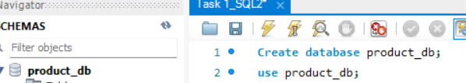

**Question 2:**

Create a table with the name "product" with the following columns

product_id - integer

product - string - size 10

quantity - integer

price - integer

purchase_cost - integer

estimated_sales_price - float

**CODE:**

use product_db;

create table product(

Product varchar(10),

Quantity int,

Price int,

purchase_cost int,

Estimated_sales_price float

);

desc product;

**Question 3:**

Display all column names and their datatype and size in product.

**CODE:**

desc product;

**OUTPUT:**

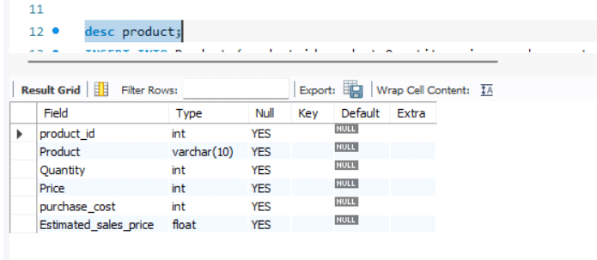

**Question 4:**

Insert the below two records into product table .

**(1)-- 1st record with values**

-- product_id : 1

-- Product : PayCard

-- Quantity: 2

-- price : 300

-- Puchase_cost : 8000

-- estimated_sale_price: 9000.56

**CODE:**

INSERT INTO product(product_id,product,Quantity,price,purchase_cost,estimated_sales_price) values(1,'paycard',2,300,8000,9000.56);

select*from product;

**OUTPUT:**

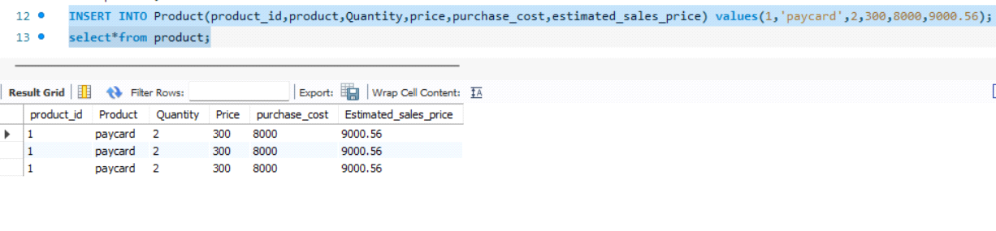

**(2)-- 2nd record with values**

-- product_id : 2

-- Product : PayPoints

-- Quantity: 4

-- price : 200

-- Puchase_cost : 7000

-- estimated_sale_price: 6700.56

**CODE:**

INSERT INTO Product(product_id,product,Quantity,price,purchase_cost,estimated_sales_price) values(2,'paypoints',4,200,7000,6700.56);

select*from product;

**OUTPUT:**

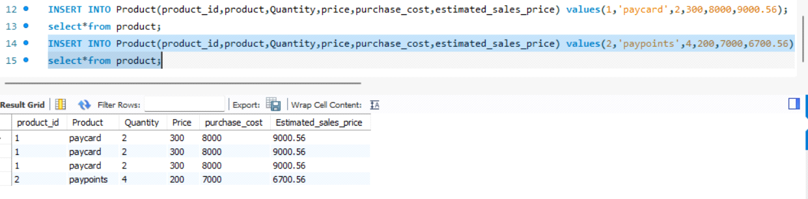

**Question 5:**

Add a column : "location" to the existing product table with data type varchar and size 50

**CODE:**

ALTER TABLE product ADD COLUMN Location varchar(50);

select*from product;

**OUTPUT:**

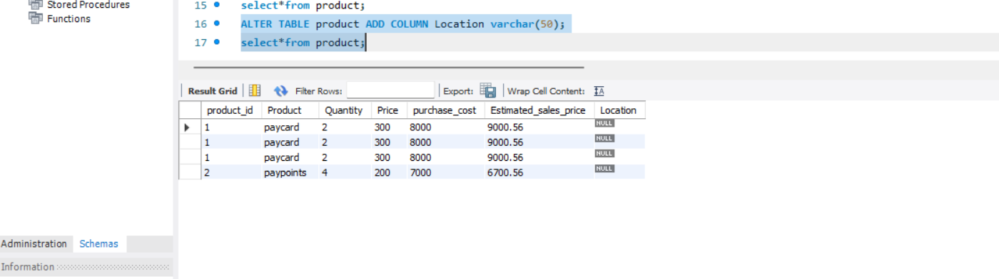

**Question 6:**

Update the value of the location

-- update location as USA for product_id = 1

-- update location as India for product_id = 2

**CODE:**

UPDATE product SET location = 'USA' WHERE product_id = 1;

UPDATE product SET location = 'INDIA' WHERE product_id = 2;

**OUTPUT:**

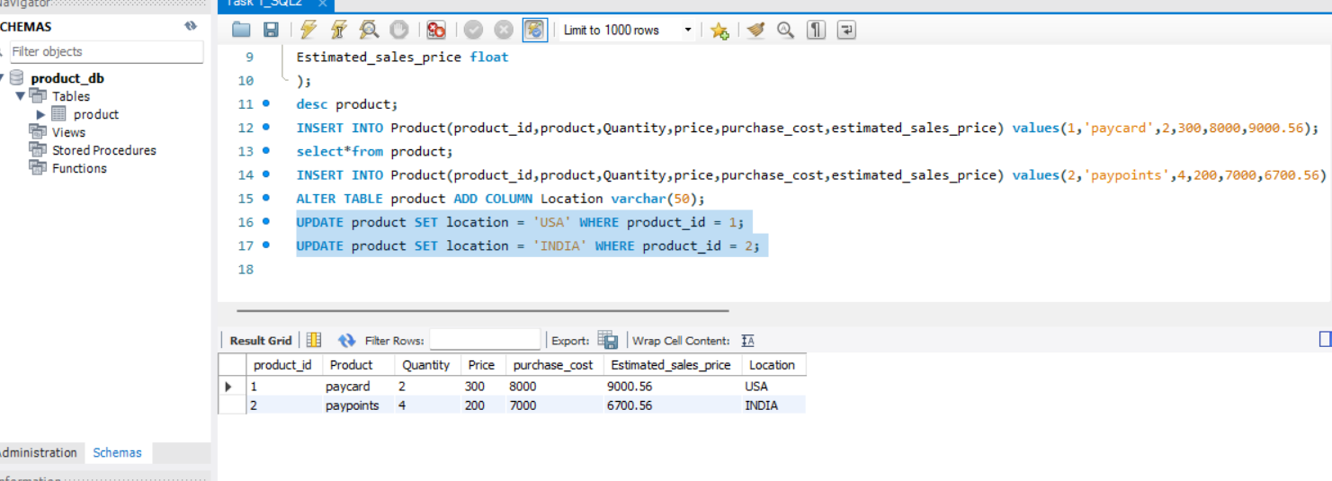

**Question 7:**

What is the value of location for product : ‘PayCard’?

**ANS: USA**

**Question 8:**

Update the product column to size of 25

**CODE:**

ALTER TABLE product MODIFY product varchar(25);

**OUTPUT:**

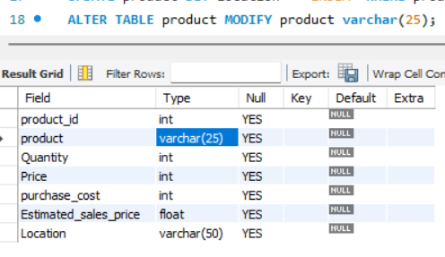

**Question 9:**

Reduce the size of the location field from 50 to 20 and check if it is possible.

**CODE:**

ALTER TABLE product MODIFY Location varchar(20);

**OUTPUT:**

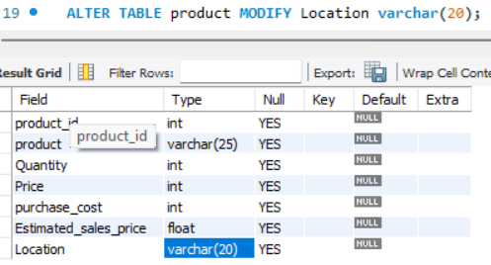

Question 10:

Update the quantity information of ‘PayCard’ product details .

-- For ‘PayCard’ product, Update the quantity from 2 to 10

**CODE:**

UPDATE product SET Quantity = 10 WHERE Quantity = 2;

**OUTPUT:**

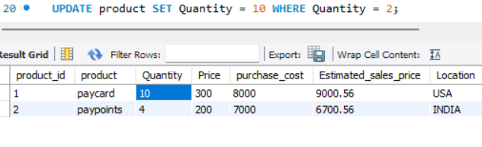

**Question 11:**

insert one more row/record to the table

record with values

-- product_id : 4

-- Product : Creditcard

-- Quantity: 2

-- price : 500

-- Puchase_cost : 900

-- estimated_sale_price: 750

-- location : India

**CODE:**

**INSERT INTO Product(product_id,product,Quantity,price,purchase_cost,estimated_sales_price,Location) values(4,'Credit Card',2,500,900,750,'India');**

**OUTPUT:**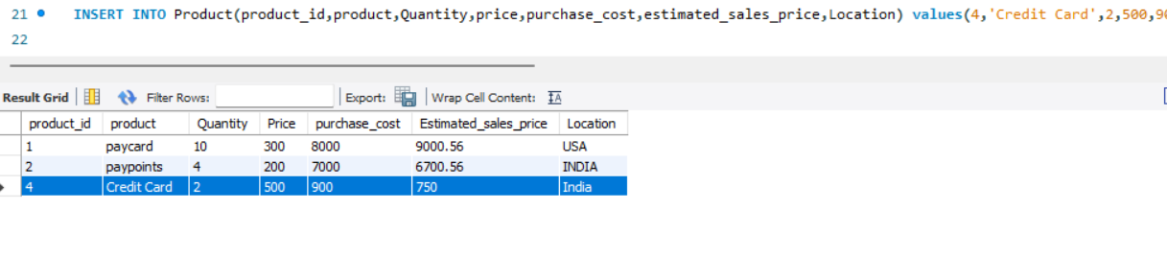

**Question 12:**

insert below two row/record to the table by using one query

record with values

1) -- product_id : 5

3 -- Product : debitcard

-- Quantity: 4

-- price : 500

-- Puchase_cost : 2000

-- estimated_sale_price: 1850

-- location : UK

2) -- product_id : 6

-- Product : buyback

-- Quantity: 20

-- price : 500

-- Puchase_cost : 10000

-- estimated_sale_price: 9800.95

-- location : USA

**CODE:**

**INSERT INTO Product(product_id,product,Quantity,price,purchase_cost,estimated_sales_price,Location)**

**VALUES(5,'Debit Card',4,500,2000,1850,'UK'),**

**(6,'Buy Back',20,500,1000,9800.85,'India');**

**OUTPUT:**

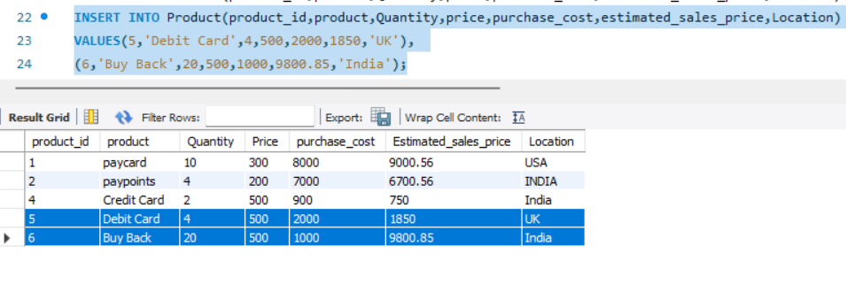

**Question 13:**

add a column zip_code to the product table

**CODE:**

**ALTER TABLE product ADD COLUMN Zipcode int;**

**OUTPUT:**

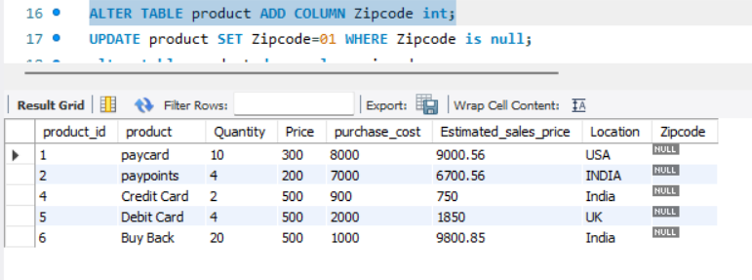

**Question 14:**

update zip_code to the product table by some random unique zip code to the product

**CODE:**

**update product set zipcode = 624103 where product_id=1;**

**UPDATE product SET Zipcode=624100 WHERE Zipcode is null;**

**OUTPUT:**

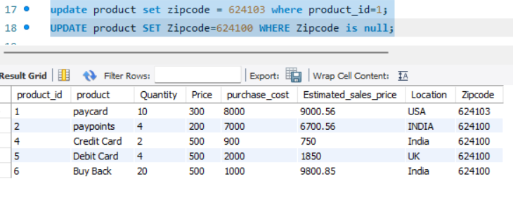

**Question 15:**

drop the column zip_code from the table

**CODE:**

ALTER TABLE product DROP COLUMN zipcode;

**OUTPUT:**

