Question 1:

Write a small explanation of all commands in Data Control Language (DCL) and Transaction Control Language (TCL), along with some examples.

ANS:

**Commands in Data Control Language (DCL) :**

1). Grant - This command gives the user access privileges to database

* Syntax : **GRANT SELECT, UPDATE ON MY_TABLE TO USER1, USER2;**

**Example :**

GRANT SELECT, INSERT, SELECT, UPDATE ON Users TO ‘ Name’@’ localhost;

GRANT ALL ON Users TO ‘ Name’@’ localhost;

GRANT SELECT ON Users TO ‘ **\***’@’ localhost; (**\* Refers to all users in Database)**

2). Revoke - This command will withdraw the user’s access privileges given by using grant command.

* Syntax : **REVOKE SELECT, UPDATE ON MY_TABLE FROM USER1, USER2;**

**Example :**

REVOKE SELECT, INSERT, SELECT, UPDATE ON Users FROM ‘ Name’@’ localhost;

REVOKE ALL ON Users FROM ‘ Name’@’ localhost;

REVOKE SELECT ON Users FROM ‘ **\***’@’ localhost;

**Commands in Transaction Control Language (TCL) :**

TCL is used to manage the transaction in relational database / used to manage transactions within the database.

1. Commit 2. RollBack 3. SavePoint

1). Commit :

The COMMIT command in SQL is used to permanently save any transaction into the database. Generally, whenever we use any DML command such as INSERT, UPDATE, or DELETE, the changes made by these commands are not permanent. Hence, before closing the current session, we may roll back any changes made through these commands.

Due to the above reason, it is mandatory to use the COMMIT command to mark any changes made as permanent.

Note : If auto commit is enabled then all the transaction will automatically be saved in to data base.

🡺 Once we have done a **COMMIT**, we cannot undo it. We can, however, rollback, but doing a rollback will undo the entire transaction.

* Syntax **: COMMIT**;
* We must write the COMMIT command before and after every DDL command to save the change permanently in the database.
* Once COMMIT is performed, it cannot be undone unless it is rolled back.

2). RollBack :

The rollback command in TCL is used for **restoring the database to the last committed state**. In other words, the rollback command restores the database to its original state since the last command that was committed.

The rollback command will basically revert or roll back any changes that were not committed during our transaction using the COMMIT command.

* Syntax : ROLLBACK;
* ROLLBACK is used to undo the transactions that have not already been permanently saved (or committed) to the database.
* The ROLLBACK command restores the previously stored value, that is, the data present before the execution of the transactions.

Interestingly, the rollback command can also be used with the SAVEPOINT command to jump to a savepoint in any ongoing transaction.

* Syntax : SAVEPOINT savepoint_name;

EX: if we already given Savepoint A;

Savepoint B;

Savepoint C;

Then to roll back 🡺 **Rollback to B;** then the transaction after savepont B will not be stored and we will not get savepoint C transaction in output.

3). Savepoint :

The SAVEPOINT command in TCL is basically used to temporarily save a transaction so that we can roll back to that point (saved point) whenever required.( used for Rollback purpose)

* Syntax : SAVEPOINT savepoint_name;

Also, we can release a savepoint, meaning, remove any particular savepoint. The syntax to release a savepoint is given below :

* Syntax : RELEASE SAVEPOINT savepoint_name;

Question 2:

create an table "customer" with following columns

cust_id -- small int

cust_no -- medium int

cust_firstname -- char

cust_lastname -- varchar

cust_gender -- varchar

cust_dob -- DATE

cust_age -- int

cust_revenue -- decimal

cust_spend_amt -- float

cust_address -- TEXT

cust_city -- CHAR

cust_comments -- TEXT

cust_status -- ENUM (active, Inactive)

cust_available -- BOOLEAN

Note : column size as per your wish and enter 5 records into the table

**CODE:**

Create table Customer (

cust_id Smallint,

cust_no mediumint,

cust_firstname char(20),

cust_lastname varchar(20),

cust_gender varchar(10),

cust_dob DATE,

cust_age int,

cust_revenue Decimal,

cust_spend_amt Float,

cust_address TEXT,

cust_city CHAR(20),

cust_comments TEXT,

cust_status ENUM('active', 'Inactive'),

cust_available BOOLEAN

);

select*from customer;

INSERT INTO Customer (cust_id, cust_no, cust_firstname, cust_lastname, cust_gender, cust_dob, cust_age, cust_revenue, cust_spend_amt, cust_address, cust_city, cust_comments, cust_status, cust_available)

VALUES

(1, 1001, 'John', 'Doe', 'Male', '1990-05-15', 31, 50000.00, 1500.00, '123 Main St', 'New York', 'Regular customer', 'active', true),

(2, 1002, 'Jane', 'Smith', 'Female', '1985-09-22', 36, 75000.00, 2000.00, '456 Elm St', 'Los Angeles', 'VIP customer', 'active', true),

(3, 1003, 'Michael', 'Johnson', 'Male', '1978-03-10', 43, 60000.00, 1800.00, '789 Oak St', 'Chicago', 'Preferred customer', 'active', true),

(4, 1004, 'Emily', 'Williams', 'Female', '1995-12-03', 26, 45000.00, 1200.00, '101 Pine St', 'Miami', 'New customer', 'active', true),

(5, 1005, 'David', 'Brown', 'Male', '2000-07-28', 21, 35000.00, 1000.00, '202 Maple St', 'San Francisco', 'Regular customer', 'active', true);

**OUTPUT:**

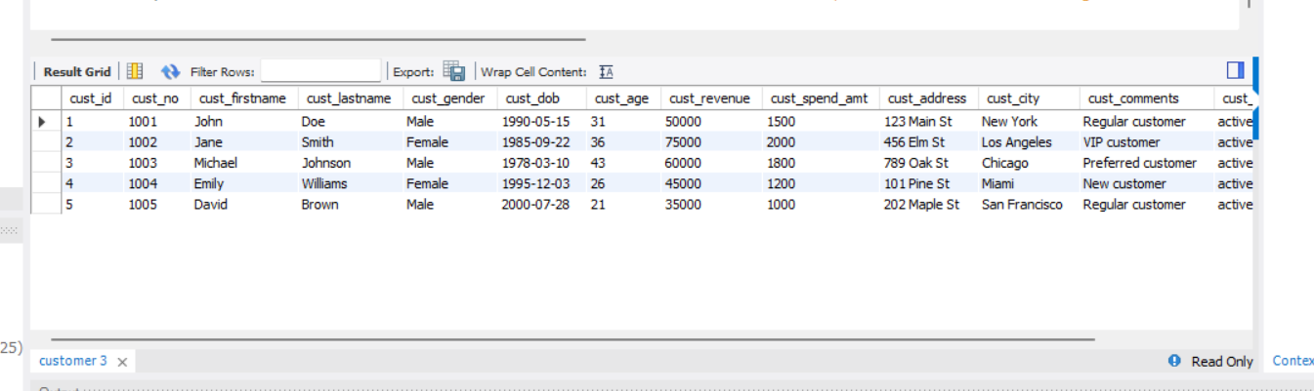

Question 3:

The output of the SELECT statement should be a single column

1. convert a value of the cust_id column to string.

**CODE:**

SELECT CAST(cust_id AS CHAR) AS cust_id_string FROM Customer;

**OUTPUT**:

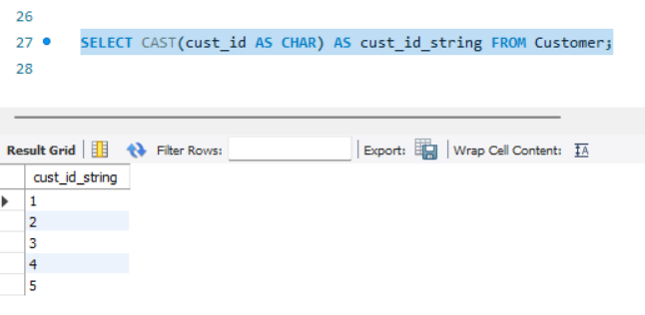

1. convert a value of the cust_dob column to date.

**CODE:**

SELECT CAST(cust_dob AS DATE) AS cust_dob_date FROM Customer;

**OUTPUT**:

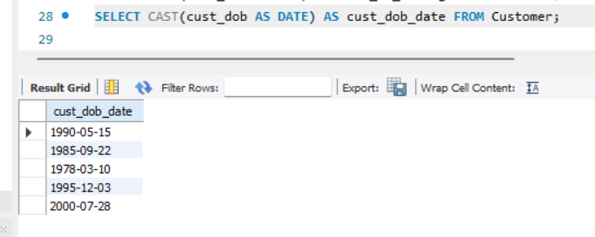

1. convert a value of the cust_revenue column to int

**CODE:**

Note : We cannot directly cast a DECIMAL column to INT using CAST. So that we can use CONVERT.

SELECT CONVERT(cust_revenue, SIGNED) AS cust_revenue_int FROM Customer;

**OUTPUT**:

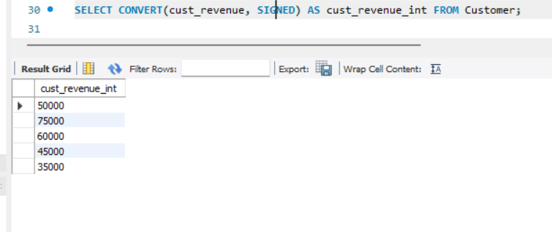

4) convert a value of the cust_available column to text

**CODE**:

SELECT CASE WHEN cust_available THEN 'true' ELSE 'false' END AS cust_available_text FROM Customer;

**OUTPUT**:

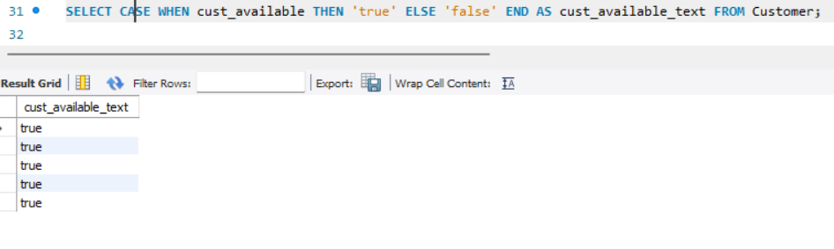

Question 4:

Return "Child" if the customer's age is less than 18,

“Adult Customer” if the customer's age is between 21 and 65,

and "Senior Customer" if the customer's age is greater than 65.

**CODE**:

SELECT CASE

WHEN cust_age < 18 THEN 'Child'

WHEN cust_age BETWEEN 21 AND 65 THEN 'Adult Customer'

WHEN cust_age > 65 THEN 'Senior Customer'

END AS Customer_is

FROM Customer;

**OUTPUT:**

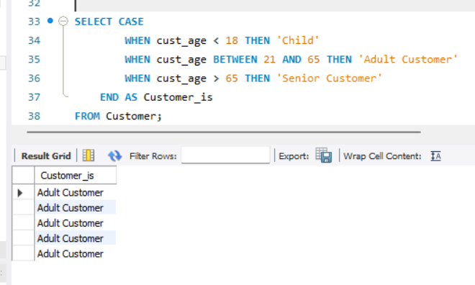

Question 5:

Alter the above table by adding the following constraints

cust_id -- not null

cust_no -- unique

cust_city -- default with a value NY

**CODE:**

ALTER TABLE Customer MODIFY COLUMN cust_id SMALLINT NOT NULL;

ALTER TABLE Customer ADD CONSTRAINT UNIQUE (cust_no);

ALTER TABLE Customer MODIFY COLUMN cust_city CHAR(20) DEFAULT 'NY';

Question 6:

Create a table called 'Employees' with the following columns:

EmployeeID as an integer primary key

Name as a non-null varchar(50)

Age as an integer with a check constraint that ensures the age is greater than or equal to 18

Department as a varchar(50) with a default value of 'IT'.

Insert some value and if its failed to insert, will provide the some comment on why it was failing

**CODE:**

CREATE TABLE Employees (

EmployeeID INT PRIMARY KEY,

Name VARCHAR(50) NOT NULL,

Age INT CHECK (Age >= 18),

Department VARCHAR(50) DEFAULT 'IT'

);

INSERT INTO Employees (EmployeeID, Name, Age, Department) VALUES (1, 'John', 25, 'HR');

INSERT INTO Employees (EmployeeID, Name, Age) VALUES (2, 'Jane', 17, 'Marketing'); // This insert is failing due to age constraint that we set

INSERT INTO Employees (EmployeeID, Name, Age, Department) VALUES (3, 'Johnson', 30, 'Finance');

INSERT INTO Employees (EmployeeID, Name, Age, Department) VALUES (4, 'William', 22, 'IT');

INSERT INTO Employees (EmployeeID, Name, Age, Department) VALUES (5, 'David', 16); // This insert is failing due to age constraint that we set

Question 7:

Create an table "customers_data" with below columns

customer_id -- INT -- PRIMARY KEY

customer_name -- VARCHAR(255) -- NOT NULL,

Create an table "orders" with below columns

order_id -- INT -- PRIMARY KEY ,

customer_id -- INT -- NOT NULL ,

order_date -- DATE

Make an connection(link) between customers_data and orders tables

explain what operation you did for that.

**CODE:**

CREATE TABLE customers_data (

customer_id INT PRIMARY KEY,

customer_name VARCHAR(255) NOT NULL

);

CREATE TABLE orders (

order_id INT PRIMARY KEY,

customer_id INT NOT NULL,

order_date DATE,

FOREIGN KEY (customer_id) REFERENCES customers_data(customer_id)

);

🡺In “customers_data” table customer_id is PRIMARY KEY which REFENCES in “Orders” table. We can link this both table by using FOREIGN key of Customer_id from “Order table”

Question 8:

Enter some random 5 records of data into customers_data and orders table.

**CODE:** (customers_data)

INSERT INTO customers_data (customer_id, customer_name)

VALUES (1, 'Shiv'),(2, 'Dev'),(3, 'Asthra'),(4, 'Isha'),(5, 'Bhramma');

**OUTPUT**: (customers_data)

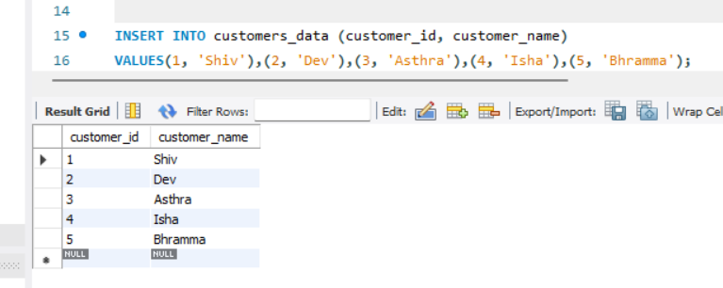

**CODE:** (Orders table)

INSERT INTO orders (order_id, customer_id, order_date)

VALUES (101, 1, '2023-08-01'),(102, 2, '2023-08-02'),(103, 1, '2023-08-03'),(104, 3, '2023-08-04'),(105, 2, '2023-08-05');

**OUTPUT**: (Orders table) 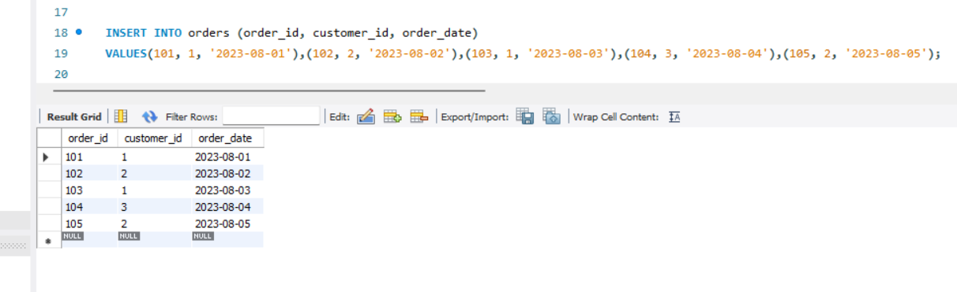

Question 9:

Remove any of 2 records from the customers_data and orders table.

Explain how to remove the data from the two tables in a steps

🡺We can remove data by using DELETE command.

CODE(Customers_data) :

DELETE FROM customers_data WHERE customer_id IN (4, 5);

**OUTPUT**:

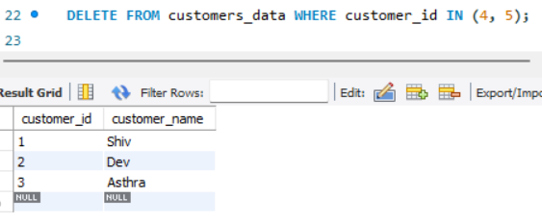

CODE (Order table):

DELETE FROM orders WHERE customer_id IN (4, 5);

**OUTPUT**:

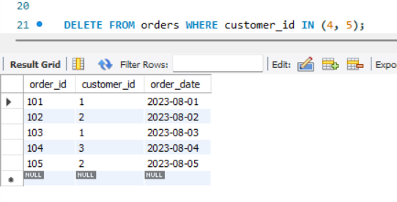

Question 10:

Difference between unique and primary key

🡺 The primary key will not accept NULL values whereas the Unique key can accept NULL values.

🡺 A table can have only one primary key whereas there can be multiple unique keys on a table.

|  |  |  |
| --- | --- | --- |
| **Parameters** | **PRIMARY KEY** | **UNIQUE KEY** |
| **Basic** | Used to serve as a unique identifier for each row in a table. | Uniquely determines a row that isn’t the primary key. |
| **NULL value acceptance** | Cannot accept NULL values. | Can accept NULL values. |
| **Number of keys that can be defined in the table** | Only one primary key | More than one unique key |
| **Index** | Creates clustered index | Creates non-clustered index |
| **Auto Increment** | A Primary key supports auto-increment value. | A unique key does not support auto-increment value. |
| **Modification** | We cannot change or delete values stored in primary keys. | We can change unique key values. |
| **Uses** | The primary Key is used for indicating the rows uniquely. | The Unique Key is used for preventing duplicate entries. |
| **Syntax** | CREATE TABLE Student  (  Student_Id INT PRIMARY KEY,  Student_name VARCHAR(150),  roll_number INT(10)  ) | CREATE TABLE House  (  House_Number INT UNIQUE,  House_Name VARCHAR(150),  House_Address VARCHAR(250)  ) |

Differnce between float, double and decimal

FLOAT 🡺Stores approximate values(0-24).

DOUBLE🡺 Stores more than precise values than FLOAT(>25 bits)

DECIMAL🡺Stores the exact values.