Table Definitions:

1. BANK_CUSTOMER - Details of Customers of the Bank

2. BANK_CUSTOMER_EXPORT - Details of Customers of the Bank - to be used only when explicitly asked.

3. Bank_Account_Details - Account Details of the customers along with ADD on cards. One customer can have multiple details for Savings deposits, Recurring deposits, Credit Cards and Add on credit cards.

4. Bank_Account_Relationship_Details - Details of secondary accounts linked to primary accounts.

5. BANK_ACCOUNT_TRANSACTION - Details of the transactions.

6. BANK_CUSTOMER_MESSAGES - Details of Messages sent to customers after a transaction takes place.

7. BANK_INTEREST_RATE - Current interest rates for savings, RD and other accounts.

8. Bank_Holidays - Details of Bank Holidays.

CREATE TABLE BANK_CUSTOMER

( customer_id INT PRIMARY KEY,

customer_name VARCHAR(20),

Address VARCHAR(100),

state_code VARCHAR(3) ,

Telephone VARCHAR(10) );

drop table BANK_CUSTOMER;

INSERT INTO BANK_CUSTOMER VALUES (123001,"Oliver", "225-5,Emeryville", "CA" , "1897614500");

INSERT INTO BANK_CUSTOMER VALUES (123002,"George", "194-6,New brighton","MN" , "1897617000");

INSERT INTO BANK_CUSTOMER VALUES (123003,"Harry", "2909-5,walnut creek","CA" , "1897617866");

INSERT INTO BANK_CUSTOMER VALUES (123004,"Jack", "229-5, Concord",null,null);

INSERT INTO BANK_CUSTOMER VALUES (123005,"Jacob", "325-7,Mission Dist","SFO", "1897637000");

INSERT INTO BANK_CUSTOMER VALUES (123006,"Noah", "275-9,saint-paul" , "MN" , "1897613200");

INSERT INTO BANK_CUSTOMER VALUES (123007,"Charlie","125-1,Richfield", "MN" , "1897617666");

INSERT INTO BANK_CUSTOMER VALUES (123008,"Robin","3005-1,Heathrow",null,null);

SELECT*from BANK_CUSTOMER;

CREATE TABLE BANK_CUSTOMER_EXPORT

(

customer_id CHAR(10)PRIMARY KEY,

customer_name CHAR(20),

Address CHAR(20),

state_code CHAR(3) ,

Telephone CHAR(10));

INSERT INTO BANK_CUSTOMER_EXPORT VALUES ("123001 ","Oliver", "225-5, Emeryville", "CA" , "1897614500") ;

INSERT INTO BANK_CUSTOMER_EXPORT VALUES ("123002 ","George", "194-6,New brighton","MN" , "189761700");

CREATE TABLE Bank_Account_Details

(Customer_id INT,

Account_Number VARCHAR(19) PRIMARY KEY,

Account_type VARCHAR(25) ,

Balance_amount INT,

Account_status VARCHAR(10),

Relationship_type varchar(1)) ;

ALTER TABLE Bank_Account_Details ADD FOREIGN KEY (Customer_id) REFERENCES bank_customer(Customer_id);

INSERT INTO Bank_Account_Details VALUES (123001, "4000-1956-3456", "SAVINGS" , 200000 ,"ACTIVE","P");

INSERT INTO Bank_Account_Details VALUES (123001, "5000-1700-3456", "RECURRING DEPOSITS" ,9400000 ,"ACTIVE","S");

INSERT INTO Bank_Account_Details VALUES (123002, "4000-1956-2001", "SAVINGS", 400000 ,"ACTIVE","P");

INSERT INTO Bank_Account_Details VALUES (123002, "5000-1700-5001", "RECURRING DEPOSITS" ,7500000 ,"ACTIVE","S");

INSERT INTO Bank_Account_Details VALUES (123003, "4000-1956-2900", "SAVINGS" ,750000,"INACTIVE","P");

INSERT INTO Bank_Account_Details VALUES (123004, "5000-1700-6091", "RECURRING DEPOSITS" ,7500000 ,"ACTIVE","S");

INSERT INTO Bank_Account_Details VALUES (123004, "4000-1956-3401", "SAVINGS" , 655000 ,"ACTIVE","P");

INSERT INTO Bank_Account_Details VALUES (123005, "4000-1956-5102", "SAVINGS" , 300000 ,"ACTIVE","P");

INSERT INTO Bank_Account_Details VALUES (123006, "4000-1956-5698", "SAVINGS" , 455000 ,"ACTIVE" ,"P");

INSERT INTO Bank_Account_Details VALUES (123007, "5000-1700-9800", "SAVINGS" , 355000 ,"ACTIVE" ,"P");

INSERT INTO Bank_Account_Details VALUES (123007, "4000-1956-9977", "RECURRING DEPOSITS" , 7025000,"ACTIVE" ,"S");

INSERT INTO Bank_Account_Details VALUES (123007, "9000-1700-7777-4321", "Credit Card",null,null,null);

INSERT INTO Bank_Account_Details VALUES (123007, '5900-1900-9877-5543', "Add-on Credit Card" , 0 ,"ACTIVE", "S");

INSERT INTO Bank_Account_Details VALUES (123008, "5000-1700-7755", "SAVINGS",null,null,null);

INSERT INTO Bank_Account_Details VALUES (123006, '5800-1700-9800-7755', "Credit Card" ,0,null,null);

INSERT INTO Bank_Account_Details VALUES (123006, '5890-1970-7706-8912', "Add-on Credit Card" ,0,null,null);

INSERT INTO Bank_Account_Details VALUES (123004,'5000-1700-7791','RECURRING DEPOSITS',40000,'ACTIVE','S');

CREATE TABLE Bank_Account_Relationship_Details

( Customer_id INT ,

Account_Number VARCHAR(19) PRIMARY KEY ,

Account_type VARCHAR(25),

Linking_Account_Number VARCHAR(19)

);

ALTER TABLE Bank_Account_Relationship_Details ADD FOREIGN KEY (Customer_id) REFERENCES bank_customer(Customer_id);

ALTER TABLE Bank_Account_Relationship_Details ADD FOREIGN KEY (Linking_Account_Number) REFERENCES bank_account_details(Account_Number);

INSERT INTO Bank_Account_Relationship_Details VALUES (123001, "4000-1956-3456", "SAVINGS" , NULL);

INSERT INTO Bank_Account_Relationship_Details VALUES (123001, "5000-1700-3456", "RECURRING DEPOSITS" , "4000-1956-3456");

INSERT INTO Bank_Account_Relationship_Details VALUES (123002, "4000-1956-2001", "SAVINGS" , NULL );

INSERT INTO Bank_Account_Relationship_Details VALUES (123002, "5000-1700-5001", "RECURRING DEPOSITS" , "4000-1956-2001" );

INSERT INTO Bank_Account_Relationship_Details VALUES (123003, "4000-1956-2900", "SAVINGS" , NULL );

INSERT INTO Bank_Account_Relationship_Details VALUES (123004, "5000-1700-6091", "RECURRING DEPOSITS" , "4000-1956-2900" );

INSERT INTO Bank_Account_Relationship_Details VALUES (123004, "5000-1700-7791", "RECURRING DEPOSITS" , "4000-1956-2900" );

INSERT INTO Bank_Account_Relationship_Details VALUES (123007, "5000-1700-9800", "SAVINGS" , NULL);

INSERT INTO Bank_Account_Relationship_Details VALUES (123007, "4000-1956-9977", "RECURRING DEPOSITS" , "5000-1700-9800" );

INSERT INTO Bank_Account_Relationship_Details VALUES (NULL, "9000-1700-7777-4321", "Credit Card" , "5000-1700-9800" );

INSERT INTO Bank_Account_Relationship_Details VALUES (NULL, '5900-1900-9877-5543', 'Add-on Credit Card', '9000-1700-7777-4321' );

INSERT INTO Bank_Account_Relationship_Details VALUES (NULL, '5800-1700-9800-7755', 'Credit Card', '4000-1956-5698' );

INSERT INTO Bank_Account_Relationship_Details VALUES (NULL, '5890-1970-7706-8912', 'Add-on Credit Card', '5800-1700-9800-7755' );

CREATE TABLE BANK_ACCOUNT_TRANSACTION

(

Account_Number VARCHAR(19),

Transaction_amount Decimal(18,2) ,

Transcation_channel VARCHAR(18) ,

Province varchar(3) ,

Transaction_Date Date

) ;

ALTER TABLE Bank_Account_Transaction ADD FOREIGN KEY (Account_number) REFERENCES Bank_Account_Details(Account_Number);

INSERT INTO BANK_ACCOUNT_TRANSACTION VALUES ( "4000-1956-3456", -2000, "ATM withdrawl" , "CA", "2020-01-13");

INSERT INTO BANK_ACCOUNT_TRANSACTION VALUES ( "4000-1956-2001", -4000, "POS-Walmart" , "MN", "2020-02-14");

INSERT INTO BANK_ACCOUNT_TRANSACTION VALUES ( "4000-1956-2001", -1600, "UPI transfer" , "MN", "2020-01-19");

INSERT INTO BANK_ACCOUNT_TRANSACTION VALUES ( "4000-1956-2001", -6000, "Bankers cheque", "CA", "2020-03-23");

INSERT INTO BANK_ACCOUNT_TRANSACTION VALUES ( "4000-1956-2001", -3000, "Net banking" , "CA", "2020-04-24");

INSERT INTO BANK_ACCOUNT_TRANSACTION VALUES ( "4000-1956-2001", 23000, "cheque deposit", "MN", "2020-03-15");

INSERT INTO BANK_ACCOUNT_TRANSACTION VALUES ( "5000-1700-6091", 40000, "ECS transfer" , "NY", "2020-02-19");

INSERT INTO BANK_ACCOUNT_TRANSACTION VALUES ( "5000-1700-7791", 40000, "ECS transfer" , "NY", "2020-02-19");

INSERT INTO BANK_ACCOUNT_TRANSACTION VALUES ( "4000-1956-3401", 8000, "Cash Deposit" , "NY", "2020-01-19");

INSERT INTO BANK_ACCOUNT_TRANSACTION VALUES ( "4000-1956-5102", -6500, "ATM withdrawal" , "NY", "2020-03-14");

INSERT INTO BANK_ACCOUNT_TRANSACTION VALUES ( "4000-1956-5698", -9000, "Cash Deposit" , "NY", "2020-03-27");

INSERT INTO BANK_ACCOUNT_TRANSACTION VALUES ( "4000-1956-9977", 50000, "ECS transfer" , "NY", "2020-01-16");

INSERT INTO BANK_ACCOUNT_TRANSACTION VALUES ( "9000-1700-7777-4321", -5000, "POS-Walmart", "NY", "2020-02-17");

INSERT INTO BANK_ACCOUNT_TRANSACTION VALUES ( "9000-1700-7777-4321", -8000, "Shopping Cart", "MN", "2020-03-13");

INSERT INTO BANK_ACCOUNT_TRANSACTION VALUES ( "9000-1700-7777-4321", -2500, "Shopping Cart", "MN", "2020-04-21");

INSERT INTO BANK_ACCOUNT_TRANSACTION VALUES ( "5800-1700-9800-7755", -9000, "POS-Walmart","MN", "2020-04-13");

INSERT INTO BANK_ACCOUNT_TRANSACTION VALUES ( '5890-1970-7706-8912', -11000, "Shopping Cart" , "NY" , "2020-03-12") ;

INSERT INTO bank_account_transaction(Account_Number, Transaction_amount, Transcation_channel, Province, Transaction_Date) VALUES

('4000-1956-9977' , 10000.00 ,'ECS transfer', 'MN' , '2020-02-16' ) ;

INSERT INTO bank_account_transaction(Account_Number, Transaction_amount, Transcation_channel, Province, Transaction_Date) VALUES

('4000-1956-9977' , 40000.00 ,'ECS transfer', 'MN' , '2020-03-18' ) ;

INSERT INTO bank_account_transaction(Account_Number, Transaction_amount, Transcation_channel, Province, Transaction_Date) VALUES

('4000-1956-9977' , 60000.00 ,'ECS transfer', 'MN' , '2020-04-18' ) ;

INSERT INTO bank_account_transaction(Account_Number, Transaction_amount, Transcation_channel, Province, Transaction_Date) VALUES

('4000-1956-9977' , 20000.00 ,'ECS transfer', 'MN' , '2020-03-20' ) ;

CREATE TABLE BANK_CUSTOMER_MESSAGES

(

Event VARCHAR(24),

Customer_message VARCHAR(75),

Notice_delivery_mode VARCHAR(15)) ;

INSERT INTO BANK_CUSTOMER_MESSAGES VALUES ( "Adhoc", "All Banks are closed due to announcement of National strike", "mobile" ) ;

INSERT INTO BANK_CUSTOMER_MESSAGES VALUES ( "Transaction Limit", "Only limited withdrawals per card are allowed from ATM machines", "mobile" );

CREATE TABLE BANK_INTEREST_RATE(

account_type varchar(24)PRIMARY KEY,

interest_rate decimal(4,2),

month varchar(2),

year varchar(4)

);

INSERT INTO BANK_INTEREST_RATE VALUES ( "SAVINGS" , 0.04 , '02' , '2020' );

INSERT INTO BANK_INTEREST_RATE VALUES ( "RECURRING DEPOSITS" , 0.07, '02' , '2020' );

INSERT INTO BANK_INTEREST_RATE VALUES ( "PRIVILEGED_INTEREST_RATE" , 0.08 , '02' , '2020' );

Create table Bank_Holidays (

Holiday date PRIMARY KEY,

Start_time datetime ,

End_time timestamp);

Insert into bank_holidays values ( '2020-05-20','2020-05-20','2020-05-20' ) ;

Insert into bank_holidays values( '2020-03-13' ,'2020-03-13' ,'2020-03-13' ) ;

############################# Questions ######################################

Question 1:

Print customer Id, customer name and average account_balance maintained by each customer for all

of his/her accounts in the bank.

**CODE:**

SELECT

BC.customer_id, BC.customer_name,

AVG(BAD.Balance_amount) AS average_account_balance

FROM BANK_CUSTOMER BC

LEFT JOIN

Bank_Account_Details BAD ON BC.customer_id = BAD.Customer_id

GROUP BY BC.customer_id, BC.customer_name;

**OUTPUT:**

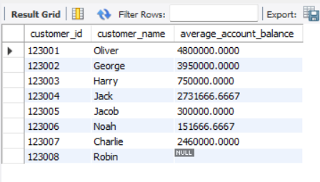

Question 2:

Print customer_id , account_number and balance_amount for all the accounts.

for account_type = "Credit Card" apply the condition that if balance_amount is nil then assign transaction_amount

**CODE:**

SELECT

BAD.Customer_id, BAD.Account_Number,

CASE

WHEN BAD.Account_type = 'Credit Card' AND BAD.Balance_amount IS NULL THEN BAT.Transaction_amount

ELSE BAD.Balance_amount

END AS balance_amount

FROM Bank_Account_Details BAD

LEFT JOIN

BANK_ACCOUNT_TRANSACTION BAT ON BAD.Account_Number = BAT.Account_Number;

**OUTPUT:**

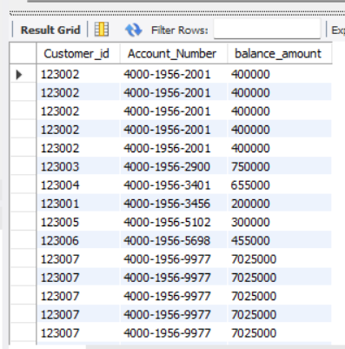

Question 3:

Print account_number and balance_amount , transaction_amount,Transaction_Date from Bank_Account_Details and bank_account_transaction for all the transactions occurred during march,2020 and april, 2020

**CODE:**

**SELECT**

**BAD.Account_Number,**

**BAD.Balance_amount,**

**BAT.Transaction_amount,**

**BAT.Transaction_Date**

**FROM**

**Bank_Account_Details BAD**

**JOIN**

**BANK_ACCOUNT_TRANSACTION BAT**

**ON**

**BAD.Account_Number = BAT.Account_Number**

**WHERE**

**YEAR(BAT.Transaction_Date) = 2020**

**AND MONTH(BAT.Transaction_Date) IN (3, 4);**

**OUTPUT:**

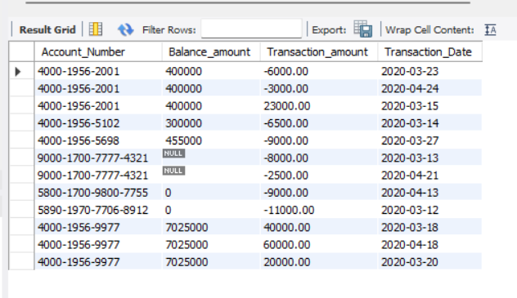

Question 4:

Print all the customer ids, account number, balance_amount, transaction_amount , Transaction_Date

from bank_customer, Bank_Account_Details and bank_account_transaction tables where excluding

all of their transactions in march, 2020 month

**CODE:**

**SELECT**

**BC.customer_id, BAD.Account_Number, BAD.Balance_amount, BAT.Transaction_amount,**

**BAT.Transaction_Date**

**FROM BANK_CUSTOMER BC JOIN Bank_Account_Details BAD**

**ON BC.customer_id = BAD.Customer_id**

**JOIN BANK_ACCOUNT_TRANSACTION BAT**

**ON BAD.Account_Number = BAT.Account_Number**

**WHERE YEAR(BAT.Transaction_Date) != 2020**

**OR (YEAR(BAT.Transaction_Date) = 2020 AND MONTH(BAT.Transaction_Date) != 3);**

**OUTPUT:**

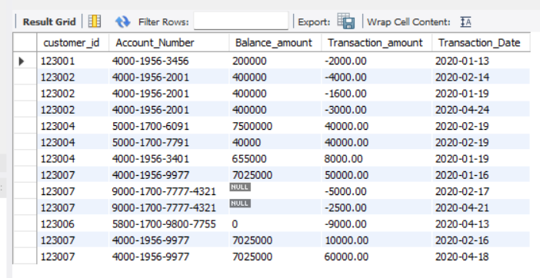

Question 5:

Print the customer ids, account_number, balance_amount,transaction_amount ,transaction_date who did transactions during the first quarter. Do not display the accounts if they have not done any transactions in the first quarter.

**CODE:**

**SELECT**

**BC.customer_id, BAD.Account_Number, BAD.Balance_amount, BAT.Transaction_amount,**

**BAT.Transaction_Date**

**FROM**

**BANK_CUSTOMER BC JOIN Bank_Account_Details BAD**

**ON**

**BC.customer_id = BAD.Customer_id**

**LEFT JOIN BANK_ACCOUNT_TRANSACTION BAT**

**ON**

**BAD.Account_Number = BAT.Account_Number**

**AND YEAR(BAT.Transaction_Date) = 2020**

**AND MONTH(BAT.Transaction_Date) BETWEEN 1 AND 3**

**WHERE**

**(YEAR(BAT.Transaction_Date) = 2020 AND MONTH(BAT.Transaction_Date) BETWEEN 1 AND 3)**

**OR BAT.Transaction_Date IS NULL;**

**OUTPUT:**

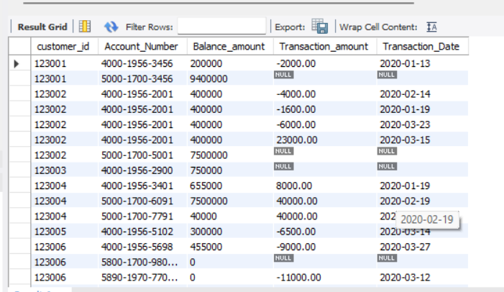

Question 6:

Print account_number, Event and Customer_message from BANK_CUSTOMER_MESSAGES and Bank_Account_Details to

display an “Adhoc" Event for all customers who have “SAVINGS" account_type account.

**\*\* We cannot display any result due to no common column in both tables\*\***

Question 7:

Print all the Customer_ids, Account_Number, Account_type, and display deducted balance_amount by

subtracting only negative transaction_amounts for Relationship_type =

P ( P - means Primary , S - means Secondary ) .

**CODE:**

**SELECT**

**BAD.Customer_id, BAD.Account_Number, BAD.Account_type,**

**BAD.Balance_amount - SUM(CASE WHEN BAT.Transaction_amount < 0 THEN BAT.Transaction_amount ELSE 0 END) AS deducted_balance**

**FROM Bank_Account_Details BAD**

**LEFT JOIN BANK_ACCOUNT_TRANSACTION BAT**

**ON BAD.Account_Number = BAT.Account_Number**

**WHERE BAD.Relationship_type = 'P'**

**GROUP BY**

**BAD.Customer_id, BAD.Account_Number, BAD.Account_type, BAD.Balance_amount;**

**OUTPUT:**

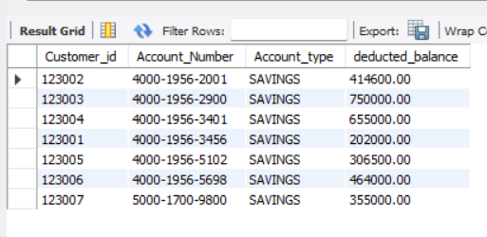

Question 8:

Display records of All Accounts , their Account_types, the balance amount. Along with first step, Display other columns with corresponding linking account number, account types

**CODE:**

**SELECT**

**BAD.Account_Number AS primary_account_number,**

**BAD.Account_type AS primary_account_type,**

**BAD.Balance_amount AS primary_balance_amount,**

**BARD.Linking_Account_Number,**

**BAD_REL.Account_type AS linked_account_type**

**FROM**

**Bank_Account_Details BAD**

**LEFT JOIN**

**Bank_Account_Relationship_Details BARD**

**ON**

**BAD.Account_Number = BARD.Account_Number**

**LEFT JOIN**

**Bank_Account_Details BAD_REL**

**ON**

**BARD.Linking_Account_Number = BAD_REL.Account_Number;**

**OUTPUT:**

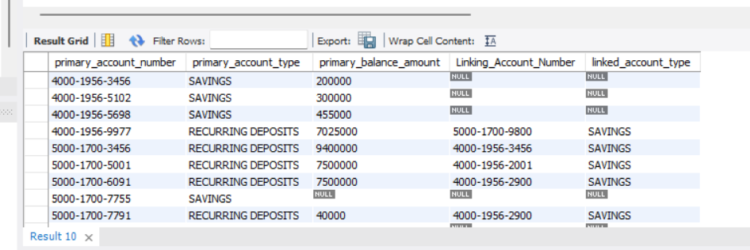

Question 9:

Display records of All Accounts , their Account_types, the balance amount.

Along with first step, Display other columns with corresponding linking account number, account types

After retrieving all records of accounts and their linked accounts, display the transaction amount of accounts appeared in another column.

**CODE:**

**SELECT**

**BAD.Account_Number AS primary_account_number,**

**BAD.Account_type AS primary_account_type,**

**BAD.Balance_amount AS primary_balance_amount,**

**BARD.Linking_Account_Number,**

**BAD_REL.Account_type AS linked_account_type,**

**BAT.Transaction_amount AS transaction_amount**

**FROM**

**Bank_Account_Details BAD LEFT JOIN Bank_Account_Relationship_Details BARD**

**ON**

**BAD.Account_Number = BARD.Account_Number**

**LEFT JOIN**

**Bank_Account_Details BAD_REL**

**ON**

**BARD.Linking_Account_Number = BAD_REL.Account_Number**

**LEFT JOIN**

**BANK_ACCOUNT_TRANSACTION BAT**

**ON**

**BAD.Account_Number = BAT.Account_Number;**

**OUTPUT:**

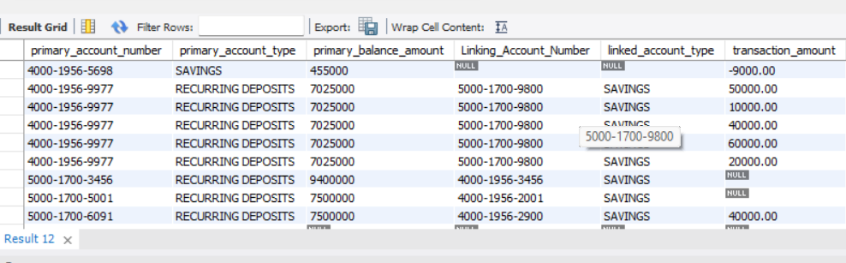

Question 10:

Display all account holders from Bank_Accounts_Details table who have “Add-on Credit Cards" and “Credit cards"

**CODE:**

**SELECT**

**Customer_id, Account_Number, Account_type**

**FROM**

**Bank_Account_Details**

**WHERE**

**Account_type IN ('Add-on Credit Cards', 'Credit Card');**

**OUTPUT:**

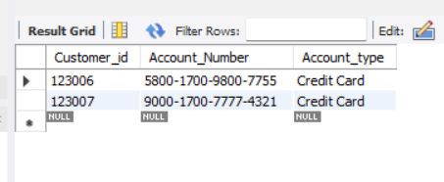

Question 11:

Display records of “SAVINGS” accounts linked with “Credit card" account_type and its creditaggregate sum of transaction amount.

Ref: Use bank_Account_Details for Credit card types

# Check transaction_amount in bank_account_transaction.

**CODE:**

**SELECT**

**BAD.Account_Number AS savings_account_number,**

**SUM(BAT.Transaction_amount) AS credit_aggregate_sum_of_transaction_amount**

**FROM Bank_Account_Details BAD**

**JOIN Bank_Account_Relationship_Details BARD**

**ON BAD.Account_Number = BARD.Linking_Account_Number**

**JOIN Bank_Account_Details BAD_Credit**

**ON BARD.Account_Number = BAD_Credit.Account_Number**

**JOIN BANK_ACCOUNT_TRANSACTION BAT**

**ON BAD_Credit.Account_Number = BAT.Account_Number**

**WHERE BAD.Account_type = 'SAVINGS'**

**AND BAD_Credit.Account_type = 'Credit Card'**

**GROUP BY BAD.Account_Number;**

**OUTPUT:**

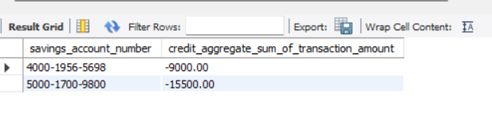

Question 12:

Display all type of “Credit cards” accounts including linked “Add-on Credit Cards"

type accounts with their respective aggregate sum of transaction amount.

Ref: Check Bank_Account_Details_table for all types of credit card.

# Check transaction_amount in bank_account_transaction.

**CODE:**

**SELECT**

**BAD.Account_type AS Credit_Card_Type,**

**SUM(BAT.Transaction_amount) AS Credit_Card_Aggregate_Sum_of_Transaction_Amount**

**FROM Bank_Account_Details BAD**

**LEFT JOIN BANK_ACCOUNT_TRANSACTION BAT**

**ON BAD.Account_Number = BAT.Account_Number**

**WHERE BAD.Account_type IN ('Credit Card', 'Add-on Credit Card')**

**GROUP BY BAD.Account_type;**

**OUTPUT:**

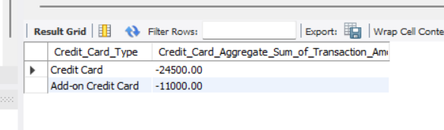

Question 13:

Display “SAVINGS” accounts and their corresponding aggregate sum of transaction amount

of all recurring deposits

**CODE:**

**SELECT**

**BAD.Account_Number AS Savings_Account_Number,**

**SUM(BAT.Transaction_amount) AS Aggregate_Sum_of_Transaction_Amount**

**FROM Bank_Account_Details BAD**

**JOIN BANK_ACCOUNT_TRANSACTION BAT**

**ON BAD.Account_Number = BAT.Account_Number**

**WHERE**

**BAD.Account_type = 'SAVINGS'**

**AND BAD.Relationship_type = 'P'**

**GROUP BY BAD.Account_Number;**

**OUTPUT:**

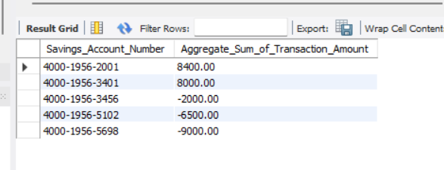

Question 14:

Display every accounts total no of transactions for every year and each month.

**CODE:**

**SELECT**

**BAD.Account_Number,**

**YEAR(BAT.Transaction_Date) AS Transaction_Year,**

**MONTH(BAT.Transaction_Date) AS Transaction_Month,**

**COUNT(*) AS Total_Number_of_Transactions**

**FROM Bank_Account_Details BAD**

**JOIN BANK_ACCOUNT_TRANSACTION BAT**

**ON BAD.Account_Number = BAT.Account_Number**

**GROUP BY BAD.Account_Number, Transaction_Year, Transaction_Month;**

**OUTPUT:** 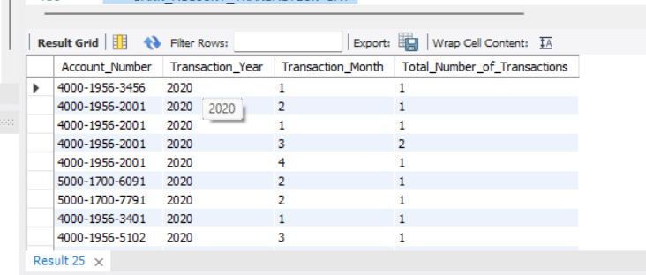

Question 15:

Compare the aggregate sum transaction amount of Feb2020 month versus Jan2020 Month for each account number.

Display account_number, transaction_amount ,

sum of feb month transaction amount ,

sum of Jan month transaction amount ,

**CODE:**

**SELECT**

**BAT.Account_Number,**

**SUM(CASE WHEN MONTH(BAT.Transaction_Date) = 2 AND YEAR(BAT.Transaction_Date) = 2020 THEN BAT.Transaction_amount ELSE 0 END) AS Feb2020_Transaction_Sum,**

**SUM(CASE WHEN MONTH(BAT.Transaction_Date) = 1 AND YEAR(BAT.Transaction_Date) = 2020 THEN BAT.Transaction_amount ELSE 0 END) AS Jan2020_Transaction_Sum**

**FROM BANK_ACCOUNT_TRANSACTION BAT**

**GROUP BY BAT.Account_Number;**

**OUTPUT:**

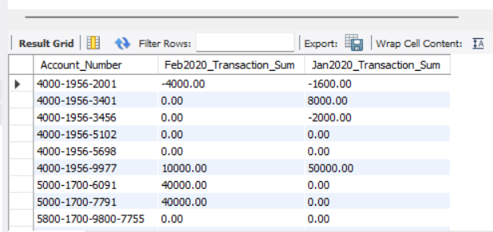

Question 16:

Display the customer names who have all three account types -

savings, recurring and credit card account holders.

**CODE:**

**SELECT**

**DISTINCT c.Customer_name**

**FROM Bank_Account_Details b**

**JOIN Bank_Customer c ON b.Customer_id = c.Customer_id**

**WHERE b.Account_type IN ('SAVINGS', 'RECURRING DEPOSITS', 'Credit card')**

**GROUP BY c.Customer_id**

**HAVING COUNT(DISTINCT b.Account_type) = 3;**

**OUTPUT:**

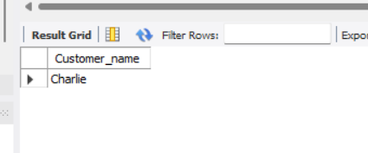

Question 17:

Display savings accounts and its corresponding Recurring deposits transactions that are occuring more than 4 times.

**CODE:**

**SELECT**

**s.Account_Number AS Savings_Account_Number,**

**r.Account_Number AS Recurring_Account_Number,**

**COUNT(t.Transaction_date) AS Transaction_Count**

**FROM Bank_Account_Details s**

**JOIN Bank_Account_Relationship_Details rel**

**ON s.Account_Number = rel.Linking_Account_Number**

**JOIN Bank_Account_Details r**

**ON rel.Account_Number = r.Account_Number**

**JOIN Bank_Account_Transaction t**

**ON r.Account_Number = t.Account_Number**

**WHERE s.Account_type = 'SAVINGS'**

**AND r.Account_type = 'RECURRING DEPOSITS'**

**GROUP BY s.Account_Number, r.Account_Number**

**HAVING COUNT(t.Transaction_date) > 4;**

**OUTPUT:**

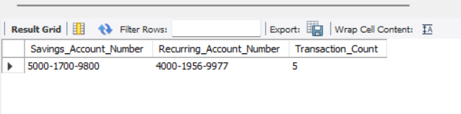

Question 18:

Find the no. of transactions of credit cards including add-on Credit Cards

**CODE:**

**SELECT**

**BAD.Account_type AS Credit_Card_Type,**

**COUNT(DISTINCT BAT.Account_Number) AS Total_Number_of_Transactions**

**FROM Bank_Account_Details BAD**

**LEFT JOIN BANK_ACCOUNT_TRANSACTION BAT**

**ON BAD.Account_Number = BAT.Account_Number**

**WHERE BAD.Account_type IN ('Credit Card', 'Add-on Credit Card')**

**GROUP BY BAD.Account_type;**

**OUTPUT:**

