Predictive accuracy of learned trees as a function of the training set size

Heart Test

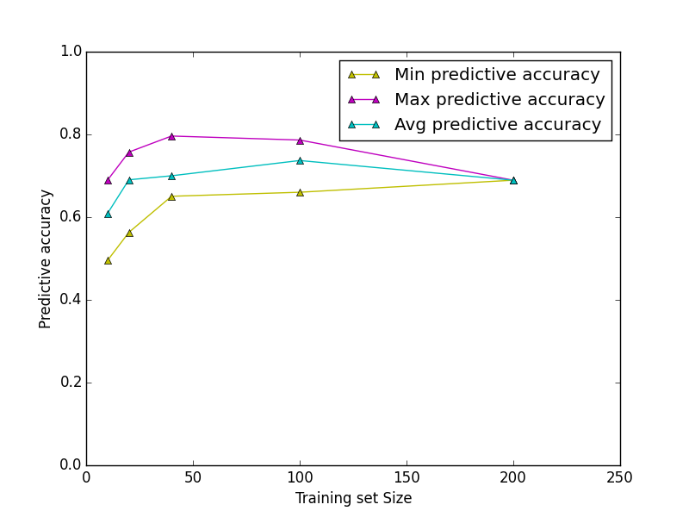

Predictive accuracy of learned trees as a function of the training set size

Diabetes Test

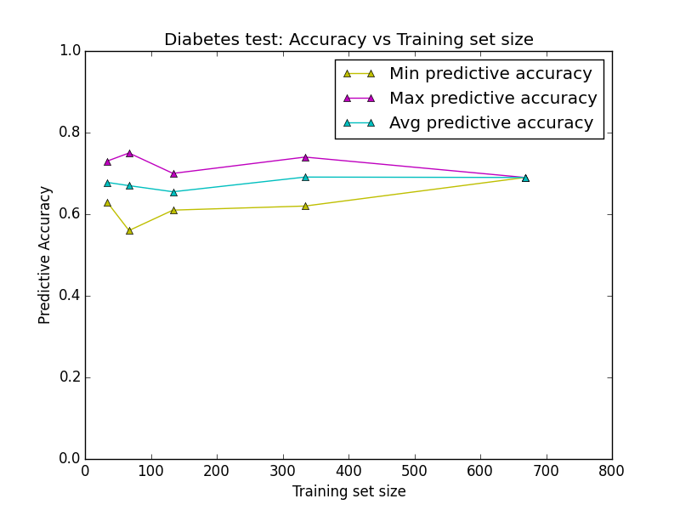

Predictive accuracy variation as a function of tree size

Heart Test

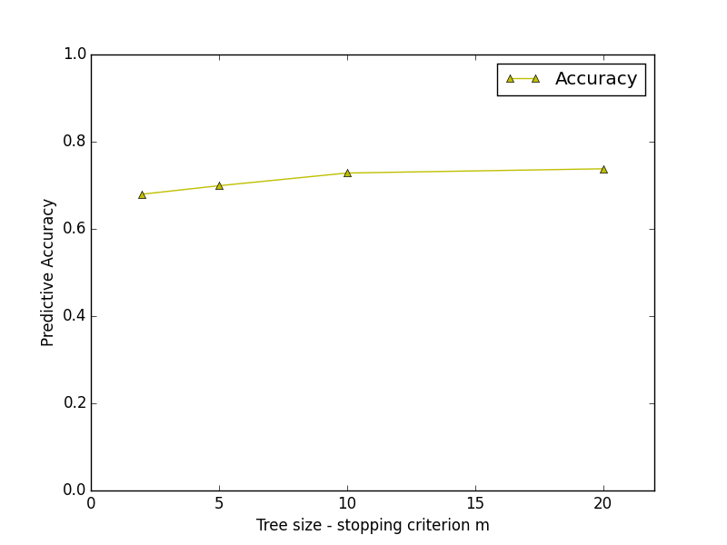

Predictive accuracy variation as a function of tree size

Diabetes

