**WORKLOAD 2**

Our Multilevel Feedback Queue is best described by the following table:

|  |  |
| --- | --- |
| Priority Queue Level | Number of timer ticks |
|  |  |
| Q-0 | 1 |
| Q-1 | 2 |
| Q-2 | 4 |
| Q-3 | 8 |

Processes in Q-0 have the highest priority and is executed first for 1 clock tick and processes in Q-3 have the least priority and are executed for 8 clock ticks. When the process arrives first, it is placed in the Q-0 and after the stipulated time for that particular queue expires, it is subsequently demoted to the lower -priority queues (from Q0->Q1->Q2->Q3).

At the same priority queue level, the processes are executed in Round Robin fashion.

Once a process reaches Q-3, it stays in that queue until it runs to completion.

Graph 2

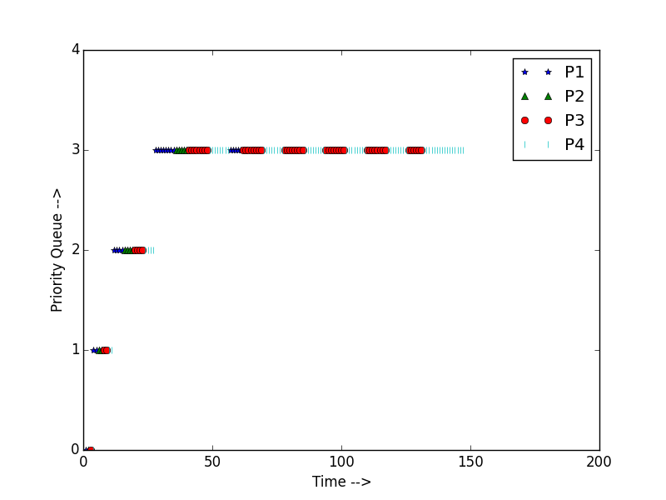

Workload Description

The workload consists of four processes (P1, P2, P3, P4) arriving at the same time. The run times (in clock ticks) of the process are:

* P1 – 20
* P2 – 12
* P3 – 53
* P4 – 63

The processes initially are in high priority queue Q-0 and each process gets executed for 1 clock tick. After that, they are demoted to Q-1 wherein they are executed for 2 clock ticks. Subsequently, they are demoted to Q-3 (execute for 4 clock ticks) and then to Q-4 (execute for 8 clock ticks). The Gantt chart distribution of the processes are shown below:

**Q-0**

|  |  |  |  |
| --- | --- | --- | --- |
| P1 | P2 | P3 | P4 |

0 1 2 3 4

**Q-1**

|  |  |  |  |
| --- | --- | --- | --- |
| P1 | P2 | P3 | P4 |

4 6 8 10 12

**Q-2**

|  |  |  |  |
| --- | --- | --- | --- |
| P1 | P2 | P3 | P4 |

12 16 20 24 28

**Q-3**

|  |  |  |  |  |  |  |  |
| --- | --- | --- | --- | --- | --- | --- | --- |
| P1 | P2 | P3 | P4 | P1 | P3 | P4 | P3 |

28 36 41 49 57 62 70 78 86

|  |  |  |  |  |  |  |  |
| --- | --- | --- | --- | --- | --- | --- | --- |
| P4 | P3 | P4 | P3 | P4 | P3 | P4 | P4 |

86 94 102 110 118 126 132 140 148