**SRM INSTITUTE OF SCIENCE AND TECHNOLOGY**



TIRUCHIRAPPALLI

**COLLEGE OF SCIENCE AND HUMANITIES**

**TIRUCHIRAPPALLI CAMPUS**

# RECORD WORK

**PCA20C05J – COMPUTER NETWORKS**

**Register No. : RA233224105000**

**Name of the Student :**

**Semester : II**

**Programme : MCA**

**SRM INSTITUTE OF SCIENCE AND TECHNOLOGY**

**COLLEGE OF SCIENCE AND HUMANITIES**



TIRUCHIRAPPALLI



**REGISTER**

**NO.**

**RAMDNFKEF**

**BONAFIDE CERTIFICATE**

Certified as the bonafide record of work done by RA23324105000 Register No. 2 of 1_ (Semester/Year), MASTER OF COMPUTER APPLICATIONS **Programme** in the practical course **PCA20C05J – COMPUTER NETWORKS** at **SRM Institute of Science and Technology, Tiruchirappalli Campus** during the Academic Year, 2023-2024.

**Faculty In-charge Head of the Department**

Submitted for the End Semester Examination held on

**Examiner-1 Examiner-2**

**INDEX**

|  |  |  |  |  |  |
| --- | --- | --- | --- | --- | --- |
| **S.NO** | **DATE** | **NAME OF THE PROGRAM** | **PAGE NO** | **MARKS** | **SIGNATURE** |
| 1. | 14.12.2023 | Familiarization with configuring and installing a LAN using packet tracer | 4 |  |  |
| 2. | 28.12.2023 | Experimenting with network protocols for achieving communication between computers using packet tracer | 7 |  |  |
| 3. | 11.12.2024 | Creating a LAN using packet tracer | 10 |  |  |
| 4. | 25.01.2024 | To study different types of transmission media | 14 |  |  |
| 5. | 02.02.2024 | Interconnection software for communication between two different network architectures using Packet Tracer | 18 |  |  |
| 6. | 16.02.2024 | Using packet tracer to connect a network with different types of media connection | 21 |  |  |
| 7. | 29.02.2024 | Error Detecting Code using CRC – CCITT (16-bit) | 23 |  |  |
| 8. | 07.03.2024 | Case study submission for Sliding Window Flow Control & Stop and Wait Flow Control | 26 |  |  |
| 9. | 22.03.2024 | Simulation of Stop and Wait Protocol using NS/2 or any other tool | 31 |  |  |
| 10. | 28.03.2024 | Study of switches, bridges using Cisco Packet Tracer | 35 |  |  |

**EX.NO: 1**

**14.12.2023**

FAMILIARIZATION WITH CONFIGURING AND INSTALLING A LAN USING PACKET TRACER

**AIM:**

Create a simple network using a HUB and two PCs. Set the IPs for the PCs and ping one from another.

**PROCEDURE:**

* Open Cisco Packet > New > File.
* Click on HUB in the toolbox and select Hub-PT and draw the same.
* Click on PCs and draw two PCs.
* Click on Wires and select Copper Straight Through Wires.
* Using the wire connect the two PCs to the HUB.
* Select the 1st PC and Set the IP address as 10.1.1.1
* Select the 2nd PC and Set the IP address as 10.1.1.2
* After the Successful Connection Select the 1st PC and click on command prompt and ping the connection as 10.1.1.2.
* Select the 2nd PC and click on command prompt and ping the connection as 10.1.1.1

**OUTPUT:**

**HUB with two PCs:**

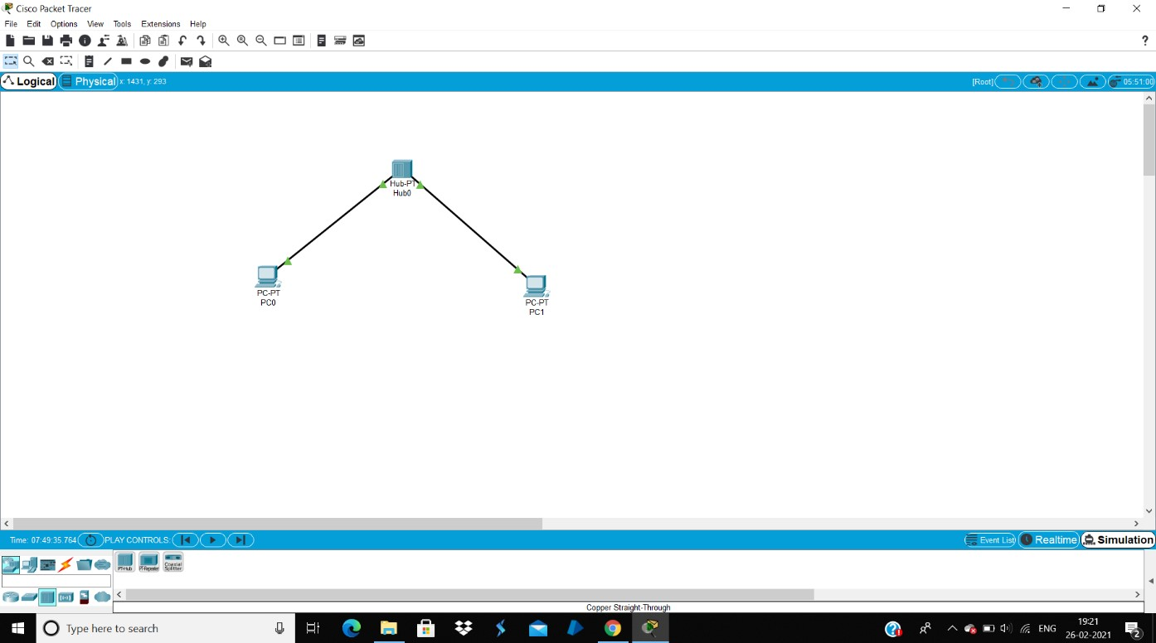

**First PC(PING):**

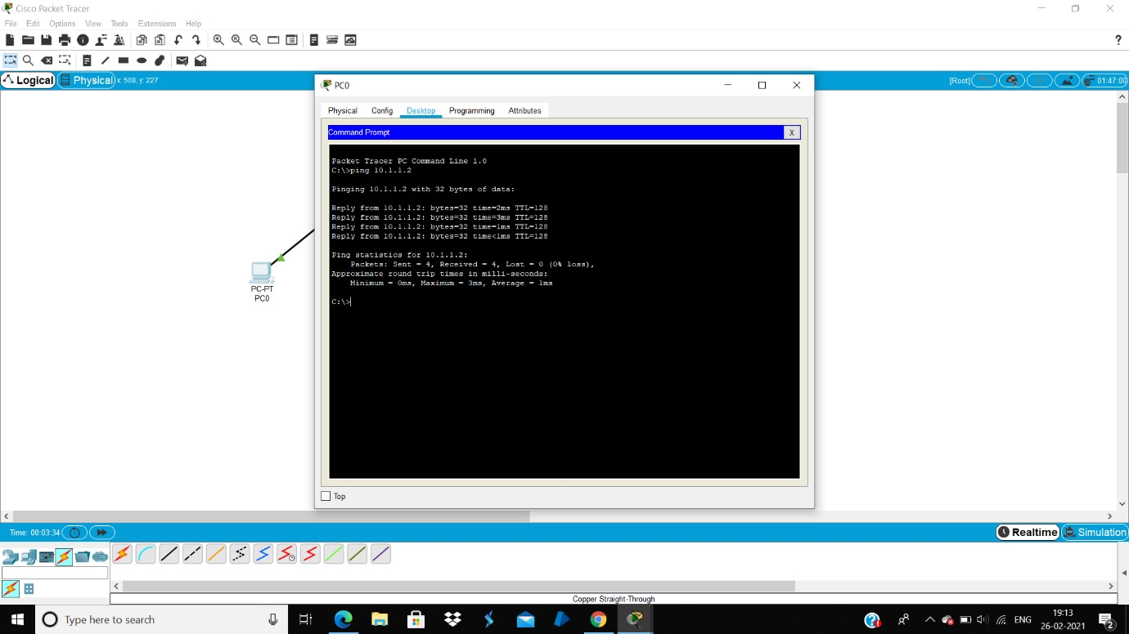

**Second PC(PING):**

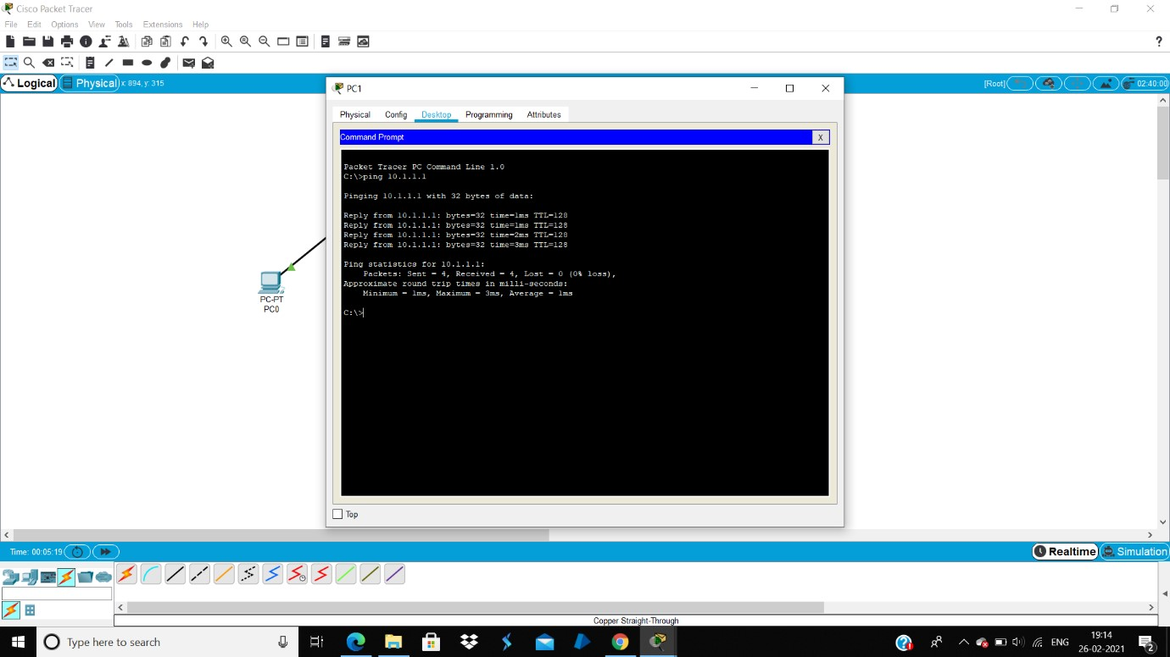

**RESULT:**

Successfully Created a simple network using a HUB and two PCs and also the IPs for the PCs and ping one from another.

**EX.NO: 2**

**28.12.2023**

EXPERIMENTING WITH NETWORK PROTOCOLS FOR ACHIEVING COMMUNICATION BETWEEN COMPUTERS USING PACKET TRACER

**AIM:**

Create a simple network using a Switch and three PCs. Set the IPs for the three PCs and send simple PDU to a PC from another.

**PROCEDURE:**

* Open Cisco Packet > New > File.
* Click on Switch in the toolbox and select 2960Switch and draw the same.
* Click on PCs and draw three PCs.
* Click on Wires and select Copper Straight Through Wires.
* Using the wire connect the three PCs to the Switch.
* Select the 1st PC and Set the IP address as 10.1.1.1
* Select the 2nd PC and Set the IP address as 10.1.1.2
* Select the 3rd PC and Set the IP address as 10.1.1.3
* After the Successful Connection Select the 1st PC and click on command prompt and ping the connection as 10.1.1.2.
* Select the 1st PC and click on command prompt and ping the connection as 10.1.1.2
* Select the 2nd PC and click on command prompt and ping the connection as 10.1.1.3
* Select the 3rd PC and click on command prompt and ping the connection as 10.1.1.1
* Then send a Simple PDU from a PC to Another.

**OUTPUT:**

**SWITCH with three PCs:**

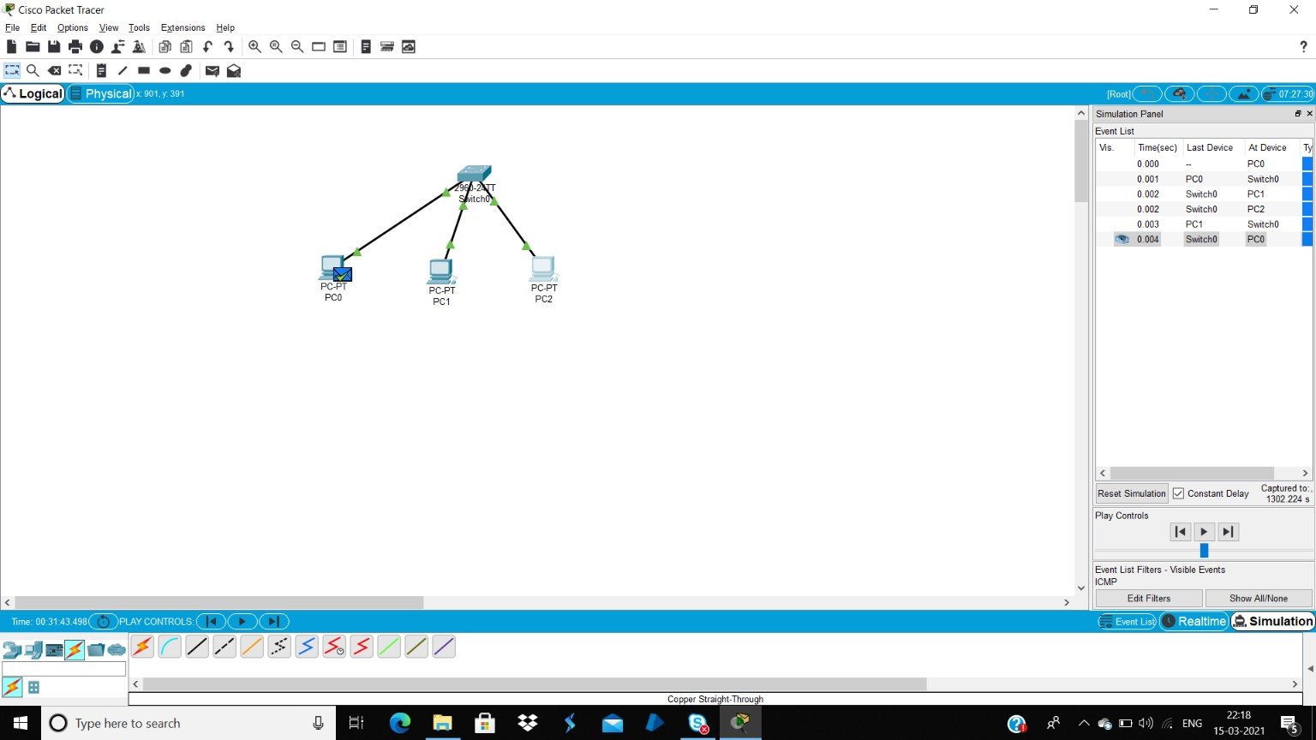

**First PC(PING):**

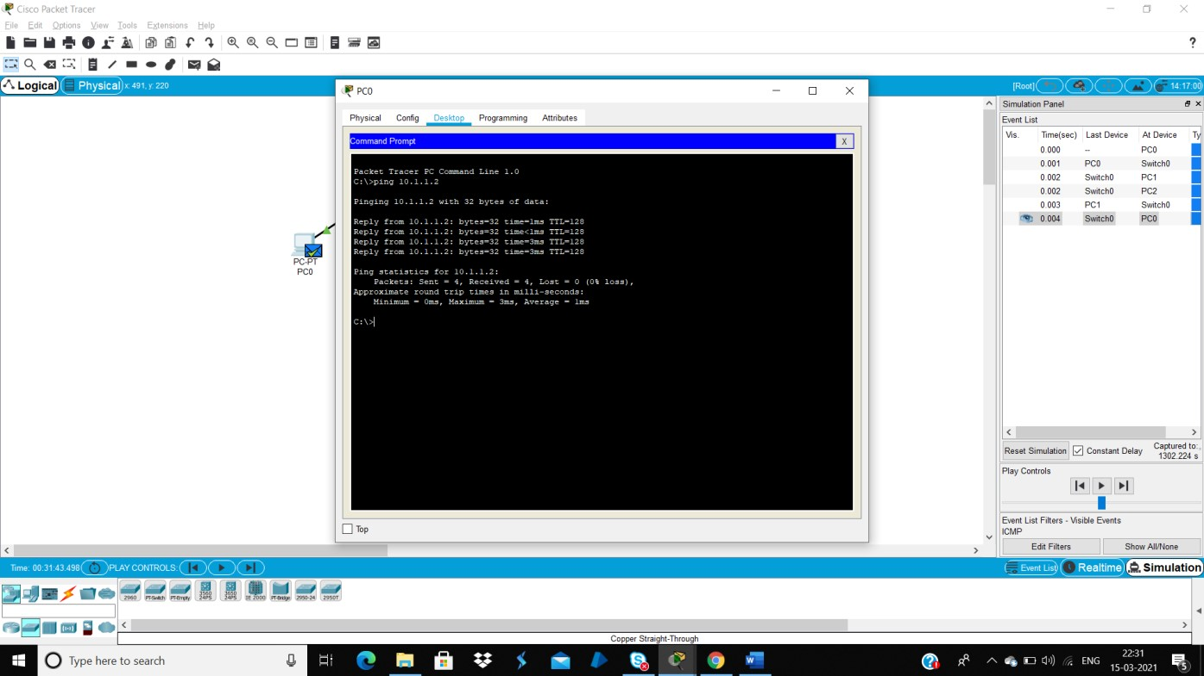

**Second PC(PING):**

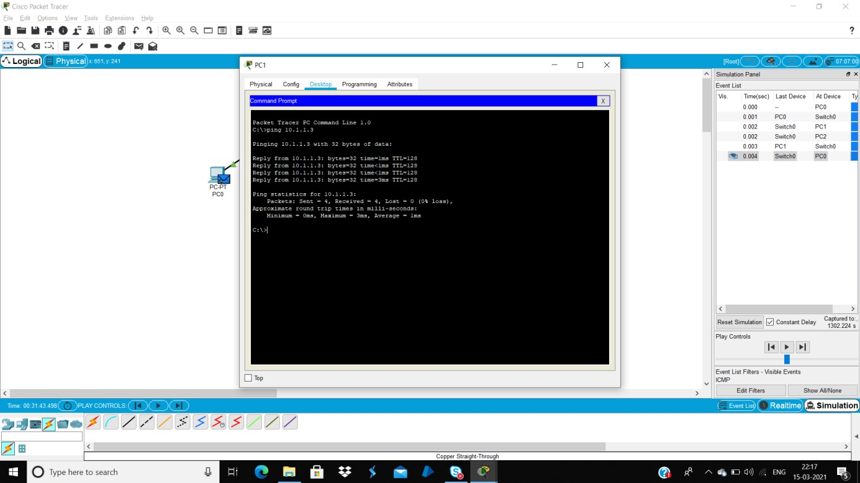

**Third PC(PING):**

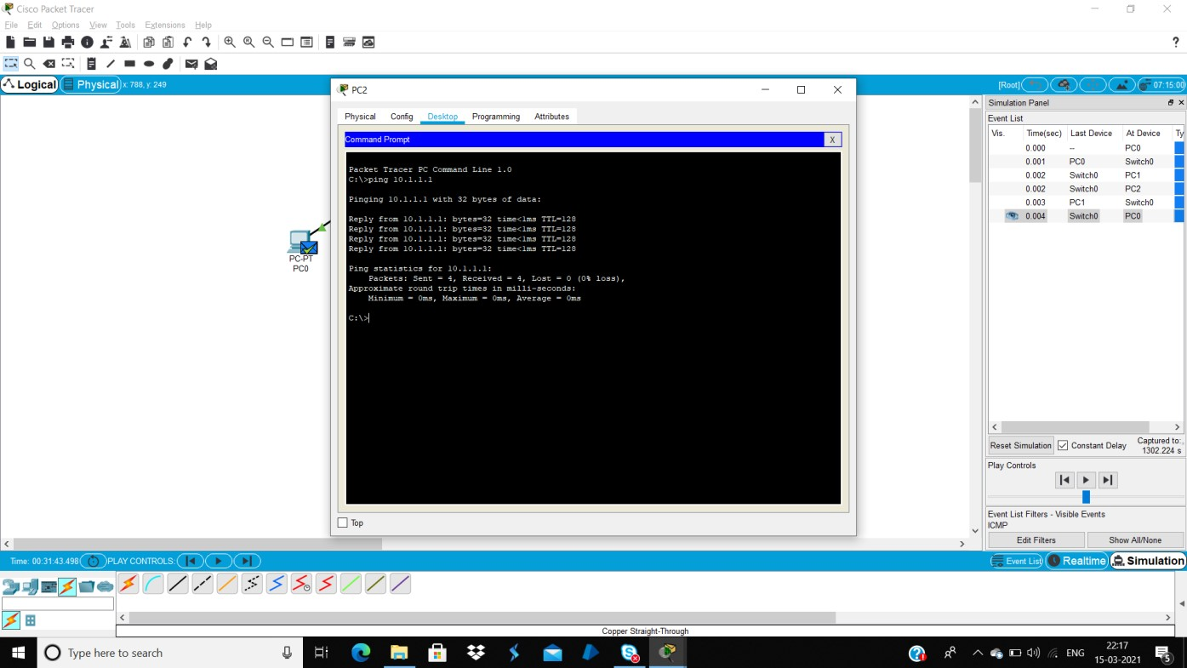

**RESULT:**

Successfully created a simple network using a Switch and three PCs. The IPs for the three PCs and send simple PDU to a PC from another.

**EX.NO: 3**

**11.01.2024**

**CREATING A LAN USING PACKET TRACER**

**AIM:**

Create a simple LAN using a Switch and 4 PCs. Set the IPs for the four PCs and find the Average Ping For accessing a PC from all the other PCs

**PROCEDURE:**

* Open Cisco Packet > New > File.
* Click on Switch in the toolbox and select 2960Switch and draw the same.
* Click on PCs and draw three PCs.
* Click on Wires and select Copper Straight Through Wires.
* Using the wire connect the three PCs to the Switch.
* Select the 1st PC and Set the IP address as 10.1.1.1
* Select the 2nd PC and Set the IP address as 10.1.1.2
* Select the 3rd PC and Set the IP address as 10.1.1.3
* Select the 4th PC and Set the IP address as 10.1.1.4
* After the Successful Connection Select the 1st PC and click on command prompt and ping the connection as 10.1.1.2.
* Select the 2nd PC and click on command prompt and ping the connection as 10.1.1.3
* Select the 3rd PC and click on command prompt and ping the connection as 10.1.1.4
* Select the 4th PC and click on command prompt and ping the connection as 10.1.1.1
* Then find the Average ping for Accessing a PC from all other

**AVERAGE:**

1ST PC: 1ms

2ND PC: 1ms

3RD PC: 0ms

4TH PC: 1ms

Average/No.of PC

¾ is equal to 0.7

**OUTPUT:**

**SWITCH with four PCs:**

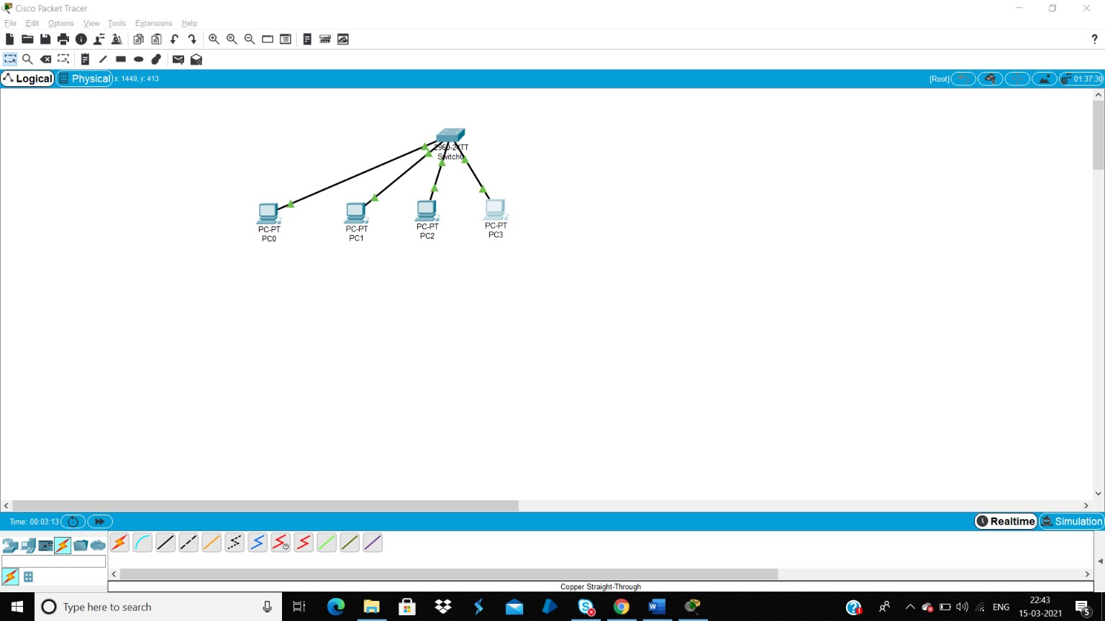

**First PC(PING):**

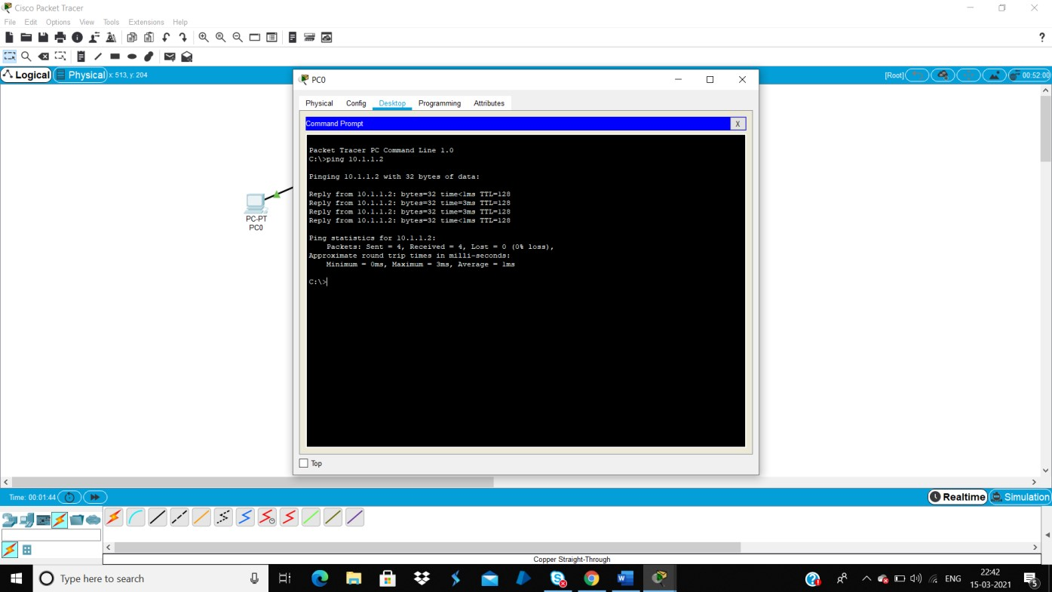

**Second PC(PING):**

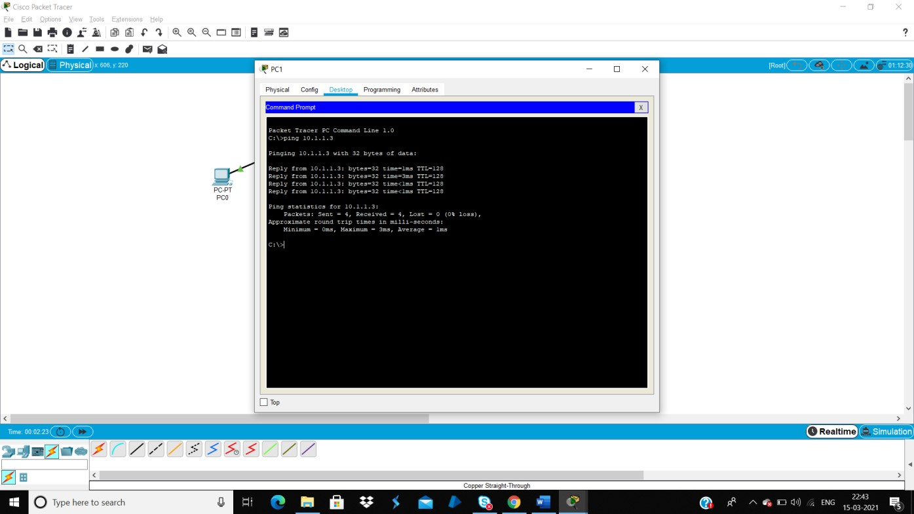

**Third PC(PING):**

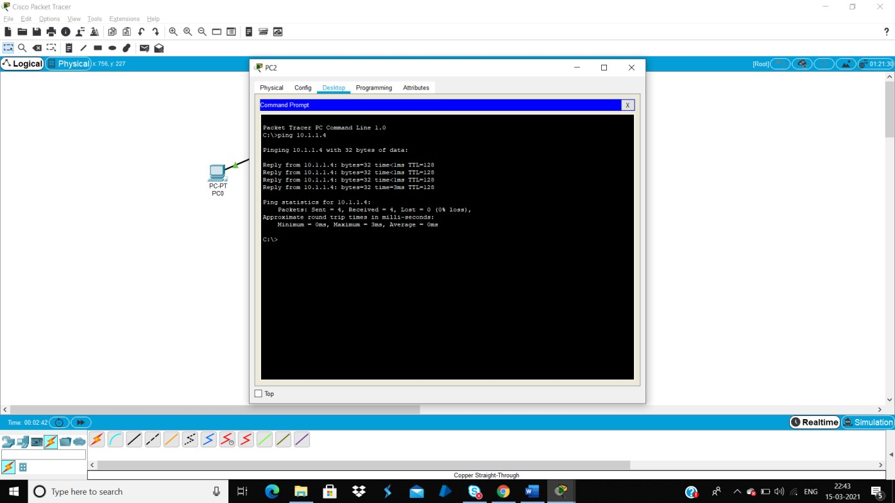

**Four PC(PING):**

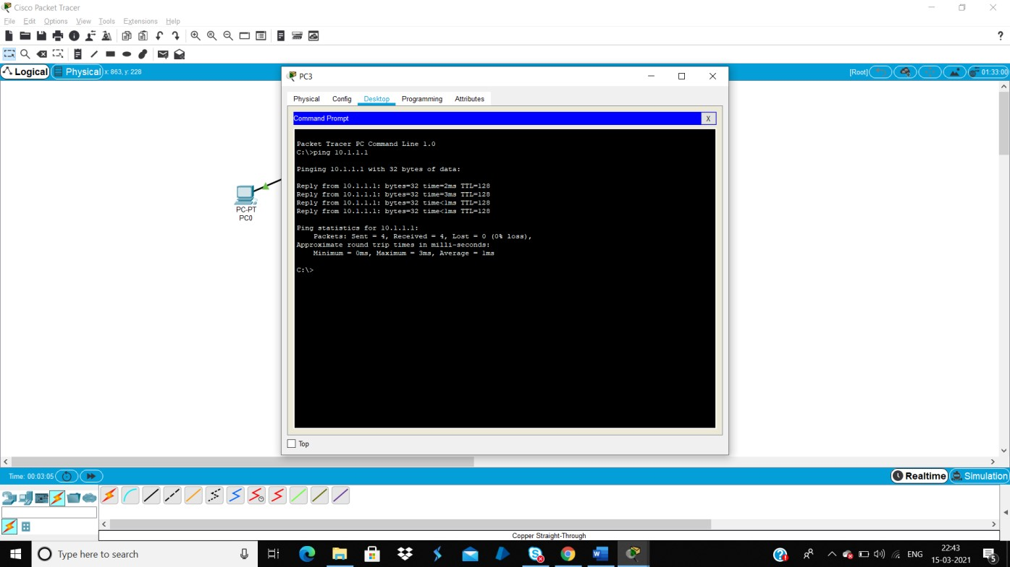

**RESULT:**

Successfully Created a Simple LAN using a Switch and 4 PCs. The IPs for the four PCs and the Average Ping For accessing a PC from all the other PCs.

**EX.NO: 4**

**25.01.2024**

**TO STUDY DIFFERENT TYPES OF TRANSMISSION MEDIA**

**AIM:**

To study different types of Transmission Media.

**CASE STUDY:**

**DIFFERENT TYPES OF TRANSMISSION MEDIA:**

In data communication terminology, a transmission medium is a physical path between the transmitter and the receiver i.e it is the channel through which data is sent from one place to another. Transmission Media is broadly classified into the following types:

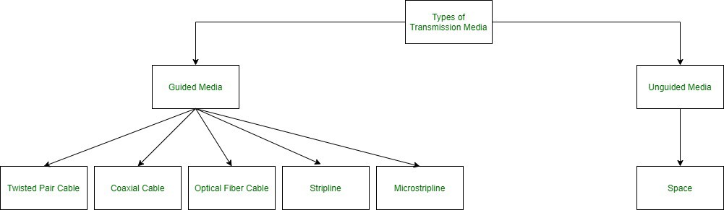

**1. Guided Media:**

It is also referred to as Wired or Bounded transmission media. Signals being transmitted are directed and confined in a narrow pathway by using physical links.

Features:

High Speed

Secure

Used for comparatively shorter distances There are 3 major types of Guided Media: **(i) Twisted Pair Cable**

It consists of 2 separately insulated conductor wires wound about each other. Generally, several such pairs are bundled together in a protective sheath. They are the most widely used Transmission Media. Twisted Pair is of two types:

**Unshielded Twisted Pair (UTP):**

This type of cable has the ability to block interference and does not depend on a physical shield for this purpose. It is used for telephonic applications.

**Advantages:**

Least expensive

Easy to install

High-speed capacity

Susceptible to external interference

Lower capacity and performance in comparison to STP Short distance transmission due to attenuation

**Shielded Twisted Pair (STP):**

This type of cable consists of a special jacket to block external interference. It is used in fast-data-rate Ethernet and in voice and data channels of telephone lines.

**Advantages:**

Better performance at a higher data rate in comparison to UTP

Eliminates crosstalk

Comparatively faster

Comparatively difficult to install and manufacture

More expensive

Bulky

**(ii) Coaxial Cable**

It has an outer plastic covering containing 2 parallel conductors each having a separate insulated protection cover. The coaxial cable transmits information in two modes: Baseband mode(dedicated cable bandwidth) and Broadband mode(cable bandwidth is split into separate ranges). Cable TVs and analog television networks widely use Coaxial cables.

**Advantages:**

High Bandwidth

Better noise Immunity

Easy to install and expand Inexpensive **Disadvantages:**

Single cable failure can disrupt the entire network

**(iii) Optical Fibre Cable**

It uses the concept of reflection of light through a core made up of glass or plastic. The core is surrounded by a less dense glass or plastic covering called the cladding. It is used for the transmission of large volumes of data.

The cable can be unidirectional or bidirectional. The WDM (Wavelength Division Multiplexer) supports two modes, namely unidirectional and bidirectional mode.

**Advantages:**

Increased capacity and bandwidth

Lightweight

Less signal attenuation

Immunity to electromagnetic interference Resistance to corrosive materials

**Disadvantages:**

Difficult to install and maintain

High cost

Fragile

1. **Strip line**

Strip line is a transverse electromagnetic (TEM) transmission line medium invented by Robert M. Barrett of the Air Force Cambridge Research Centre in the 1950s. Strip line is the earliest form of the planar transmission line. It uses a conducting material to transmit high-frequency waves it is also called a waveguide. This conducting material is sandwiched between two layers of the ground plane which are usually shorted to provide EMI immunity.

1. **Microstrip line**

In this, the conducting material is separated from the ground plane by a layer of dielectric.

**2. Unguided Media:**

It is also referred to as Wireless or Unbounded transmission media. No physical medium is required for the transmission of electromagnetic signals.

**Features**:

The signal is broadcasted through air

Less Secure

Used for larger distances

There are 3 types of Signals transmitted through unguided media:

1. **Radio waves**

These are easy to generate and can penetrate through buildings. The sending and receiving antennas need not be aligned. Frequency Range:3KHz – 1GHz. AM and FM radios and cordless phones use Radiowaves for transmission.

Further Categorized as (i) Terrestrial and (ii) Satellite.

1. **Microwaves**

It is a line-of-sight transmission i.e. the sending and receiving antennas need to be properly aligned with each other. The distance covered by the signal is directly proportional to the height of the antenna. Frequency Range:1GHz – 300GHz. These are majorly used for mobile phone communication and television distribution.

1. **Infrared**

Infrared waves are used for very short distance communication. They

cannot penetrate through obstacles. This prevents interference between systems. Frequency Range:300GHz – 400THz. It is used in TV remotes, wireless mouse, keyboard, printer, etc.

**EX.NO: 5**

**02.02.2024**

**INTERCONNECTION SOFTWARE FOR COMMUNICATION BETWEEN TWO DIFFERENT NETWORK ARCHITECTURES USING PACKET TRACER**

**AIM:**

Create two different networks using a router, configure the devices and send a simple PDU from a device in one network to a device in another network.

**PROCEDURE:**

* Open Cisco Packet > New >File.
* Connect two networks and connect them with a router
* To configure a router do the following in the IOS Command Line.

Router> en

Router# Show IP interface brief

Router# Config t

Router(Config)# interface fa 0/0

#description 192.168.250.0/24

#IP address 192.168.250.254

#no shut

#do wr

Router config #interface fa 0/1

#IP address 192.168.251.254 255.255.255.0

#no shut

#do wr

* After router configuration, configure the IP address of the two servers.
* Set static and set the server1 IP address as 192.168.250.100, default

Gateway as 192.168.250.254 and the server2 IP address as

192.168.251.100, Gateway as192.168.251.254

* Set the DWS as 192.168.250.100 for both the servers.
* To configure and set PCs IP address, go to each PCs properties, IP Configuration and choose DHCP option instead of static. IP will be automatically allocated.
* To check if the connections are successful, ping from command line
* Send a message from PC to server or PC to PC or server to server using the simple PDU.
* Auto capture/play Simulation to view the connection and communication path.

**OUTPUT:-**

**Create a network using a SWITCH with four PCs using a router:**

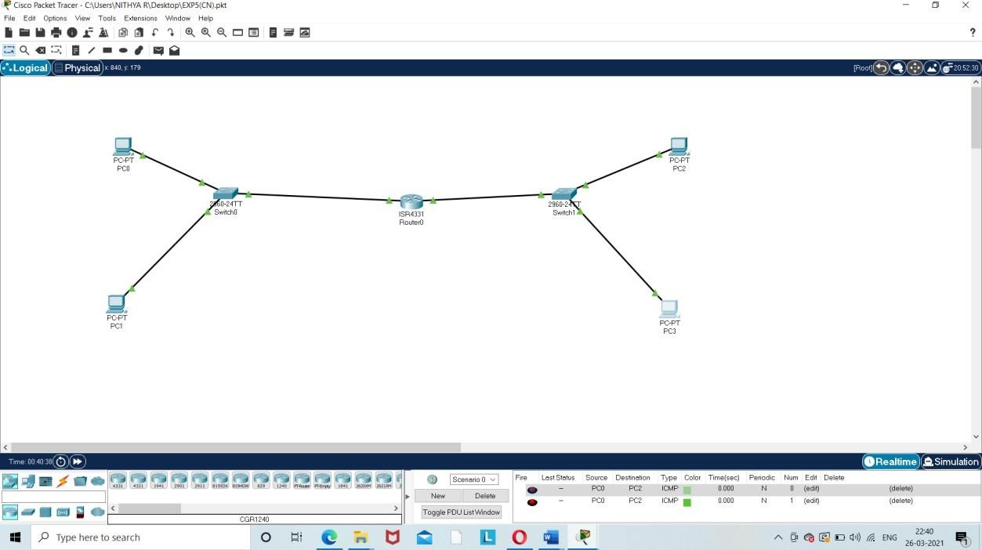

**Send a simple PDU from a device in one network to a device in another** **net**

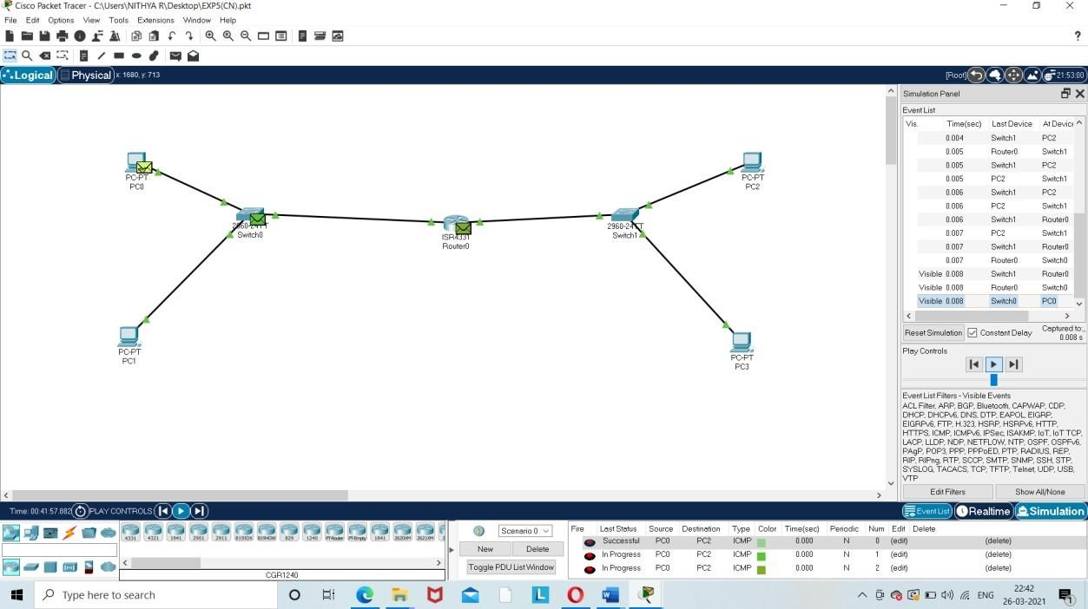

**RESULT:**

Successfully Created two different networks using a router, configure the devices and send a simple PDU from a device in one network to a device in another network.

**EX.NO: 6**

**16.02.2024**

USING PACKET TRACER TO CONNECT A NETWORK WITH DIFFERENT TYPES OF MEDIA CONNECTION

**AIM:**

Using packet tracer to connect to a network with different types of media connection.

**PROCEDURE :**

* Open Cisco Packet Tracer.ClickNew File.
* From the toolbox in the bottom left, choose the requiredcomponents.
* Select 2 PCs , a wireless router , a laptop , cloud pt and a dslmodem0.
* Connect wireless router to laptopwireless.
* Connect cloud to modem using phonewire.
* In pc0 and pc1 select dhcp in ipconfiguration
* In laptop select the Linksys-WPC300N module and switch iton.
* In cloud 0 select the PT-CLOUD-NM-1AM and switchon.
* In dsl modem0 select the PT-MODEM-NM-1CE and switchon.
* Send a PDU from PC0 toPC1.

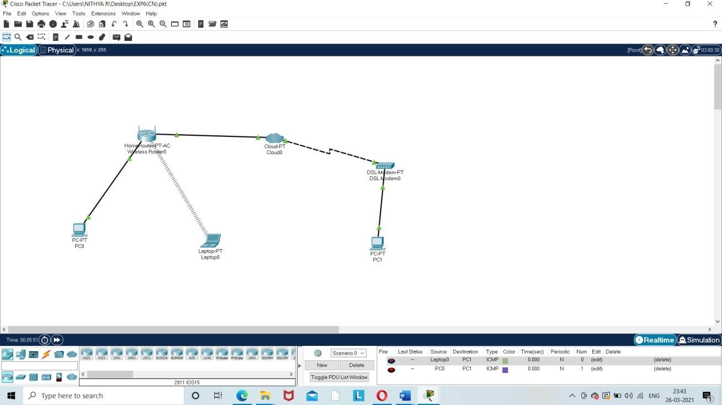**OUTPUT :**

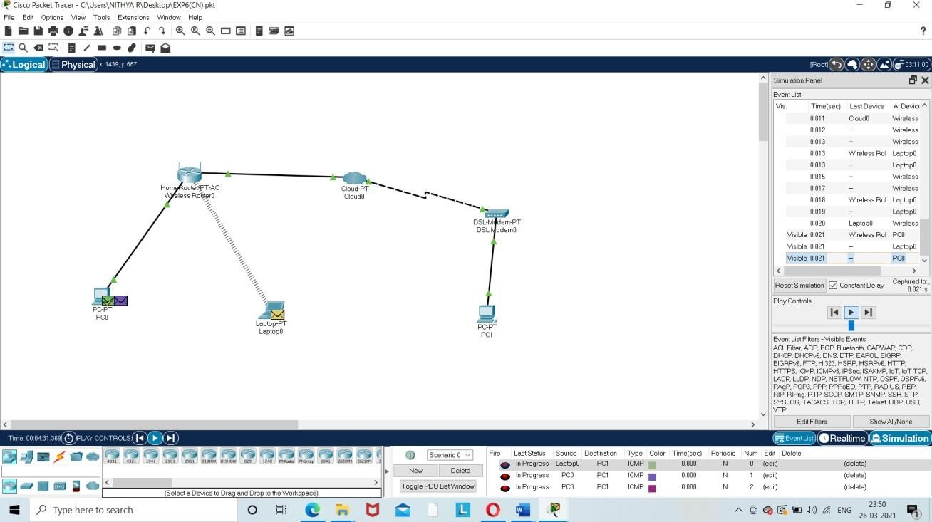

**RESULT:**

Hence, the connection is established and packets are sent and received.

**EX.NO: 7**

**29.02.2024**

**ERROR DETECTION CODE USING CRC-CCITT(16-BITS)**

**AIM:-**

To write a program for Error Detection Code Using CRC-CCITT(16-bits)

**ALGORITHM:-**

* Start.
* Enter the message to be transmitted.
* Append the message with 16(since it is 16-bit CRC ) 0’s (i . e if you input a 5 digit

message, the appended message should be 21-bits.)

* XOR appended message and transmit it. (Here, you compare with an already existing string such as 10001000000100001 and replace the bits the same way XOR operation works.)
* Verify the message that is received is the same as the one sent.
* End.

**CODE:-**

#include <iostream> #include <string.h> using namespace std;

int crc(char *ip, char *op, char *poly, int mode)

{

strcpy(op, ip);

if (mode) {

for (int i = 1; i < strlen(poly); i++) strcat(op, "0");

}

/* Perform XOR on the msg with the selected polynomial */ for (int i = 0; i < strlen(ip); i++) { if (op[i] == '1') {

for (int j = 0; j < strlen(poly); j++) { if (op[i + j] == poly[j]) op[i + j] = '0'; else op[i + j] = '1';

}

}

}

/* check for errors. return 0 if error detected */ for (int i = 0; i < strlen(op); i++) if (op[i] == '1') return 0; return 1;

}

int main() {

char ip[50], op[50], recv[50]; char poly[] = "10001000000100001";

cout << "Enter the input message in binary"<< endl; cin >> ip; crc(ip, op, poly, 1);

cout << "The transmitted message is: " << ip << op + strlen(ip) << endl; cout << "Enter the recevied message in binary" << endl; cin >> recv; if (crc(recv, op, poly, 0)) cout << "No error in data" << endl; else

cout << "Error in data transmission has occurred" << endl;

return 0;

}

**OUTPUT:-**

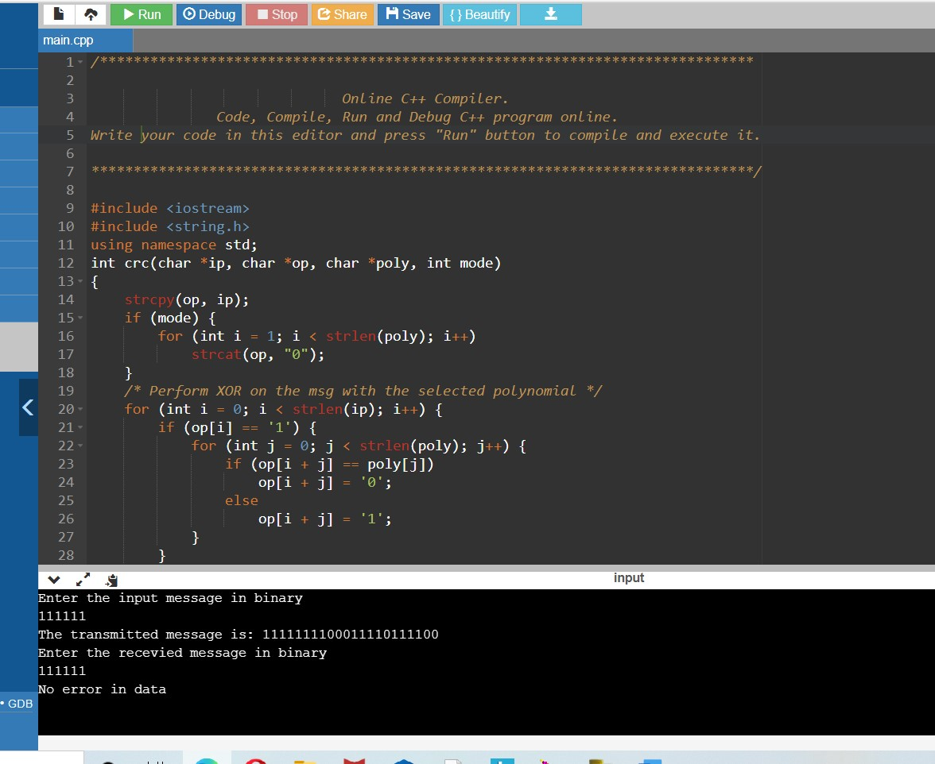

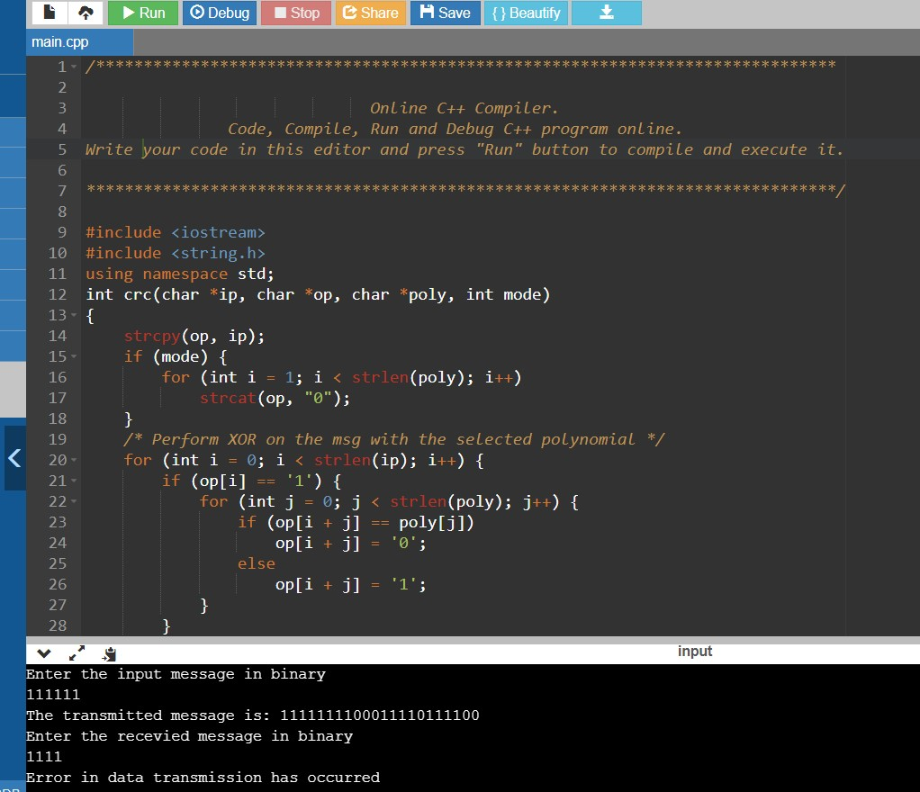

**RESULT:-**

Thus, the Error detection Code using CRC-CCITT(16 bits) is successfully run and completed.

**EX.NO: 8**

**07.03.2024**

**CASE STUDY FOR SLIDING WINDOW FLOW CONTROL, STOP AND WAIT CONTROL**

**Sliding Window Flow Control:**

* The sliding window is a technique for sending multiple frames at a time.
* It controls the data packets between the two devices where reliable and gradual delivery of data frames is needed.
* It is also used in TCP (Transmission Control Protocol).
* In this technique, each frame has sent from the sequence number.
* The sequence numbers are used to find the missing data in the receiver end.
* The purpose of the sliding window technique is to avoid duplicate data, so it uses the sequence number.

# Types of Sliding Window Protocols:

Sliding window protocol has two types:

1. Go-Back-N ARQ
2. Selective Repeat ARQ

**Go-Back-N ARQ**

Go-Back-N ARQ protocol is also known as Go-Back-N Automatic Repeat Request. It is a data link layer protocol that uses a sliding window method. In this, if any frame is corrupted or lost, all subsequent frames have to be sent again.

The size of the sender window is N in this protocol. For example, Go-Back-8, the size of the sender window, will be 8. The receiver window size is always 1.

If the receiver receives a corrupted frame, it cancels it. The receiver does not accept a corrupted frame. When the timer expires, the sender sends the correct frame again.

**Selective Repeat ARQ**

Selective Repeat ARQ is also known as the Selective Repeat Automatic Repeat Request. It is a data link layer protocol that uses a sliding window method. The Go-back-N ARQ protocol works well if it has fewer errors. But if there is a lot of error in the frame, lots of bandwidth loss in sending the frames again. So, we use the Selective Repeat ARQ protocol. In this protocol, the size of the sender window is always equal to the size of the receiver window. The size of the sliding window is always greater than 1.

If the receiver receives a corrupt frame, it does not directly discard it. It sends a negative acknowledgment to the sender. The sender sends that frame again as soon as on the receiving negative acknowledgment. There is no waiting for any time-out to send that frame. The design of the Selective Repeat ARQ protocol is shown below.

Difference between the Go-Back-N ARQ and Selective Repeat ARQ?

|  |  |
| --- | --- |
| **Go-Back-N ARQ** | **Selective Repeat ARQ** |
| If a frame is corrupted or lost in it,all subsequent frames have to be sent again. | In this, only the frame is sent again, which is  corrupted or lost. |
| If it has a high error rate,it wastes a lot of bandwidth. | There is a loss of low bandwidth. |
| It is less complex. | It is more complex because it has to do sorting  and searching as well. And it also requires  more storage. |
| It does not require sorting. | In this, sorting is done to get the frames in the  correct order. |
| It does not require searching. | The search operation is performed in it. |

**Stop and Wait protocol:**

While sending the data from the sender to the receiver the flow of data needs to be controlled. Suppose a situation where the sender is sending the data at a rate higher than the receiver is able to receive and process it, then the data will get lost. The Flow-control methods will help in ensuring that the data doesn't get lost. The flow control method will keep a check that the senders send the data only at a rate that the receiver is able to receive and process. There are mainly two ways in which this can be achieved i.e. using Stop-and-wait protocol or sliding window protocol. In this blog, we are going to learn about the Stop-and-wait protocol. So, let’s get started.

It is the simplest flow control method. In this, the sender will send one frame at a time to the receiver. The sender will stop and wait for the acknowledgment from the receiver. This time(i.e. the time between message sending and acknowledgement receiving) is the waiting time for the sender and the sender is totally idle during this time. When the sender gets the acknowledgment(ACK), then it will send the next data packet to the receiver and wait for the acknowledgment again and this process will continue as long as the sender has the data to send. This can be understood by the diagram below:

The above diagram explains the normal operation in a stop-and-wait protocol. Now, we will see some situations where the data or acknowledgment is lost and how the stop-and-wait protocol responds to it.

Suppose if any frame sent is not received by the receiver and is lost. So the receiver will not send any acknowledgment as it has not received any frame. Also, the sender will not send the next frame as it will wait for the acknowledgment for the previous frame which it had sent. So a deadlock situation arises here. To avoid any such situation there is a time-out timer. The sender waits for this fixed amount of time for the acknowledgment and if the acknowledgment is not received then it will send the frame again.

Consider a situation where the receiver has received the data and sent the acknowledgment but the ACK is lost. So, again the sender might wait till infinite time if there is no system of time-out timer. So, in this case also, the time-out timer will be used and the sender will wait for a fixed amount of time for the acknowledgment and then send the frame again if the acknowledgement is not received.

There are two types of delays while sending these frames:

**Transmission Delay:** Time taken by the sender to send all the bits of the frame onto the wire is called transmission delay. This is calculated by dividing the data size(D) which has to be sent by the bandwidth(B) of the link.

Td = D / B

**Propagation Delay:** Time taken by the last bit of the frame to reach from one side to the other side is called propagation delay. It is calculated by dividing the distance between the sender and receiver by the wave propagation speed.

Tp = d / s ; where d = distance between sender and receiver, s = wave propagation speed

The propagation delay for sending the data frame and the acknowledgment frame is the same as distance and speed will remain the same for both frames. Hence, the total time required to send a frame is:

Total time= Td(Transmission Delay) + Tp(Propagation Delay for data frame) + Tp(Propagation Delay for acknowledgment frame)

Total time=Td+ 2Tp

The sender is doing work only for Td time (useful time)and for the rest 2Tp time the sender is waiting for the acknowledgment.

Efficiency

Efficiency = Useful Time/ Total Time

η = Td / (Td+2*Tp)

η = 1/(1+2a) →(1)

where a=Tp / Td

Throughput

The number of bits that a receiver can accept in total time duration (i.e. transmission time(Td) + 2 * propagation delay(Tp)). It is also called effective bandwidth or bandwidth utilization.

In Stop and Wait, in the total duration, the receiver can accept only one frame. One frame is of data size D i.e. D bits in one frame.

Therefore, Throughput= D / (Td + 2Tp)

Throughput = D / Td(1+2a) →(2)

where a= Tp / Td

From the definition of Transmission delay,

Td=D/B

Cross multiplying B and Td, we get

B = D/Td → (3)

Now putting the value of equation 3 in equation 2, we get,

Throughput= B /(1+2a) → (4)

Now, putting the value of equation 1 in equation 4, we get,

Throughput= η * B

Thumbnail Image

NEW

Android App Development Online Course by MindOrks

Start your career in Android Development. Learn by doing real projects.

**Advantages of Stop and Wait Protocol**

It is very simple to implement.

The main advantage of this protocol is the accuracy. The next frame is sent only when the first frame is acknowledged. So, there is no chance of any frame being lost.

**Disadvantages of Stop and Wait Protocol**

We can send only one packet at a time.

If the distance between the sender and the receiver is large then the propagation delay would be more than the transmission delay. Hence, efficiency would become very low.

After every transmission, the sender has to wait for the acknowledgment and this time will increase the total transmission time. This makes the transmission process slow.

This is how the flow of data is controlled using the stop-and-wait protocol.

**EX.NO: 9**

**22.03.2024**

**SIMULATE STOP AND WAIT PROTOCOL USING C++**

**AIM:**

To implement simulation of stop and wait protocol using C++

**SOURCE CODE:-**

#include<iostream>

#include <time.h>

#include <cstdlib>

#include<ctime>

#include <unistd.h>

using namespace std;

class timer {

private:

unsigned long begTime;

public:

void start() {

begTime = clock();

}

unsigned long elapsedTime() {

return ((unsigned long) clock() - begTime) / CLOCKS_PER_SEC;

}

bool isTimeout(unsigned long seconds) {

return seconds >= elapsedTime();

}

};

int main()

{

int frames[] = {1,2,3,4,5,6,7,8,9,10};

unsigned long seconds = 5;

srand(time(NULL));

timer t;

cout<<"Sender has to send frames : ";

for(int i=0;i<10;i++)

cout<<frames[i]<<" ";

cout<<endl;

int count = 0;

bool delay = false;

cout<<endl<<"Sender\t\t\t\t\tReceiver"<<endl;

do

{

bool timeout = false;

cout<<"Sending Frame : "<<frames[count];

cout.flush();

cout<<"\t\t";

t.start();

if(rand()%2)

{

int to = 24600 + rand()%(64000 - 24600) + 1;

for(int i=0;i<64000;i++)

for(int j=0;j<to;j++) {}

}

if(t.elapsedTime() <= seconds)

{

cout<<"Received Frame : "<<frames[count]<<" ";

if(delay)

{

cout<<"Duplicate";

delay = false;

}

cout<<endl;

count++;

}

else

{

cout<<"---"<<endl;

cout<<"Timeout"<<endl;

timeout = true;

}

t.start();

if(rand()%2 || !timeout)

{

int to = 24600 + rand()%(64000 - 24600) + 1;

for(int i=0;i<64000;i++)

for(int j=0;j<to;j++) {}

if(t.elapsedTime() > seconds )

{

cout<<"Delayed Ack"<<endl;

count--;

delay = true;

}

else if(!timeout)

cout<<"Acknowledgement : "<<frames[count]-1<<endl;

}

}while(count!=10);

return 0;}

**OUTPUT: -**

**STOP AND WAIT PROTOCOL USING C++**

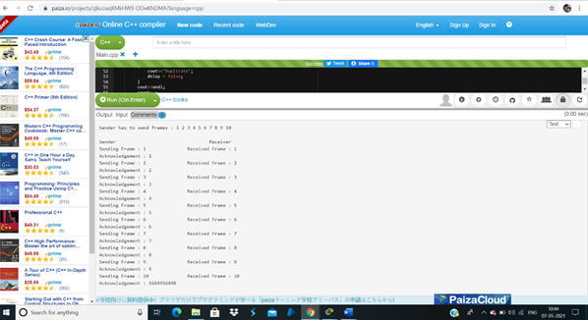

**RESULT:**

Simulation of Stop and Wait protocol in C++ has been Successfully run and completed.

**EX.NO: 10**

**28.03.2024**

**STUDY OF SWITCHES, BRIDGES USING CISCO PACKET TRACER**

**AIM:**

To Study of Switches, Bridges using Cisco Packet Tracer.

**PROCEDURE:**

* Open Cisco Packet > New > File.
* Click on Switch in the toolbox and select two PT Switch
* Click on Bridge in the toolbox and select a Bridge
* Click on PCs and draw Six PCs.
* Click on Wires and select Automatically connected Wires.
* Using the wire connect the three PCs to the Switch and Switch to the Bridge
* Select all the PC’s and Set the IP Configuration as DHCP.
* After the Successful Connection send a message from a PC to another PC using Simple PDU.
* Auto capture/play Simulation to view the connection and communication path.

**OUTPUT:**

**Network Diagram:**

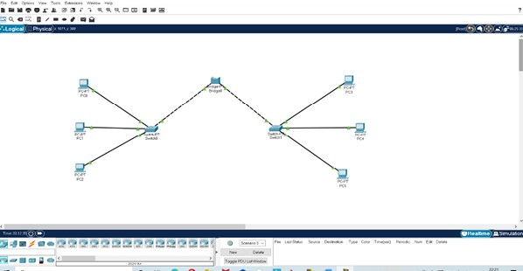

**Sending a message from a PC to another PC using Simple PDU:**

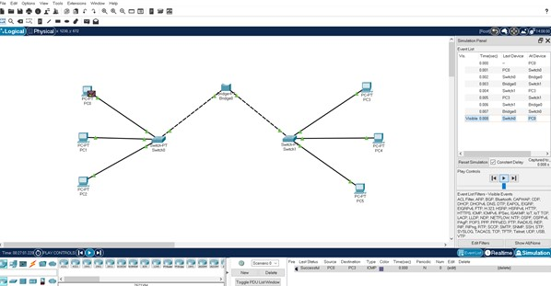

**RESULT:** To Study of Switches, Bridges using Cisco Packet Tracer has been Successfully and Completed.