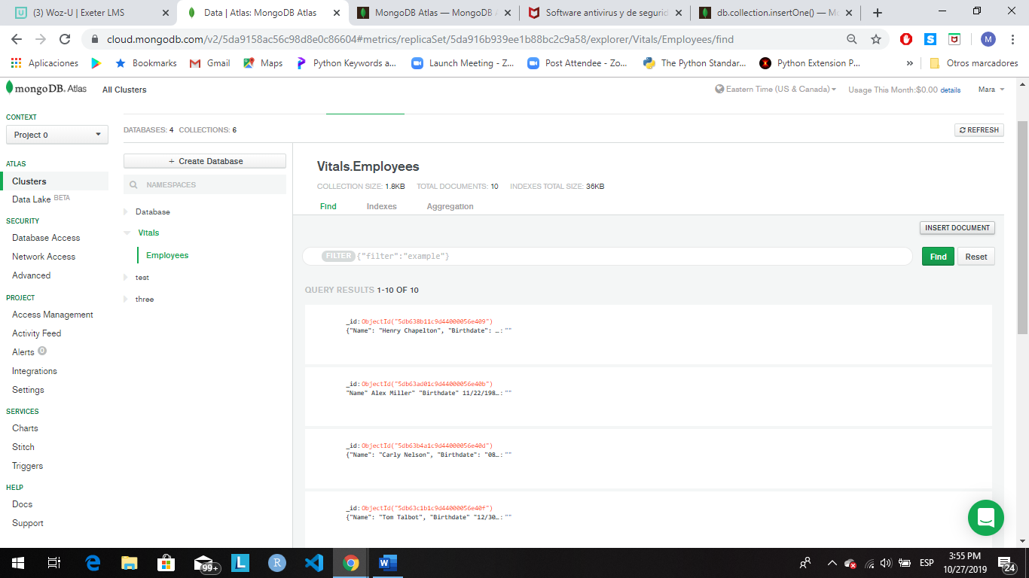

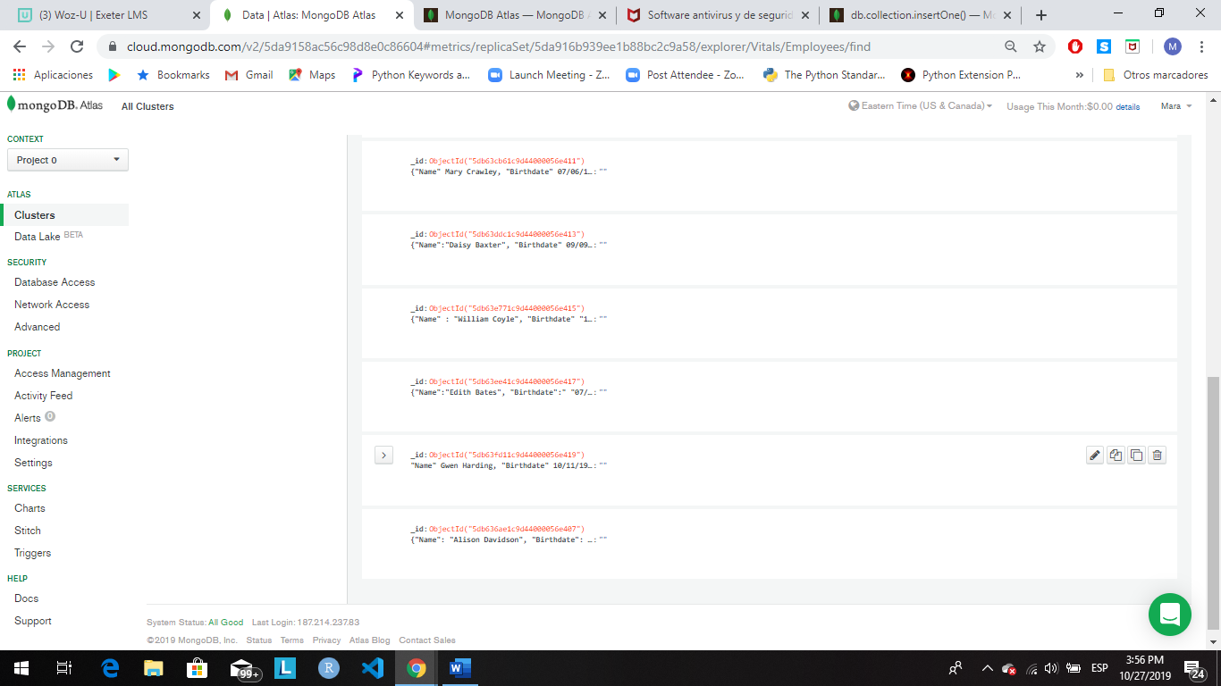

**Notes:**

* The Birthdate field should have a data type of Date.

|  |  |
| --- | --- |
| [date](https://docs.microsoft.com/en-us/sql/t-sql/data-types/date-transact-sql?view=sql-server-ver15) | MM-DD-YYY |

* The Position Name, Remote, and Full Time fields should be within an embedded document called position.

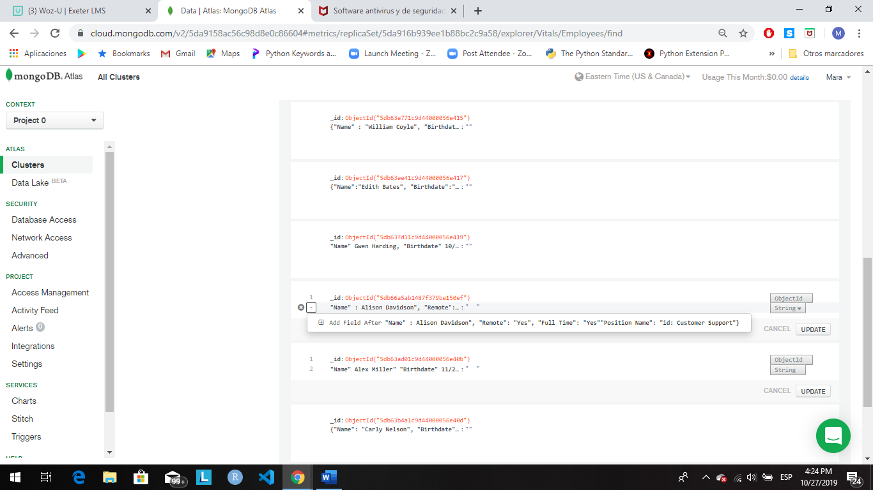

* Remote and Full Time fields should have boolean values.

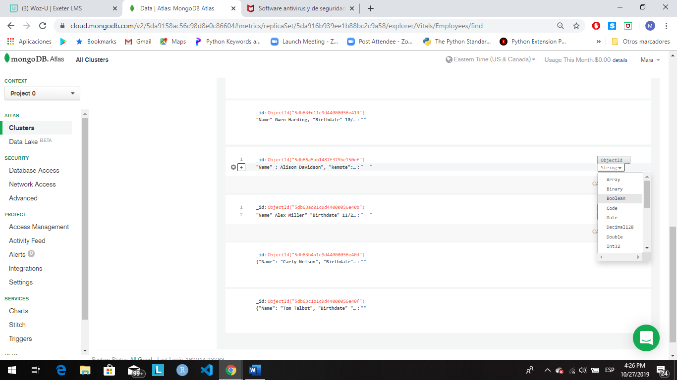

It's been about a month since you have inserted all employees into the database. There have been a couple of changes to the company. The CEO decided that he no longer wants remote employees, so they have transferred the remote employees and they are now living in Arizona. Alison Davidson now lives at 777 E. 1st St. # 120 Tempe, AZ and Mary Crawley now lives at 8322 W. Vista Pl. Scottsdale, AZ.

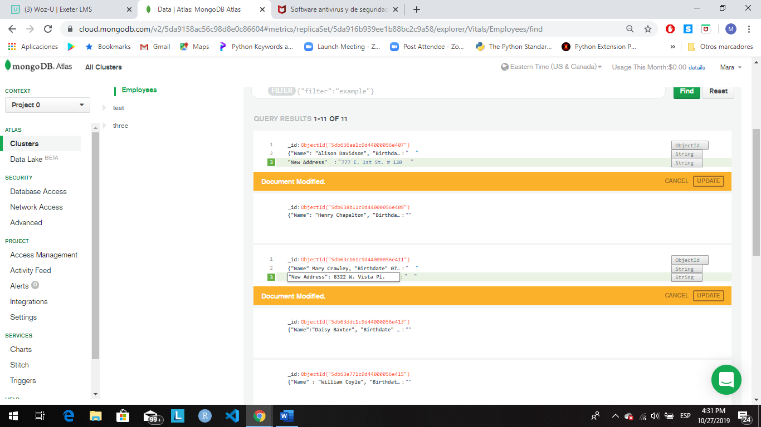

Since all employees now all live in Arizona, there is no need to have a field named "state" within this collection, so please remove it. Lastly, they would like very efficient searching using the "position" field (remember that field includes a document with three other fields).

Part2

**Notes:**

* The artist, album, and releaseYear fields should be an embedded document named details.

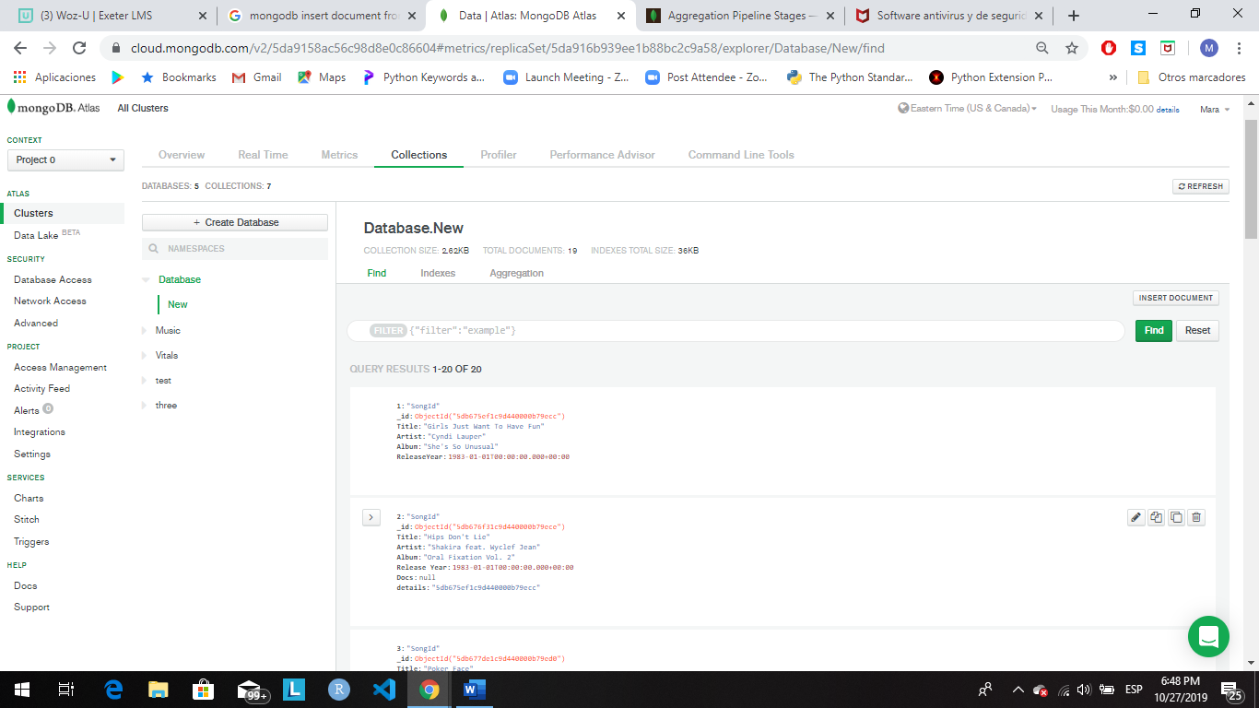

Be sure that the songId and releaseYear fields have a type of number.

Next, your company has run into some things they would like to be changed within the database:

* The title field needs to be renamed to songTitle, so it is clearer to the developers working with the data.

