**Task 1. Will the conversion to BCNF be dependency preserving in any case? Proof your statement and give a reasoning for choosing BCNF design.**

A relation schema R is in BCNF with respect to a set F of functional dependencies if for all functional dependencies in F+ of the for  
 α→β

where α⊆R and β⊆R, at least one of the following holds:

α→β is trivial (i.e., β⊆α)

α is a superkey for R

It is not always possible to achieve both BCNF and dependency preservation.

Consider a schema:

dept_advisor(s_ID, i_ID, department_name)

With function dependencies:

i_ID→dept_name

s_ID, dept_name→i_ID

dept_advisor is not in BCNF

i_ID is not a superkey.

Any decomposition of dept_advisor will not include all the attributes in

s_ID, dept_name→i_ID

Thus, the composition is NOT be dependency preserving

**Task 2. Given table in 1NF, convert to 3NF if PK is {UnitID, StudentID}:**

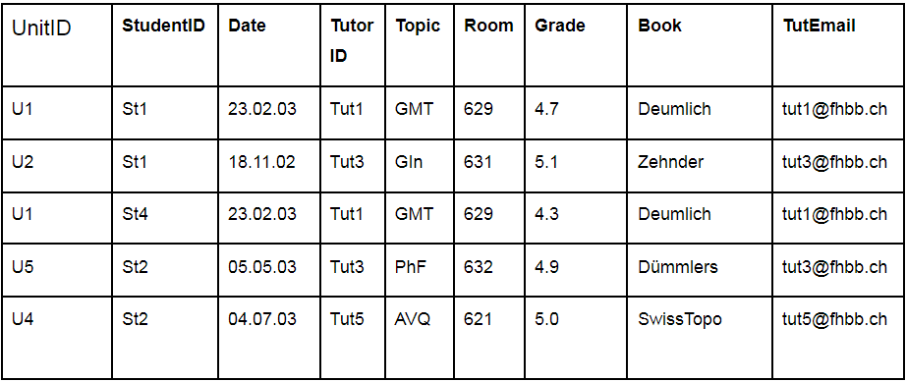

Transitive dependency:

TutorID -> TutEmail;

Topic -> Room;

Topic -> Book;

Topic -> Grade;

Topic -> Date;



**Task 3. Given table in 1NF, convert to 2NF if PK is {ProjectName, ProjectManager}, use decomposition:**

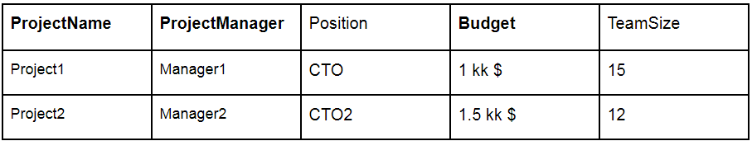

ProjectName -> Position;

ProjectName -> Budget;

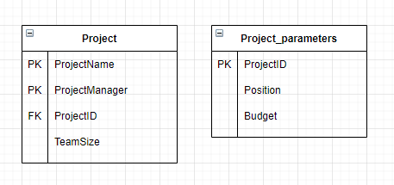

**Task 4. Given table, convert to 3NF if PK is Group, use decomposition:**

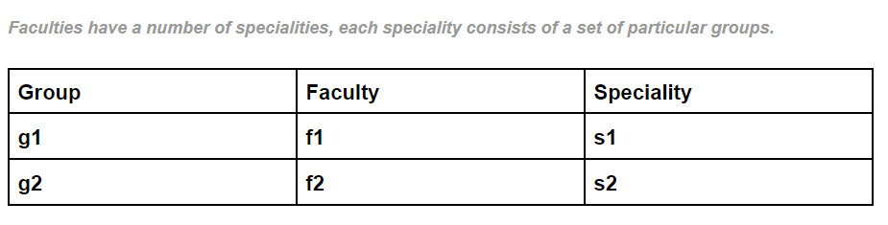

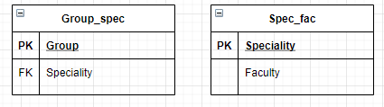

**Task 5. Given table, convert to BCNF if PK is {ProjectID, Department}, use decomposition:**

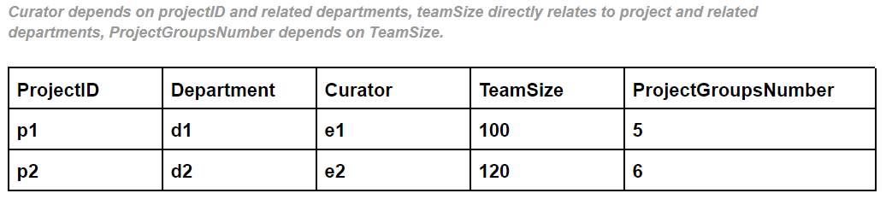

ProjectID -> Curator;

Department -> Curator;

ProjectID -> teamSize;

TeamSize -> ProjectGroupsNumber;

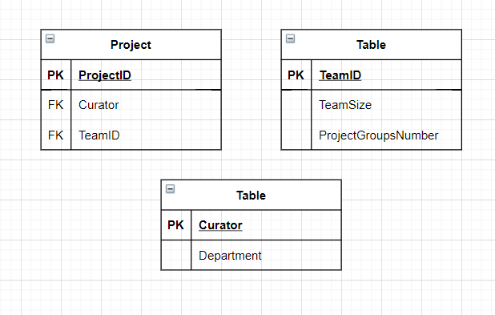

**Task 6. List the three design goals for relational databases, and explain why each is**

**desirable. Give an example of both desirable and undesirable types of**

**decompositions.**

For relational databases, atomicity of data is important, uniqueness in attributes in all tables, as well as reducing the number of transitive dependencies, but primary and secondary keys are also needed to preserve logical relationships.