The design of the mobile app for KBTU students and professors. This is the whole version of the homepage. It is the update version of wsp.kbtu.kz. Everyone can benefit from such kind of app in our university.

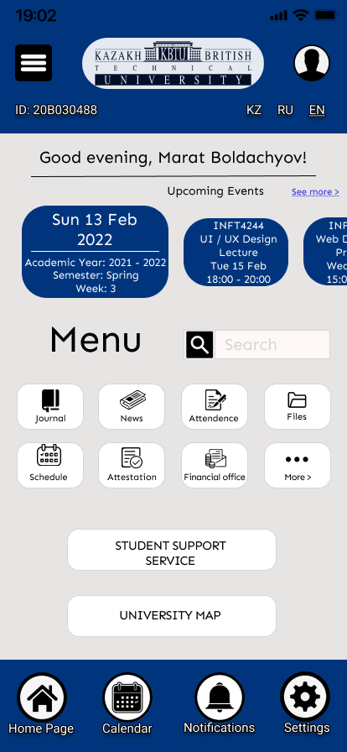

Home page of WSP KBTU

