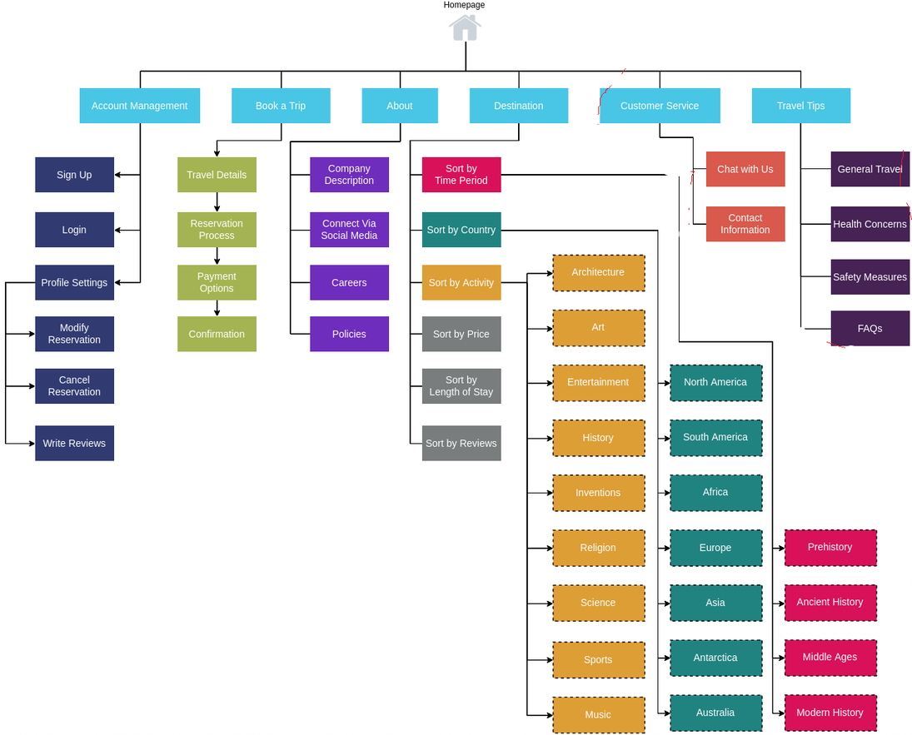

<https://7d28apdp.optimalworkshop.com/treejack/b4rd82g3/tasks> - Interface of the application

Where I can find the info about Ancient History?

You should follow the next path: «Homepage -> Destination -> Sort by Time Period -> Ancient History»

Where I can read the policies?

You should follow the next path: «Homepage -> About -> Policies»

How can I sign up?

You should follow the next path: «Homepage -> Account Management -> Sign Up»