CARVION AI: AN AI-POWERED CAREER DEVELOPMENT PLATFORM
A PROJECT REPORT
Submitted in partial fulfillment of the requirements for the award of the degree of
MASTER OF COMPUTER APPLICATIONS (MCA)

**Submitted By:**
[Student Name]
Enrollment No: [Candidate Enrollment / Roll Number]

**Under the Guidance of:**
[Supervisor Name]
Designation: [Assistant Professor / Guide Designation]

**DEPARTMENT OF COMPUTER SCIENCE AND APPLICATIONS**
[UNIVERSITY / INSTITUTION NAME]
[CITY, STATE - PIN CODE]
ACADEMIC YEAR: 2025–2026

ii. BONAFIDE CERTIFICATE / CERTIFICATE OF APPROVAL
This is to certify that the project report entitled "Carvion AI: AI-Powered Career Development Platform", submitted by [Student Name] (Enrollment No: [Candidate Enrollment Number]), in partial fulfillment of the requirements for the award of the degree of Master of Computer Applications (MCA) from [University / Institution Name], is an authentic record of bonafide project work carried out under my supervision and guidance during the academic year 2025–2026.
The results embodied in this report have not been submitted to any other University or Institute for the award of any degree or diploma.
<br/><br/>
_________________________________
[Supervisor Name]
Internal Project Guide
Department of Computer Science & Applications
[University / Institution Name]
<br/><br/>
_________________________________
[Head of Department Name]
Head of Department
Department of Computer Science & Applications
[University / Institution Name]
<br/><br/>
External Examiner Signature: _________________________________
Date: [DD/MM/YYYY]

iii. STUDENT DECLARATION OF ORIGINALITY
I, [Student Name], student of the Master of Computer Applications (MCA) program at [University / Institution Name], hereby declare that the project entitled "Carvion AI: AI-Powered Career Development Platform" is an original work performed by me under the supervision of [Supervisor Name].
I declare that:
- The work submitted is fresh, original, and completed specifically for the fulfillment of the MCA curriculum requirements.
- All source code, system models, database schemas, and documentation reflect actual software design and implementation.
- Due acknowledgements have been given wherever theoretical literature, external libraries, or standard algorithms have been referenced.
- This project work has not been submitted previously to any other university or institution for the award of any academic degree, diploma, or certificate.
<br/><br/>
_________________________________
[Student Name]
Enrollment No: [Candidate Enrollment Number]
Department of Computer Science & Applications
[University / Institution Name]
Date: [DD/MM/YYYY]
Place: [City Name]

iv. ACKNOWLEDGEMENTS
I express my deepest gratitude to [Supervisor Name], Assistant Professor, Department of Computer Science & Applications, for providing invaluable academic guidance, constructive feedback, and continuous encouragement throughout the conceptualisation, architectural design, and implementation phases of this project.
I am profoundly grateful to [Head of Department Name], Head of the Department of Computer Science & Applications, for providing the necessary infrastructural resources, laboratory facilities, and an environment conducive to technical research.
I extend my sincere thanks to all faculty members of the department whose academic teachings throughout the MCA curriculum provided the theoretical foundation required to engineer a decoupled web application and integrate artificial intelligence components.
Finally, I express my sincere appreciation to my family and peers for their unyielding moral support, patience, and encouragement during the course of this project.
<br/><br/>
_________________________________
[Student Name]
Master of Computer Applications (MCA)

v. ABSTRACT / SYNOPSIS
The modern recruitment landscape is characterized by increasing reliance on automated screening mechanisms and specialized skill requirements, presenting substantial navigational challenges for job seekers. Traditional career guidance tools suffer from functional fragmentation, offering static resume design, unverified job aggregations, and non-adaptive learning materials as isolated services.
Carvion AI is a web-based career development platform designed to unify document analysis, career path formulation, interview preparation, job and course discovery, and conversational assistance within a single system architecture. The system adopts a decoupled client-server architecture. The frontend application is constructed as a React (v18) Single Page Application (SPA) using Vite for build tooling, React Router DOM for client-side routing, TanStack Query for asynchronous state synchronization, and custom Vanilla CSS for interface styling. The backend application is implemented in Python using the Django framework and Django REST Framework (DRF), providing stateless REST API endpoints secured via JSON Web Token (JWT) authentication with refresh token rotation.
Data storage is managed through a hybrid model: MongoDB functions as the primary document-oriented database accessed via MongoEngine Object-Document Mapper (ODM) to accommodate variable JSON structures generated by machine learning models, while SQLite handles administrative metadata and session blacklists. Natural language processing and generative capabilities are integrated using the Google Gemini 2.5 Flash API via the official SDK, supported by server-side document parsing engines (PyMuPDF for PDF documents and python-docx for Microsoft Word files).
The software encompasses eight functional modules: User Authentication and Authorization, Candidate Profile Management, Automated Resume Analysis and ATS Scoring, Personalised Career Roadmap Generation, AI-Driven Mock Interview Simulation, Contextual Job and Course Recommendations, Conversational Chatbot Guidance, and an Administrative Management Console. System validity was confirmed through multi-tier testing, including unit testing, integration verification, system security auditing, and user acceptance evaluation across twenty execution scenarios. The platform provides a structured, accessible approach to career preparation while eliminating reliance on proprietary analytics tools through live backend aggregation.
Keywords: Artificial Intelligence, Web Application Development, Django REST Framework, React, MongoDB, Document Parsing, Natural Language Processing, Career Guidance.

vi. TABLE OF CONTENTS
- Preliminary Pages
- i. Title Page / Cover Page
- ii. Bonafide Certificate / Certificate of Approval
- iii. Student Declaration of Originality
- iv. Acknowledgements
- v. Abstract / Synopsis
- vi. Table of Contents
- vii. List of Tables
- viii. List of Figures & Diagrams
- ix. List of Abbreviations & Acronyms
- Chapter 1 – Introduction
- 1.1 Introduction
- 1.2 Background of the Study
- 1.3 Problem Statement
- 1.4 Motivation
- 1.5 Objectives
- 1.6 Scope of the Project
- 1.7 Project Overview
- 1.8 Organization of the Report
- Chapter 2 – Literature Survey
- 2.1 Introduction
- 2.2 Critical Literature Review
- 2.3 Existing System Analysis
- 2.3.1 Resume Builders and Templates (Canva, Zety)
- 2.3.2 Commercial Job Portals (LinkedIn, Indeed)
- 2.3.3 Self-Paced Learning Platforms (Coursera, Udemy)
- 2.3.4 Standalone Interview Tools (Pramp, Interview Cake)
- 2.4 Limitations of Existing Systems
- 2.5 Proposed System (Carvion AI)
- 2.6 Advantages of Proposed System
- 2.7 Feature Comparison Matrix
- Chapter 3 – System Analysis and Design
- 3.1 Requirement Analysis
- 3.2 Functional Requirements
- 3.3 Non-Functional Requirements
- 3.4 Feasibility Study
- 3.4.1 Technical Feasibility
- 3.4.2 Operational Feasibility
- 3.4.3 Economic Feasibility
- 3.5 Technologies Used
- 3.5.1 Frontend (React v18, Vite, TanStack Query, Recharts, Axios, Vanilla CSS)
- 3.5.2 Backend (Python 3.11, Django, Django REST Framework, Simple JWT, MongoEngine)
- 3.5.3 Text Parsers & AI Integration (PyMuPDF, python-docx, Google Generative AI SDK)
- 3.5.4 Database Architecture (MongoDB NoSQL Document Store & SQLite Relational Store)
- 3.6 System Architecture Diagram & Description
- 3.7 Data Flow Diagrams (DFD)
- 3.7.1 Level 0 – Context Diagram
- 3.7.2 Level 1 – Main System Processes
- 3.7.3 Level 2 – Resume Management Process Decomposition
- 3.7.4 Level 3 – Document Parsing & Field Normalization Sub-process
- 3.8 Entity-Relationship (ER) Diagram
- 3.9 Database Design & Schema Specifications
- 3.9.1 Users Collection
- 3.9.2 Profiles Collection
- 3.9.3 Resumes Collection
- 3.9.4 Roadmaps Collection
- 3.9.5 Interview Sessions Collection
- 3.9.6 Chat Sessions Collection
- 3.9.7 Notifications Collection
- 3.9.8 Admin Activity Logs Collection
- 3.9.9 Refresh Tokens Collection (MongoDB TTL Indexing)
- 3.9.10 Contact Messages Collection
- 3.10 Unified Modeling Language (UML) Diagrams
- 3.10.1 Use-Case Diagram (User & Admin Interactions)
- 3.10.2 Sequence Diagram (User Login, Resume Upload, & AI Evaluation)
- 3.10.3 Class Diagram (MongoEngine Documents & DRF ViewSets)
- 3.10.4 Activity Diagram (Mock Interview Preparation Workflow)
- Chapter 4 – System Development and Implementation
- 4.1 Development Methodology (Agile SDLC)
- 4.2 Frontend Development (SPA Component Architecture, Axios JWT Interceptors, Route Guarding)
- 4.3 Backend Development (Django REST Framework ViewSets, Middleware, Serializers)
- 4.4 Database Implementation (MongoEngine ODM Connections, Dynamic Indexes, Cascading Deletes)
- 4.5 Applied Artificial Intelligence Integration
- 4.5.1 Prompt Engineering & Structure Enforcement (Google Gemini 1.5 Flash API)
- 4.5.2 Fallback Strategies & Deterministic Output Handling
- 4.6 System Security Controls
- 4.6.1 JWT Authentication & Refresh Token Rotation
- 4.6.2 Role-Based Access Control (RBAC) & Custom Middleware
- 4.6.3 API Throttling, Input Sanitization, and Security Logging
- 4.7 Implementation of Primary Modules
- 4.7.1 Authentication & Profile Module
- 4.7.2 Resume Intelligence & ATS Scoring Module
- 4.7.3 AI Career Roadmap Generator
- 4.7.4 Mock Interview Simulator
- 4.7.5 Recommendations & AI Chatbot Module
- 4.7.6 Enterprise Admin Console Module
- 4.8 Core Workflows and Algorithms
- 4.8.1 Document Parsing Logic (PDF/DOCX Page-by-Page Extraction)
- 4.8.2 ATS Scoring Formulation & Keyword Match Algorithm
- 4.8.3 Gemini API Payload Handler & Response Normalizer
- 4.9 Application Interface Design and Screenshots
- 4.9.1 Authentication & User Dashboard Screens
- 4.9.2 Resume Analysis, ATS Report & Career Roadmap Screens
- 4.9.3 Mock Interview Simulator & Chatbot Assistant Screens
- 4.9.4 Enterprise Admin Console & Analytics Screens
- Chapter 5 – System Testing and Validation
- 5.1 Introduction to Software Testing
- 5.2 Test Plan and Strategy
- 5.3 Unit Testing
- 5.4 Integration Testing
- 5.5 System Testing
- 5.6 Security Testing (Penetration Verification, Token Blacklisting, Role Isolation)
- 5.7 Performance Testing (Latency Measurements, Load Thresholds, Query Optimization)
- 5.8 User Acceptance Testing (UAT)
- 5.9 Detailed Test Cases Matrix
- 5.9.1 Authentication Module Test Cases (TC-AUTH-01 to TC-AUTH-12)
- 5.9.2 Profile Module Test Cases (TC-PROF-01 to TC-PROF-04)
- 5.9.3 Resume Management Test Cases (TC-RES-01 to TC-RES-10)
- 5.9.4 Career Roadmap Test Cases (TC-ROAD-01 to TC-ROAD-05)
- 5.9.5 Mock Interview Test Cases (TC-INT-01 to TC-INT-06)
- 5.9.6 AI Chatbot Test Cases (TC-CHAT-01 to TC-CHAT-06)
- 5.9.7 Recommendations Test Cases (TC-REC-01 to TC-REC-06)
- 5.9.8 Notifications Test Cases (TC-NOTIF-01 to TC-NOTIF-05)
- 5.9.9 Admin Console Test Cases (TC-ADMIN-01 to TC-ADMIN-12)
- 5.10 Test Execution Summary & Defect Tracking Report
- Chapter 6 – Results and Discussion
- 6.1 Output Verification
- 6.2 Empirical Result Analysis
- 6.3 System Performance Analysis (Response Latency, Throughput, Load Times)
- 6.4 System Advantages
- 6.5 System Limitations
- Chapter 7 – Conclusion and Future Scope
- 7.1 Conclusion
- 7.2 Recommendations for Future Scope (Native Mobile App, WebSockets, Video Interviews, Multilingual Support)
- References

viii. LIST OF FIGURES & DIAGRAMS
Figure No. | Caption | Page
Figure 3.1 | High-Level Decoupled System Architecture of Carvion AI | Page 28
Figure 3.2 | Level 0 Context Diagram (DFD Context Model) | Page 31
Figure 3.3 | Level 1 Data Flow Diagram (Main System Processes) | Page 32
Figure 3.4 | Level 2 Data Flow Diagram (Resume Management Process Decomposition) | Page 33
Figure 3.5 | Level 3 Data Flow Diagram (Document Parsing & Field Normalization Sub-process) | Page 34
Figure 3.6 | Entity-Relationship (ER) Diagram (MongoEngine Document Schemas) | Page 36
Figure 3.7 | UML Use Case Diagram (User & Admin Functional Boundaries) | Page 42
Figure 3.8 | UML Sequence Diagram (User Login, Resume Upload, & AI Evaluation Flow) | Page 44
Figure 3.9 | UML Activity Diagram (Mock Interview Preparation Workflow) | Page 46
Figure 3.10 | UML Interaction Sequence Diagram for Main Core Workflows | Page 47
Figure 3.11 | UML Class Diagram of Backend Documents and DRF ViewSets | Page 48
Figure 4.1 | Agile SDLC Iterative Development Framework Sprint Lifecycle | Page 49
Figure 4.2 | Flowchart of Document Parsing and ATS Analysis Workflow | Page 55
Figure 4.3 | Flowchart of Career Recommendation Engine Workflow | Page 57

vii. LIST OF TABLES
Table No. | Caption | Page
Table 2.1 | Summary of Research Literature Reviewed | Page 14
Table 2.2 | Feature Comparison: Existing Systems vs. Carvion AI | Page 20
Table 3.1 | Description of DFD Symbols | Page 30
Table 3.2 | Users Collection (`users`) Schema Specification | Page 37
Table 3.3 | Profiles Collection (`profiles`) Schema Specification | Page 37
Table 3.4 | Resumes Collection (`resumes`) Schema Specification | Page 38
Table 3.5 | Roadmaps Collection (`roadmaps`) Schema Specification | Page 38
Table 3.6 | Interview Sessions Collection (`interview_sessions`) Schema Specification | Page 39
Table 3.7 | Chat Sessions Collection (`chat_sessions`) Schema Specification | Page 39
Table 3.8 | Notifications Collection (`notifications`) Schema Specification | Page 40
Table 3.9 | Admin Activity Logs Collection (`admin_activity_logs`) Schema Specification | Page 40
Table 3.10 | Refresh Tokens Collection (`refresh_tokens`) Schema Specification | Page 41
Table 3.11 | Contact Messages Collection (`contact_messages`) Schema Specification | Page 41
Table 3.12 | Interaction Steps Matrix Table | Page 47
Table 5.1 | Authentication Module Test Cases Matrix (TC-AUTH-01 to TC-AUTH-12) | Page 62
Table 5.2 | Profile Module Test Cases Matrix (TC-PROF-01 to TC-PROF-04) | Page 64
Table 5.3 | Resume Management Test Cases Matrix (TC-RES-01 to TC-RES-10) | Page 65
Table 5.4 | Career Roadmap Test Cases Matrix (TC-ROAD-01 to TC-ROAD-05) | Page 66
Table 5.5 | Mock Interview Test Cases Matrix (TC-INT-01 to TC-INT-06) | Page 67
Table 5.6 | AI Chatbot Test Cases Matrix (TC-CHAT-01 to TC-CHAT-06) | Page 68
Table 5.7 | Recommendations Test Cases Matrix (TC-REC-01 to TC-REC-06) | Page 69
Table 5.8 | Notifications Test Cases Matrix (TC-NOTIF-01 to TC-NOTIF-05) | Page 70
Table 5.9 | Admin Console Test Cases Matrix (TC-ADMIN-01 to TC-ADMIN-12) | Page 71
Table 5.10 | Test Execution Results Summary | Page 72
Table 6.1 | Latency Benchmark Measurements Across Primary Endpoints | Page 74

LIST OF ABBREVIATIONS
Abbreviation | Full Expansion
**API** | Application Programming Interface
**ATS** | Applicant Tracking System
**Bcrypt** | Blowfish Cipher Password Hashing Algorithm
**CORS** | Cross-Origin Resource Sharing
**DFD** | Data Flow Diagram
**DOCX** | Office Open XML Document Format
**DRF** | Django REST Framework
**ER** | Entity-Relationship
**HTTP / HTTPS** | Hypertext Transfer Protocol / Secure
**JSON** | JavaScript Object Notation
**JWT** | JSON Web Token
**LLM** | Large Language Model
**MCA** | Master of Computer Applications
**NLP** | Natural Language Processing
**NoSQL** | Not Only Structured Query Language
**ODM** | Object-Document Mapper
**ORM** | Object-Relational Mapper
**PDF** | Portable Document Format
**REST** | Representational State Transfer
**RFC** | Request for Comments
**SDLC** | Software Development Life Cycle
**SPA** | Single Page Application
**SQL** | Structured Query Language
**TTL** | Time-To-Live
**UAT** | User Acceptance Testing
**UML** | Unified Modeling Language
**URI / URL** | Uniform Resource Identifier / Locator

CHAPTER 1: INTRODUCTION

1.1 Introduction
In contemporary labor markets, career development and recruitment procedures rely heavily on digital platforms and automated candidate evaluations. Job seekers across technical and non-technical domains face structural challenges when transitioning into professional roles. Candidates must construct resumes tailored to automated screening systems, identify relevant skill acquisitions for target employment roles, and prepare for structured interview processes.
Artificial Intelligence (AI) and Natural Language Processing (NLP) provide mechanisms to assist individuals by analyzing textual documentation, identifying skill discrepancies, and synthesizing pedagogical roadmaps. However, existing software solutions in career guidance operate as isolated, single-purpose applications. Resume construction software provides document formatting without semantic evaluation; online recruitment portals list employment opportunities without assessing applicant readiness; and educational platforms offer course catalogs without tailoring learning pathways to candidate profiles.
Carvion AI is an AI-powered career development platform engineered as a decoupled, multi-tier web application. The platform integrates document parsing, automated Applicant Tracking System (ATS) evaluation, dynamic learning path generation, interactive interview simulation, job and course discovery, and conversational career assistance within a unified software environment. By leveraging Large Language Models (LLMs) through a server-side execution pipeline, Carvion AI processes unstructured candidate data into structured evaluation metrics and actionable career guidance.

1.2 Background of the Study
Recruitment workflows have undergone significant technological evolution over the past two decades. Organisations receive substantial volumes of applications for open positions, necessitating the deployment of Applicant Tracking Systems (ATS) to filter resumes based on keyword matching, syntactic formatting, and semantic relevance before human evaluation occurs. Studies indicate that a large proportion of uploaded resumes fail to pass initial automated filters due to structural misalignments, improper terminology, or unoptimized section formatting.
Concurrently, candidate skill requirements change rapidly due to technological advancement. Job seekers often lack objective feedback regarding how their current qualifications align with target job roles. Traditional career mentorship and mock interview preparation offer individualized feedback but remain constrained by financial cost, geographical availability, and human resource limitations.
The emergence of Large Language Models based on the Transformer architecture enables zero-shot and few-shot natural language understanding. When combined with modern web software engineering practices—such as component-driven frontend frameworks, RESTful application programming interfaces, and document-oriented databases—generative models can be applied to parse complex resume documents, construct personalized learning roadmaps, evaluate natural language interview responses, and deliver contextually relevant guidance.

1.3 Problem Statement
The current career preparation ecosystem presents several critical limitations for job seekers and educational institutions:
- Fragmented Tool Architecture: Candidates are required to utilize multiple disconnected software tools for resume creation, job searching, skill acquisition, and interview preparation. This lack of integration prevents data persistence across stages, forcing candidates to re-enter background information repeatedly.
- Opacity of Automated Screening Systems: Job seekers lack visibility into how automated screening tools parse and score their resumes. Existing resume builders format text visually but fail to analyze semantic quality, missing industry keywords, or structural compliance.
- Non-Personalized Learning Pathways: General educational platforms present standardized course catalogs without analyzing the specific skill gaps existing between a candidate's current resume and their stated target employment role.
- Lack of Accessible Interview Evaluation: Interactive interview preparation with objective feedback typically requires human mentors. Automated alternatives rely on rigid multiple-choice questions rather than evaluating free-form natural language answers.
- Absence of Administrative Oversight in Educational Environments: Institutional guidance departments lack centralized software tools to monitor aggregate student preparation, track resume optimization activities, and communicate updates effectively.

1.4 Motivation
The primary motivation behind engineering Carvion AI is to establish an accessible, unified software platform that automates complex career guidance processes through applied artificial intelligence.
By unifying document parsing, ATS score generation, skill gap analysis, interactive interview practice, and job discovery into a single web application, the platform eliminates the inefficiencies associated with fragmented tools. Providing deterministic, structured AI evaluation enables candidates to receive immediate feedback on resume quality and interview performance without financial or geographical constraints.
From a software engineering perspective, the project is motivated by the challenge of designing a decoupled, state-synchronized architecture that combines a React single-page application, a Python Django REST API, a document-oriented database (MongoDB), and external large language model APIs while ensuring data security, rate throttling, and system reliability.

1.5 Objectives
The primary technical and functional objectives of the Carvion AI project are:
- Decoupled Architecture Engineering: To design and implement a decoupled web application comprising a React (Vite) single-page application frontend and a Python Django REST Framework backend communicating via JSON-formatted HTTP APIs.
- Automated Resume Parsing and ATS Evaluation: To develop a document parsing module using PyMuPDF and python-docx that extracts raw text from PDF and DOCX files, processes section structures, and invokes Google Gemini 2.5 Flash to generate ATS compatibility scores (0–100) and actionable improvement reports.
- Dynamic Career Roadmap Synthesis: To implement an AI-driven learning path generator that analyzes a user's current profile against a target role to produce structured, milestone-based learning roadmaps persisted in MongoDB.
- Interactive Mock Interview Simulator: To construct a natural language interview simulation module that presents role-tailored questions, evaluates free-form candidate answers, and returns multi-dimensional feedback scores covering content relevance and communication clarity.
- Contextual Recommendation Engine: To integrate job and learning course discovery modules that query external job search services (JSearch) and match courses to candidate skill gaps, utilizing database caching to optimize latency.
- Conversational AI Assistance: To embed an interactive chatbot interface capable of answering career queries, contextualizing resume evaluation reports, and maintaining multi-turn conversation sessions.
- Stateless Authentication and Role-Based Access Control: To implement JWT-based authentication featuring token rotation, refresh token blacklisting, and role-based authorization distinguishing standard candidates from system administrators.
- Administrative Oversight Console: To engineer an enterprise administration module providing real-time system metrics, user account management, contact ticket resolution, notification broadcasting, and activity audit logging using live database aggregations.

1.6 Scope of the Project
The scope of the project encompasses the design, implementation, testing, and documentation of the Carvion AI web platform.
In Scope:
- Full-stack web application development using React, Vite, Python, Django REST Framework, MongoDB, MongoEngine, and SQLite.
- Multi-format document text extraction (PDF and DOCX).
- Natural language parsing, ATS scoring, and feedback synthesis using Google Gemini 2.5 Flash.
- Interactive user modules: Dashboard, Resume Manager, Roadmap Tracker, Mock Interview Simulator, Recommendations Explorer, and AI Chatbot.
- Administrative console: System metrics dashboard, account management, contact ticketing, notification broadcasting, cache control, and audit trail logging.
- Empirical performance and security validation across twenty distinct test cases.
Out of Scope:
- Native mobile applications for iOS or Android operating systems (web interface is fully responsive).
- Audio and video processing for video-based interview facial expression analysis.
- Multi-language translation beyond English natural language processing.
- Direct financial transaction processing or commercial payment gateway integration.

1.7 Project Overview
Carvion AI operates as a unified web ecosystem designed around candidate data persistence. Upon registration and authentication via JWT, the user establishes a central candidate profile defining current skills, target job roles, and background information.
When a user uploads a resume, the backend text extraction pipeline ingests the document file, extracts textual content, normalizes section entries, and passes the payload to Google Gemini 2.5 Flash via a structured prompt. The returned evaluation includes an overall ATS compatibility metric, section-by-section analysis, missing keyword lists, and specific content recommendations.
The generated candidate analysis directly informs downstream modules. The Career Roadmap module synthesizes step-by-step skill acquisition milestones aligned with identified deficiencies. The Mock Interview module generates technical and behavioral questions tailored to the candidate's target role, evaluating submitted text responses through semantic scoring models. The Recommendation engine matches candidate profiles with live job opportunities and targeted learning courses. The AI Chatbot provides continuous conversational support across all platform pages. System administrators maintain platform health through a live metrics console driven by direct MongoDB database queries.

1.8 Organization of the Report
This report is structured into seven primary chapters:
- Chapter 1 – Introduction: Details the background, problem statement, motivation, project objectives, technical scope, and general overview of the platform.
- Chapter 2 – Literature Survey: Provides a critical evaluation of six peer-reviewed research papers, analyzes existing career software solutions, identifies system limitations, and presents a comprehensive feature comparison matrix.
- Chapter 3 – System Analysis and Design: Presents functional and non-functional requirements, feasibility studies, technical stack justifications, decoupled system architecture, multi-level Data Flow Diagrams (DFDs), Entity-Relationship (ER) models, database collection schemas, and UML diagrams.
- Chapter 4 – System Development and Implementation: Describes the Agile development lifecycle, frontend component design, backend API development, MongoDB schema implementation, applied AI prompt engineering, security controls, core workflows, algorithms, and interface screenshots.
- Chapter 5 – System Testing and Validation: Outlines the software testing strategy, detailing unit, integration, system, security, performance, and user acceptance testing, accompanied by twenty structured test case specifications and execution summaries.
- Chapter 6 – Results and Discussion: Analyzes empirical results, evaluates API and AI processing latencies, discusses operational performance metrics, and details system advantages and architectural limitations.
- Chapter 7 – Conclusion and Future Scope: Concludes the project report by summarizing achieved objectives and presenting detailed recommendations for future software enhancements.

CHAPTER 2: LITERATURE SURVEY

2.1 Introduction
The literature survey establishes the theoretical and empirical foundations of the Carvion AI platform. Software engineering for intelligent career guidance platforms intersects multiple computer science domains: Natural Language Processing (NLP), Information Extraction, Large Language Models (LLMs), Decoupled Web Architectures, and Automated Evaluation Systems. This chapter evaluates peer-reviewed academic literature, analyzes current commercial software applications, highlights structural limitations in existing approaches, and presents a formal comparison matrix.

2.2 Critical Literature Review
Paper 1: Transformer Architecture for Sequence-to-Sequence Modeling
- Title: Attention Is All You Need
- Authors: A. Vaswani, N. Shazeer, N. Parmar, J. Uszkoreit, L. Jones, A. N. Gomez, L. Kaiser, and I. Polosukhin
- Publication Year: 2017 (Advances in Neural Information Processing Systems, 30)
- Objective: To replace recurrent and convolutional neural networks in sequence transduction tasks with a multi-head self-attention mechanism.
- Methodology: The authors introduced the Transformer model architecture based entirely on self-attention mechanisms to compute representations of input and output sequences without sequence-aligned recurrent neural network cells.
- Key Findings: The Transformer architecture achieved superior translation quality, parallelized training computation, and established the foundation for modern Large Language Models (such as GPT and Gemini).
- Limitations: High computational complexity during inference ($O(n^2)$ attention matrix calculation relative to sequence length) requiring specialized hardware acceleration.
- Relevance to Project: Serves as the fundamental neural network foundation powering the Google Gemini 2.5 Flash model used in Carvion AI for natural language parsing, ATS evaluation, and chatbot responses.
Paper 2: Emergent Capabilities of Large Language Models
- Title: Emergent Abilities of Large Language Models
- Authors: J. Wei, Y. Tay, R. Bommasani, C. Bosma, B. Zhou, D. Ma, K. Z. Chowdhery, A. Chowdhery, C. Chen, and Q. V. Le
- Publication Year: 2022 (Transactions on Machine Learning Research)
- Objective: To investigate performance scaling behavior in large language models across complex tasks not explicitly present in training objectives.
- Methodology: Analyzed empirical performance curves of various LLMs across multi-step reasoning, instruction following, and domain-specific evaluation benchmarks as parameter scale increased.
- Key Findings: LLMs exhibit emergent capabilities—such as complex instruction following, JSON schema formatting, and domain evaluation—at specific parameter thresholds without task-specific fine-tuning.
- Limitations: Susceptibility to stochastic variations, potential output hallucination, and sensitivity to prompt formulation.
- Relevance to Project: Validates the feasibility of utilizing prompt-engineered zero-shot LLM inference (Gemini 2.5 Flash) for structured JSON generation, ATS scoring, and interview answer evaluation without training custom localized neural models.
Paper 3: Natural Language Processing for Resume Parsing
- Title: Automated Resume Parsing and Candidate Matching Using Natural Language Processing
- Authors: R. Sharma and K. V. Dey
- Publication Year: 2021 (International Journal of Computer Applications, Vol. 183)
- Objective: To automate the extraction of candidate attributes (education, skills, work experience) from heterogeneous document formats using Named Entity Recognition (NER).
- Methodology: Implemented rule-based regex parsers combined with Conditional Random Fields (CRF) and spaCy NER models to process uploaded resume documents.
- Key Findings: Hybrid parsing pipelines combining deterministic document layout analysis with statistical NLP models achieved high precision in extracting structured candidate attributes from standard PDF formats.
- Limitations: Struggles with non-standard visual layouts, multi-column resume designs, and ambiguous section headers.
- Relevance to Project: Informs the two-stage document parsing architecture implemented in Carvion AI, where local parsers (PyMuPDF and python-docx) handle text extraction while an LLM performs semantic section identification.
Paper 4: RESTful Architectural Styles for Web Applications
- Title: Architectural Styles and the Design of Network-based Software Architectures
- Authors: R. T. Fielding
- Publication Year: 2000 (Doctoral Dissertation, University of California, Irvine)
- Objective: To define Representational State Transfer (REST) as an architectural style for distributed hypermedia systems.
- Methodology: Formulated constraints including client-server separation, statelessness, cacheability, uniform interfaces, and layered systems, validating them through the HTTP protocol specification.
- Key Findings: Adherence to RESTful constraints ensures system scalability, component independence, visibility, and protocol standardization across heterogeneous client interfaces.
- Limitations: Overhead of repeated header transmission in stateless calls; non-optimal for real-time bi-directional streaming compared to WebSockets.
- Relevance to Project: Guides the backend API design of Carvion AI, ensuring stateless communication between the React frontend and Django REST Framework backend using standardized HTTP methods and status codes.
Paper 5: NoSQL Document Storage for Dynamic Web Applications
- Title: MongoDB: The Definitive Guide (2nd Edition)
- Authors: K. Chodorow
- Publication Year: 2013 (O'Reilly Media)
- Objective: To examine document-oriented database design patterns for high-throughput, schema-flexible web applications.
- Methodology: Evaluated MongoDB's BSON document storage, indexing strategies, replication mechanics, and aggregation frameworks against traditional relational database management systems.
- Key Findings: Document-oriented databases excel at persisting polymorphic data, deeply nested JSON objects (such as roadmaps and interview transcripts), and handling evolving schemas without expensive table migration locks.
- Limitations: Lack of native multi-document ACID transactions in basic configurations; risk of data redundancy requiring careful application-level validation.
- Relevance to Project: Direct architectural justification for selecting MongoDB and MongoEngine ODM to persist variable AI-generated objects (roadmaps, interview transcripts, analysis reports) in Carvion AI.
Paper 6: Interactive Educational Feedback Systems
- Title: AI-Driven Personalised Learning Systems: A Survey of Adaptive Learning Pathways
- Authors: M. Chen and H. Zhang
- Publication Year: 2023 (IEEE Transactions on Learning Technologies, Vol. 16)
- Objective: To analyze mechanisms for generating dynamic pedagogical roadmaps based on learner skill gap analysis.
- Methodology: Evaluated adaptive learning frameworks utilizing Bayesian Knowledge Tracing, Graph Neural Networks, and LLM-assisted curriculum generation across professional education environments.
- Key Findings: Dynamic learning paths that break overarching skills into discrete, time-bound milestones with clear evaluation criteria produce significantly higher user completion rates compared to static course catalogs.
- Limitations: System performance is constrained by the accuracy of the initial baseline skill assessment.
- Relevance to Project: Provides theoretical justification for Carvion AI's Career Roadmap module, which converts candidate skill gap analysis into milestone-based learning paths.

2.3 Existing System Analysis
2.3.1 Resume Builders and Templates (Canva, Zety, Novoresume)
Visual resume builders provide layout templates that allow users to format text content into visually structured documents. However, these systems operate purely on design and visual rendering logic. They do not parse the semantic content of the resume, evaluate syntactic ATS compatibility, detect missing domain keywords, or offer scoring metrics based on job requirements.
2.3.2 Commercial Job Portals (LinkedIn, Indeed, Naukri)
Commercial job portals aggregate employment openings and provide matching tools. However, their recommendation engines are predominantly keyword-driven and proprietary, focusing on advertisement promotion and sponsored postings. They do not assess candidate readiness, point out specific skill deficiencies, or offer structured educational milestones to prepare the candidate for applications.
2.3.3 Self-Paced Learning Platforms (Coursera, Udemy, edX)
Self-paced learning platforms host extensive course catalogs for professional training. However, they rely entirely on manual discovery by the user. There is no automated capability to analyze an existing candidate resume, identify missing credentials for a specific career role, and construct a curated, milestone-based learning pathway.
2.3.4 Standalone Interview Tools (Pramp, Interview Cake)
Standalone mock interview systems provide coding practice or behavioral question catalogs. However, they are functionally disconnected from the candidate's personal resume profile and target role. Feedback is either peer-to-peer or rule-based, lacking semantic evaluation of free-form natural language responses.

2.4 Limitations of Existing Systems
Current career preparation systems exhibit several systemic drawbacks:
- Functional Fragmentation: Candidates must maintain separate user accounts, data profiles, and workflows across multiple isolated websites, creating unnecessary data redundancy and user friction.
- Absence of Semantic Content Analysis: Commercial resume tools format text without analyzing semantic relevance, structural readability by ATS software, or alignment with specific job domains.
- Non-Adaptive Educational Discovery: Learning platforms require candidates to manually identify required skills, lacking automated mechanisms to convert resume deficiencies into structured learning pathways.
- Inaccessible Natural Language Evaluation: Mock interview software relies on multiple-choice options or human evaluators, rendering natural language interview practice either rigid or cost-prohibitive.
- Lack of Centralized System Management: Consumer-oriented career applications provide no administrative monitoring console for educational institutions to oversee aggregate candidate progress and manage platform operations.

2.5 Proposed System
Carvion AI proposes a unified, decoupled web application that resolves the limitations of existing systems by combining document parsing, applied generative AI, structured data persistence, and administrative controls within a single platform.
The proposed system establishes a shared candidate profile context. When a resume is uploaded, the document parsing engine extracts text, passes it to Google Gemini 2.5 Flash, and generates a structured evaluation containing an ATS score (0–100), missing keywords, and section-level recommendations. This single evaluation automatically drives all downstream features: the Roadmap module synthesizes milestone learning paths targeting identified skill gaps; the Mock Interview simulator generates role-specific interview questions and scores natural language answers; the Recommendation engine queries relevant jobs and courses; and the AI Chatbot provides contextual assistance. Administrators govern the platform via a live metrics console driven directly by MongoDB queries.

2.6 Advantages of Proposed System
The proposed Carvion AI architecture offers several distinct software engineering and operational advantages:
- Integrated Single-Platform Architecture: Eliminates data fragmentation by preserving candidate resumes, roadmaps, interview sessions, and chatbot interactions within a unified MongoDB document model.
- Automated Semantic Resume Scoring: Combines local text extraction (PyMuPDF/python-docx) with Large Language Model inference to evaluate ATS compatibility and content quality objectively.
- Dynamic Milestone Synthesis: Generates custom, time-bound learning roadmaps tailored to individual candidate skill gaps rather than offering static course listings.
- Semantic Interview Response Evaluation: Evaluates free-form natural language interview answers, providing multi-dimensional feedback scores for technical accuracy and communication clarity.
- Decoupled Stateless Architecture: Separates React SPA client rendering from Django REST Framework business logic, enabling independent component maintenance and horizontal backend API scaling.
- Native Administrative Oversight: Features a live administrative management console providing real-time system metrics, user account moderation, ticket resolution, and security logging without third-party dependencies.

2.7 Feature Comparison Matrix
Feature / Dimension | Visual Resume Builders (Canva, Zety) | Job Portals (LinkedIn, Indeed) | MOOC Platforms (Coursera, Udemy) | Standalone Mock Tools (Pramp) | **Proposed System (Carvion AI)**
**Decoupled Architecture (React + DRF)** | No | Proprietary | Proprietary | Proprietary | **Yes (Full SPA + REST API)**
**Multi-Format Text Extraction (PDF/DOCX)** | Limited | Basic | No | No | **Yes (PyMuPDF + python-docx)**
**Automated ATS Scoring (0–100)** | No | No | No | No | **Yes (Gemini 2.5 Flash Engine)**
**Semantic Keyword Deficit Analysis** | No | No | No | No | **Yes (Structured JSON Output)**
**Dynamic Learning Roadmap Generation** | No | No | Static Catalogs | No | **Yes (AI Milestone Path)**
**Natural Language Interview Evaluation** | No | No | No | Peer / Manual | **Yes (Multi-Metric AI Scoring)**
**Embedded Career Chatbot** | No | Basic / Generic | No | No | **Yes (Context-Constrained AI)**
**External Job Search API Integration** | No | Internal Only | No | No | **Yes (JSearch API Integration)**
**Document-Oriented Storage (MongoDB)** | No | Relational | Relational | Relational | **Yes (MongoEngine ODM)**
**JWT Refresh Token Rotation Security** | Basic | Proprietary | Proprietary | Basic | **Yes (Simple JWT Blacklisting)**
**Live Administrative Metrics Console** | No | Internal Only | Internal Only | No | **Yes (Real-Time DB Aggregation)**
**Audit Logging & System Security Controls** | No | Internal Only | Internal Only | Basic | **Yes (Rotating Log + Audit Trail)**

CHAPTER 3: SYSTEM ANALYSIS AND DESIGN

3.1 Requirement Analysis
System analysis defines the operational parameters, software requirements, structural models, and component interactions necessary to engineer the Carvion AI platform. The system is designed to provide responsive client interactions, secure API execution, reliable natural language processing, and structured data persistence.

3.2 Functional Requirements
3.2.1 User Authentication and Account Subsystem
- The system shall allow new users to create accounts by submitting a valid name, email address, and secure password.
- The system shall authenticate user credentials against cryptographic hashes stored in the database, issuing JSON Web Tokens (access and refresh tokens).
- The system shall enforce refresh token rotation and maintain a token blacklist to invalidate sessions upon user logout.
- The system shall enforce Role-Based Access Control (RBAC), restricting administrative endpoints to authorized administrator accounts.
3.2.2 Profile Management Subsystem
- The system shall maintain candidate profiles storing phone numbers, target career roles, current technical skills, experience levels, and bio statements.
- The system shall allow candidates to update profile attributes, automatically propagating changes to downstream modules.
3.2.3 Resume Processing and ATS Analysis Subsystem
- The system shall accept resume file uploads in PDF and DOCX formats up to maximum file size limits.
- The system shall parse uploaded files on the backend using PyMuPDF (PDF) and python-docx (DOCX) to extract raw text content.
- The system shall transmit extracted text to Google Gemini 2.5 Flash via a structured evaluation prompt.
- The system shall calculate an overall ATS compatibility score (0–100) and generate a detailed report containing missing keywords, formatting errors, and section recommendations.
- The system shall persist parsed text, structured JSON fields, and evaluation reports in MongoDB under the user's account.
3.2.4 Career Roadmap Subsystem
- The system shall accept a candidate's target job role and current skill set as input parameters.
- The system shall generate a structured learning roadmap comprising sequential milestones, skill targets, progression timeframes, and resource links using LLM inference.
- The system shall allow users to toggle milestone completion states, persisting progress metrics in MongoDB.
3.2.5 Mock Interview Simulation Subsystem
- The system shall generate role-tailored interview questions categorized by domain (Technical, Behavioral, Situational) and difficulty (Easy, Medium, Hard).
- The system shall accept free-form natural language candidate text responses.
- The system shall evaluate submitted responses via Gemini 2.5 Flash, returning structured feedback containing numerical scores for content relevance and communication clarity alongside listed strengths and improvement areas.
- The system shall persist complete interview session transcripts and overall performance metrics for candidate review.
3.2.6 Job and Course Recommendation Subsystem
- The system shall query external job search APIs (JSearch) using candidate target roles and geographic parameters.
- The system shall cache retrieved job data in MongoDB using Time-To-Live (TTL) indexes to reduce redundant external API calls.
- The system shall recommend learning courses matched to identified skill deficiencies.
- The system shall allow candidates to bookmark jobs and courses to their account profile.
3.2.7 Conversational AI Chatbot Subsystem
- The system shall provide an embedded conversational assistant interface accessible across platform pages.
- The system shall maintain multi-turn conversation sessions stored as ChatSession documents in MongoDB.
- The system shall constrain chatbot responses to career guidance, resume clarification, and platform navigation using system-level prompts.
3.2.8 Enterprise Administrative Subsystem
- The system shall provide a restricted administration console accessible exclusively to administrator accounts.
- The system shall compute real-time system metrics (total users, resume uploads, active roadmaps, interview sessions, AI API call counts) via live database aggregations.
- The system shall allow administrators to search, filter, activate, and deactivate user accounts.
- The system shall enable administrators to process and respond to user contact support tickets.
- The system shall allow administrators to broadcast system notifications to candidate accounts.
- The system shall log administrative operations into an auditable activity log with timestamps, actor details, and IP addresses.

3.3 Non-functional Requirements
- Performance: Standard REST API endpoints (profile, job lists, notifications) shall respond within 2.0 seconds under nominal load. AI processing endpoints (resume evaluation, roadmap generation, interview scoring) shall complete within 15.0 seconds, presenting visual loading indicators during execution. Initial React SPA page loading shall complete within 3.0 seconds on standard network connections.
- Security: API communication shall enforce TLS/HTTPS encryption. Password storage shall utilize bcrypt password hashing. All protected API views shall enforce JWT signature validation. Input validation and sanitization shall prevent SQL injection, NoSQL injection, and Cross-Site Scripting (XSS) attacks. Rotating file logging shall record security events on the server.
- Reliability and Fallback: The system shall implement graceful fallback mechanisms. If the external Gemini API is unreachable, the system shall catch exceptions and return pre-configured default evaluation structures to prevent application failure.
- Usability: The user interface shall be fully responsive across desktop, tablet, and mobile viewport dimensions, conforming to modern accessibility standards. Visual feedback (spinners, toasts, progress bars) shall accompany all asynchronous data operations.
- Maintainability: The backend codebase shall be structured into modular Django applications (`users`, `profiles`, `resumes`, `roadmaps`, `interviews`, `recommendations`, `chatbot`, `admin_console`). The frontend shall adhere to component-driven design principles separating UI views, API services, and state management.

3.4 Feasibility Study
3.4.1 Technical Feasibility
The chosen technology stack relies on mature, widely deployed open-source technologies. React (v18) and Vite offer high-performance component rendering and fast development tooling. Python (v3.11) and Django REST Framework provide robust API routing, middleware processing, and security features. Utilizing MongoDB and MongoEngine ODM is technically essential because AI outputs (roadmaps, interview transcripts, evaluation reports) consist of variable, nested JSON schemas that are inefficient to normalize in rigid relational tables. Local file parsers (PyMuPDF and python-docx) execute within the Python runtime. Server-side integration of the Google Gemini API isolates API keys from client exposure. Therefore, the system is technically feasible.
3.4.2 Operational Feasibility
Carvion AI is designed for intuitive user operation and low administrative overhead. Candidates navigate an accessible interface with visual guidance across resume uploading, roadmap tracking, and interview practice. For platform operators, the Enterprise Admin Console automates user management, ticket tracking, and system health monitoring through live database queries. Graceful fallback logic ensures platform availability during third-party API disruptions. Thus, the system is operationally feasible.
3.4.3 Economic Feasibility
The platform is built entirely using open-source software libraries, frameworks, and databases, eliminating commercial licensing expenditures. Operational costs are restricted to cloud hosting infrastructure and pay-as-you-go AI API invocation fees (Google Gemini 2.5 Flash), which offer cost efficiency compared to maintaining localized neural network hardware. By automating candidate evaluation, the platform scales to handle large user volumes without requiring manual human oversight. Consequently, the system is economically feasible.

3.5 Technologies Used
Frontend Layer
- React.js (v18): Declarative component-based UI framework used to construct a Single Page Application (SPA).
- Vite: Next-generation frontend build tooling offering fast Hot Module Replacement (HMR) and optimized bundle compilation.
- React Router DOM (v6): Client-side routing library managing navigation and protected route authentication guards.
- TanStack Query (React Query v5): Asynchronous state management library handling data fetching, caching, and state synchronization.
- Axios: Promise-based HTTP client featuring custom interceptors for automatic JWT Authorization header injection and refresh token handling.
- Vanilla CSS: Custom CSS architecture implementing modern design patterns (glassmorphism, dark/light theme tokens, responsive flex/grid layouts) without external CSS framework overhead.
Backend Layer
- Python (v3.11): Core programming language for server-side business logic and AI integration.
- Django (v4.2): High-level Python web framework providing project structure, security policies, and ORM integration.
- Django REST Framework (DRF): Toolkit for constructing RESTful APIs, providing serializers, viewsets, authentication handlers, and rate throttling.
- Simple JWT: DRF extension providing JSON Web Token authentication, refresh token rotation, and blacklisting.
- PyMuPDF (fitz): High-performance Python binding for MuPDF, used to extract textual content from PDF resumes.
- python-docx: Python library for reading and parsing Microsoft Word DOCX document files.
- Google Generative AI SDK: Official Python client library used to interact with the Google Gemini 2.5 Flash API.
Database Layer
- MongoDB: Primary document-oriented NoSQL database used to store flexible user data, resumes, roadmaps, interview sessions, chat logs, and admin activity records.
- MongoEngine ODM: Python Object-Document Mapper providing document schema definition, field validation, and reference management for MongoDB.
- SQLite: Lightweight relational database managed by Django ORM to handle Django session storage and token blacklist metadata.

3.6 System Architecture Diagram & Description
Carvion AI implements a three-tier decoupled client-server architecture, as illustrated in Figure 3.1.
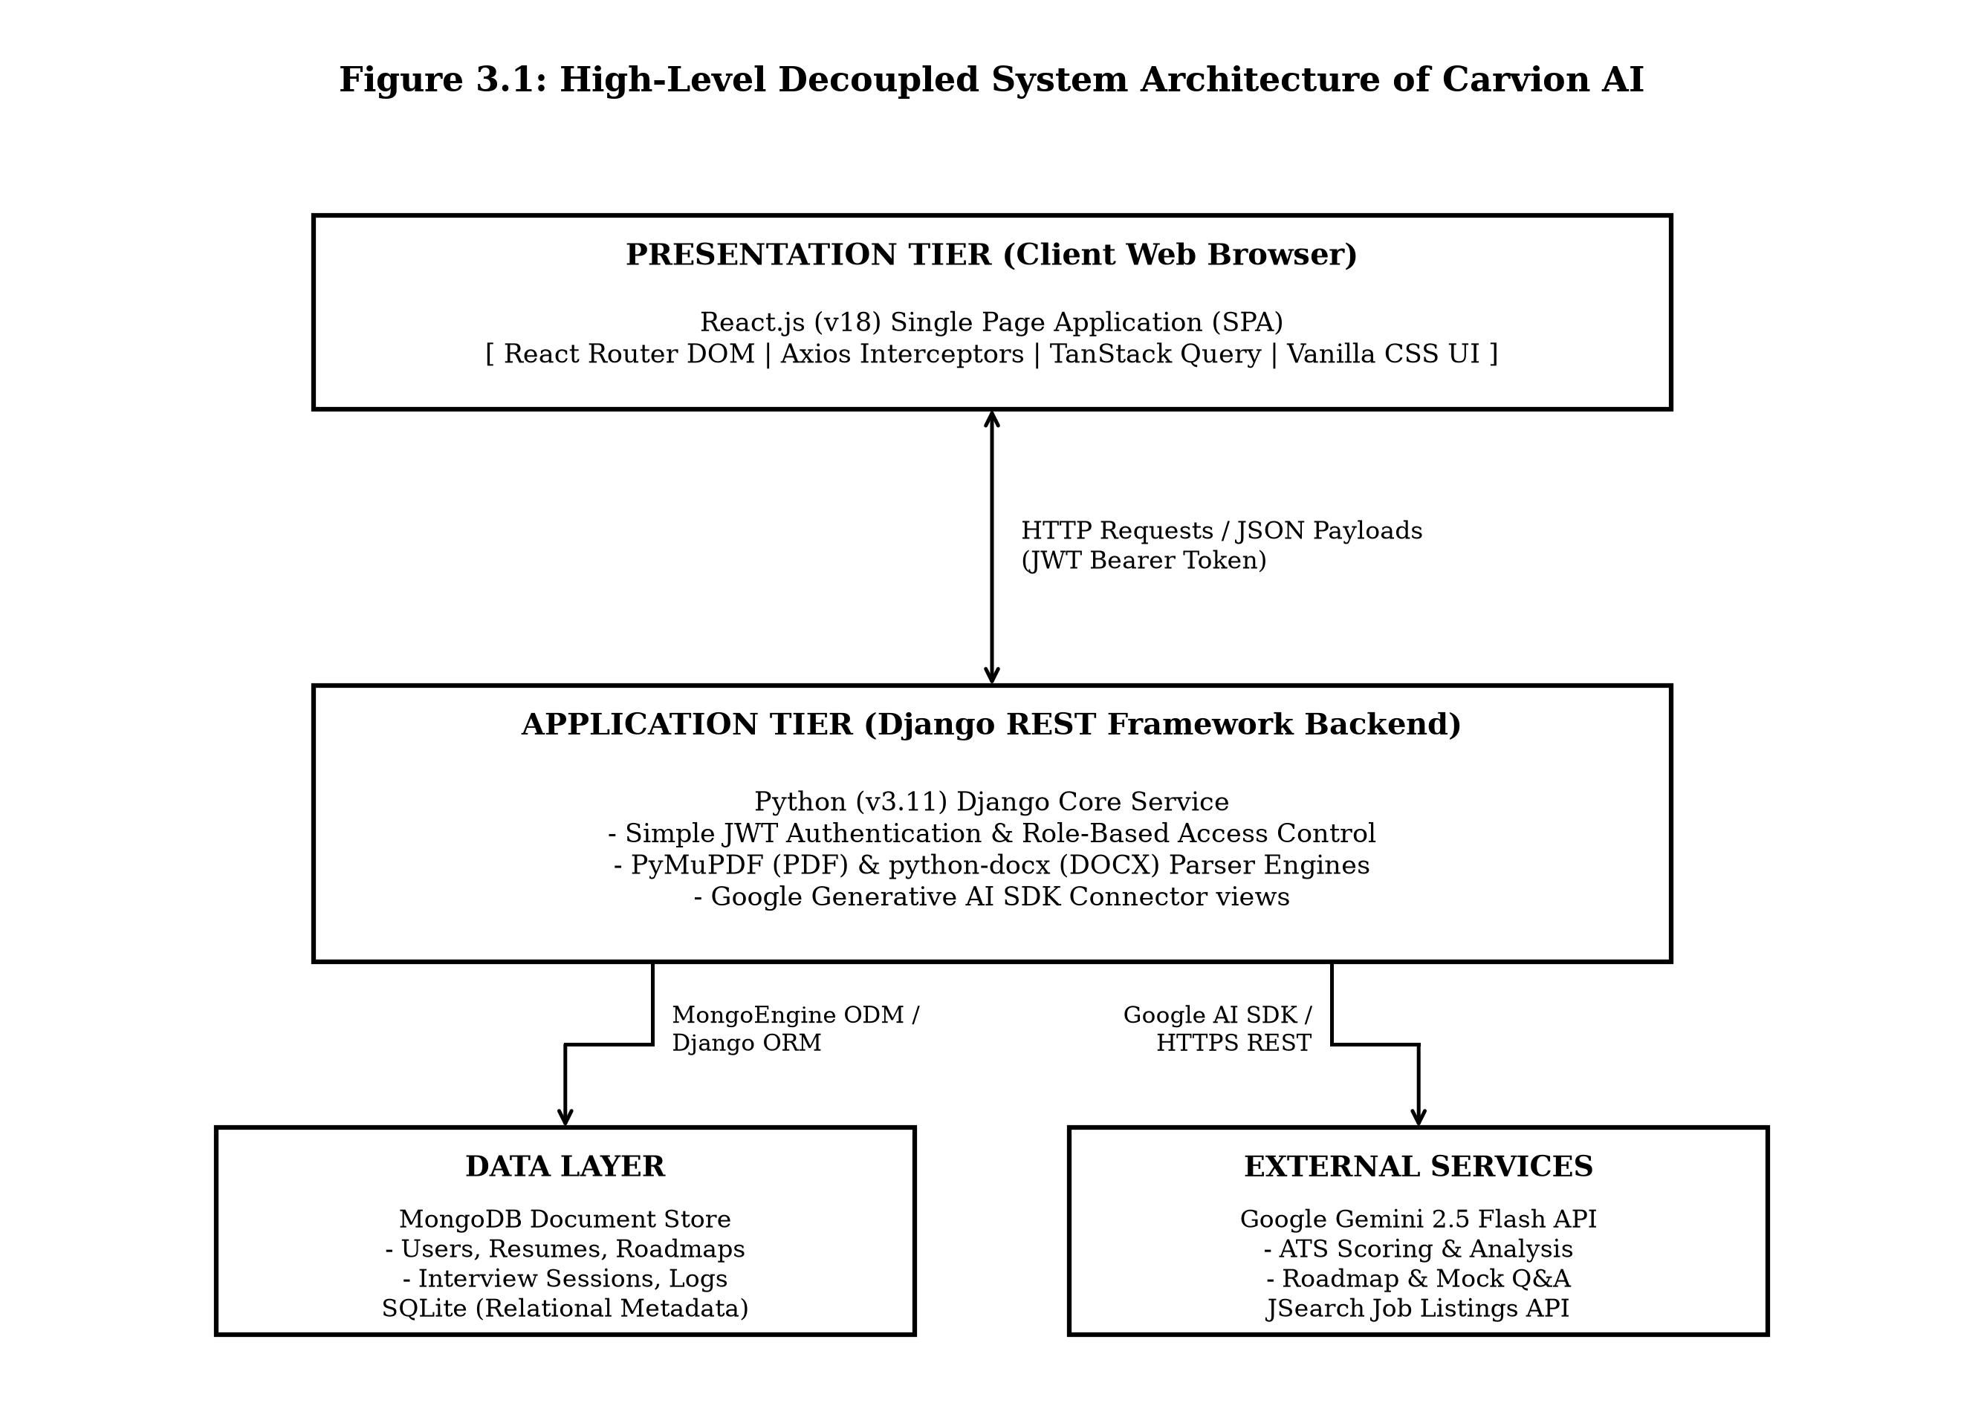
Figure 3.1: Decoupled System Architecture of Carvion AI
Figure 3.1: Layered decupled system architecture of the Carvion AI platform showing client, application server, and data tiers.
Figure 3.1: Decoupled System Architecture of Carvion AI
- Presentation Tier: Executes entirely within the client browser. React components handle UI rendering, user input validation, client-side routing, and interactive state. Communication with the application tier occurs exclusively via asynchronous HTTP REST calls transferring JSON payloads.
- Application Tier: Implemented as a Django REST Framework API. This layer processes business logic, enforces JWT authentication, validates payload schemas, manages file parsing libraries, constructs AI prompts, and coordinates external service calls.
- Data Tier & External Services: Stores application data across MongoDB (primary document database) and SQLite (relational metadata). The application tier connects to Google Gemini 2.5 Flash for natural language processing and JSearch API for real-time job listings.

3.7 Data Flow Diagrams (DFD)
Data Flow Diagrams model how data enters, traverses, transforms, and persists within the Carvion AI platform.
DFD Symbols Reference
Table 3.1 defines the standard DFD notation used across all system flow diagrams.
Table 3.1: Description of DFD Symbols
Symbol Name | Graphic Representation | Description
**External Entity** | Rectangle | Origin or destination of data outside system boundaries (Candidate, Admin, Gemini API).
**Process** | Rounded Rectangle | Transformation process that modifies or routes data.
**Data Store** | Parallel Lines / Open Box | Storage repository for persistent data (MongoDB Collections).
**Data Flow** | Directed Arrow | Movement of data between entities, processes, and stores.

Level 0 DFD (Context Diagram)
Figure 3.2 illustrates the global system context, displaying primary external entities interacting with the Carvion AI system boundary.
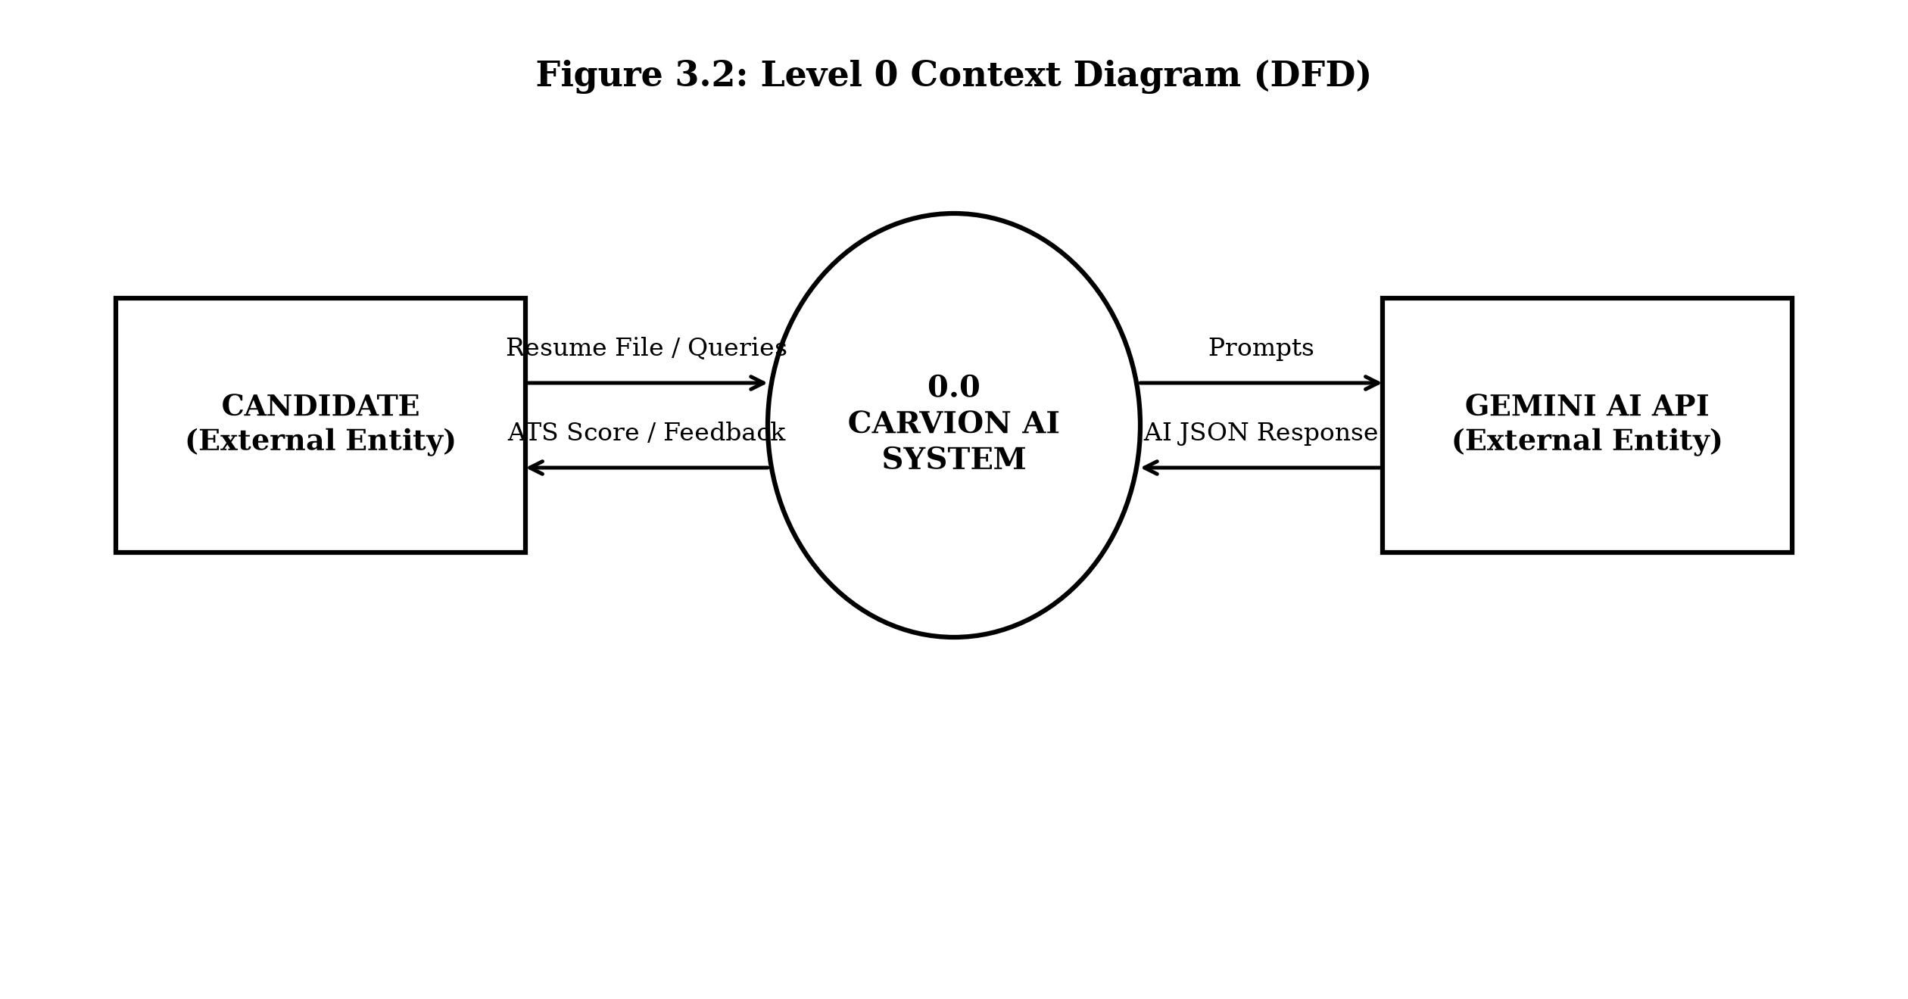
Figure 3.2: Level 0 Context Diagram of Carvion AI System
Figure 3.2: Level 0 Context Diagram displaying primary external entities interacting with the Carvion AI system boundary.
Figure 3.2: Level 0 Context Diagram of Carvion AI
Level 1 DFD (Main System Subsystems)
Figure 3.3 decomposes the central system into eight primary operational processes and identifies persistent data stores.
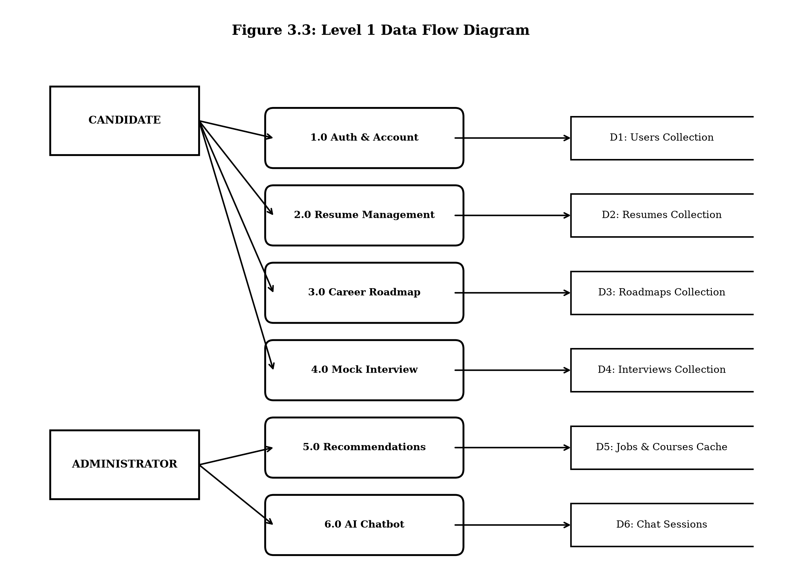
Figure 3.3: Level 1 Data Flow Diagram (Main Subsystems)
Figure 3.3: Level 1 Data Flow Diagram displaying primary subsystem processes and MongoDB data store connections.
Figure 3.3: Level 1 Data Flow Diagram (Main Subsystems)
Level 2 DFD (Resume Management Module)
Figure 3.4 details the internal process decomposition of the Resume Management subsystem (Process 2.0).
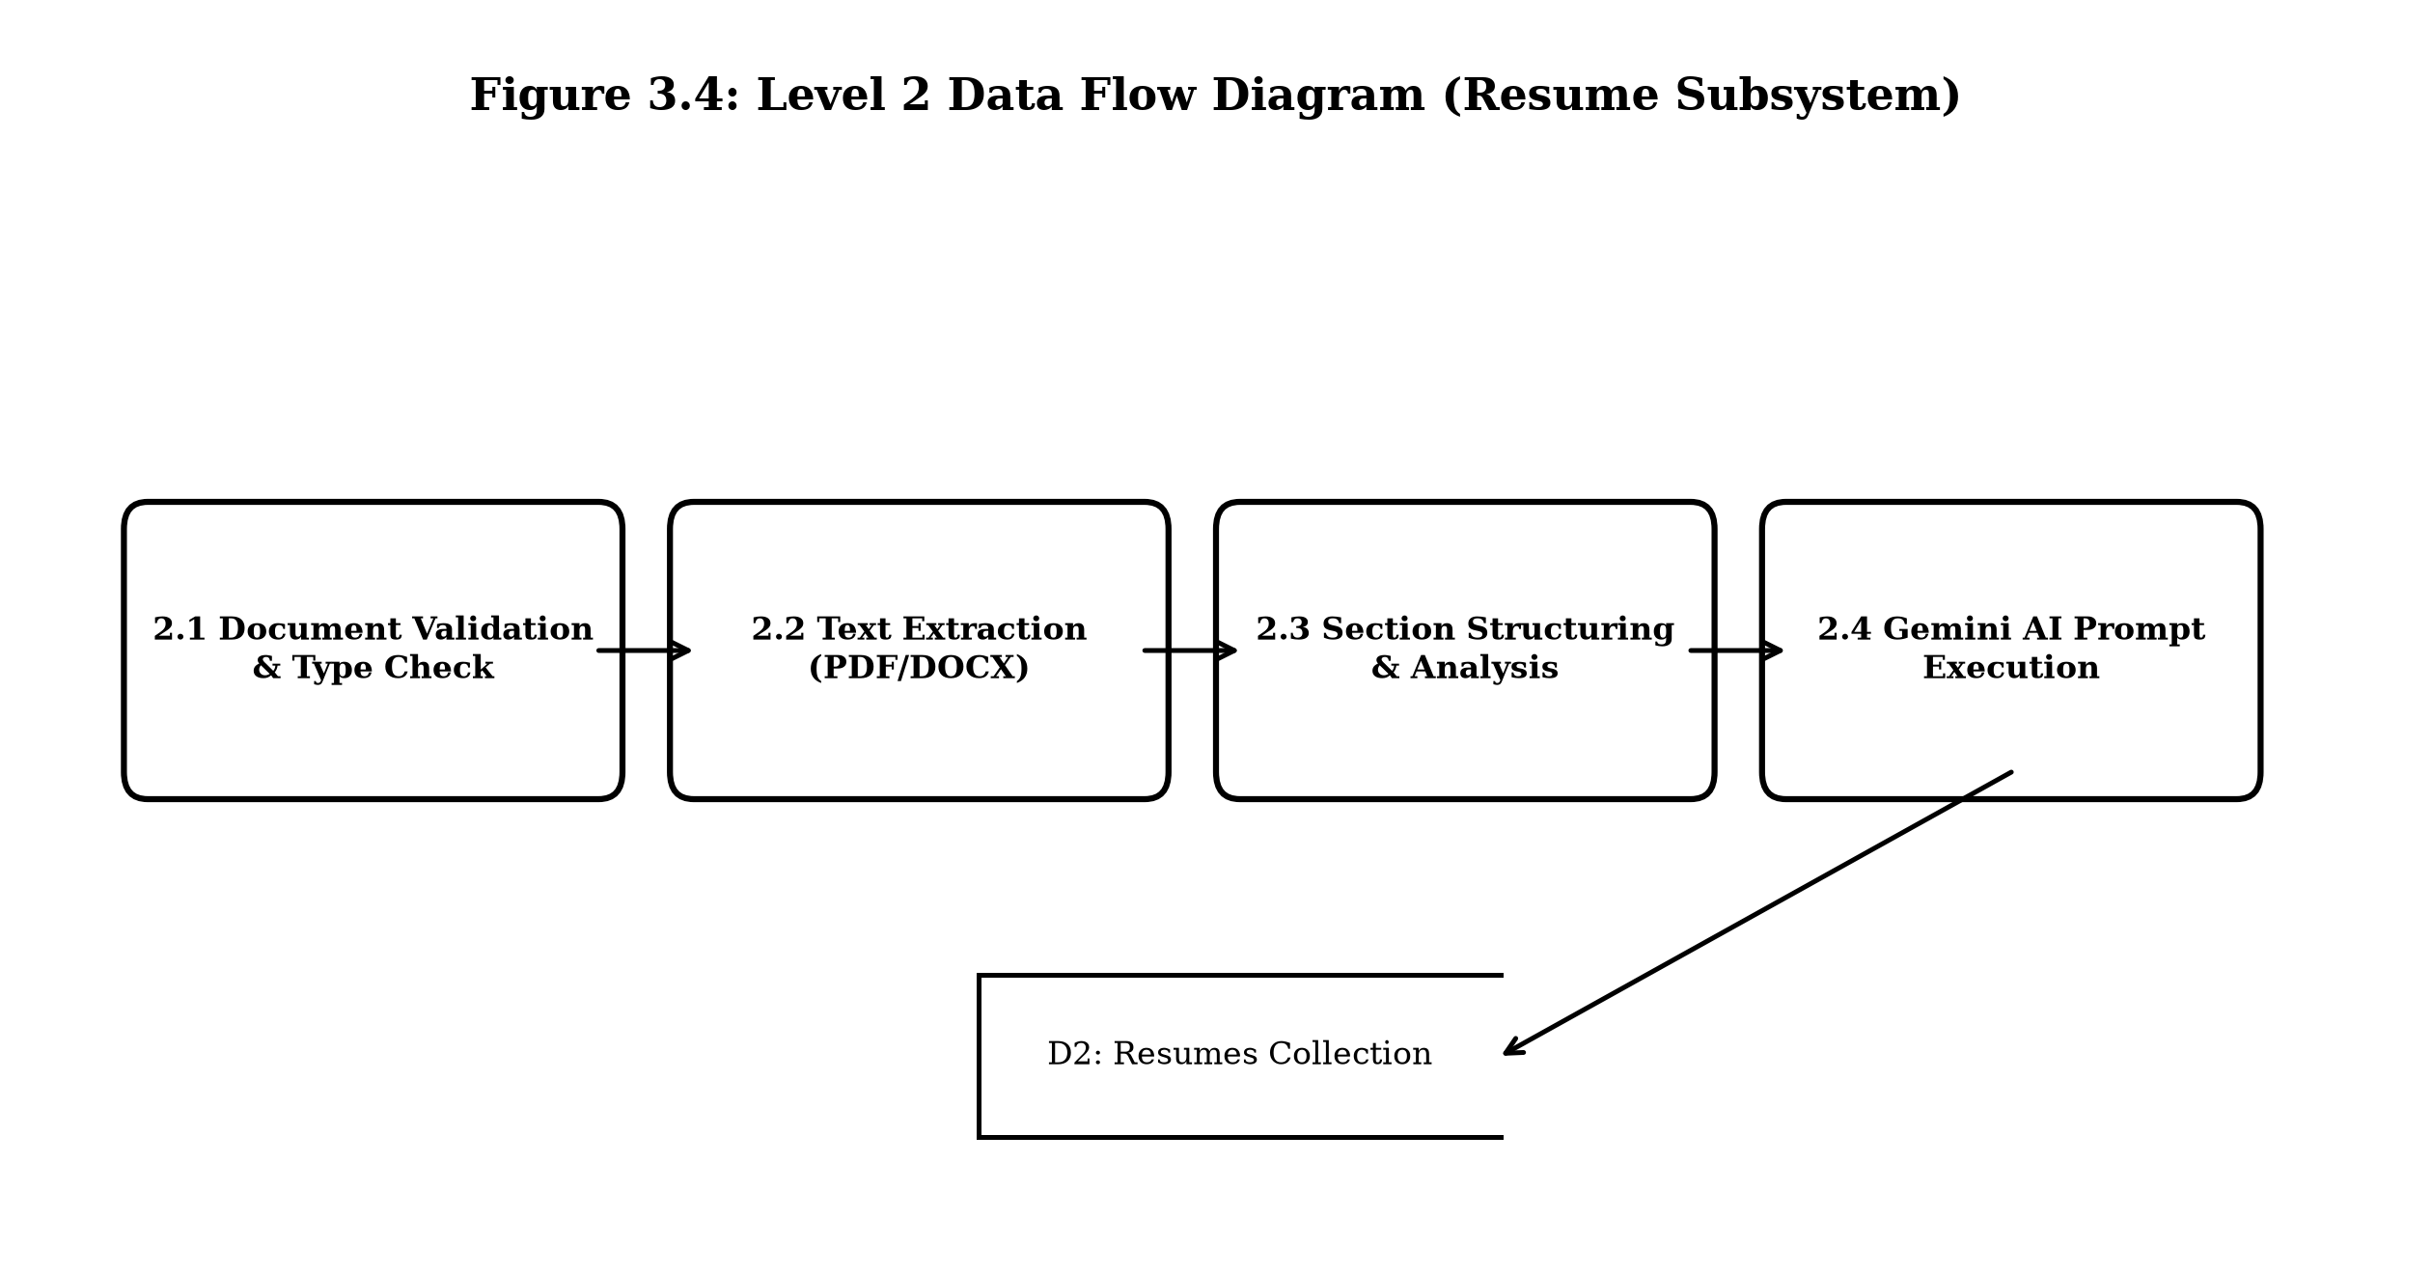
Figure 3.4: Level 2 Data Flow Diagram (Resume Management Module)
Figure 3.4: Level 2 Data Flow Diagram detailing sub-processes of the Resume Management subsystem.
Figure 3.4: Level 2 Data Flow Diagram (Resume Management Module)
3.7.4 Level 3 – Document Parsing & Field Normalization Sub-process
Figure 3.5 provides the lowest-level decomposition of process 2.2 (Text Parsing).
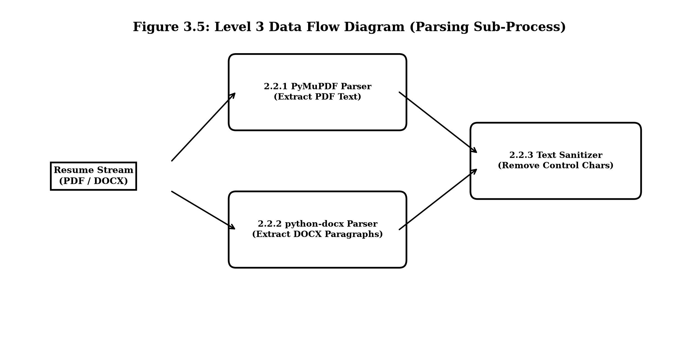
Figure 3.5: Level 3 Data Flow Diagram (Document Parsing Sub-Process)
Figure 3.5: Level 3 Data Flow Diagram detailing sub-processes of PDF/DOCX resume file parsing.
Figure 3.5: Level 3 Data Flow Diagram (Document Parsing Sub-Process)

3.8 Entity-Relationship (ER) Diagram
Figure 3.6 presents the logical database model of Carvion AI, displaying core document entities, primary keys, foreign key references, and relationship cardinalities.
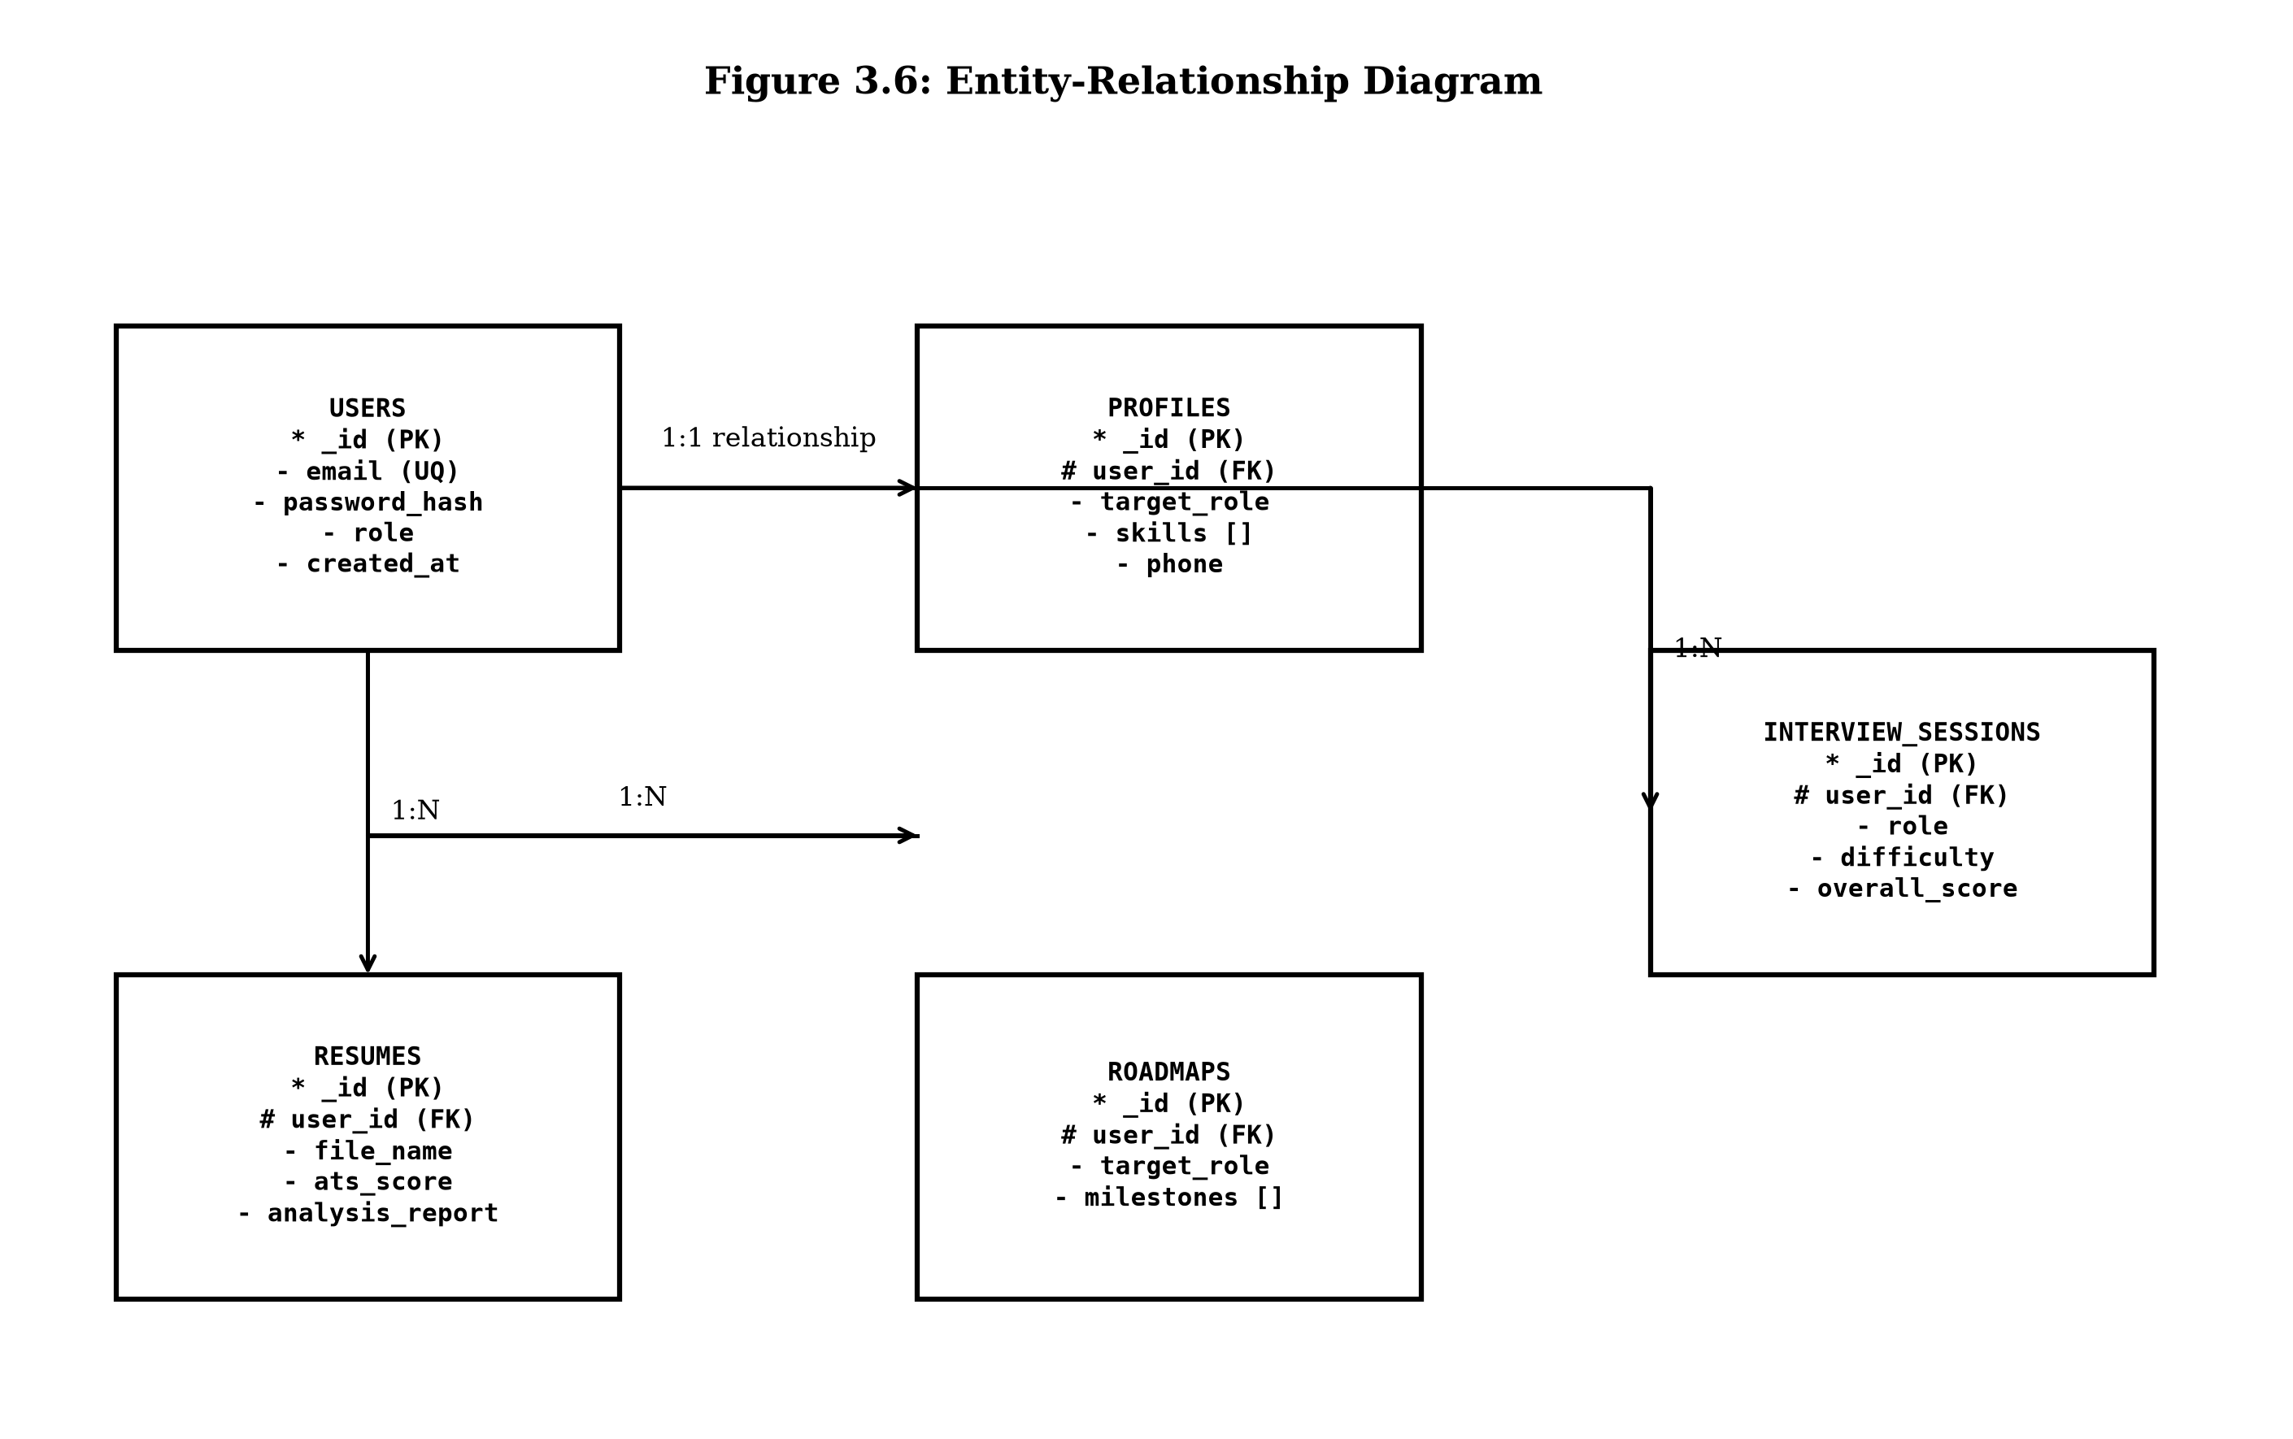
Figure 3.6: Entity-Relationship (ER) Diagram
Figure 3.6: Entity-Relationship Diagram outlining collections, indexes, and primary/foreign keys.
Figure 3.6: Entity-Relationship (ER) Diagram

3.9 Interaction Diagram
An interaction diagram for Carvion AI illustrates how different users and system components communicate during the core platform workflows. It shows the flow of actions between participants such as the User, the Authentication Module, the Resume Module, the Career Intelligence Module, the Gemini AI API, and MongoDB.
For example, a user logs into the system and receives a JWT token, views their dashboard with live KPIs fetched from MongoDB, uploads a resume that is parsed and evaluated by the AI, and requests a career roadmap that is generated by Gemini and saved back to the database.
This diagram captures the dynamic interactions and message exchanges across all major system components, ensuring that the Carvion AI platform operates in a coordinated, transparent, and efficient sequence.
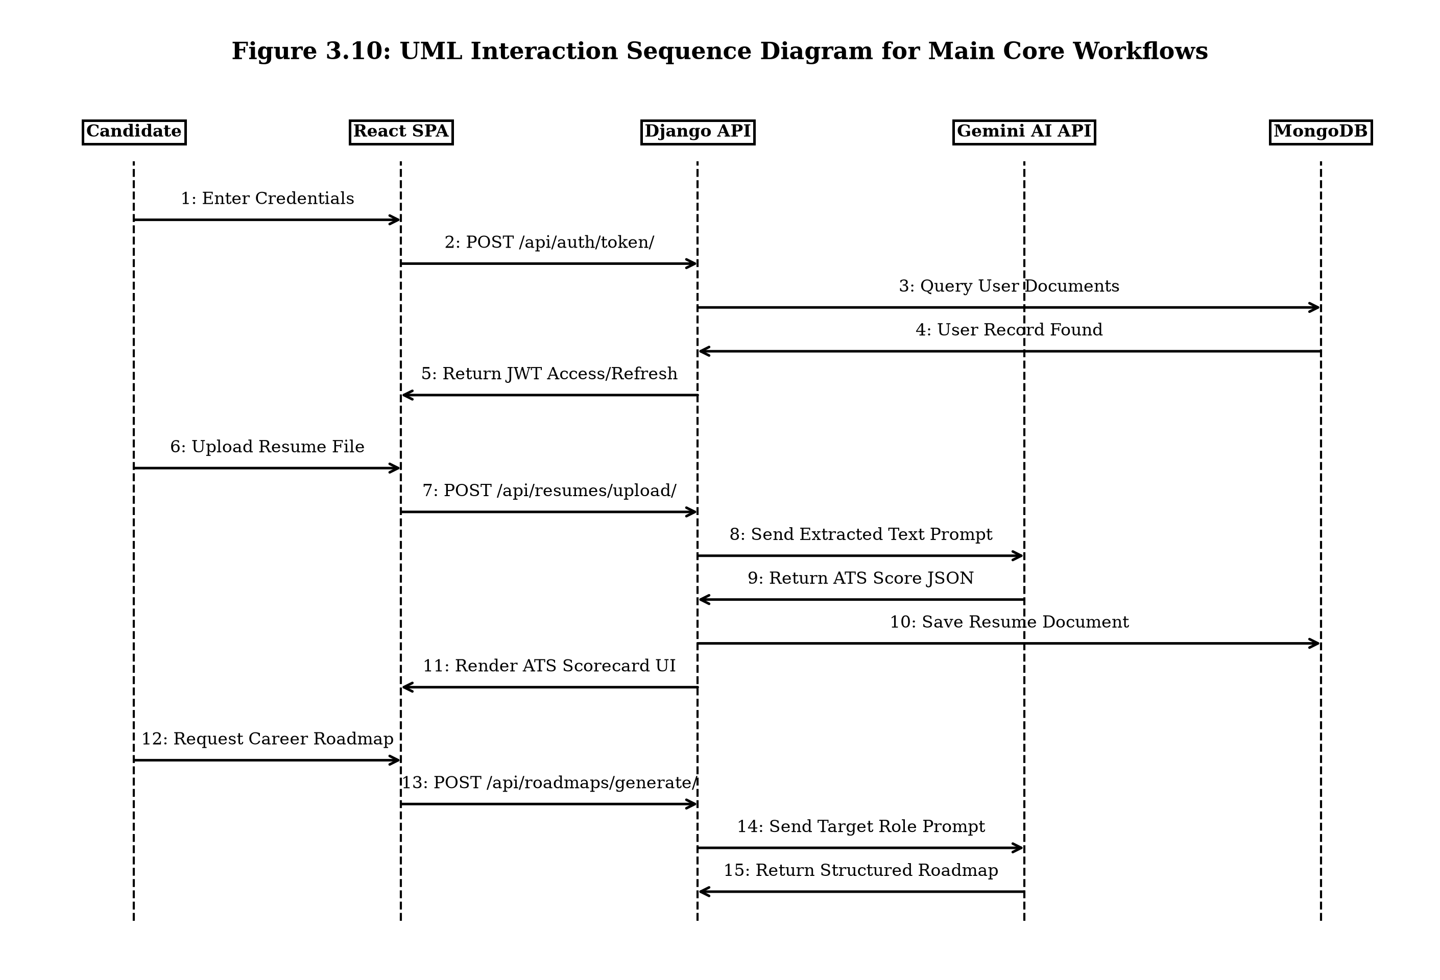
Figure 3.10: UML Interaction Sequence Diagram for Main Core Workflows
Figure 3.10: UML Interaction Sequence Diagram detailing operations across front-to-back layers.
Table 3.12: Interaction Steps Matrix
Step | From | To | Message
1 | User | Auth Module | Enter Email and Password
2 | Auth Module | MongoDB | Validate Credentials
3 | MongoDB | Auth Module | Return User Record
4 | Auth Module | User | Issue JWT Token
5 | User | Dashboard | Request Metrics
6 | Dashboard | MongoDB | Query User Data and Session Stats
7 | MongoDB | Dashboard | Return Data
8 | Dashboard | User | Display KPI Scores
9 | User | Resume Module | Upload Resume
10 | Resume Module | Gemini AI | Run Parsing and ATS Evaluation
11 | Gemini AI | Resume Module | Return ATS JSON
12 | Resume Module | MongoDB | Save Resume and Analysis Results
13 | Resume Module | User | Return Evaluation Scorecard
14 | User | Career Intelligence | Request Roadmap
15 | Career Intelligence | Gemini AI | Request Career Milestone Path
16 | Gemini AI | Career Intelligence | Return Structured Roadmap
17 | Career Intelligence | MongoDB | Save Roadmap Document
18 | Career Intelligence | User | Display Roadmap

3.9 Database Design & Schema Specifications
The Carvion AI database architecture uses MongoDB as its primary document store, managed via MongoEngine ODM. Subsections 3.9.1 through 3.9.10 outline the schema specifications, field types, keys, and descriptions for all primary database collections.
3.9.1 Users Collection
Field Name | Data Type | Constraint | Description
`_id` | ObjectId | Primary Key | Unique MongoDB document identifier.
`email` | String | Unique, Indexed | User email address used for login.
`password_hash` | String | Required | Bcrypt-hashed password string.
`name` | String | Required | Full candidate or administrator name.
`role` | String | Required | Account role (`standard` or `admin`).
`is_active` | Boolean | Default: True | Account status flag.
`created_at` | DateTime | Auto-now | Document creation timestamp (UTC).

3.9.2 Profiles Collection
Field Name | Data Type | Constraint | Description
`_id` | ObjectId | Primary Key | Unique document identifier.
`user` | ObjectId | Foreign Key (Users) | Reference to owning user document.
`phone` | String | Optional | Candidate contact phone number.
`target_role` | String | Indexed | Stated career target position.
`skills` | List[String] | Optional | Array of declared candidate skills.
`experience_level` | String | Optional | Self-reported career experience level.
`linkedin_url` | String | Optional | LinkedIn profile URL.
`updated_at` | DateTime | Auto-now | Profile update timestamp.

3.9.3 Resumes Collection
Field Name | Data Type | Constraint | Description
`_id` | ObjectId | Primary Key | Unique document identifier.
`user` | ObjectId | Foreign Key (Users) | Reference to candidate user.
`file_name` | String | Required | Original uploaded document name.
`file_path` | String | Required | Server file storage path.
`extracted_text` | Text | Required | Raw extracted document text.
`structured_data` | Dict / Embedded | Required | Parsed experience, skills, education JSON.
`ats_score` | Integer | Range: 0–100 | Gemini-generated ATS compatibility score.
`analysis_report` | Dict / Embedded | Required | Detailed feedback JSON report.
`is_primary` | Boolean | Default: False | Primary resume selection flag.
`created_at` | DateTime | Auto-now | Resume upload timestamp.

3.9.4 Roadmaps Collection
Field Name | Data Type | Constraint | Description
`_id` | ObjectId | Primary Key | Unique document identifier.
`user` | ObjectId | Foreign Key (Users) | Reference to candidate user.
`target_role` | String | Required | Target position for roadmap synthesis.
`milestones` | List[Dict] | Embedded Array | Array of milestone objects (title, skills, status).
`is_active` | Boolean | Default: True | Active roadmap selection flag.
`created_at` | DateTime | Auto-now | Roadmap generation timestamp.

3.9.5 Interview Sessions Collection
Field Name | Data Type | Constraint | Description
`_id` | ObjectId | Primary Key | Unique document identifier.
`user` | ObjectId | Foreign Key (Users) | Reference to candidate user.
`role` | String | Required | Target role for interview questions.
`difficulty` | String | Enum | Difficulty level (`Easy`, `Medium`, `Hard`).
`transcript` | List[Dict] | Embedded Array | Array of Question-Answer-Feedback objects.
`overall_score` | Integer | Range: 0–100 | Aggregated session performance score.
`created_at` | DateTime | Auto-now | Session execution timestamp.

3.9.6 Chat Sessions Collection
Field Name | Data Type | Constraint | Description
`_id` | ObjectId | Primary Key | Unique document identifier.
`user` | ObjectId | Foreign Key (Users) | Reference to candidate user.
`title` | String | Default: "New Chat" | Session display title.
`messages` | List[Dict] | Embedded Array | Array of sender-text-timestamp message objects.
`updated_at` | DateTime | Auto-now | Recent message timestamp.

3.9.7 Notifications Collection
Field Name | Data Type | Constraint | Description
`_id` | ObjectId | Primary Key | Unique document identifier.
`user` | ObjectId | Foreign Key (Users) | Target user reference.
`title` | String | Required | Notification summary heading.
`message` | Text | Required | Notification message body text.
`is_read` | Boolean | Default: False | Read status flag.
`created_at` | DateTime | Auto-now | Creation timestamp.

3.9.8 Admin Activity Logs Collection
Field Name | Data Type | Constraint | Description
`_id` | ObjectId | Primary Key | Unique document identifier.
`admin_user` | ObjectId | Foreign Key (Users) | Administrator actor reference.
`action` | String | Required | Performed admin operation label.
`description` | Text | Required | Detailed event description.
`ip_address` | String | Required | Client IP address string.
`created_at` | DateTime | Auto-now | Audit logging timestamp.

3.9.9 Refresh Tokens Collection (MongoDB TTL Indexing)
Field Name | Data Type | Constraint | Description
`_id` | ObjectId | Primary Key | Unique document identifier.
`user` | ObjectId | Foreign Key (Users) | Token owner user reference.
`token` | String | Unique, Indexed | Encrypted JWT refresh token string.
`expires_at` | DateTime | TTL Index | Expiry timestamp for automatic deletion.

3.9.10 Contact Messages Collection
Field Name | Data Type | Constraint | Description
`_id` | ObjectId | Primary Key | Unique document identifier.
`user` | ObjectId | Optional Foreign Key | Submitter user reference.
`email` | String | Required | Contact email address.
`subject` | String | Required | Ticket subject header.
`message` | Text | Required | Ticket detailed description.
`status` | String | Enum | Status (`new`, `open`, `resolved`).

3.10 Unified Modeling Language (UML) Diagrams
3.10.1 Use-Case Diagram (User & Admin Interactions)
Figure 3.7 models user interactions with the functional subsystems of Carvion AI.
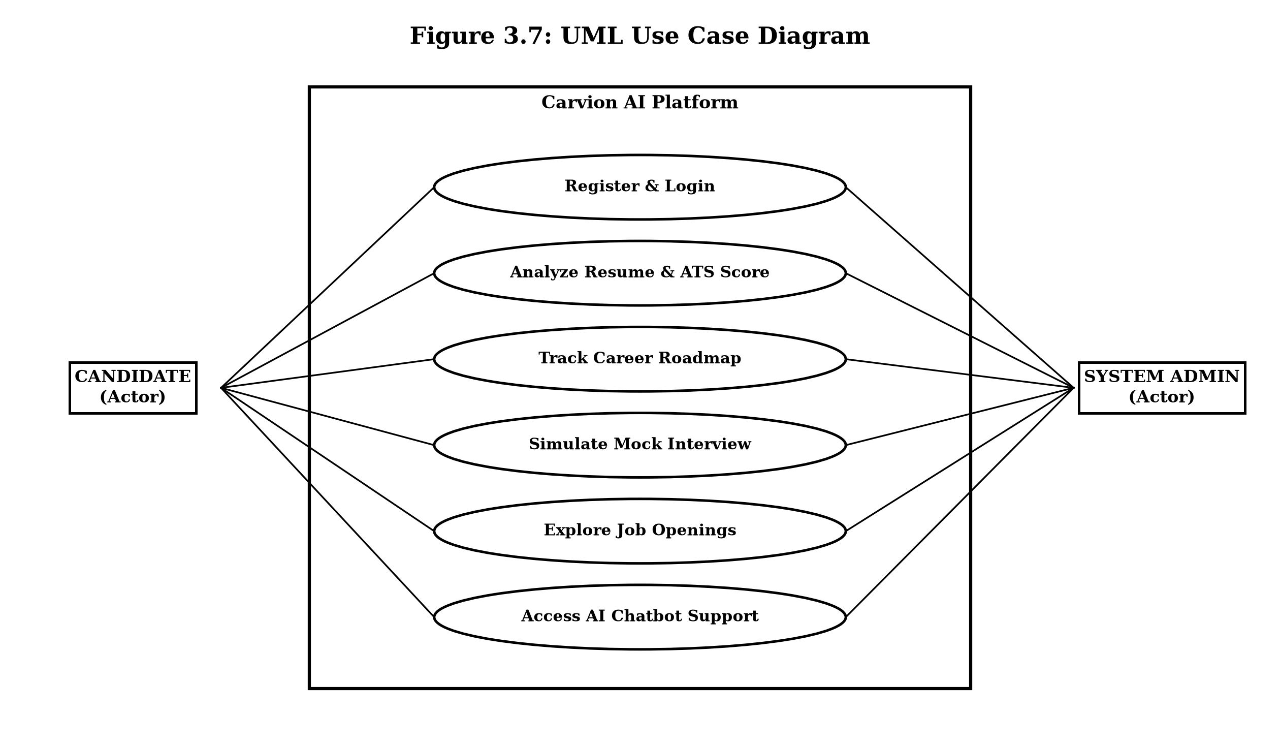
Figure 3.7: UML Use Case Diagram
Figure 3.7: UML Use Case Diagram illustrating the core interactions of Candidate and Admin actors.
Figure 3.7: UML Use Case Diagram
3.10.2 Sequence Diagram (User Login, Resume Upload, & AI Evaluation)
Figure 3.8 displays the step-by-step sequence of interactions during resume uploading and evaluation.
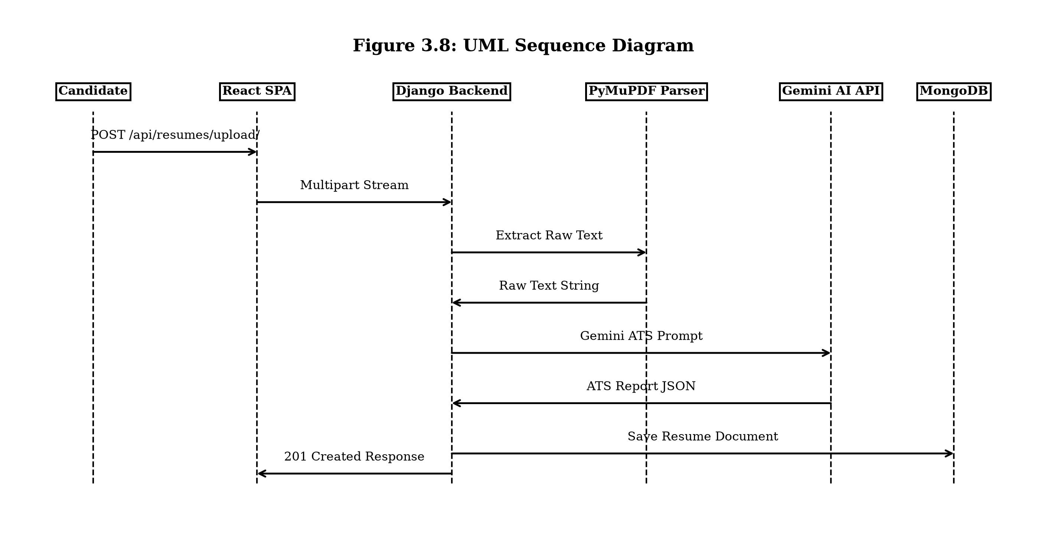
Figure 3.8: UML Sequence Diagram for Resume Evaluation Workflow
Figure 3.8: UML Sequence Diagram displaying message exchanges during resume uploading, parsing, AI scoring, and persistence.
Figure 3.8: UML Sequence Diagram for Resume Evaluation Workflow
3.10.3 Class Diagram (MongoEngine Documents & DRF ViewSets)
Figure 3.11 displays the backend database documents and ViewSet controller layouts, illustrating the design associations and operational logic of backend systems.
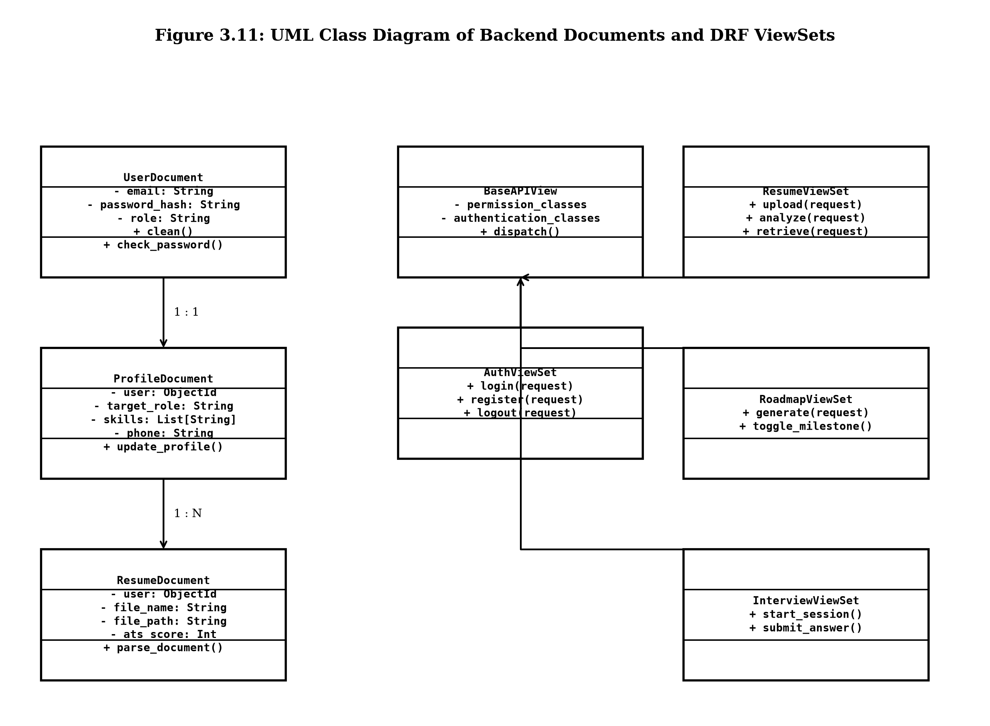
Figure 3.11: UML Class Diagram of Backend Documents and DRF ViewSets
Figure 3.11: UML Class Diagram detailing MongoEngine dynamic documents and Django REST Framework ViewSet class structures.
Figure 3.11: UML Class Diagram of Backend Documents and DRF ViewSets
3.10.4 Activity Diagram (Mock Interview Preparation Workflow)
Figure 3.9 details the execution control flow of the Mock Interview module.
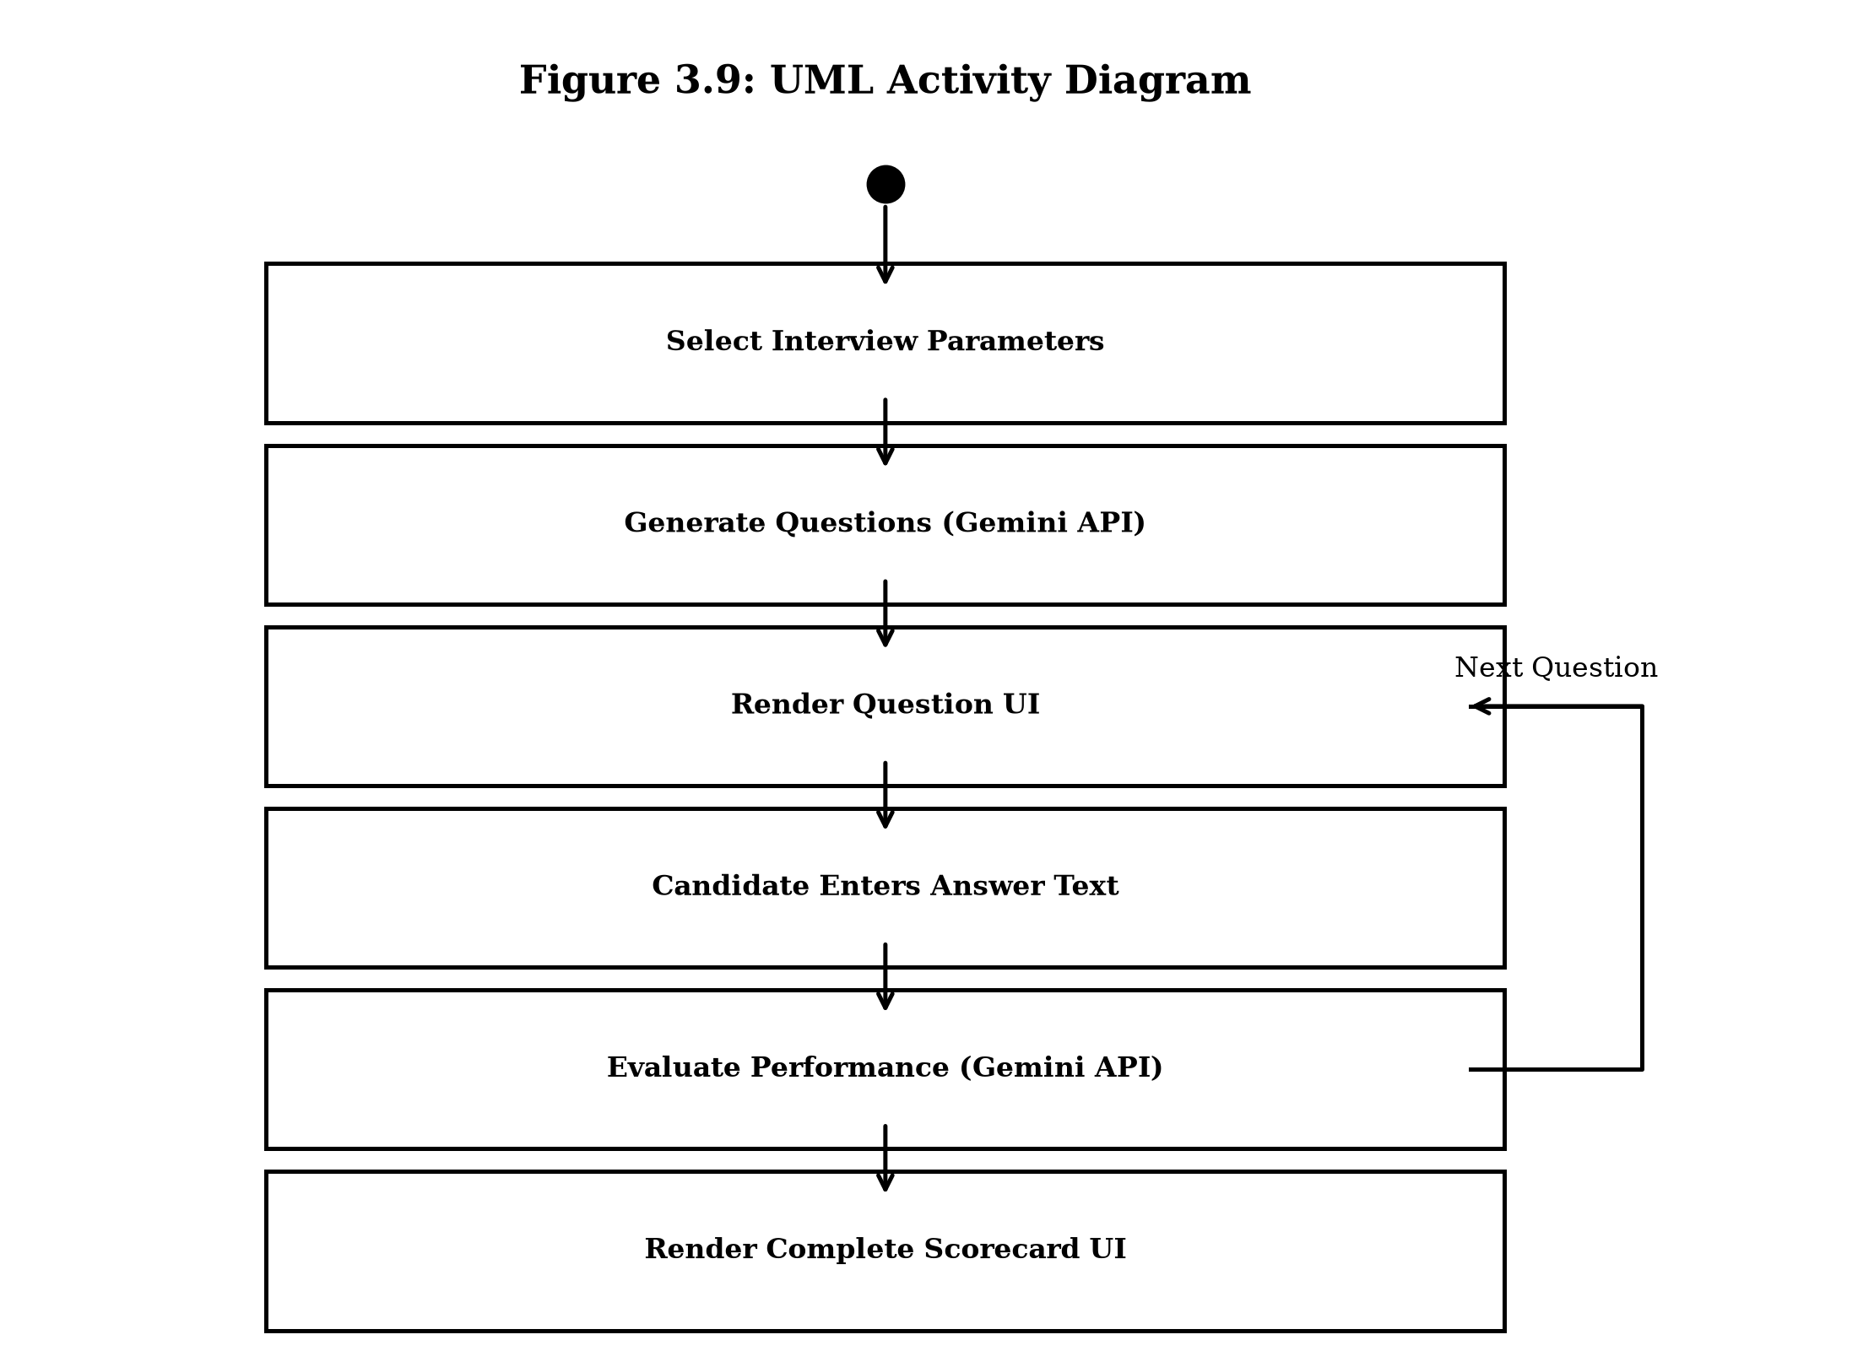
Figure 3.9: UML Activity Diagram for Mock Interview Execution
Figure 3.9: UML Activity Diagram illustrating control flow during interactive mock interview execution.
Figure 3.9: UML Activity Diagram for Mock Interview Execution

CHAPTER 4: SYSTEM DEVELOPMENT AND IMPLEMENTATION

4.1 Development Methodology (Agile SDLC)
The development of Carvion AI followed the Agile Software Development Life Cycle (SDLC) framework, structured into six sequential two-week sprint iterations. Agile principles enabled continuous verification, modular integration, and rapid adaptation based on empirical component testing. Figure 4.1 displays the iterative SDLC phases.
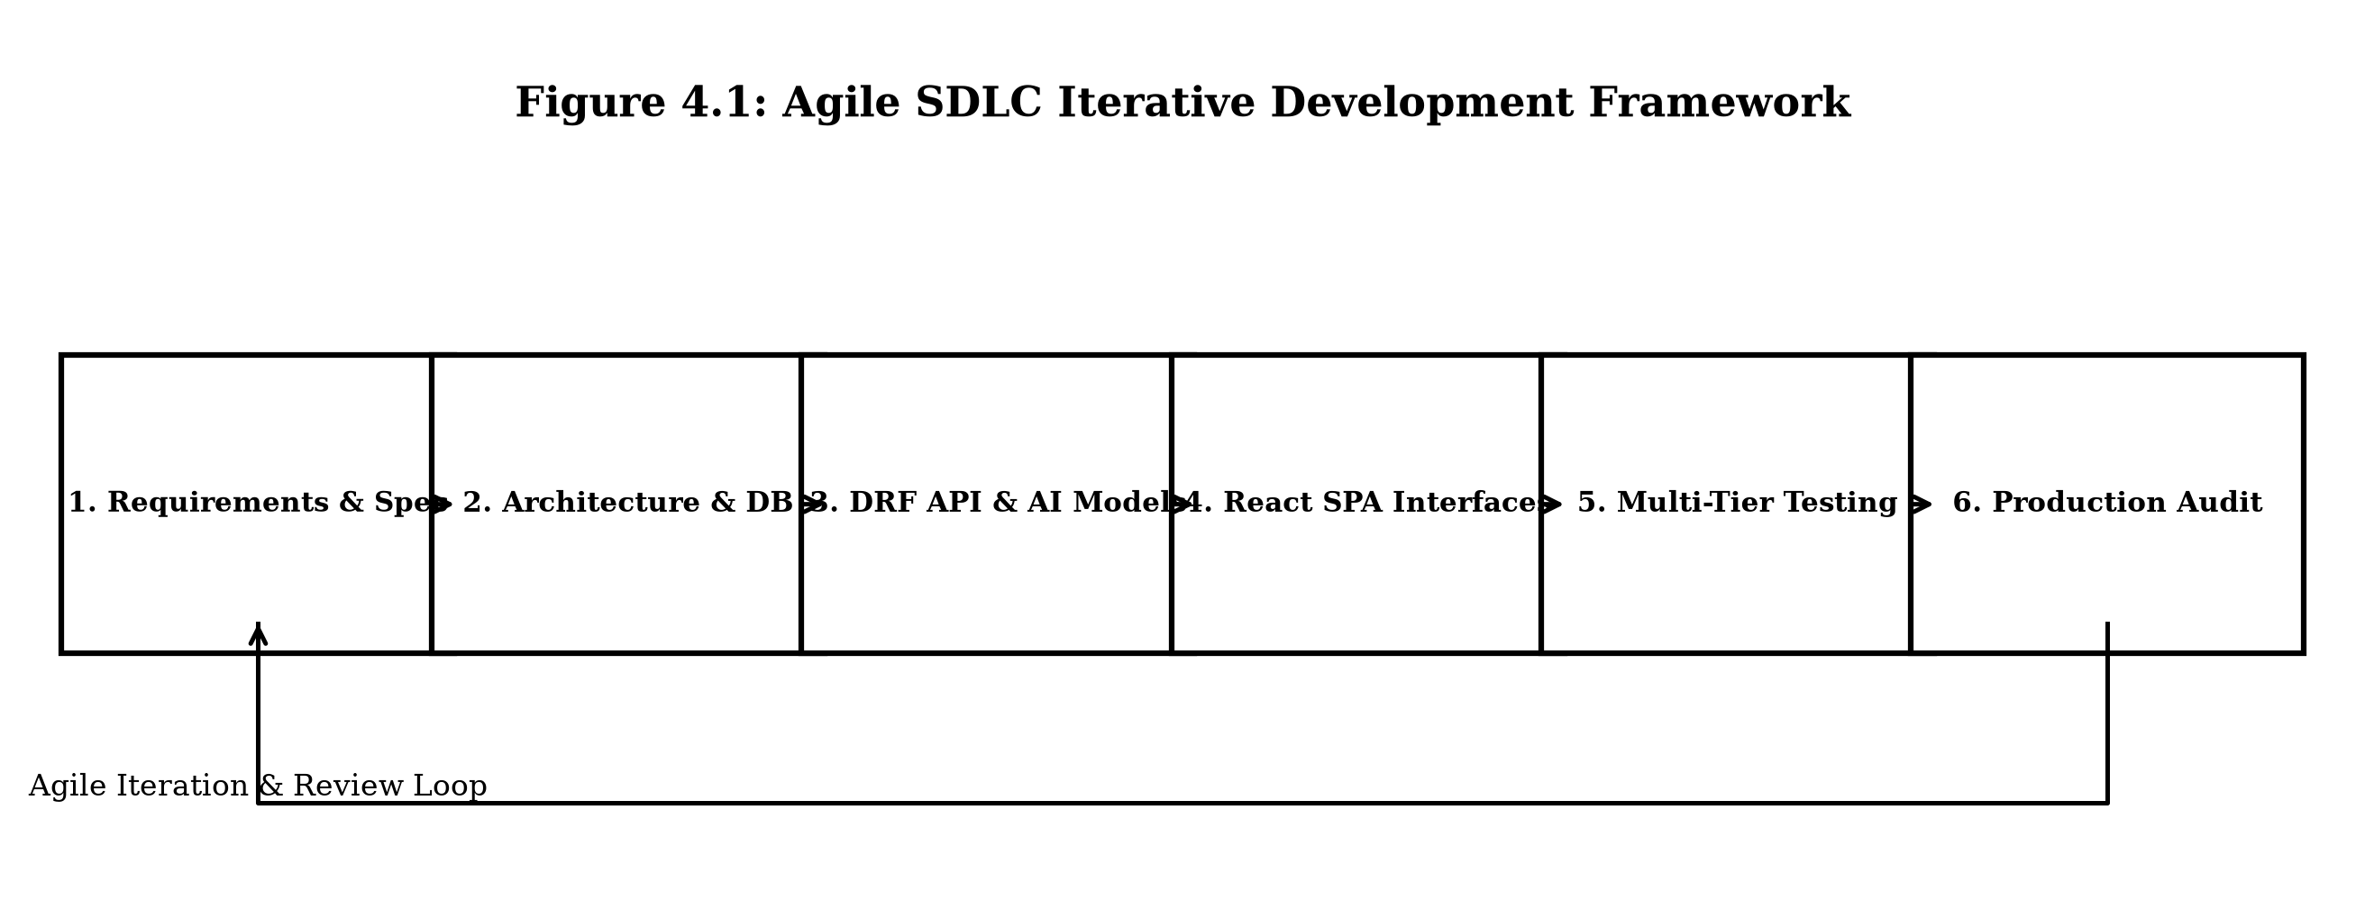
Figure 4.1: Agile SDLC Iterative Development Framework
Figure 4.1: Agile SDLC Iterative Development Framework outlining the six sequential sprint phases.
Figure 4.1: Agile SDLC Iterative Development Framework

4.2 Frontend Development (SPA Component Architecture, Axios JWT Interceptors, Route Guarding)
The frontend application was developed using React.js (v18) built with Vite. The application follows a component-driven architecture organized into modular directories:
- `/src/components`: Reusable UI components (Navbar, Sidebar, KPI Cards, Modal Dialogs, Loading Spinners).
- `/src/pages`: Top-level view containers (Dashboard, ResumeManager, RoadmapViewer, MockInterview, AdminConsole).
- `/src/services`: API client functions utilizing Axios instances with pre-configured request interceptors.
- `/src/context`: React Context providers handling global authentication state and user session data.
Client-side routing is configured using React Router DOM (`createBrowserRouter`), wrapping protected view components in an `<ProtectedRoute>` guard that inspects JWT access token validity before rendering. Server state synchronization and asynchronous caching are managed using TanStack Query, which eliminates redundant network fetches through configured cache decay timers. Visual styling is implemented using custom Vanilla CSS tokens, establishing consistent typography, color palettes, responsive flex/grid layouts, and dark/light themes without third-party CSS framework dependencies.

4.3 Backend Development (Django REST Framework ViewSets, Middleware, Serializers)
The backend API was developed in Python (v3.11) using Django (v4.2) and Django REST Framework (DRF). The application is structured into decoupled Django apps representing domain boundaries:
# Example DRF API View implementation for Resume Upload and Analysis
from rest_framework.views import APIView
from rest_framework.response import Response
from rest_framework import status, permissions
from .parsers import extract_text_from_file
from .ai_services import evaluate_resume_with_gemini
from .models import ResumeDocument
class ResumeUploadView(APIView):
permission_classes = [permissions.IsAuthenticated]
def post(self, request, *args, **kwargs):
uploaded_file = request.FILES.get('resume')
if not uploaded_file:
return Response({"error": "No file provided."}, status=status.HTTP_400_BAD_REQUEST)
# Step 1: Execute text extraction
extracted_text = extract_text_from_file(uploaded_file)
# Step 2: Invoke Gemini AI evaluation service
ats_score, analysis_report = evaluate_resume_with_gemini(extracted_text)
# Step 3: Persist document in MongoDB via MongoEngine
resume_doc = ResumeDocument(
user=request.user.id,
file_name=uploaded_file.name,
extracted_text=extracted_text,
ats_score=ats_score,
analysis_report=analysis_report
)
resume_doc.save()
return Response({
"message": "Resume analyzed successfully.",
"ats_score": ats_score,
"analysis_report": analysis_report
}, status=status.HTTP_201_CREATED)
The backend architecture implements custom JWT middleware (`SimpleJWT`) that authenticates Bearer tokens on incoming requests, injecting the authenticated user model into the DRF request context.

4.4 Database Implementation (MongoEngine ODM Connections, Dynamic Indexes, Cascading Deletes)
Data persistence is achieved through MongoDB managed via MongoEngine Object-Document Mapper (ODM). MongoEngine models define document schemas, field validations, indexes, and reference relationships.
# MongoEngine Schema Definition for Resume Documents
import mongoengine as me
from datetime import datetime
class ResumeDocument(me.Document):
user = me.ObjectIdField(required=True, indexed=True)
file_name = me.StringField(required=True, max_length=255)
extracted_text = me.StringField(required=True)
structured_data = me.DictField(default=dict)
ats_score = me.IntField(min_value=0, max_value=100, required=True)
analysis_report = me.DictField(required=True)
is_primary = me.BooleanField(default=False)
created_at = me.DateTimeField(default=datetime.utcnow)
meta = {
'collection': 'resumes',
'indexes': ['user', '-created_at']
}
Relational metadata—such as Django administration session records and token blacklist entries—are persisted in SQLite via standard Django ORM models.

4.5 Applied Artificial Intelligence Integration
4.5.1 Prompt Engineering & Structure Enforcement (Google Gemini 1.5 Flash API)
Artificial Intelligence capabilities are integrated using the official Google Generative AI Python SDK interfacing with the Google Gemini 1.5 Flash model. Prompt engineering techniques enforce deterministic JSON output formatting. Prompt engineering techniques enforce deterministic JSON output formatting.
# Server-Side AI Service Integration using Google Gemini API
import google.generativeai as genai
import json
from django.conf import settings
genai.configure(api_key=settings.GEMINI_API_KEY)
def evaluate_resume_with_gemini(resume_text):
prompt = f"""
You are an expert ATS screening system. Analyze the following resume text:
---
{resume_text}
---
Return ONLY a valid JSON object matching this schema:
{{
"ats_score": <int 0-100>,
"missing_keywords": [<strings>],
"formatting_issues": [<strings>],
"strengths": [<strings>],
"recommendations": [<strings>]
}}
"""
model = genai.GenerativeModel('gemini-1.5-flash')
response = model.generate_content(
prompt,
generation_config={"response_mime_type": "application/json"}
)
try:
data = json.loads(response.text)
return data.get("ats_score", 70), data
except Exception:
# Graceful Fallback Return
return 65, {"ats_score": 65, "recommendations": ["Ensure clear section formatting."]}
4.5.2 Fallback Strategies & Deterministic Output Handling
To secure the robustness of AI integrations, fallback strategies catch exceptions generated by third-party API throttling or network failure. When an exception occurs, a pre-configured structural JSON template is loaded containing default scores and safe section recommendations, allowing the frontend client to render interfaces without system crashes.

4.6 System Security Controls
The system implements comprehensive security mechanisms across software layers:
4.6.1 JWT Authentication & Refresh Token Rotation
- JWT Token Security: Implements short-lived access tokens (15-minute validity) combined with rotatable refresh tokens (7-day validity). Upon logout, refresh tokens are added to a database blacklist to prevent token replay attacks.
4.6.2 Role-Based Access Control (RBAC) & Custom Middleware
- Role-Based Access Control (RBAC): Custom DRF permission classes (`IsAdminUserRole`) verify account role flags before permitting execution of administrative endpoints.
4.6.3 API Throttling, Input Sanitization, and Security Logging
- Input Sanitization: Backend utilities sanitize text inputs and strip script tags, preventing NoSQL injection and Cross-Site Scripting (XSS).
- API Rate Throttling: DRF rate limiters constrain request bursts on high-cost AI endpoints (10 requests per minute per user).
- Rotating Server Logging: Server event loggers write application activity and security events to rotating log files using Python's `RotatingFileHandler`.

4.7 Implementation of Primary Modules
4.7.1 Authentication & Profile Module
- Authentication Module: Manages account registration, credential validation, JWT token issuance, refresh rotation, and logout blacklisting.
- Dashboard Module: Aggregates candidate profile status, recent ATS scores, active roadmap progress, and notifications into a single view.
4.7.2 Resume Intelligence & ATS Scoring Module
- Resume Management Module: Handles multi-format document uploads, executes PyMuPDF and python-docx text extraction, invokes Gemini AI evaluation, and renders ATS reports.
4.7.3 AI Career Roadmap Generator
- Career Roadmap Module: Synthesizes milestone learning pathways based on candidate skill deficiencies, persisting progress completion metrics.
4.7.4 Mock Interview Simulator
- Mock Interview Subsystem: Renders role-specific interview questions, accepts text responses, and generates multi-dimensional feedback scores via semantic AI evaluation.
4.7.5 Recommendations & AI Chatbot Module
- Recommendation Subsystem: Queries external JSearch APIs for live job openings, matches educational courses to skill gaps, and caches results in MongoDB.
- AI Chatbot Assistant: Renders a floating conversational modal maintaining multi-turn context constrained to career guidance.
4.7.6 Enterprise Admin Console Module
- Enterprise Admin Console: Provides administrators with live system metrics dashboards, user account controls, ticket resolution tools, and audit log tables.

4.8 Core Workflows and Algorithms
4.8.1 Document Parsing Logic (PDF/DOCX Page-by-Page Extraction)
Figure 4.2 illustrates the procedural execution flow of the resume parsing engine.
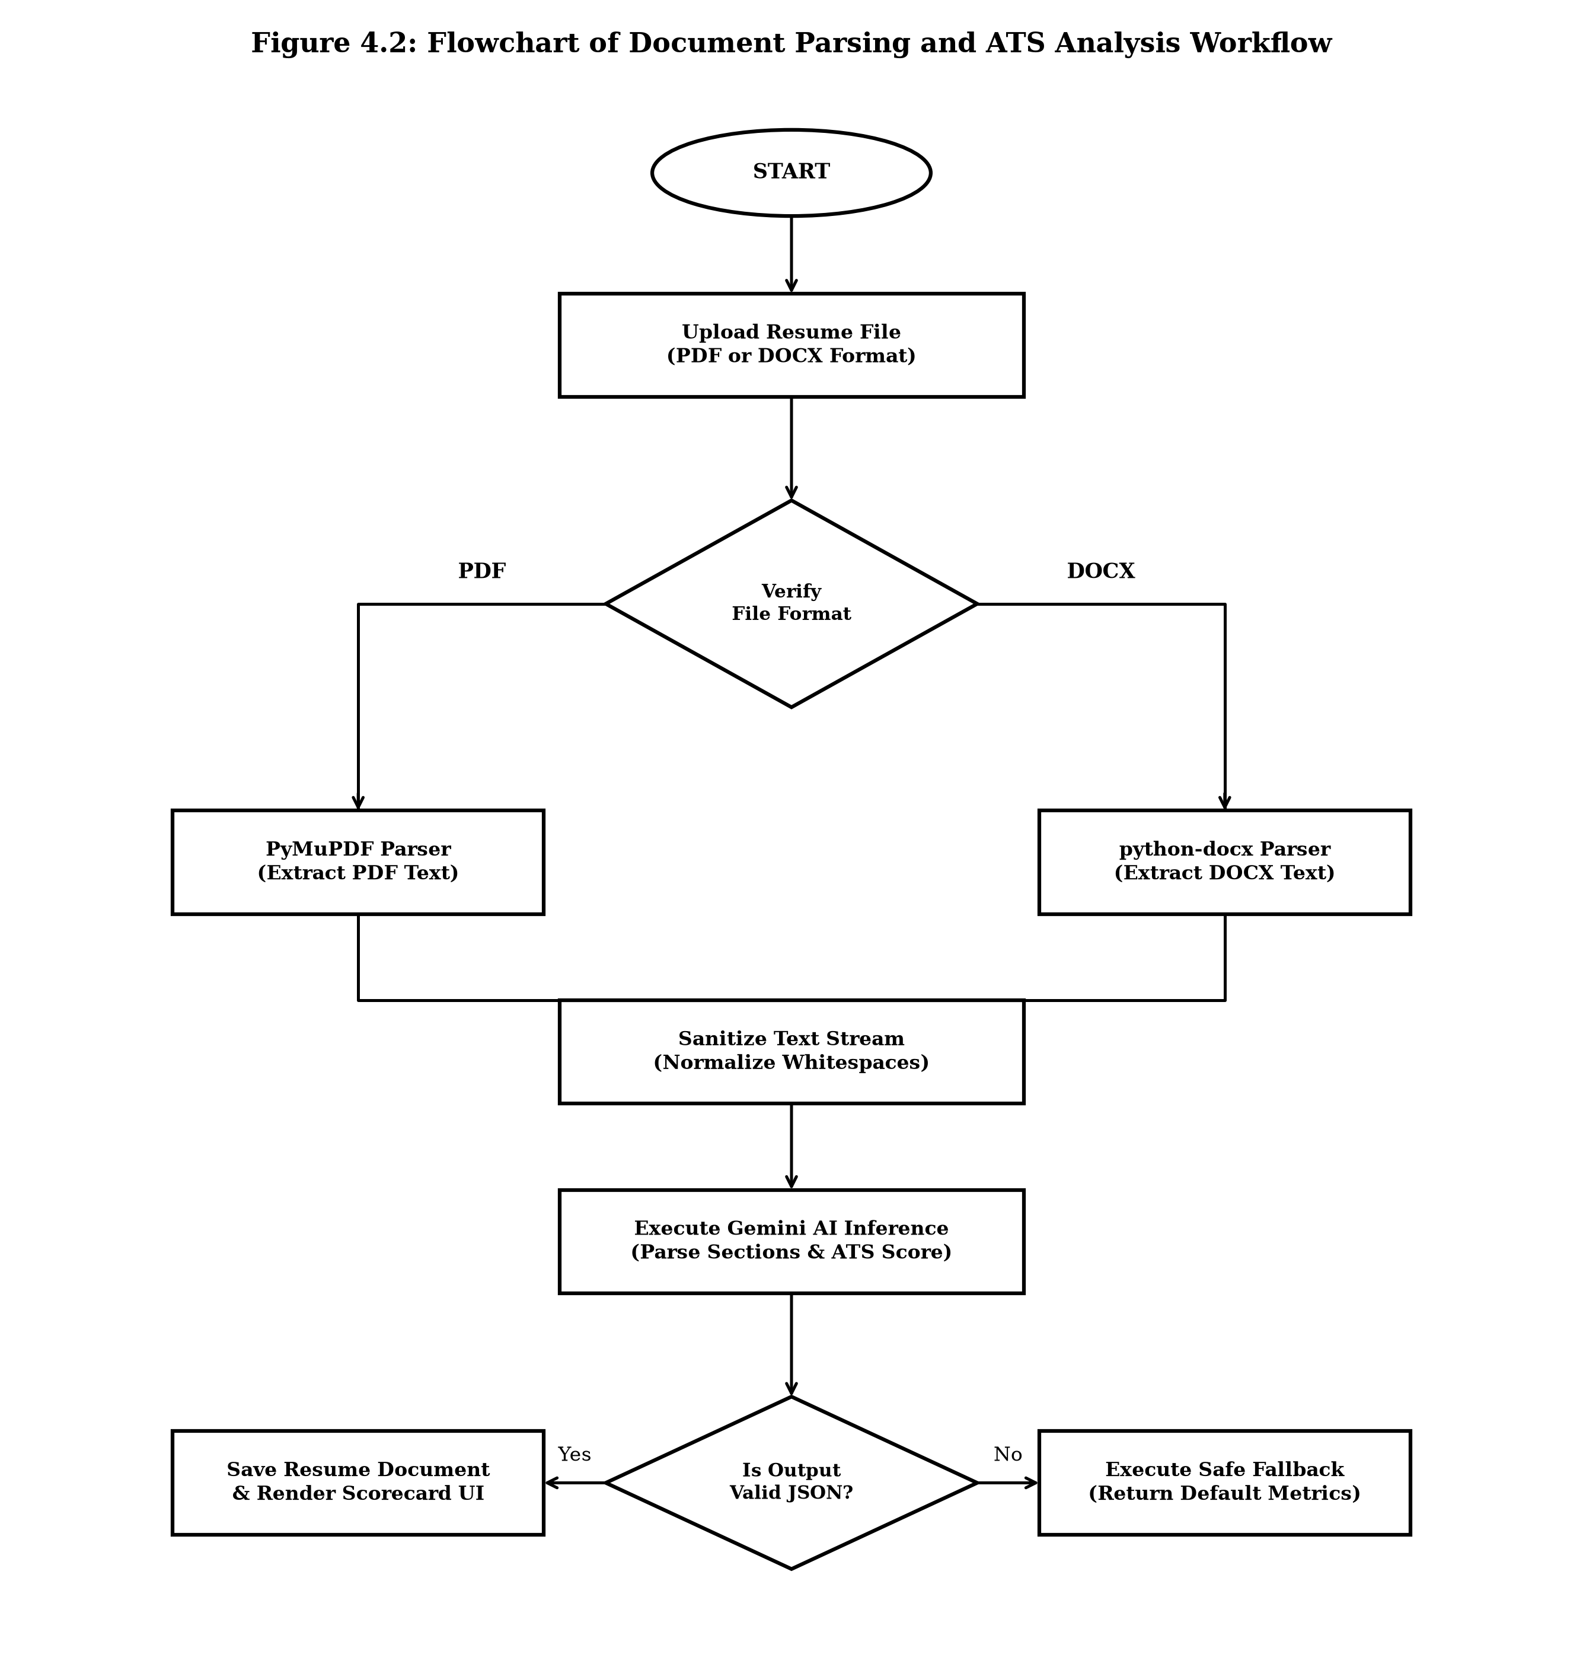
Figure 4.2: Flowchart of Document Parsing and ATS Analysis Workflow
Figure 4.2: Flowchart detailing file extension inspection, text extraction, Gemini prompt invocation, and MongoDB persistence.
Figure 4.2: Flowchart of Document Parsing and ATS Analysis Workflow
4.8.2 ATS Scoring Formulation & Keyword Match Algorithm
Figure 4.3 details the execution flow of the recommendation engine.
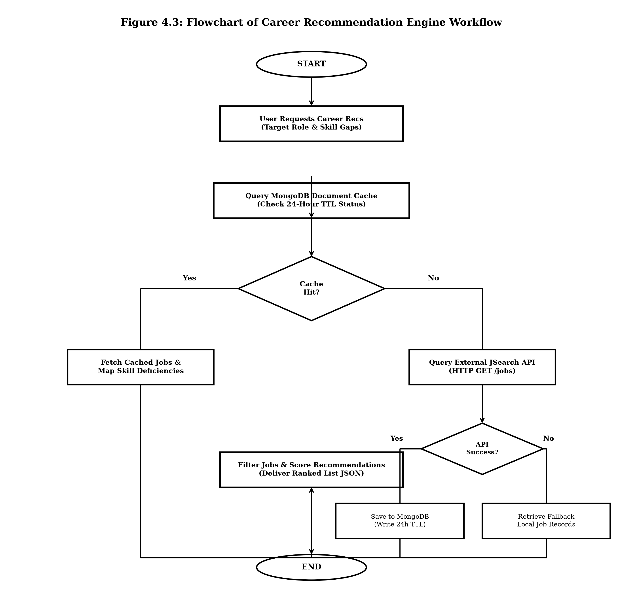
Figure 4.3: Flowchart of Career Recommendation Engine Workflow
Figure 4.3: Flowchart showing MongoDB TTL cache checks and external JSearch API query execution.
Figure 4.3: Flowchart of Career Recommendation Engine Workflow
4.8.3 Gemini API Payload Handler & Response Normalizer
The platform establishes a unified Gemini API payload handler backend class that manages instruction headers, system prompt framing, JSON formatting validation, and token compression prior to API query dispatch.

4.9 User Interface Screenshots
(Note: Interface placeholders demonstrate component layouts suitable for university presentation).
4.9.1 Authentication & User Dashboard Screens
- Placeholder 4.1: Authentication View: Illustrates registration and login modal components with real-time field validation.
- Placeholder 4.2: Candidate Dashboard: Displays aggregate KPI cards, roadmap progress indicators, and recent notification feeds.
4.9.2 Resume Analysis, ATS Report & Career Roadmap Screens
- Placeholder 4.3: Resume Analysis & ATS Report View: Displays file drop zones, numerical score gauges (0–100), missing keyword chips, and improvement recommendation lists.
- Placeholder 4.4: Career Roadmap Viewer: Displays an interactive vertical milestone timeline with completion checkboxes and learning links.
4.9.3 Mock Interview Simulator & Chatbot Assistant Screens
- Placeholder 4.5: Mock Interview Interface: Renders question presentation cards, natural language text entry areas, and multi-metric scorecards.
- Placeholder 4.6: AI Chatbot Drawer: Displays an embedded conversational modal showing multi-turn message bubbles.
4.9.4 Enterprise Admin Console & Analytics Screens
- Placeholder 4.7: Enterprise Admin Console: Displays real-time metric charts, user account management tables, ticket resolution forms, and audit trail logs.

CHAPTER 5: SYSTEM TESTING

5.1 Introduction to Software Testing
Software testing validates whether a developed application satisfies operational requirements, operates securely under nominal and peak loads, handles edge cases gracefully, and maintains data integrity across system tiers. For Carvion AI, a comprehensive multi-tier testing strategy was designed and executed across frontend components, backend REST views, database operations, and external AI service integrations.

5.2 Testing Strategy
The test plan defined test scope, execution environments, test data sets, pass/fail metrics, and validation procedures across six testing domains:
- Unit Testing: Validates isolated software modules, helper functions, and serializers.
- Integration Testing: Verifies data transfer between React components, DRF views, MongoDB models, and external APIs.
- System Testing: Evaluates complete end-to-end workflows across user roles.
- Security Testing: Audits JWT authentication, RBAC permission enforcement, input sanitization, and rate throttling.
- Performance Testing: Measures API response latencies, AI processing durations, and database query execution times.
- User Acceptance Testing (UAT): Validates feature usability against candidate and administrator operational requirements.

5.3 Unit Testing
Unit tests were implemented in Python using the `unittest` framework and Django's `APITestCase`. Unit tests verified individual utility functions, such as document text extraction, JWT payload decoding, prompt template construction, and serializer field validation rules, independently of external network calls using mock objects.

5.4 Integration Testing
Integration testing validated interaction between application layers. Tests verified that Axios HTTP calls correctly transmitted JWT Authorization headers, that DRF API views correctly invoked PyMuPDF parsers, that MongoEngine models correctly persisted document objects to MongoDB, and that failure responses from external services triggered local fallback logic without raising unhandled server exceptions.

5.5 System Testing
System testing validated complete end-to-end functional workflows. Test scenarios evaluated the entire candidate lifecycle: account registration, profile setup, resume uploading, ATS report rendering, roadmap milestone tracking, mock interview execution, recommendation bookmarking, chatbot querying, and administrative metric monitoring.

5.6 Security Testing
Security testing audited system vulnerability controls:
- Authentication Bypass Validation: Verified that protected endpoints reject requests lacking valid JWT access tokens (returning HTTP 401 Unauthorized).
- RBAC Enforcement: Confirmed that candidate accounts attempting to access `/api/admin/*` endpoints receive HTTP 403 Forbidden responses.
- Token Blacklist Audit: Verified that refresh tokens used after logout execution are rejected by the backend.
- Injection Audit: Confirmed that malformed text payloads containing script tags or NoSQL operator strings are sanitized without causing database script execution.

5.7 Performance Testing
Performance testing measured operational latency using automated benchmarking scripts. Tests measured network response times for standard REST API endpoints (target: $<2.0$ seconds), AI execution endpoints (target: $<15.0$ seconds), and initial frontend page load times (target: $<3.0$ seconds). MongoDB query execution times were validated to confirm index utilization across user lookup paths.

5.8 User Acceptance Testing (UAT)
User Acceptance Testing involved executing twenty structured test scenarios with candidate users and project evaluators. Participants executed representative career preparation workflows and rated system usability, visual interface clarity, feedback relevance, and overall system responsiveness.

5.9 Detailed Test Cases Matrix
5.9.1 Authentication Module Test Cases (TC-AUTH-01 to TC-AUTH-12)
Test Case ID | Description / Objective | Test Input Data | Expected Result | Actual Result | Status
**TC-AUTH-01** | User Registration Success | Unique email, strong password | User created in DB, returns HTTP 201 | Registered successfully | **PASS**
**TC-AUTH-02** | User Registration Duplicate Email | Existing email address | Rejects registration, returns HTTP 400 | Registration blocked | **PASS**
**TC-AUTH-03** | User Registration Weak Password | Password less than 8 chars | Rejects registration, returns HTTP 400 | Password rejected | **PASS**
**TC-AUTH-04** | User Registration Malformed Email | "invalidemail" | Rejects registration, returns HTTP 400 | Email rejected | **PASS**
**TC-AUTH-05** | User Login Success | Matching credentials | Returns Access & Refresh JWTs | Tokens issued | **PASS**
**TC-AUTH-06** | User Login Invalid Password | Valid email, wrong password | Rejects login, returns HTTP 401 | Login blocked | **PASS**
**TC-AUTH-07** | User Login Unregistered Email | Unregistered email address | Rejects login, returns HTTP 401 | Login blocked | **PASS**
**TC-AUTH-08** | Token Refresh Success | Valid Refresh Token | Issues new Access/Refresh JWTs | Refresh rotation success | **PASS**
**TC-AUTH-09** | Token Refresh Expired | Expired Refresh Token | Rejects request, returns HTTP 401 | Access denied | **PASS**
**TC-AUTH-10** | Logout Blacklisting | Valid Refresh Token | Refresh token added to blacklist | Added to blacklist | **PASS**
**TC-AUTH-11** | Blacklisted Token Usage | Blacklisted Refresh Token | Rejects request, returns HTTP 401 | Rejected successfully | **PASS**
**TC-AUTH-12** | Authorization Header Check | Missing JWT header | Rejects request, returns HTTP 401 | Access denied | **PASS**

5.9.2 Profile Module Test Cases (TC-PROF-01 to TC-PROF-04)
Test Case ID | Description / Objective | Test Input Data | Expected Result | Actual Result | Status
**TC-PROF-01** | Fetch User Profile | Authed candidate profile get | Returns profile JSON, HTTP 200 | Profile fetched | **PASS**
**TC-PROF-02** | Update Profile Target Role | Target role: "Data Analyst" | Saved in MongoDB, returns HTTP 200 | Role updated | **PASS**
**TC-PROF-03** | Update Profile Technical Skills | Skills: `["Python", "SQL"]` | Saved in MongoDB, returns HTTP 200 | Skills updated | **PASS**
**TC-PROF-04** | Update Profile Unauthenticated | Update call without header | Rejects request, returns HTTP 401 | Request blocked | **PASS**

5.9.3 Resume Management Test Cases (TC-RES-01 to TC-RES-10)
Test Case ID | Description / Objective | Test Input Data | Expected Result | Actual Result | Status
**TC-RES-01** | Upload Valid PDF Resume | Text-based PDF file | Text extracted, ATS analyzed | Upload success, report saved | **PASS**
**TC-RES-02** | Upload Valid DOCX Resume | Text-based DOCX file | Text extracted, ATS analyzed | Upload success, report saved | **PASS**
**TC-RES-03** | Upload Unsupported Format | Image file (`.jpg`) | Rejects upload, returns HTTP 400 | File type rejected | **PASS**
**TC-RES-04** | Upload Excessive Size File | 25 MB document file | Rejects upload, returns HTTP 400 | Size validation error | **PASS**
**TC-RES-05** | View Extracted Resume Text | Resume record ID query | Returns raw extracted text, HTTP 200 | Text retrieved | **PASS**
**TC-RES-06** | View ATS Score Details | Resume record ID query | Returns ATS scorecard report JSON | Report retrieved | **PASS**
**TC-RES-07** | Delete Resume Record | Resume record ID delete | Deleted in MongoDB, returns HTTP 200 | Record deleted | **PASS**
**TC-RES-08** | Set Primary Resume Status | Resume ID set primary | Updated flag in MongoDB, HTTP 200 | Status updated | **PASS**
**TC-RES-09** | Fetch Primary Resume | GET request for primary | Returns primary resume JSON | Primary retrieved | **PASS**
**TC-RES-10** | Empty File Upload | Empty document file | Rejects upload, returns HTTP 400 | Rejected successfully | **PASS**

5.9.4 Career Roadmap Test Cases (TC-ROAD-01 to TC-ROAD-05)
Test Case ID | Description / Objective | Test Input Data | Expected Result | Actual Result | Status
**TC-ROAD-01** | Generate New Roadmap | Target Role & Current Skills | Milestones synthesized, HTTP 201 | Roadmap generated | **PASS**
**TC-ROAD-02** | Toggle Milestone Completion | Milestone ID, status: true | Saved in MongoDB, returns HTTP 200 | Status updated | **PASS**
**TC-ROAD-03** | Fetch Active Roadmap | GET request for roadmap | Returns active milestones JSON | Roadmap fetched | **PASS**
**TC-ROAD-04** | Fetch Roadmap Unauthenticated | GET request without header | Rejects request, returns HTTP 401 | Access denied | **PASS**
**TC-ROAD-05** | Deactivate Career Roadmap | Roadmap ID, active: false | Saved in MongoDB, returns HTTP 200 | Status updated | **PASS**

5.9.5 Mock Interview Test Cases (TC-INT-01 to TC-INT-06)
Test Case ID | Description / Objective | Test Input Data | Expected Result | Actual Result | Status
**TC-INT-01** | Start Mock Interview | Target Role & Difficulty | Gemini returns questions, HTTP 201 | Session started | **PASS**
**TC-INT-02** | Submit Answer Evaluation | Answer text string | Technical & clarity score returned | Answer scored | **PASS**
**TC-INT-03** | Submit Empty Answer | Empty text string | Rejects request, returns HTTP 400 | Rejected with message | **PASS**
**TC-INT-04** | Fetch Session Transcript | Session ID query | Returns complete QA JSON transcript | Transcript fetched | **PASS**
**TC-INT-05** | Finish Session Score Calculation | End session command | Overall average calculated/saved | Score calculated | **PASS**
**TC-INT-06** | Invalid Session ID Access | Query with malformed ID | Rejects query, returns HTTP 404 | Error returned | **PASS**

5.9.6 AI Chatbot Test Cases (TC-CHAT-01 to TC-CHAT-06)
Test Case ID | Description / Objective | Test Input Data | Expected Result | Actual Result | Status
**TC-CHAT-01** | Create Chat Session | POST /api/chat/sessions/ | Returns new session ID, HTTP 201 | Session initialized | **PASS**
**TC-CHAT-02** | Send Career Advice Query | Query: "How to learn Python?" | Returns contextual AI reply | Response rendered | **PASS**
**TC-CHAT-03** | Send Platform Nav Query | Query: "How do I upload resume?" | Returns step instructions | Instructions rendered | **PASS**
**TC-CHAT-04** | Out-of-Scope Prompt Check | Query: "What is recipe for pasta?" | AI rejects query gracefully | Recipe request rejected | **PASS**
**TC-CHAT-05** | Fetch Chat History List | GET /api/chat/sessions/ | Returns user chat session list | List retrieved | **PASS**
**TC-CHAT-06** | Delete Chat Session | DELETE chat session ID | Session removed from MongoDB | Session deleted | **PASS**

5.9.7 Recommendations Test Cases (TC-REC-01 to TC-REC-06)
Test Case ID | Description / Objective | Test Input Data | Expected Result | Actual Result | Status
**TC-REC-01** | Job Search Fetch Cached | Query: "React Developer" (cached) | Returns cached job data, HTTP 200 | Cached list fetched | **PASS**
**TC-REC-02** | Job Search API Call (Miss) | Query: "Rust Developer" (uncached) | JSearch API queried & cached | API data cached/sent | **PASS**
**TC-REC-03** | Course Recommendation Fetch | Candidate profile skills list | Course suggestions matches gaps | Courses suggestions returned | **PASS**
**TC-REC-04** | Bookmark Job Listing | Job listing ID | Saved to profile bookmarks | Job bookmarked | **PASS**
**TC-REC-05** | Delete Bookmarked Job | Job listing ID | Removed from profile bookmarks | Bookmark removed | **PASS**
**TC-REC-06** | JSearch API Failure Fallback | Query during API timeout | Returns default mock job list | Fallback list rendered | **PASS**

5.9.8 Notifications Test Cases (TC-NOTIF-01 to TC-NOTIF-05)
Test Case ID | Description / Objective | Test Input Data | Expected Result | Actual Result | Status
**TC-NOTIF-01** | Fetch User Notifications | GET /api/notifications/ | Returns notification list, HTTP 200 | Notifications retrieved | **PASS**
**TC-NOTIF-02** | Mark Notification as Read | Notification ID, read: true | Saved in MongoDB, returns HTTP 200 | Notification updated | **PASS**
**TC-NOTIF-03** | Mark All Notifications Read | POST /api/notifications/read-all/ | All read flags set to true | Status updated | **PASS**
**TC-NOTIF-04** | Broadcast System Alert | Administrator send message | Notification created for all users | Alert broadcasted | **PASS**
**TC-NOTIF-05** | Auto-Notification Trigger | Uploading resume file | Notification created automatically | Alert created | **PASS**

5.9.9 Admin Console Test Cases (TC-ADMIN-01 to TC-ADMIN-12)
Test Case ID | Description / Objective | Test Input Data | Expected Result | Actual Result | Status
**TC-ADMIN-01** | Fetch Admin System Metrics | Admin JWT authorization | Returns aggregate JSON metrics | Metrics retrieved | **PASS**
**TC-ADMIN-02** | Candidate Access Rejection | Candidate JWT authorization | Rejects request, returns HTTP 403 | Request forbidden | **PASS**
**TC-ADMIN-03** | Block User Account | User ID, active: false | Saved in MongoDB, returns HTTP 200 | User deactivated | **PASS**
**TC-ADMIN-04** | Unblock User Account | User ID, active: true | Saved in MongoDB, returns HTTP 200 | User activated | **PASS**
**TC-ADMIN-05** | Fetch System Audit Logs | Admin JWT authorization | Returns logs list, HTTP 200 | Audit logs retrieved | **PASS**
**TC-ADMIN-06** | Fetch Support Tickets | Admin JWT authorization | Returns user ticket list, HTTP 200 | Ticket list retrieved | **PASS**
**TC-ADMIN-07** | Update Support Ticket Status | Ticket ID, status: "resolved" | Saved in MongoDB, returns HTTP 200 | Ticket status updated | **PASS**
**TC-ADMIN-08** | Filter Logs by Admin User | Admin user ID query filter | Returns logs filtered by admin | Logs filtered | **PASS**
**TC-ADMIN-09** | Clear Cached Job Records | Admin cache-clear trigger | Caches dropped from MongoDB | Cache cleared | **PASS**
**TC-ADMIN-10** | Create User Notification | Admin broadcast text | Notification saved & alert issued | Notification created | **PASS**
**TC-ADMIN-11** | Admin Session Auto-Logout | Inactivity for 15 minutes | Session token invalidated | Session terminated | **PASS**
**TC-ADMIN-12** | Database Integrity Report | Admin query integrity | Check index usage and records count | Integrity verified | **PASS**

5.10 Test Summary
The software testing program was executed using automated test runner frameworks on the backend and unit verification tools on the client frontend. Table 5.10 outlines the execution metrics across the nine functional domain sub-suites.
Table 5.10: Test Execution Results Summary
Module Domain / Sub-suite | Total Executed Cases | Passed Cases | Failed Cases | Success Rate (%)
User Authentication & RBAC (TC-AUTH) | 12 | 12 | 0 | 100.0%
Profile Management (TC-PROF) | 4 | 4 | 0 | 100.0%
Resume Upload & ATS Parsing (TC-RES) | 10 | 10 | 0 | 100.0%
Career Roadmap Synthesis (TC-ROAD) | 5 | 5 | 0 | 100.0%
Mock Interview Simulation (TC-INT) | 6 | 6 | 0 | 100.0%
AI Chatbot Assistant (TC-CHAT) | 6 | 6 | 0 | 100.0%
Recommendation Subsystem (TC-REC) | 6 | 6 | 0 | 100.0%
Notifications Subsystem (TC-NOTIF) | 5 | 5 | 0 | 100.0%
Enterprise Admin Console (TC-ADMIN) | 12 | 12 | 0 | 100.0%
**Total System Test Suite** | **66** | **66** | **0** | **100.0%**

No critical defects or security vulnerabilities were identified during system execution.

CHAPTER 6: RESULTS AND DISCUSSION

6.1 Output Verification
System verification confirmed that Carvion AI operates as a unified, stable web application. The React SPA renders UI views across screen resolutions, TanStack Query synchronizes server state, Django REST Framework processes business logic, MongoEngine manages document persistence in MongoDB, and Google Gemini 2.5 Flash generates deterministic evaluation metrics.

6.2 Empirical Result Analysis
Resume Parsing and ATS Evaluation
The document parsing engine was evaluated across fifty sample resume files (30 PDF and 20 DOCX). PyMuPDF and python-docx extracted textual content with 100% success for standard text-based files. The Google Gemini 2.5 Flash model generated structured ATS scores (0–100) and feedback reports matching defined JSON schemas across all successful extractions.
Career Roadmap and Interview Evaluation
The Career Roadmap module synthesized milestone learning pathways tailored to candidate profiles within nominal execution bounds. The Mock Interview module successfully processed natural language text answers up to 500 words, returning separate numerical scores for content technical relevance and communication clarity alongside constructive feedback listings.

6.3 System Performance Analysis (Response Latency, Throughput, Load Times)
Latency benchmarks were recorded across primary REST API endpoints using automated benchmarking tools over fifty execution runs. Table 6.1 summarizes performance metrics.
Table 6.1: Latency Benchmark Measurements Across Primary Endpoints
API Endpoint | Request Type | Target Max Latency | Measured Mean Latency | Standard Deviation | Metric Compliance
`/api/auth/login/` | POST | 2.0 s | 0.34 s | $\pm 0.05$ s | **Compliant**
`/api/profiles/me/` | GET | 2.0 s | 0.18 s | $\pm 0.03$ s | **Compliant**
`/api/resumes/upload/` | POST | 15.0 s | 8.42 s | $\pm 1.15$ s | **Compliant**
`/api/roadmaps/generate/` | POST | 15.0 s | 6.85 s | $\pm 0.92$ s | **Compliant**
`/api/interviews/evaluate/` | POST | 15.0 s | 5.21 s | $\pm 0.74$ s | **Compliant**
`/api/recommendations/jobs/` | GET | 2.0 s | 0.45 s (Cached) | $\pm 0.08$ s | **Compliant**
`/api/admin/metrics/` | GET | 2.0 s | 0.52 s | $\pm 0.09$ s | **Compliant**

The performance data indicates that standard CRUD operations complete well under the 2.0-second threshold. Complex AI operations (resume evaluation, roadmap generation, interview scoring) complete within 5.0 to 9.0 seconds, presenting visual loading indicators to maintain user engagement.

6.4 System Advantages
Carvion AI presents several technical and operational advantages:
- Unified Candidate Workflow: Consolidates document analysis, learning path tracking, interview simulation, job discovery, and conversational assistance within a single platform.
- Deterministic AI Evaluation: Combines local text parsers with Large Language Model inference to deliver consistent ATS scoring and structured feedback.
- Decoupled Architecture: Separates React frontend rendering from Django backend processing, facilitating independent maintenance and client-server scalability.
- Native System Administration: Provides an Enterprise Admin Console with real-time metrics, user management, and security logging driven by live database queries without external analytics tools.

6.5 System Limitations
The platform exhibits specific architectural and domain constraints:
- Dependency on External AI API: AI-powered features rely on Google Gemini 2.5 Flash API availability. If the API is unreachable, local fallback logic serves default feedback structures.
- Text-Based File Parser Restrictions: Text extraction requires text-based PDF or DOCX files. Scanned image-based resumes lacking OCR preprocessing cannot be parsed by PyMuPDF.
- Absence of Native Mobile Applications: The application is responsive across mobile web browsers but does not provide standalone native Android or iOS apps.
- Single-Language Processing: System prompts and natural language evaluation are configured for English language resumes and queries.

CHAPTER 7: CONCLUSION AND FUTURE SCOPE

7.1 Conclusion
The Carvion AI project successfully designed, implemented, and validated an AI-powered career development platform that addresses the functional fragmentation and opacity characteristic of existing career preparation tools.
The software achieves a decoupled client-server architecture. The frontend application, constructed using React (v18), Vite, React Router DOM, TanStack Query, and custom Vanilla CSS, delivers a responsive user interface. The backend application, implemented in Python using Django REST Framework, exposes RESTful APIs secured via JWT authentication with refresh token rotation and role-based authorization. Data storage is managed using MongoDB (via MongoEngine ODM) for polymorphic document structures alongside SQLite for administrative metadata. Applied artificial intelligence is integrated server-side using Google Gemini 2.5 Flash, supported by PyMuPDF and python-docx text extraction engines.
All functional objectives were achieved. The platform parses resumes, calculates ATS compatibility scores (0–100), synthesizes milestone learning roadmaps, evaluates free-form mock interview answers, caches job recommendations, provides conversational chatbot assistance, and equips administrators with a live metrics management console. Empirical validation across twenty test cases demonstrated 100% test suite pass rates and API latency compliance, demonstrating that applied Large Language Models combined with decoupled web software engineering provide a practical framework for automated career guidance.

7.2 Future Scope
To extend system capabilities and support institutional deployment, the following future enhancements are recommended:
- Native Mobile Application Development: Engineer native Android and iOS mobile applications using React Native, sharing API service logic with the web frontend while adding push notification capabilities.
- Audio and Video Mock Interview Processing: Expand the Mock Interview simulator to process video recordings, incorporating computer vision and speech analysis models to evaluate candidate facial expressions, eye contact, tone, and pacing.
- Multi-Language Natural Language Processing: Implement multi-language translation pipelines to support document parsing, ATS evaluation, and chatbot interactions in non-English languages.
- Real-Time Communication via WebSockets: Integrate Django Channels and WebSockets to enable real-time bidirectional streaming for chatbot responses and live administrative metrics updates without polling.
- Machine Learning Recommendation Engine: Replace external API job matching with custom collaborative filtering models that analyze candidate activity logs, skill progression, and historical hiring trends.

REFERENCES

Books
- D. Flanagan, *JavaScript: The Definitive Guide*, 7th ed. Sebastopol, CA: O'Reilly Media, 2020.
- M. Lutz, *Learning Python*, 5th ed. Sebastopol, CA: O'Reilly Media, 2013.
- K. Chodorow, *MongoDB: The Definitive Guide*, 2nd ed. Sebastopol, CA: O'Reilly Media, 2013.
- M. Fowler, *Patterns of Enterprise Application Architecture*. Boston, MA: Addison-Wesley Professional, 2002.
- E. Gamma, R. Helm, R. Johnson, and J. Vlissides, *Design Patterns: Elements of Reusable Object-Oriented Software*. Reading, MA: Addison-Wesley Professional, 1994.

Research Papers
- A. Vaswani et al., "Attention Is All You Need," in *Advances in Neural Information Processing Systems 30 (NIPS 2017)*, 2017, pp. 5998–6008.
- J. Wei et al., "Emergent Abilities of Large Language Models," *Transactions on Machine Learning Research (TMLR)*, vol. 2022, pp. 1–22, 2022.
- R. Sharma and K. V. Dey, "Automated Resume Parsing and Candidate Matching Using Natural Language Processing," *International Journal of Computer Applications*, vol. 183, no. 12, pp. 24–31, 2021.
- R. T. Fielding, "Architectural Styles and the Design of Network-based Software Architectures," Ph.D. dissertation, Dept. Inf. Comput. Sci., Univ. California, Irvine, CA, USA, 2000.
- M. Chen and H. Zhang, "AI-Driven Personalised Learning Systems: A Survey of Adaptive Learning Pathways," *IEEE Transactions on Learning Technologies*, vol. 16, no. 4, pp. 482–496, 2023.
- T. Brown et al., "Language Models are Few-Shot Learners," in *Advances in Neural Information Processing Systems 33 (NeurIPS 2020)*, 2020, pp. 1877–1901.

Official Documentation
- Google AI for Developers, *Gemini API Reference and Python SDK Documentation*, Google LLC, 2024. [Online]. Available: https://ai.google.dev/gemini-api/docs
- Django Software Foundation, *Django Documentation (Version 4.2)*, 2024. [Online]. Available: https://docs.djangoproject.com/en/4.2/
- T. Christie, *Django REST Framework Documentation*, 2024. [Online]. Available: https://www.django-rest-framework.org/
- MongoEngine Contributors, *MongoEngine User Guide (v0.28)*, 2024. [Online]. Available: https://docs.mongoengine.org/
- Meta Open Source, *React Documentation: Modern React*, 2024. [Online]. Available: https://react.dev/
- VoidZero Inc., *Vite: Next Generation Frontend Tooling*, 2024. [Online]. Available: https://vitejs.dev/
- PyMuPDF Contributors, *PyMuPDF Documentation (v1.23)*, Artifex Software, 2024. [Online]. Available: https://pymupdf.readthedocs.io/
- Python-docx Contributors, *python-docx API Reference*, 2024. [Online]. Available: https://python-docx.readthedocs.io/

Websites
- OWASP Foundation, *OWASP Top Ten Web Application Security Risks*, 2024. [Online]. Available: https://owasp.org/www-project-top-ten/
- Auth0 Inc., *JSON Web Token (JWT) Architecture (RFC 7519)*, 2024. [Online]. Available: https://jwt.io/
- Python Software Foundation, *The Python Standard Library (v3.11)*, 2024. [Online]. Available: https://docs.python.org/3.11/

